|  |  |  |  |  |  |  |  |
| --- | --- | --- | --- | --- | --- | --- | --- |
| 4.1 Component Design | | | | | | | |
| Component | Location | Type | Purpose | Dependencies | Input(s) | Processing | Output(s) |
| Load profile button (Start page) | Start page | Button | Links the Start Page to the Load Profile page | Application launch | Mouse click | Queries the database then displays users if they are available | Load Profile page |
| Create profile button (Start page) | Start page | Button | Links from the Start page to the Create Profile | Application launch | Mouse click | Sends the user to the Create Profile page | Create Profile page |
| Username text box | Create Profile page | Text box | Location to enter the user’s desired username | Create profile button (Start page) click | Username | Holds text typed by user | N/A |
| First Name text box | Create Profile page | Text box | Location to enter the user’s first name | Create profile button (Start page) click | First name | Holds text typed by user | N/A |
| Last Name text box | Create Profile page | Text box | Location to enter the user’s last name | Create profile button (Start page) click | Last name | Holds text typed by user | N/A |
| Create profile button | Create Profile page | Button | Allows user to create a new profile | Username text box, first name text box and last name text box | Mouse click | Calls the Create Profile function | Signal to start create profile function |
| Create profile function | Create Profile page | Function | Creates a new profile in the database | Username, first name, last name and create profile button click | Username, first name and last name | Adds a new profile to the database, checks for duplicate username. If duplicate, rejects and redirects user back to the Create Profile page. If no duplicates, the profile is created in the database and the user is sent to the Start page. | Invalid username message or a successful profile creation message and Start page |
| Profile list box | Load Profile page | List box | Displays the usernames of created profiles | Load profile (start page) button click | User selection from list box | Selects the profile that the user wants to load | Selected profile |
| Load profile button | Load Profile page | Button | Allows user to start a session under a created profile account | Profile selection | Mouse click | Calls the load profile function | Signal to start load profile function |
| Load profile function | Load Profile page | Function | Starts a session under the selected profile account. | Load profile button click and profile selection | User selection from list box | Queries the database and obtains saved profile data from training and testing portions of the application | Loaded user data, User Home page |
| Train button | User Home page | Button | Allows user to starts a training session | Loaded profile | Mouse click | Calls the train function | Signals train function to start |
| Train function | User Home page | Function | Brings user to the Training page | Train button click | User progress completion | Views the user’s training completion progress and starts the user on the Training page from the last saved point. Loads training video for the corresponding letter. | Training page |
| Test button | User Home page | Button | Allows user to start a testing session. Button remains greyed out if user completion progress is below 100%. | Loaded profile, 100% training progress completion | Mouse click | Calls the test function | Signals the test function to start |
| Test function | User Home page | Function | Brings user to the Testing page | Test button click | Signal to start | Randomize alphabet then sends user to the Testing page | Testing page |
| Delete profile button | User Home page | Button | Allows user to delete the user profile | Loaded profile | User mouse click and current profile | Sends the current profile to the delete profile function and calls the delete profile function | Confirmation of profile being cleared and user interface is reset |
| Delete profile function | User Home page | Function | Deletes the designated profile and all associated data | Delete profile button click, user confirmation | Profile to delete | Sends delete statements to the SQL database, erasing all of the data associated with profile | Deleted profile |
| Exit button | Testing page | Button | Allows user to exit the testing page at any time | Test button click | User mouse click | Calls exit function | Exit signal |
| Exit function | Testing page | Function | Exits the testing session | Exit button click, user confirmation | Exit signal | Asks for user confirmation before exiting the testing session. If yes, the testing session is terminated and user is sent back to User Home page | User Home page |
| Save and Exit button | Training page | Button | Allows user to exit the training page at any time | Train button click | User mouse click | Calls the Save and Exit function | Save and Exit signal |
| Save and Exit function | Training page | Function | Exits the training session and saves the progress of the user | Save and Exit button click, user confirmation | Save and Exit signal | Updates the progress field of the user profile in the database then exits the Training page and sends user back to User Home page | Updated user progress completion percentage, User Home page |
| Hand recognition | Testing page, Training page | Sub program | Identifies the position of the user’s hand | Train button click or Test button click | Kinect read in, user’s hand | Finds the user’s palm using the Kinect SDK and tracks its center-point | 3D coordinates of the center-point of the user’s hand |
| Hand contour recognition | Testing page, Training page | Sub program | Identifies the shape of the user’s hand | Train button click or Test button click | Kinect read in, user’s hand, hand location | Using the location of the hand, it looks for the palm, fingers and thumb by separating it from the background, based on its distance from the Kinect | Set of points shaping the hand |
| Hand square dimensions | Testing page, Training page | Sub program | Identifies the height and width of user’s hand | Hand contour recognition | Set of points from hand contour recognition | Finds the maximum and minimum X and Y values, creates a square based on these values | A square with the height and width of the user’s hand |
| Fingertip recognition | Testing page, Training page | Sub program | Identifies the user’s finger tips | Hand contour recognition | Set of points from hand contour recognition | Uses a K-means algorithm on the set of the hand’s coordinates to find the location of the fingertips | Number of fingers held up, coordinates of the fingers |
| User ready to sign detection | Testing page, Training page | Sub program | Identifies that the user is ready to sign from an open hand, palm forward | Fingertip recognition | Fingertip recognition | Once the fingertip detection recognizes five fingers, this signals that the user is ready to begin | Signal that the user is ready to sign |
| Area calculation | Testing page, Training page | Function | Finds the area of the hand | Hand contour recognition | Set of points from hand contour recognition | Uses points on the hand and calculates its area | Area of the hand in pixels |
| Percentage of square area | Testing page, Training page | Function | Calculates the percentage of area that the user’s hand is taking up from the hand square | Area calculation, hand square dimensions | Area of the hand, square dimensions of the hand | Area of the hand divided by the area of its square dimensions | Percentage of the square that the hand occupies |
| Nearest point | Training page, Testing page | Sub program | Finds nearest point of user’s hand to Kinect | Hand contour recognition | Sets of points from hand contour recognition | Finds the Z value of the user’s hand closest to the Kinect | Z value of closest point |
| Hand sign capture | Training page | Sub program | Captures the user’s sign for each letter | User ready to sign detection, percentage of square area, area calculation, fingertip recognition, | Number of fingers, area of hand, percentage of square area, nearest point | Snapshots a data set of the hand area, number of fingers, percentage of hand and nearest point once the user has stopped moving their hand and all values from Kinect read in are alike. | Captured sign saved to database |
| Hand sign training | Training page | Sub program | Teaches user how to sign and use the application with video demonstration | Train button click | User training progress | Shows user how to sign certain letters through video demonstration | Video output |
| Hand sign testing | Testing page | Sub program | Prompts user to sign a letter and sees if it was done correctly | Test button click | Hand sign snapshots from the training sessions | Compares the user’s attempt at signing a letter they were instructed to and compares it to the average of signs made during training to confirm accuracy | Message stating if sign was accurate or inaccurate |

4.2 Interface Design

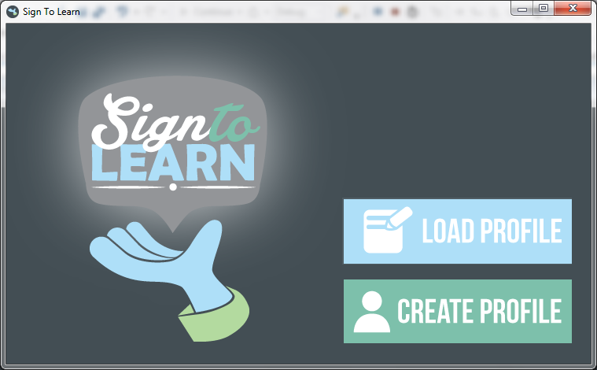

The Start page is the first page of the application after launch. The user will have the options of creating a new user profile or loading an existing user profile to begin using the application.

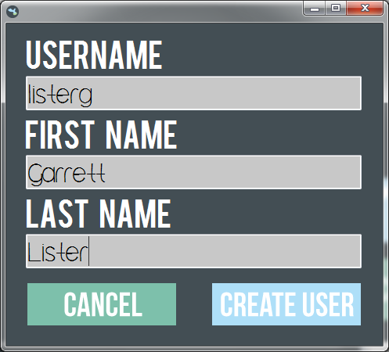

Triggered by the create profile button from the Start page, the Create Profile page prompts the user to enter a username, first name and last name in order to create the user account profile. The profile will store their training completion progress, hand sign data and test scores. All fields are necessary. The user can forfeit creating a profile by clicking on the Cancel button. When the user clicks the Create Profile button, the username is validated and the new user is stored into the database.

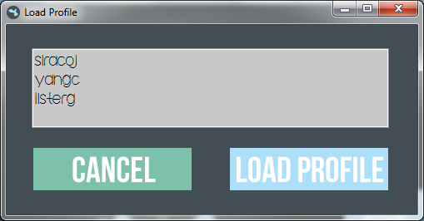

Triggered by the load profile button from the Start page, the Load Profile page shows a list of available profiles to load. If the user tries to load a profile before creating any profiles, the list of available profiles will be blank and they will be unable to proceed any further. The user needs to select a profile to load before clicking on the Load Profile button. The user can forfeit loading a profile by clicking on the Cancel button.

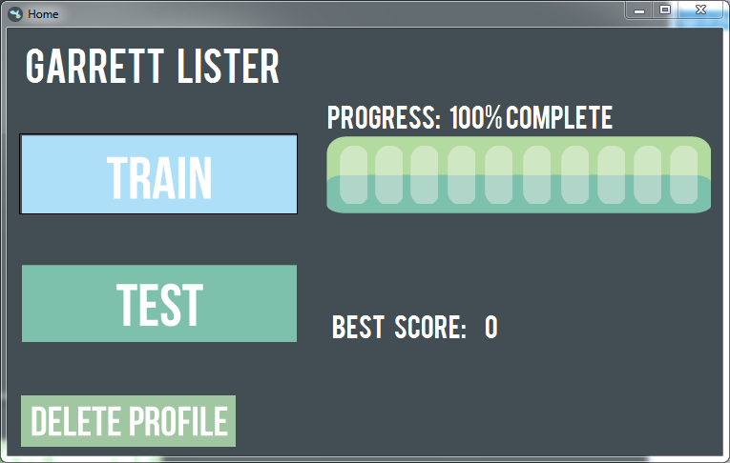

Triggered by the load profile button from the Load Profile page, the User Home page displays the first and last name of the user as well as the user’s training completion progress and the user’s best recorded score. Until the user has 100% completion, the Test button will be greyed out. The user always has the option to train regardless of training completion. The user has the option to delete the profile here. Once the user has confirmed the deletion, the user will be taken back to the Start page.

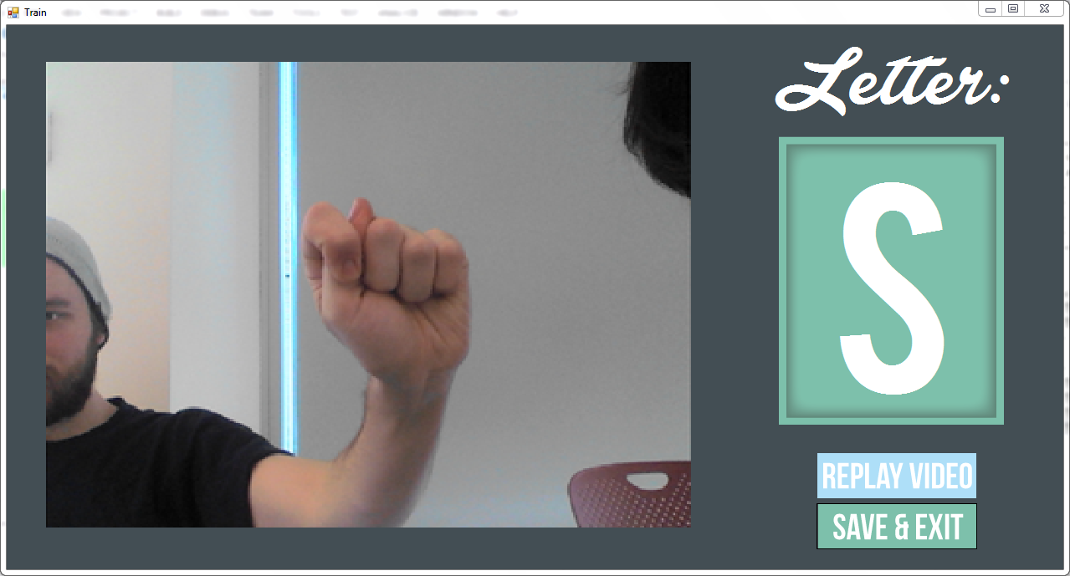

Triggered by the train button from the User Home page, the Training page will educate the user on how to sign a letter via video demonstration then prompt the user to sign the letter. The user will need to correctly sign the letter 10 times in a row in order to move on to the next letter. The user will be able to replay the video at any time as well as save their progress at any time, which will bring the user back to the User Home page and update their training progress completion. The user’s progress completion reaches 100% when all letters of the alphabet have been successfully signed by the user.

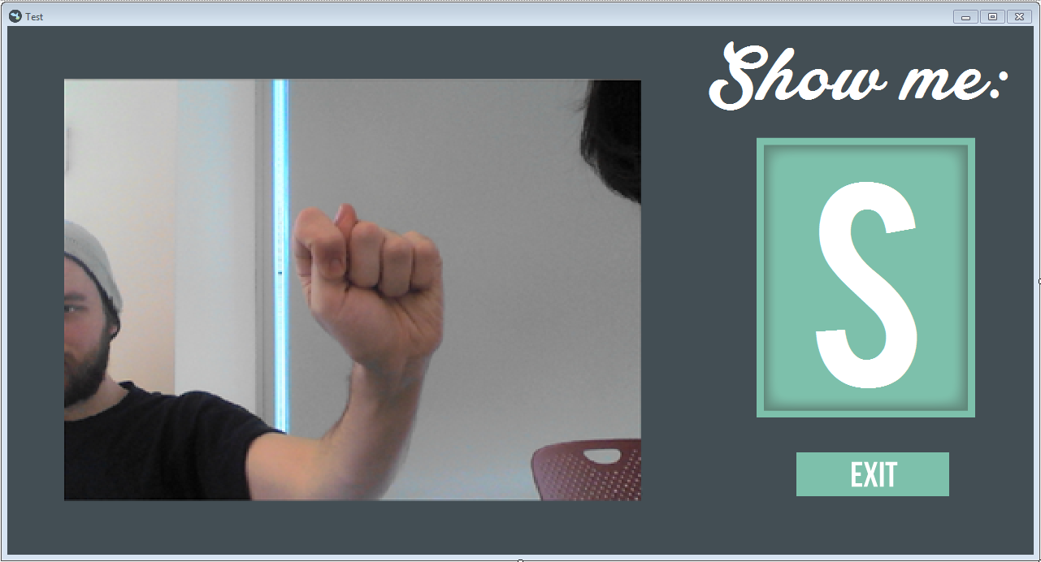

Triggered by the test button from the User Home page, the Testing page will prompt the user to sign a letter of the alphabet. The order of the alphabet will be randomized and all 26 letters of the alphabet will be tested. The sign is considered incorrect if the read-in data of the sign surpasses a certain threshold of the stored data of the sign. If the user completes the test, a score is calculated from the number of incorrect signs and correct signs and recorded into the user profile in the database. The user can exit the test at any time, which will take them back to the User Home page without saving their progress.