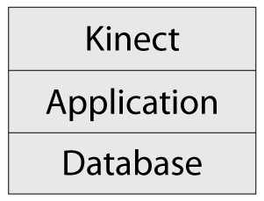
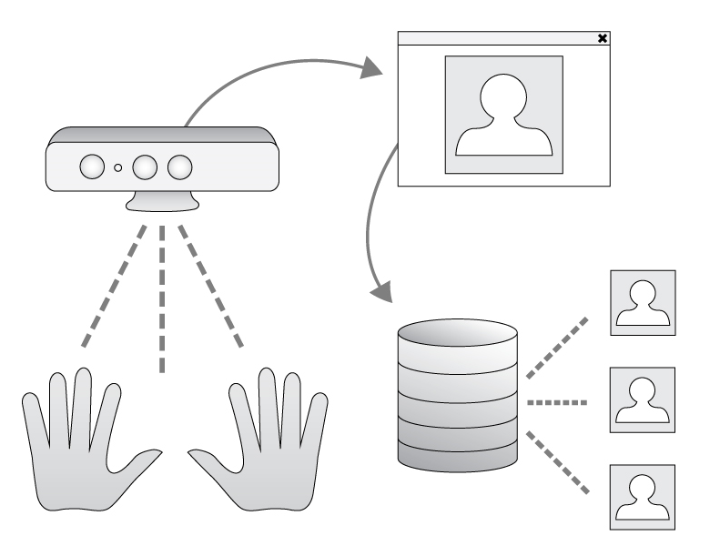

Software Requirements Specification (SRS)
For
SignToLearn – ASL Alphabet Learning Application

Wentworth Institute of Technology
Department of Computer Science and Networking
Software Design and Development – COMP566

Jared Siraco, Garrett Lister and Chou Yang

Last Submission: 16, Feb 2014 8:56 PM
Table of Contents
Introduction

  - Purpose of this Document ……………………………………………………………………………………............... 3
  - Scope of the Development Project …………………………………………………………………………………….. 3
  - Definitions, Acronyms and Abbreviations ……………………………………………………………….………….. 3
1.3.1 Acronyms …......................................................................................................................3
1.3.2 Definitions …....................................................................................................................3
1.3.3 Abbreviations …...............................................................................................................3
  - References ……………………………………………………………………………….………….…………………………….. 3
  - Overview of Document ………………………..……………………………………………………………………………..4

General Description
2.1 User Characteristics ………………………………………………..………………………………………………………….. 4
2.2 Product Perspective ……………………………………………..…………………………………………………………….. 4
2.3 Overview of Functional Requirements ………………………………………………………………………………... 4
2.4 Overview of Data Requirements ………………………………..……………………………………………………….. 5
2.5 General Constraints, Assumptions, Dependencies, Guidelines ………………………………..………….. 5
2.5.1 Constraints ………………………………………………………………………………………………………….. 5
2.5.2 Assumptions ……………………………………………………………………………………………………….. 5
2.5.3 Dependencies …………………………………….……………………………………………………………….. 5
2.5.4 Guidelines ……………………………………………….………………………………………………………….. 5
2.6 User View of Product Use .........................................................................................................6
Specific Requirements
  - External Interface Requirements …………………….………………………………………………………………….. 7
3.2 Detailed Description of Functional Requirements …………………………………………………………….... 7
3.3 Performance Requirements ………………………………………………………………………………………………..12
3.4 Quality Attributes …………………………………………………………………………………………………..….……….12
3.4.1 Security.....................................................................................................................12
3.4.2 Availability................................................................................................................12
3.4.3 Reliability..................................................................................................................12
3.4.4 Maintainability.........................................................................................................12

Other Requirements ……………………………………………………………………….…………………………………………………….13
Use Cases …………………………………………………………………………………………………….………………………………………13

1. INTRODUCTION
1.1 Purpose of this Document
This SRS describes the purpose of the SignToLearn application. SignToLearn is a standalone application that works with the Microsoft Kinect camera.

1.2 Scope of the Development Project
SignToLearn is an application working with the Microsoft Kinect camera to teach users the American Sign Language (ASL) alphabet. The user will have to sign letters as instructed by SignToLearn at defined intervals. The Kinect's gesture tracking would check the users’ accuracy.
1.3 Definitions, Acronyms, and Abbreviations
1.3.1 Acronyms
ASL: American Sign Language
SDK: Software Development Kit
SRS: Software Requirements Specification
SQL: Structured Query Language
UI: User Interface
1.3.2 Definitions
K-means Algorithm: Groups data points into K groups based on how similar they are
Microsoft Kinect: A motion sensing input devices that captures data in two dimensional video and three dimensional coordinates.
Kinect near mode: A function exclusive to the Kinect for windows version, that allows the better capture of objects between 600 and 800 millimeters away from the camera.
1.3.3 Abbreviations
3D: Three Dimensional

1.4 References
Get started building kinect for windows apps and experiences. (n.d.). Retrieved from http://lifeprint.com/asl101/topics/wallpaper1.htm
Vicars, W. (n.d.). Sign language. Retrieved from http://lifeprint.com/asl101/topics/wallpaper1.htm

1.5 Overview of Document
This SRS will review the hardware, software, interface and user requirements as well as the constraints and dependencies of the SignToLearn application.

2. GENERAL DESCRIPTION
Using Microsoft’s Kinect hardware, SignToLearn will allow users to learn the ASL alphabet like never before. This isn’t a passive learning application! Using the user’s own input, the Kinect will be able to guide the user into performing all signs he or she wants to learn. This sets SignToLearn apart from any other ASL teaching utility on the market.

2.1 User Characteristics
As a teaching utility using hand tracking to teach ASL, one major critical characteristic of the human interface is the ability to perform the given signs. Individuals who can’t physically perform the signs for various reasons would not be able to take full advantage of the program.

2.2 Product Perspective
SignToLearn is a stand-alone product which interfaces with the user through a graphical user interface and also through a natural user interface using a Microsoft Kinect, a motion sensing input device which features a z-pixel depth sensor and is based on a web-cam design. This application uses the Microsoft Kinect to capture 3 dimensional models as well as detect defined gestures as input.

2.3 Overview of Functional Requirements
First the user will need to be able to create and load profiles to store their configuration and test data in. Next the user's hand will need to be calibrated so that the application can read the user's signs as accurately as possible. This will be done by having the user hold their hand at a specified distance to determine the users finger placement and minimize background interference. After calibration, the application will show the user how to sign each letter and have them sign it 10 times, data will be gathered from this and recorded to help the application recognize gestures later on. Once the user is ready the application will display words for users to spell in ASL, the user will then be asked to spell each letter of the displayed word at defined intervals. If the user signs a letter incorrectly they will be asked to sign that letter again at the next interval until it is done correctly.

2.4 Overview of Data Requirements
Gesture tracking and configuration data will be gathered through the Kinect device and used during run-time within the application. Users should be able to save the configuration data and access it through created profiles. Data from the learning phase will be saved to each user profile as well

2.5 General Constraints, Assumptions, Dependencies, Guidelines

2.5.1 Constraints
This product must be used in a clutter free space.
The user must stand in front of the Kinect with their hand between 600 and 800 millimeters away from the Kinect.

2.5.2 Assumptions
N/A

2.5.3 Dependencies
This product will only work on windows systems enabled to work with Kinect hardware.
This product needs a Microsoft Kinect for Windows (Near mode enabled)

2.5.4 Guidelines
This product must be able to calibrate for many different hand sizes and shapes.

2.6 User View of Product Use
The user begins by ether creating a profile, loading a profile, or choosing to sign in as a guest. They are then directed to the application landing page where they have two choices, ether to start training or testing. If the user has not completed training, the testing option will not be available. The training option begins by the user holding their hand close to the Kinect to properly configure the application for their hand. Then the user is instructed on how to sign each letter and to repeat the sign several times. Once training is complete, the testing option is made available to the user. Once the user chooses the testing option, the user will be displayed letters to sign. After this the user will see each letter displayed and will be directed to make the sign for that letter. If the user gets the letter correct the next letter will be displayed, otherwise the user will be shown a demonstration of the letter to be signed and directed to try to sign the letter again. After the word is completed, another word will be displayed to complete until the user desires to end their session.

3. SPECIFIC REQUIREMENTS
3.1 External Interface Requirements
This application needs access to the Kinect SDK version 1.8 to be able to interact with the Kinect camera. A SQL database is also needed to be able to save and load the potentially large amounts of user data efficiently.
3.2 Detailed Description of Functional Requirements

Component | Purpose | Input(s) | Processing | Output(s)
Profile selection drop down menu | Provides a list of saved profiles | Profile table in the SQL database | Querys the database, then displays users if they are available | A drop down menu of users to choose from
Guest profile | Allows users to log in without creating a user | N/A | Runs like a normal user with the save button disabled | N/A
Create profile button | Link from the main page to the profile creation page | User mouse click | Sends the user to the profile creation page | N/A
Create profile name entry | Place to enter real name | Full name | holds text typed by user | N/A
Create profile username entry | Place to enter username | username | holds text typed by user | N/A
Create profile submit button | Allows user to submit the new profile to the database | Mouse click | Starts create profile function | N/A
Create profile function | Allows users to create new profiles | Username, name | Adds a new profile to the database, checks for duplicate username, rejects and redirects user back to the creation page. If not the profile is created and the user is sent to the main page | Invalid username / name message, or successful creation message
Load profile function | Gives users access to their saved profiles | User selection from drop down menu | Querys the database, and grabs saved data from training and testing portions of the application | User profile data
SQL Database | Holds profile information, recorded gestures, and test data | User training, testing, requests and creation | SQL statements sent from the main body of code manipulate and read the database | Stored and retrieved data
Training start button | Starts the training sequence | User mouse click | Loads the training portion of the application | Training process signal to start
Testing start button | Starts the testing sequence | User mouse click, training database table | Checks if the user has completed training, if not the button is disabled, else the button begins the testing application | Shows disabled or enabled, sends signal to start testing process
Save profile button | Button that allows the user to save their profile data at anytime | user mouse click, current profile | Starts saving process | Confirmation that the user saved their profile
Clear profile button | Button to allow the user to reset their profile | User mouse click, current profile | Sends the current profile and signal to delete to the clear function | Confirmation of profile being cleared, UI reset
Clear profile function | Clears the designated profile of associated data | Profile to clear | Sends delete statements to the SQL database, erasing all of the data associated with the current profile | Cleared profile
Save profile function | Allows users to store current data | Temporary data collected during the current session | Copies data changes made during the current session to the profile data | Save confirmation, data changes to the profile
Hand recognition | Identifies the position of the users hand | Kinect read in, users hand | Finds the users palm using the Kinect SDK, and tracks its center-point | 3D coordinates of the center-point of the users hand
Hand contour recognition | Identifies the shape of the users hand | Kinect read in, users hand, hand location | Using the location of the hand looks for parts of the hand by separating it from the background based on its distance from the Kinect | Set of points shaping the hand
Hand square dimensions | Identifies the height and width of the hand | Set of points from the hand contour recognition | Finds the maximum and minimum x and y values, creates a square based on this | A square with the height and width of the user's hand
Fingertip Recognition | Identifies user's finger tips | Set of points from the hand contour recognition | Uses a K-means Algorithm on the set of the hands coordinates to find the location of the users fingertips | Number of fingers held up, coordinates of fingers
User ready to sign detection | From the user holding their hand open, palm forward in front of Kinect this will determine that the user is ready to sign | Finger tip detection | Once the fingertip detection recognizes five fingers this signals that the user is ready to sign | Signal that the user is ready to sign
Area calculation | Finds the area of the hand | Set of points from the hand contour recognition | Uses points on the hand to calculate its area | Area of the hand in pixels
Percentage of square area | Calculates the percentage of the area of the hand's square dimensions it takes up | Area of the hand, Square dimensions of the hand | Area of the hand divided by the area of its square dimensions | Percentage of the square dimensions the hand occupies
Hand Sign training | Teaches user how to sign, and use the application | Signal to start training, hand recognition | Shows user how to sign certain letters through video demonstration
Hand configuration | Collect data on how a user preforms hand signs to compare with during testing | Captured hand signs from the training sessions, Percentage of square area, square dimensions after the user has signed | Takes the percentage of the square area and the height and width of the hand while signing and stores them in the user's selected profile to compare with while testing | Hand sign data stored to the SQL database
Hand sign testing | Tells the user what letter to sign, and if it was done correctly | Hand sign data from the training sessions, Captured sign during testing, Percentage of square area, square dimensions after the user has signed | Compares the user's attempt at signing a letter they were instructed to and compares it to the average of signs made during training to confirm accuracy | Message stating if it was an accurate or inaccurate sign
Exit button | Allows users to exit at anytime | User mouse click | Sends signal to exit application | Exit signal
Exit function | Exits the application | Profile save status | Checks if the user has saved their profile if they haven't a pop-up will appear and ask if they would like to save | Pop-up, exited application

3.3 Performance Requirements
The application should not require any network connection and should only have one user at a time. The application needs to be able to recognize hand gestures quickly and accurately so that the user can sign at their own pace. Each user on a system will have their own profile containing files with their configuration and recorded gestures.

3.4 Quality Attributes
3.4.1 Security
N/A
3.4.2 Availability
As user profiles are created in the application, the amount of data stored will increase. In the event where the disk space is filled, the user will need to remove profiles or move the installation to another disk.
3.4.3 Reliability
The data captured of the user's hands must be reliable and consistent in order for the application to compare the hand signs the user makes during testing to the hand signs made during training. Reliability in this area can be increase by adding more data from training to compare against.
3.4.4 Maintainability
N/A

4 Other Requirements
N/A

5 Use Cases
The user will be able to log in, create a profile and start a session where they can train, test their skills and save their progress. When loading a profile, if the username does not exist, they are notified that the username entered is invalid. When creating a profile, if the username contains non alphanumeric characters, or if the username already exists, the user will be notified. A user can also log in as a guest. In this case, any progress the user makes during testing cannot be saved.

