These are steps for algorithm

* Initialize
* Prediction: 3 steps
* Update: 2 steps

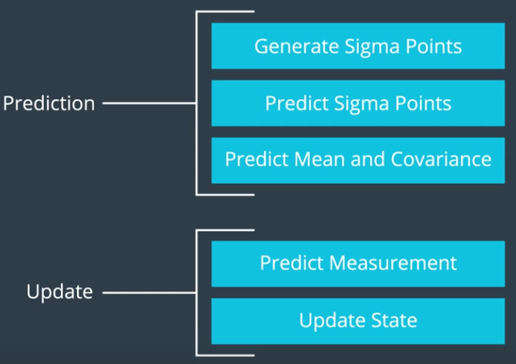

## Initialization

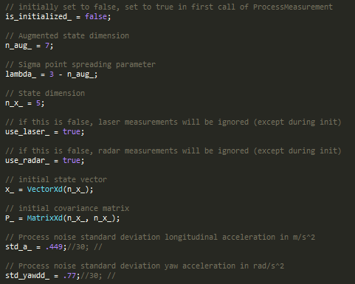

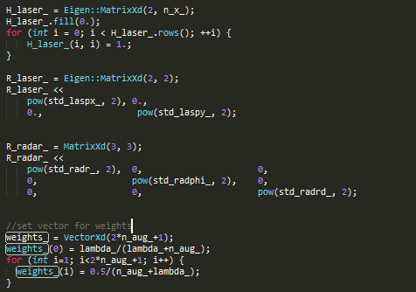

* Prediction Step 1: Generate Sigma Points 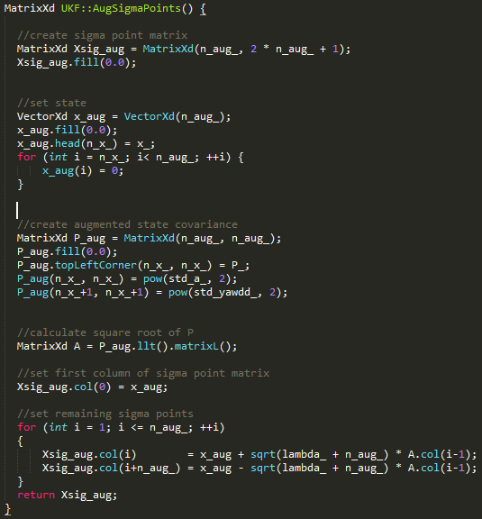

## Prediction Step 2: Predict Sigma Points

* 1. How Delta (dt) is calculated?



* 1. Create matrix with predicted sigma points as columns



* 1. Predict state

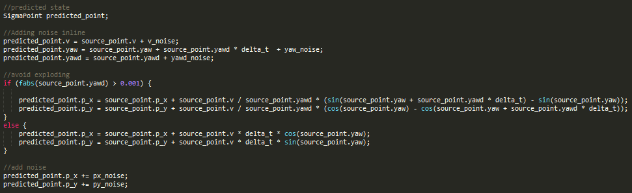

Variables used in above equation

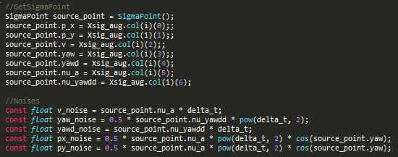

* 1. Predict Sigma Points

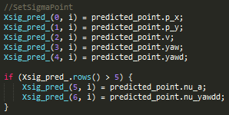

## Prediction Step 3: Predict Mean and Covariance

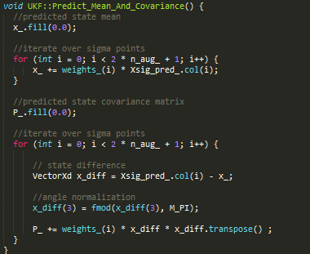

How weight is initialized

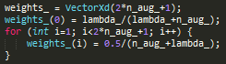

## Update: Measure and Update for Radar

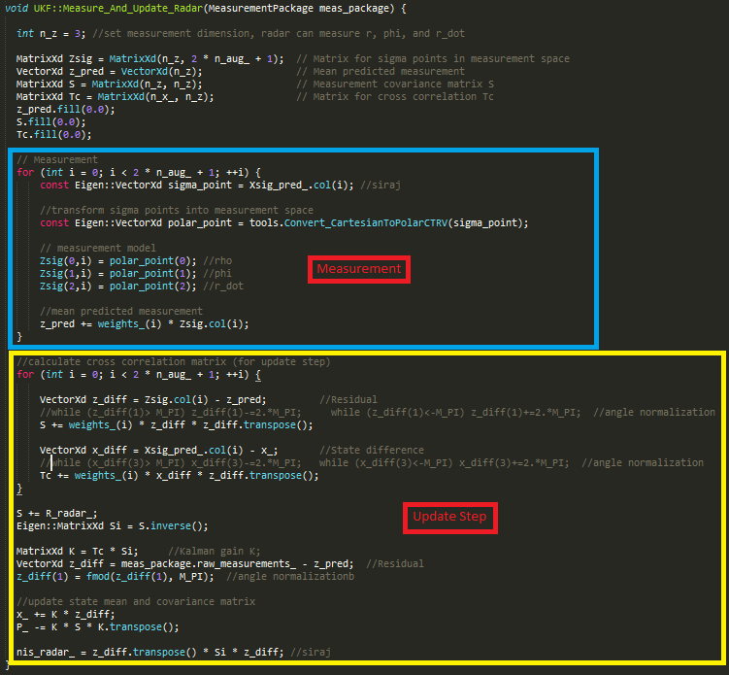

## Update: Measure and Update for Lider

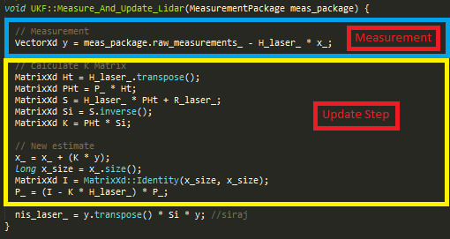

## RMSE Function

