1. Preprocessing & Polynomial fitting

In a preprocessing step, the state values received from the environment are transformed into vehicle coordinates

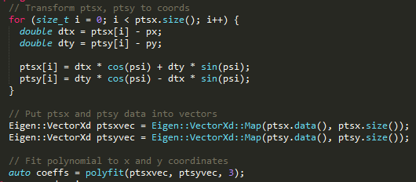

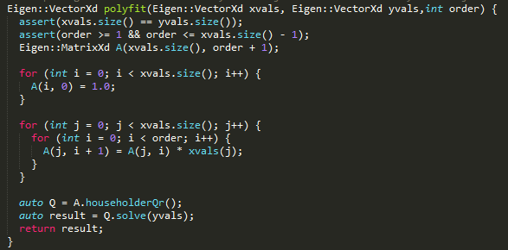

1. Timestep Length and Elapsed Duration

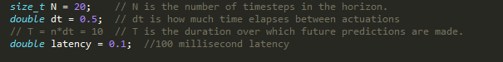

1. how latency is simulated

We add delay 100ms to simulate actuator response delay to state.

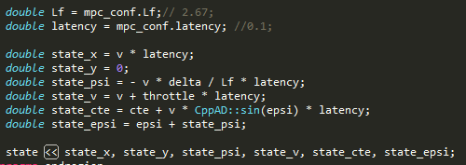



1. State Content

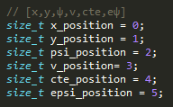

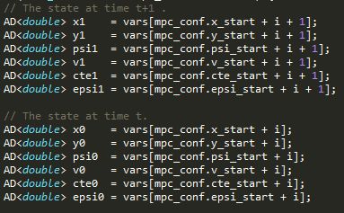

1. Model : State is updated by the following statements:

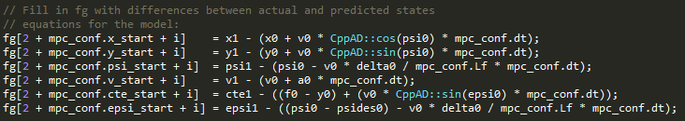

1. Tuning and configuration values

// Set cost tunning factors

int cost_cte_factor = 3000;

int cost_epsi_factor = 500; // made initial portion etc much less snaky

int cost_v_factor = 1;

int cost_current_delta_factor = 1;

int cost_diff_delta_factor = 200;

int cost_current_a_factor = 1;

int cost_diff_a_factor = 1;