1. PID & its initial parameters

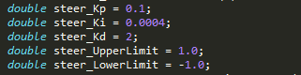

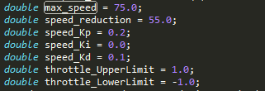

For steering upper and lower limit correspond to left and right turn, for throttle 0 means slow speed close to 1 or -1 mean high speed. Kp Ki & kd values are relativity empirical , after playing around I found these as suitable.

1. PID controller Structure

Standard Update formula

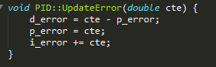

Calculation of total error is also standard. After calculation “range Limiting” and smoothing formula is applied too to avoid drastic change in numbers.

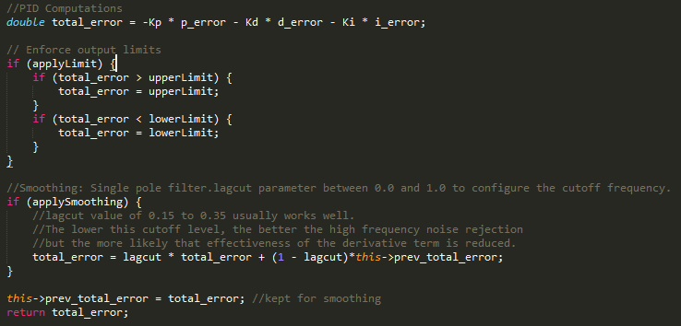

1. PID and parameter optimization

Just like PID controllers we have two separate twiddle optimizer. Flow both throttle and steering controller are same except speed adjustor which keeps car from slowing down. Twiddle optimizer is following same algorithm as discussed in class. Window for optimizer is selected 40. It empirical value, too small or too big number tends to decrease or nullify optimizer performance.

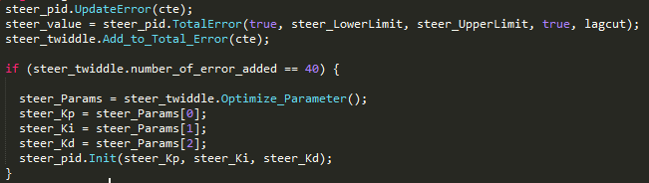

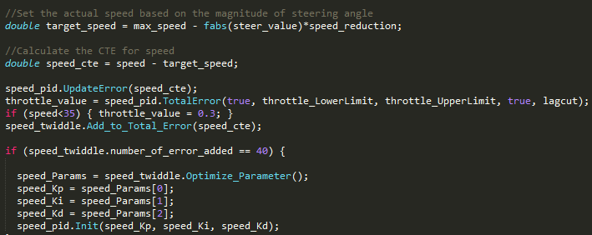

1. How speed is controlled

Speed was associated with steering angle, more speed on less angle (driving straight) and less speed on turns (more steering angle)

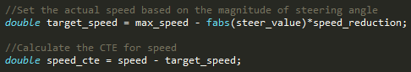

Throttle value was kept at 0.3 to keep car moving and that too relativity smoothly at low speed.



I used these as source of ref  
<https://github.com/tekdemo/MiniPID/blob/master/MiniPID.cpp>  
<http://www.mstarlabs.com/apeng/techniques/pidsoftw.html>