Main Path Agent with

* Trajectory Genrator
* Finate state machine FSM
* Fusion data (other Vehicles)

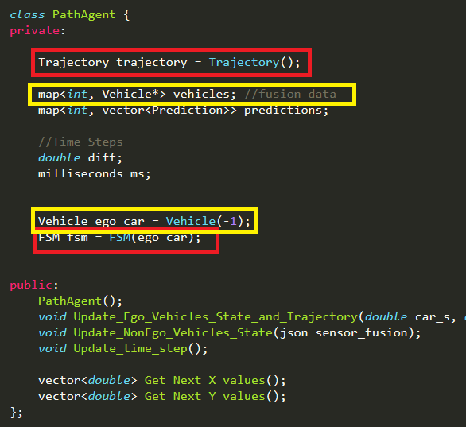

**FSM**

States of FSM



Functions used to change state of FSM

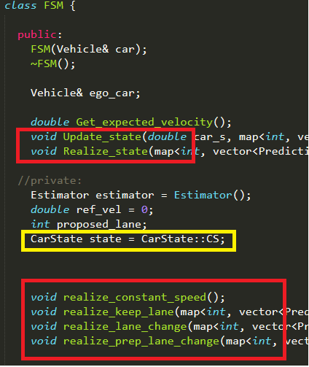

**Cost Estimator of FSM**

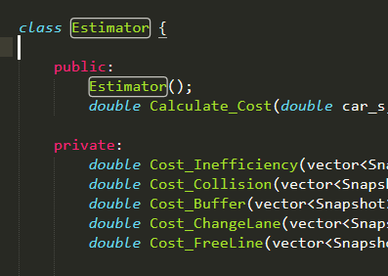

**Map Data & Trajectory Generator**

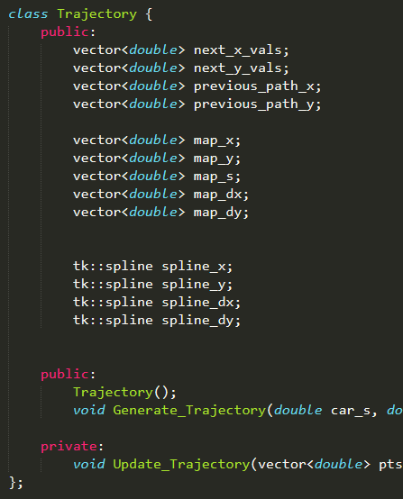

**Map data Load**

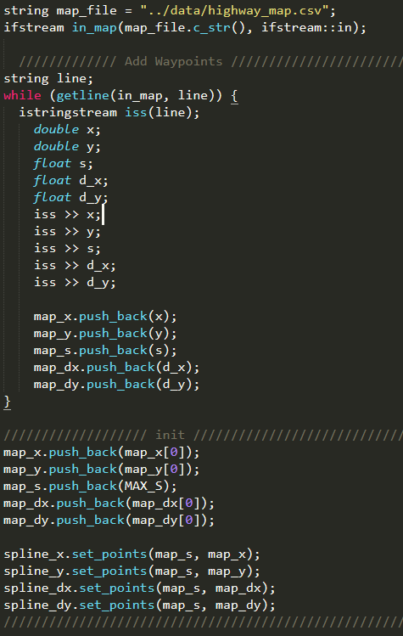

**Constants**

