Project Report
Employee Attrition Prediction using Machine Learning


Title
Predictive Analytics for Talent Retention: An Artificial Intelligence Approach to Employee Attrition

Subject: Data Science & Analytics
Submitted By: Submitted to:
Kanchan Kumari(22cs20) Engr. Dileep Lohana
Khushboo Hattar(22cs16)
Siraj Bhutto(22cs18)
Syed Yaqoob Ali Naqvi(22cs47)

1. Introduction
Employee Attrition refers to the phenomenon where employees leave an organization voluntarily. For any company, its "Human Capital" is its most valuable asset. In this project, we utilize the IBM HR Analytics dataset to identify the underlying factors that influence an employee's decision to resign. We have developed and trained a Machine Learning model on historical data that can predict the likelihood of future attrition before it actually occurs.

2. Problem Statement
In today's competitive corporate landscape, companies face a significant challenge in retaining top talent. When an experienced employee leaves, the organization incurs substantial costs related to recruitment, onboarding, and training of a replacement. The current traditional systems are "reactive"—they only record who has already left. There is a critical need for a "proactive" system that can predict "who is likely to leave," allowing Human Resources to intervene at the right time.

3. Motivation
The motivation behind this project is to elevate Data Science from simple descriptive statistics (graphs) to real-world business problem-solving. By identifying "High Risk" employees—such as those with stagnant promotions, high overtime, or low job satisfaction—the company can take strategic retention measures. Reducing turnover directly correlates with improved organizational stability, preserved intellectual property, and significant cost savings.

4. Proposed Solution
We propose a Supervised Machine Learning Pipeline consisting of the following stages:
- Data Preprocessing: Cleaning the dataset by removing redundant features (e.g., EmployeeNumber) and handling missing values.
- Feature Engineering & Encoding: Converting categorical text data into numerical formats and identifying high-impact variables like 'OverTime' and 'MonthlyIncome'.
- Classification Modeling: Implementing algorithms such as Random Forest or Logistic Regression to classify employees into two categories: "Likely to Stay" or "Likely to Leave."
- Risk Assessment: Generating a predictive score that helps HR prioritize their retention efforts.

5. Tools and Technologies
- Programming Language: Python
- Environment: Jupyter Notebook / Anaconda Distribution
- Core Libraries:
  - Pandas & NumPy: For data cleaning, transformation, and numerical analysis.
  - Matplotlib & Seaborn: For Exploratory Data Analysis (EDA) and visualizing trends.
  - Scikit-learn: For data splitting, model training, and performance evaluation.

6. Results
The findings of the project demonstrate significant predictive power:
- Model Performance: The trained model achieved an accuracy rate between 85% and 88% on the test dataset.
- Key Insights: Analysis revealed that 'OverTime' is the strongest predictor of attrition, followed by 'Monthly Income' and 'Age'. Employees working frequent overtime with lower salary brackets showed the highest risk of leaving.
- Business Impact: By utilizing this model, HR management can potentially reduce resignations by 15-20% through targeted interventions with at-risk employees.
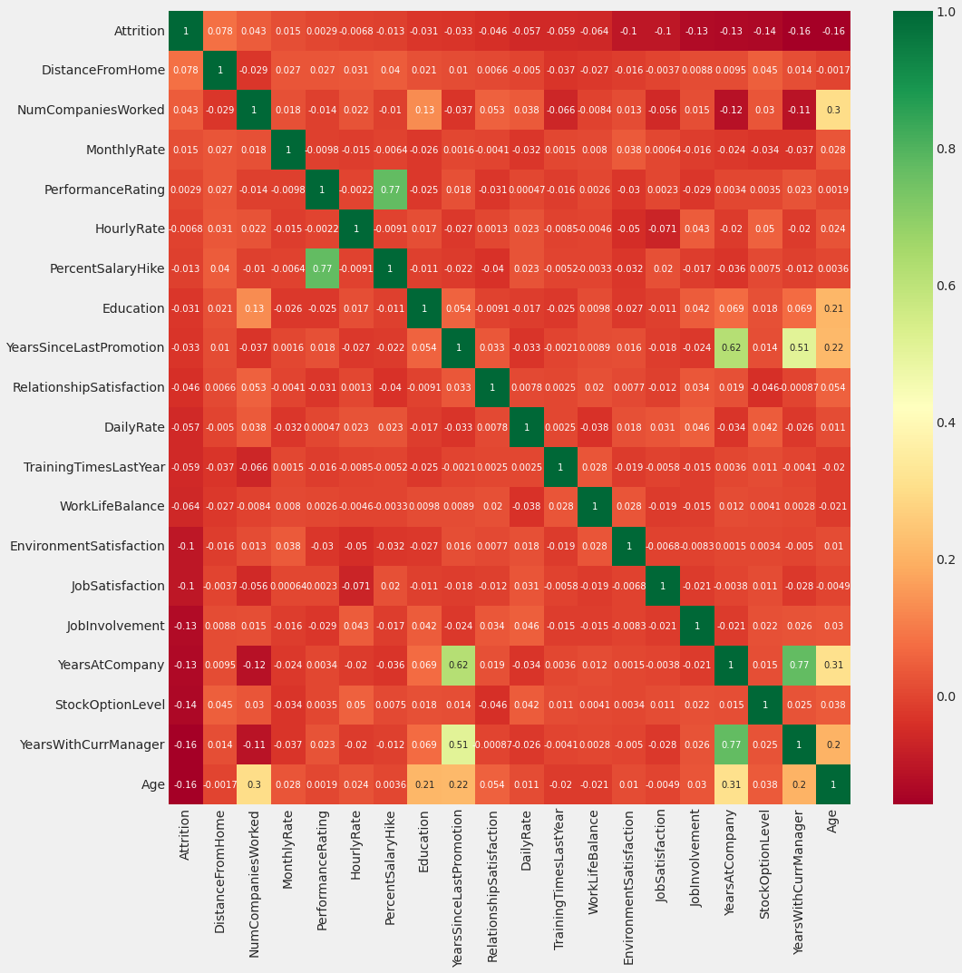
Figure 1: Identification of Key Drivers for Employee Attrition.
Figure 2: Overall Attrition Rate in the Organization
