**Topics: Confidence Intervals**

1. For each of the following statements, indicate whether it is True/False. If false, explain why.
2. The sample size of the survey should at least be a fixed percentage of the population size in order to produce representative results.

**False:** The statement is false.

**Explanation**: The size of a sample in a survey isn't required to be a constant percentage of the population size for generating representative outcomes. The suitable sample size is contingent on several considerations, including the preferred confidence level, margin of error, population heterogeneity, and the employed survey methodology, such as random or stratified sampling.

1. The sampling frame is a list of every item that appears in a survey sample, including those that did not respond to questions.

**False**: The statement is false.

**Explanation:** The sampling frame constitutes a roster of all elements or units from which a sample is extracted. Ideally, it should encompass the entire population under investigation and be comprehensive, although it commonly excludes individuals who did not respond to inquiries. The sampling frame forms the foundation for choosing a representative sample from the population

1. Larger surveys convey a more accurate impression of the population than smaller surveys.

**True**

1. *PC Magazine* asked all of its readers to participate in a survey of their satisfaction with different brands of electronics. In the 2004 survey, which was included in an issue of the magazine that year, more than 9000 readers rated the products on a scale from 1 to 10. The magazine reported that the average rating assigned by 225 readers to a Kodak compact digital camera was 7.5. For this product, identify the following:
2. **The population:**

All readers of PC Magazine who were asked to participate in the survey, specifically those interested in providing feedback on different brands of electronics.

1. **The parameter of interest:**

he true average rating that all readers of PC Magazine would give to the Kodak compact digital camera, if they were all surveyed.

1. **The sampling frame:**

The sampling frame comprises individuals who were invited to take part in the survey among the readership of PC Magazine. It's crucial to acknowledge that not all readers may have engaged in the survey, making the sampling frame a subset of the entire readership.

1. **The sample size:**

225 readers who rated the Kodak compact digital camera.

1. **The sampling design:**

The survey employed a voluntary response sampling design, wherein readers were encouraged to participate and assess the products using a scale from 1 to 10. This sampling method has the potential to introduce bias because it only involves individuals who opt to respond, and their opinions may not accurately reflect those of the entire readership.

1. **Any potential sources of bias or other problems with the survey or sample:**

Voluntary Response Bias: As participation in the survey is voluntary, individuals with particularly strong opinions, whether positive or negative, may be more inclined to participate, potentially resulting in a biased sample.

Self-Selection Bias: The respondents who choose to participate may hold differing opinions compared to those who opt not to respond, introducing a potential source of bias.

Sampling Bias: Since the sample is exclusively drawn from PC Magazine readers, it may not accurately represent the broader population's viewpoints, particularly those who do not read the magazine.

Rating Scale Bias: The use of a 1 to 10 rating scale may not be uniformly interpreted by all participants, leading to potential variations in responses.

1. For each of the following statements, indicate whether it is True/False. If false, explain why.
2. If the 95% confidence interval for the average purchase of customers at a department store is $50 to $110, then $100 is a plausible value for the population mean at this level of confidence.

**True:**

If the 95% confidence interval for the average purchase of customers at a department store is $50 to $110, then any value within this range is a plausible value for the population mean at the 95% confidence level. In this case, $100 falls within the range and is a plausible value for the population mean.

1. If the 95% confidence interval for the number of moviegoers who purchase concessions is 30% to 45%, this means that fewer than half of all moviegoers purchase concessions.

**False:**

A 95% confidence interval of 30% to 45% for the number of moviegoers who purchase concessions does not mean that fewer than half of all moviegoers purchase concessions. The 95% confidence interval provides a range of estimates, and it is possible that half or more of the moviegoers purchase concessions as 45% is included in this interval.

1. The 95% Confidence-Interval for *μ* only applies if the sample data are nearly normally distributed.

**False:**

The central limit theorem asserts that with a sample size sufficiently large, the sampling distribution of the sample mean tends to be approximately normally distributed, irrespective of the population distribution, under the condition that the sample is randomly chosen. Consequently, the application of a 95% confidence interval for the population mean is valid even when the sample data deviate from a perfect normal distribution, particularly when the sample size is substantial (e.g., n > 30).

1. What are the chances that 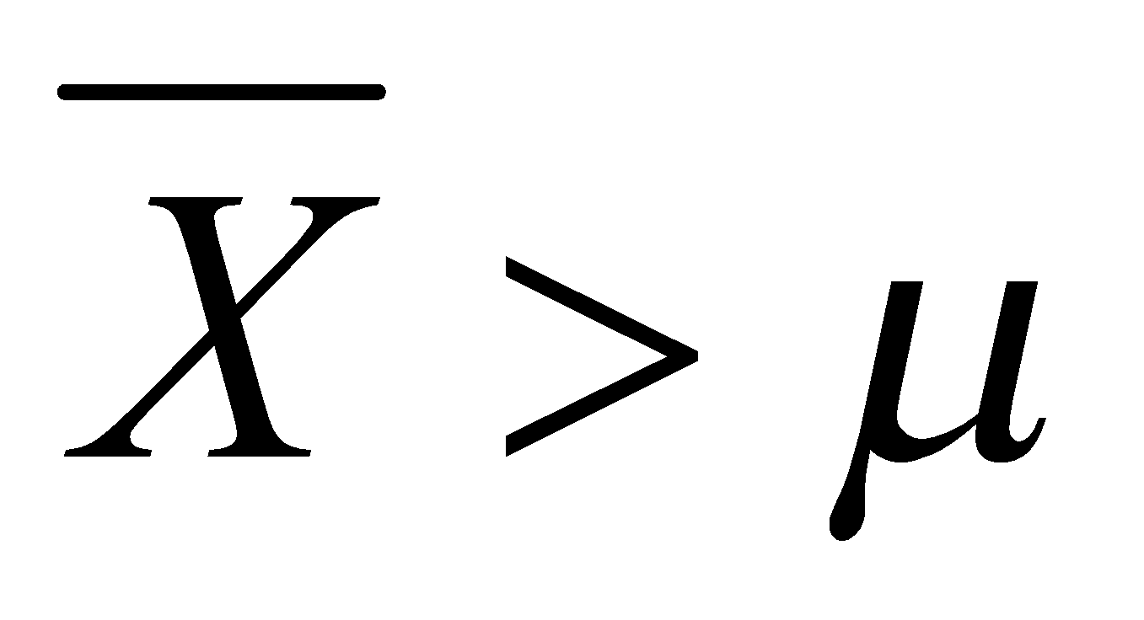?
2. ¼
3. **½**
4. ¾
5. 1

**Ans:** B. 1/2

1. In January 2005, a company that monitors Internet traffic (WebSideStory) reported that its sampling revealed that the Mozilla Firefox browser launched in 2004 had grabbed a 4.6% share of the market.
2. If the sample were based on 2,000 users, could Microsoft conclude that Mozilla has a less than 5% share of the market?

**Yes:** If the sample is based on 2,000 users and 4.6% of them use Mozilla Firefox, then this is less than 5%. Microsoft could conclude that, based on this sample, Mozilla has a less than 5% share of the market.

1. WebSideStory claims that its sample includes all the daily Internet users. If that’s the case, then can Microsoft conclude that Mozilla has a less than 5% share of the market?

**No:** While WebSideStory asserts that its sample encompasses all daily Internet users, Microsoft cannot confidently deduce that Mozilla has less than a 5% market share among all Internet users based solely on the 4.6% share found in their sample. The sample may not be a perfect representation of the entire population of Internet users, and various factors could contribute to the disparity between the sample result and the actual share of Mozilla Firefox users in the broader population. A more thorough study and analysis would be essential to draw such a conclusion with confidence.

1. A book publisher monitors the size of shipments of its textbooks to university bookstores. For a sample of texts used at various schools, the 95% confidence interval for the size of the shipment was 250 ± 45 books. Which, if any, of the following interpretations of this interval are correct?
2. All shipments are between 205 and 295 books.

**False:** This interpretation is incorrect. The 95% confidence interval (250 ± 45 books) does not mean that all shipments fall within this range. It's an estimate for the population mean.

1. 95% of shipments are between 205 and 295 books.

**False:** This interpretation is incorrect. The 95% confidence interval is an estimate for the population mean, not a statement about the distribution of individual shipments.

1. The procedure that produced this interval generates ranges that hold the population mean for 95% of samples.

**True:** This interpretation is correct. The 95% confidence interval is constructed in a way that, if you were to repeat the sampling process and construct intervals in the same manner, 95% of those intervals would capture the true population mean.

1. If we get another sample, then we can be 95% sure that the mean of this second sample is between 205 and 295.

**True:** This interpretation is correct. If you were to take another sample and construct a 95% confidence interval, you would expect the population mean to fall within that interval 95% of the time.

1. We can be 95% confident that the range 160 to 340 holds the population mean.

**True:** This interpretation is correct. While the original 95% confidence interval is 205 to 295 books, the population mean is expected to be within a wider range (160 to 340 books) with 95% confidence. This wider range reflects the uncertainty associated with the sample estimate.

1. Which is shorter: a 95% *z*-interval or a 95% *t*-interval for *μ* if we know that σ =s?
2. **The z-interval is shorter**
3. The t-interval is shorter
4. Both are equal
5. We cannot say

**Ans: A.** The z-interval is shorter

Questions 8 and 9 are based on the following: To prepare a report on the economy, analysts need to estimate the percentage of businesses that plan to hire additional employees in the next 60 days.

1. How many randomly selected employers (minimum number) must we contact in order to guarantee a margin of error of no more than 4% (at 95% confidence)?
2. **600**
3. 400
4. 550
5. 1000

Ans: **A**. 600

1. Suppose we want the above margin of error to be based on a 98% confidence level. What sample size (minimum) must we now use?
2. 1000
3. 757
4. **848**
5. 543

Ans: **C.** 848