BillDesk — User Guide and Help
Billing, orders, purchases, stock and accounts for a fruit & vegetable wholesale business
Every screenshot was taken from the real application using made-up demo data (fictional customers, items and amounts). Your screens show your own data. This guide is also the help inside BillDesk: press F9* on any screen, or open Help in the menu bar, and type your question.*

Contents
Chapter 1. Start here
1.1 How to use this guide
1.2 What BillDesk does
1.3 Signing in
1.4 Finding your way around
1.5 The dashboard
Chapter 2. Billing at the counter
2.1 Making a bill
2.2 Choosing the customer
2.3 The bill date and the calendar
2.4 Entering items
2.5 The same item twice
2.6 Taking payment
2.7 Park a bill and recall it
2.8 Print and PDF
Chapter 3. Bill history and returns
3.1 Bill History
3.2 Searching and filtering bills
3.3 Viewing a bill
3.4 Void a bill
3.5 Return goods (credit note)
3.6 Credit notes
3.7 Cancel a return
Chapter 4. Customer orders
4.1 Orders and shipments
4.2 New customer order
4.3 Order and delivery dates
4.4 Smart Importer (photo, scan or text)
4.5 Importing order text
4.6 Convert an order to a bill
4.7 Order matrix: how much to buy
Chapter 5. Masters: items, customers, suppliers
5.1 Items
5.2 Customers
5.3 Suppliers
5.4 Fixed contract rates
Chapter 6. Stock and purchases
6.1 Inventory: live stock
6.2 Stock adjustment (after counting)
6.3 Waste and spoilage
6.4 Crates
6.5 Procurement and vendor bills
6.6 Enter a vendor bill
6.7 Purchase orders and goods receipts
6.8 Return goods to a supplier (debit note)
Chapter 7. Money and accounts
7.1 Accounting dashboard
7.2 Receivables: who owes you
7.3 Customer receipts
7.4 Customer statement
7.5 Payables and supplier payments
7.6 Pay a supplier
7.7 Banking and reconciliation
7.8 General ledger and manual journal
7.9 Trial balance, profit and loss, balance sheet
7.10 Integrity check
Chapter 8. Reports
8.1 Daybook
8.2 Item-wise sales
8.3 Customer-wise sales
8.4 Dates in reports
8.5 Consolidated bills
Chapter 9. Administration
9.1 Cash drawer
9.2 Users and roles
9.3 Company configuration
9.4 Backup and database
9.5 System audit logs
Chapter 10. Reference
10.1 Keyboard shortcuts
10.2 Dates and the calendar
10.3 What each form accepts
10.4 Messages and what to do
10.5 Frequently asked questions
10.6 Glossary
10.7 About this guide
Index of words
Tip: press Ctrl+F in Word and type what you are looking for, or open the Navigation Pane (View → Navigation Pane) to jump between chapters and topics.

Chapter 1. Start here

1.1 How to use this guide
Screen: Help
This guide is written so you can ask a question instead of reading it from page one.
1. In BillDesk press F9 (on any screen it opens the help for that screen) or choose Help → Help & User Guide.
2. Type what you want in your own words, for example how do I return goods, cancel a bill, customer owes money, backup. Press Enter.
3. Click the best result. Each result shows the first steps right away; the topic page has the pictures and details.
4. Use ◀ Back to return to your results, and Contents to browse by chapter.
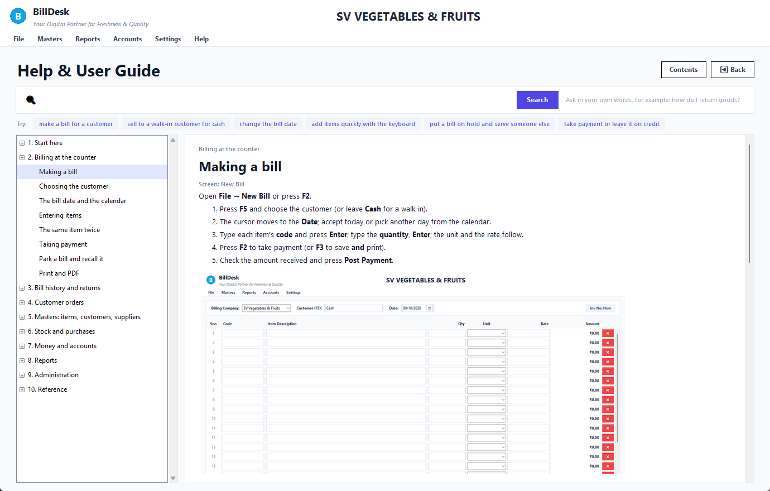
F9 on the New Bill screen opens the help for that screen
Typing a question lists the best topics first, with the first steps of each so you may not need to open it:
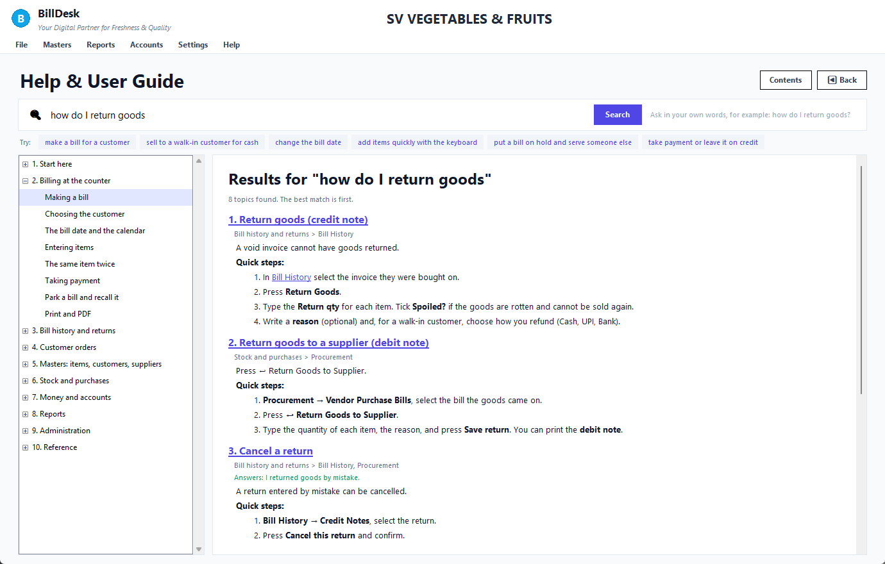
Searching the help
On paper, in Word, in the PDF or in the notebook, use Ctrl+F and the same words. The notebook edition also has a ask("...") search (see the last cell).
Find it by what you want to do
I want to… | Go to
make a bill for a customer | Making a bill
sell to a walk-in customer for cash | Choosing the customer
change the bill date | The bill date and the calendar
add items quickly with the keyboard | Entering items
put a bill on hold and serve someone else | Park a bill and recall it
take payment or leave it on credit | Taking payment
print or save an invoice or delivery challan | Print and PDF
find an old bill | Bill History
see who has not paid | Filtering bills
cancel a bill I made by mistake | Void a bill
take goods back from a customer | Return goods (credit note)
cancel a return I entered by mistake | Cancel a return
print a credit note | Credit notes
record a customer's order | New customer order
read an order from a photo or WhatsApp image | Smart Importer
turn an order into a bill | Convert an order
know how much to buy for tomorrow | Order matrix
add a customer, item or supplier | Customers, Items, Suppliers
give a customer a fixed rate | Fixed contract rates
correct stock after counting | Stock adjustment
write off rotten produce | Waste and spoilage
enter a supplier's bill | Vendor bills
send goods back to a supplier | Return to supplier (debit note)
record money received from a customer | Customer receipts
see what a customer owes, bill by bill | Customer statement
pay a supplier | Supplier payments
see today's money in and out | Daybook
see which items sell best | Item-wise sales
count the cash drawer | Cash drawer
add a user or change who can do what | Users and roles
change the company name, address or logo | Company configuration
back up my data | Backup and database
check that the books add up | Integrity check
understand an error message | Messages and what to do

Still stuck? See Frequently asked questions and Messages and what to do.
See also: Keyboard shortcuts · Frequently asked questions · Messages and what to do

1.2 What BillDesk does
Screen: All
BillDesk is a desktop program for the billing counter and the back office of a wholesale fruit and vegetable business. One program, one database, one set of numbers.
You do this… | …and BillDesk automatically
Make a bill | reduces stock, adds to the customer's balance, records the sale and its cost in the accounts
Receive payment | reduces the customer's balance, records cash or bank in the accounts, closes the bill
Enter a supplier bill | adds what you owe the supplier (and TDS if it applies)
Return goods | credits the customer, puts good stock back, reverses the sale in the accounts
Void a bill | puts the stock back, reverses the balance and the accounts
Take a customer order | lists it in the order matrix so you know how much to buy, and turns it into a bill with one click

GST is not used (fresh fruit and vegetables are exempt), so there is no tax set-up. A GSTIN can still be stored for a customer or supplier if you want it on file.
Who sees what. Menus depend on your role. Cashiers normally see Billing, Orders and Bill History; managers also see Masters, Reports and Accounts; administrators see everything including Settings. If a menu is missing, your role does not include it: ask the administrator (Users and roles).
See also: The dashboard · Signing in

1.3 Signing in
Screen: Login
1. Double-click BillDesk on the desktop or in the Start menu. The first start takes a few seconds because BillDesk starts its own database.
2. Type your username and password.
3. Press Enter or click Login.
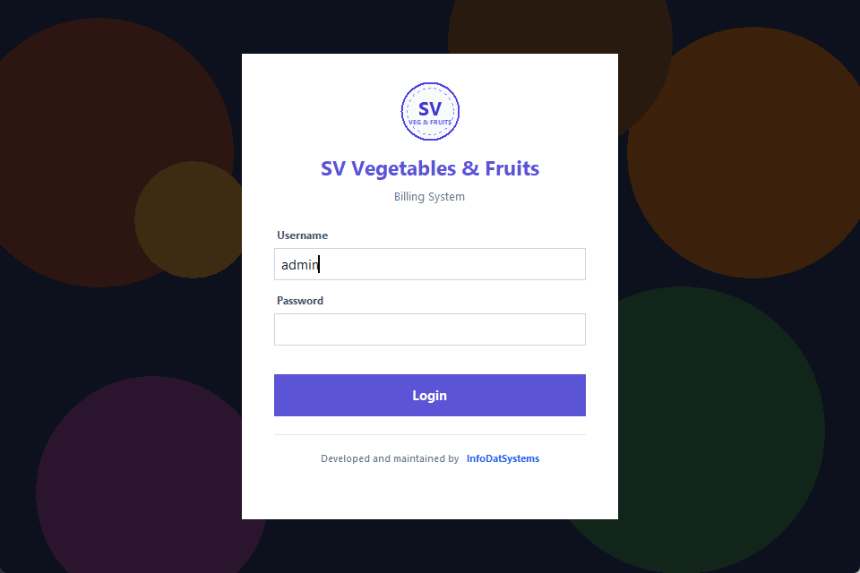
Sign-in screen
• First time ever: the installer creates one administrator named admin with a random password shown once. Write it down, then create the other users in Users and roles.
• Forgot the administrator password? Ask your IT person to run python scripts\reset_password.py --user admin.
• Only one BillDesk window can be open on a computer; if you start it twice, the second copy tells you.
• To sign out press F12 (you are asked to confirm).
See also: Users and roles · Finding your way around · Frequently asked questions

1.4 Finding your way around
Screen: Main window
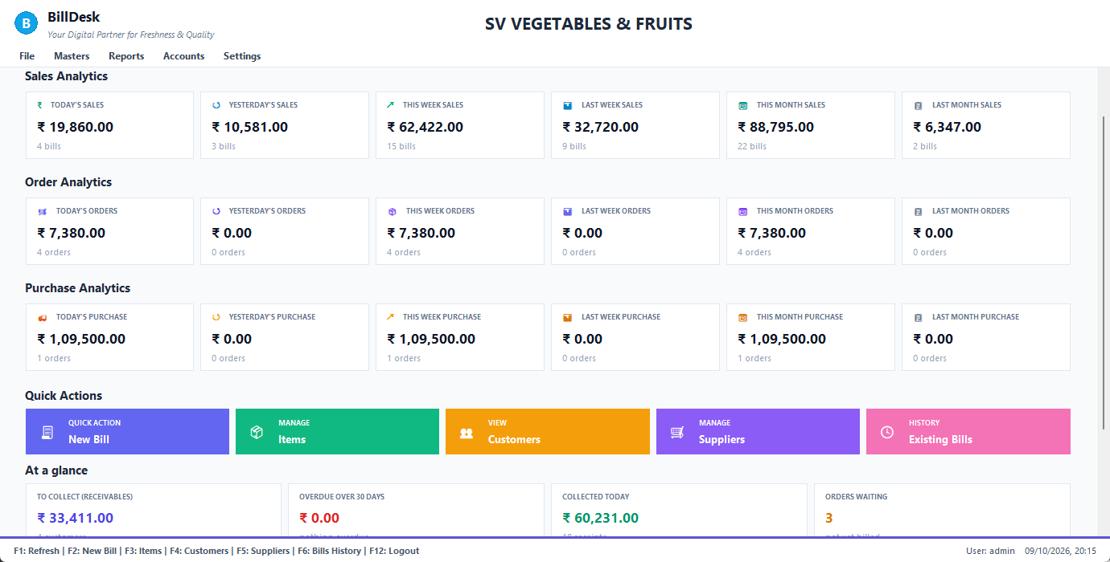
Menu bar
• Top: your company name and the menu bar.
• Middle: the screen you are working on.
• Bottom strip: the keys that work on this screen, who is signed in and the date and time.
Menu | Contains
File | New Bill (F2), New Customer Order, Ordering System (Ctrl+O), Purchase system (Ctrl+P), Logout (F12), Exit
Masters | Item Master (F10), Customer Master (F4), Supplier Master (F5), Waste Management
Reports | Bills History (F6), Daybook, Item-wise Sales, Customer-wise Sales, Bills Consolidated Report, Order Consolidation, Fixed Rates Report, Profit & Loss, Balance Sheet, Dashboard (F1)
Accounts | Accounting Dashboard (Ctrl+D), Trial Balance, Profit & Loss, Balance Sheet, BRS, Handover & Settlement, Integrity Check, Accounts Receivables, Accounts Payables
Settings | User Management, Company Settings, Database Settings, System Audit Logs
Help | Help & User Guide (F9), Keyboard shortcuts, About

Press F9 on any screen for help about that screen. All shortcut keys are listed in Keyboard shortcuts.
See also: Keyboard shortcuts · The dashboard · How to use this guide

1.5 The dashboard
Screen: Dashboard
The dashboard is the first screen after you sign in. Press F1 from anywhere to come back to it (the figures are re-read each time).
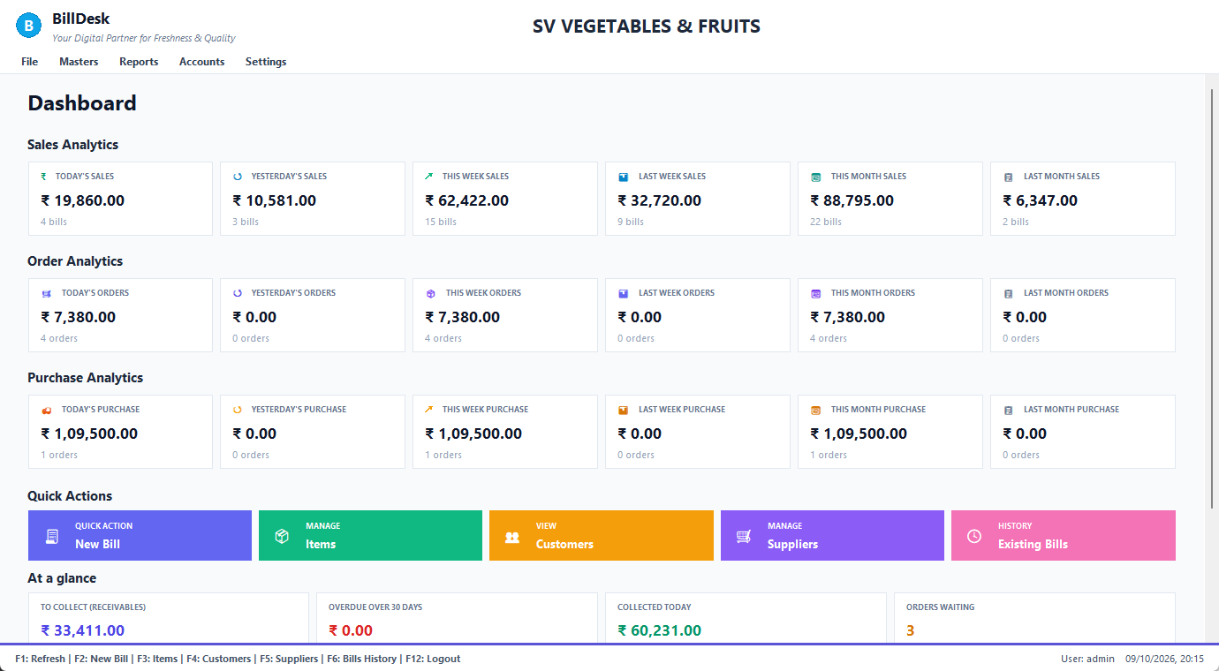
Dashboard
• Sales, Order and Purchase Analytics: six small cards each: today, yesterday, this week, last week, this month, last month. Every card shows the amount and how many bills or orders it covers.
• Quick Actions: big buttons for New Bill, Items, Customers, Suppliers and Existing Bills.
• At a glance (scroll down):
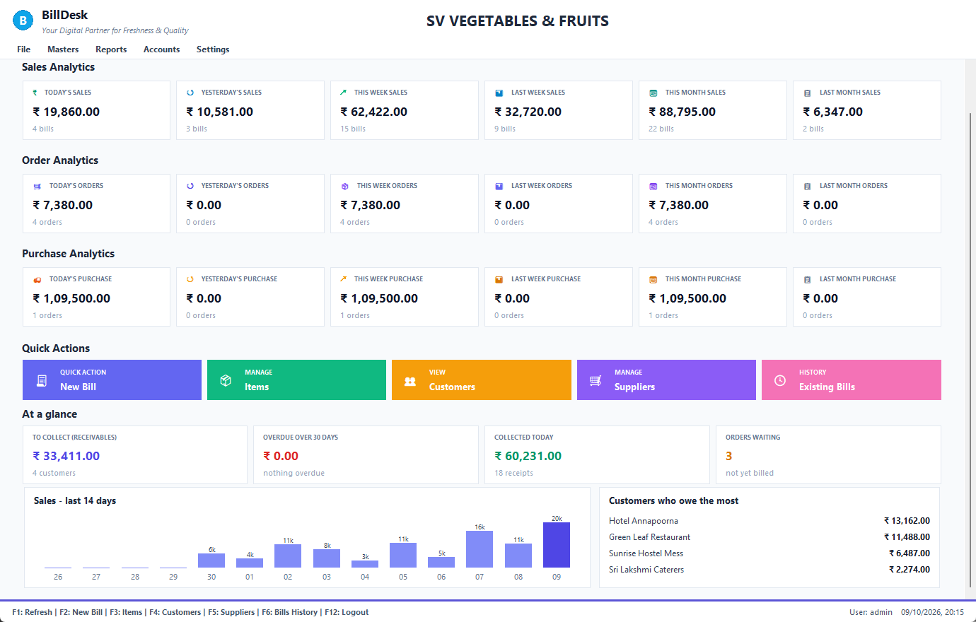
At a glance
Card | Meaning
To collect (receivables) | everything customers owe you now (customers who have paid in advance are shown separately as "advances held", not subtracted)
Overdue over 30 days | the part of that which is older than 30 days
Collected today | receipts recorded today
Orders waiting | customer orders not yet billed
Sales – last 14 days | one bar per day
Customers who owe the most | the top four balances

See also: Making a bill · Receivables: who owes you · Daybook

Chapter 2. Billing at the counter

2.1 Making a bill
Screen: New Bill
Open File → New Bill or press F2.
1. Press F5 and choose the customer (or leave Cash for a walk-in).
2. The cursor moves to the Date; accept today or pick another day from the calendar.
3. Type each item's code and press Enter; type the quantity, Enter; the unit and the rate follow.
4. Press F2 to take payment (or F3 to save and print).
5. Check the amount received and press Post Payment.
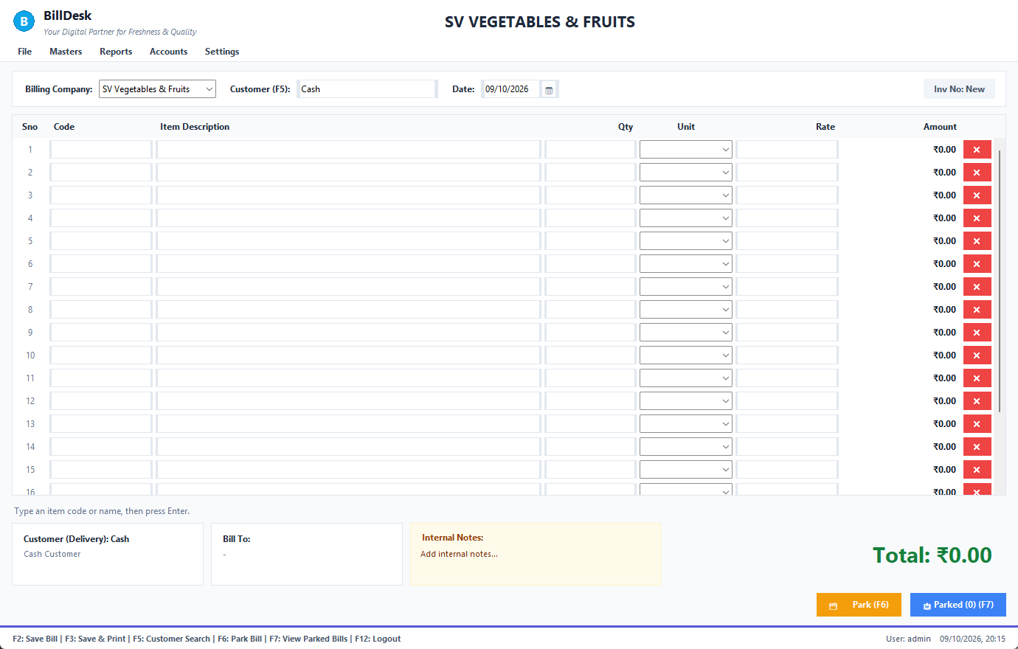
New Bill, empty
Part of the screen | What it is
Billing Company | which of your companies the invoice is issued under
Customer (F5) | who the bill is for (choosing the customer)
Date | the bill date, with a drop-down calendar (dates)
The grid | one row per item: Code, Item Description, Qty, Unit, Rate, Amount, and a red ✕ to clear the row
Line under the grid | stock and rate of the item you just entered (the hint line)
Customer (Delivery) / Bill To | where the goods go and who is invoiced
Internal Notes | for your own use, not printed
Total | the bill total
Park (F6) / Parked (F7) | put a bill on hold, or bring one back

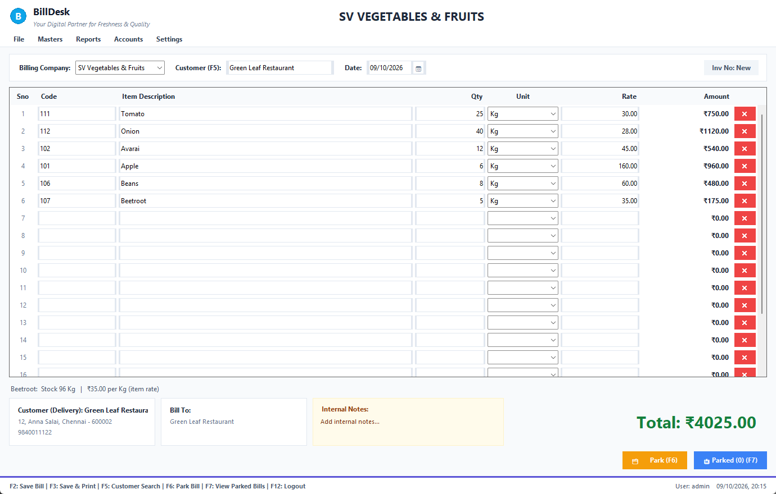
A bill with six items
See also: Choosing the customer · The bill date and the calendar · Entering items · Taking payment

2.2 Choosing the customer
Screen: New Bill
Press F5 (or click the customer box).
1. Type part of the customer's name or phone number: the list narrows as you type.
2. Press ↓ or ↑ to move, Enter to choose. (Esc closes the list; a click also chooses.)
3. Choose Cash Customer for a walk-in sale.
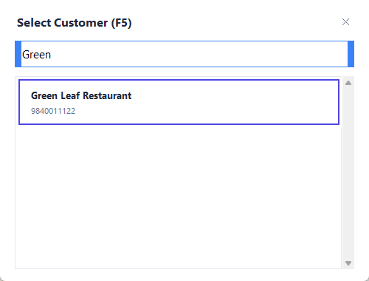
Customer search
• The customer's address, their "bill to" name and their company are filled in for you, and any fixed contract rates for that customer are used.
• The same dialog is used on New customer order, so it works the same everywhere. Orders need a real customer (no Cash option there).
• A customer who is not in the list must be added first in the Customer Master.
See also: Making a bill · The bill date and the calendar · Customers

2.3 The bill date and the calendar
Screen: New Bill
Right after you choose the customer the cursor goes to Date and a calendar drops down under it.
1. Click a day, or use the arrow keys and press Enter. Today jumps to today.
2. Or type a date (13/10/2026, 13-10-26) and press Enter.
3. The cursor moves on to the first empty row of the grid.
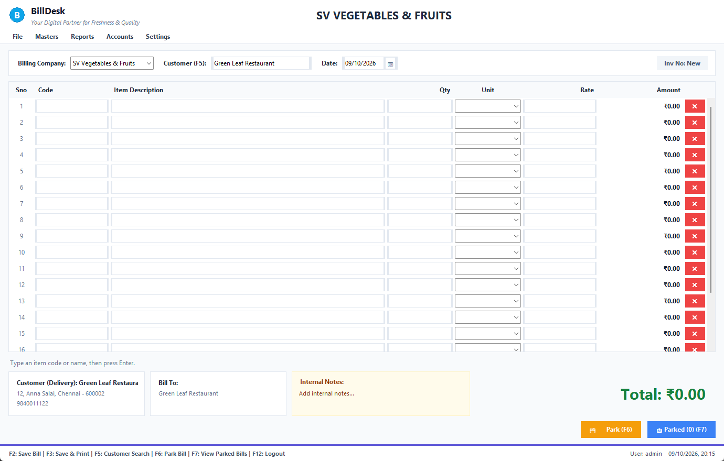
Calendar under the date box
• The date you choose is the date of the bill and its invoice number follows that day (20261005-0003 for 5 October).
• A bill cannot be dated in the future.
• More about date boxes everywhere in the program: Dates and the calendar.
See also: Dates and the calendar · Entering items

2.4 Entering items
Screen: New Bill
Work row by row with the keyboard: Code → Qty → Unit → Rate → next row, pressing Enter each time.
1. Type the item code (for example 111) or a part of its name (tom), press Enter. The description, unit and rate appear and the cursor goes to Qty (1 is filled in).
2. Type the quantity, press Enter. The cursor passes through Unit to Rate.
3. Change the rate if you need to; press Enter to go to the next row.
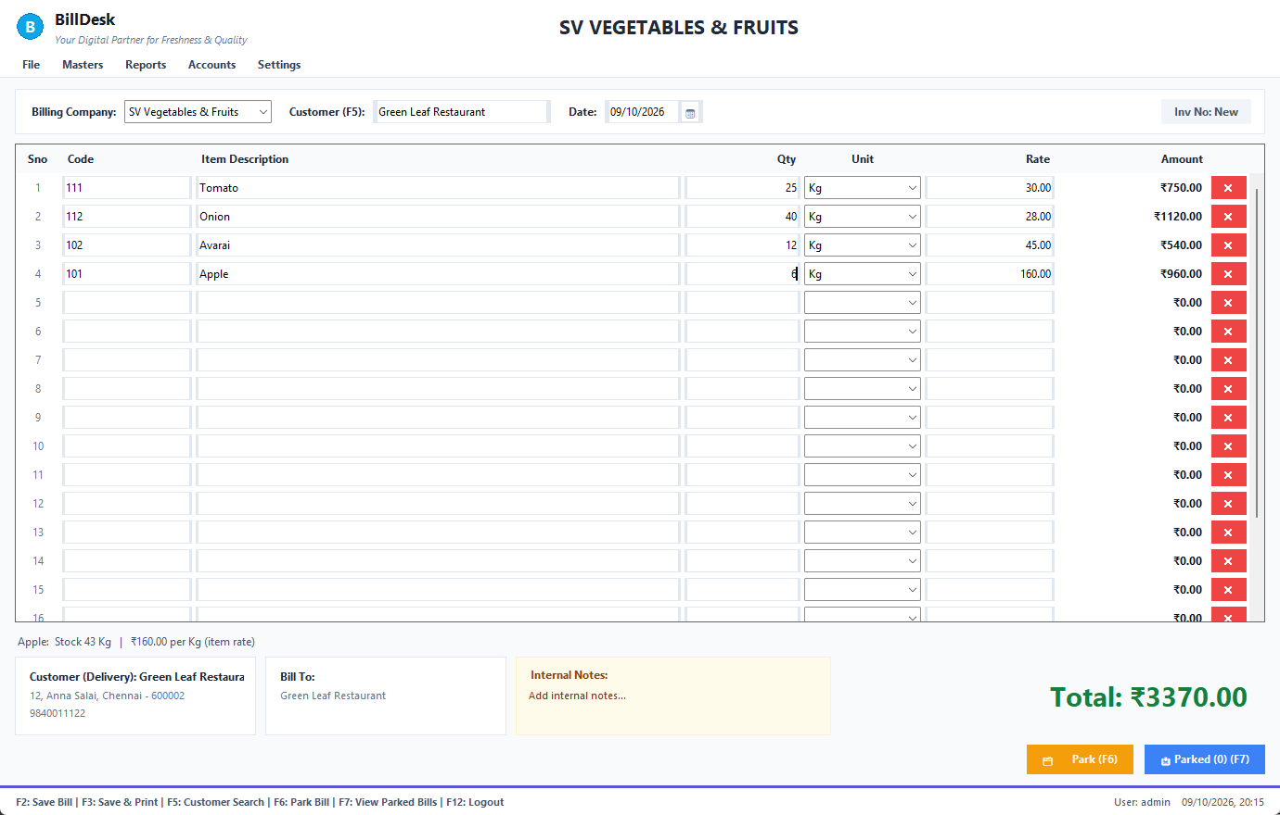
The hint line
• The hint line under the grid tells you the item, its stock ("No stock recorded" if stock is not tracked for it) and the rate and where it came from: fixed rate for <customer> or item rate.
• Several items fit what you typed? A list opens: ↑ / ↓ to move, Enter to choose, Esc to cancel. BillDesk never picks the first match for you.
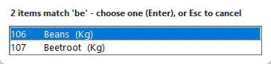
Choose between items
• An item typed in a lower row moves up to the first empty row, so there are never gaps.
• The red ✕ clears a row and the rows below move up.
• You can sell more than the stock shows; BillDesk warns but does not stop you (your administrator can change this).
• Quantity and rate must be numbers; a bill cannot have a zero quantity or a negative rate.
See also: The same item twice · Taking payment · Fixed contract rates

2.5 The same item twice
Screen: New Bill
If you type an item that is already on the bill, BillDesk asks what to do.
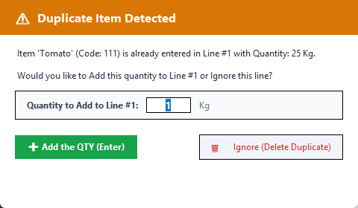
Duplicate item
• Add the QTY (Enter) adds the new quantity to the existing row.
• Ignore (Delete Duplicate) removes the new row.
See also: Entering items

2.6 Taking payment
Screen: New Bill
1. Press F2 (save) or F3 (save and print).
2. The amount received is filled in with the whole total. Change it if the customer pays part.
3. Choose the payment method and, for UPI or a cheque, the reference.
4. Press Enter or Post Payment.
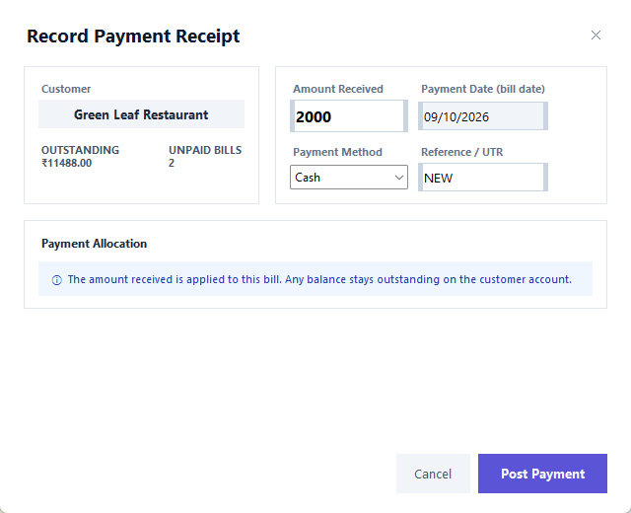
Payment dialog
Box | Meaning
Outstanding / Unpaid bills | what this customer already owes before this bill
Amount Received | what the customer pays now; anything not paid stays on their account
Payment Date | shown for information: a counter payment is recorded on the bill's date
Payment Method | Cash, UPI, Cheque, NEFT/RTGS, or Credit/Due (nothing paid now)
Reference / UTR | UPI or cheque number (optional)

• You cannot receive more than the bill total.
• After posting, the sheet is cleared for the next bill. With F3 the invoice opens for printing.
• Later payments are recorded as a customer receipt.
See also: Print and PDF · Customer receipts · Customer statement

2.7 Park a bill and recall it
Screen: New Bill
Serving two customers at once? Put one aside.
1. Press F6 (or Park) with the items entered. The sheet clears.
2. Serve the next customer.
3. Press F7 (or Parked (n)), click the parked bill to bring it back. If another bill is on the sheet you are asked before it is replaced.
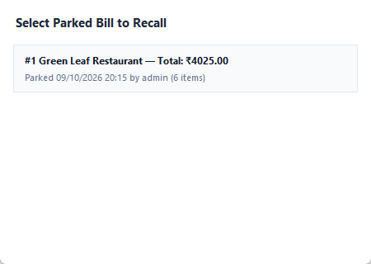
Parked bills
Parked bills are kept on disk: they survive closing BillDesk or a power cut.
See also: Making a bill

2.8 Print and PDF
Screen: New Bill, Bill History
After F3, or from Bill History, the invoice opens in the print preview.
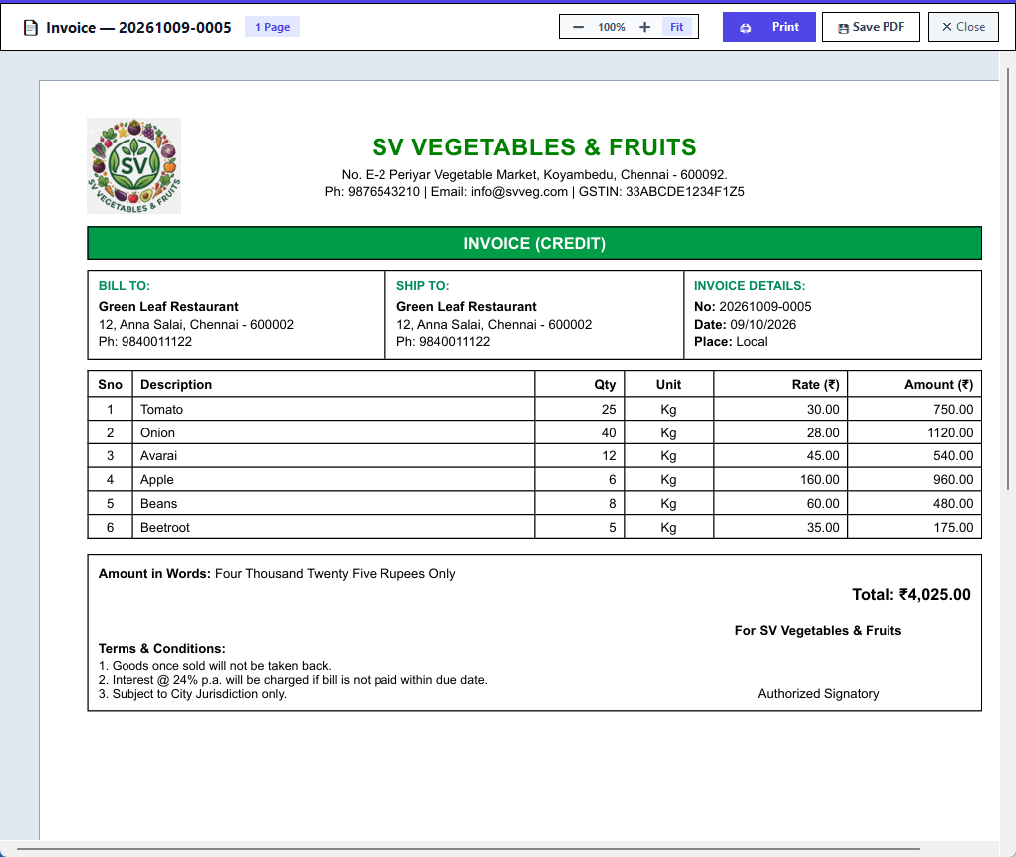
Print preview
• − / + / Fit change the zoom; Print sends it to the printer; Save PDF saves a file; Close leaves.
• The invoice shows the company, customer, items with rates and amounts, the total in words and your terms:
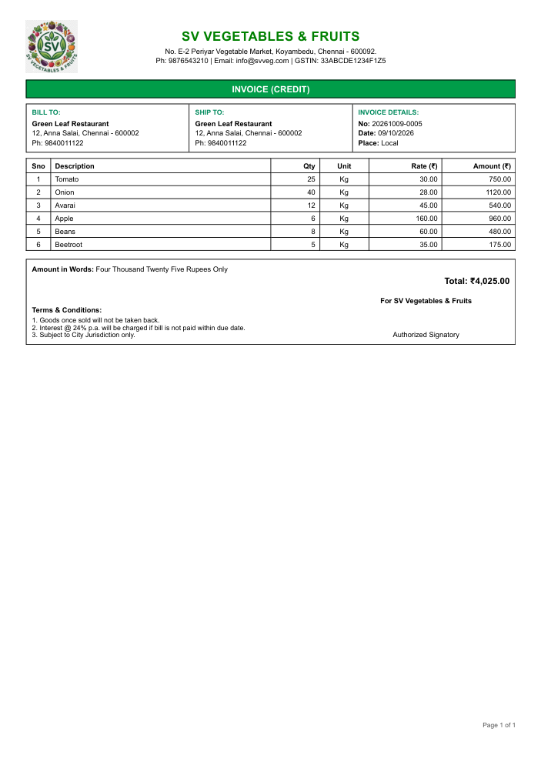
Invoice
• The delivery challan (DC) is the same bill without prices, for the driver and the customer's receiving staff:
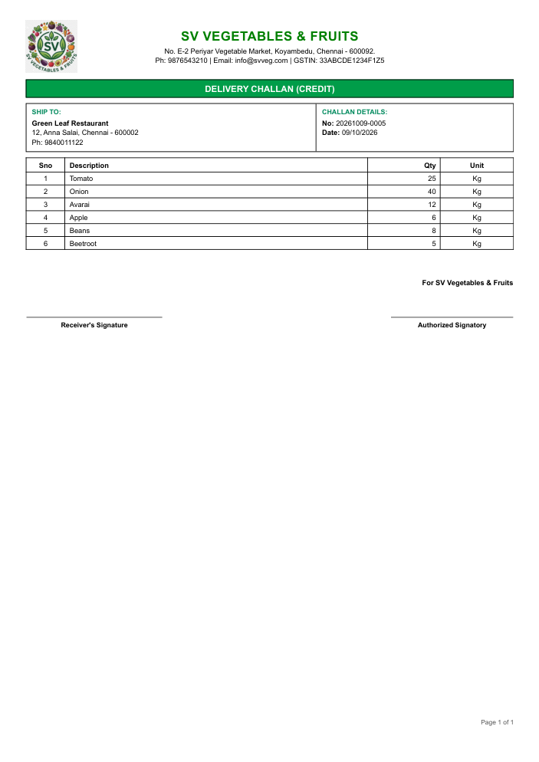
Delivery challan
See also: Taking payment · Viewing a bill

Chapter 3. Bill history and returns

3.1 Bill History
Screen: Bill History
Open Reports → Bills History or press F6.
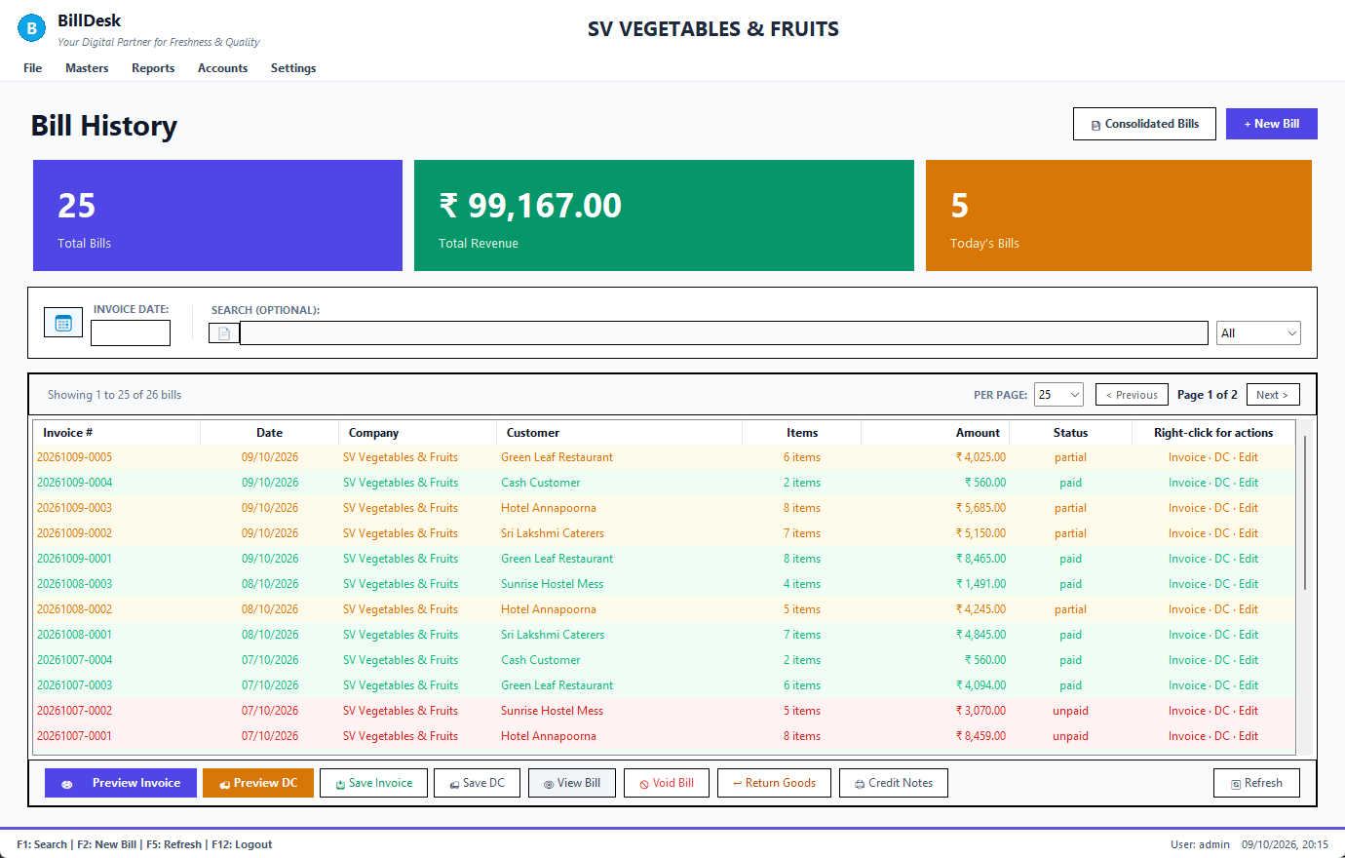
Bill History
• The three coloured cards show the number of bills, total sales and today's bills.
• The table lists the newest bills first: invoice number, date, company, customer, number of items, amount and status.
• Select a bill, then use the buttons at the bottom (or right-click it):
Button | What it does
Preview Invoice / Preview DC | opens the invoice or the delivery challan
Save Invoice / Save DC | saves the PDF
View Bill | shows the bill's details
Void Bill | cancels the bill (void)
Return Goods | takes goods back (return)
Credit Notes | lists and prints the returns on this bill (credit notes)
Refresh | reloads the list

• Per page and Previous / Next move through long lists.
See also: Searching and filtering bills · Viewing a bill · Void a bill · Return goods (credit note)

3.2 Searching and filtering bills
Screen: Bill History
• Search (F1): type part of an invoice number or customer name.
• Status list: All, Unpaid, Partial, Paid, Void or Legacy.
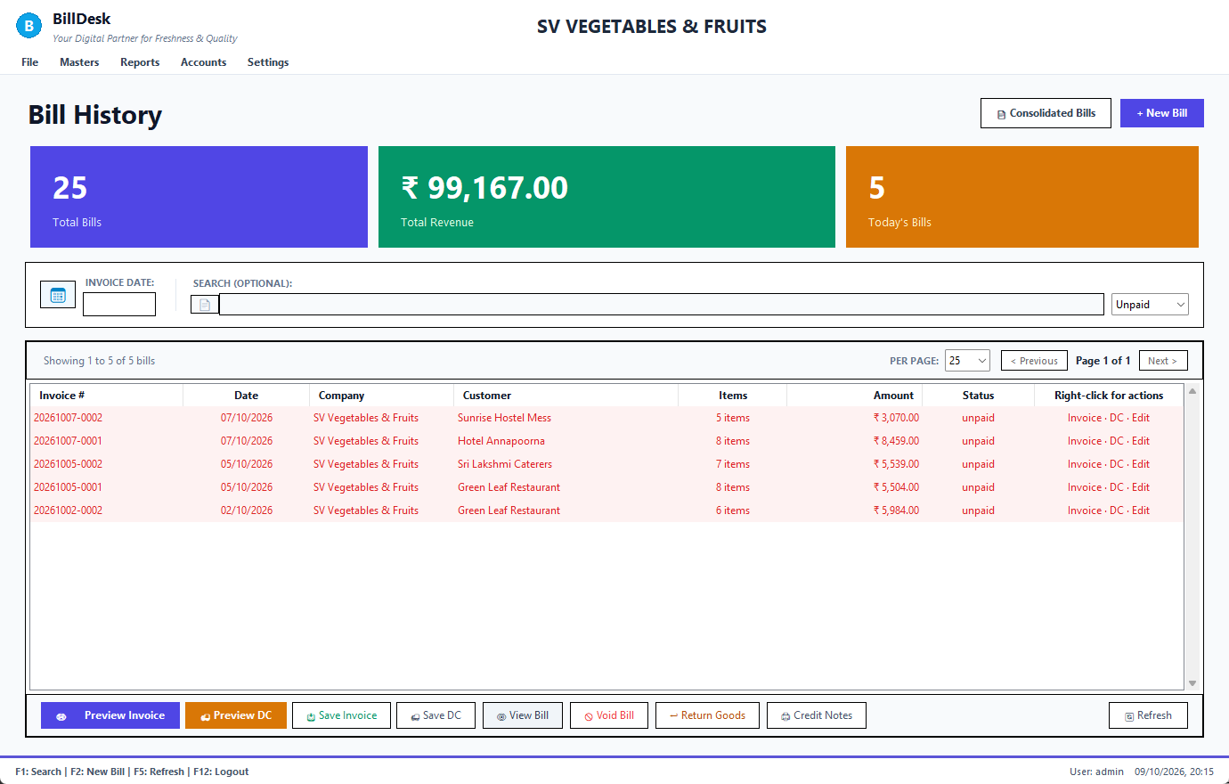
Only unpaid bills
• Invoice date: click the box and pick a day from the calendar; Reset Date clears it. You can also type part of a date (09/2026) to see a month.
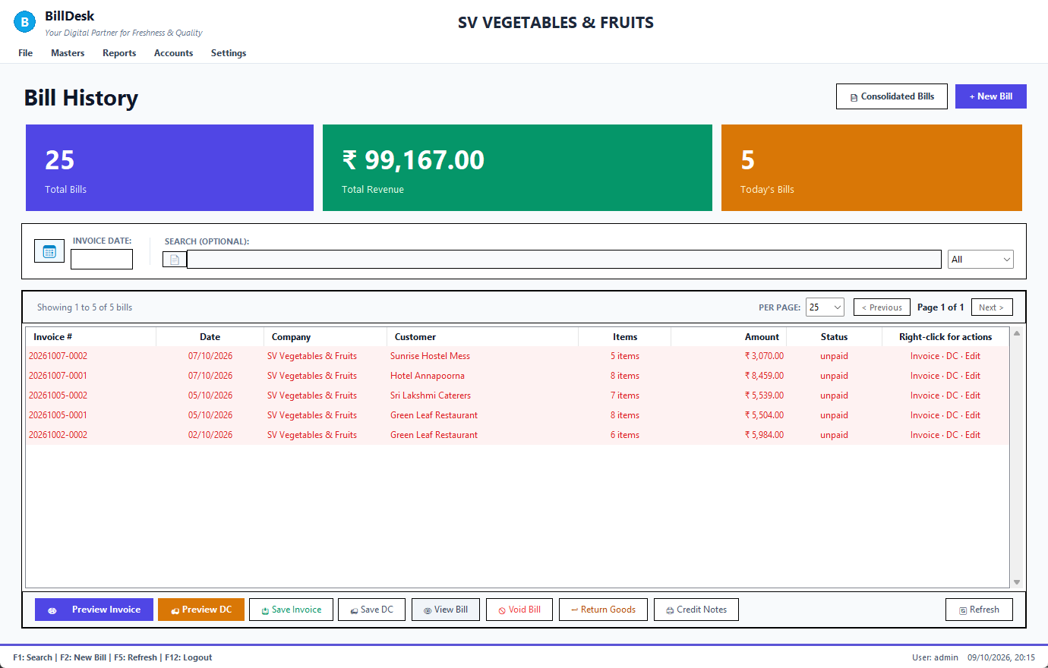
Date filter
Status | Meaning
paid | fully paid
unpaid / partial | nothing / part paid; the rest is due
void | cancelled
legacy | bills made by the older program: it did not track payment per bill; their money is in the customer's balance

To see what a customer owes bill by bill use the customer statement.
See also: Bill History · Customer statement · Receivables: who owes you

3.3 Viewing a bill
Screen: Bill History
Double-click a bill (or select it and press View Bill).
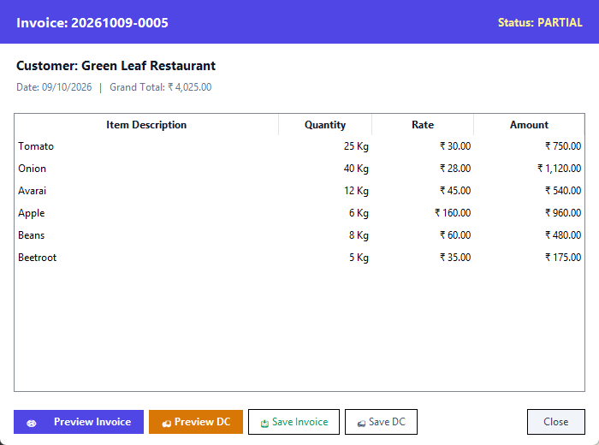
Bill details
It shows the customer, date, status, the items with quantity, rate and amount and the grand total, with buttons to preview or save the invoice and the challan.
See also: Bill History · Print and PDF

3.4 Void a bill
Screen: Bill History
A bill made by mistake is voided, not deleted, so the record and the invoice number stay.
1. Open Bill History and select the bill.
2. Press Void Bill.
3. Read what will happen and confirm.
Voiding: reverses the customer's balance, puts the stock back, reverses the crates and the accounts, and marks the bill void. Payments that had been allocated to it become the customer's advance (credit).
• A bill that has goods returned against it cannot be voided: cancel the return first.
• A voided bill cannot be voided twice.
• To take back only some goods, use Return goods, not void.
See also: Return goods (credit note) · Bill History

3.5 Return goods (credit note)
Screen: Bill History
A customer brings goods back.
1. In Bill History select the invoice they were bought on.
2. Press Return Goods.
3. Type the Return qty for each item. Tick Spoiled? if the goods are rotten and cannot be sold again.
4. Write a reason (optional) and, for a walk-in customer, choose how you refund (Cash, UPI, Bank).
5. Press Save return. You are offered the credit note to print.
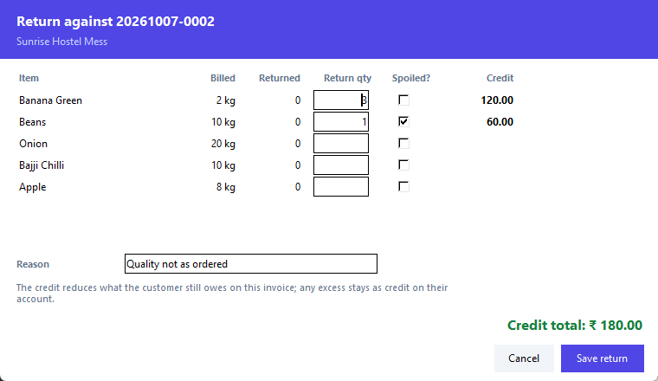
Return goods
What happens:
 | Good goods | Spoiled goods
Customer is credited at the rate billed | yes | yes
Goes back into stock | yes, at the cost it was sold at | no
Sales are reduced in the accounts | yes | yes

• The credit first reduces what the customer still owes on that invoice; anything more stays as credit on their account (shown as Cr in the customer list).
• You cannot return more than was billed minus what was already returned.
• A void invoice cannot have goods returned.
• A walk-in customer is refunded from the cash drawer or bank.
See also: Credit notes · Cancel a return · Void a bill · Customer statement

3.6 Credit notes
Screen: Bill History
Bill History → Credit Notes lists the returns made on the selected invoice, each with its number, date and amount.
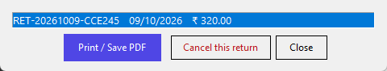
Credit notes for an invoice
Select one and press Print / Save PDF. The credit note shows each item, whether it was good or spoiled, the total in words and how the credit was applied.
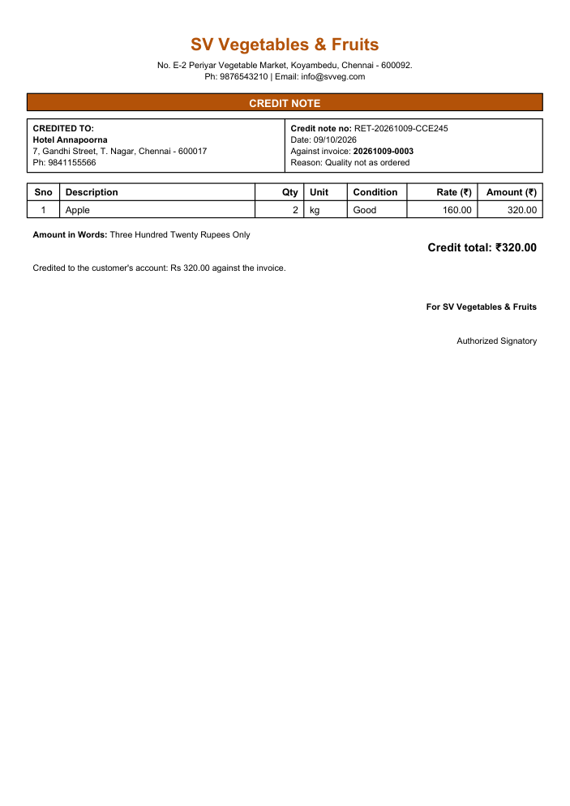
Credit note
See also: Return goods (credit note) · Cancel a return

3.7 Cancel a return
Screen: Bill History, Procurement
A return entered by mistake can be cancelled.
1. Bill History → Credit Notes, select the return.
2. Press Cancel this return and confirm.
BillDesk puts back the customer's balance, the invoice's balance due, the stock and the accounts exactly as they were; the credit note stays on file, marked cancelled, and no longer counts anywhere. The whole quantity can be returned again afterwards.
• A return can be cancelled once only.
• Returns made by the older program cannot be cancelled here.
• A supplier return (debit note) is cancelled from Procurement → Returns to Suppliers → Cancel Debit Note (purchase return).
See also: Return goods (credit note) · Return goods to a supplier (debit note) · Credit notes

Chapter 4. Customer orders

4.1 Orders and shipments
Screen: Orders
Open File → Ordering System or press Ctrl+O.
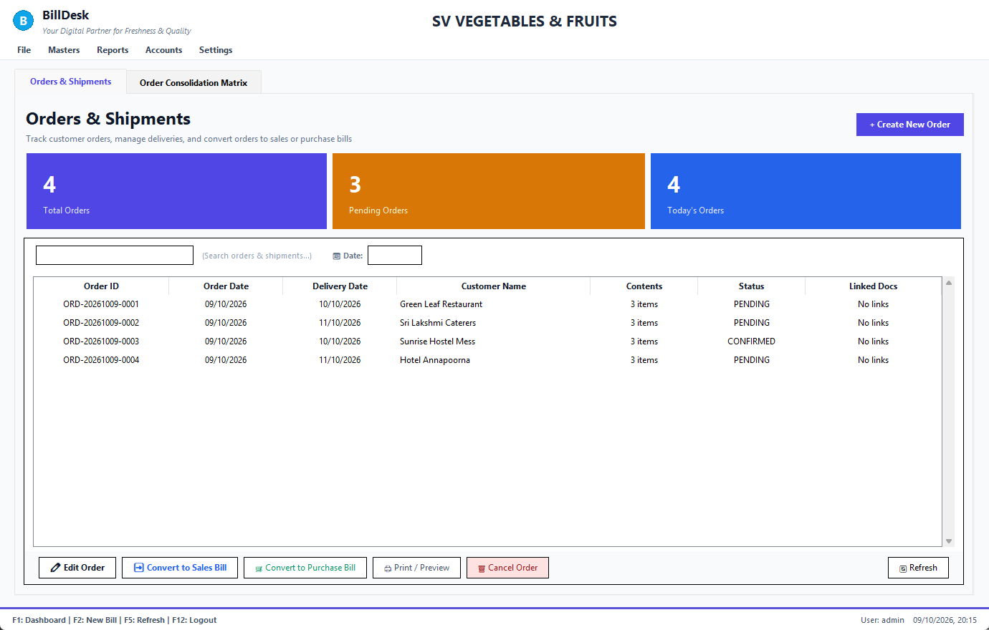
Orders
• The cards show total, pending and today's orders.
• Search by order number or customer; the Date box filters by order date (pick it from the calendar).
Order date filter
Button | What it does
+ Create New Order | opens the order form
Edit Order | changes an order that is not yet billed
Convert to Sales Bill | makes the bill from the order (convert)
Convert to Purchase Bill | turns the order into a purchase from a supplier
Print / Preview | prints the order as a challan
Cancel Order | cancels an order that has not been billed

Status: pending, confirmed, billed, cancelled.
See also: New customer order · Convert an order to a bill · Order matrix: how much to buy

4.2 New customer order
Screen: New Order
Press + Create New Order on the Orders screen, or File → New Customer Order.
1. Press F5 and choose the customer.
2. The cursor goes to the order date, then the delivery date, then the first empty row of the items.
3. Enter the items exactly as on a bill (code, quantity, unit, rate).
4. Enter Crates out / in if returnable crates go with the order.
5. Press F3 to save (or F10 to save and print).
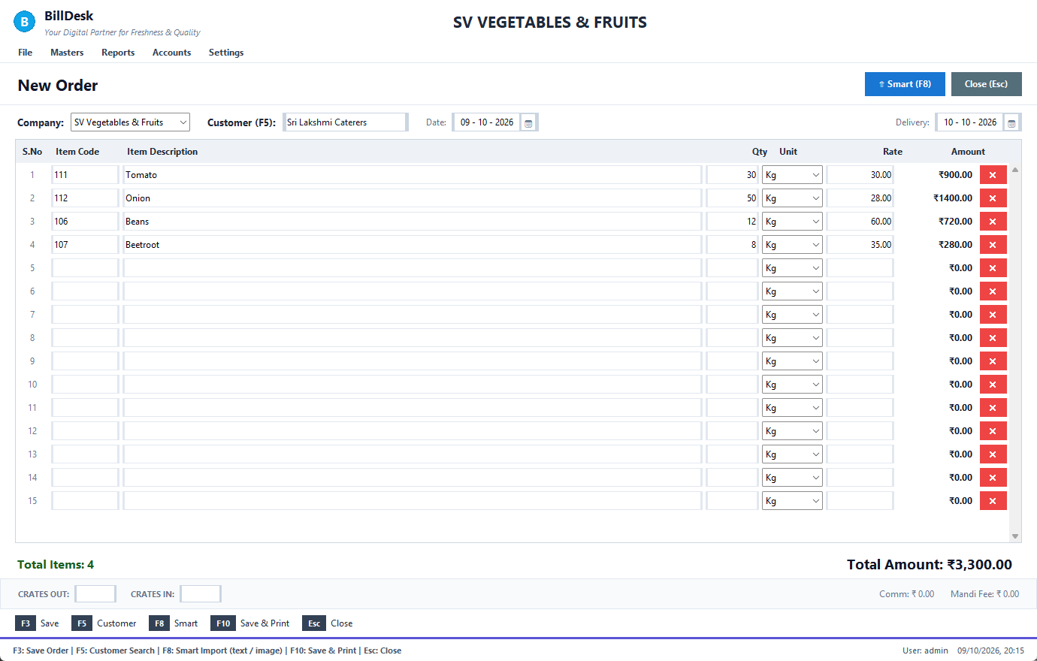
New order
Key | Does
F3 | save the order (F2 does the same)
F5 | choose the customer, from any box
F8 | Smart Importer: read the order from a photo or text
F10 | save and print
Esc | close the form

• Orders need a customer from the customer master.
• The commission and mandi fee shown at the bottom come from your settings (both are zero unless your administrator sets them).
See also: Order and delivery dates · Smart Importer (photo, scan or text) · Convert an order to a bill

4.3 Order and delivery dates
Screen: New Order
Both date boxes drop down the calendar when you click them or reach them with the keyboard.
Delivery date calendar
• The order date cannot be in the future.
• The delivery date cannot be before the order date (those days are greyed out in the calendar). It starts as tomorrow.
• Both are required; an unusable date turns red and the form tells you which one when you save.
See also: New customer order · Dates and the calendar

4.4 Smart Importer (photo, scan or text)
Screen: New Order
Customers send orders as photos or messages. F8 on the order form reads them for you.
1. Press F8.
2. Press Upload Image… and choose the photo or scan (PNG, JPG, BMP, TIFF, WebP).
3. Wait a few seconds: the picture shows on the left and what was read on the right.
4. Check the customer, the date and every row. A row marked ? (choose item) could not be matched: double-click it to pick the item, correct the quantity or unit, or remove the line.
5. Press Import to Grid. The items go into the order; check the quantities, then save with F3.
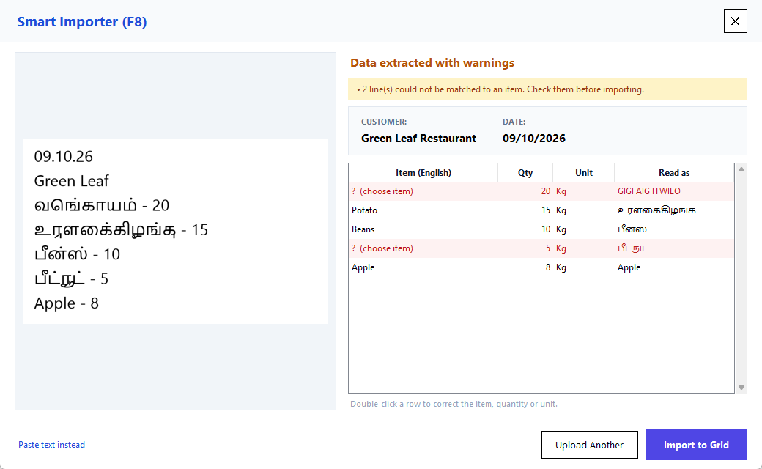
Smart Importer
• BillDesk reads English and Tamil (and Hindi, Telugu, Kannada, Malayalam) with the built-in Tesseract reader, converts Tamil numerals, translates the item names to English and matches them to your Item Master.
• The date and the customer at the top of the note are picked up too.
• Printed or typed orders read well. Handwriting is hard for this kind of reader: if nothing can be read the window says so instead of guessing. Use a straight, bright photo, or type the lines with Paste text instead.
• The same item twice in one order is added together.
See also: Importing order text · New customer order

4.5 Importing order text
Screen: New Order
For orders that arrive as text (WhatsApp, SMS): in the Smart Importer choose Paste text instead.
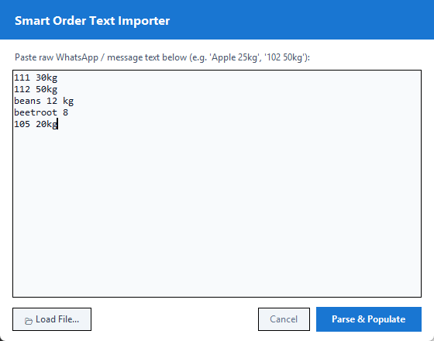
Text importer
1. Paste the message, one item per line: 111 30kg, beans 12 kg, 105 20.
2. Press Parse & Populate (or Load File… for a .txt / .csv).
Item codes and names both work, in either order with the quantity. Lines that cannot be matched to an item are not guessed: they are listed so you can add them by hand.
See also: Smart Importer (photo, scan or text) · New customer order

4.6 Convert an order to a bill
Screen: Orders
1. On Orders, select the order.
2. Press Convert to Sales Bill.
The bill is made with the order's items and rates and the order becomes billed, linked to the invoice (shown in Linked Docs). A billed order cannot be converted again. Convert to Purchase Bill does the same for buying the goods from a supplier.
See also: Orders and shipments · Making a bill

4.7 Order matrix: how much to buy
Screen: Order Matrix
Reports → Order Consolidation adds up all pending orders: one row per item, one column per customer, then the total order, current stock and to purchase.
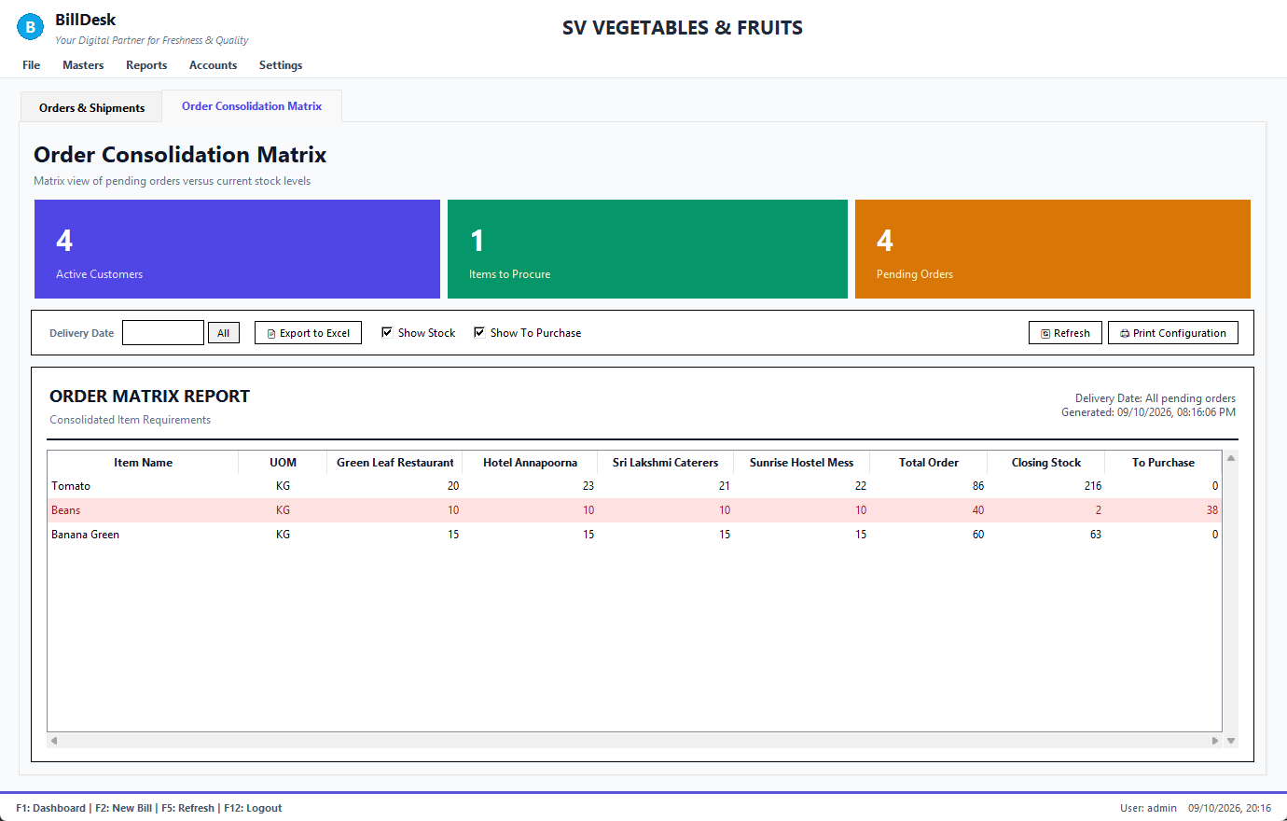
Order matrix
• Delivery Date limits the matrix to orders due on that day (pick it from the calendar); All shows every pending order.
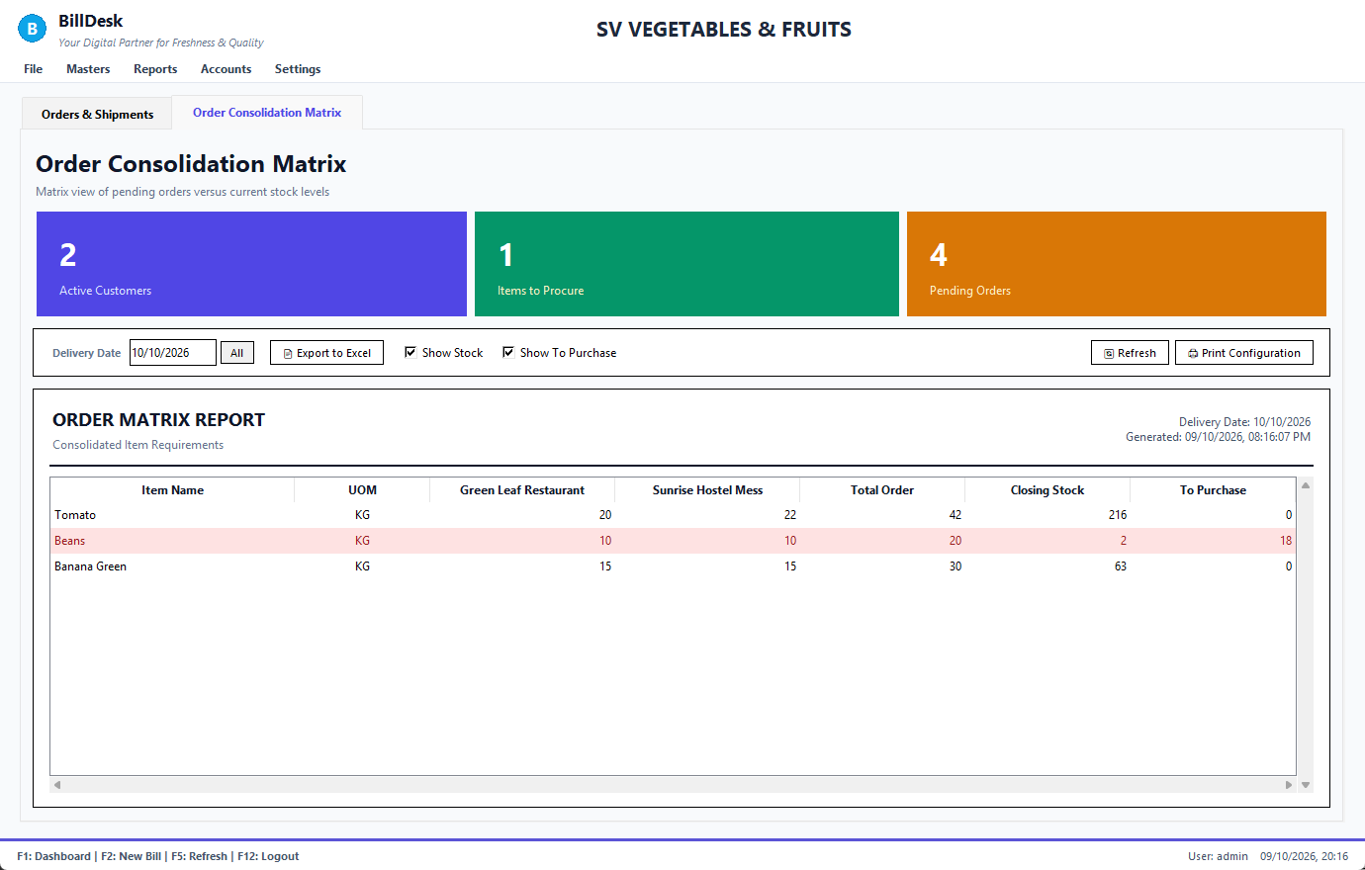
Matrix for one delivery date
• Show Stock and Show To Purchase switch those columns; Export to Excel and Print Configuration produce a copy.
See also: Orders and shipments · Inventory: live stock

Chapter 5. Masters: items, customers, suppliers

5.1 Items
Screen: Item Master
Masters → Item Master (F10).
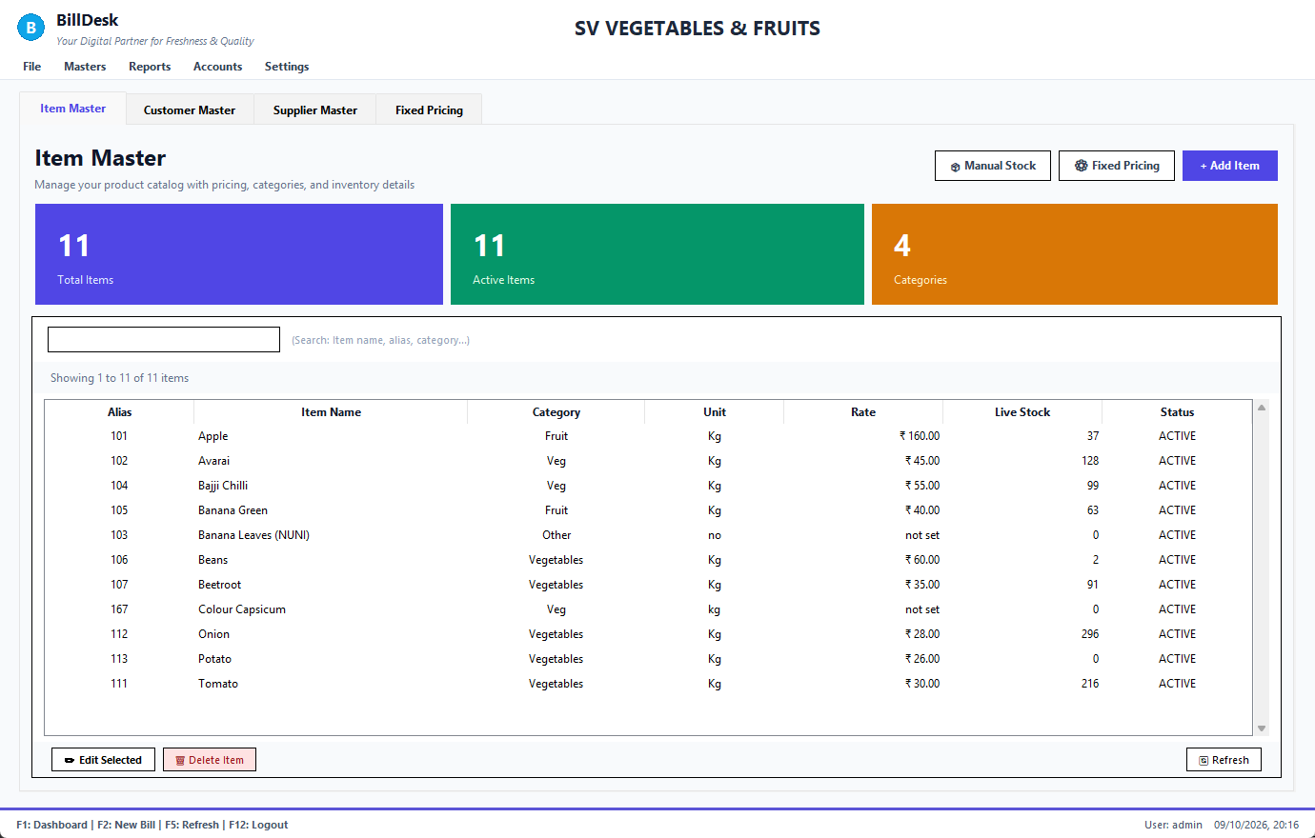
Item Master
1. Press + Add Item.
2. Fill the form and press Save Item. To change an item, double-click it (or Edit Selected).
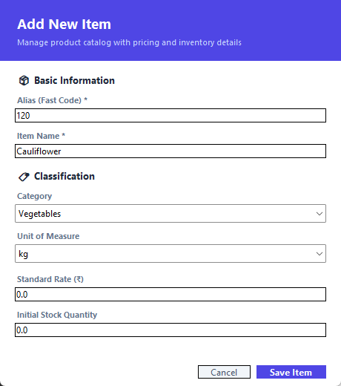
Add item
Box | Meaning
Alias (Fast Code) | the short code you type when billing (111); no spaces, unique
Item Name | up to 80 characters; two items cannot have the same name
Category / Unit of Measure | for grouping; the unit appears on the bill
Standard Rate (₹) | the rate used when a customer has no fixed rate (0 or more)
Initial Stock Quantity | opening quantity (0 or more)

See also: Fixed contract rates · What each form accepts

5.2 Customers
Screen: Customer Master
Masters → Customer Master (F4).
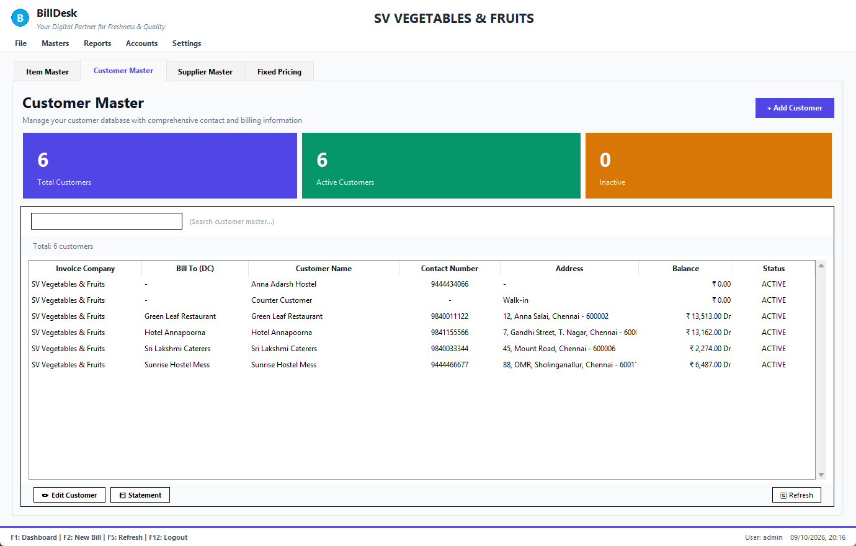
Customer Master
• Balance shows Dr when the customer owes you and Cr when you hold their advance or a return credit.
• Buttons: + Add Customer, Edit Customer, Statement (the customer's account, bill by bill: statement) and Refresh.
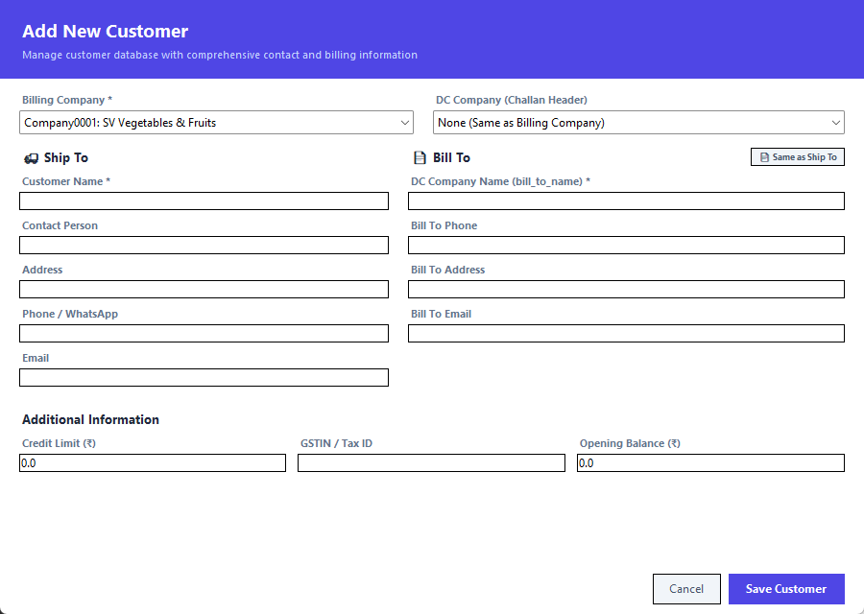
Add customer
• Customer Name (ship-to) and DC Company Name (the "bill to") can differ: goods go to one place, the invoice to another company. Invoices and the consolidated report use both.
• Phone: 7 to 15 digits, up to three numbers separated by commas. Email and GSTIN are optional but checked when given (GSTIN is 15 letters or digits). Names must be unique.
• Credit limit and Opening balance must be numbers. A customer's balance is changed only by bills, receipts and returns, never by editing the form.
See also: Customer statement · Fixed contract rates · What each form accepts

5.3 Suppliers
Screen: Supplier Master
Masters → Supplier Master.
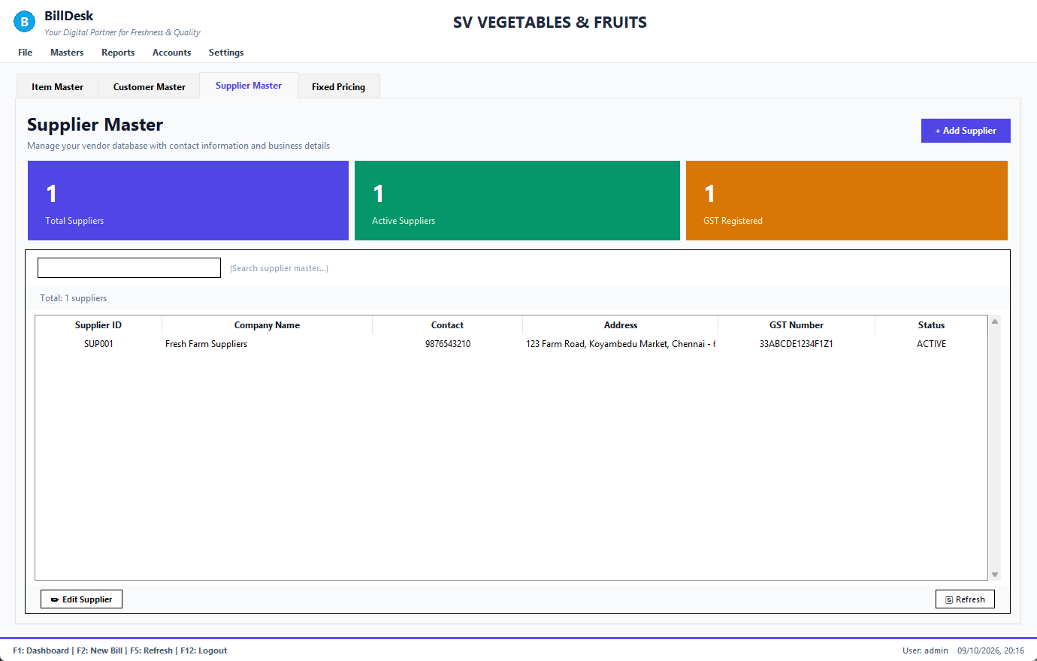
Supplier Master
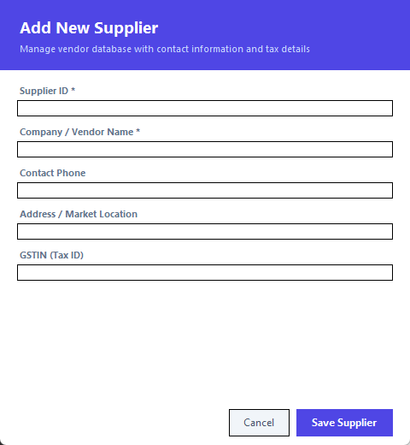
Add supplier
Name, phone, address and GSTIN (optional) as for customers. If TDS applies to the supplier, set the TDS rate (0 to 100): vendor bills then deduct it automatically.
See also: Enter a vendor bill · Pay a supplier

5.4 Fixed contract rates
Screen: Fixed Rates
A customer with an agreed price for an item gets that rate automatically on every bill and order while the contract is valid.
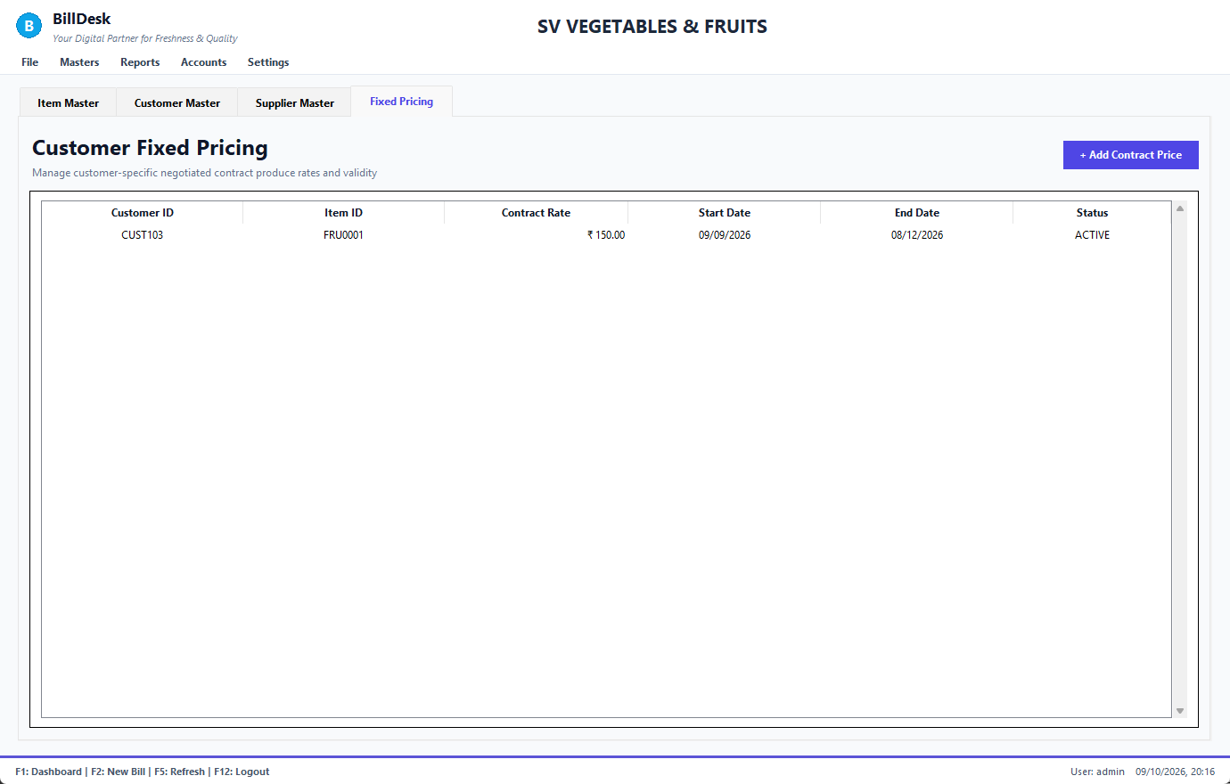
Fixed rates
1. Reports → Fixed Rates Report, press + Add Contract Price.
2. Enter the customer ID, the item ID or code and the rate (must be above zero).
3. Pick the start and end dates from the calendars (the end cannot be before the start).
4. Press Save Price.
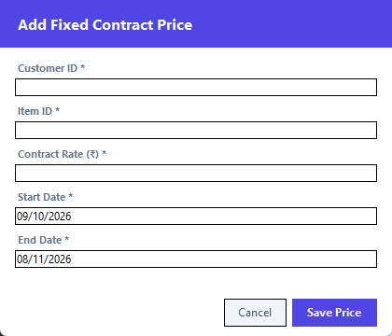
Add contract price
A new price for the same customer and item replaces the old one. The billing hint line says fixed rate for <customer> when one is used.
See also: Items · Customers · Entering items

Chapter 6. Stock and purchases

6.1 Inventory: live stock
Screen: Inventory
Masters → Waste Management opens the inventory screen with four tabs.
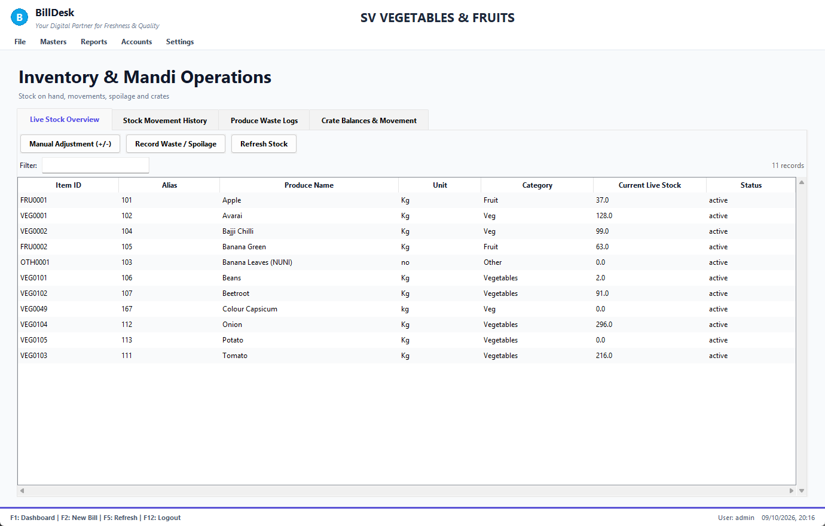
Live stock
• Live Stock Overview: every item with its quantity on hand.
• Stock Movement History: every sale, return, goods receipt, adjustment and waste that changed stock, with date and reference.
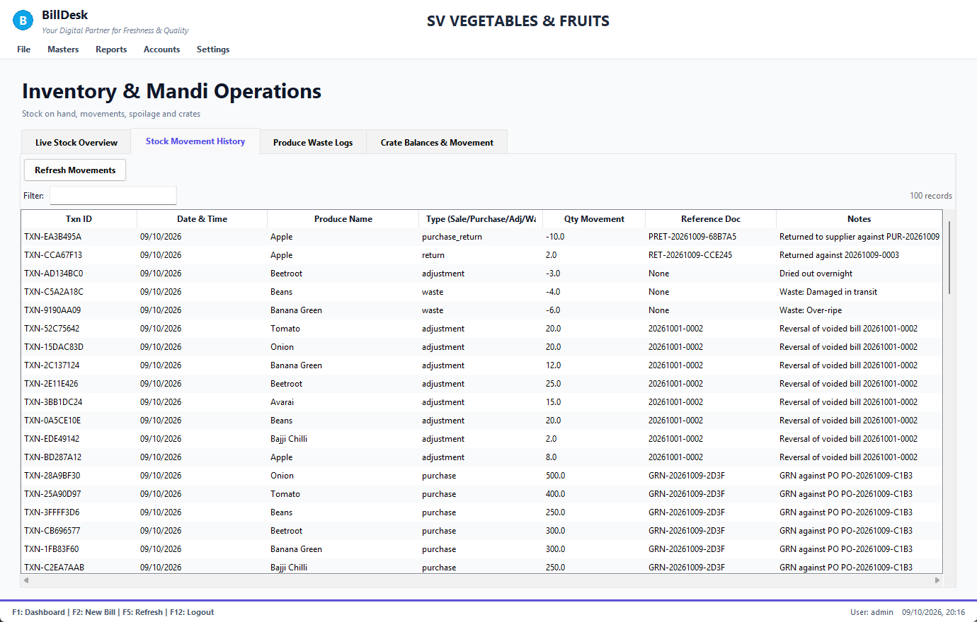
Stock movements
• Produce Waste Logs and Crate Balances are described next.
• Stock for an item may show 0 if you never entered it: BillDesk then does not block sales. Goods receipts and adjustments start it.
See also: Stock adjustment (after counting) · Waste and spoilage · Crates

6.2 Stock adjustment (after counting)
Screen: Inventory
1. Select the item on Live Stock Overview.
2. Press Manual Adjustment (+/-).
3. Type the change (+5 to add, -3 to reduce) and the reason (required for the audit trail).
4. Press Commit Adjustment.
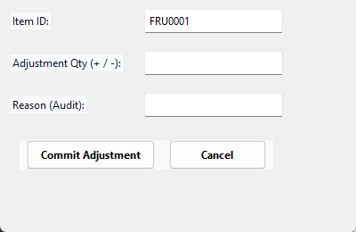
Stock adjustment
• The item can be entered by its id or its code.
• Stock cannot go below zero by adjusting; the quantity must be a number.
See also: Inventory: live stock · Waste and spoilage

6.3 Waste and spoilage
Screen: Inventory
Produce that rots or is damaged is recorded as waste, so it reduces stock and shows as a loss in your profit and loss.
1. Select the item, press Record Waste / Spoilage.
2. Enter the quantity, the estimated cost rate and the reason (Rotten, Crushed…).
3. Press Record Waste.
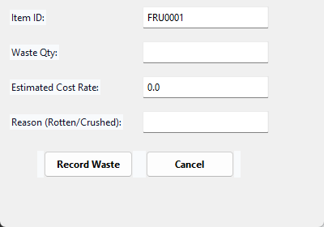
Record waste
The Produce Waste Logs tab lists them:
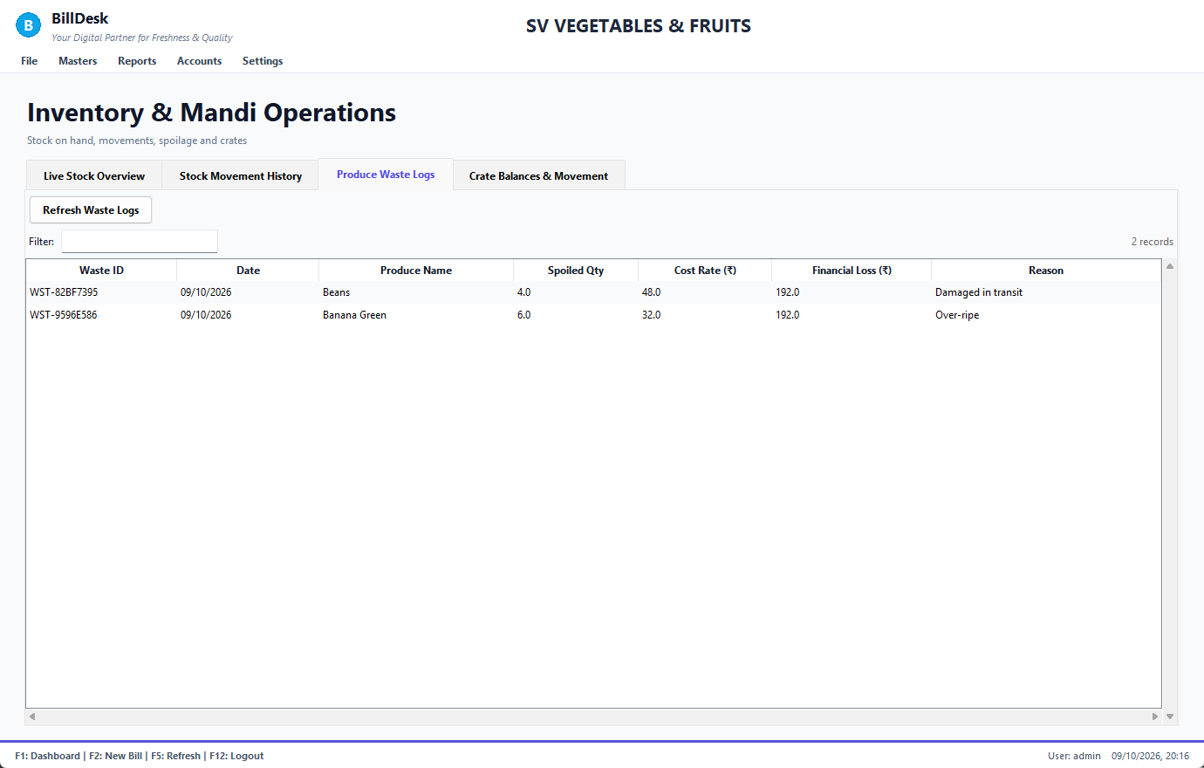
Waste logs
If the stock is tracked you cannot waste more than is on hand. Goods a customer returns as spoiled are handled by Return goods, not here.
See also: Stock adjustment (after counting) · Return goods (credit note) · Inventory: live stock

6.4 Crates
Screen: Inventory
Returnable crates that go out with a bill or an order (Crates out) and come back (Crates in) are tracked per customer.
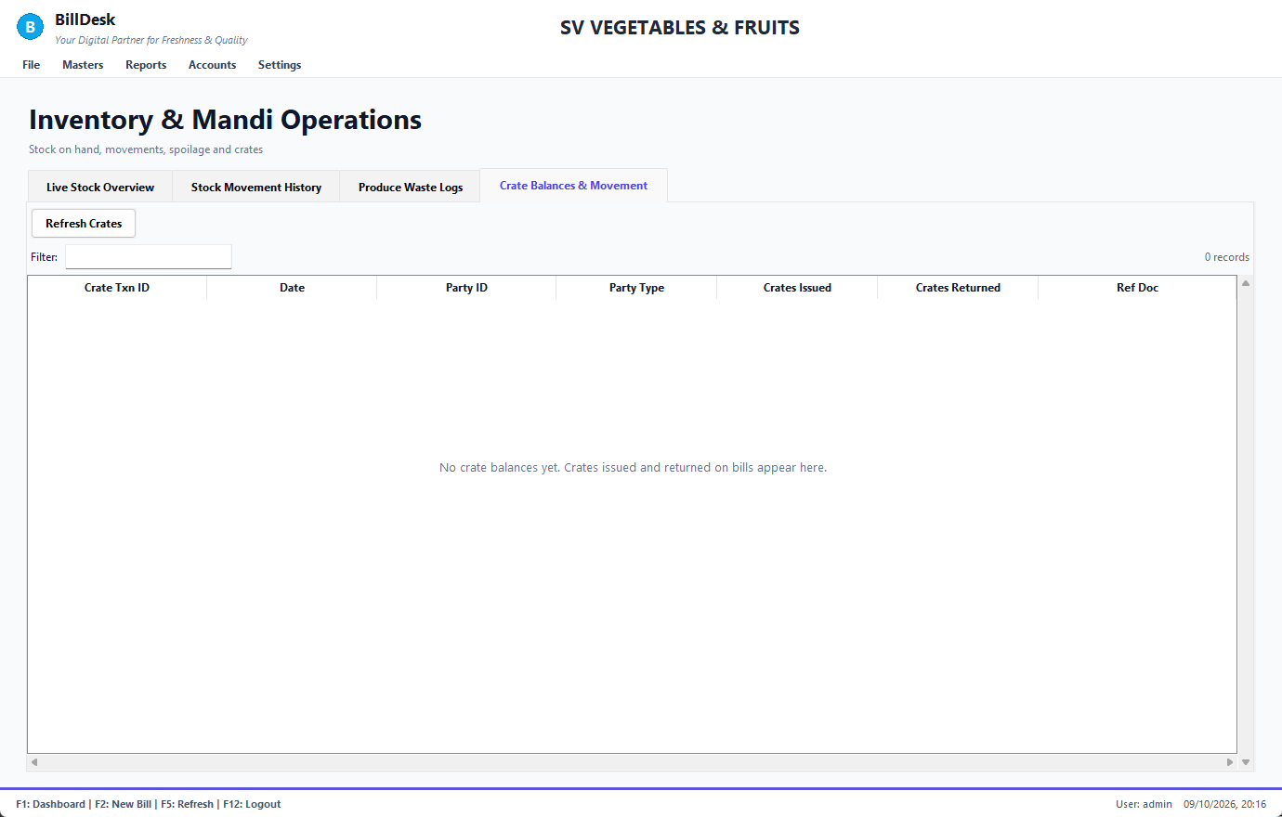
Crate balances
Voiding a bill reverses its crates. Crate numbers must be whole numbers, 0 or more.
See also: New customer order · Inventory: live stock

6.5 Procurement and vendor bills
Screen: Procurement
File → Purchase system or Ctrl+P.
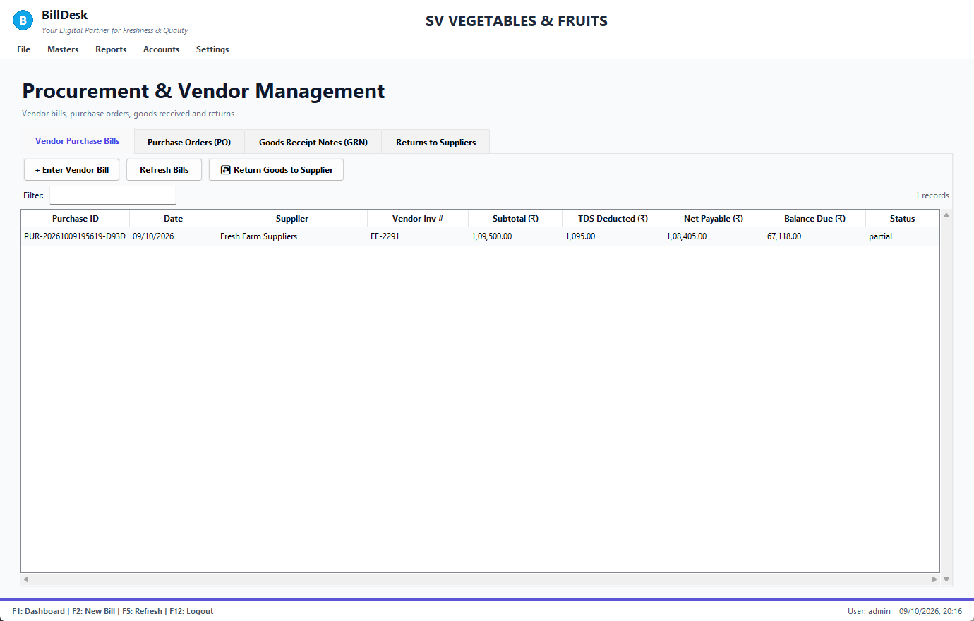
Vendor purchase bills
Four tabs: Vendor Purchase Bills, Purchase Orders, Goods Receipt Notes and Returns to Suppliers. The bills tab lists each supplier invoice with subtotal, TDS, net payable, balance due and status.
See also: Enter a vendor bill · Purchase orders and goods receipts · Return goods to a supplier (debit note)

6.6 Enter a vendor bill
Screen: Procurement
1. + Enter Vendor Bill.
2. Type the Supplier ID, the supplier's invoice number, the item (id or code), the quantity and the rate.
3. Press Record Bill.
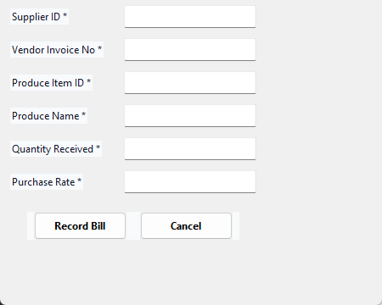
Enter a vendor bill
• TDS is worked out from the supplier's rate and what you owe is the net payable.
• The same supplier invoice number cannot be entered twice (BillDesk tells you the purchase it already belongs to).
• Quantity and rate must be above zero and the item must exist.
See also: Pay a supplier · Return goods to a supplier (debit note) · Suppliers

6.7 Purchase orders and goods receipts
Screen: Procurement
• Purchase Orders: what you asked a supplier to send.
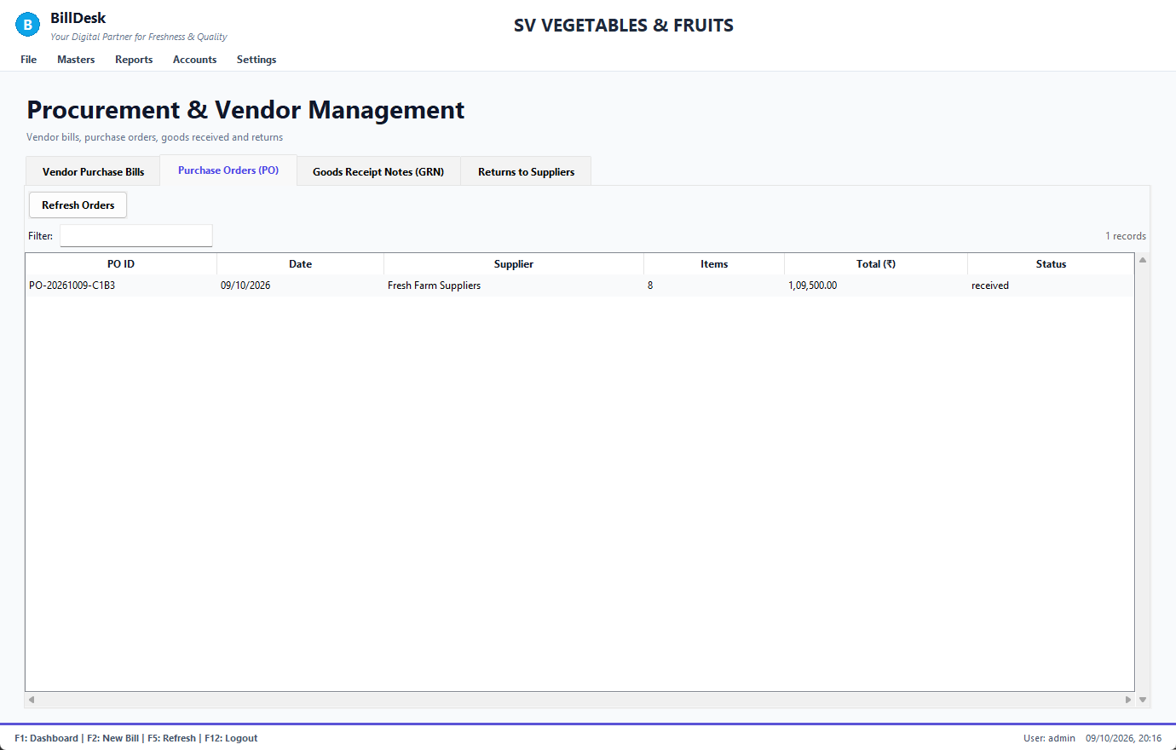
Purchase orders
• Goods Receipt Notes (GRN): what actually arrived against a PO; receiving adds to stock.
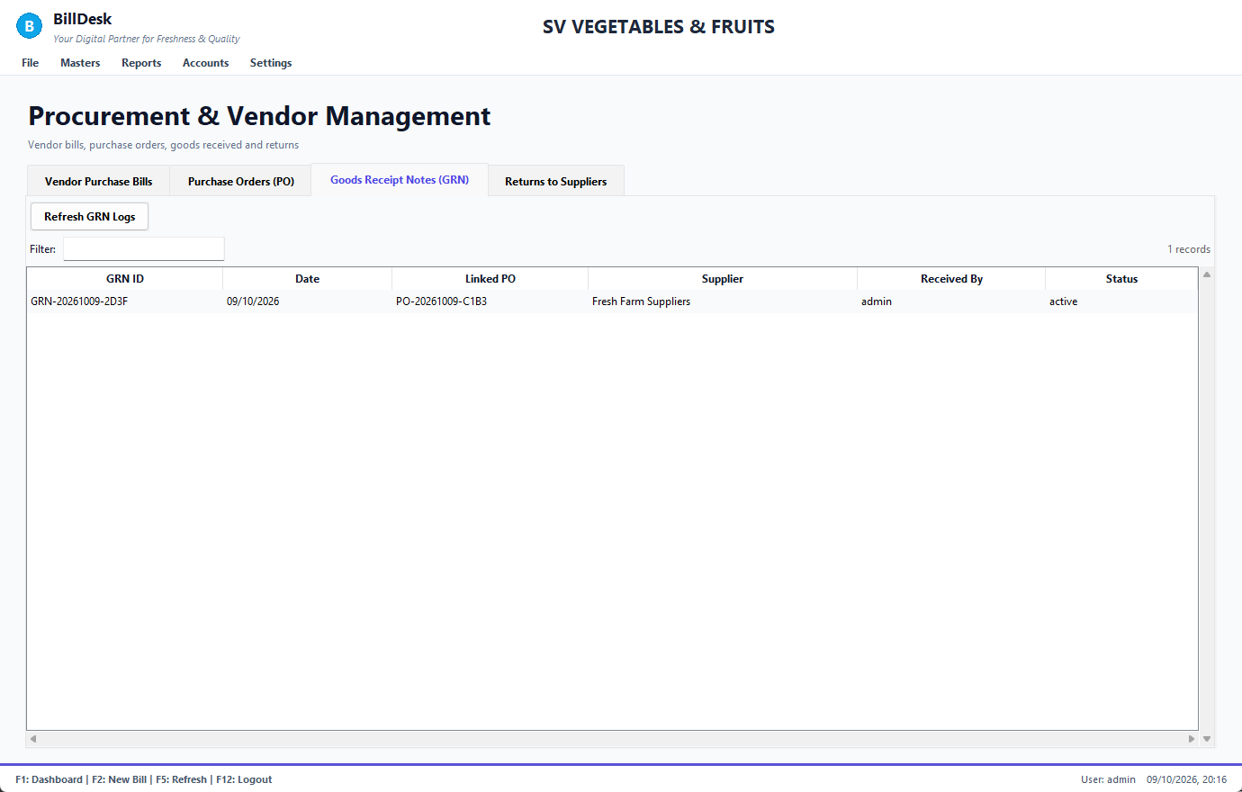
Goods receipts
A vendor bill linked to a PO and a GRN is checked three ways (rates against the PO, quantities against what was received) and mismatches are flagged.
See also: Enter a vendor bill · Inventory: live stock

6.8 Return goods to a supplier (debit note)
Screen: Procurement
1. Procurement → Vendor Purchase Bills, select the bill the goods came on.
2. Press ↩ Return Goods to Supplier.
3. Type the quantity of each item, the reason, and press Save return. You can print the debit note.
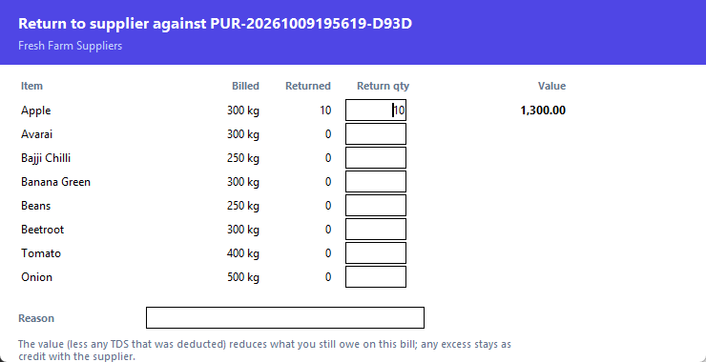
Return to supplier
• The value is at the bill's rate. If TDS was deducted, the same share comes back, so what you owe falls by the net amount.
• It reduces what you still owe on that bill first; any excess is credit with the supplier.
• Stock goes down only if the goods had been received into stock (the bill has a goods receipt).
• The Returns to Suppliers tab lists them; Print Debit Note and Cancel Debit Note are there.
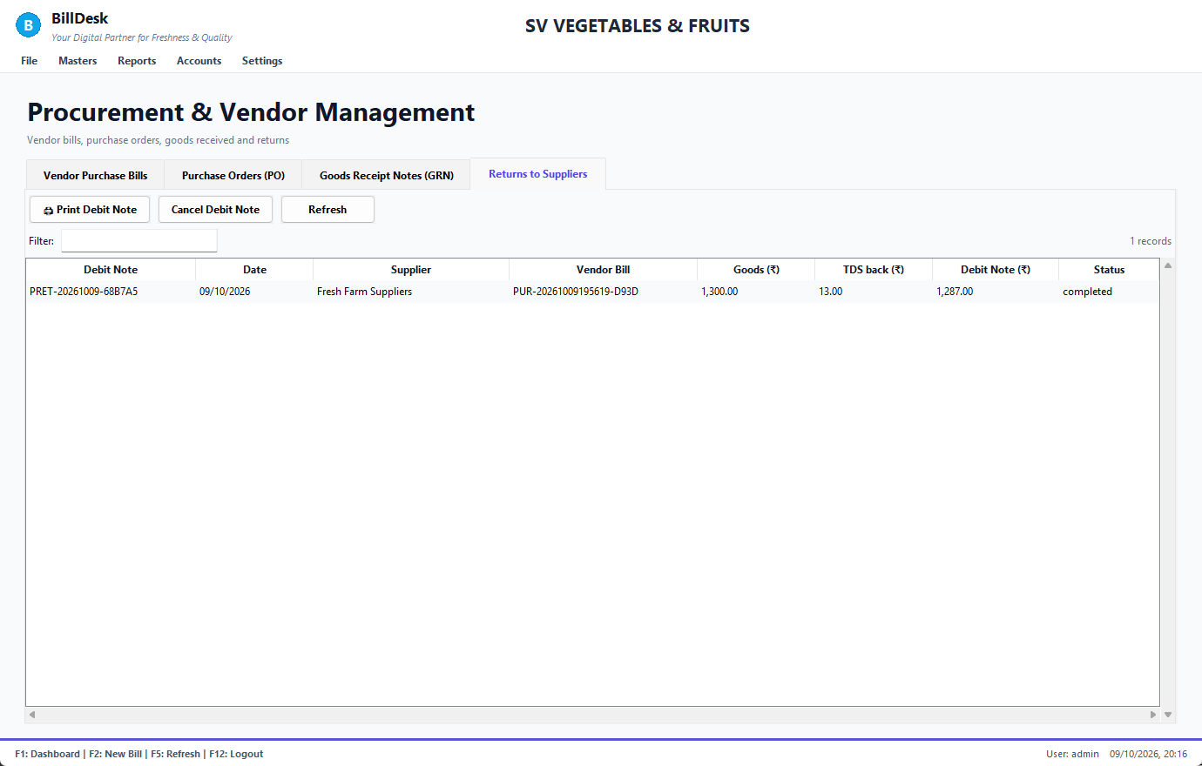
Returns to suppliers
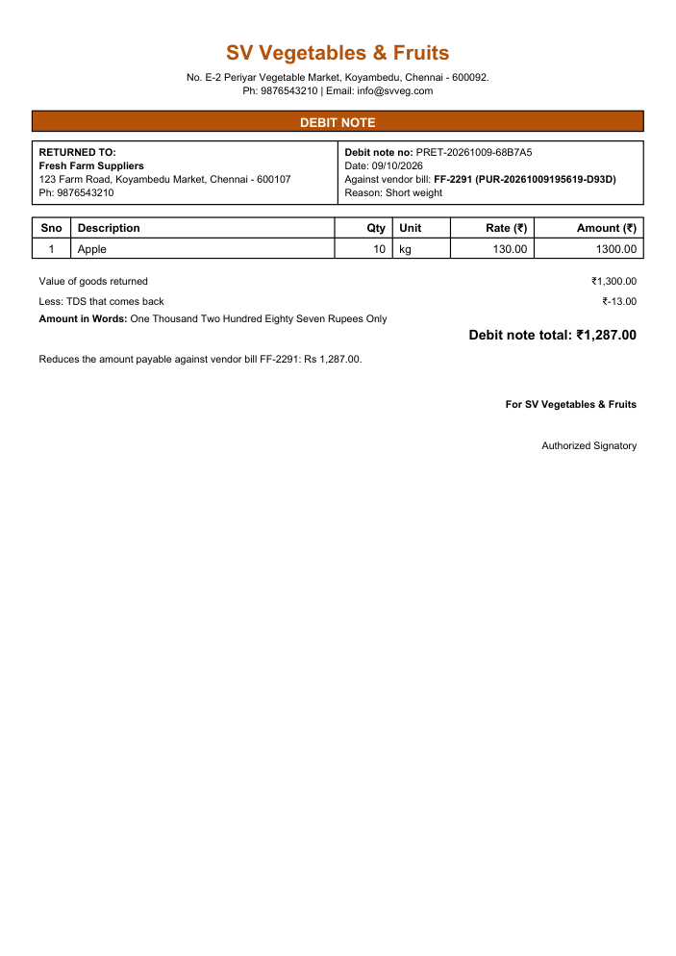
Debit note
See also: Cancel a return · Enter a vendor bill · Pay a supplier

Chapter 7. Money and accounts

7.1 Accounting dashboard
Screen: Finance
Accounts → Accounting Dashboard (Ctrl+D).
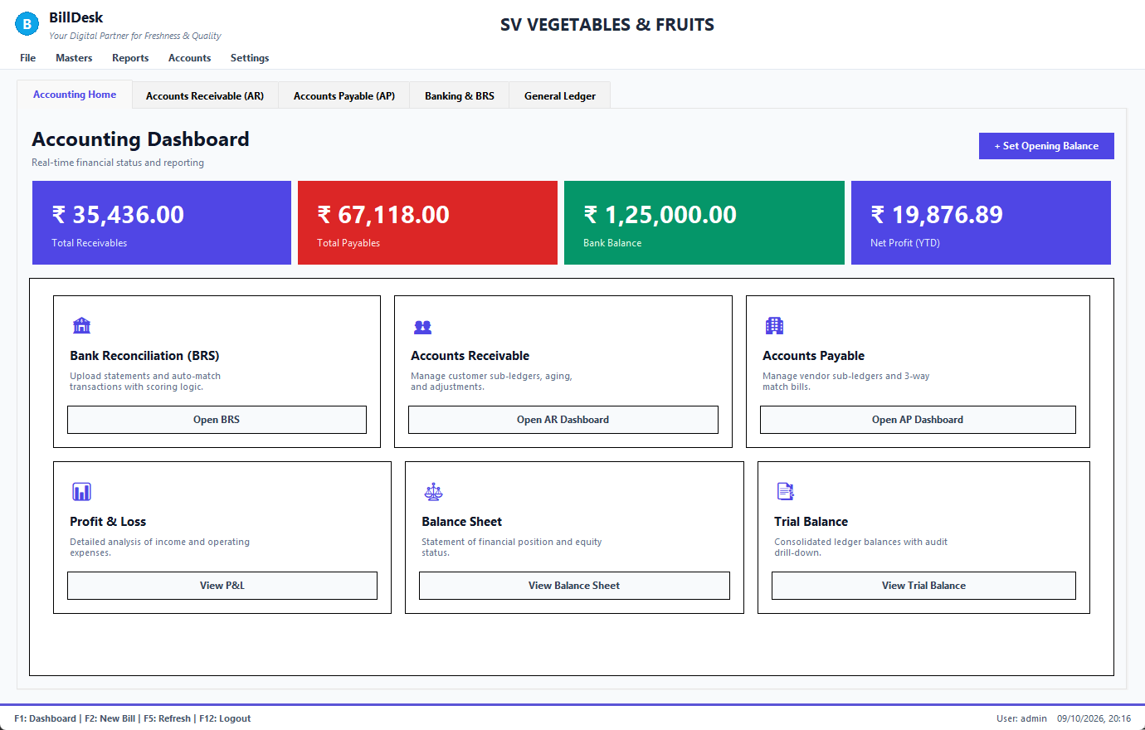
Accounting dashboard
The cards show total receivables, payables, bank balance and net profit; the quick buttons open the other tabs: Accounts Receivable (AR), Accounts Payable (AP), Banking & BRS and General Ledger.
See also: Receivables: who owes you · Payables and supplier payments · Banking and reconciliation · Trial balance, profit and loss, balance sheet

7.2 Receivables: who owes you
Screen: Accounts Receivables
Accounts → Accounts Receivables.
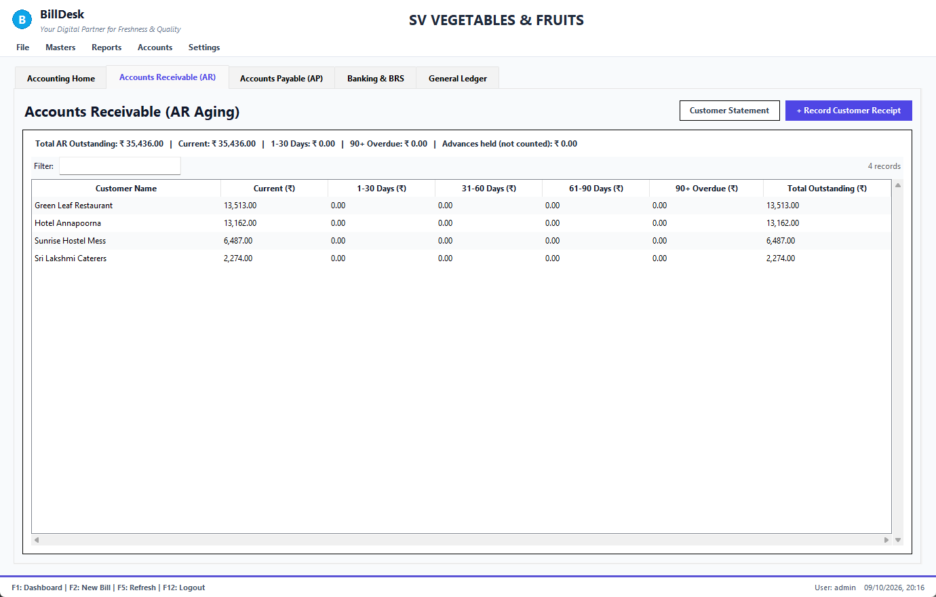
Receivables
Each customer who owes money, split by age: Current, 1–30, 31–60, 61–90 and 90+ days. The total here equals the customer balances, the ledger and the dashboard card. Customers who have paid in advance are not subtracted: they are shown in the line above as Advances held.
• + Record Customer Receipt records a payment (receipt).
• Customer Statement opens the selected customer's account (statement).
See also: Customer receipts · Customer statement · Searching and filtering bills

7.3 Customer receipts
Screen: Accounts Receivables
When a customer pays later (not at the counter):
1. Accounts Receivables → + Record Customer Receipt.
2. Enter the Customer ID, the amount and choose the payment mode from the list.
3. Leave Invoice No blank to settle the oldest bills first (FIFO), or type one invoice number.
4. Add the UTR / cheque reference and press Save Receipt.
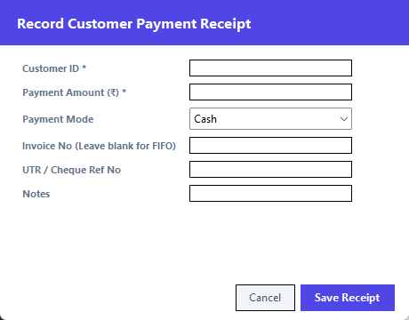
Customer receipt
The customer's balance goes down and the matching bills are marked paid. An amount larger than what they owe becomes their advance.
See also: Customer statement · Receivables: who owes you · Taking payment

7.4 Customer statement
Screen: Customer Master, Receivables
From Customer Master → Statement or Accounts Receivables → Customer Statement.
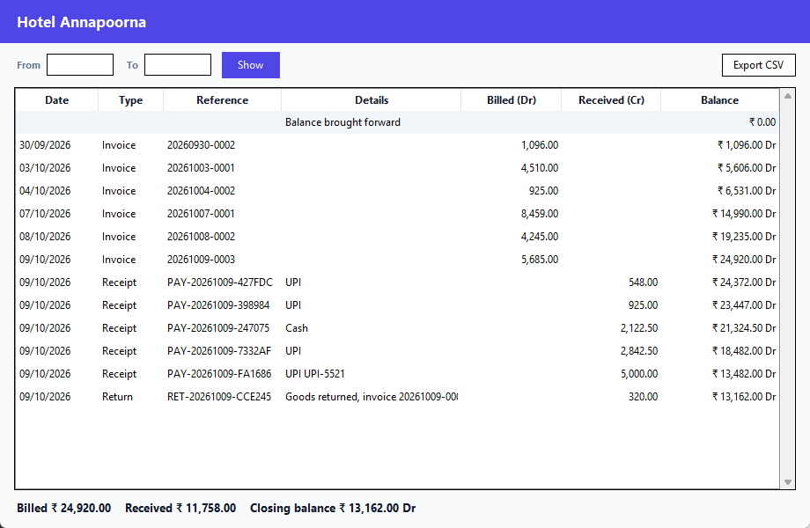
Customer statement
• Lists invoices (billed), receipts, returns and adjustments with a running balance, ending on the customer's balance.
• From / To (calendar boxes) show one period; the earlier balance is brought forward.
• Export CSV saves it for Excel.
• "Adjustment" appears when the customer paid something that was never recorded here.
See also: Customer receipts · Customers · Receivables: who owes you

7.5 Payables and supplier payments
Screen: Accounts Payables
Accounts → Accounts Payables lists your vendor bills with net payable, balance due and status.
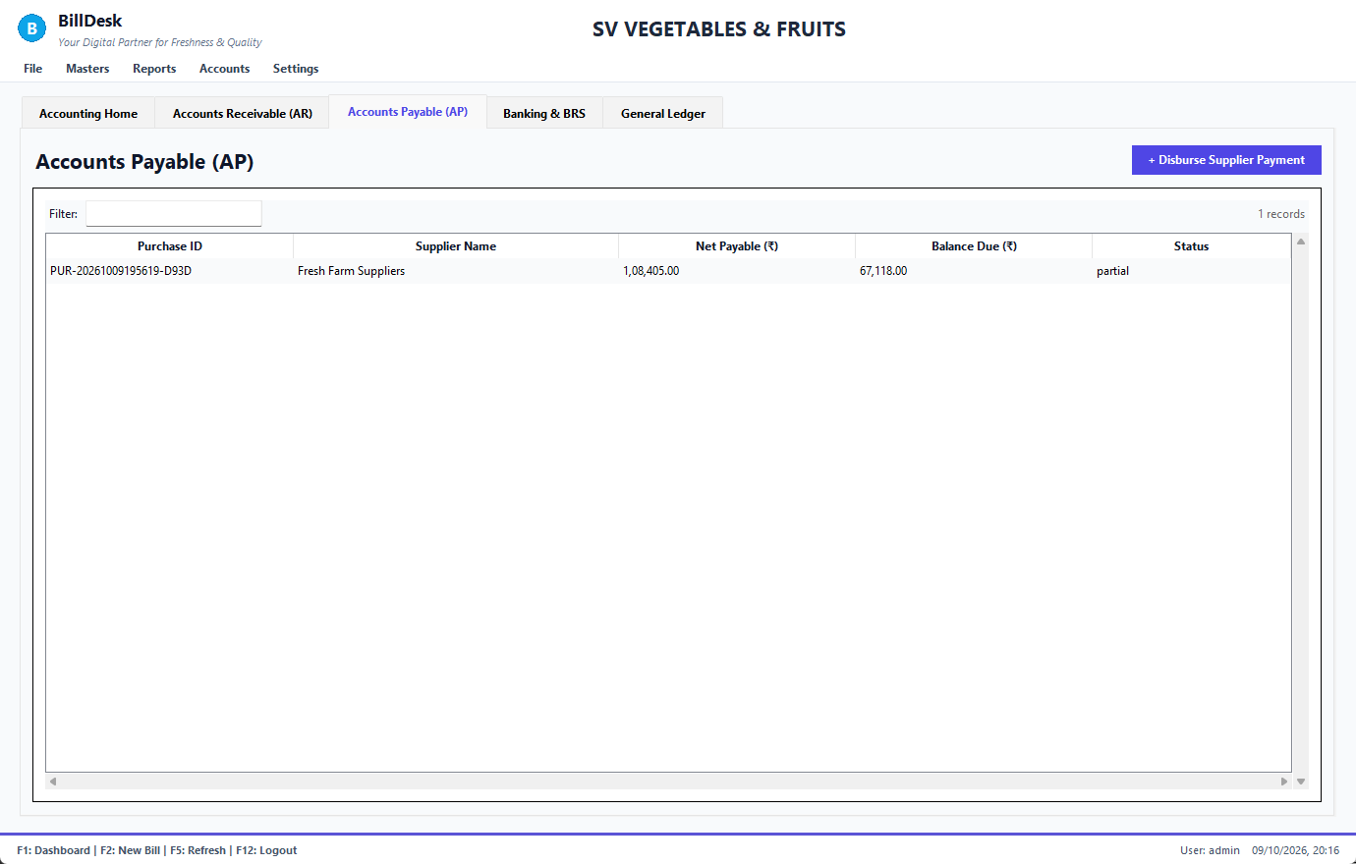
Payables
See also: Pay a supplier · Enter a vendor bill

7.6 Pay a supplier
Screen: Accounts Payables
1. Accounts Payables → + Disburse Supplier Payment.
2. Enter the Purchase ID, the Supplier ID, the amount and the payment mode.
3. Add the UTR and press Disburse Payment.
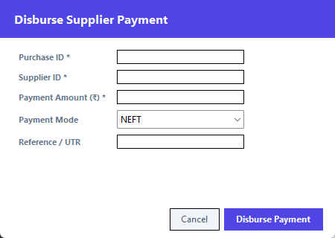
Supplier payment
You cannot pay more than the bill's balance due.
See also: Payables and supplier payments · Enter a vendor bill

7.7 Banking and reconciliation
Screen: BRS
Accounts → BRS.
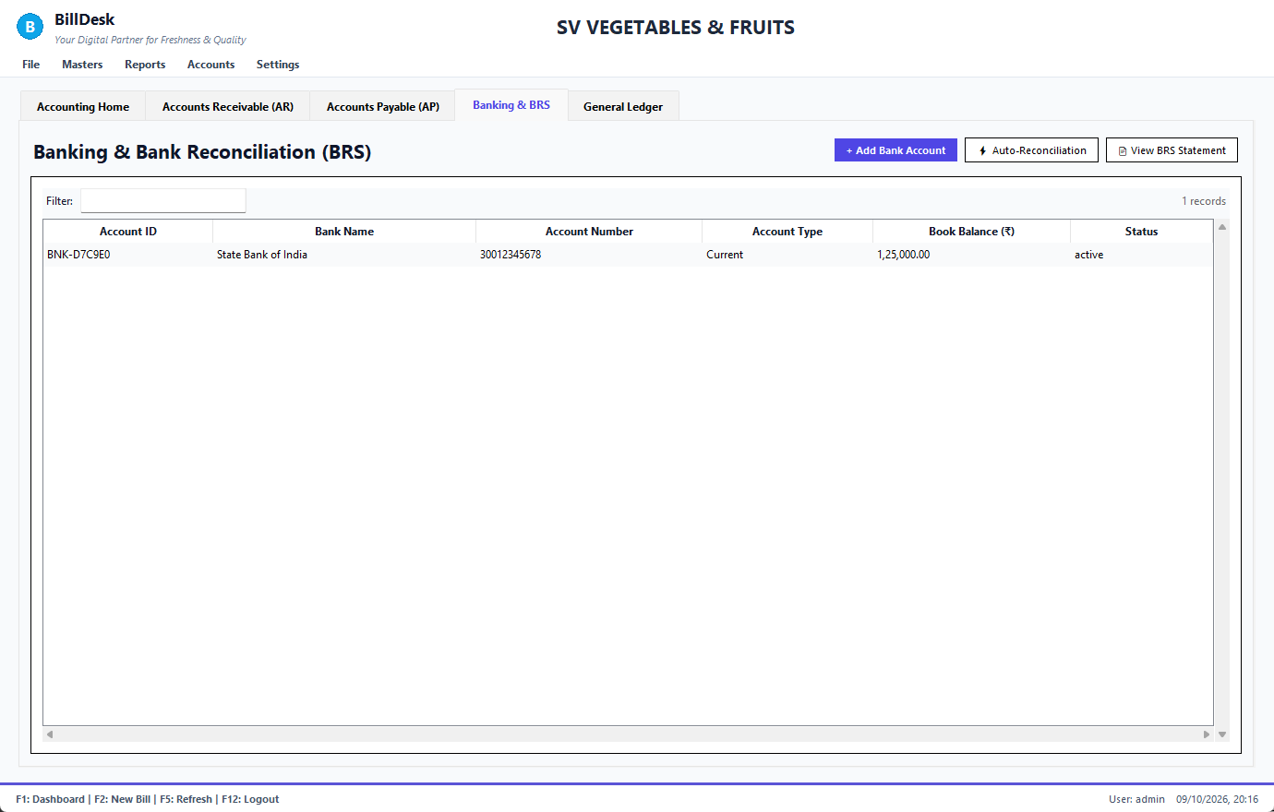
Banking
1. + Add Bank Account and fill in the form.
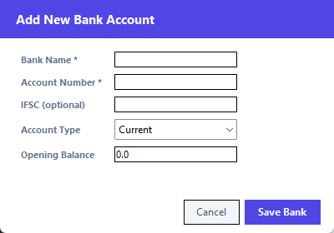
Add bank account
Box | Rule
Bank name | required
Account number | 6–20 digits, registered once
IFSC | optional; 4 letters, a 0, 6 letters/digits (SBIN0001234)
Account type | Current, Savings or OD
Opening balance | a number

1. ⚡ Auto-Reconciliation matches bank statement lines with your records by reference and amount; View BRS Statement shows the reconciliation.
See also: General ledger and manual journal · Accounting dashboard

7.8 General ledger and manual journal
Screen: Finance
The General Ledger tab lists every accounting entry. BillDesk posts them automatically for bills, receipts, purchases, payments, returns and waste; use a manual journal only for what has no screen (for example opening capital).
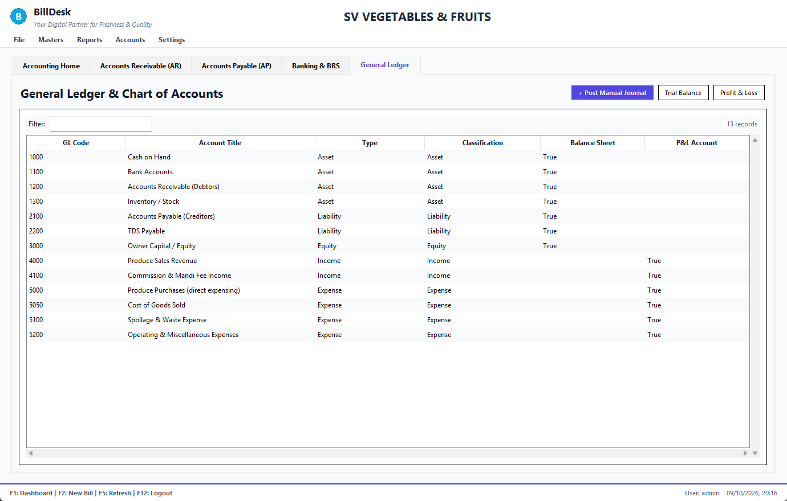
General ledger
1. + Post Manual Journal.
2. Enter a reference (ADJ-001), the debit account code and amount, the credit account code and amount.
3. Press Post Entry.
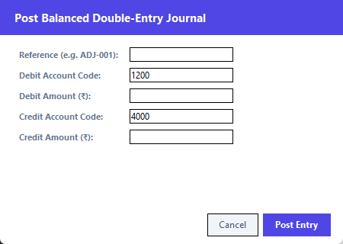
Manual journal
The two accounts must be different and the amounts must be equal; otherwise the form tells you before anything is posted.
See also: Trial balance, profit and loss, balance sheet · Accounting dashboard

7.9 Trial balance, profit and loss, balance sheet
Screen: Finance
Accounts → Trial Balance / Profit & Loss / Balance Sheet each open a report window.
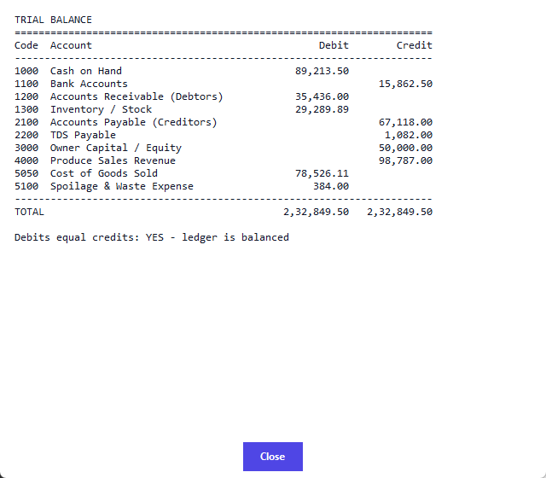
Trial balance
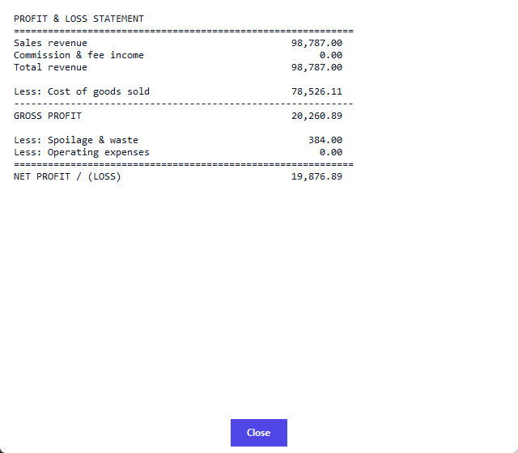
Profit and loss
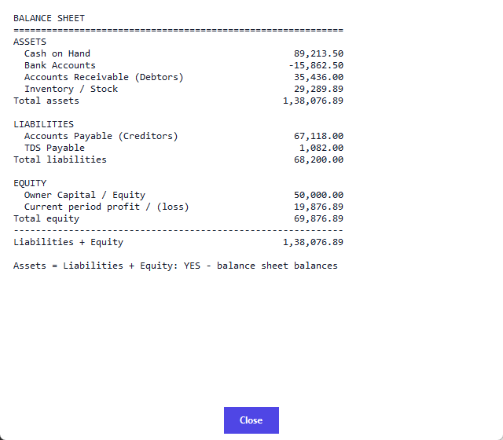
Balance sheet
• Trial balance: every account's debits and credits; the totals must be equal.
• Profit and loss: sales (net of returns), cost of goods sold, waste and expenses, giving the profit.
• Balance sheet: what you own, owe and the owner's capital.
See also: General ledger and manual journal · Integrity check

7.10 Integrity check
Screen: Integrity Check
Accounts → Integrity Check → Run Check reads your data (it changes nothing) and tests that the books are consistent.
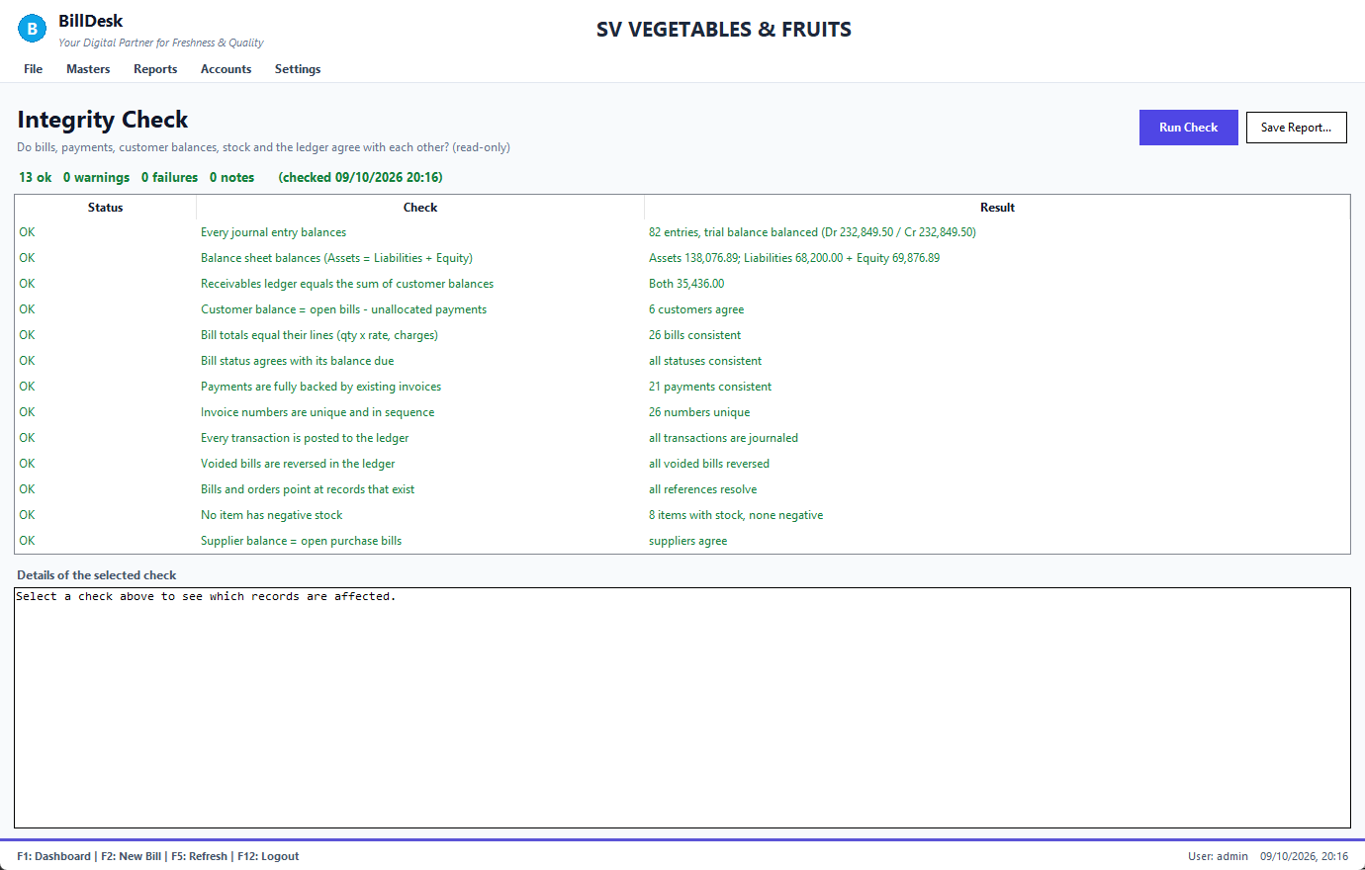
Integrity check
Each line is OK, Info, Warning or Fail: journals balance, receivables equal customer balances, bills add up, statuses agree with balances, invoice numbers are unique, stock is not negative, and more. Open a line to see exactly which records. Save Report… keeps a copy. Run it before closing the month and after restoring a backup.
See also: Trial balance, profit and loss, balance sheet · Backup and database

Chapter 8. Reports

8.1 Daybook
Screen: Reports
Reports → Daybook: every event in date order: sales, returns, purchases, receipts and supplier payments, with Billed, Bought, Money in and Money out and a total line.
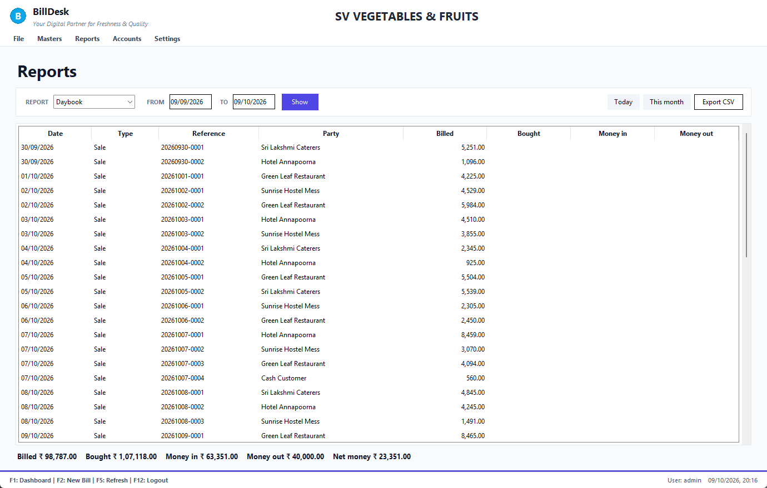
Daybook
Choose the period with the From / To boxes (dates in reports), or Today / This month. Export CSV saves it.
See also: Item-wise sales · Customer-wise sales · Dates in reports

8.2 Item-wise sales
Screen: Reports
Reports → Item-wise Sales: for each item the bills it was on, quantity sold, quantity returned, net quantity, average rate and net amount, best sellers first.
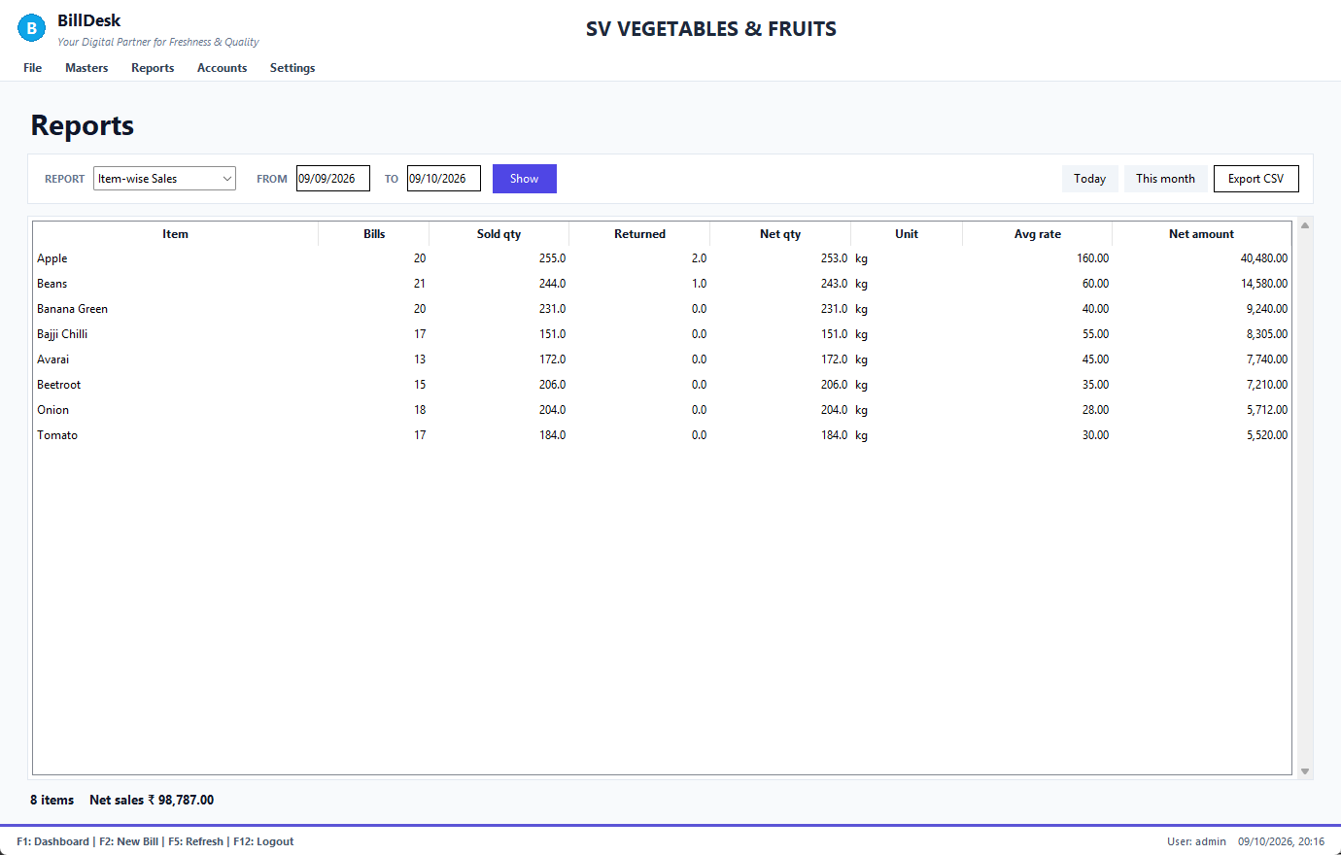
Item-wise sales
See also: Daybook · Customer-wise sales

8.3 Customer-wise sales
Screen: Reports
Reports → Customer-wise Sales: bills, billed, returned, net sales and what each customer owes now.
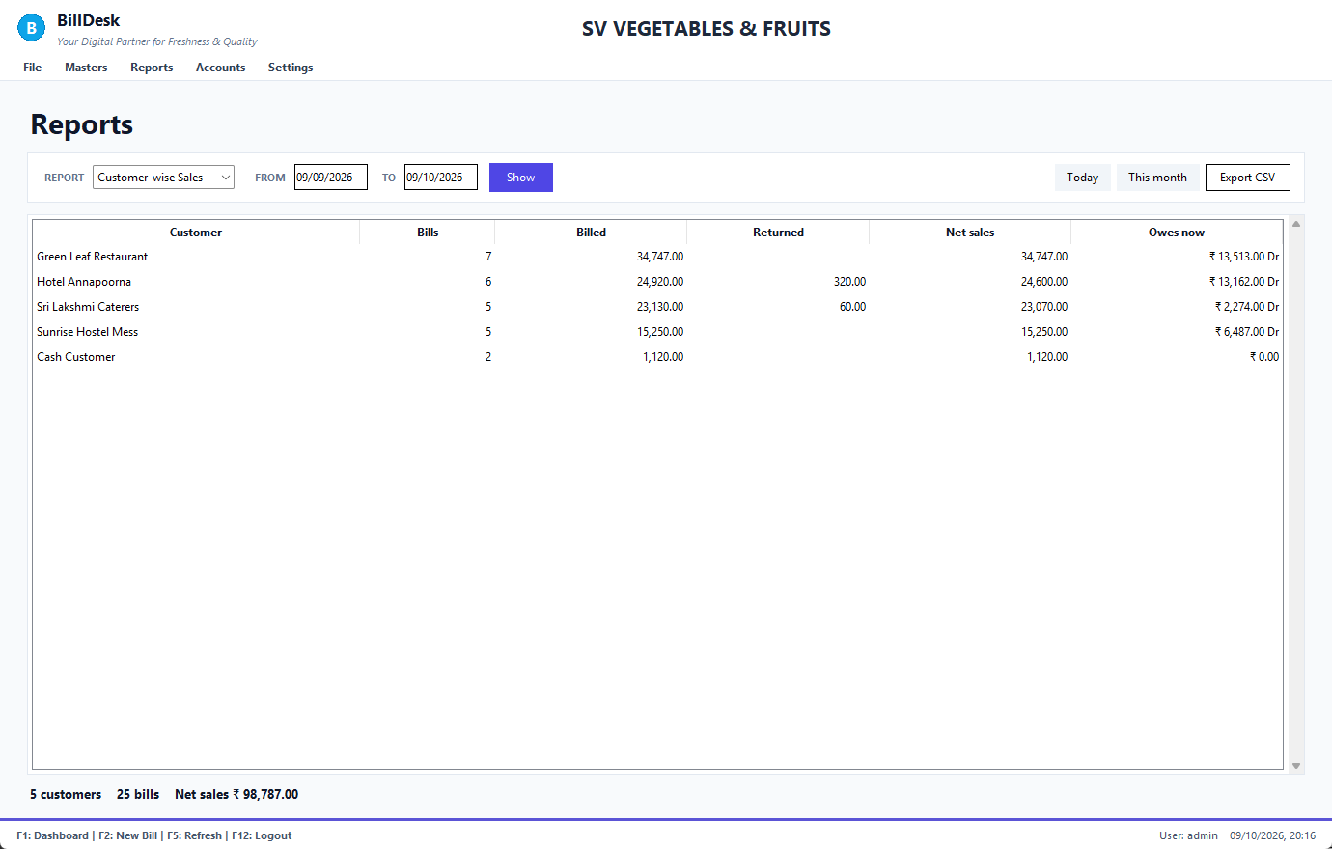
Customer-wise sales
See also: Daybook · Item-wise sales · Customer statement

8.4 Dates in reports
Screen: Reports
All three reports share the From / To boxes.
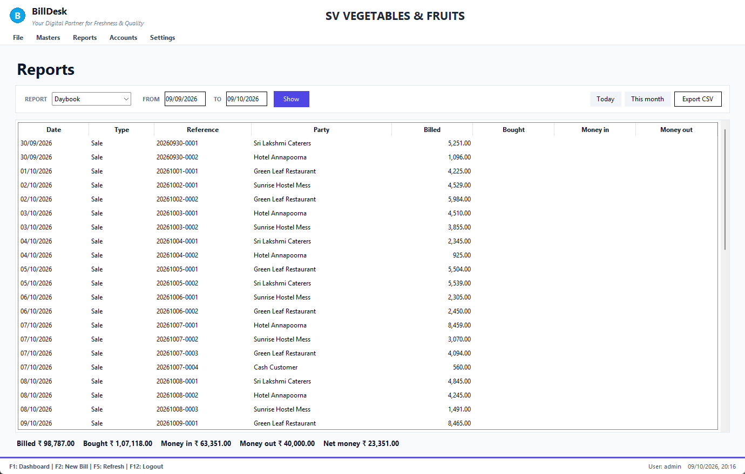
Report calendar
• Pick a day or type it; the To date cannot be before the From date.
• Leave a box empty for "no limit".
• The reports always net out returns, and cancelled returns are ignored.
See also: Daybook · Dates and the calendar

8.5 Consolidated bills
Screen: Consolidated Billing
Reports → Bills Consolidated Report: one statement of all bills for a "bill to" company over a period, grouped by delivery address.
1. Press the search icon and choose the Bill To company.
2. Pick From and To (they start at the 1st of this month and today).
3. Press Generate, then save or print the PDF.
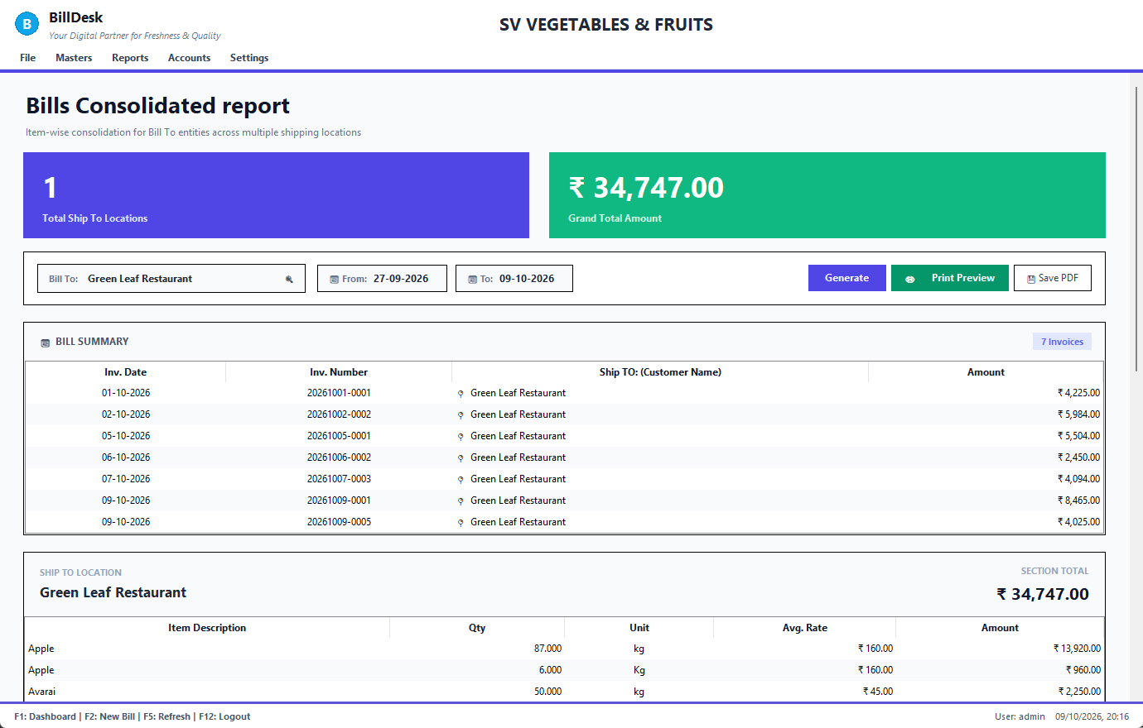
Consolidated bills
See also: Customers · Bill History

Chapter 9. Administration

9.1 Cash drawer
Screen: Handover & Settlement
Accounts → Handover & Settlement.
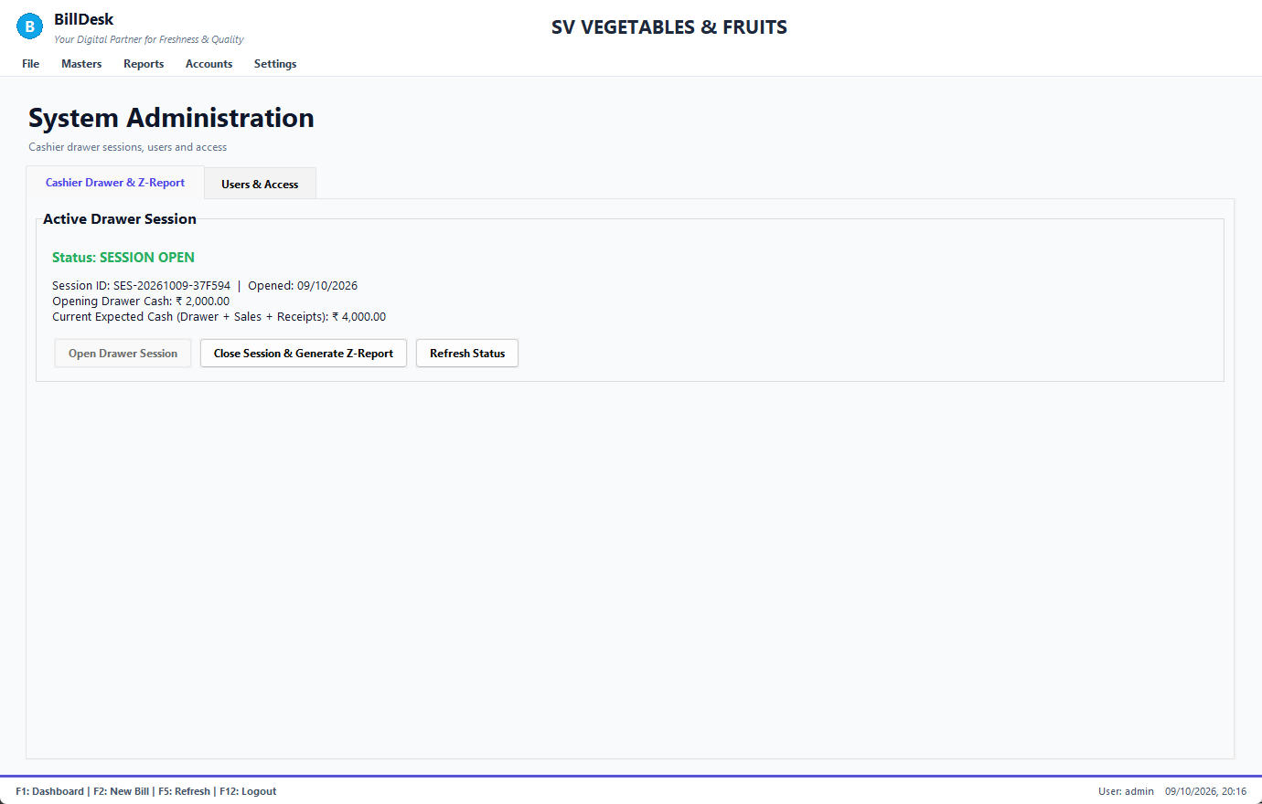
Cash drawer
1. At the start of the day press Open Drawer Session, type the opening float and press Start Session.
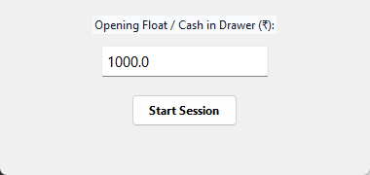
Open the drawer
1. Work as usual: cash receipts are added to the expected cash.
2. At the end press Close Drawer & Generate Report, type the cash you counted and a note for any difference.
3. BillDesk shows the Z-report: expected, counted and short / excess.
Amounts must be numbers (0 or more). You can have only one open session.
See also: Users and roles · Taking payment

9.2 Users and roles
Screen: User Management
Settings → User Management, tab Users & Access.
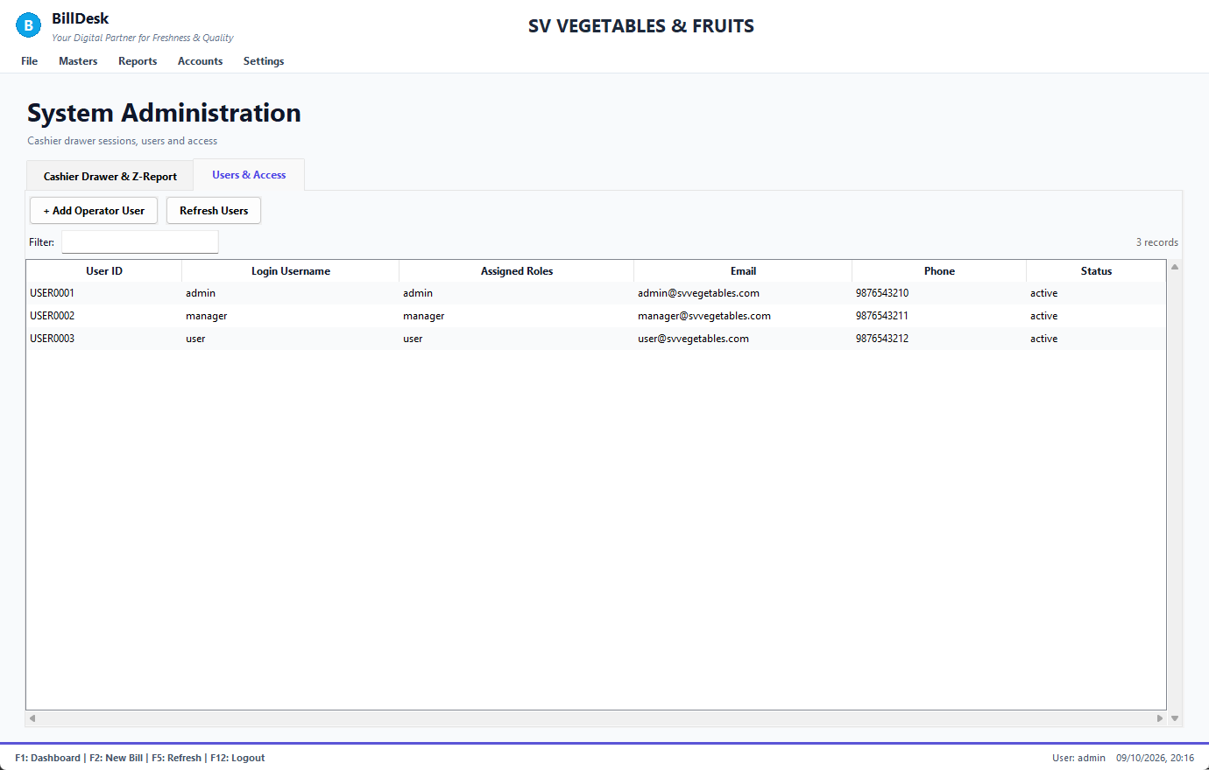
Users
1. + Add Operator User.
2. Type a username (3–30 letters, digits, dot, dash or underscore, unique), a password (at least 6 characters, not the same as the username), choose the role from the list, add email and phone (optional).
3. Press Create User.
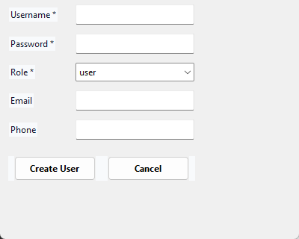
Add user
The role decides which menus a person sees. A forgotten password is reset by the administrator with scripts\reset_password.py.
See also: Signing in · Company configuration

9.3 Company configuration
Screen: Company Settings
Settings → Company Settings: your business details as they appear on every invoice.
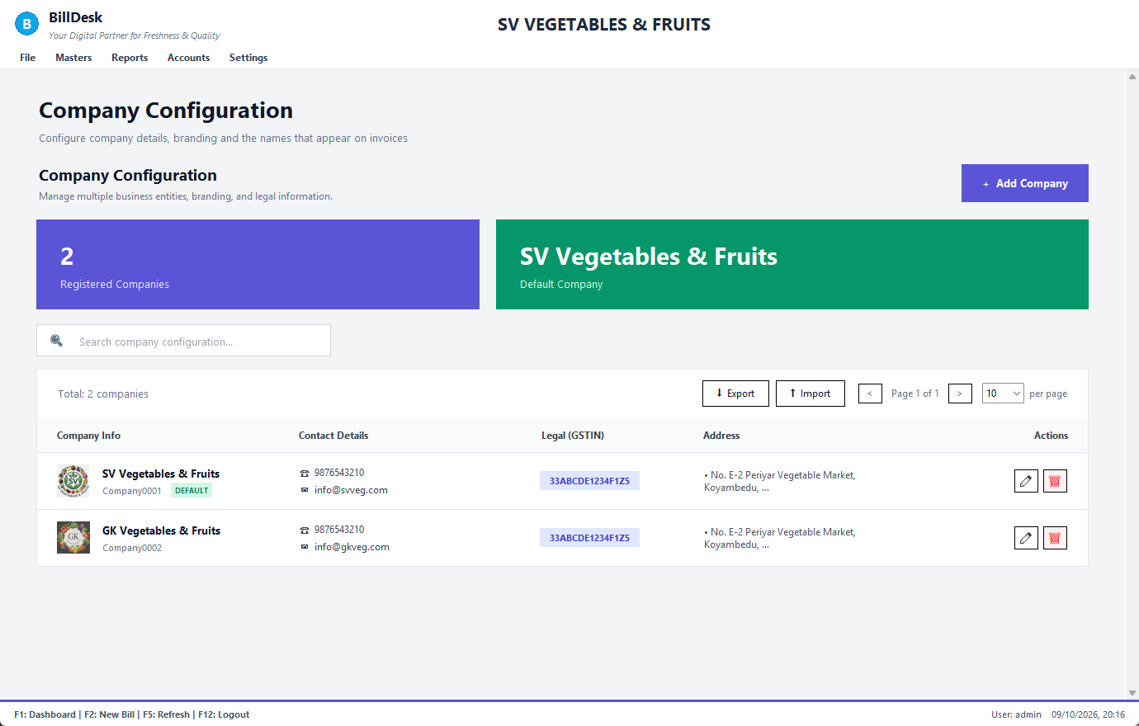
Company configuration
• + Add Company and the ✏ edit icon open the form; the trash icon deletes (the default company and the last company cannot be deleted).
• Search, Export and Import (a CSV with a name column) manage many companies.
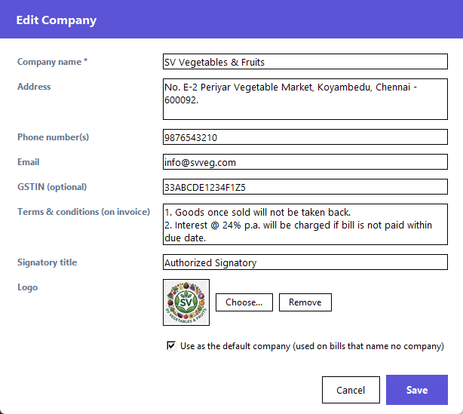
Edit company
Name, address, phones, email, GSTIN (optional), terms and conditions, signatory title, a logo (any picture; it is shrunk) and use as default company. Changes appear on the next invoice you print.
See also: Print and PDF · Users and roles

9.4 Backup and database
Screen: Database Settings
Settings → Database Settings (titled Backup & Database).
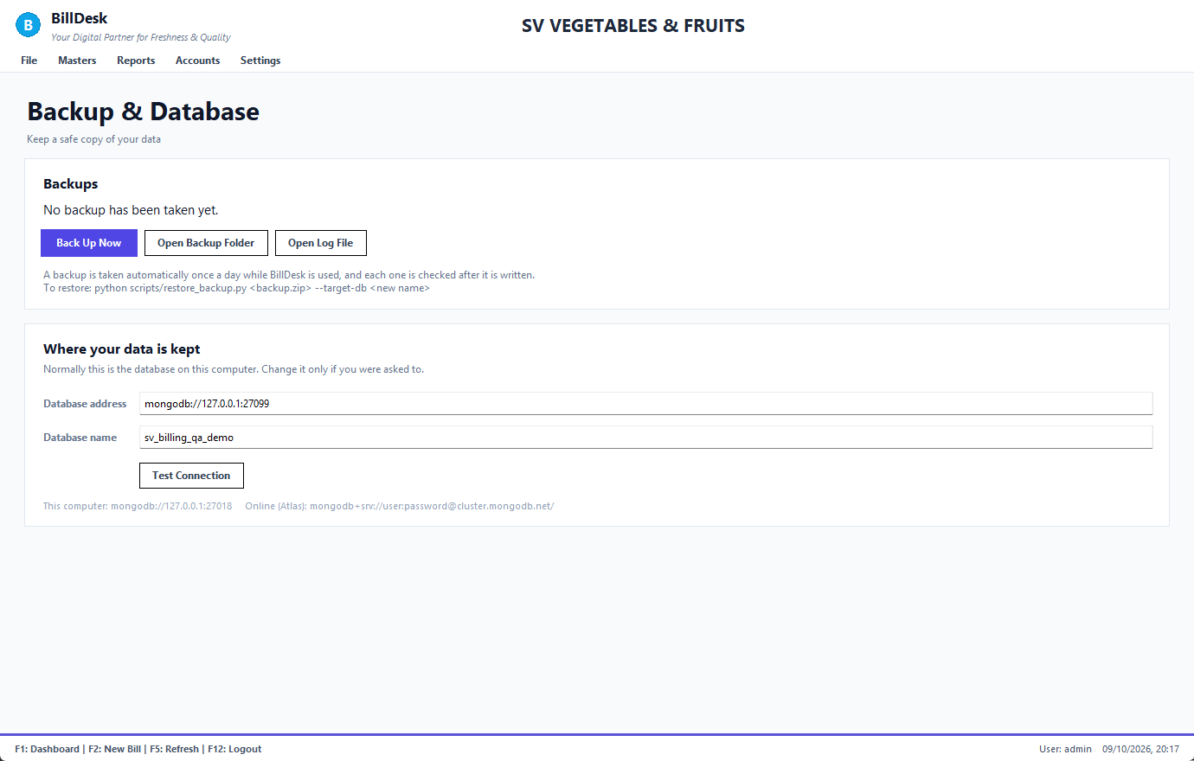
Backup and database
• A backup is taken automatically once a day while BillDesk is used, and each one is checked after it is written.
• Back Up Now makes one immediately; Open Backup Folder shows the files; Open Log File helps your IT person.
• To restore, your IT person runs python scripts\restore_backup.py <backup.zip> --target-db <new name>; then run the Integrity check.
• Where your data is kept normally needs no change. Test Connection checks the database address.
• Copy the backup folder to a pen drive or cloud drive regularly: a backup on the same computer does not help if the computer is lost.
See also: Integrity check · Frequently asked questions

9.5 System audit logs
Screen: System Audit Logs
Settings → System Audit Logs lists what users did and when, so you can see who made, voided or changed something.
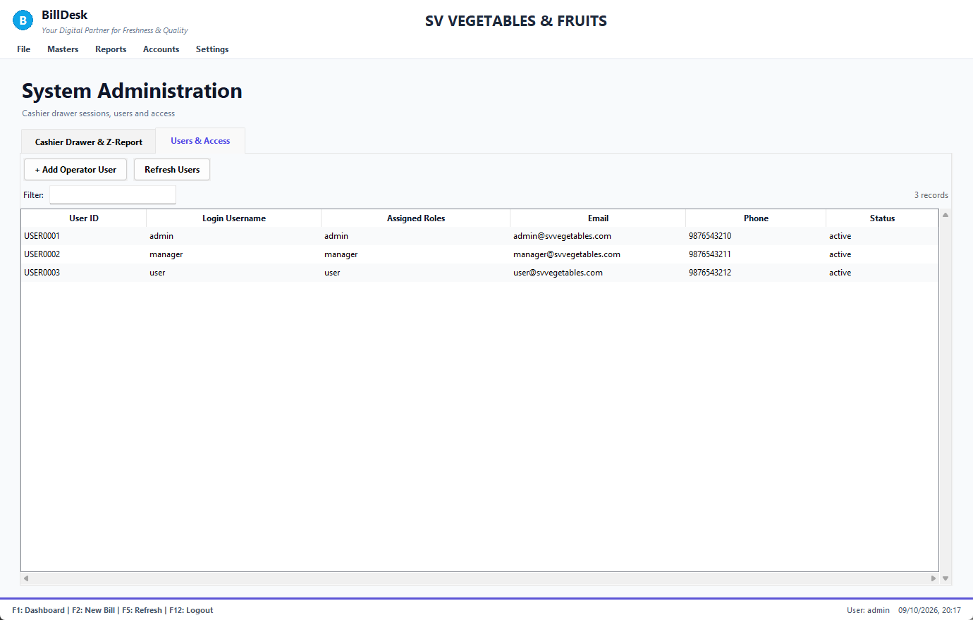
Audit logs
See also: Users and roles

Chapter 10. Reference

10.1 Keyboard shortcuts
Screen: All
The strip at the bottom of each screen lists the keys that work there.
Key | Anywhere | On New Bill | On New Order
F1 | Dashboard (search on Bill History)
F2 | New Bill | save and take payment | save the order
F3 | Item Master | save and print | save the order
F4 | Customer Master
F5 | Supplier Master (from Dashboard); refresh | choose customer | choose customer
F6 | Bills History | park the bill
F7 |  | parked bills
F8 |  |  | Smart Importer
F9 | Help for this screen
F10 | Item Master |  | save and print
F11 | Customer Master
F12 | Log out
Esc | close a dialog | close a dialog | close the form
Ctrl+O | Orders
Ctrl+P | Procurement
Ctrl+D | Accounting Dashboard

In lists and dialogs: ↑ / ↓ move, Enter chooses, Esc closes. In the grids: Enter moves to the next box. In any date box: ↓ opens the calendar.
See also: Finding your way around · Entering items

10.2 Dates and the calendar
Screen: All
Every date box in BillDesk works the same way:
• Click it (or move to it with the keyboard): a calendar drops down. Click a day, or use the arrow keys (Page Up / Down change month) and Enter; Today jumps to today.
• You can also type a date: 13/10/2026, 13-10-26, 2026-10-13. Press Enter to accept it.
• Text turns red when the date cannot be used; the form tells you why when you save.
• Days that are not allowed are greyed in the calendar.
Where | Rule
Bill date | required; not in the future
Order date | required; not in the future
Delivery date | required; not before the order date
Fixed rate start / end | required; end not before start
Report and statement From / To | optional; To not before From
Consolidated report From / To | required; To not before From
Filters (Bill History, Orders) | optional; part of a date (09/2026) is fine

See also: The bill date and the calendar · Order and delivery dates · Dates in reports

10.3 What each form accepts
Screen: All forms
BillDesk checks what you type and says what is wrong instead of saving bad data.
Field | Rule
Quantity, rate, amount | a real number; quantity above zero; rate zero or more; not absurdly large
Item name | required, up to 80 characters, not already used
Item code | no spaces, up to 20 characters, unique
Customer / supplier name | required, up to 80 characters, not already used
Phone | 7–15 digits; up to three numbers separated by comma or slash
Email | like name@shop.com
GSTIN | optional; 15 letters/digits
Credit limit, opening balance | a number (credit limit 0 or more)
TDS rate | 0 to 100
Username | 3–30 letters, digits, . - _
Password | at least 6 characters, at most 72 bytes, not the username
Payment mode | Cash, UPI, Cheque, NEFT, RTGS, NEFT/RTGS, Bank, Card (and Credit/Due on a bill)
Vendor invoice number | required, up to 40 characters, once per supplier
Bank account | 6–20 digits; IFSC like SBIN0001234; type Current, Savings or OD
Cash drawer amounts | 0 or more
Crates | whole numbers, 0 or more
Journal entry | reference required; two different accounts; debit equals credit

See also: Messages and what to do · Dates and the calendar

10.4 Messages and what to do
Screen: All
Find the words you see on the screen in the first column; the next columns say why it happened and what to do.
What you see | Why | What to do
"Choose a customer from the customer master (F5)" | an order needs a real customer | press F5, choose one; add the customer first if missing
"The bill date cannot be in the future" | the date box holds a later day | pick today or an earlier day
"… is not a valid date. Use DD/MM/YYYY" | text in a date box can't be read | pick from the calendar
"The To date cannot be before …" | To is earlier than From | change one of them
"Amount received (…) is more than the bill total" | more entered than the bill | type the bill amount or less
"Item … not found" / "No item matches" | wrong code | check the code in the Item Master
"… must be a number" | letters or symbols in a number box | type digits only (decimals allowed)
"An item / customer named … already exists" | the name is taken | use another name, or edit the existing one
"Vendor invoice … is already recorded as PUR-…" | the same supplier invoice was entered before | do not enter it again
"Payment amount … exceeds purchase balance due" | paying a supplier more than owed | pay the balance due or less
"Waste quantity … exceeds stock on hand" | more than the tracked stock | check the quantity
"Invoice … has goods returned against it, so it cannot be voided" | a return exists | cancel the return first, then void
"only n can still be returned" | more than billed minus earlier returns | reduce the return quantity
"Return … was made by the older BillDesk and cannot be cancelled here" | old returns lack detail | leave it; it is already reflected in the balance
"The entry does not balance" | journal debit ≠ credit | make the two amounts equal
"You already have an open cashier session" | a drawer is open | close it first
"Access Denied" | your role does not include that screen | ask the administrator
"Tesseract OCR engine is not installed" | the image reader is missing | use Paste text instead, or ask IT to reinstall
"The text in this image could not be read reliably" | handwriting or a blurry photo | take a straighter, brighter photo or type the lines
Integrity check shows Warning | an older-data difference | open the line; ask your accountant if unsure
Cannot start: database error | the database did not start | restart the computer, then BillDesk; call IT if it repeats

See also: What each form accepts · Frequently asked questions · Backup and database

10.5 Frequently asked questions
Screen: All
Short answers to the questions people ask most; follow the link in the last column for the full steps.
Question | Answer | More
Can I change the date of a bill after saving? | No. Void the bill and make it again with the right date. | Void
How do I sell to someone who is not a customer? | Leave Cash as the customer and take the full payment. | Customer
Why did the bill number have a different date? | The invoice number follows the bill date you chose. | Bill date
A customer paid half. What now? | Enter the amount received; the rest stays on their account. | Payment
A customer paid later in cash. How do I record it? | Use Record Customer Receipt. | Receipt
How do I see what one customer owes, bill by bill? | Open the customer's Statement. | Statement
What is "Cr" next to a balance? | You hold the customer's money (advance or return credit). | Customers
What is the difference between void and return? | Void cancels the whole bill; return takes back some goods and keeps the bill. | Return
I returned goods by mistake. | Cancel the return. | Cancel return
Does BillDesk handle GST? | No: fruit and vegetables are exempt, so no GST is calculated. | What it does
Can two people bill at once? | Yes on different computers using the same database; park a bill to serve two customers at one counter. | Park
How often should I back up? | BillDesk backs up daily; also copy the backup folder to another drive weekly. | Backup
Can it read my customer's handwritten list? | Not reliably. Printed or typed lists work; otherwise type or paste. | Smart Importer
Stock shows 0 but I can still sell. Is that wrong? | No. Stock only tracks what you entered through purchases or adjustments. | Inventory
I forgot my password. | Ask the administrator; they reset it. | Signing in
Where do I change my shop name and address on invoices? | Settings → Company Settings. | Company

See also: Messages and what to do · How to use this guide

10.6 Glossary
Screen: All
The words used in BillDesk and in this guide, in plain language.
Word | Meaning
Bill / Invoice | the document you give the customer for goods sold
Challan (DC) | the same bill without prices, for delivery
Void | cancel a whole bill, keeping its record
Credit note | document for goods a customer returned (their balance goes down)
Debit note | document for goods you send back to a supplier
Dr / Cr | Dr: the customer owes you; Cr: you hold their money
Advance | money received before a bill or more than was owed
Receivables | money customers owe you
Payables | money you owe suppliers
PO / GRN | purchase order / goods receipt note (what actually arrived)
TDS | tax deducted from a supplier's payment
FIFO | oldest bill settled first
BRS | bank reconciliation statement
Trial balance | list of all accounts; debits must equal credits
Float | cash put in the drawer at the start of the day
Legacy bill | a bill made by the older program (no per-bill payment record)
Parked bill | a bill put on hold

See also: How to use this guide

10.7 About this guide
Screen: Help
This guide is written once in Docs/BillDesk_Native_User_Guide.md and turned into the Word, PDF and Jupyter notebook editions and the in-program Help by python scripts/build_user_guide.py. The screenshots come from python scripts/user_guide/capture_screenshots.py running on a demo database (see scripts/user_guide/README.md), so they can be redone whenever a screen changes.
See also: How to use this guide

Index of words
A
about — 1.2, 10.7
about this guide — 10.7
access — 9.2
account code — 7.8
accountant — 9.2
accounting — 7.1
accounting dashboard — 7.1
accounts — 1.2
accounts add up — 7.10
accounts dashboard — 7.1
activity — 9.5
add company — 9.3
add customer — 5.2
add item — 5.1
add quantity — 2.5
add stock — 6.2
add supplier — 5.3
add user — 9.2
address — 5.2, 9.3
adjust quantity — 6.2
admin — 1.3, 9.2
advance — 5.2, 7.3, 10.6
aging — 7.2
agreed price — 5.4
alias — 5.1
all transactions — 8.1
amount received — 2.6
analytics — 1.5
ap — 7.5
ar — 7.2
ask — 1.1
assets — 7.9
at a glance — 1.5
audit — 7.10, 9.5
audit log — 9.5
auto reconcile — 7.7
automatic — 1.2
average rate — 8.2
B
back date — 2.3
back up — 9.4
backup — 9.4
backup and database — 9.4
backup folder — 9.4
balance — 2.6, 5.2
balance sheet — 7.9
bank — 7.7
bank account — 7.7
bank balance — 7.1
bank reconciliation — 7.7
banking — 7.7
banking and reconciliation — 7.7
best selling — 8.2
bill by bill — 7.4
bill date — 2.3
bill details — 3.3
bill history — 3.1
bill to — 8.5
billed — 4.6
billing — 2.1
books balance — 7.10
brs — 7.7, 10.6
buy — 6.6
C
calendar — 2.3, 4.3, 10.2
cancel a return — 3.7
cancel bill — 3.4
cancel credit note — 3.7
cancel debit note — 3.7, 6.8
cancel order — 4.1
cancel return — 3.7
cannot — 10.4
cards — 1.5
cash — 2.6
cash bill — 2.1
cash book — 8.1
cash customer — 2.2
cash drawer — 9.1
cash sale — 2.2
cashbook — 8.1
cashier — 9.1, 9.2
challan — 10.6
check — 7.10
cheque — 2.6, 7.3, 7.6
choose item — 2.4
choosing the customer — 2.2
close drawer — 9.1
code — 2.4, 5.1
collect — 7.3
collect money — 7.2
collected today — 1.5
common questions — 10.5
company — 9.3
company configuration — 9.3
company settings — 9.3
connection — 9.4
consolidated — 8.5
consolidated bills — 8.5
consolidation — 4.7
contents — 1.1
contract rate — 5.4
convert an order to a bill — 4.6
convert order — 4.6
copy — 2.8
copy data — 9.4
correct stock — 6.2
counted cash — 9.1
counter — 2.1
cr — 5.2
crate balance — 6.4
crates — 4.2, 6.4
crates in — 6.4
crates out — 6.4
create order — 4.2
credit — 2.6, 7.8
credit bill — 2.1
credit limit — 5.2
credit note — 3.5, 3.6, 10.6
credit note pdf — 3.6
credit notes — 3.6
csv — 4.5, 7.4
ctrl — 10.1
ctrl+d — 7.1
ctrl+o — 4.1
ctrl+p — 6.5
customer — 2.2
customer account — 7.4
customer balance — 7.2
customer master — 5.2
customer order — 4.2
customer payment — 7.3
customer price — 5.4
customer receipts — 7.3
customer returned — 3.5
customer statement — 7.4
customer wise — 8.3
customer-wise sales — 8.3
customers — 5.2
D
damaged — 3.5, 6.3
dashboard — 1.5
data safe — 9.4
database — 9.4
date — 2.3, 10.2
date before — 4.3
date box — 10.2
date filter — 3.2
date format — 10.2
date picker — 2.3
dates and the calendar — 10.2
dates in reports — 8.4
day book — 8.1
daybook — 8.1
dc — 2.8, 10.6
dd/mm/yyyy — 10.2
debit — 7.8
debit note — 6.8, 10.6
decimal — 10.3
default company — 9.3
delete bill — 3.4
deliver order — 4.6
delivery challan — 2.8
delivery date — 4.2, 4.3, 4.7
delivery tomorrow — 4.3
demand — 4.7
disburse — 7.6
documentation — 10.7
double click — 3.3
double entry — 7.8
dr — 5.2
due — 2.6
duplicate — 2.5
duplicate invoice — 6.6
E
edit customer — 5.2
edit item — 5.1
edit order — 4.1
edit supplier — 5.3
email — 9.3, 10.3
end date — 5.4
enter a vendor bill — 6.6
enter key — 2.4
enter purchase — 6.6
entering items — 2.4
error — 10.4
errors in data — 7.10
esc — 10.1
excess — 9.1
export — 7.4
export csv — 8.4
F
f1 — 1.5, 10.1
f10 — 5.1, 10.1
f11 — 10.1
f12 — 1.3, 10.1
f2 — 2.1, 2.6, 10.1
f3 — 2.6, 4.2, 10.1
f4 — 5.2, 10.1
f5 — 2.2, 4.2, 5.3, 10.1
f6 — 2.7, 3.1, 10.1
f7 — 2.7, 10.1
f8 — 4.2, 4.4, 10.1
f9 — 1.1, 10.1
failed — 10.4
faq — 10.5
farmer — 5.3
features — 1.2
field rules — 10.3
fifo — 7.3, 10.6
filter — 3.2
finance — 7.1
financial statements — 7.9
find — 1.1
find bill — 3.1
find unpaid bills — 3.2
finding your way around — 1.4
first time — 1.3
fix — 10.4
fixed contract rates — 5.4
fixed rate — 2.4, 5.4
float — 9.1
forgot password — 1.3
frequently asked questions — 10.5
from to — 8.4, 10.2
future date — 2.3, 10.2
G
general ledger — 7.8
general ledger and manual journal — 7.8
glossary — 10.6
godown — 6.1
goods back — 3.5
goods receipt — 6.7
grid — 2.1
grn — 6.7, 10.6
group bills — 8.5
gst — 1.2
gstin — 5.2, 9.3, 10.3
guide — 1.1
H
handover — 9.1
handwritten — 4.4
health check — 7.10
help — 1.1, 10.5
hint line — 2.4
history — 6.1
history of changes — 9.5
hold — 2.7
home — 1.5
hotkey — 10.1
how much to buy — 4.7
how to bill — 2.1
how to use — 1.1
how to use this guide — 1.1
I
ifsc — 7.7, 10.3
image — 4.4
import file — 4.5
importing order text — 4.5
index — 1.1
integrity — 7.10
integrity check — 7.10
invalid — 10.3
invalid date — 4.3, 10.2
inventory — 6.1
inventory: live stock — 6.1
invoice — 2.1, 2.8
invoice header — 9.3
invoices — 3.1
item master — 5.1
item wise — 8.2
item-wise sales — 8.2
items — 2.4, 5.1
items on bill — 3.3
items to procure — 4.7
J
jali — 6.4
journal — 7.8
K
keyboard — 2.4, 10.1
keyboard shortcuts — 10.1
keys — 1.4, 10.1
L
layout — 1.4
ledger — 7.4
legacy — 3.2
liabilities — 7.9
limits — 10.3
list of bills — 3.1
list of returns — 3.6
live stock — 6.1
log file — 9.4
log out — 1.3
login — 1.3
logo — 9.3
logout — 1.3
loss — 6.3
lost data — 9.4
M
make a bill — 2.1
make bill from order — 4.6
making a bill — 2.1
manager — 9.2
manual entry — 7.8
match — 7.7
meaning — 10.6
menu — 1.4
menu bar — 1.4
message — 10.4
messages and what to do — 10.4
mistake — 3.4
money in — 8.1
money out — 8.1
month end statement — 8.5
movements — 6.1
multiple bills one invoice — 8.5
N
navigation — 1.4
neft — 7.3, 7.6
negative — 10.3
net profit — 7.1, 7.9
new bill — 2.1
new customer order — 4.2
new item — 5.1
new order — 4.2
not working — 10.4
number — 10.3
O
ocr — 4.4
old bills — 3.1
opening balance — 7.8
order and delivery dates — 4.3
order date — 4.3
order form — 4.2
order list — 4.1
order matrix — 4.7
order matrix: how much to buy — 4.7
order to bill — 4.6
orders — 4.1
orders and shipments — 4.1
outstanding — 2.6, 7.2
outstanding bills — 3.2
overdue — 1.5, 7.2
overview — 1.2
owe suppliers — 7.5
P
p&l — 7.9
paid — 3.2
park — 2.7
park a bill and recall it — 2.7
parked bills — 2.7
parse — 4.5
part payment — 7.6
partial — 3.2
password — 1.3, 9.2
paste text — 4.5
pause — 2.7
pay — 2.6
pay a supplier — 7.6
pay later — 7.3
pay supplier — 7.6
payable — 6.5, 6.6
payables — 7.1, 7.5
payables and supplier payments — 7.5
payment — 2.6
pdf — 2.8, 8.5
pending orders — 4.1
period — 8.4
permissions — 9.2
phone — 5.2, 9.3, 10.3
photo — 4.4
physical count — 6.2
pick customer — 2.2
po — 6.7, 10.6
post journal — 7.8
post payment — 2.6
preview — 2.8
previous day — 2.3
print — 2.8
print and pdf — 2.8
print credit note — 3.6
print order — 4.1
printer — 2.8
problem — 10.4
procurement — 6.5
procurement and vendor bills — 6.5
product — 5.1
profit and loss — 7.9
purchase — 6.5
purchase bills — 6.5
purchase from order — 4.6
purchase invoice — 6.6
purchase order — 6.7
purchase orders and goods receipts — 6.7
purchase return — 6.8
Q
qty — 2.4
quantity — 2.4
quantity on hand — 6.1
quantity sold — 8.2
questions — 10.5
quick actions — 1.5
R
rate — 2.4, 5.1
read order from picture — 4.4
rebuild guide — 10.7
recall — 2.7
receipt — 7.3
receivables — 1.5, 7.2
receivables total — 7.1
receivables: who owes you — 7.2
receive goods — 6.7
received — 6.7
received money — 7.3
reconcile — 7.10
record payment — 7.3
recover — 9.4
red date — 10.2
reduce stock — 6.2
reference — 2.6
refund — 3.5
repeated item — 2.5
report dates — 8.4
reprint — 3.6
required — 10.3
restore — 9.4
return — 3.5
return by mistake — 3.7
return goods — 3.5
return goods (credit note) — 3.5
return goods to a supplier (debit note) — 6.8
return to supplier — 6.8
returnable — 6.4
returns by customer — 8.3
reverse bill — 3.4
reverse return — 3.7
roles — 9.2
rotten — 3.5, 6.3
rtgs — 7.6
rules — 10.3
running balance — 7.4
S
sale — 2.1
sales by customer — 8.3
sales by item — 8.2
sales return — 3.5
sales today — 1.5
same item twice — 2.5
save bill — 2.6
save order — 4.2
save pdf — 2.8
scan — 4.4
screens — 1.4
search — 1.1, 3.2
search bill — 3.1
search customer — 2.2
searching and filtering bills — 3.2
select customer — 2.2
send back — 6.8
serve another customer — 2.7
session — 9.1
shortage — 9.1
shortcut — 10.1
shortcut strip — 1.4
shortcuts — 10.1
shortfall — 4.7
sign in — 1.3
signatory — 9.3
signing in — 1.3
smart importer — 4.4
smart importer (photo, scan or text) — 4.4
special price — 5.4
spoilage — 6.3
spoiled — 3.5, 6.3
start date — 5.4
statement — 5.2, 7.4, 7.7
statement of bills — 8.5
status — 3.2
stock — 2.4, 5.1, 6.1
stock adjustment — 6.2
stock adjustment (after counting) — 6.2
stock count — 6.2
stock overview — 6.1
supplier balance — 7.5
supplier bill — 6.6
supplier credit — 6.8
supplier invoice — 6.5
supplier master — 5.3
supplier payment — 7.6
suppliers — 5.3
system audit logs — 9.5
T
take back — 3.5
taking payment — 2.6
tamil — 4.4
tds — 5.3, 6.5, 6.6, 10.6
terms — 10.6
terms and conditions — 9.3
tesseract — 4.4
text importer — 4.5
the bill date and the calendar — 2.3
the dashboard — 1.5
the same item twice — 2.5
this month — 8.4
three way match — 6.7
tips — 10.5
to purchase — 4.7
today — 8.4
today's bills — 3.1
today's transactions — 8.1
top customers — 8.3
top items — 8.2
translate — 4.4
trial balance — 7.9
trial balance, profit and loss, balance sheet — 7.9
troubleshoot — 10.4
U
undo bill — 3.4
undo return — 3.7
unit — 2.4, 5.1
unpaid — 3.2
update guide — 10.7
upi — 2.6, 7.3
upload image — 4.4
user activity — 9.5
username — 1.3
users — 9.2
users and roles — 9.2
utr — 2.6
V
validation — 10.3
validity — 5.4
vendor bill — 6.6
vendor bills — 6.5
vendors — 5.3
version — 10.7
view bill — 3.3
viewing a bill — 3.3
void — 3.2, 3.4
void a bill — 3.4
W
wait — 2.7
walk-in — 2.2
warning — 10.4
wastage — 6.3
waste — 6.3
waste and spoilage — 6.3
what billdesk does — 1.2
what can i type — 10.3
what do i owe — 7.5
what does a customer owe — 7.4
what each form accepts — 10.3
what is billdesk — 1.2
whatsapp — 4.4
whatsapp order — 4.2
whatsapp text — 4.5
where is — 1.4
which item — 2.4
which item sells — 8.2
who buys most — 8.3
who can do what — 9.2
who did what — 9.5
who has not paid — 3.2
who owes — 7.2
why — 10.4
words — 10.6
write off — 6.3
wrong — 10.4
wrong bill — 3.4
wrong date — 2.3
wrong item — 2.4
Z
z report — 9.1

