**CSE2311 Group 3 Tab2PDF**

**User Manual**

**Table of Contents**

1. **Starting Menu – 3** 
   1. Overview – 3
   2. Menu Bar – 3
   3. Opening the File – 5
2. **Extended Menu – 6**
   1. Overview – 6
   2. PDF Previewer – 6
   3. “View” Section – 6
   4. “Edit” Section – 7
3. **Save and Print – 9** 
   1. Saving – 9
   2. Printing – 9

**1 - Starting Menu**

**1.0 – Overview**

When the application is executed, a menu will be displayed. This menu consists of four buttons: “Open”, “Help”, “Save” and “Print”. To avoid any complications of attempting to save or print a pdf file without opening a text file to be converted first, those buttons have been disabled. These buttons will be enabled only after a text file is opened. Clicking the “Open” button will open a file selector to choose a text file. Clicking the “Help” button will open a link to a useful guide. This guide will aid in the traversing of the application.

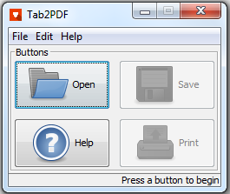

**1.1 – Menu Bar**

In the menu bar, there are two selections to choose from, including “File”, “Edit” and “Help”. Note that these drop menus will stay the same, regardless of whether the user is in the starting menu or the extended menu. Also note that the functions in the “Edit” drop menu will be disabled along with the “Save” and “Print” button, because they are to only be used in the extended menu. The functions will be discussed later in the manual.

When the “File” button is clicked, a drop menu will be accessed and include the following: three of the original four buttons, “Recent” which will allow the user to reopen a text file that was chosen before, and “Exit” which will close the application. Note that the application may also be closed using the “X” button on the top right. Also note that “Save” and “Print” will still be disabled if a text file hasn’t been opened and converted yet.

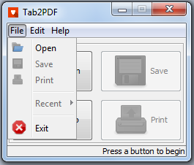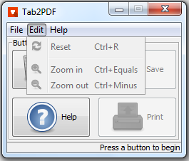

“Help” will drop a menu consisting of the same “Help” button of the four original buttons and an “About” button, opening a message dialog with a brief description of the application.

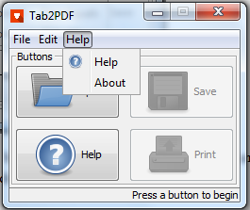

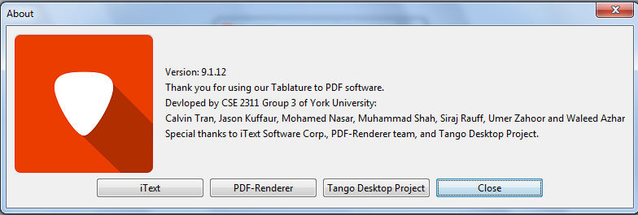

**1.2 – Opening the File**

Clicking the “Open” button will open up a file selector. At this point, the user will navigate and select the text file containing the tabs of their choice by either double clicking the file, or highlighting the file and clicking the “Open” button. When the text file is chosen, it will be converted and an extended menu will be viewed. At this point, the “Save” and “Print” buttons will be enabled.

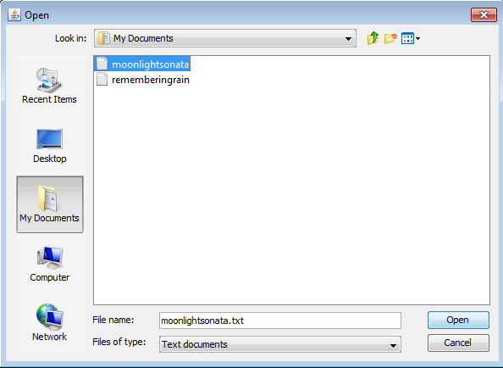

**2 – Extended Menu**

**2.0 – Overview**

When a text file is opened, an extension of the starting menu will appear. The new menu will show the original four buttons, all of which are enabled now, a preview of the newly converted pdf file and section for customization purposes. Note that the functions in the “Edit” drop bar will be enabled as well.

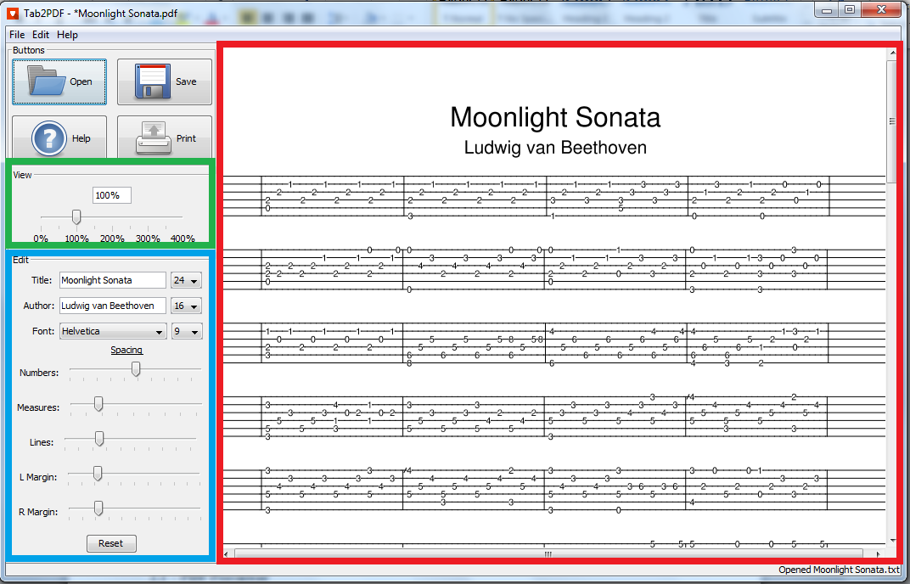

**2.1 – PDF Previewer**

A preview of the pdf file is shown for the user to confirm that the conversion of the given text file to the pdf file was a success, and that he/she is satisfied with the result (red box).

When the pdf is first created, a set of default spacing values, fonts and sizes are pre-set. If the user wants to further edit any features of the pdf file, they may go to the “Edit” section of the menu.

**2.2 – “View” Section**

If the user may want to further inspect the pdf file before print or saving it, the “View” section of the menu is available for use. This section allows the user to zoom in or out of the preview using either the slider, or the text field.

The text field will only allow integers (no decimals!) between the range of 1% and 400%. If the inputted range exceeds 400%, the application will set the zoom level to 400%. If the inputted range is below 1%, the application will reset the zoom level to 100%. If an invalid input is placed in the text field, the application will set the zoom level to the previous zoom level. Note that inputting the “%” is optional.

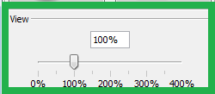

Note that in the “Edit” drop menu, there are two buttons: “Zoom in” and “Zoom out”. These buttons will make the preview zoom in and out by 25%. This function can also be achieved using the key combination “Ctrl” + “=” and “Ctrl” + “-“ respectively.

**2.3 – “Edit” Section**

The “Edit” section of the menu allows the user to edit the title and the author for the pdf file, as well as change the size for each individually, using the drop menu beside the text fields. There is a library of fonts available to change for the title, the author and the characters in the tab. To choose the font, there is a drop menu beside the label “Font”. Changing the size of the characters in the tab is also possible with the drop menu beside the “Font” drop menu.

There is a subsection of the “Edit” section. This subsection is called the “Spacing” section. This section contains a set of sliders, each controlling a certain spacing feature of the tab.

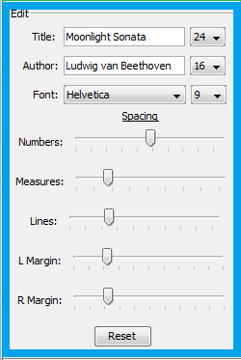

At the bottom of the “Edit” section, there is a reset button. This will reset all the features of the pdf file to the default set, as if the text file has just been converted. This can also be accessed in the “Edit” drop menu and by pressing the key combination “Ctrl” + “R”.

The application will automatically update any features done when the mouse lets go of the slider. When a text field is updated, the preview will be automatically updated after a certain period of time after the last key has been pressed and released. The user may also immediately update the preview by pressing the “Enter” key on the keyboard.

**3 – Save and Print**

**3.0 – Saving**

To save the pdf file, select the now enabled “Save” button. When selected, a file chooser will appear where the user may select what directory they would like to save in (blue box) and give the pdf file a name (red box). By default, the file name will be the same as the title of the tab. The user may change that if he/she may please.

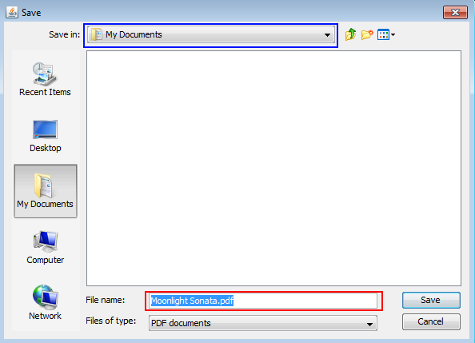

**3.1 – Printing**

To print the pdf file through the application, the user may click the “Print” button, which along with the “Save” button is now enabled. When selected, the application will open a print menu used by the system. The image below displays the print menu for Windows 7.

