IMAGE RECOGNITION WITH CLOUD COMPUTING

PHASE 3: DEVELOPMENT PART 1

From IBM Cloud, you need to access Watson and create a Visual Recognition service. From the created service, you have to acquire the API key for performing operations through the API.

You will also need an API key from the HERE Developer Portal (which we will use in the code). Simply sign up for your free account and generate API key on your account page.

For coding, your machine should have Python installed (I have Python 3.8).

In this part, you will learn to run image recognition code on your machine and extract the required result from the JSON response. (We will cover the location element in next blog post).

Lets get started then!

Creating Visual Recognition Service and Acquiring API key

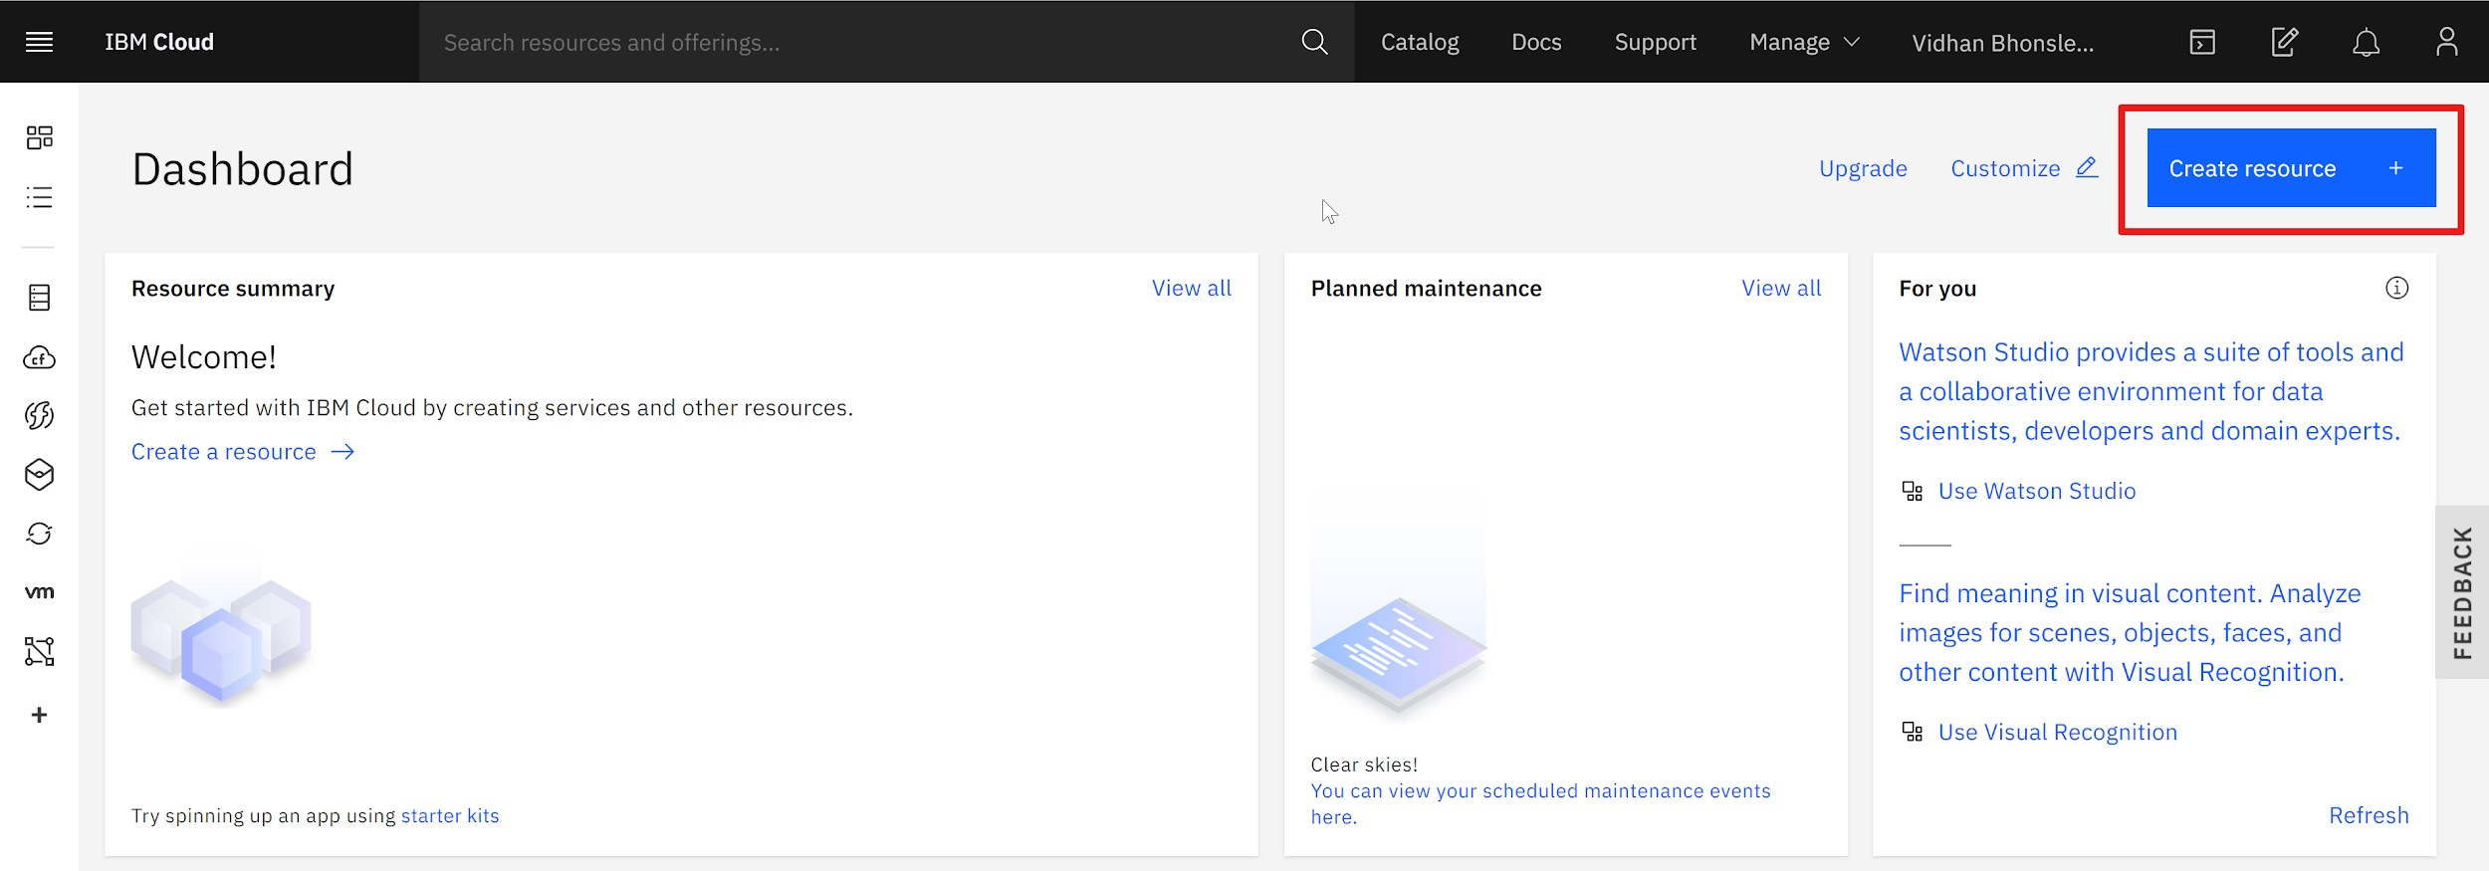After logging into your IBM Cloud account, you will be on the dashboard page. You need to create a service by clicking on 'Create resource' (as shown in the image below).

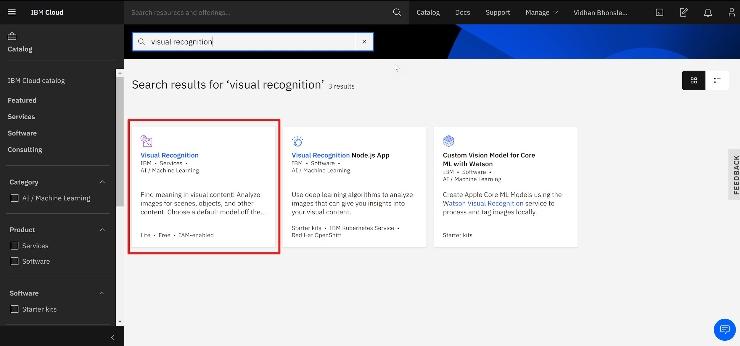This will take you to the IBM Product Catalog page. There, search for 'visual recognition' (as shown below) and select the first option.

The Visual Recognition service uses deep learning algorithms to analyze images for scenes, objects and other content. And it also has a set of built-in models for ease of use.

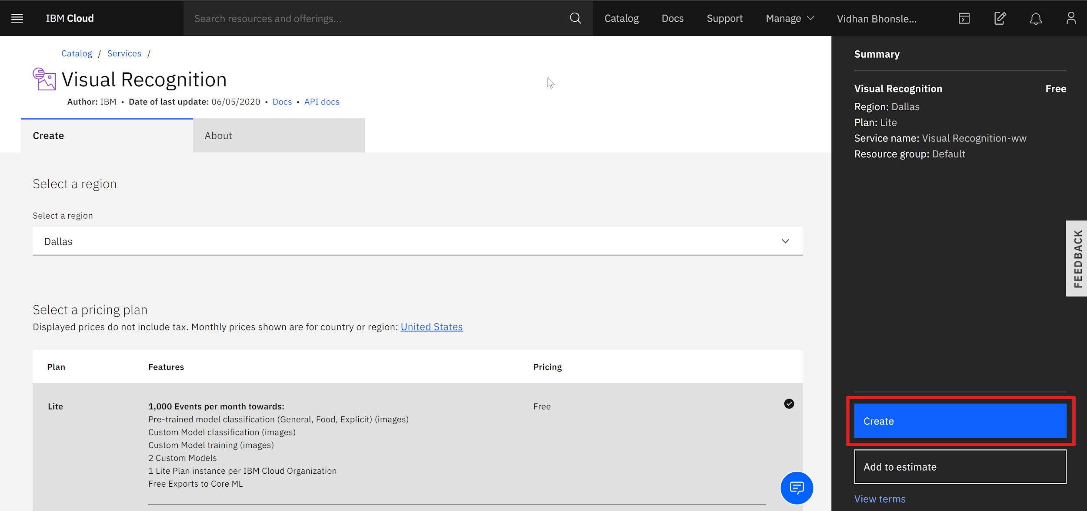You will reach a page where you have to select the region and configure resources. It can be edited as per your wish or can be left unaltered (see the below image). Then click on 'Create' to move to the next step.

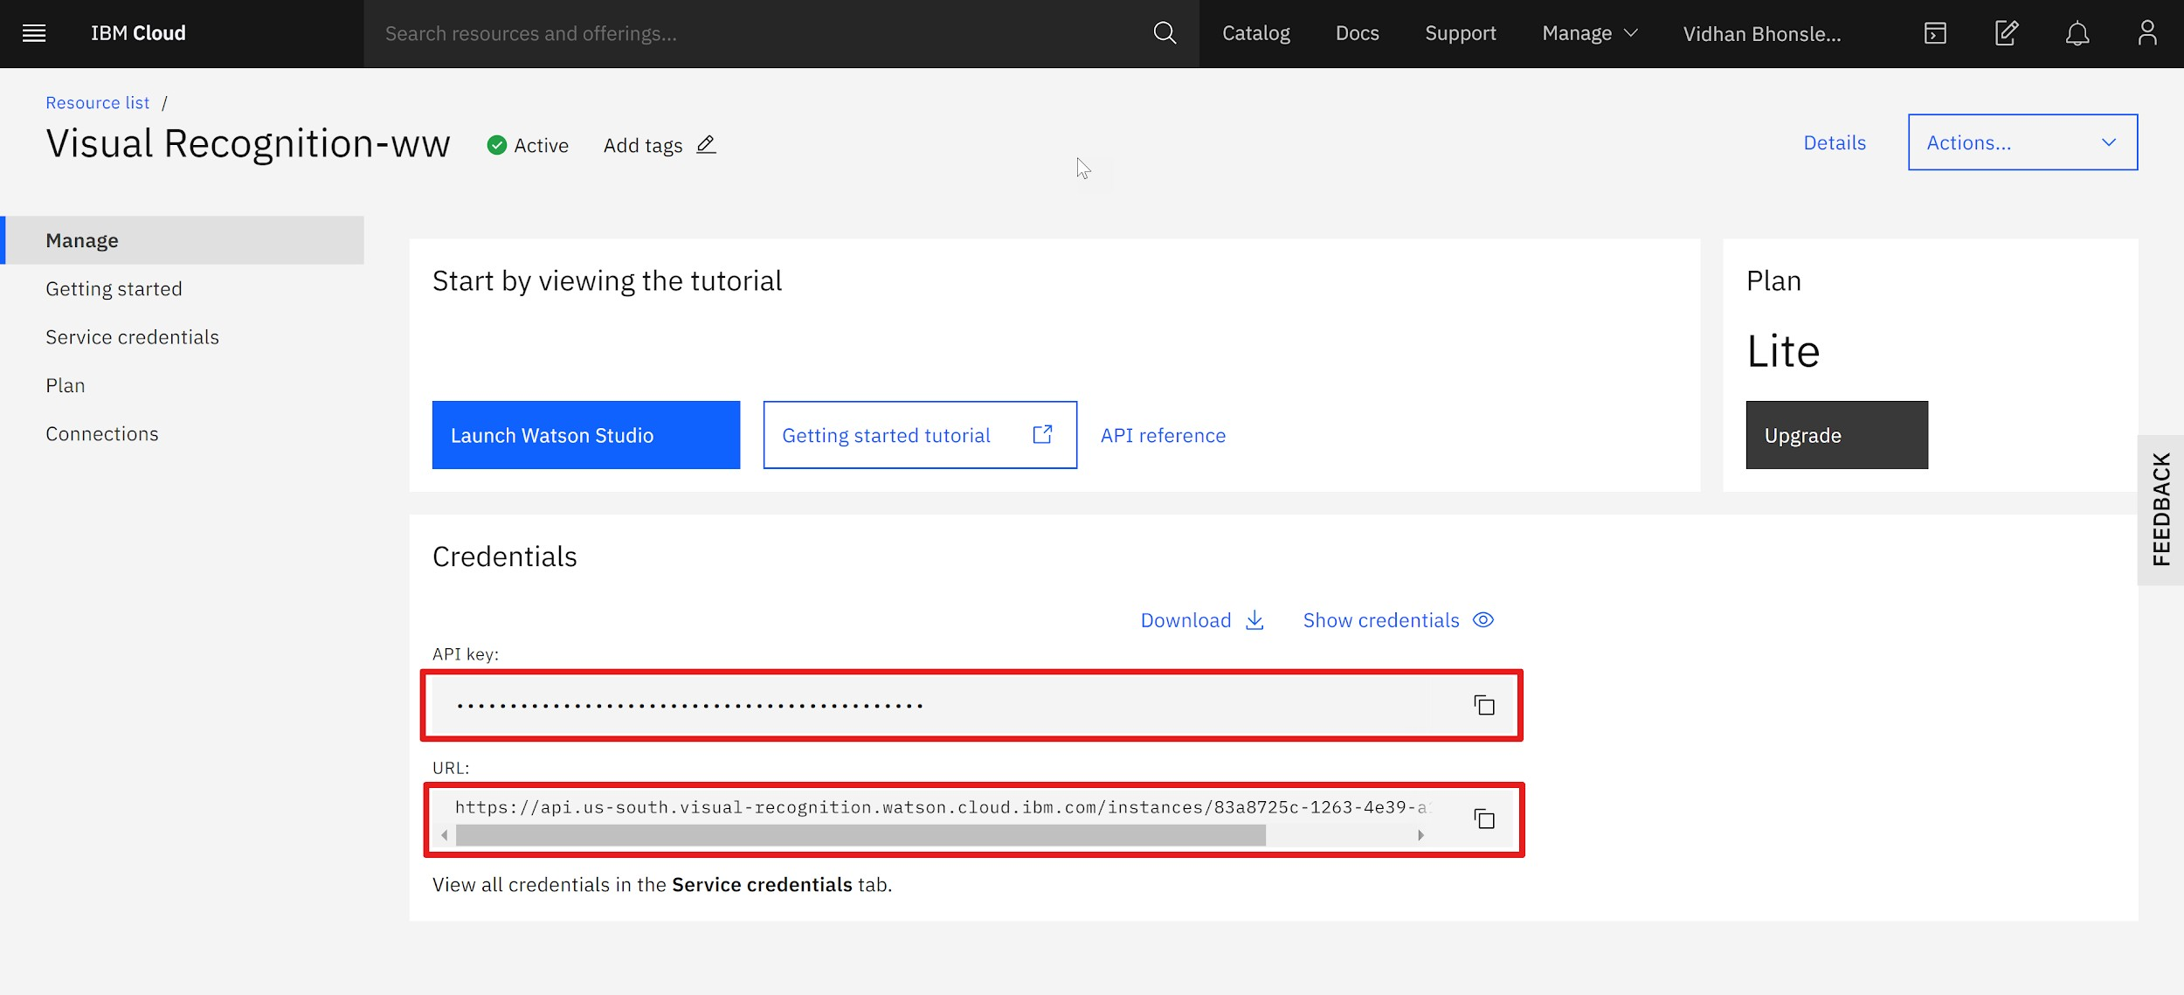Finally, you will be on the page from where you need to copy the API key and URL. Keep both the values for further coding (represented as IBM API KEY and IBM URL later in the code

Writing Python Code for Visual Recognition

Once you have acquired an API key associated with the Visual Recognition service, the next step is to install Watson Developer Cloud using pip:

pip install --upgrade "ibm-watson>=4.0.1"

The library can be installed using the command prompt, terminal or a Python IDE (PyCharm, Spyder, etc), depending on how you are working with Python.

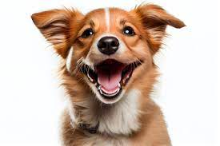

Conclusion:

The world is moving more and more toward automation and visual recognition is one of the best example of automation. The real question is how to use the output of Machine Learning and AI based model. Till then, happy learning!

Watson's Visual Recognition comes with a number of default classification models. We will use the animals for recognizing images animals.