FINDMYBUS: A REAL-TIME GPS-BASED SCHOOL BUS TRACKING AND NOTIFICATION SYSTEM
A Base Paper
Submitted in partial fulfilment of the requirements
for the award of the degree of
BACHELOR OF TECHNOLOGY
in
ARTIFICIAL INTELLIGENCE AND DATA SCIENCE
Submitted by
SIRANJEEVI
Department of Artificial Intelligence and Data Science
SHREENIVASA ENGINEERING COLLEGE
2026

TABLE OF CONTENTS
ABSTRACT 4
CHAPTER 1 — INTRODUCTION 5
1.1 Background 5
1.2 Motivation 5
1.3 Problem Statement 5
1.4 Objectives 6
1.5 Overall Application Flow 6
1.6 Scope of the Project 7
CHAPTER 2 — LITERATURE SURVEY 8
2.1 RFID and Barcode-Based Attendance Systems 8
2.2 GPS + GSM/SMS-Based Tracking Systems 8
2.3 App-Based / Smartphone-Centric Tracking Systems 8
2.4 Real-Time Communication Technologies 9
2.5 Cross-Platform Mobile Development 9
2.6 Summary of Literature Survey 9
CHAPTER 3 — SYSTEM ANALYSIS 10
3.1 Existing System 10
3.2 Proposed System 10
3.3 Advantages of the Proposed System 10
CHAPTER 4 — SYSTEM REQUIREMENTS 12
4.1 Hardware Requirements 12
4.2 Software Requirements 12
4.3 Functional Requirements 12
4.4 Non-Functional Requirements 13
CHAPTER 5 — SYSTEM DESIGN 14
5.1 System Architecture 14
5.2 Data Model / Entity Relationship Overview 15
5.3 Module Description 16
5.3.1 Admin Web Dashboard (find-my-bus) 16
5.3.2 Driver Mobile App (findmybus, driver role) 16
5.3.3 Parent Mobile App (findmybus, parent role) 16
5.3.4 Backend API & Real-Time Service (Server) 17
5.4 Use Case Overview 17
CHAPTER 6 — SYSTEM IMPLEMENTATION 18
6.1 Technology Stack Rationale 18
6.2 Authentication Flow 18
6.3 Trip Lifecycle and Location Streaming 18
6.4 Live Map Rendering on the Parent Side 21
6.5 Assignment Integrity 21
6.6 Sample Code Snippet 21
CHAPTER 7 — TESTING 22
7.1 Testing Approach 22
7.2 Representative Test Cases 22
CHAPTER 8 — RESULTS AND DISCUSSION 23
CHAPTER 9 — CONCLUSION AND FUTURE SCOPE 24
9.1 Conclusion 24
9.2 Future Scope 24
REFERENCES 25

ABSTRACT
School transportation is one of the most safety-critical yet least visible parts of a student's daily routine. Parents typically have no way of knowing where their child's bus is until it either arrives or fails to arrive, and school administrators manage buses, drivers, and student-to-route assignments largely through manual registers and phone calls. This lack of visibility causes parental anxiety, inefficient handling of delays, and difficulty in accounting for students during an active trip. FindMyBus is a full-stack, real-time school bus tracking platform designed to close this visibility gap. The system is composed of three integrated components: a web-based administrative dashboard for school staff to manage buses, drivers, students, and bus-driver assignments; a cross-platform mobile application (built with React Native and Expo) used by drivers to start and stop trips and stream their live location; and the same mobile application, presented in a parent-facing mode, that renders the assigned bus's live position on an interactive map for the duration of the trip. A Node.js/Express backend, backed by MongoDB and Socket.IO, exposes REST APIs for administrative operations and a WebSocket channel for low-latency location broadcast, with a One-Time-Password (OTP) based authentication flow securing driver and parent mobile access independent of the school's web credentials. This paper documents the motivation, related work, system architecture, data model, module-level design, and implementation of FindMyBus, and evaluates it against existing manual and semi-automated school transport tracking practices.
Keywords: School Bus Tracking, GPS, Real-Time Location, React Native, Node.js, Socket.IO, MongoDB, Parent Notification System, IoT-free Fleet Visibility.

CHAPTER 1

1. INTRODUCTION

1.1 Background
School buses form the backbone of daily commute for a large fraction of students, particularly in cities where independent commuting is impractical for younger children. Despite this dependency, the operational visibility around a school bus's location, timing, and status remains almost entirely offline in most schools: drivers are handed a printed route sheet, parents are informed of delays through phone calls or word of mouth, and school administrators reconcile which student rides which bus using spreadsheets or paper registers. As smartphone penetration and affordable GPS-enabled devices have become the norm, there is a clear opportunity to digitize this workflow end-to-end — from the school's back-office administration down to the parent's phone screen — without requiring any additional hardware to be fitted on the bus itself.

1.2 Motivation
The motivation for FindMyBus stems from three recurring pain points observed in typical school transport operations:
- Parental uncertainty — parents do not know when to send their child to the bus stop, or how far away the bus is on the return trip, leading to either children waiting unsupervised for long periods or being late.
- Administrative overhead — school transport coordinators maintain bus, driver, and student-route data manually, making it error-prone to answer simple questions such as "which bus is student X on" or "which driver is currently assigned to bus Y".
- Lack of accountability during transit — once a bus leaves the school premises, there is no record of its route, timing, or the fact that a trip was even undertaken, which becomes a problem in the event of a complaint or an incident.

1.3 Problem Statement
To design and implement a real-time, low-cost school bus tracking system that (a) allows school administrators to digitally manage buses, drivers, students, and their assignments; (b) allows a driver to mark the start and end of a trip from a mobile phone, during which the phone's own GPS is streamed to the backend; and (c) allows the parent of an assigned student to view the live location of the bus on a map for the duration of that trip, using only a smartphone on each side and no dedicated on-board hardware.

1.4 Objectives
- Design a normalised, multi-tenant data model (School → Bus / Driver / Student → Assignment → Trip → Trip Location) capable of supporting many schools on one deployment.
- Build a secure, role-aware authentication system: password-based login for school administrators on the web, and OTP-based mobile login for drivers and parents.
- Implement a driver-facing trip lifecycle (start trip → stream location → stop trip) using the device's foreground and background GPS with battery-aware update intervals.
- Implement a parent-facing live map view that consumes a WebSocket stream and renders smooth, interpolated bus movement rather than jumpy raw GPS points.
- Provide a web administrative console for CRUD (create, read, update, delete) management of buses, drivers, students and bus-driver assignments, plus a summary dashboard.
- Evaluate the system's architecture for scalability, security and real-world deployability.

1.5 Overall Application Flow
Figure 1.1 summarises how the three FindMyBus clients — the school admin web dashboard, the driver mobile app, and the parent mobile app — connect to the same shared backend, and the high-level sequence of screens/actions each role moves through.
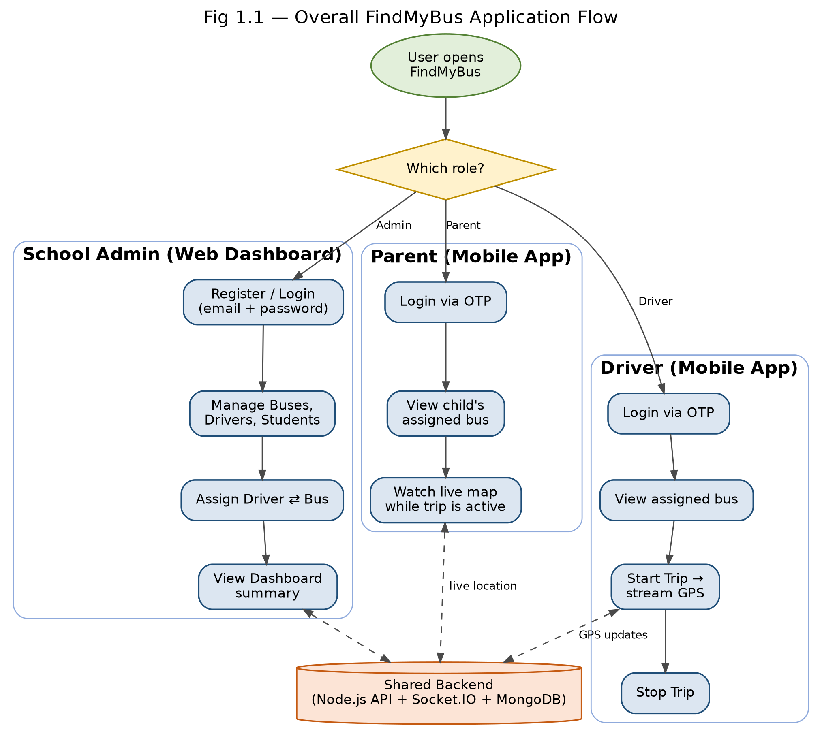
Figure 1.1 — Overall FindMyBus application flow across the three clients

1.6 Scope of the Project
The scope of the current implementation covers a single-school-tenant data model that is extensible to multiple schools (each row of every collection is scoped by schoolId), student-to-bus assignment (rather than fine-grained per-stop routing), one active trip per bus/driver at a time, and live-only tracking (historical playback of past trips is captured in the data model via the TripLocation collection but is not yet exposed as a feature in the current UI). Push notifications, geofencing-based automatic alerts (e.g., "bus is 500 m from your stop"), and multi-school billing/subscription management are identified as extensions and are discussed in the Future Scope (Chapter 9).

CHAPTER 2

2. LITERATURE SURVEY
School and public transport tracking has been an active area of applied research and commercial product development for over a decade, and the approaches broadly fall into three generations, summarised below. Note: the specific paper titles, authors and years in this section are placeholders — the author (Siranjeevi) should replace them with citations gathered from Google Scholar / IEEE Xplore / college library resources during the literature survey phase of the project, since this document was prepared without live internet/database access.

2.1 RFID and Barcode-Based Attendance Systems
An early generation of school transport systems used RFID (Radio-Frequency Identification) cards issued to students, tapped against a reader mounted at the bus door. These systems answer "did the student board/alight the bus" reliably, but provide no information about the bus's position between stops, and require dedicated hardware (readers, cards, and often a local processing unit) to be fitted on every bus, which raises upfront and maintenance cost.

2.2 GPS + GSM/SMS-Based Tracking Systems
A second generation of systems pairs a dedicated GPS module with a GSM modem mounted on the bus, periodically transmitting coordinates via SMS or a cellular data link to a central server, which parents can query through an SMS keyword or a basic web page. These systems decouple tracking from student identity (they track the vehicle, not the student), and were a significant improvement in vehicle-level visibility, but again require dedicated on-board hardware, a SIM card and airtime plan per vehicle, and typically offer only periodic (non-real-time) position updates because of GSM/SMS latency and cost.

2.3 App-Based / Smartphone-Centric Tracking Systems
The most recent generation — and the one FindMyBus belongs to — eliminates dedicated on-board hardware entirely by treating the driver's own smartphone as the GPS sensor. The driver runs a mobile application that reads the phone's GPS while a trip is active and streams it to a backend, which in turn pushes it to subscribed parent clients over a persistent connection (WebSocket) rather than polling. This class of system is attractive because it has near-zero incremental hardware cost per bus, supports genuinely real-time (sub-5-second) location updates, and can be extended purely in software (e.g., adding geofencing or ETA prediction) without touching the vehicle.

2.4 Real-Time Communication Technologies
The real-time delivery layer in modern tracking systems is generally implemented using either long-polling, Server-Sent Events, or full-duplex WebSockets. Socket.IO, used in FindMyBus, is a widely adopted library that provides a WebSocket connection with automatic fallback and reconnection handling, and is well suited to a many-parents-subscribe-to-one-bus broadcast pattern via its "room" abstraction, where all parents of students on a given bus join a room keyed by the bus ID or trip ID and receive location events pushed by the driver's session.

2.5 Cross-Platform Mobile Development
Native development (separate Android/Kotlin and iOS/Swift codebases) doubles engineering effort for functionally identical driver and parent apps. Cross-platform frameworks — React Native (used in FindMyBus via the Expo toolchain), Flutter, and others — allow a single TypeScript/JavaScript codebase to ship to both platforms (and, in the case of Expo, to the web as well), which is well suited to a project of this scope and team size.

2.6 Summary of Literature Survey
Approach | Position Update | On-Bus Hardware | Relative Cost | Real-Time?
RFID / Barcode attendance | None (boarding event only) | RFID reader + cards | Medium | No
GPS + GSM/SMS tracker | Periodic (30s–5min) | Dedicated GPS/GSM unit | High (hardware + SIM) | Near real-time
App-based (FindMyBus) | Continuous while trip active | None (driver's own phone) | Low (software only) | Yes
Table 2.1 — Comparison of school transport tracking approaches

CHAPTER 3

3. SYSTEM ANALYSIS

3.1 Existing System
In most schools today, bus operations are managed through a combination of a manual/spreadsheet-based register for student-to-bus mapping, verbal or phone-based communication between drivers, the transport coordinator, and parents, and — at best — a third-party GPS tracker fitted to the bus whose data is visible only to the transport vendor, not integrated with the school's own student records. This results in the following limitations:
- No single system of record connecting a student, their guardian's contact details, and the bus/driver currently assigned to them.
- Parents have no self-service way to check the bus's live location; they must call the school or driver directly.
- Reassigning a bus or driver (e.g., due to a breakdown or driver leave) is a manual, undocumented process with no audit trail.
- No digital record of whether a trip actually took place, when it started/ended, or the route taken.

3.2 Proposed System
FindMyBus proposes a unified, three-part digital system: a School Admin Web Dashboard as the single system of record for school-side master data (buses, drivers, students, assignments); a Driver Mobile App that turns every driver's phone into the location source for the currently active trip, with an explicit start/stop trip lifecycle so tracking is only active (and battery/data is only consumed) while a trip is genuinely in progress; and a Parent Mobile App (a role-based view of the same application) that shows the live position of the child's assigned bus on a map only while a trip is active, with a smoothing algorithm so the marker moves fluidly rather than jumping between raw GPS fixes.

3.3 Advantages of the Proposed System
- Zero additional on-bus hardware — every device required (driver phone, parent phone, admin's browser) already exists.
- Real-time updates via WebSockets rather than SMS or periodic polling.
- Role-based OTP authentication decouples driver/parent mobile access from the school's administrative password, improving security posture (no shared or reused admin credentials on the shop floor).
- A normalised multi-tenant data model (every record is scoped to a schoolId) means the same backend deployment can, in principle, serve many schools.
- A full audit trail of trips (Trip collection) and GPS breadcrumbs (TripLocation collection) is captured for every trip, enabling future historical playback and reporting.

CHAPTER 4

4. SYSTEM REQUIREMENTS

4.1 Hardware Requirements
Component | Minimum Requirement
Development Machine | 8 GB RAM, Intel i5 / Apple Silicon or equivalent, 20 GB free disk
Driver's Device | Android 8+ or iOS 14+ smartphone with GPS and mobile data
Parent's Device | Android 8+ or iOS 14+ smartphone (or any modern web browser)
Server (Production) | Cloud VM / container — 1 vCPU, 1–2 GB RAM minimum (scales with concurrent trips)
Table 4.1 — Hardware requirements

4.2 Software Requirements
Layer | Technology Used
Backend Runtime | Node.js with Express.js 5
Database | MongoDB (via Mongoose ODM)
Real-Time Communication | Socket.IO 4
Authentication | JSON Web Tokens (jsonwebtoken), bcryptjs for password hashing, OTP-based mobile login
Admin Web Frontend | React 19, TypeScript, Vite, Material UI (MUI), TanStack React Query, React Router
Mobile App | React Native 0.86 with Expo SDK 57, Expo Router, NativeWind (Tailwind for RN), Zustand
Maps | MapLibre GL (via @maplibre/maplibre-react-native)
Validation | Zod schema validation on both API and client
Version Control | Git
Table 4.2 — Software requirements

4.3 Functional Requirements
- The system shall allow a school to register and log in to a web-based administrative account.
- The system shall allow an admin to create, update, and soft-delete Bus, Driver, and Student records.
- The system shall allow an admin to assign a driver to a bus, with the constraint that a driver and a bus may each have only one active assignment at a time.
- The system shall allow a driver to log in via OTP sent to their registered email/phone.
- The system shall allow a driver with an active bus assignment to start a trip, which begins continuous GPS streaming, and stop a trip, which ends streaming.
- The system shall allow a parent to log in via OTP and view their child's currently assigned bus.
- The system shall push the bus's live coordinates to all connected parents of students on that bus in near real time while a trip is active.
- The system shall persist a breadcrumb trail of GPS points for every trip for later analysis.

4.4 Non-Functional Requirements
- Performance: location updates should be reflected on the parent's map within a few seconds of the driver's device reporting them.
- Security: passwords are hashed (bcrypt) and never stored or transmitted in plain text; API endpoints are protected by JWT-based middleware; OTPs expire after a short, configurable window.
- Scalability: the schoolId-scoped schema and Socket.IO room-based broadcast are designed so that adding schools/buses does not require redesigning the data model.
- Usability: the driver app exposes a minimal one-button (start/stop trip) interface to reduce distraction while operating a vehicle.
- Portability: the mobile app is built once with React Native/Expo and targets Android, iOS and web from a single codebase.

CHAPTER 5

5. SYSTEM DESIGN

5.1 System Architecture
FindMyBus follows a three-tier client/server architecture. The client tier consists of the React (Vite) admin web application and the React Native (Expo) mobile application, the latter serving both the driver and parent roles from one codebase via role-based routing. The application/service tier is a single Node.js/Express server exposing two categories of REST routes (web-admin routes protected by a School-scoped JWT, and mobile routes protected by a separate driver/parent-scoped JWT) plus a Socket.IO server for real-time location broadcast. The data tier is a MongoDB instance holding all persistent collections. The overall data/control flow for a trip is: Driver app calls Start Trip → server creates a Trip document and driver's socket joins a trip/bus room → driver app streams GPS coordinates over the socket connection (and/or REST fallback) → server updates the Trip document's current* fields, appends a TripLocation breadcrumb, and re-broadcasts the coordinate to the room → Parent app, subscribed to that room, receives the update and re-renders the map marker with smoothing → Driver calls Stop Trip → server marks the Trip completed and the room stops receiving updates.
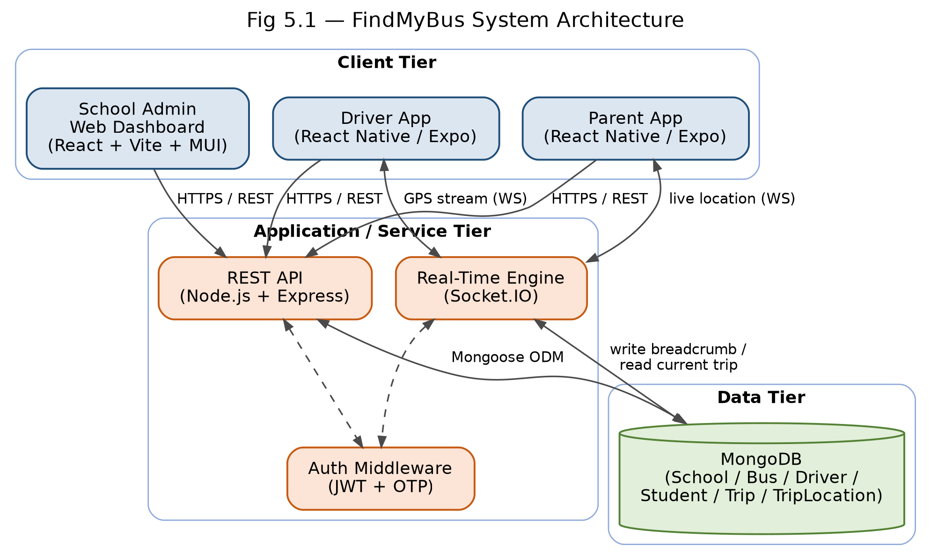
Figure 5.1 — FindMyBus three-tier system architecture

5.2 Data Model / Entity Relationship Overview
The MongoDB schema is centred on the School as the tenant boundary, with every other collection carrying a schoolId reference for isolation:
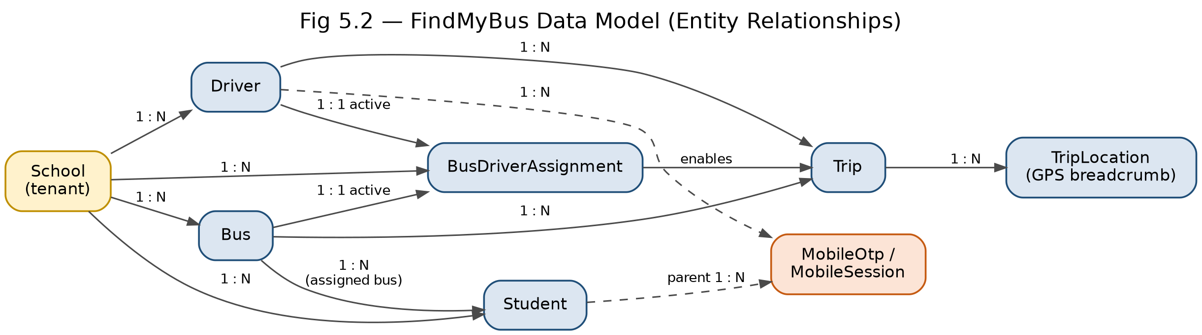
Figure 5.2 — FindMyBus data model / entity relationships
Collection | Purpose | Key Fields
School | Tenant / admin account | name, email, passwordHash, emailVerified, status
Bus | A vehicle in the fleet | schoolId, busNumber, registrationNumber, busType, capacity, status
Driver | A bus driver | schoolId, firstName, lastName, phoneNumber, email, licenseNumber, licenseExpiryDate, emergencyContact, status
Student | A student rider | schoolId, studentName, studentId, grade, section, parentName, parentEmail, parentPhone, busId, status
BusDriverAssignment | Links one driver to one bus | schoolId, busId, driverId, assignedAt, unassignedAt, status (one active per bus/driver, enforced by partial unique index)
Trip | One driving session | schoolId, busId, driverId, status (active/completed/cancelled), startedAt, endedAt, current latitude/longitude/speed/heading
TripLocation | GPS breadcrumb for a trip | tripId, latitude, longitude, accuracy, speed, heading, timestamp
MobileOtp / MobileSession | OTP login + refresh-token session for driver/parent apps | identifier, otpHash/expiry, userId, role, refreshToken
Table 5.1 — Core data model
Two data-integrity constraints are enforced at the database level via partial unique indexes: a driver may hold only one active BusDriverAssignment at a time, and a bus may likewise be actively assigned to only one driver at a time — preventing double-booking without requiring extra application-level locking.

5.3 Module Description

5.3.1 Admin Web Dashboard (find-my-bus)
- Auth Module — school registration, login, and OTP email verification (Login.tsx, Register.tsx, VerifyOtp.tsx, AuthContext.tsx).
- Dashboard Module — summary statistics (active buses, drivers, students, ongoing trips).
- Bus Management — list/create/edit/deactivate buses (BusesPage.tsx, busApi.ts).
- Driver Management — list/create/edit/deactivate drivers, including license and emergency-contact details (DriversPage.tsx, driverApi.ts).
- Student Management — register students and link each to a parent's contact details and a bus (StudentsPage.tsx, studentApi.ts).
- Assignment Management — assign/unassign a driver to a bus (AssignmentsPage.tsx, assignmentApi.ts).

5.3.2 Driver Mobile App (findmybus, driver role)
- Driver Auth — OTP login and session persistence (useSendOtp, useVerifyOtp, authStore).
- Assignment & Profile View — shows the driver's currently assigned bus (useDriverAssignment, useDriverProfile).
- Trip Lifecycle — Start Trip / Stop Trip actions (useStartTrip, useStopTrip, useCurrentTrip) with elapsed-time display.
- Location Tracking Service — requests foreground and background location permission, samples GPS at an interval, and pushes coordinates to the server, queuing points locally if connectivity drops (useLocationTracking, locationService.ts, locationQueue.ts).

5.3.3 Parent Mobile App (findmybus, parent role)
- Parent Auth — OTP login keyed to the parent's registered email/phone (useSendOtp, useVerifyOtp).
- Student/Bus Lookup — resolves the parent's child and assigned bus (useParentProfile, useStudentBus).
- Live Map View — MapLibre-based map centred on and following the bus's live position (ParentDashboard, useLiveBusLocation).
- Location Smoothing — interpolates between successive raw GPS fixes so the marker animates fluidly instead of jumping (useSmoothLocation).
- Connection Status — indicates whether the app currently has a live socket connection to the tracking channel (tripStore.isConnectedToSocket).

5.3.4 Backend API & Real-Time Service (Server)
- Auth Services — authService.js (school), mobileAuthService.js (driver/parent OTP + JWT + refresh tokens).
- Domain Services — busService, driverService, studentService, assignmentService, dashboardService, tripService, parentService — one service per domain entity, called from thin controllers.
- Socket Manager — socketManager.js manages room membership (per bus/trip) and broadcasts incoming driver location events to subscribed parent sockets.
- Middleware — auth.js / mobileAuth.js (JWT verification), validate.js (Zod-based request validation), errorHandler.js (centralised error responses).

5.4 Use Case Overview
Actor | Primary Use Cases
School Admin | Register/Login, Manage Buses, Manage Drivers, Manage Students, Manage Assignments, View Dashboard
Driver | Login via OTP, View Assignment, Start Trip, Stream Location, Stop Trip
Parent | Login via OTP, View Assigned Bus, View Live Location on Map
Table 5.2 — Actors and use cases

CHAPTER 6

6. SYSTEM IMPLEMENTATION

6.1 Technology Stack Rationale
Node.js with Express was chosen for the backend for its non-blocking I/O model, which suits an application dominated by many short-lived concurrent connections (frequent location pushes from multiple active trips) rather than heavy CPU-bound work. MongoDB was chosen over a relational database because the domain entities (buses, drivers, students, trips) are naturally document-shaped and the schoolId-scoped, mostly-independent collections do not require complex multi-table joins; Mongoose provides schema validation and indexing (including the partial unique indexes used for assignment integrity) on top of MongoDB's flexibility. Socket.IO was chosen over a hand-rolled WebSocket server because it provides automatic reconnection, transport fallback, and a room abstraction that maps directly onto the "broadcast this bus's location to all its parents" requirement. React Native with Expo was chosen for the mobile app so that one TypeScript codebase serves Android, iOS, and web, and so that native modules for GPS (expo-location, expo-task-manager for background tracking) and secure storage (expo-secure-store) are available without ejecting to native project files.

6.2 Authentication Flow
The system implements two independent authentication flows sharing the same underlying JWT approach. School (web) authentication uses email/password: the password is hashed with bcryptjs at registration and compared on login, and a JWT is issued for subsequent requests (jwt.js, authService.js, auth.js middleware). Driver/parent (mobile) authentication is OTP-based and password-free: a one-time code is generated and (in production) emailed to the registered address via emailService.js, stored (hashed, time-limited) in the MobileOtp collection, and verified against the user's submission; on success, a MobileSession record is created holding an access token and a refresh token (mobileJwt.js, mobileAuthService.js, mobileAuth.js middleware), allowing the mobile app to silently refresh its session without asking the driver or parent to log in again on every launch.

6.3 Trip Lifecycle and Location Streaming
When a driver taps Start Trip, the client first calls ensurePermissions() to request foreground and, critically, background location permission — background permission is required because parents need to keep seeing the bus even while the driver's phone screen is off or another app is in the foreground. On confirmation, the client calls the start-trip API, which creates a Trip document with status 'active' and the driver's phone begins sampling GPS at a fixed interval through locationService.ts. Each sample is sent to the server, which (a) updates the Trip document's current latitude/longitude/speed/heading/accuracy fields for fast "where is the bus right now" reads, (b) inserts a TripLocation breadcrumb document for historical trail data, and (c) emits the coordinate over Socket.IO to the room associated with that bus/trip, which every connected parent client for that bus has joined. If the device temporarily loses connectivity, locationQueue.ts buffers unsent points locally and flushes them once the connection is restored, so brief network gaps do not silently lose breadcrumb data. Tapping Stop Trip marks the Trip 'completed', sets endedAt, and stops the sampling loop.
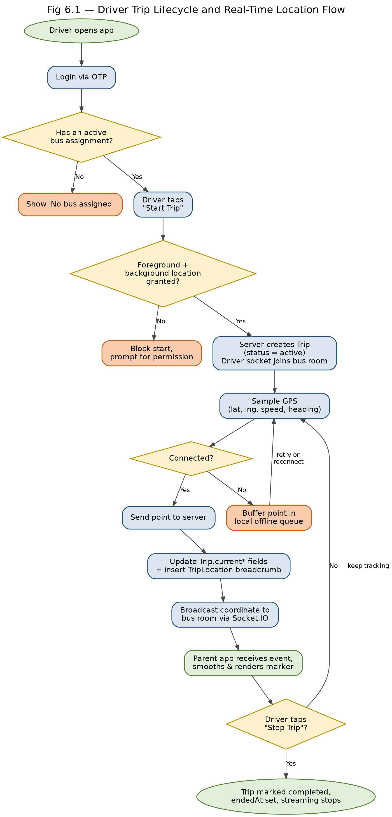
Figure 6.1 — Driver trip lifecycle and real-time location flow

6.4 Live Map Rendering on the Parent Side
The parent app resolves the student's assigned bus (useParentProfile, useStudentBus), then subscribes to that bus's live-location channel (useLiveBusLocation), storing incoming coordinates in a Zustand store (tripStore.ts) along with a connectivity flag. Raw GPS fixes arrive at discrete intervals and, if rendered directly, would cause the map marker to visibly jump; useSmoothLocation therefore interpolates the marker's position between the previous and newest fix over a short animation window, giving the appearance of continuous motion. The map itself is rendered with MapLibre GL (an open-source, vendor-neutral mapping library), with the camera set to fly to and follow the bus's interpolated position.

6.5 Assignment Integrity
Because a single driver cannot physically operate two buses at once (nor should one bus be double-assigned), the BusDriverAssignment schema enforces, at the database level, a partial unique index on {schoolId, driverId} and {schoolId, busId} scoped to status: 'active'. This guarantees correctness even under concurrent admin requests, without relying solely on application-level checks.

6.6 Sample Code Snippet — Assignment Uniqueness (Server/src/models/BusDriverAssignment.js)
busDriverAssignmentSchema.index(
{ schoolId: 1, driverId: 1 },
{ unique: true, partialFilterExpression: { status: 'active' } }
);

CHAPTER 7

7. TESTING
The system was validated through manual functional testing of each module rather than an automated test suite, given the project's academic scope. The following test approach and representative cases are documented for reference.

7.1 Testing Approach
- Unit-level validation of request payloads via Zod schemas on the server (validators/*.js) rejects malformed input before it reaches business logic.
- Manual functional testing of each admin CRUD flow (create/edit/deactivate bus, driver, student, assignment) against expected database state.
- Manual end-to-end testing of the trip lifecycle using two physical/emulated devices — one running the driver role and one the parent role — confirming that a location sent by the driver device is reflected on the parent's map within a few seconds.
- Boundary testing of the assignment-uniqueness constraint by attempting to assign an already-assigned driver/bus and confirming the API returns a conflict error rather than creating a duplicate active assignment.

7.2 Representative Test Cases
Test Case | Steps | Expected Result
Duplicate active assignment | Assign Driver A to Bus 1, then attempt to assign Driver A to Bus 2 while still active on Bus 1 | Second assignment is rejected with a conflict error
Trip start without assignment | Driver with no active bus assignment attempts to start a trip | Start Trip is blocked with an explanatory error
Location update propagation | Driver starts a trip and moves; parent app is open on the assigned bus | Parent's map marker updates within a few seconds of each server-side location event
OTP expiry | Parent requests OTP, waits beyond the expiry window, then submits it | Verification is rejected as expired; a new OTP must be requested
Trip stop clears live view | Driver stops an active trip | Parent app shows the bus as not currently active / no live location
Table 7.1 — Representative test cases

CHAPTER 8

8. RESULTS AND DISCUSSION
The implemented system successfully demonstrates the end-to-end flow described in the objectives: a school administrator can, from the web dashboard, register a bus, register a driver, register a student linked to a parent's contact details, and assign the driver to the bus; the driver can log in on the mobile app via OTP, see that assignment, and start a trip, after which their live GPS position streams to the backend; and the parent, logged in on the same mobile app under the parent role, sees their child's bus appear on a live, smoothly animated map for the duration of the trip, with the view reverting to a "no active trip" state once the driver stops the trip.
Architecturally, the schoolId-scoped, multi-tenant data model behaved as intended, supporting isolated test data for multiple schools without cross-contamination. The partial-unique-index approach to assignment integrity avoided the need for explicit application-level locks, and the Socket.IO room-based broadcast pattern kept the real-time layer simple: a client subscribes to a room named after the bus/trip and receives only events relevant to it, rather than every location event system-wide. The OTP-based mobile authentication, decoupled from the school's administrative password, means that a compromised driver or parent device does not expose the school's admin account, and vice versa.
The principal observed limitation is that continuous foreground/background GPS sampling is inherently battery-intensive on the driver's device over a long route, which is mitigated but not eliminated by sampling-interval tuning and the offline location queue. A second limitation is that the current UI does not yet expose the historical TripLocation breadcrumb trail that the data model already captures — this is deferred to Future Scope. Overall, the results support the central hypothesis of the project: a purely software, smartphone-only architecture can deliver real-time school bus visibility at a fraction of the cost and deployment complexity of dedicated on-board GPS/GSM hardware.

CHAPTER 9

9. CONCLUSION AND FUTURE SCOPE

9.1 Conclusion
FindMyBus demonstrates that a real-time, multi-tenant school bus tracking system can be built entirely on commodity smartphones and modern web technologies, without any dedicated on-board tracking hardware. By combining a role-based OTP mobile authentication scheme, a schoolId-scoped MongoDB data model with database-enforced assignment integrity, and a Socket.IO room-based real-time broadcast layer, the system delivers the three core outcomes school transport stakeholders need: administrators get a single system of record for buses, drivers, students and assignments; drivers get a minimal, low-distraction trip start/stop control; and parents get genuine real-time visibility of their child's bus, replacing phone calls and guesswork with a live map.

9.2 Future Scope
- Geofencing-based push notifications — automatically alert a parent when the bus is within a configurable distance of their stop, rather than requiring them to keep the map open.
- Historical trip playback — surface the already-captured TripLocation breadcrumb trail as a route-replay view for administrators, useful for incident review and route optimisation.
- Route and stop modelling — extend beyond bus-level assignment to per-stop scheduling with estimated time of arrival (ETA) per stop, using historical speed data.
- Multi-school SaaS rollout — since the data model is already schoolId-scoped, the next step is a self-service school onboarding flow and usage-based billing to operate the platform as a service for multiple institutions.
- Offline-first driver app hardening — extend the existing location queue into a fuller offline-first sync layer so trips can start/continue seamlessly through longer connectivity gaps (tunnels, rural stretches).
- Attendance integration — optionally combine the app-based tracking with a lightweight boarding confirmation (e.g., driver taps present/absent per student, or a low-cost BLE/RFID tap) to also answer "did the student board", not just "where is the bus".
- Automated testing — introduce an automated unit/integration test suite (e.g., Jest for the API, Detox or Maestro for the mobile app) to complement the manual testing carried out during this project.

REFERENCES
The following references cover the primary technologies, standards and platforms used to build FindMyBus. As noted in Chapter 2, this document was prepared without live access to academic search databases; Siranjeevi should add 3–5 peer-reviewed papers on GPS/IoT-based school bus or public-transport tracking systems from IEEE Xplore, Google Scholar, or the college library to strengthen the Literature Survey (Chapter 2) before final submission.
- Node.js Foundation, "Node.js Documentation," https://nodejs.org/en/docs/
- Express.js, "Express — Node.js web application framework," https://expressjs.com/
- MongoDB, Inc., "MongoDB Manual," https://www.mongodb.com/docs/manual/
- Mongoose, "Mongoose ODM v9 Documentation," https://mongoosejs.com/docs/
- Socket.IO, "Socket.IO Documentation," https://socket.io/docs/
- Meta Platforms, Inc., "React — A JavaScript library for building user interfaces," https://react.dev/
- Expo, "Expo Documentation (SDK 57)," https://docs.expo.dev/versions/v57.0.0/
- React Native, "React Native Documentation," https://reactnative.dev/docs/getting-started
- MapLibre, "MapLibre GL Native / React Native," https://maplibre.org/
- Material UI, "MUI Documentation," https://mui.com/material-ui/
- TanStack, "TanStack Query Documentation," https://tanstack.com/query/latest
- Auth0 / jwt.io, "Introduction to JSON Web Tokens," https://jwt.io/introduction
- Zod, "Zod: TypeScript-first schema validation," https://zod.dev/
- National Marine Electronics Association, "NMEA 0183 Standard for GPS data interchange" (general reference for GPS positioning data fields such as latitude, longitude, speed and heading used in the Trip and TripLocation models).

