This Postman collection demonstrates CRUD operations using the Swagger Petstore API. Each request contains valid parameters, headers, and example responses.
GET (Find pet by status)
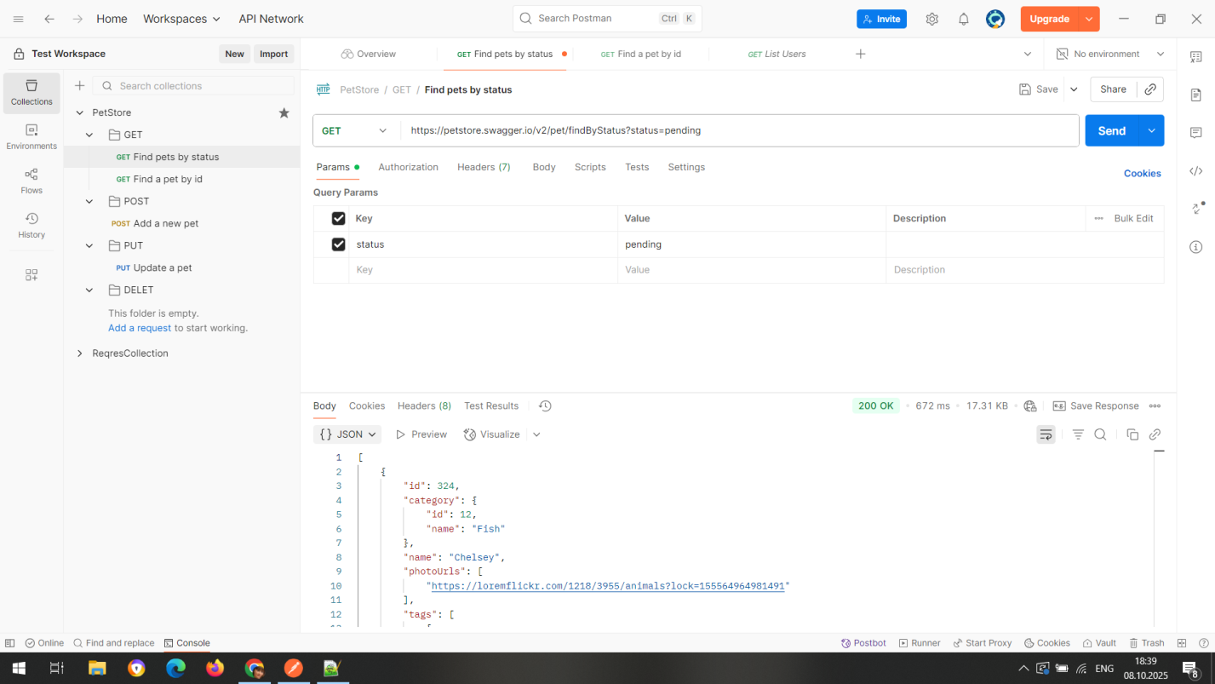
POST (Add a new pet)
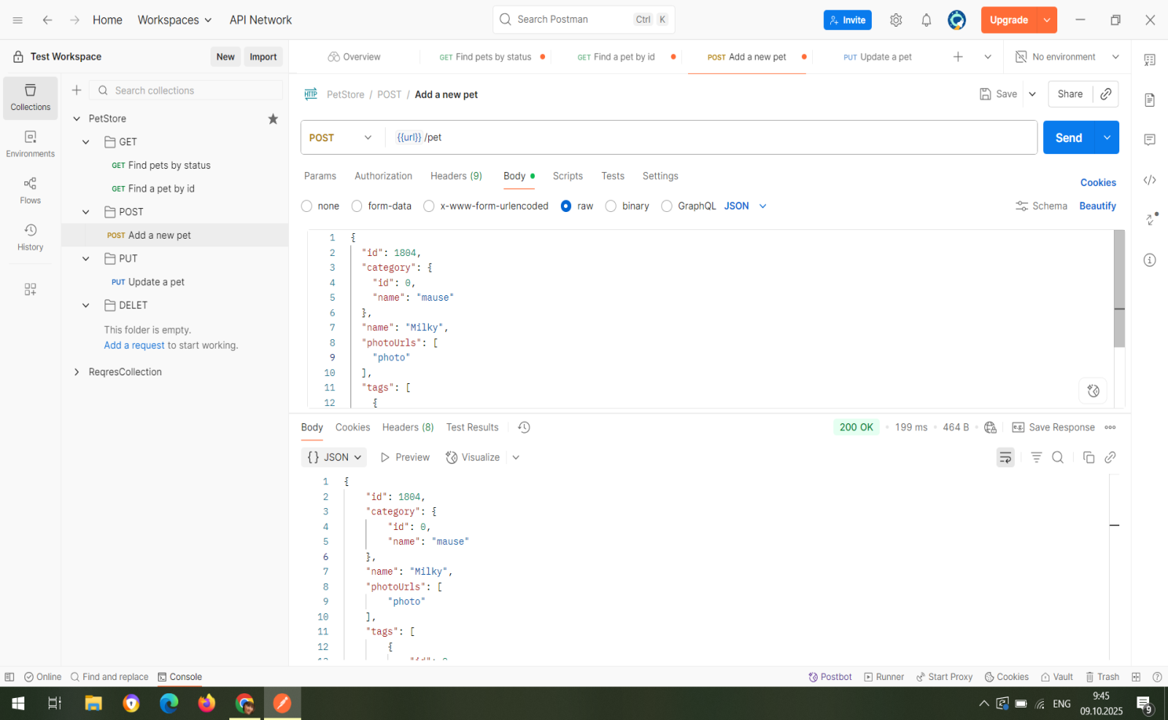

PUT (Update a pet)
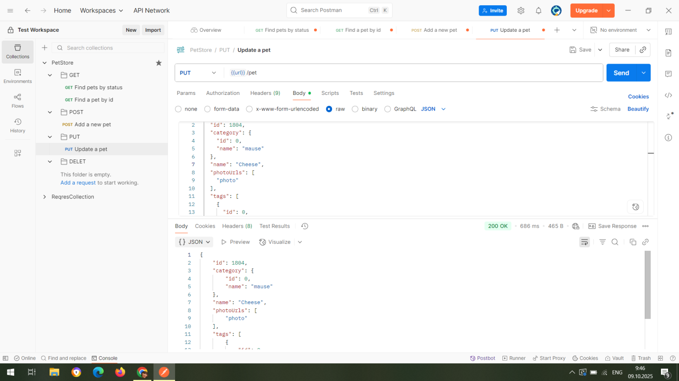

DELETE (Delete pet)
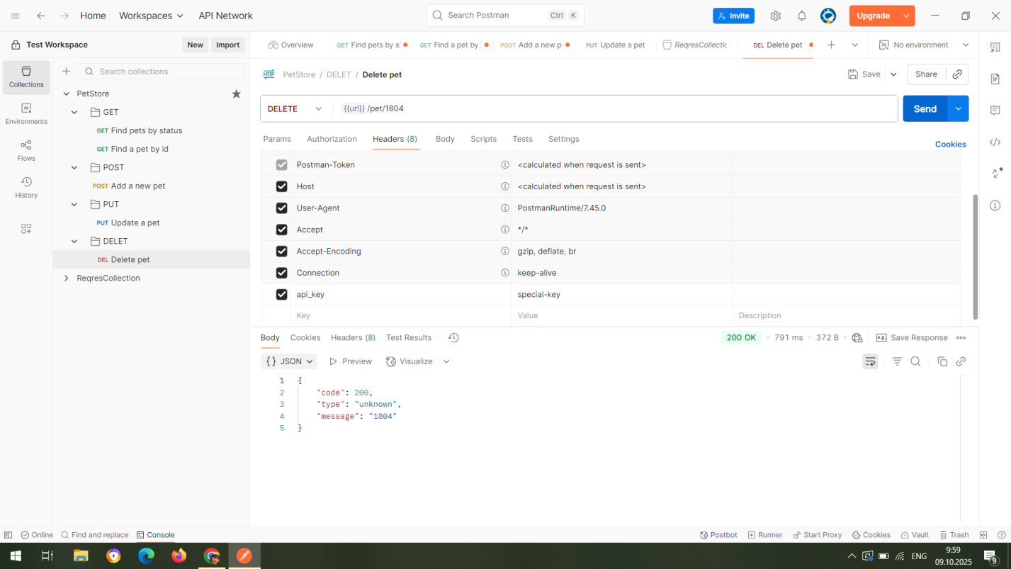

Expected response (200 OK):

