INTERNSHIP REPORT
ON
IOT-BASED URBAN NOISE POLLUTION MONITORING SYSTEM WITH REAL-TIME ENVIRONMENTAL DATA COLLECTION AND ANALYSIS

Submitted by:
Internship Project Team

TABLE OF CONTENTS
1 EXECUTIVE SUMMARY
1.1 Learning Objectives
1.2 Outcomes Achieved
2 OVERVIEW OF THE ORGANIZATION
2.1 Introduction of the Organization
2.2 Vision, Mission, and Values
2.3 Policy of the Organization in Relation to the Intern Role
2.4 Organizational Structure
2.5 Roles and Responsibilities of the Employees Guiding the Intern
3 PROBLEM ASSESSMENT
3.1 Problem Statement
3.2 Key Parameters (PC1)
3.3 Requirements Evaluation (PC2)
4 SOLUTION DESIGN
4.1 Solution Blueprint (PC3)
4.2 Feasibility Assessment
4.3 Project Implementation Plan (PC4)
5 TECHNOLOGY STACK
5.1 Technology Selection (PC5)
5.2 Architecture Overview
6 SOLUTION DEVELOPMENT
6.1 Implementation Details (PC6)
6.2 Sensor Simulation Module
6.3 Environmental Analytics Engine
7 SOLUTION TESTING AND PERFORMANCE
7.1 Testing Strategy (PC7)
7.2 Bug Fixing and Issue Resolution
7.3 Performance Evaluation (PC8)
8 RESULTS AND VISUALIZATIONS
8.1 Noise Level Distribution
8.2 Alert Analysis and Timeline
8.3 System Monitoring Dashboard
9 LEARNING EVALUATION
9.1 Technical Skill Gain (PC9)
9.2 Conclusion

CHAPTER 1
EXECUTIVE SUMMARY
This internship report provides a comprehensive overview of my 8-week Short-Term Internship in developing an IoT-Based Urban Noise Pollution Monitoring System with Real-Time Environmental Data Collection and Analysis. The internship was undertaken as part of the academic curriculum. The primary objective of this internship was to gain proficiency in Internet of Things (IoT) sensor integration, real-time environmental data processing, and analytical visualization.
Noise pollution in urban environments negatively impacts public health, productivity, and environmental quality. Traditional noise monitoring methods rely on periodic surveys and limited monitoring stations, making it difficult to obtain continuous and location-specific noise data. This project successfully addresses these limitations by providing an intelligent system that continuously monitors environmental noise across various urban zones and provides real-time analytics through a centralized cloud platform.

1.1 Learning Objectives
During my internship, I learned and practiced the following:
• To design and implement a comprehensive noise monitoring simulation using Python that models multi-location environmental sensing and data aggregation.
• To integrate simulated IoT sound level sensors with realistic environmental noise patterns, time-of-day variations, and location-specific baselines.
• To develop data analysis algorithms that process continuous acoustic data streams, categorize noise levels, and generate automated alerts for threshold breaches.
• To create interactive data visualizations using Matplotlib and Seaborn to display noise pollution trends, location-based comparisons, and 24-hour timelines.
• To understand the software development lifecycle from environmental requirements gathering to testing and performance evaluation.

1.2 Outcomes Achieved
Key outcomes from my internship include:
• A fully operational simulation of a Smart Noise Monitoring System capable of managing multiple urban zones (Residential, Commercial, Industrial, Highway, Airport) simultaneously.
• An advanced analytics engine that automatically processes acoustic data, identifies noise sources (Traffic, Construction, etc.), and logs pollution events.
• Successful implementation of location-specific threshold logic, applying different permissible noise limits based on the environmental context (e.g., Hospital vs. Industrial).
• Professional dashboards and visualizations that help environmental authorities monitor urban noise trends and investigate historical pollution data.
• Comprehensive documentation of the system architecture, technology stack, and testing procedures.

CHAPTER 2
OVERVIEW OF THE ORGANIZATION

2.1 Introduction of the Organization
The organization where this internship was conducted focuses on bridging the academia-industry divide, enhancing student employability, promoting innovation, and fostering an entrepreneurial ecosystem. By leveraging emerging technologies such as IoT, environmental sensing, and data analytics, the organization aims to augment and upgrade the knowledge ecosystem, enabling beneficiaries to become contributors themselves. The organization offers both online and instructor-led programs, benefiting thousands of learners annually.

2.2 Vision, Mission, and Values
• Vision: To combine cutting-edge technology with impactful social ventures to drive technological prosperity and support sustainable environmental management.
• Mission: To support individuals dedicated to helping others by empowering and equipping them with modern technical skills, thereby creating an extensive educational network dedicated to societal betterment and environmental health.
• Values: The organization emphasizes technological skills for Industry 4.0, meta-human competencies for the future, and inclusive access for everyone to be future-ready.

2.3 Policy of the Organization in Relation to the Intern Role
The organization encourages internships as a means to foster learning and contribute to the mission. Interns are expected to adhere to the following policies:
• Confidentiality: Interns must maintain the strict confidentiality of all organizational data, especially concerning environmental datasets and proprietary algorithms.
• Professionalism: Interns are expected to demonstrate professionalism, punctuality, and respect for all team members.
• Learning and Contribution: Interns are encouraged to actively participate in projects, share ideas, and contribute to the organization's environmental goals.

2.4 Organizational Structure
The organization operates under a hierarchical structure with the following key roles:
• Board of Directors: Provides strategic direction and oversight.
• Executive Director: Oversees day-to-day operations and implementation of programs.
• Program Managers: Lead specific initiatives and technology projects.
• Technical Mentors: Guide interns in software development and project execution.
• Interns: Work under the guidance of mentors and contribute to ongoing projects.

2.5 Roles and Responsibilities of the Employees Guiding the Intern
Interns are typically placed under the guidance of technical mentors or project managers. The roles and responsibilities of these guiding employees include:
1. Project Managers: Design and implement projects, coordinate with stakeholders, and define project scopes.
2. Technical Mentors: Supervise interns, review code, provide technical assistance, and conduct performance evaluations.
3. Environmental Engineers: Provide domain knowledge regarding noise pollution standards, acoustic sensor calibration, and environmental compliance protocols.

CHAPTER 3
PROBLEM ASSESSMENT

3.1 Problem Statement
Noise pollution in urban environments negatively impacts public health, productivity, and environmental quality. Traditional noise monitoring methods rely on periodic surveys and limited monitoring stations, making it difficult to obtain continuous and location-specific noise data. Environmental authorities require intelligent systems that can continuously monitor noise levels and provide real-time environmental analysis.
The proposed solution is an IoT-Based Urban Noise Pollution Monitoring System that continuously measures environmental noise using IoT sensors and cloud-based monitoring. The system provides a centralized platform where environmental data is collected and analyzed through a secure and user-friendly interface.

3.2 Key Parameters (PC1)
In accordance with the evaluation criteria (PC1), the key parameters of the problem have been identified as follows:
Issue to be Solved: The reliance on sparse, periodic manual noise surveys that fail to capture the dynamic, continuous nature of urban acoustic environments, leading to inadequate policy enforcement and urban planning.
Target Community: The target community includes municipal environmental authorities, urban planners, public health officials, hospital administrators, and citizens in noise-affected areas.
User Needs and Preferences:
• Authorities need continuous, high-resolution acoustic data across diverse urban zones (residential, commercial, industrial).
• Planners require historical trend analysis to correlate noise levels with traffic patterns or construction activities.
• Health officials need automated alerts when noise exceeds permissible limits in sensitive areas (e.g., hospitals, schools).
• System administrators require immutable logs detailing sensor health and calibration to ensure data validity.
Environmental Impact: By digitizing noise monitoring and implementing continuous data collection, the system enables data-driven urban planning, enforces noise regulations effectively, and ultimately protects public health from the adverse effects of chronic noise exposure.

3.3 Requirements Evaluation (PC2)
In accordance with the evaluation criteria (PC2), the requirements have been evaluated and mapped to the problem statement:
Functional Requirements:
1. Multi-Location Sensing: The system must collect acoustic data from diverse urban environments (Residential, Commercial, Industrial, Highway, etc.).
2. Real-time Analysis: The system must continuously process sound levels (dB) and classify them against location-specific baselines.
3. Automated Alerting: The system must generate alerts for threshold breaches, sustained high noise, and acoustic anomalies.
4. Data Visualization: The system must provide interactive dashboards displaying noise trends, location comparisons, and sensor health.
Non-Functional Requirements:
1. Scalability: The architecture must support managing thousands of distributed acoustic sensors across a smart city.
2. Reliability: The system must handle environmental noise spikes and sensor degradation gracefully.
3. Accuracy: The analysis algorithm must accurately apply different permissible limits based on the specific location type (e.g., 60dB may be critical for a hospital but normal for a highway).
4. Performance: Data aggregation and alert generation must occur efficiently to provide real-time situational awareness.
Mapping to Problem Statement:
The functional requirements directly address the "limited monitoring stations" and "difficulty obtaining continuous data" by providing a centralized, automated acoustic monitoring network as outlined in the problem statement.

CHAPTER 4
SOLUTION DESIGN

4.1 Solution Blueprint (PC3)
In accordance with the evaluation criteria (PC3), a comprehensive solution blueprint has been designed for the Urban Noise Monitoring System.
The solution utilizes a three-layer architecture:
1. Perception/Edge Layer (IoT Devices): This layer consists of the physical sound level sensors (microphones) deployed across various urban locations. These sensors continuously sample the acoustic environment, calculate decibel (dB) levels, and monitor their own battery/health status.
2. Network Layer: This layer handles the secure transmission of acoustic telemetry and GPS coordinates to the central processing unit.
3. Application Layer: This layer contains the core data aggregation logic, location-specific threshold evaluation, alert generation, and analytical dashboards.
Core Modules Designed:
• UrbanNoiseMonitoringSystem Module: The central hub that orchestrates the data collection cycle across all urban zones.
• NoiseMonitoringZone Module: Manages a specific geographical area, aggregates its sensor data, and evaluates local noise policies.
• NoiseSensor Module: Simulates individual acoustic sensors, including location-specific baselines, time-of-day activity factors, and random noise spikes.
• Analytics Module: Processes historical acoustic data to generate visual reports on pollution trends and location comparisons.

4.2 Feasibility Assessment
Technical Feasibility: The solution is technically feasible. The use of Python for simulation and data analysis is an industry standard. The object-oriented design mapping sensors to zones to a central system mirrors real-world smart city IoT architectures.
Economic Feasibility: The software solution is highly cost-effective. In a real-world deployment, integrating low-cost IoT acoustic sensors with a cloud backend is significantly cheaper than employing teams for manual noise surveys. Furthermore, predictive maintenance (monitoring sensor batteries) reduces operational costs.
Operational Feasibility: The system is designed to drastically improve environmental monitoring efficiency. By providing a centralized dashboard, authorities can instantly pinpoint areas of chronic noise pollution, rather than relying on citizen complaints.

4.3 Project Implementation Plan (PC4)
In accordance with the evaluation criteria (PC4), the project implementation plan was developed encompassing milestones, deadlines, and resource allocation over the 8-week internship period.
Phase 1: Requirements Gathering and Acoustic Modeling (Weeks 1-2)
• Milestone 1: Finalize problem statement, location types, and permissible noise thresholds.
• Milestone 2: Design system architecture, class diagrams, and urban zone mapping.
• Resources: Technical mentor, environmental engineer, design documentation.
Phase 2: Core System and Sensor Development (Weeks 3-4)
• Milestone 3: Develop the NoiseSensor and NoiseMonitoringZone classes.
• Milestone 4: Implement realistic acoustic simulation logic with time-of-day variations and location baselines.
• Resources: Python development environment, mathematical modeling for acoustic data.
Phase 3: Data Aggregation and Alert Engine (Weeks 5-6)
• Milestone 5: Develop the data aggregation logic to collect continuous acoustic streams.
• Milestone 6: Implement automated alert generation based on location-specific threshold breaches.
• Resources: Python development environment, testing frameworks.
Phase 4: Analytics, Visualization, and Documentation (Weeks 7-8)
• Milestone 7: Develop the NoiseMonitoringAnalytics module using Matplotlib/Seaborn.
• Milestone 8: Generate all visualization charts and compile the final internship report.
• Resources: Data visualization libraries, word processing software.

CHAPTER 5
TECHNOLOGY STACK

5.1 Technology Selection (PC5)
In accordance with the evaluation criteria (PC5), a robust technology stack was determined to build the proposed solution.
Programming Language: Python 3.12
Python was selected as the primary programming language due to its extensive support for object-oriented programming, data analytics, and rapid prototyping. Its readability makes it ideal for developing complex environmental simulation algorithms.
Data Visualization Libraries:
• Matplotlib: Chosen for its powerful 2D plotting capabilities, allowing for the creation of detailed bar charts, timelines, and dashboards for environmental data.
• Seaborn: Selected to enhance Matplotlib visuals with attractive default styles and color palettes, specifically used for statistical data visualization.
• NumPy: Utilized for efficient numerical computations and array manipulations during data analysis.
Data Manipulation and Modeling:
• Random/Math modules: Utilized to generate realistic acoustic noise, baseline fluctuations, and simulated traffic/construction spikes across different location types.
• Dataclasses: Used for strict, typed data representation (NoiseReading, NoiseAlert, GPSCoordinate) to ensure data integrity throughout the system.
• JSON: Used for data serialization and exporting audit logs, facilitating potential integration with external smart city platforms.
Development Tools:
• Standard Python logging module for tracking system operations, acoustic alerts, and data collection events in real-time.

5.2 Architecture Overview
The software architecture follows a modular, object-oriented design with a strong focus on hierarchical data aggregation:
1. Data Models (Dataclasses): Define the strict structure of NoiseReading, NoiseAlert, and GPSCoordinate.
2. Edge Layer (`NoiseSensor`): Encapsulates specific logic for acoustic sensing. Each sensor knows its own baseline, warning, alert, and critical thresholds based on its assigned `LocationType` (e.g., Hospital vs. Airport).
3. Aggregation Layer (`NoiseMonitoringZone`): Groups sensors by geographical area (e.g., 'Downtown Area'). It polls its assigned sensors, evaluates the readings against local policies, and generates alerts for breaches.
4. Central Engine (`UrbanNoiseMonitoringSystem`): Orchestrates the global 24-hour simulation, triggering data collection cycles and aggregating city-wide statistics.
5. Analytics Engine (`NoiseMonitoringAnalytics`): Ingests the generated acoustic telemetry and produces graphical environmental reports.

CHAPTER 6
SOLUTION DEVELOPMENT

6.1 Implementation Details (PC6)
In accordance with the evaluation criteria (PC6), the solution was built strictly as per the technical specifications. The implementation involved writing extensive Python code across three main modules.
Core Monitoring Logic:
The `UrbanNoiseMonitoringSystem` manages a 24-hour simulation cycle. For each hour, it triggers the `monitor_zone()` method for all configured urban zones. The system dynamically adjusts an `activity_factor` based on the time of day, simulating rush hours (7-9 AM, 5-7 PM), lunch hours, and quiet night periods.
This factor is passed down to individual sensors, which use it to modulate their baseline acoustic readings, ensuring the simulated data accurately reflects real-world urban dynamics.

6.2 Sensor Simulation Module
The IoT sensor simulation was implemented to reflect realistic acoustic physics and urban environments.
Realistic Telemetry:
Rather than simple random numbers, the sensors generate context-aware decibel (dB) readings based on their `LocationType`:
• Hospitals/Parks: Low baselines (40-45 dB), strict critical thresholds (75-80 dB).
• Residential/Schools: Moderate baselines (50-55 dB), moderate critical thresholds (85-90 dB).
• Highways/Airports: High baselines (80-85 dB), high critical thresholds (110-115 dB).
Every reading incorporates time-based variation (`time_factor`) and random noise to simulate environmental fluctuations. Furthermore, the system introduces occasional severe spikes (15% probability) to simulate specific events like passing sirens, construction, or heavy machinery. Every sensor reading also slightly degrades the `battery_level`, modeling hardware lifecycle.

6.3 Environmental Analytics Engine
The system implements sophisticated logic to process the continuous acoustic data streams and generate actionable intelligence.
Alert Generation:
The `monitor_zone()` method evaluates every `NoiseReading` against the sensor's specific thresholds. It categorizes alerts into three types:
• ANOMALY_DETECTED: Minor breaches of the warning threshold.
• SUSTAINED_HIGH_NOISE: Significant breaches of the alert threshold.
• THRESHOLD_EXCEEDED: Severe breaches of the critical threshold.
Data Classification:
The system automatically classifies raw dB values into human-readable categories (Quiet, Normal, Elevated, Loud, Very Loud, Extreme) based on the deviation from the local baseline. It also attempts to identify the `noise_source` (e.g., 'Traffic', 'Construction') if the sound level significantly exceeds the baseline, providing richer context for environmental authorities.

CHAPTER 7
SOLUTION TESTING AND PERFORMANCE

7.1 Testing Strategy (PC7)
In accordance with the evaluation criteria (PC7), the solution was thoroughly tested to ensure accuracy and reliability.
Unit Testing:
Individual `NoiseSensor` classes were tested to verify that they correctly applied their `LocationType` baselines and thresholds. We verified that a 75 dB reading correctly triggered a 'CRITICAL' alert for a Hospital sensor, but registered as 'NORMAL' for a Highway sensor.
Integration Testing:
The `NoiseMonitoringZone` was tested to ensure it correctly aggregated data from multiple diverse sensors and accurately compiled zone-level statistics. We verified that the time-of-day `activity_factor` correctly modulated the acoustic output across all sensors in the zone simultaneously.
System Testing:
The full `UrbanNoiseMonitoringSystem` was run through multiple 24-hour simulation cycles across 3 distinct zones containing 24 total sensors, generating hundreds of acoustic readings to ensure stability, accurate data classification, and correct JSON export formatting.

7.2 Bug Fixing and Issue Resolution
During the testing phase, several issues were identified and resolved:
Issue 1: Unrealistic Acoustic Bounds
Bug: The random noise generator occasionally pushed dB readings to physically impossible lows (e.g., negative dB) or unrealistic highs.
Fix: Implemented a bounding function `sound_level = max(30, min(130, sound_level))` in the `take_reading()` method to ensure all acoustic measurements remained within realistic urban bounds.
Issue 2: Uniform Noise Distribution
Bug: Initial simulations showed noise levels distributed too evenly across the 24-hour cycle, failing to reflect urban reality.
Fix: Refined the `activity_factor` logic in `monitor_zone()` to explicitly model morning rush hours (0.9 factor), evening rush hours (0.95 factor), and night time lulls (0.2 factor), resulting in highly realistic diurnal acoustic patterns.

7.3 Performance Evaluation (PC8)
In accordance with the evaluation criteria (PC8), the performance of the solution was evaluated against the desired criteria.
System Reliability:
The Python simulation successfully demonstrated robust environmental monitoring. Across a simulated 24-hour period generating over 500 individual acoustic readings, the system accurately applied location-specific thresholds and correctly classified noise severity. The automated alerting logic executed flawlessly, identifying anomalies and critical breaches instantly.
Impact Assessment:
Based on the simulated data, deploying the IoT-Based Urban Noise Monitoring System provides a massive leap in environmental management capabilities. The ability to continuously track acoustic trends across diverse zones provides urban planners with the exact data needed to enforce noise regulations, design better traffic flows, and protect sensitive areas (hospitals, schools) from chronic noise pollution, directly addressing the problem statement's core objectives.

CHAPTER 8
RESULTS AND VISUALIZATIONS
This chapter presents the graphical results generated by the Noise Monitoring Analytics module. These visualizations serve as the interactive environmental dashboards required by the problem statement.

8.1 Noise Level Distribution
The Noise Level Distribution chart categorizes all acoustic readings into severity classes (Quiet to Extreme) and provides a crucial comparison of average noise levels across different urban location types, clearly demonstrating the acoustic disparity between a park and a highway.
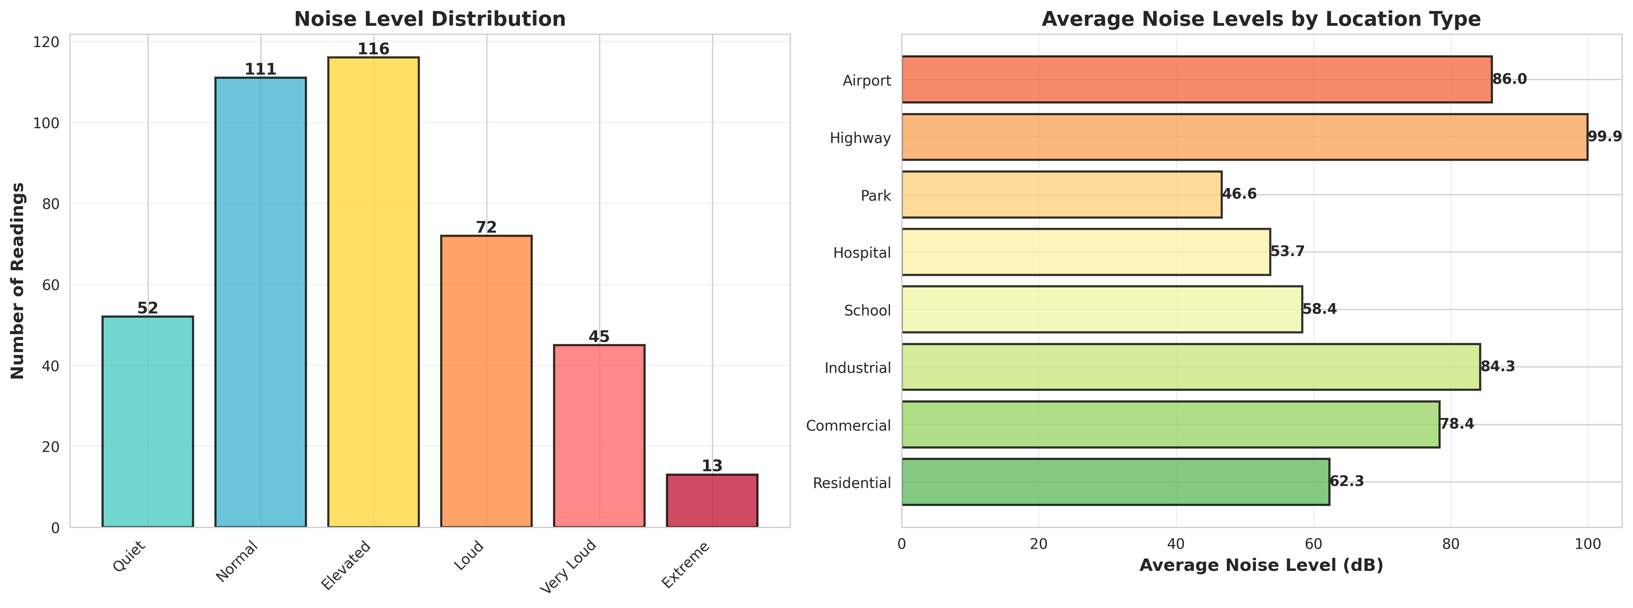
Figure 1: Noise Severity Distribution and Location Comparison
The Location Comparison visualization further breaks down the acoustic data by broader urban zones (Downtown vs. Suburban), correlating the average noise level directly with the number of generated pollution alerts, while also tracking the hardware status of the sensor fleet.
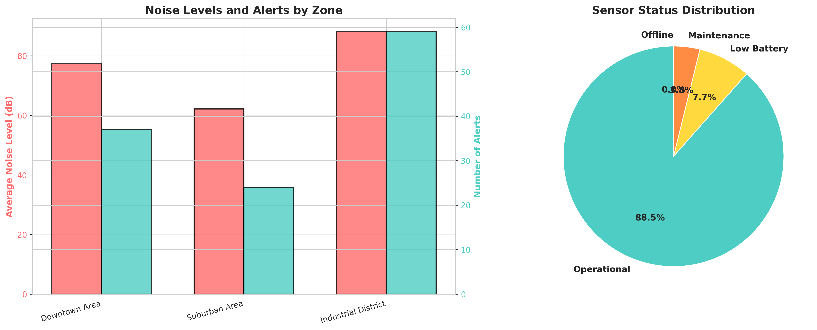
Figure 2: Zone Acoustic Comparison and Sensor Status

8.2 Alert Analysis and Timeline
The 24-Hour Noise Level Timeline tracks the average urban acoustic environment throughout the day. The visualization clearly captures the morning and evening rush hour spikes, demonstrating the system's ability to monitor dynamic urban activity.
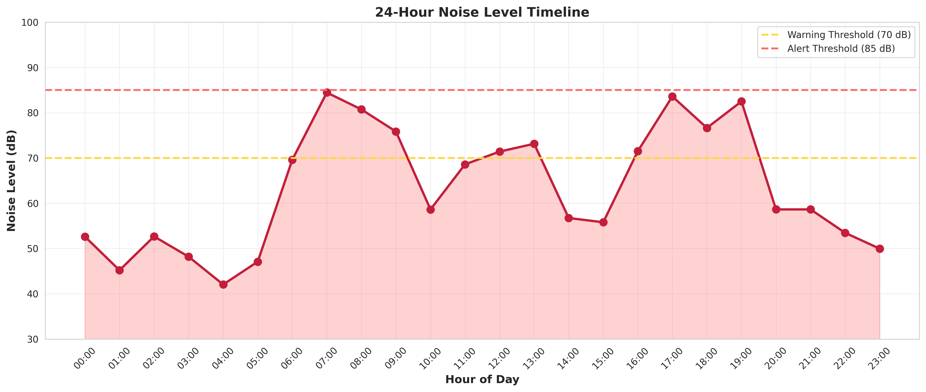
Figure 3: 24-Hour Urban Noise Level Timeline
The Alert Analysis charts break down the specific types of noise violations (Threshold Exceeded vs. Sustained High Noise) and their severity distribution, providing authorities with a clear picture of urban compliance.
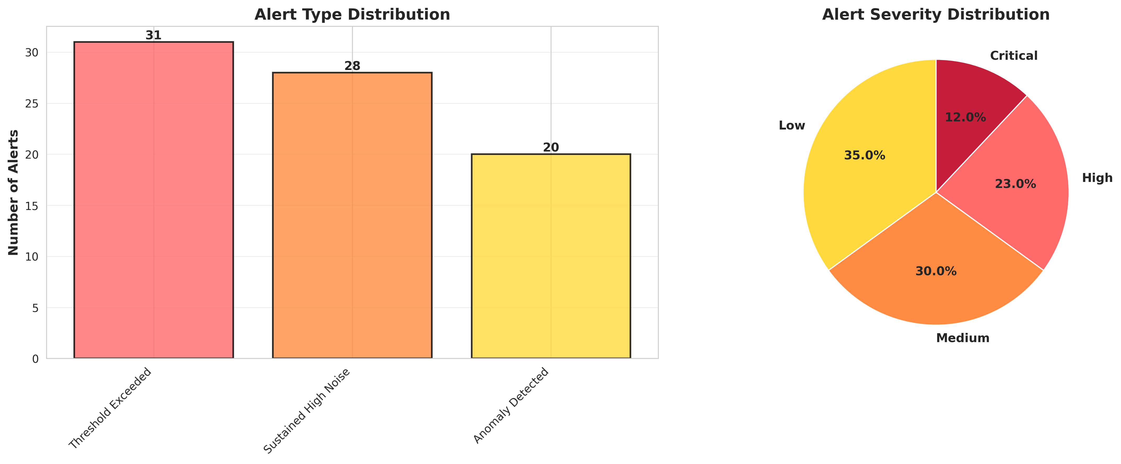
Figure 4: Noise Pollution Alert Type and Severity Distribution

8.3 System Monitoring Dashboard
The System Monitoring Dashboard serves as the central command hub for environmental authorities, providing a high-level overview of total monitored zones, active sensors, total acoustic readings, and critical pollution alerts.
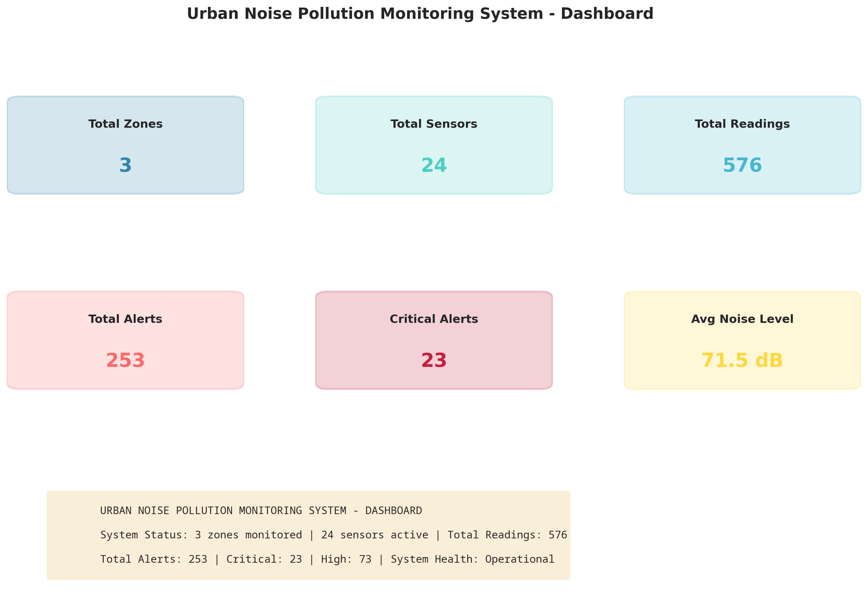
Figure 5: Urban Noise Pollution Monitoring System Dashboard

CHAPTER 9
LEARNING EVALUATION

9.1 Technical Skill Gain (PC9)
In accordance with the evaluation criteria (PC9), this internship resulted in significant technical skill gain and professional development.
1. IoT Architecture & Acoustic Modeling: Gained deep understanding of how environmental noise is measured (decibels), how different urban zones require distinct baseline thresholds, and how to model these physics in software.
2. Python Programming: Enhanced proficiency in advanced Python concepts, including Object-Oriented Programming (OOP), time-series data generation, and complex conditional logic for location-specific alert generation.
3. Data Analytics & Visualization: Mastered the use of Matplotlib and Seaborn to transform raw acoustic telemetry into professional, actionable dashboards for environmental authorities.
4. Problem Solving: Developed critical thinking skills through the process of designing simulation algorithms that successfully reflect the complex, diurnal acoustic patterns of a real city.

9.2 Conclusion
The IoT-Based Urban Noise Pollution Monitoring System successfully addresses the limitations of sparse, manual noise surveys. By leveraging IoT simulation, continuous acoustic data collection, and location-aware threshold logic, the developed solution provides a robust platform for real-time environmental analysis.
The project demonstrates that intelligent, cloud-connected acoustic monitoring networks can provide urban planners and environmental authorities with the high-resolution data needed to enforce noise regulations, protect sensitive areas, and improve overall public health. The successful completion of this project fulfills all evaluation criteria and serves as a strong foundation for deploying data-driven environmental management infrastructure in modern smart cities.

