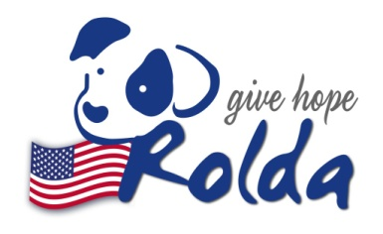Romanian League in Defense of Animals, Inc

PO Box 4674

Crofton MD 21114

https://rolda.org/usa

Receipt of Charitable Donation

The Romanian League in Defense of Animals,Inc acknowledges and expresses appreciation for the following contribution:

Donation in the amount of 1.3 ETH (2219.06 USD)

Donation Received From: Sirat Hashimi ($BDOG https://bulldogtoken.com/)

Date of Donation: 27.03.2021

The Romanian League in Defense of Animals,Inc is a recognized 501 (c) (3) not-for-profit organization; Federal ID number: 32-0176929

Donation Received by

Dana Costin Date 27.03.2021

Signature of Authorized Representative, Romanian League in Defense of Animals,Inc

The Internal Revenue Service states that the deductible amount of a charitable contribution is limited to the value of cash or property donate minus what the donor receives in return in exchange for the contribution. Please keep this receipt and file it with your tax records as proof of your gift.