**INT102 Lab 2: Working with HTML Elements (1/2023)**

1. Download lab2.zip and unzip the file
2. Open Visual Studio Code editor > Open folder > lab2
3. Create a HTML file called “lab2.zip” and copy the content of recipe.txt and paste them between <body> </body>
4. Se the title page to Tapenade.
5. Use the proper HTML elements to format the content as follows:

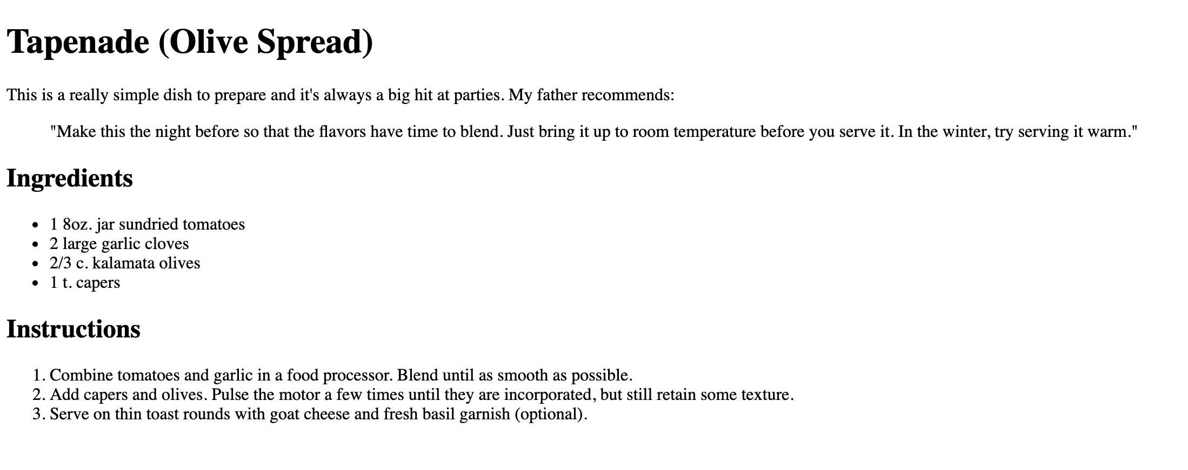

1. Group the HTML elements into three parts and provide the unique id to each part as
   1. description
   2. ingredients
   3. instructions



**description**

**instructions**

**ingredients**

1. Add a few fine details. Classify each ingredient as "ingredient" using span elements for the following texts:
   1. sundried tomatoes
   2. garlic cloves
   3. kalamata olives
   4. capers
2. Add the style element between </title> and </head> as follows

</title>

<style>

.ingredient {

font-weight: bold;

color: purple

}

</style>

</head>

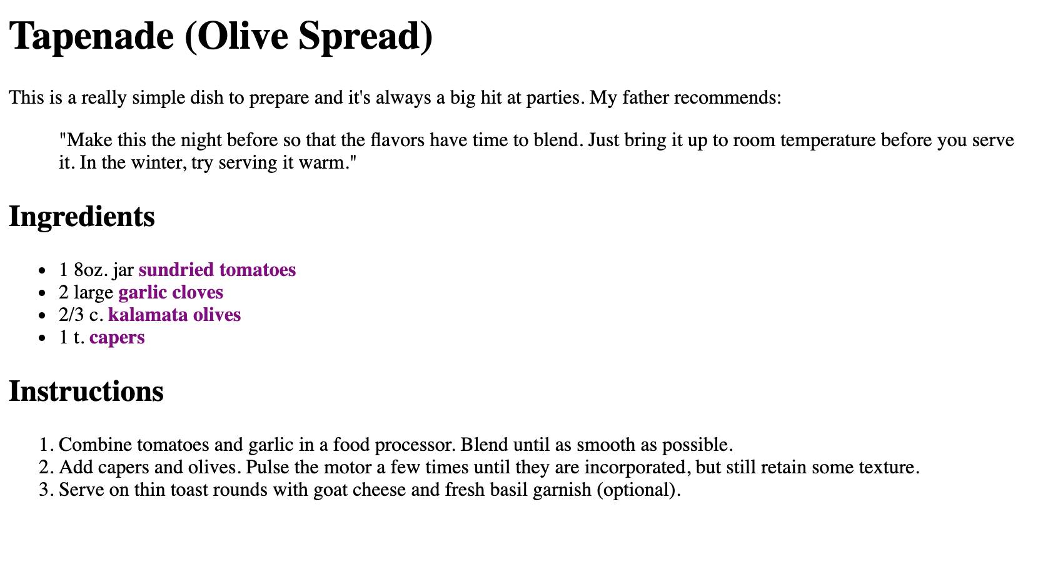

1. Save the file and click Live Preview to view the content in Web Browser.
2. Before submitting your lab2.html, rename the lab2.html to **xxxxxxxxxxx.html** (xxxxxxxxxxx is your student id) and upload only **xxxxxxxxxxx.html to** LEB2.