**INT102 Lab 3: Links and Navigation (1/2023)**

1. Download Lab4.zip from COD and extract the file in Downloads folder by selecting the Lab3.zip > Right-click > 7-Zip > Extract here
2. Open Visual Studio Code editor > Open folder > jenskitchen

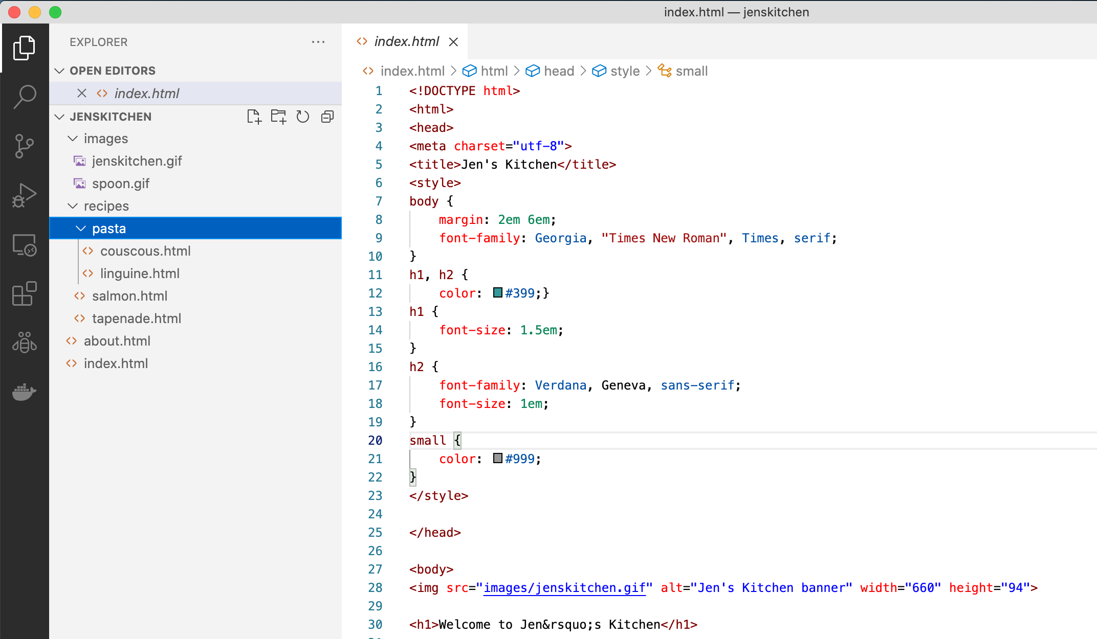

1. Click the index.html in the folder navigator. It will open the index.html file in the editor. You can modify the content of the file and click File > Save to save the modified content.

**Open the file index.html:**

1. Make the list item “The Food Network” link to its web page at [www.foodnetwork.com](http://www.foodnetwork.com) (don’t forget to prefix the URL with the protocol http://).
2. Make the list item “Epicurious” link to its web page at [www.epicurious.com](http://www.epicurious.com) (don’t forget to prefix the URL with the protocol http://).
3. Make the list item “Tapenade (Olive Spread)” link to the file tapenade.html in the receipts directory. (Remember to nest the elements correctly!)
4. Make the list item “Garlic Salmon” link to the file salmon.html in the receipts directory
5. Make the list item “Linguine with Clam Sauce” link to the file linguine.html in the pasta directory
6. Make the list item “Couscous with Peas and Mint” link to the file couscous.html in the pasta directory
7. Make the paragraph item “About the site” link to a general information (about.html).
8. Save the index.html and open with Live Server to preview the HTML file. Try to click on the links that you add them in the index.html.

**Open about.html, salmon.html, tapenade.html, couscous.html and linguine.html:**

1. Make the paragraph “Back to the home page” at the bottom of the page link to the file index.html. The anchor element should be contained in the p element. (Remember the URL for each link might not be the same value. It depends on the level of directory that the file is located).
2. Save all the modified files. Open with Live Server to preview the HTML file. and try to click on the links that you have modified them.
3. Zip the folder jenskitchen, rename the zip as xxxxxxxxxxx_lab3.zip (xxxxxxxxxxx is your student id) and upload to LEB2.