Sirawitch Butryojantho 643040542-0

These are three items of what I think the web should be improved based on web design best-practices:

1. There is a lot of text on this website's homepage. They should minimize text. It would be better if they could explain things with images related to what they want to show..

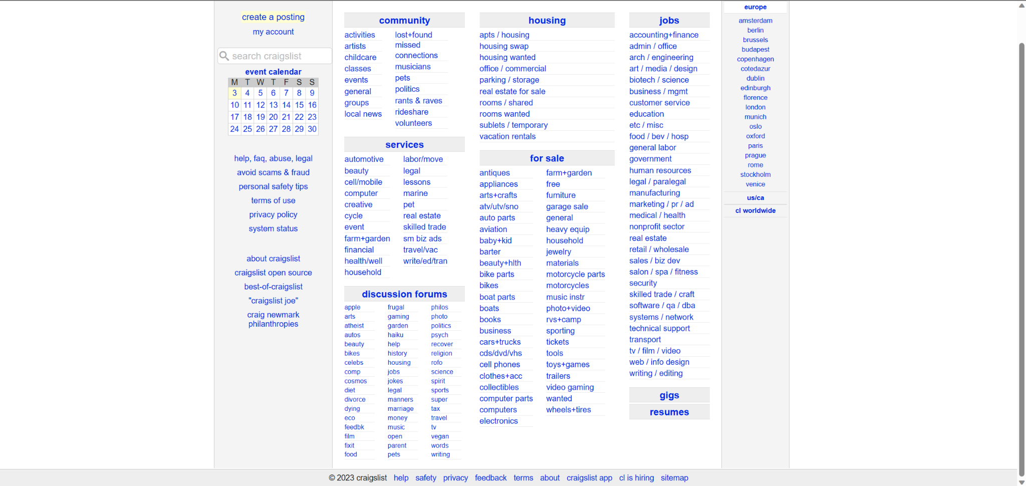

(website’s homepage)

2. There is still a lot of empty space on the page. Space should be allocated more appropriately.

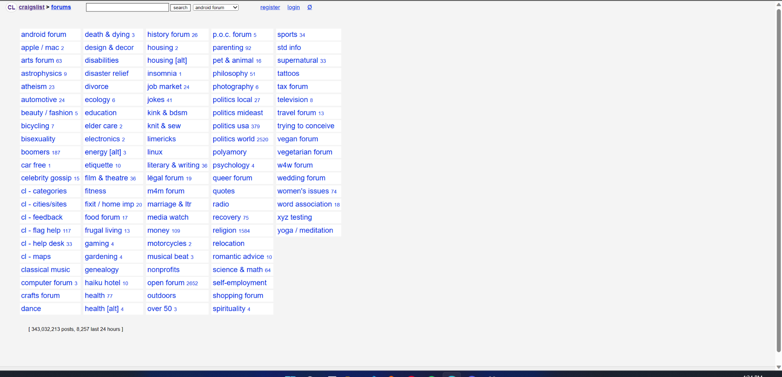

(website’s forums page)

3. The website looks too ordinary. They should add more colors. The white background makes the website look too ordinary.