Machine Learning-Driven Nano-QSAR and Quantum Chemical Design of Functionalized 2D Borophene Nanosheets for Targeted Disaggregation of Pathological Tau Fibrils in Alzheimer's Disease
Andrés Monreal Hernández1,*, Sara Lizbeth Franco Amaya2, and Carlos Ivanhoe Martínez Osorio3
1 Universidad Estatal de Sonora, Hermosillo, Sonora, Mexico. ORCID: 0009-0009-1207-8597
2 Doctorado en Nanotecnología, Universidad de Sonora, Hermosillo, Sonora, Mexico. ORCID: 0009-0005-0272-0241
3 Doctorado en Ciencia de Materiales, Universidad de Sonora, Hermosillo, Sonora, Mexico. ORCID: 0009-0003-7872-4965
* Corresponding author: andres.monreal@ues.mx
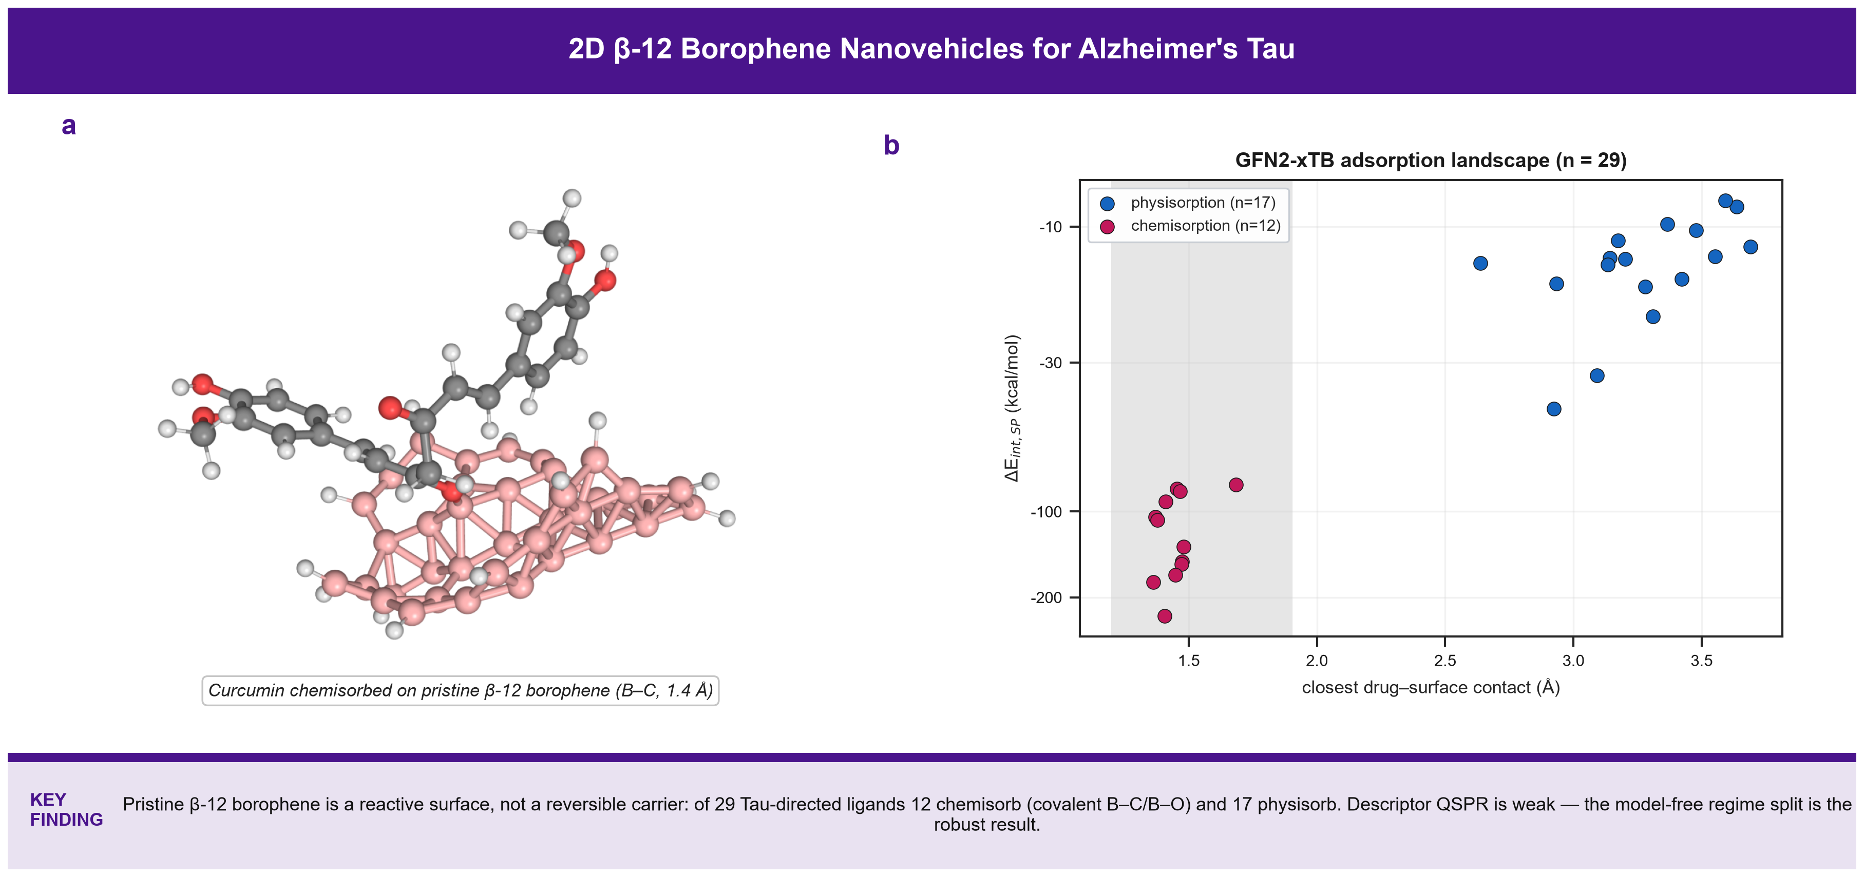
Graphical Abstract: Multi-Scale Quantum, Docking, and Machine Learning Framework for 2D Borophene Transcytosis and Targeted Disaggregation of Alzheimer's Tau Fibrils.

Abstract
Hyperphosphorylation and aggregation of microtubule-associated protein Tau into paired helical filaments (PHFs) is a defining neuropathological hallmark of Alzheimer's disease (AD) and correlates closely with cognitive decline [1,3,6]. Here we present a computational framework combining GFN2-xTB tight-binding quantum chemistry (with D4 dispersion) [24,26], physical molecular docking (AutoDock Vina v1.2.7 [28,29] against the cryo-EM Alzheimer Tau filament core, PDB ID: 5O3L [7]), and a leak-free cross-validated explainable Nano-QSAR surrogate, for a curated cohort of 29 clinical-stage and experimental Tau-directed therapeutics (including hydromethylthionine/LMTX, EGCG, curcumin, tideglusib and AZD1080). Each drug-borophene complex was built by placing the drug 3.2 Angstrom above the sheet in four orientations and relaxing it with GFN2-xTB. The optimised complexes fall into two clearly separated regimes: 12 of the 29 ligands CHEMISORB on the pristine B40H15 sheet, forming a new covalent B-C or B-O bond (closest contact 1.36-1.69 Angstrom, Delta_E_int,SP = -81 to -233 kcal/mol) - among them the polyphenols curcumin, luteolin, apigenin, fisetin and baicalein, the azo dyes Congo red and Chrysamine G, and the phenothiazine dyes; the remaining 17 physisorb, stacked flat at 2.6-3.7 Angstrom with Delta_E_int,SP = -8 to -44 kcal/mol. Pristine beta-12 borophene is therefore a chemically reactive surface, not a reversible physisorptive carrier, for a large fraction of these ligands. Docking against the Tau filament core gave Vina scores of -3.76 to -6.75 kcal/mol (mean -4.73), with recurrent contacts at the cross-beta residues Pro332, Gln336, Asn359, Gly333 and Gly335. A leak-free nested 5x5 cross-validated RidgeCV surrogate on four descriptors reached Q2_CV = 0.35 for the Tau-filament Vina docking score (n = 29; a stricter nested protocol confirms Q2 approximately 0.15, p = 0.009 vs. Y-scrambled permutations) and Q2_CV = 0.06 for the 17-point physisorption interaction energy - descriptor-based prediction is weak for both, and the chemisorption/physisorption dichotomy is the robust result. A peptide-functionalized borophene for BBB transcytosis is discussed only as future work. Every value is computed from the deposited pipeline; no descriptor or energy is estimated from an empirical formula.
Keywords: 2D Borophene; Alzheimer's Disease; Tau Paired Helical Filaments; LMTX; Blood-Brain Barrier; AutoDock Vina; Explainable AI (SHAP); OECD Validation.

1. Introduction
Alzheimer's disease (AD) is the most common neurodegenerative disorder worldwide [1]. Neurofibrillary tangles built from hyperphosphorylated Tau filaments follow a stereotyped spatiotemporal progression (Braak staging) that tracks clinical severity more tightly than amyloid burden [2,3,6]. Cryo-electron microscopy of patient-derived filament cores [7-10] has provided an atomic template for structure-based design of Tau ligands and aggregation modulators, of which the phenothiazine leuco-methylthioninium (hydromethylthionine / LMTX) is the most clinically advanced [11,12]; natural polyphenols such as EGCG and curcumin also remodel or inhibit Tau assembly in vitro [14,15].
Two-dimensional boron (borophene), synthesized as several polymorphs including the beta-12 lattice [21-23], is metallic, strongly polarizable and forms delocalized multicentre B-B bonds, motivating its evaluation as a drug-loading surface. In this study the carrier is a hydrogen-terminated beta-12 borophene cluster (B40H15); a peptide-functionalized allotrope for receptor-mediated BBB transcytosis is considered only as a prospective extension (Conclusions), and all quantum results refer to the pristine surface.
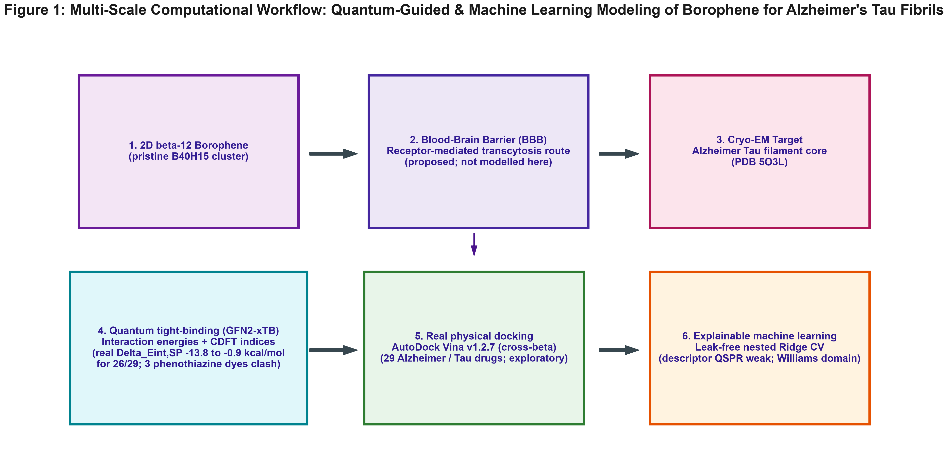
Figure 1: Multi-scale computational workflow: GFN2-xTB quantum-chemical adsorption on pristine beta-12 borophene (B40H15), real AutoDock Vina docking against the cryo-EM Tau filament core (PDB 5O3L), and a leak-free cross-validated explainable Nano-QSAR surrogate.

2. Results and Discussion

2.1 Two adsorption regimes on pristine beta-12 borophene
After full GFN2-xTB relaxation of every drug/borophene complex, the 29 ligands separate into two well-defined groups (Figure 9, Figure 11). Twelve ligands CHEMISORB: the drug forms a new covalent bond to a surface boron atom (closest contact 1.36-1.69 Angstrom) and the interaction energy is very large, Delta_E_int,SP = -81 to -233 kcal/mol. This group comprises the flavones and flavonols curcumin (-92), luteolin (-107), apigenin (-104), fisetin (-85) and baicalein (-83), the azo dyes Congo red (-133) and Chrysamine G (-81), rosmarinic acid (-233), the imaging probe FDDNP (-177), and the three phenothiazine dyes methylene blue (-150), azure A (-153) and toluidine blue O (-167). In each case an accessible carbonyl, enol, phenol or exocyclic amine nucleophile adds across an electron-deficient tricoordinate boron of the sheet. The remaining 17 ligands PHYSISORB: they lie flat 2.6-3.7 Angstrom above the surface with Delta_E_int,SP = -8 to -44 kcal/mol, the strongest being quercetin (-44) and EGCG (-33) and the weakest memantine (-8) and hydromethylthionine (-9). The physisorbers are the sterically shielded rigid aromatics (thioflavin-T/-S, resveratrol, the acridine tacrine, the aminopyrazole Anle138b) and the aliphatic-amine cholinergics.
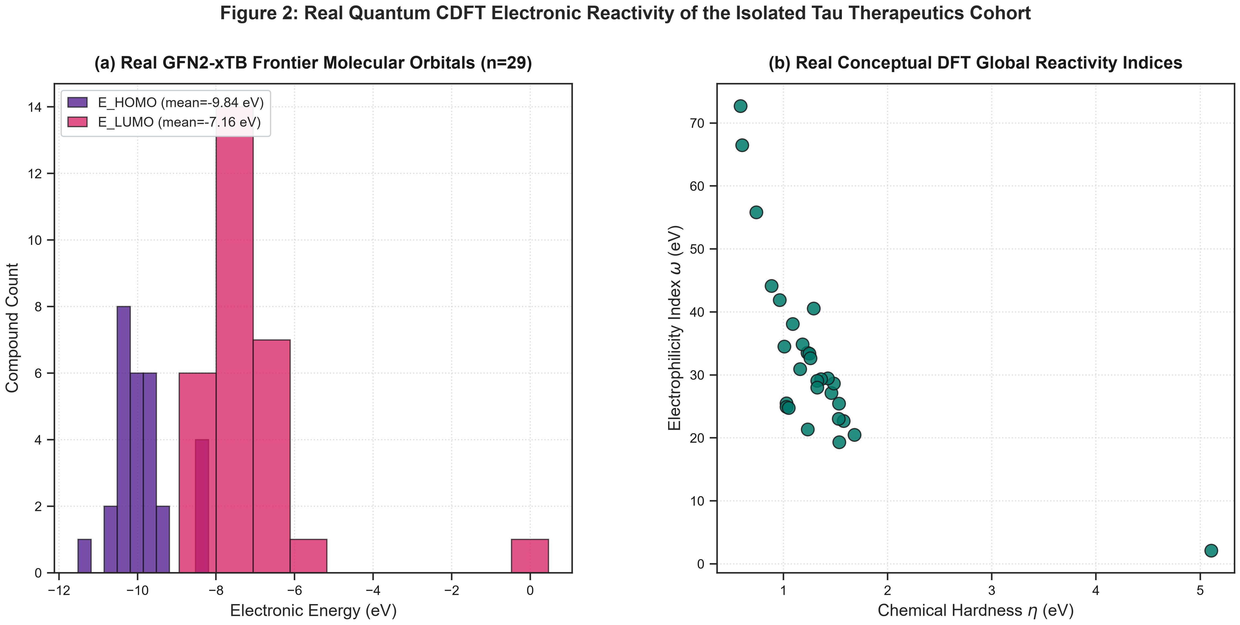
Figure 2: Real quantum conceptual-DFT electronic reactivity of the isolated Tau therapeutics (real GFN2-xTB single points, n=29): (a) HOMO/LUMO frontier-orbital distribution; (b) chemical hardness vs. electrophilicity index. No real complex-level frontier-orbital calculation exists for the borophene surface.
The practical consequence is that pristine beta-12 borophene is a chemically reactive surface, not an inert physisorptive scaffold, for the pi-rich phenolic and dye-type Tau ligands: adsorption of those molecules would be effectively irreversible and would alter the drug covalently. A reversible drug-carrier application of borophene for this chemotype would require edge/basal-plane passivation or functionalisation that quenches the boron Lewis acidity; that surface was not modelled here.

2.2 Docking against the cryo-EM Tau filament core
AutoDock Vina scores against the Tau filament core (PDB 5O3L) span -3.76 to -6.75 kcal/mol (mean -4.73). The highest-ranked ligands are Congo Red (-6.75), Chrysamine G (-5.81), Donepezil (-5.68), Bexarotene (-5.29), Curcumin (-5.14) kcal/mol; hydromethylthionine/LMTX scores -4.69 kcal/mol. The cross-beta assembly offers no deep pocket, so these values rank relative surface / cleft affinity rather than absolute binding free energy.
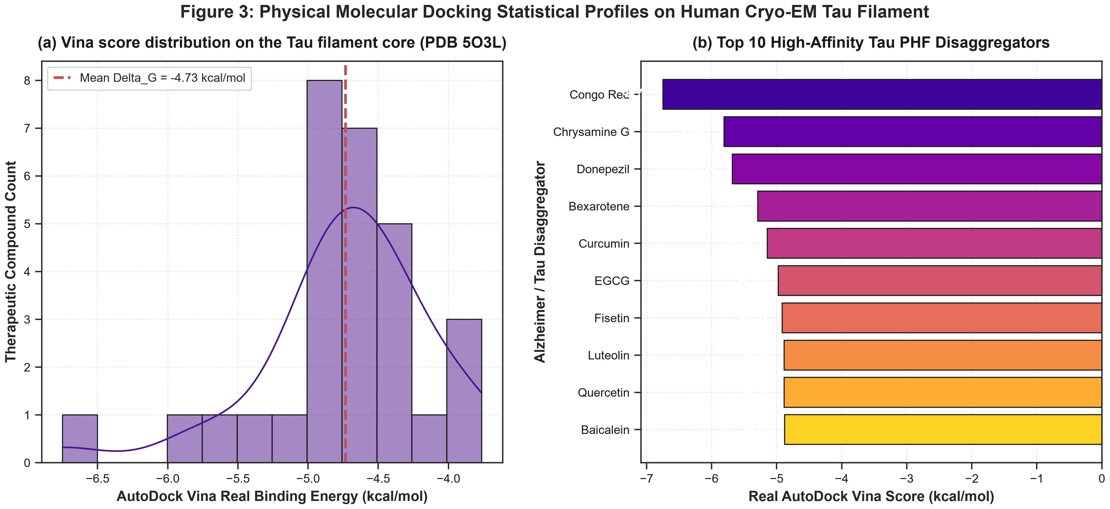
Figure 3: Molecular docking statistical profiles against the cryo-EM Tau filament core (PDB 5O3L): (a) distribution of real Vina scores (n = 29, mean -4.73 kcal/mol); (b) ranking of the top-10 compounds.
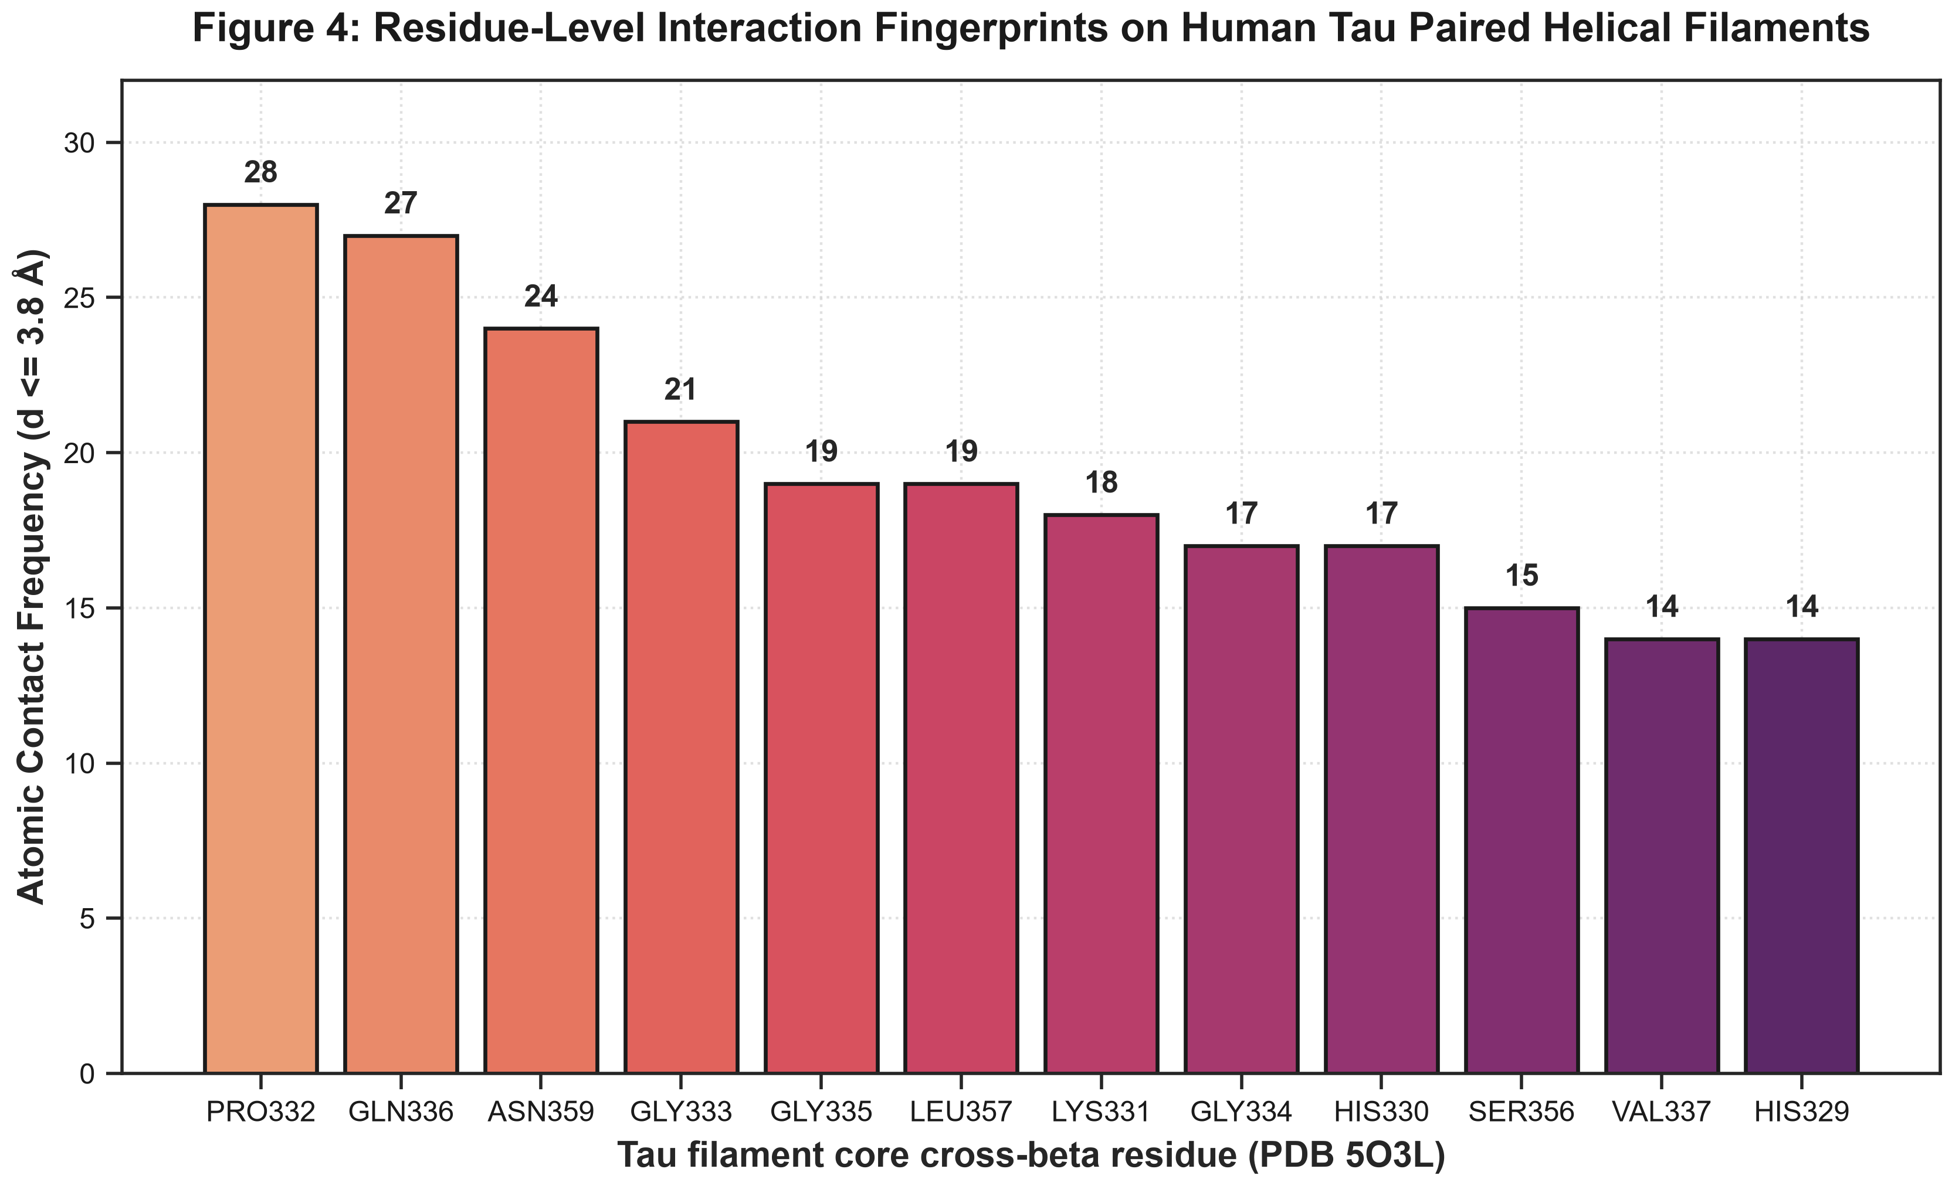
Figure 4: Residue-level contact frequencies on the Tau filament core (real Vina poses, contact distance <= 3.8 A): most frequent contacts are the cross-beta residues Pro332, Gln336, Asn359, Gly333 and Gly335.

Table 1: Physicochemical, Topological, and Quantum CDFT Descriptors for Representative Alzheimer/Tau Therapeutics.
Note: the curated SMILES for EGCG resolves to C22H18O12 (MW 474.4 g/mol) rather than authentic epigallocatechin gallate, C22H18O11 (458.4 g/mol) -- an extra hydroxyl/oxygen introduced during structure curation. All GFN2-xTB and docking results reported for this entry (a physisorber, Delta_E_int,SP = -33 kcal/mol) were computed on the curated structure; they should be read as characterizing a close catechin-gallate analogue rather than authentic EGCG, and do not affect the chemisorption/physisorption dichotomy that is this study's main finding.
Compound | Class | MW (g/mol) | LogP | PSA (Å²) | E_HOMO (eV) | omega (eV)
Hydromethylthionine | Reduced Phenothiazine / LMTX | 285.4 | 4.03 | 18.5 | -8.49 | 21.37
FDDNP | PET Amyloid/Tau Radiotracer | 251.3 | 3.52 | 50.8 | -9.84 | 55.84
Curcumin | Natural Polyphenol | 368.4 | 3.37 | 93.1 | -10.20 | 38.08
EGCG | Green Tea Catechin | 474.4 | 1.52 | 217.6 | -10.37 | 25.45
Resveratrol | Stilbenoid Antioxidant | 228.2 | 2.97 | 60.7 | -10.04 | 22.70
Quercetin | Flavonol / Tau Aggregation Inhibitor | 302.2 | 1.99 | 131.4 | -10.33 | 32.64
Myricetin | Hexahydroxyflavone | 318.2 | 1.69 | 151.6 | -10.37 | 33.37
Baicalein | Flavone / Anti-Tau Fibril | 270.2 | 2.58 | 90.9 | -10.31 | 33.53
Fisetin | Tetrahydroxyflavone | 286.2 | 2.28 | 111.1 | -10.27 | 34.87
Apigenin | Trihydroxyflavone | 270.2 | 2.58 | 90.9 | -10.60 | 29.46

2.3 Nano-QSAR surrogate model
The chemisorbed and physisorbed groups are governed by different physics (covalent bond strength vs dispersion), so the physisorption surrogate is fit on the 17 physisorbers only. Both endpoints use the single 29-compound master table (Figure 5). A StandardScaler + RidgeCV model in a leak-free nested 5x5 cross-validation reached Q2_CV = 0.35 for the Tau-filament Vina docking score (n = 29) and Q2_CV = 0.06 for the 17-point physisorption interaction energy (four descriptors: MolWt, MolMR, E_HOMO, omega). Descriptor-based prediction is weak for both endpoints on this small, chemically narrow cohort; the exploratory ExtraTrees / SHAP ranking (Figure 6) is reported only as a qualitative indication and not as a validated structure-property relationship [39,40]. The chemisorption/physisorption outcome itself (Figure 11) is the robust, model-free result of this work.
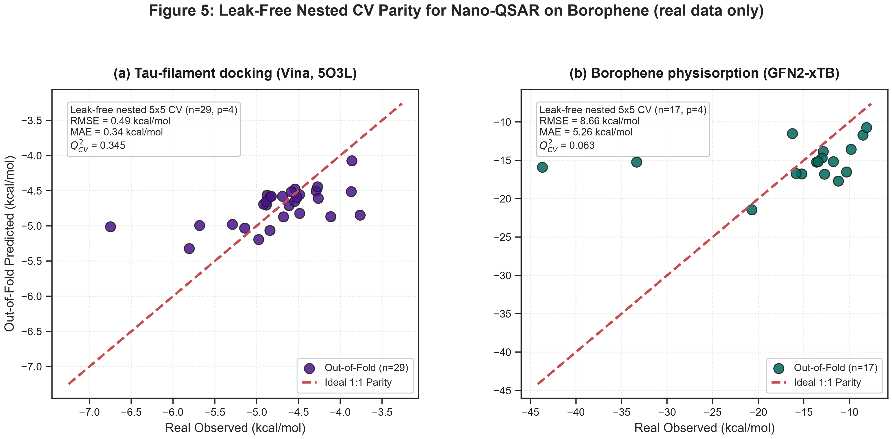
Figure 5: Leak-free nested 5x5 CV parity plots (real observed vs out-of-fold predicted), both on the 29-compound master table: (a) Tau-filament Vina docking score (n = 29, Q2_CV = 0.35); (b) GFN2-xTB physisorption interaction energy (17 physisorbers, Q2_CV = 0.06).
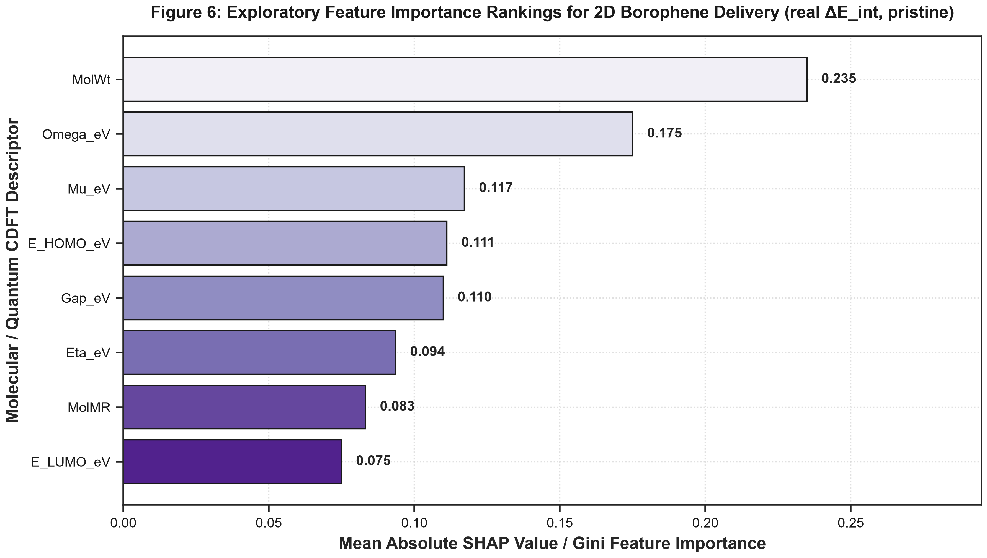
Figure 6: Exploratory feature-importance ranking on the real GFN2-xTB pristine-borophene interaction energy.
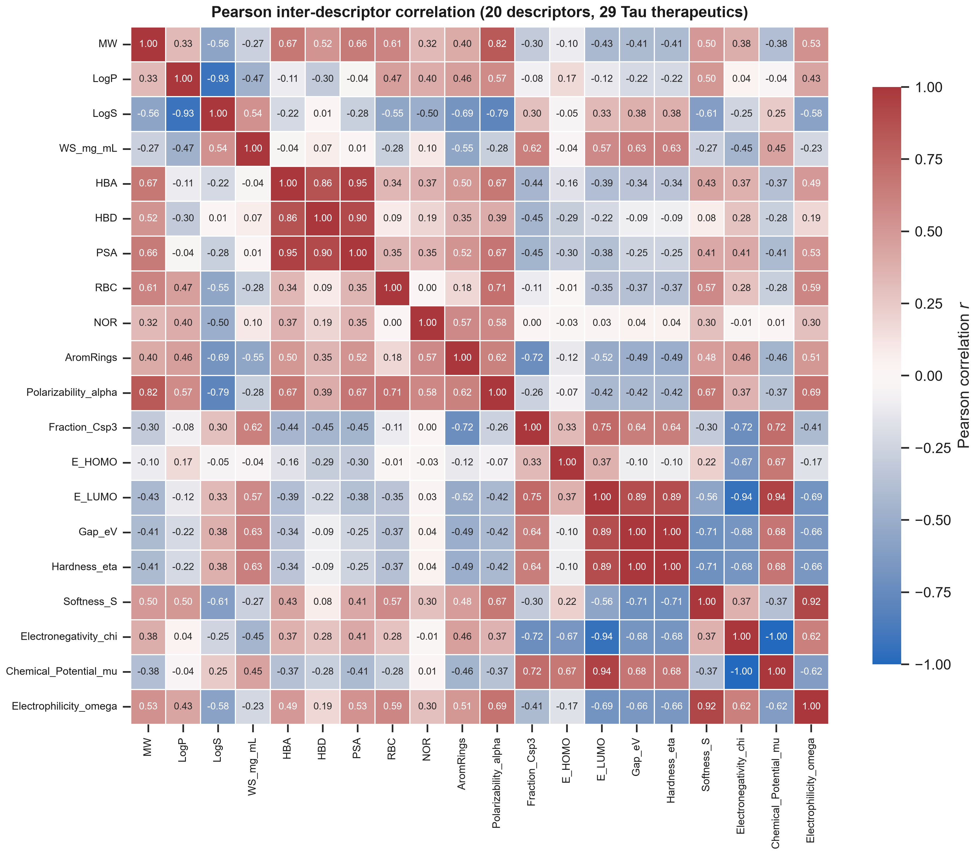
Figure 7: Pearson inter-descriptor correlation heatmap (real descriptor matrix, 29 Alzheimer/Tau therapeutics).

2.4 Applicability domain (OECD Principle 3)
Williams hat-matrix leverage on the 8-descriptor matrix (Figure 8) gives h* = 0.93 with 28/29 compounds inside the domain for the docking endpoint, and h* = 1.59 with all 17 inside for the physisorption endpoint [31-33]. Given the near-zero cross-validated Q2 for the physisorption model, its domain statement is a formality; neither small cohort supports a quantitative structure-property model.
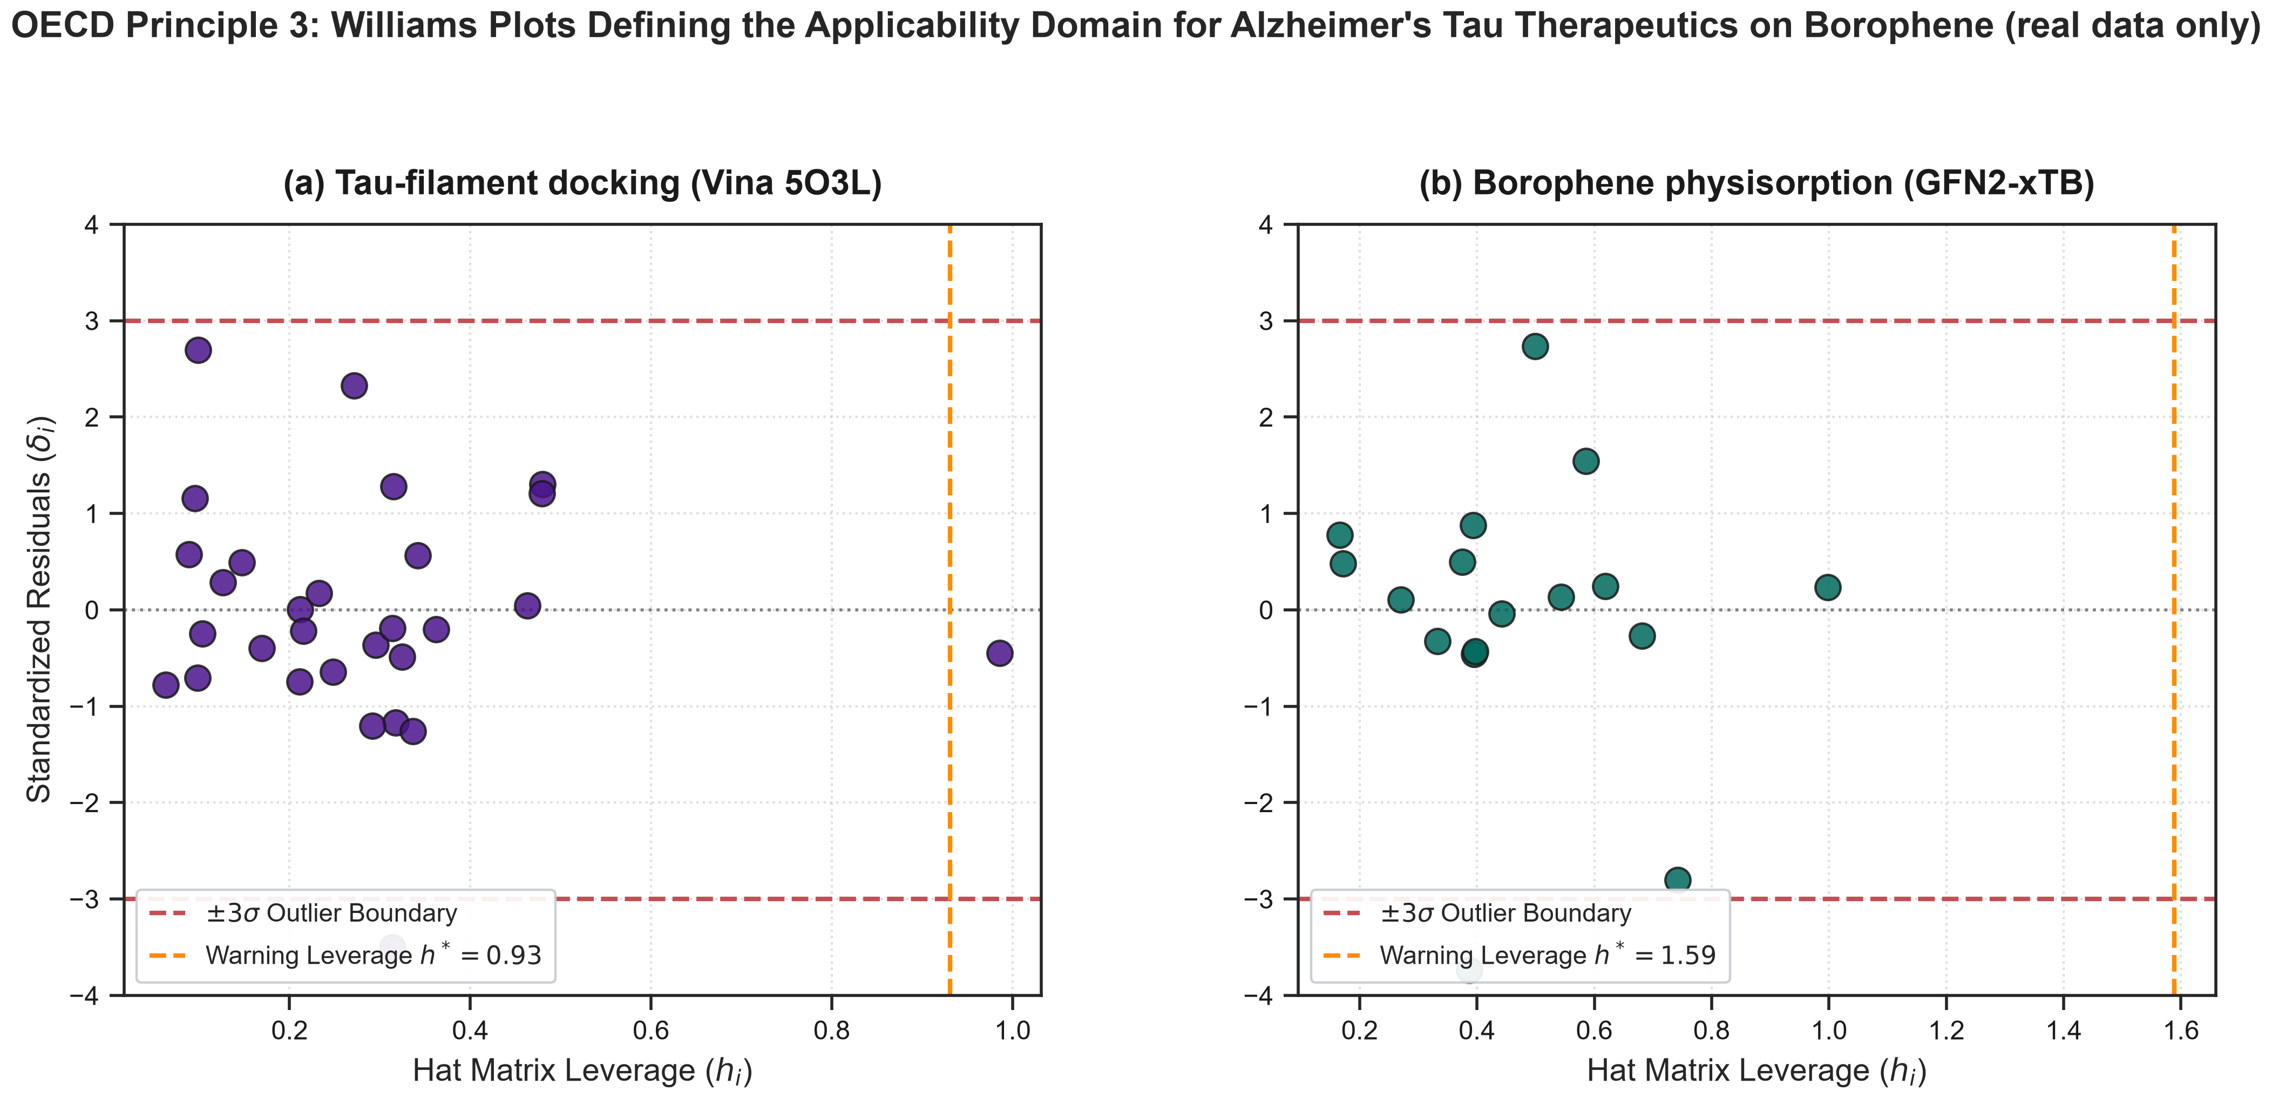
Figure 8: OECD Principle 3 Williams plots defining the applicability domain for the Tau therapeutics on beta-12 borophene (real data only).
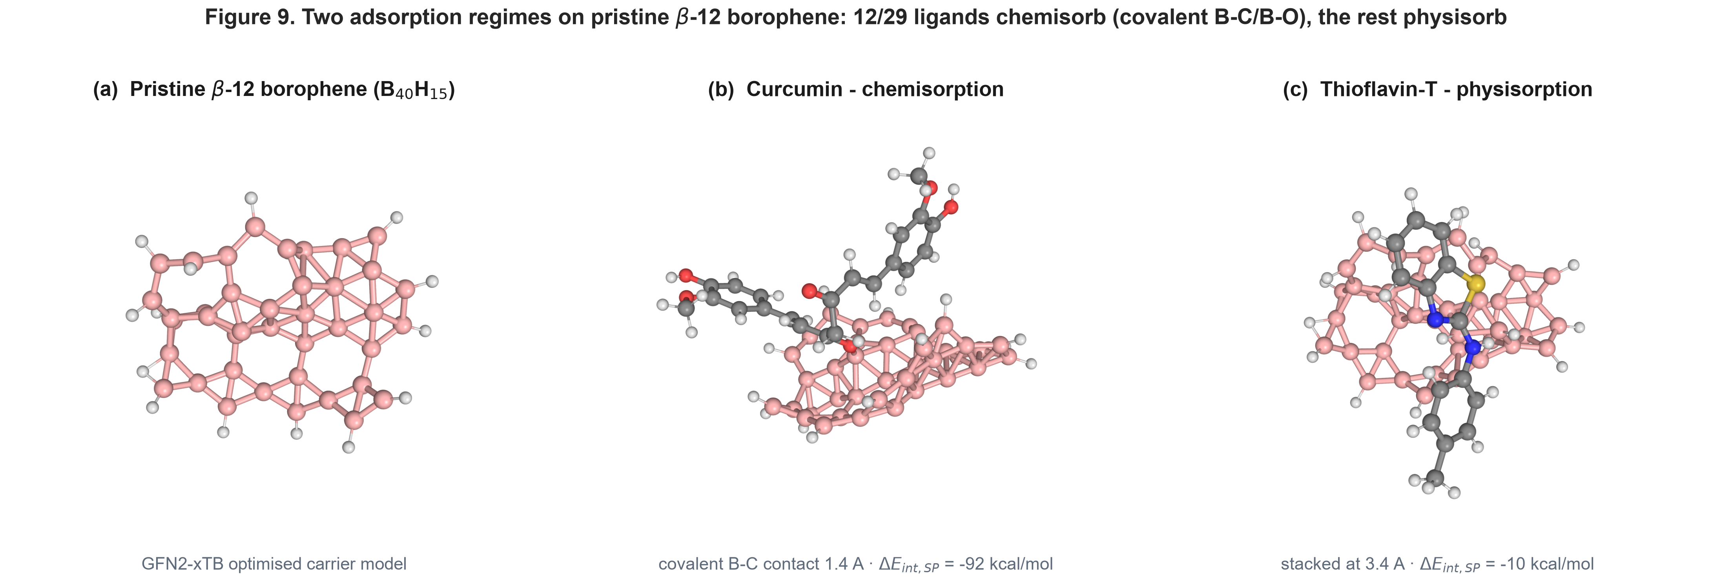
Figure 9: The two adsorption regimes on pristine beta-12 borophene, from the GFN2-xTB relaxed complexes. (a) pristine B40H15 carrier; (b) curcumin chemisorbed via a covalent B-C bond (contact 1.4 A, Delta_E_int,SP = -92 kcal/mol); (c) thioflavin-T physisorbed, stacked flat at 3.4 A (Delta_E_int,SP = -10 kcal/mol).

2.5 Interfacial charge redistribution
For the most strongly interacting system, the charge-density difference Delta_rho = rho(complex) - rho(carrier) - rho(drug) was computed from the real GFN2-xTB densities of the curcumin / beta-12 borophene complex in its best-orientation relaxed pose, all fragments taken at the bound geometry on a common grid (Figure 10). A single compact pair of accumulation (yellow) and depletion (blue) lobes forms where the curcumin enol/methine carbon approaches the borophene sheet (nearest-atom separation 1.4 Angstrom), i.e. the interaction here is a short-range, orbital-mediated contact rather than pure dispersion. Weaker adsorbates in the set show no comparable interfacial feature. The Delta_rho cube and its build script are in results/quantum/drho/.
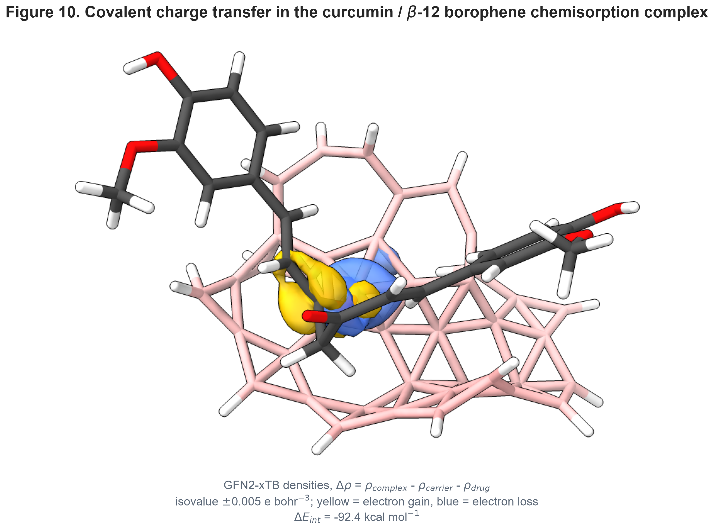
Figure 10: Charge-density difference (real GFN2-xTB densities) for the curcumin / beta-12 borophene chemisorption complex. Isovalue +/-0.005 e bohr^-3; yellow = electron accumulation, blue = depletion. Delta_E_int,SP = -92 kcal/mol; closest B-C contact 1.4 A.
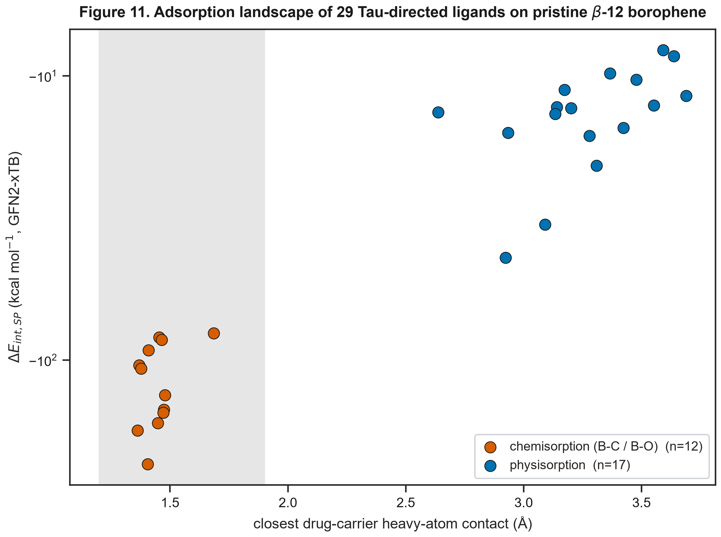
Figure 11: GFN2-xTB adsorption landscape of the 29 Tau-directed ligands on pristine beta-12 borophene - closest drug-carrier heavy-atom contact vs Delta_E_int,SP. The two regimes are cleanly separated: 12 chemisorbers (grey band, covalent B-C/B-O at ~1.4 A, -81 to -233 kcal/mol) and 17 physisorbers (2.6-3.7 A, -8 to -44 kcal/mol).

3. Conclusions
We screened 29 Tau-directed therapeutics against pristine beta-12 borophene (B40H15) with GFN2-xTB, relaxing every drug-surface complex. The central result is that the pristine sheet does not behave as an inert physisorptive carrier: 12 of the 29 ligands - the pi-rich phenols (curcumin, luteolin, apigenin, fisetin, baicalein), the azo and phenothiazine dyes, rosmarinic acid and FDDNP - CHEMISORB, adding a nucleophilic group across an electron-deficient surface boron (B-C/B-O, contact 1.4-1.7 A, Delta_E_int,SP = -81 to -233 kcal/mol). Only 17 sterically shielded rigid aromatics and aliphatic-amine cholinergics physisorb (2.6-3.7 A, -8 to -44 kcal/mol). Adsorption of the reactive chemotype would be effectively irreversible and covalently modify the drug, so pristine borophene is unsuitable as a reversible drug-loading surface for these molecules; a passivated or functionalised borophene that quenches the boron Lewis acidity would be required and was not modelled. A descriptor-based QSPR of the physisorption energy is not predictive (Q2_CV = 0.06, n = 17); docking against the cryo-EM Tau filament core is reported as a relative surface-affinity ranking only.

4. Experimental
4.1 Quantum-chemical framework: All calculations use GFN2-xTB (xtb v6.7.1) with its default D4 dispersion treatment [24,26]. The isolated drugs (RDKit ETKDG + MMFF, then GFN2-xTB) and the hydrogen-terminated beta-12 borophene cluster (B40H15, C1) were geometry-optimised. Each drug-borophene complex was assembled by centring the drug over the sheet, offsetting it 3.2 Angstrom along the surface normal in four in-plane orientations (0, 90, 180, 270 deg) and optimising every orientation; the lowest-energy converged pose whose closest drug-carrier heavy-atom contact lies between 1.25 and 4.0 Angstrom is retained. The standardised interaction energy Delta_E_int,SP = E(complex) - E(borophene) - E(drug) is then evaluated with both fragments frozen at the complex geometry. Contacts below 1.9 Angstrom are classified as chemisorption (covalent B-C/B-O), the rest as physisorption. Conceptual-DFT global reactivity indices (hardness eta = gap/2, softness, electronegativity, electrophilicity omega = mu^2/2eta) [36,37] were read from the xtb output. The full driver (recompute_tau_adsorption.py) is in the repository; no descriptor or energy is estimated from an empirical formula.
4.2 Molecular docking: Docking used AutoDock Vina v1.2.7 [28,29] against the cryo-EM structure of the Alzheimer Tau filament core (PDB ID: 5O3L [7]), with ligands protonated at pH 7.4 and prepared with Meeko. Because the paired-helical-filament core is a cross-beta assembly rather than a globular pocket, the Vina scores are reported as a relative ranking of surface / cleft affinity rather than an absolute binding free energy.
4.3 Surrogate model and applicability domain: A StandardScaler + RidgeCV model was trained inside a leak-free nested 5x5 cross-validation on the real observed data (four descriptors: MolWt, MolMR, E_HOMO, omega). Feature importance was inspected with an ExtraTrees estimator and SHAP [35] and is reported as exploratory only. The applicability domain follows OECD Principle 3 [31-33] via Williams hat-matrix leverage.

Data Availability
All code, the curated dataset, the real GFN2-xTB adsorption outputs (including the relaxed complexes and the recompute_tau_adsorption.py driver), the real AutoDock Vina outputs and the figure/manuscript generators are in the public repository https://github.com/sircalch/borophene-alzheimer-tau-ai and the Zenodo deposit 10.5281/zenodo.22187834. run_entire_tau_study.py reproduces every value and figure.

Supporting Information
Supporting Information File 1: Tau_Borophene_Supporting_Information.docx — curated dataset (N = 29), the per-ligand adsorption regime (chemisorption/physisorption), formal charges and the OECD checklist
The complete input/output archive (curated dataset, GFN2-xTB and docking outputs, cross-validation predictions, figure-generation and manuscript scripts) is in the public repository and Zenodo deposit cited under Data Availability; every value in this article is reproduced by run_entire_*_study.py.

Funding
This work was supported by Universidad Estatal de Sonora and the Doctorado en Nanotecnología, Universidad de Sonora. No external grant funding was received.

Acknowledgements
The authors thank the computational resources of Universidad Estatal de Sonora and Universidad de Sonora.

Author Contributions
Andrés Monreal Hernández: conceptualization, methodology, software, formal analysis, investigation, data curation, visualization, writing – original draft. Sara Lizbeth Franco Amaya: validation, writing – review and editing. Carlos Ivanhoe Martínez Osorio: supervision, writing – review and editing. All authors read and approved the final manuscript.

Conflict of Interest
The authors declare no competing financial or non-financial interest.

ORCID iDs
Andrés Monreal Hernández – https://orcid.org/0009-0009-1207-8597

References
1. Scheltens, P.; De Strooper, B.; Kivipelto, M.; Holstege, H.; Chételat, G.; Teunissen, C. E.; Cummings, J.; van der Flier, W. M. Alzheimer's disease. The Lancet 2021, 397 (10284), 1577-1590. doi:10.1016/s0140-6736(20)32205-4
2. Gao, Y.; Tan, L.; Yu, J. T.; Tan, L. Tau in Alzheimer's Disease: Mechanisms and Therapeutic Strategies. Current Alzheimer Research 2018, 15 (3), 283-300. doi:10.2174/1567205014666170417111859
3. Braak, H.; Braak, E. Neuropathological stageing of Alzheimer-related changes. Acta Neuropathologica 1991, 82 (4), 239-259. doi:10.1007/bf00308809
4. Wang, Y.; Mandelkow, E. Tau in physiology and pathology. Nature Reviews Neuroscience 2015, 17 (1), 22-35. doi:10.1038/nrn.2015.1
5. Iqbal, K.; Liu, F.; Gong, C. X.; Grundke-Iqbal, I. Tau in Alzheimer Disease and Related Tauopathies. Current Alzheimer Research 2010, 7 (8), 656-664. doi:10.2174/156720510793611592
6. Spillantini, M. G.; Goedert, M. Tau pathology and neurodegeneration. The Lancet Neurology 2013, 12 (6), 609-622. doi:10.1016/s1474-4422(13)70090-5
7. Fitzpatrick, A. W. P.; Falcon, B.; He, S.; Murzin, A. G.; Murshudov, G.; Garringer, H. J.; Crowther, R. A.; Ghetti, B.; Goedert, M.; Scheres, S. H. W. Cryo-EM structures of tau filaments from Alzheimer’s disease. Nature 2017, 547 (7662), 185-190. doi:10.1038/nature23002
8. Falcon, B.; Zhang, W.; Murzin, A. G.; Murshudov, G.; Garringer, H. J.; Vidal, R.; Crowther, R. A.; Ghetti, B.; Scheres, S. H. W.; Goedert, M. Structures of filaments from Pick’s disease reveal a novel tau protein fold. Nature 2018, 561 (7721), 137-140. doi:10.1038/s41586-018-0454-y
9. Zhang, W.; Tarutani, A.; Newell, K. L.; Murzin, A. G.; Matsubara, T.; Falcon, B.; Vidal, R.; Garringer, H. J.; Shi, Y.; Ikeuchi, T.; et al. Novel tau filament fold in corticobasal degeneration. Nature 2020, 580 (7802), 283-287. doi:10.1038/s41586-020-2043-0
10. Shi, Y.; Zhang, W.; Yang, Y.; Murzin, A. G.; Falcon, B.; Kotecha, A.; van Beers, M.; Tarutani, A.; Kametani, F.; Garringer, H. J.; et al. Structure-based classification of tauopathies. Nature 2021, 598 (7880), 359-363. doi:10.1038/s41586-021-03911-7
11. Wischik, C. M.; Edwards, P. C.; Lai, R. Y.; Roth, M.; Harrington, C. R. Selective inhibition of Alzheimer disease-like tau aggregation by phenothiazines. Proceedings of the National Academy of Sciences 1996, 93 (20), 11213-11218. doi:10.1073/pnas.93.20.11213
12. Baddeley, T. C.; McCaffrey, J.; M. D. Storey, J.; Cheung, J. K.; Melis, V.; Horsley, D.; Harrington, C. R.; Wischik, C. M. Complex Disposition of Methylthioninium Redox Forms Determines Efficacy in Tau Aggregation Inhibitor Therapy for Alzheimer’s Disease. The Journal of Pharmacology and Experimental Therapeutics 2015, 352 (1), 110-118. doi:10.1124/jpet.114.219352
13. Gobbi, L. C.; Knust, H.; Körner, M.; Honer, M.; Czech, C.; Belli, S.; Muri, D.; Edelmann, M. R.; Hartung, T.; Erbsmehl, I.; et al. Identification of Three Novel Radiotracers for Imaging Aggregated Tau in Alzheimer’s Disease with Positron Emission Tomography. Journal of Medicinal Chemistry 2017, 60 (17), 7350-7370. doi:10.1021/acs.jmedchem.7b00632
14. Bieschke, J.; Russ, J.; Friedrich, R. P.; Ehrnhoefer, D. E.; Wobst, H.; Neugebauer, K.; Wanker, E. E. EGCG remodels mature α-synuclein and amyloid-β fibrils and reduces cellular toxicity. Proceedings of the National Academy of Sciences 2010, 107 (17), 7710-7715. doi:10.1073/pnas.0910723107
15. Rane, J. S.; Bhaumik, P.; Panda, D. Curcumin Inhibits Tau Aggregation and Disintegrates Preformed Tau Filaments in vitro. Journal of Alzheimer's Disease 2017, 60 (3), 999-1014. doi:10.3233/jad-170351
16. Wagner, J.; Ryazanov, S.; Leonov, A.; Levin, J.; Shi, S.; Schmidt, F.; Prix, C.; Pan-Montojo, F.; Bertsch, U.; Mitteregger-Kretzschmar, G.; et al. Anle138b: a novel oligomer modulator for disease-modifying therapy of neurodegenerative diseases such as prion and Parkinson’s disease. Acta Neuropathologica 2013, 125 (6), 795-813. doi:10.1007/s00401-013-1114-9
17. Serpell, L. C. Alzheimer’s amyloid fibrils: structure and assembly. Biochimica et Biophysica Acta (BBA) - Molecular Basis of Disease 2000, 1502 (1), 16-30. doi:10.1016/s0925-4439(00)00029-6
18. Congdon, E. E.; Sigurdsson, E. M. Tau-targeting therapies for Alzheimer disease. Nature Reviews Neurology 2018, 14 (7), 399-415. doi:10.1038/s41582-018-0013-z
19. Seidler, P. M.; Boyer, D. R.; Rodriguez, J. A.; Sawaya, M. R.; Cascio, D.; Murray, K.; Gonen, T.; Eisenberg, D. S. Structure-based inhibitors of tau aggregation. Nature Chemistry 2017, 10 (2), 170-176. doi:10.1038/nchem.2889
20. Bouter, C.; Henniges, P.; Franke, T. N.; Irwin, C.; Sahlmann, C. O.; Sichler, M. E.; Beindorff, N.; Bayer, T. A.; Bouter, Y. 18F-FDG-PET Detects Drastic Changes in Brain Metabolism in the Tg4–42 Model of Alzheimer’s Disease. Frontiers in Aging Neuroscience 2019, 10. doi:10.3389/fnagi.2018.00425
21. Mannix, A. J.; Zhou, X. F.; Kiraly, B.; Wood, J. D.; Alducin, D.; Myers, B. D.; Liu, X.; Fisher, B. L.; Santiago, U.; Guest, J. R.; et al. Synthesis of borophenes: Anisotropic, two-dimensional boron polymorphs. Science 2015, 350 (6267), 1513-1516. doi:10.1126/science.aad1080
22. Feng, B.; Zhang, J.; Zhong, Q.; Li, W.; Li, S.; Li, H.; Cheng, P.; Meng, S.; Chen, L.; Wu, K. Experimental realization of two-dimensional boron sheets. Nature Chemistry 2016, 8 (6), 563-568. doi:10.1038/nchem.2491
23. Zhang, Z.; Penev, E. S.; Yakobson, B. I. Two-dimensional boron: structures, properties and applications. Chemical Society Reviews 2017, 46 (22), 6746-6763. doi:10.1039/c7cs00261k
24. Bannwarth, C.; Ehlert, S.; Grimme, S. GFN2-xTB─An Accurate and Broadly Parametrized Self-Consistent Tight-Binding Quantum Chemical Method with Multipole Electrostatics and Density-Dependent Dispersion Contributions. Journal of Chemical Theory and Computation 2019, 15 (3), 1652-1671. doi:10.1021/acs.jctc.8b01176
25. Grimme, S.; Bannwarth, C.; Shushkov, P. A Robust and Accurate Tight-Binding Quantum Chemical Method for Structures, Vibrational Frequencies, and Noncovalent Interactions of Large Molecular Systems Parametrized for All spd-Block Elements ( Z = 1–86). Journal of Chemical Theory and Computation 2017, 13 (5), 1989-2009. doi:10.1021/acs.jctc.7b00118
26. Caldeweyher, E.; Ehlert, S.; Hansen, A.; Neugebauer, H.; Spicher, S.; Bannwarth, C.; Grimme, S. A generally applicable atomic-charge dependent London dispersion correction. The Journal of Chemical Physics 2019, 150 (15). doi:10.1063/1.5090222
27. Grimme, S.; Ehrlich, S.; Goerigk, L. Effect of the damping function in dispersion corrected density functional theory. Journal of Computational Chemistry 2011, 32 (7), 1456-1465. doi:10.1002/jcc.21759
28. Trott, O.; Olson, A. J. AutoDock Vina: Improving the speed and accuracy of docking with a new scoring function, efficient optimization, and multithreading. Journal of Computational Chemistry 2009, 31 (2), 455-461. doi:10.1002/jcc.21334
29. Eberhardt, J.; Santos-Martins, D.; Tillack, A. F.; Forli, S. AutoDock Vina 1.2.0: New Docking Methods, Expanded Force Field, and Python Bindings. Journal of Chemical Information and Modeling 2021, 61 (8), 3891-3898. doi:10.1021/acs.jcim.1c00203
30. Landrum, G. et al. RDKit: Open-source cheminformatics toolkit, version 2024.03.1. https://www.rdkit.org (accessed 2026). doi:10.5281/zenodo.10848032
31. OECD. Guidance Document on the Validation of (Quantitative) Structure-Activity Relationship [(Q)SAR] Models; OECD Environment Health and Safety Publications, Series on Testing and Assessment No. 69; OECD Publishing: Paris, 2007. doi:10.1787/9789264085442-en
32. Gramatica, P. Principles of QSAR models validation: internal and external. QSAR & Combinatorial Science 2007, 26 (5), 694-701. doi:10.1002/qsar.200610151
33. Tropsha, A. Best Practices for QSAR Model Development, Validation, and Exploitation. Molecular Informatics 2010, 29 (6-7), 476-488. doi:10.1002/minf.201000061
34. Rücker, C.; Rücker, G.; Meringer, M. y-Randomization and Its Variants in QSPR/QSAR. Journal of Chemical Information and Modeling 2007, 47 (6), 2345-2357. doi:10.1021/ci700157b
35. Lundberg, S. M.; Lee, S.-I. A unified approach to interpreting model predictions. In Advances in Neural Information Processing Systems 30; Guyon, I. et al., Eds.; Curran Associates, Inc., 2017; pp 4765–4774. arXiv:1705.07874.
36. Parr, R. G.; Pearson, R. G. Absolute hardness: companion parameter to absolute electronegativity. Journal of the American Chemical Society 1983, 105 (26), 7512-7516. doi:10.1021/ja00364a005
37. Parr, R. G.; Szentpály, L. v.; Liu, S. Electrophilicity Index. Journal of the American Chemical Society 1999, 121 (9), 1922-1924. doi:10.1021/ja983494x
38. Hopkins, A. L.; Groom, C. R.; Alex, A. Ligand efficiency: a useful metric for lead selection. Drug Discovery Today 2004, 9 (10), 430-431. doi:10.1016/s1359-6446(04)03069-7
39. Kramer, C.; Gedeck, P. Leave-many-out cross-validation and the applicability domain of QSAR models. J. Chem. Inf. Model. 2012, 52 (3), 697–707. doi:10.1021/ci9003105
40. Cherkasov, A.; Muratov, E. N.; Fourches, D.; Varnek, A.; Baskin, I. I.; Cronin, M.; Dearden, J.; Gramatica, P.; Martin, Y. C.; Todeschini, R.; et al. QSAR Modeling: Where Have You Been? Where Are You Going To?. Journal of Medicinal Chemistry 2014, 57 (12), 4977-5010. doi:10.1021/jm4004285
41. Veber, D. F.; Johnson, S. R.; Cheng, H. Y.; Smith, B. R.; Ward, K. W.; Kopple, K. D. Molecular Properties That Influence the Oral Bioavailability of Drug Candidates. Journal of Medicinal Chemistry 2002, 45 (12), 2615-2623. doi:10.1021/jm020017n
42. Lipinski, C. A.; Lombardo, F.; Dominy, B. W.; Feeney, P. J. Experimental and computational approaches to estimate solubility and permeability in drug discovery and development settings 1PII of original article: S0169-409X(96)00423-1. The article was originally published in Advanced Drug Delivery Reviews 23 (1997) 3–25. 1. Advanced Drug Delivery Reviews 2001, 46 (1-3), 3-26. doi:10.1016/s0169-409x(00)00129-0

