Tau-directed drugs on β₁₂ borophene: docking at the GTP-1 site of Alzheimer paired helical filaments and GFN2-xTB adsorption on a substrate-supported sheet
Andrés Monreal Hernández*
Universidad Estatal de Sonora, Ley Federal del Trabajo S/N, Col. Apolo, 83100 Hermosillo, Sonora, Mexico
*Corresponding author: andres.monreal@ues.mx; ORCID 0009-0009-1207-8597

Abstract
Context Tau aggregation inhibitors and imaging probes act on paired helical filaments (PHF) in the Alzheimer brain. For 28 tau-directed and Alzheimer drugs we docked each compound at the GTP-1 tracer site of a PHF cryo-EM structure and computed its adsorption on β₁₂ borophene. Docking into the ligand-free fibril does not reproduce the tracer pose (root-mean-square deviation 6.7 and 6.3 Å); the docking scores are therefore exploratory. An unconstrained borophene flake reconstructs into a compact cluster during adsorption, so the carrier was modelled as a planar B₄₄H₁₆ sheet held at the β₁₂ lattice, as it is when grown on Ag(111). On this sheet 25 drugs physisorb and 3 chemisorb; Congo Red and tideglusib react. Physisorption is strongest for the cationic phenothiazinium and benzothiazolium dyes (ΔE_{int} −69.7 to −99.1 kcal mol⁻¹) and weakest for the symptomatic Alzheimer drugs. A ridge model on four pre-selected descriptors explains part of the variance (Q²_{CV} = 0.23, Y-scrambling p = 0.004), mainly through formal charge.
Methods Structures were taken from PubChem. Drugs were docked with AutoDock Vina 1.2.7 into the PHF segment of PDB 8FUG at the GTP-1 site, with four redocking controls. The carrier and all complexes were computed with GFN2-xTB (xtb 6.7.1), with the boron atoms of the sheet restrained to the β₁₂ lattice; each drug was adsorbed from four relaxed orientations and the regime was assigned from drug–carrier bond formation. Ridge quantitative structure–property relationship (QSPR) models were assessed by nested 5×5 cross-validation, 1,000-fold Y-scrambling and a leverage applicability domain.
Keywords Tau · Paired helical filament · Borophene · GFN2-xTB · Molecular docking · Drug delivery

Introduction
In Alzheimer's disease the microtubule-associated protein tau assembles into paired helical filaments (PHF), whose amount and spread track neurodegeneration [1, 2]. Cryo-EM structures of PHF isolated from patient brain show a C-shaped core of residues 306–378, identical across patients [3, 4]. Small molecules that bind these filaments include imaging probes and aggregation inhibitors: phenothiazines such as methylene blue and its reduced form hydromethylthionine [5–7], polyphenols such as curcumin and EGCG [8, 9], and oligomer modulators such as anle138b [10]. The PET tracer GTP-1 has been resolved bound to PHF at 2.7 Å, stacked along the fibril axis in a cleft of each protofilament (PDB 8FUG) [11], which provides a structurally defined site for docking.
Many of these compounds reach the brain poorly, and two-dimensional materials have been proposed as carriers. Borophene, a single atomic layer of boron, has been grown on Ag(111) in several polymorphs, of which β₁₂ is a triangular lattice with one sixth of the sites vacant [12–14]. It is metallic and, unlike graphene or boron nitride, its boron atoms are electron-deficient, so it may bind drugs through lone-pair donation as well as by dispersion. Freestanding borophene is not stable: it exists on its growth substrate, which keeps it planar [14].
This study characterises a cohort of tau-directed and Alzheimer drugs on two fronts: docking at the GTP-1 site of PHF, with explicit redocking controls, and GFN2-xTB adsorption on a β₁₂ borophene model whose geometry is held at the supported lattice. It reports which drugs physisorb or chemisorb, which react with the sheet, and whether the interaction energy can be anticipated from four molecular descriptors under leak-free validation.

Methods

Compound set
The cohort comprises 29 compounds. Every structure was retrieved from PubChem by name [15] and its identity checked by InChIKey (Online Resource 1, Table S1). Counter-ions were removed and acids and bases neutralised where a neutral form exists; the phenothiazinium dyes and thioflavin T keep their permanent positive charge. Thioflavin S, a mixture of sulfonated oligomers rather than a single compound, was excluded, leaving 28 drugs in four families: 8 dyes and imaging probes, 11 polyphenols, 4 aggregation or kinase modulators and 5 symptomatic Alzheimer drugs.

Docking at the GTP-1 site of PHF
The receptor is the 23-chain PHF segment of PDB 8FUG [11, 16], prepared with PDBFixer [17] (all GTP-1 copies removed, missing atoms added, protonation at pH 7.4) and typed with Meeko. The docking box, a 22 Å cube, was centred on the GTP-1 copy bound to chain K, in the middle of the stack of protofilament 1 and away from the segment ends. Ligands were built from SMILES with RDKit [18] (ETKDGv3 [19], MMFF94 [20]); up to five ring conformers per drug were docked and the best score was kept. Docking used AutoDock Vina 1.2.7 [21, 22] (exhaustiveness 16, nine modes, fixed seed). Four controls were run: GTP-1 redocked from its cryo-EM conformation and from SMILES, each into the ligand-free fibril and into the fibril with the neighbouring GTP-1 copies of the stack kept as receptor atoms. RMSDs were computed on heavy atoms with symmetry correction and without re-alignment. The cohort was docked into the ligand-free fibril. Residues within 4.0 Å of the top pose were counted as contacts, and N/O pairs within 3.5 Å as polar contacts.

β₁₂ borophene model
A first model, an H-terminated B₄₀H₁₅ flake relaxed without constraints, was a local minimum (no imaginary frequencies) but not a stable carrier: in 17 of 28 adsorption complexes its energy fell below that of the isolated flake as it contracted toward a more compact boron cluster, by up to 110.7 kcal mol⁻¹ (Table S2), so that the computed binding energies contained the energy of the reconstruction of the carrier. Because borophene exists only on a supporting metal, which holds it planar [13, 14], the carrier was rebuilt as a substrate-supported sheet. A planar β₁₂ lattice (triangular lattice, B–B 1.69 Å, rectangular cell a = 2.93 Å, b = 5.07 Å, one vacancy per six sites [13, 14]) was cut to a B₄₄H₁₆ flake, and every edge boron that had lost a neighbour was capped with hydrogen. When the whole lattice is scaled uniformly, the GFN2-xTB energy of this planar flake is lowest at the reference B–B distance (Table S3), so the model is not strained against the method. Throughout, the boron atoms were held at the lattice by harmonic restraints on their interatomic distances (xtb $constrain, force constant 5 E_{h} bohr⁻²), and hydrogens and drugs relaxed freely. The singlet lies 2.1 kcal mol⁻¹ below the triplet, and the vanishing HOMO–LUMO gap reflects the metallic character of the sheet; all calculations on the carrier used Fermi smearing (1500 K).

Adsorption calculations
All quantum-chemical calculations used GFN2-xTB [23] (xtb 6.7.1, D4 dispersion [24]) in the gas phase, with the drug in its PubChem charge state. Each drug was relaxed in isolation from its lowest MMFF94 conformer, placed with its mean plane parallel to the sheet 3.2 Å above it, and four rotations about the surface normal (0, 90, 180 and 270°) were relaxed; the lowest-energy converged pose with a closest drug–carrier heavy-atom contact of 1.25–4.0 Å was kept. On that pose the interaction energy ΔE_{int} = E_{complex} − E_{carrier} − E_{drug} was computed with both fragments frozen at the complex geometry. The adsorption energy ΔE_{ads} is referenced to the relaxed drug and to the relaxed restrained sheet. Within the restraints the sheet can buckle by about 0.1 Å, and it has several such minima; the reference energy is the lowest one, obtained by re-relaxing the carrier from each of the 25 physisorbed complexes (21.0 kcal mol⁻¹ below the initial planar geometry; Table S4). A complex was classed as chemisorbed when at least one drug–carrier pair was closer than 1.15 times the sum of the covalent radii. The bonding of every drug was compared before and after adsorption to detect proton transfer or bond breaking.

Descriptors and QSPR model
Four descriptors were fixed before any model was fitted: molecular weight and topological polar surface area (RDKit), the static polarizability α(0) of the relaxed isolated drug (GFN2-xTB) and the formal charge. Conceptual-DFT indices such as electrophilicity [25] were not used, because they are not comparable between neutral and cationic molecules. The target is ΔE_{int} for drugs whose own bonding was unchanged on adsorption. A ridge-regression model (scikit-learn [26], standardisation and penalty inside one pipeline) was evaluated by nested cross-validation, with five outer folds for performance and a five-fold inner loop for the penalty [27]. Chance correlation was tested by repeating the whole procedure on 1,000 permutations of the target [28], and the applicability domain follows OECD principle 3 [29–31] (leverage warning h* = 3(p + 1)/n, standardised residuals within ±3).

Use of AI tools
[AUTHOR TO COMPLETE BEFORE SUBMISSION: statement on the use of AI tools in this work, as required by the journal (Springer policy: use of large language models beyond copy editing must be documented in the Methods).]

Results and discussion
The workflow is summarised in Fig. 1. All quantities are computed; none is fitted to experimental data.
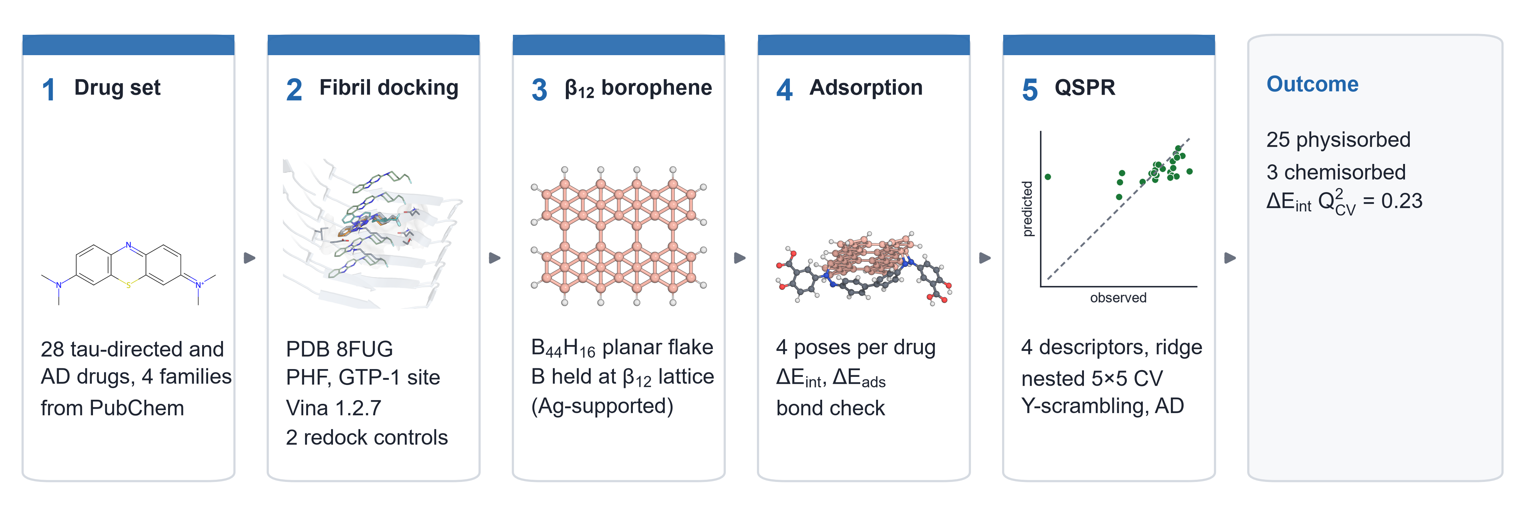
Fig. 1 Workflow of the study: PubChem compound set, docking at the GTP-1 site of Alzheimer PHF (PDB 8FUG), the supported β₁₂ borophene model, GFN2-xTB adsorption, and the QSPR model with its validation. The inset of the last stage is the out-of-fold parity plot of Fig. 7a

Docking at the GTP-1 site
Redocking shows how far docking into a fibril can be trusted. Into the ligand-free fibril, GTP-1 docked 6.7 Å (cryo-EM conformation) and 6.3 Å (from SMILES) away from its observed pose, both outside the usual 2 Å criterion. With the neighbouring GTP-1 copies of the stack kept, the cryo-EM conformation was recovered at 0.71 Å, whereas the ligand rebuilt from SMILES reached 2.81 Å (Fig. 2a; Table S5). The observed pose therefore depends on stacking against the ligands above and below it, which a single-ligand docking into the empty cleft does not reproduce [11]. The cohort scores reported below were obtained on the ligand-free fibril and are an exploratory ranking of how well each drug fits the cleft, not predicted binding modes.
Nearly all top poses sit on the same three residues: Lys353 (100% of drugs), Gln351 (96%) and Ser352 (96%), with polar contacts to Ser352 in 89% and to Gln351 in 64% of drugs (Fig. 2b). These residues line the GTP-1 cleft on consecutive rungs of the stack (chains E, G, I, K, M, O). Scores ranged from −5.1 to −9.3 kcal mol⁻¹ (Fig. 3a); the extended azo dyes chrysamine G and Congo Red scored best, and the small symptomatic drugs worst (family median −5.3 against −7.2 for dyes and probes). Over the whole cohort the score follows molecular size (Spearman ρ = −0.65 with heavy-atom count), as expected for an empirical score [32].
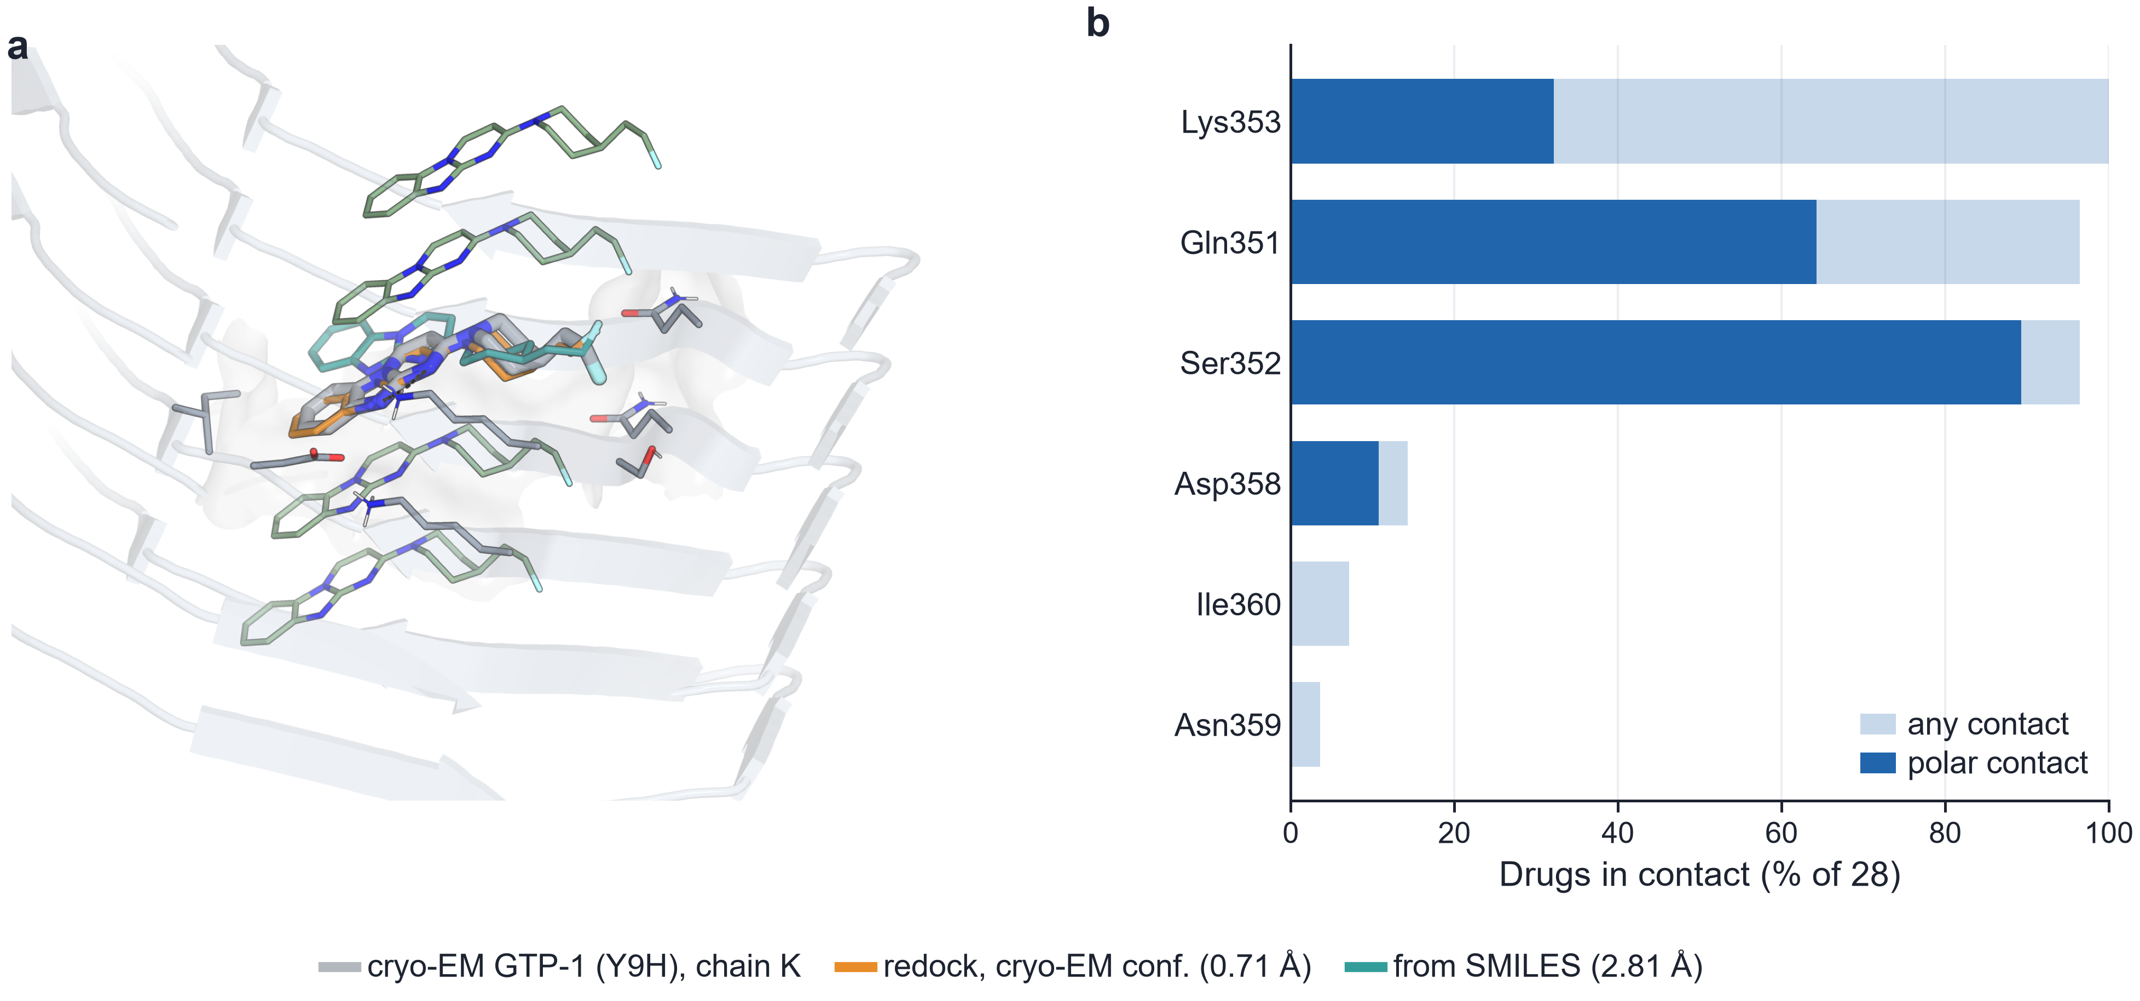
Fig. 2 Docking at the GTP-1 site of PHF (PDB 8FUG). a Cryo-EM GTP-1 bound to chain K (grey), with the stacked copies above and below (green), the pose redocked from its cryo-EM conformation with the stack present (orange, 0.71 Å) and the pose from SMILES (teal, 2.81 Å); contacting side chains as thin sticks. b Percentage of the 28 drugs whose top pose contacts each residue (light bars, any heavy atom within 4.0 Å; dark bars, N/O pairs within 3.5 Å)
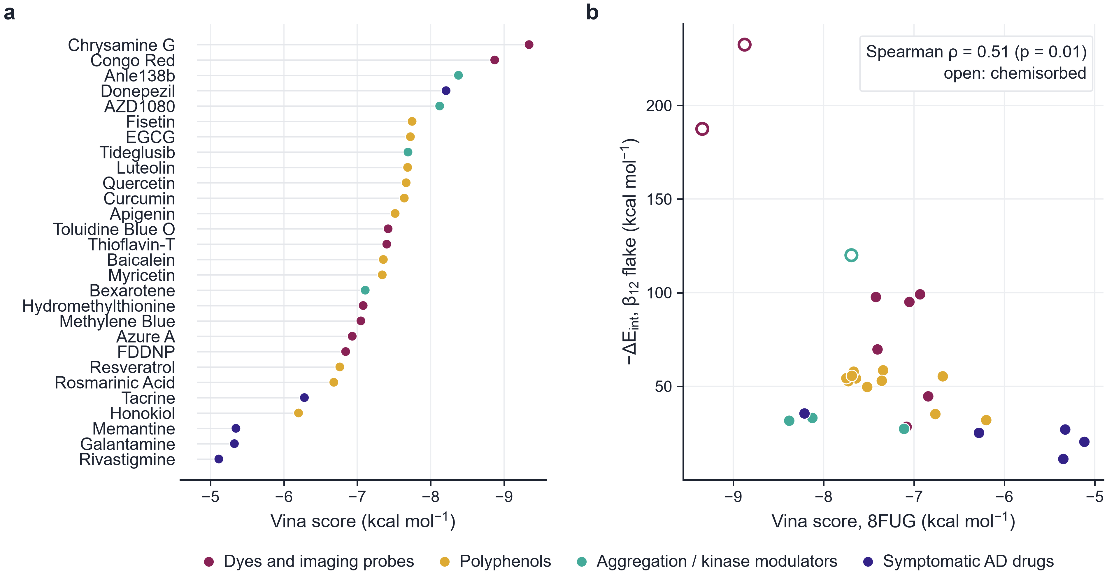
Fig. 3 Docking scores and their relation to adsorption. a Vina score of every drug in the ligand-free fibril, coloured by family. b −ΔE_{int} on the β₁₂ sheet against the Vina score; open symbols, chemisorbed complexes

The supported β₁₂ sheet
The planar B₄₄H₁₆ flake (Fig. 4a) is metallic at the GFN2-xTB level, with a Fermi level near −6.54 eV. For 23 of the 28 drugs this lies above the drug LUMO, and for the cationic dyes it lies several eV above both frontier orbitals (Fig. 4b); at this level of theory the sheet is therefore an electron donor toward most drugs. Absolute GFN2-xTB orbital energies are not quantitative, and the comparison is qualitative.
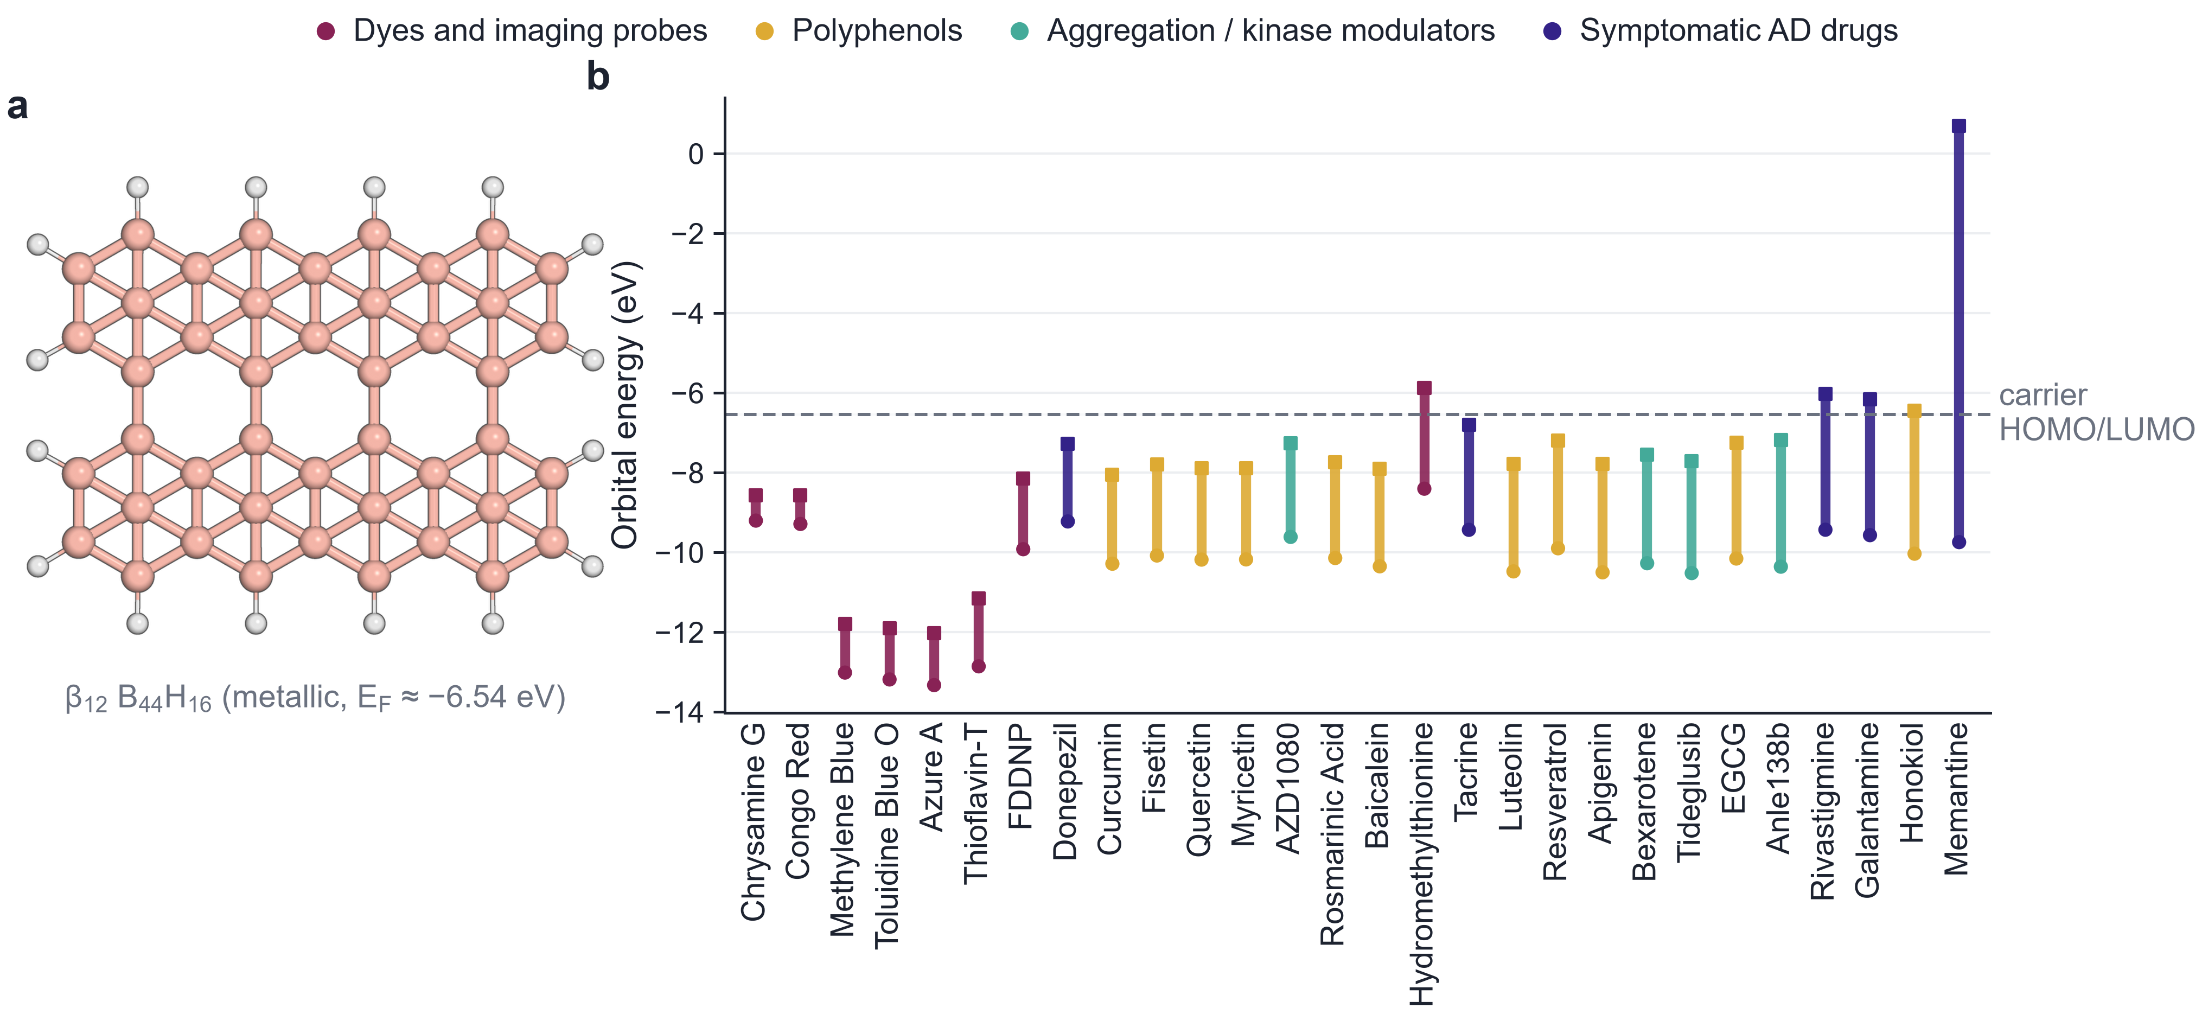
Fig. 4 Carrier and frontier orbitals. a Planar β₁₂ B₄₄H₁₆ flake (B pink, H white). b GFN2-xTB HOMO (circles) and LUMO (squares) of the relaxed drugs, sorted by gap and coloured by family; dashed line, Fermi level of the sheet

Adsorption
On the supported sheet 25 of the 28 drugs physisorbed, with closest contacts of 2.87–3.58 Å and ΔE_{int} from −11.1 to −99.1 kcal mol⁻¹ (Fig. 5, Table 1). The strongest physisorbed drugs are the four cations (methylene blue, azure A, toluidine blue O and thioflavin T, −69.7 to −99.1 kcal mol⁻¹), consistent with electrostatic polarisation of the metallic sheet in addition to dispersion, although the energy was not decomposed; among neutral physisorbed drugs ΔE_{int} ranged from −11.1 to −58.5 kcal mol⁻¹. Across physisorbed drugs the energy follows the formal charge (ρ = −0.64) but not size (ρ = −0.16 with heavy-atom count). The families differ (Kruskal–Wallis p = 0.004; Fig. 5b): the median ΔE_{int} is −96.3 kcal mol⁻¹ for dyes and probes, −54.2 for polyphenols, −32.3 for modulators and −25.1 for symptomatic drugs. In the gas phase the cation–sheet attraction is not screened; in water it would be weaker, so the gap between cationic and neutral drugs is likely overestimated here.
Three drugs chemisorbed. Chrysamine G bonded to boron through three of its four azo nitrogens (ΔE_{int} −187.5 kcal mol⁻¹) without any change in its own bonding (Fig. 6a). Congo Red transferred the proton of a sulfonic acid group to a boron atom and bonded to boron through a sulfonate oxygen (−232.5; Fig. 6c); as a disodium salt in practice, it would not carry that proton. Tideglusib opened its thiadiazolidinedione ring at the S–N bond and bonded to boron through sulfur (−120.0). For these two drugs ΔE_{int} contains a reaction energy. The electron-deficient boron sheet thus forms B–N bonds with azo nitrogens, takes up an acidic proton and opens a strained S–N heterocycle, but binds the phenothiazines, flavonoids and cholinesterase inhibitors by physisorption alone.
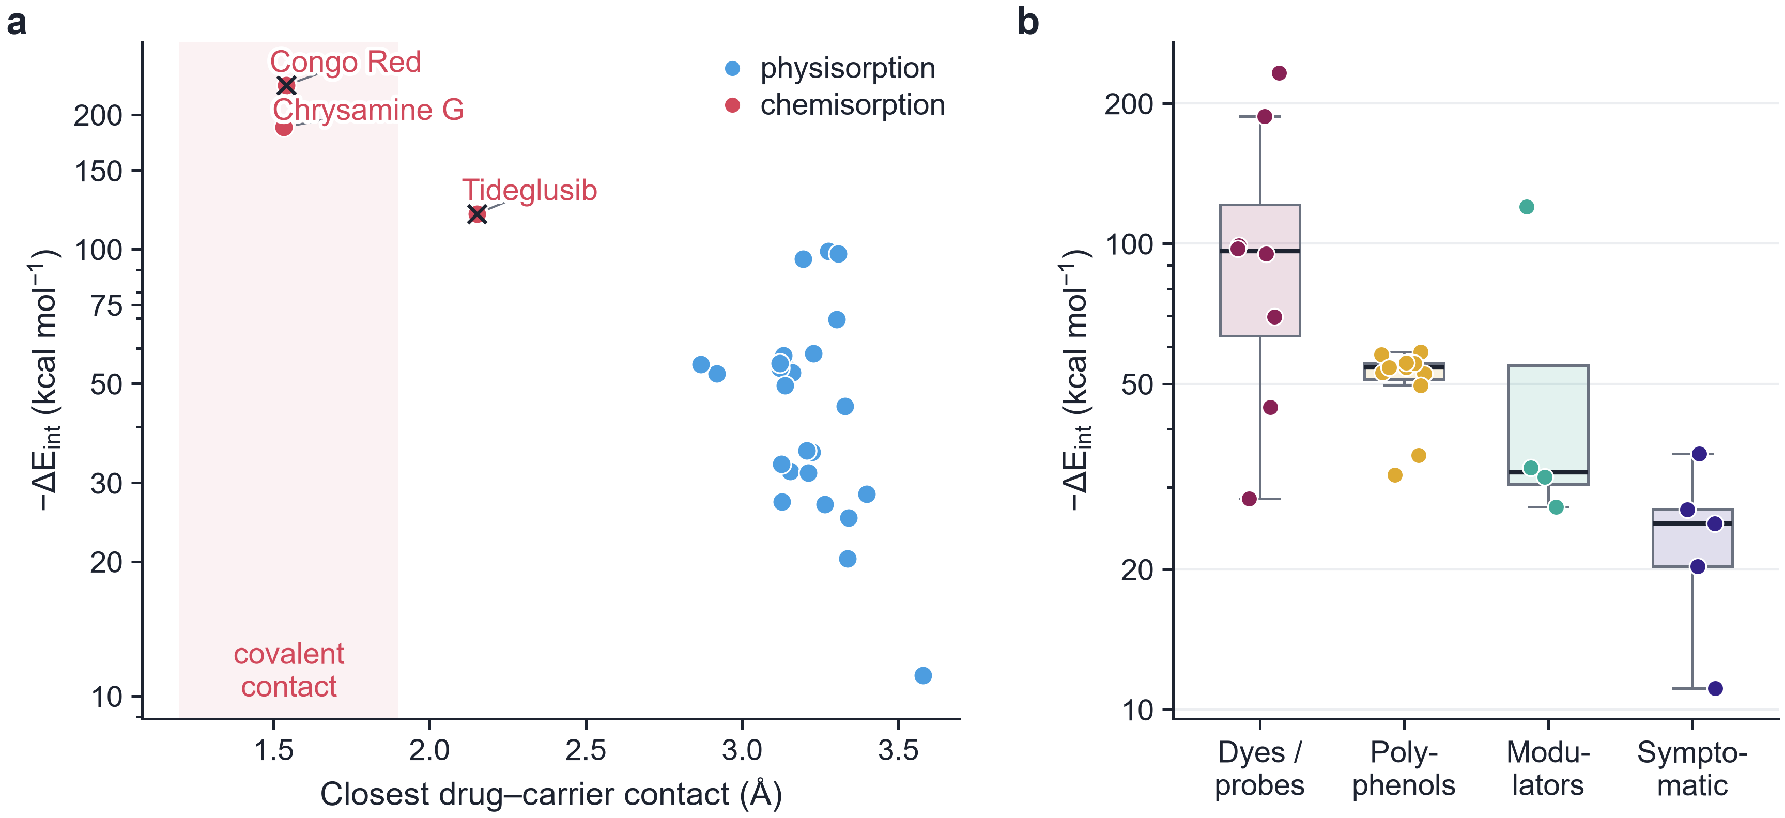
Fig. 5 Adsorption on the supported β₁₂ sheet. a −ΔE_{int} against the closest drug–carrier heavy-atom contact, coloured by regime (chemisorption: at least one drug–carrier pair closer than 1.15 times the sum of covalent radii; crosses, drugs whose own bonding changed). b −ΔE_{int} by family; boxes show the median and interquartile range
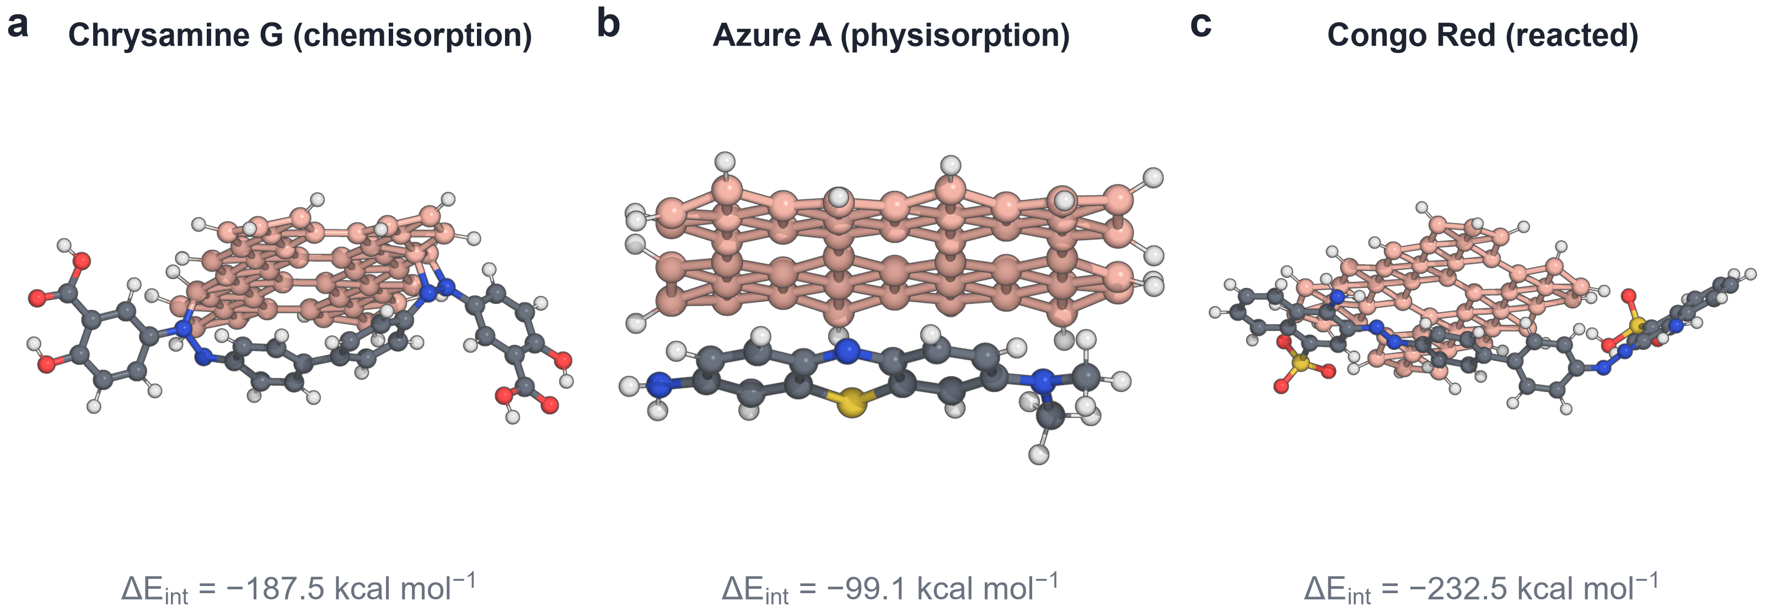
Fig. 6 Relaxed GFN2-xTB complexes. a Chrysamine G (chemisorbed, strongest intact binder). b Azure A (strongest physisorbed). c Congo Red, which transferred a proton to the sheet. Colours: B pink, C grey, N blue, O red, S yellow, H white
Table 1 Docking and adsorption by drug family.
Family | n | Phys. / chem. | Vina | ΔE_{int} | ΔE_{ads}
Dyes and imaging probes | 8 | 6 / 2 | −7.2 | −96.3 (−28.3 to −232.5) | −83.1
Polyphenols | 11 | 11 / 0 | −7.5 | −54.2 (−31.9 to −58.5) | −43.3
Aggregation / kinase modulators | 4 | 3 / 1 | −7.9 | −32.3 (−27.2 to −120.0) | −26.7
Symptomatic AD drugs | 5 | 5 / 0 | −5.3 | −25.1 (−11.1 to −35.4) | −17.6
Energies in kcal mol⁻¹; Vina, median score in PDB 8FUG; ΔE_{int}, median (range); ΔE_{ads}, median. Per-drug values are in Table S6.

Docking score and adsorption
Drugs that score well at the GTP-1 site also bind the sheet more strongly (Spearman ρ = 0.51, p = 0.006; Fig. 3b). The trend appears to come from the two ends of the cohort: the extended, planar dyes, which fit the elongated cleft and stack on the sheet, and the small aliphatic symptomatic drugs, which do neither well; it should not be read as a mechanistic link between the two endpoints.

QSPR model of the interaction energy
For the 26 drugs that kept their bonding, the ridge model reaches an out-of-fold Q²_{CV} of 0.23 (RMSE 30.7, MAE 17.4 kcal mol⁻¹; Table 2, Fig. 7). Only 3 of 1,000 permuted targets gave a Q²_{CV} as high (p = 0.004), so the signal is real, but it is weak and uneven: the outer-fold Q² values range from −14.71 to 0.22. The largest standardised coefficient is that of formal charge (−22.29), which separates the four cations from the rest; chrysamine G, bound through three N–B bonds, is under-predicted by about 128.4 kcal mol⁻¹ and is a residual outlier, and anle138b lies beyond the leverage threshold. The model captures the cation effect but not the chemistry of individual contacts, and it should not be used to rank new compounds.
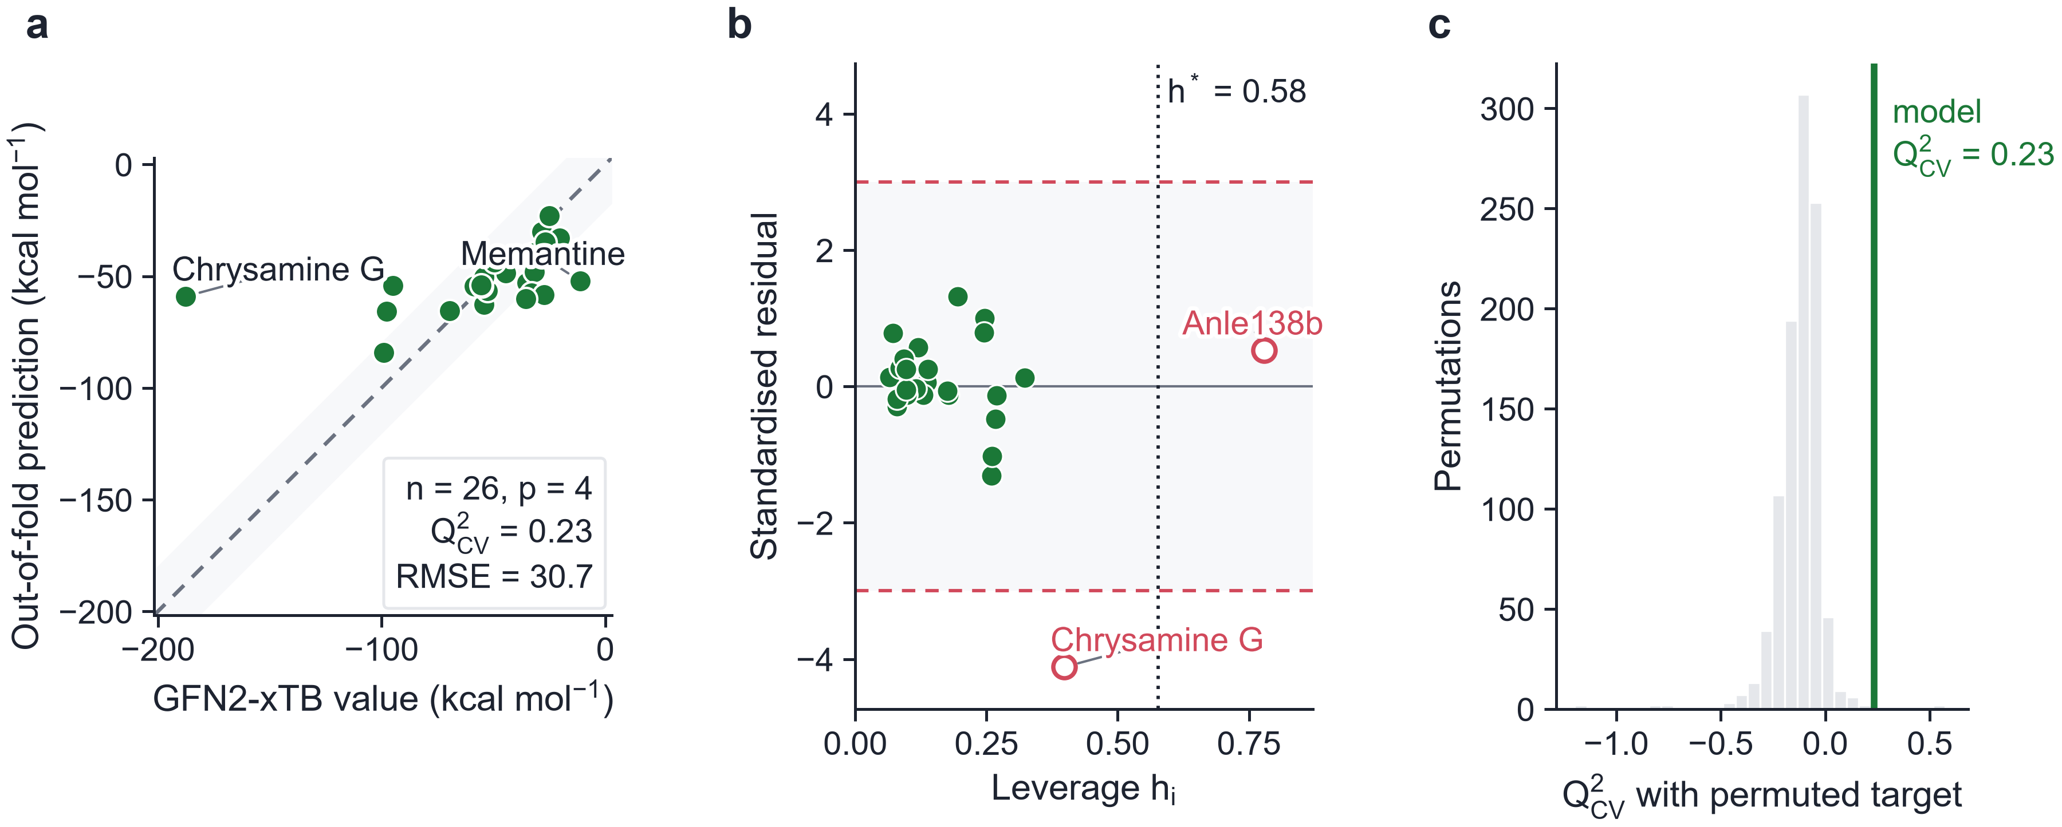
Fig. 7 Validation of the QSPR model for ΔE_{int}. a Out-of-fold predictions from nested 5×5 cross-validation against the GFN2-xTB values; the shaded band is ±10% of the range. b Williams plot (dotted line, h*; open symbols, outside the applicability domain). c Distribution of Q²_{CV} over 1,000 permuted targets, with the value of the model
Table 2 Ridge QSPR model of ΔE_{int} (MW, TPSA, α(0), formal charge) under nested 5×5 cross-validation.
Quantity | Value
n, p | 26, 4
Q²_{CV} (out-of-fold) | 0.23
Q² of the outer folds | 0.04, 0.07, 0.22, −14.71, −0.76
RMSE / MAE (kcal mol⁻¹) | 30.7 / 17.4
Ridge penalty λ (inner CV) | 1
Standardised coefficients | MW 2.79, TPSA −17.74, α(0) −13.31, charge −22.29
Y-scrambling, 1,000 runs: mean Q²; p | −0.13; 0.004
Applicability domain: h*; outside | 0.58; Chrysamine G, Anle138b
Excluded (bonding changed) | Congo Red, Tideglusib

Limitations
The docking controls fail on the ligand-free fibril, so the cohort scores are exploratory. The carrier is a finite flake whose boron atoms are held at the lattice of Ag-supported β₁₂ borophene; the metal substrate itself, which interacts electronically with the sheet [13], is not included. All energies are gas-phase GFN2-xTB values [23]; the interactions of the cationic dyes and the bond-forming events in particular should be revisited with DFT and implicit or explicit solvent. None of the results has been compared with experiment.

Conclusions
Docking into the ligand-free PHF of PDB 8FUG places nearly every drug on Gln351, Ser352 and Lys353, but it does not reproduce the stacked GTP-1 pose, and its scores are exploratory. A finite, unconstrained borophene flake is not a usable carrier model at the GFN2-xTB level, because it reconstructs during adsorption; a planar sheet held at the β₁₂ lattice, as on Ag(111), is. On this sheet 25 of 28 drugs physisorb, the cationic dyes most strongly, and 3 chemisorb, of which Congo Red and tideglusib react. The interaction energy is partly predictable from four descriptors (Q²_{CV} = 0.23), mainly through formal charge. Calculations with the metal substrate and with solvent are the next step before any experimental test.

References
1. Wang Y, Mandelkow E (2016) Tau in physiology and pathology. Nat Rev Neurosci 17:22–35. https://doi.org/10.1038/nrn.2015.1
2. Congdon EE, Sigurdsson EM (2018) Tau-targeting therapies for Alzheimer disease. Nat Rev Neurol 14:399–415. https://doi.org/10.1038/s41582-018-0013-z
3. Fitzpatrick AWP, Falcon B, He S, Murzin AG, Murshudov G, Garringer HJ, Crowther RA, Ghetti B, Goedert M, Scheres SHW (2017) Cryo-EM structures of tau filaments from Alzheimer’s disease. Nature 547:185–190. https://doi.org/10.1038/nature23002
4. Shi Y, Zhang W, Yang Y, Murzin AG, Falcon B, Kotecha A, van Beers M, Tarutani A, Kametani F, Garringer HJ et al (2021) Structure-based classification of tauopathies. Nature 598:359–363. https://doi.org/10.1038/s41586-021-03911-7
5. Wischik CM, Edwards PC, Lai RY, Roth M, Harrington CR (1996) Selective inhibition of Alzheimer disease-like tau aggregation by phenothiazines. Proc Natl Acad Sci USA 93:11213–11218. https://doi.org/10.1073/pnas.93.20.11213
6. Baddeley TC, McCaffrey J, Storey JMD, Cheung JKS, Melis V, Horsley D, Harrington CR, Wischik CM (2015) Complex Disposition of Methylthioninium Redox Forms Determines Efficacy in Tau Aggregation Inhibitor Therapy for Alzheimer’s Disease. J Pharmacol Exp Ther 352:110–118. https://doi.org/10.1124/jpet.114.219352
7. Gauthier S, Feldman HH, Schneider LS, Wilcock GK, Frisoni GB, Hardlund JH, Moebius HJ, Bentham P, Kook KA, Wischik DJ et al (2016) Efficacy and safety of tau-aggregation inhibitor therapy in patients with mild or moderate Alzheimer's disease: a randomised, controlled, double-blind, parallel-arm, phase 3 trial. Lancet 388:2873–2884. https://doi.org/10.1016/s0140-6736(16)31275-2
8. Rane JS, Bhaumik P, Panda D (2017) Curcumin Inhibits Tau Aggregation and Disintegrates Preformed Tau Filaments in vitro. J Alzheimers Dis 60:999–1014. https://doi.org/10.3233/jad-170351
9. Wobst HJ, Sharma A, Diamond MI, Wanker EE, Bieschke J (2015) The green tea polyphenol (−)-epigallocatechin gallate prevents the aggregation of tau protein into toxic oligomers at substoichiometric ratios. FEBS Lett 589:77–83. https://doi.org/10.1016/j.febslet.2014.11.026
10. Wagner J, Ryazanov S, Leonov A, Levin J, Shi S, Schmidt F, Prix C, Pan-Montojo F, Bertsch U, Mitteregger-Kretzschmar G et al (2013) Anle138b: a novel oligomer modulator for disease-modifying therapy of neurodegenerative diseases such as prion and Parkinson’s disease. Acta Neuropathol 125:795–813. https://doi.org/10.1007/s00401-013-1114-9
11. Merz GE, Chalkley MJ, Tan SK, Tse E, Lee J, Prusiner SB, Paras NA, DeGrado WF, Southworth DR (2023) Stacked binding of a PET ligand to Alzheimer’s tau paired helical filaments. Nat Commun 14:3048. https://doi.org/10.1038/s41467-023-38537-y
12. Mannix AJ, Zhou XF, Kiraly B, Wood JD, Alducin D, Myers BD, Liu X, Fisher BL, Santiago U, Guest JR et al (2015) Synthesis of borophenes: Anisotropic, two-dimensional boron polymorphs. Science 350:1513–1516. https://doi.org/10.1126/science.aad1080
13. Feng B, Zhang J, Zhong Q, Li W, Li S, Li H, Cheng P, Meng S, Chen L, Wu K (2016) Experimental realization of two-dimensional boron sheets. Nat Chem 8:563–568. https://doi.org/10.1038/nchem.2491
14. Zhang Z, Penev ES, Yakobson BI (2017) Two-dimensional boron: structures, properties and applications. Chem Soc Rev 46:6746–6763. https://doi.org/10.1039/c7cs00261k
15. Kim S, Chen J, Cheng T, Gindulyte A, He J, He S, Li Q, Shoemaker BA, Thiessen PA, Yu B et al (2021) PubChem in 2021: new data content and improved web interfaces. Nucleic Acids Res 49:D1388–D1395. https://doi.org/10.1093/nar/gkaa971
16. Berman HM, Westbrook J, Feng Z, Gilliland G, Bhat TN, Weissig H, Shindyalov IN, Bourne PE (2000) The Protein Data Bank. Nucleic Acids Res 28:235–242. https://doi.org/10.1093/nar/28.1.235
17. Eastman P, Swails J, Chodera JD, McGibbon RT, Zhao Y, Beauchamp KA, Wang LP, Simmonett AC, Harrigan MP, Stern CD et al (2017) OpenMM 7: rapid development of high performance algorithms for molecular dynamics. PLoS Comput Biol 13:e1005659. https://doi.org/10.1371/journal.pcbi.1005659
18. Landrum G et al (2024) RDKit: open-source cheminformatics, version 2024.03. https://www.rdkit.org. https://doi.org/10.5281/zenodo.591637
19. Wang S, Witek J, Landrum GA, Riniker S (2020) Improving conformer generation for small rings and macrocycles based on distance geometry and experimental torsional-angle preferences. J Chem Inf Model 60:2044–2058. https://doi.org/10.1021/acs.jcim.0c00025
20. Halgren TA (1996) Merck molecular force field. I. Basis, form, scope, parameterization, and performance of MMFF94. J Comput Chem 17:490–519. https://doi.org/10.1002/(SICI)1096-987X(199604)17:5/6<490::AID-JCC1>3.0.CO;2-P
21. Trott O, Olson AJ (2010) AutoDock Vina: improving the speed and accuracy of docking with a new scoring function, efficient optimization, and multithreading. J Comput Chem 31:455–461. https://doi.org/10.1002/jcc.21334
22. Eberhardt J, Santos-Martins D, Tillack AF, Forli S (2021) AutoDock Vina 1.2.0: new docking methods, expanded force field, and Python bindings. J Chem Inf Model 61:3891–3898. https://doi.org/10.1021/acs.jcim.1c00203
23. Bannwarth C, Ehlert S, Grimme S (2019) GFN2-xTB — an accurate and broadly parametrized self-consistent tight-binding quantum chemical method with multipole electrostatics and density-dependent dispersion contributions. J Chem Theory Comput 15:1652–1671. https://doi.org/10.1021/acs.jctc.8b01176
24. Caldeweyher E, Ehlert S, Hansen A, Neugebauer H, Spicher S, Bannwarth C, Grimme S (2019) A generally applicable atomic-charge dependent London dispersion correction. J Chem Phys 150:154122. https://doi.org/10.1063/1.5090222
25. Parr RG, Szentpály Lv, Liu S (1999) Electrophilicity index. J Am Chem Soc 121:1922–1924. https://doi.org/10.1021/ja983494x
26. Pedregosa F, Varoquaux G, Gramfort A, Michel V, Thirion B, Grisel O, Blondel M, Prettenhofer P, Weiss R, Dubourg V et al (2011) Scikit-learn: machine learning in Python. J Mach Learn Res 12:2825–2830
27. Cawley GC, Talbot NLC (2010) On over-fitting in model selection and subsequent selection bias in performance evaluation. J Mach Learn Res 11:2079–2107
28. Rücker C, Rücker G, Meringer M (2007) y-Randomization and its variants in QSPR/QSAR. J Chem Inf Model 47:2345–2357. https://doi.org/10.1021/ci700157b
29. OECD (2007) Guidance document on the validation of (quantitative) structure-activity relationship [(Q)SAR] models. OECD Series on Testing and Assessment, No. 69. OECD Publishing, Paris. https://doi.org/10.1787/9789264085442-en
30. Gramatica P (2007) Principles of QSAR models validation: internal and external. QSAR Comb Sci 26:694–701. https://doi.org/10.1002/qsar.200610151
31. Tropsha A (2010) Best practices for QSAR model development, validation, and exploitation. Mol Inform 29:476–488. https://doi.org/10.1002/minf.201000061
32. Kitchen DB, Decornez H, Furr JR, Bajorath J (2004) Docking and scoring in virtual screening for drug discovery: methods and applications. Nat Rev Drug Discov 3:935–949. https://doi.org/10.1038/nrd1549

Statements and Declarations
Author contribution Andrés Monreal Hernández conceived the study, performed all calculations and analyses, and wrote the manuscript.
Funding No funding was received for this work.
Data availability All input structures, relaxed geometries, docking poses, xtb outputs and result tables are available at https://github.com/sircalch/borophene-alzheimer-tau-ai.
Code availability The complete pipeline, which regenerates every number, table and figure of this article from the raw inputs, is available at https://github.com/sircalch/borophene-alzheimer-tau-ai under the MIT licence. Software: xtb 6.7.1, AutoDock Vina 1.2.7, Meeko, RDKit, PDBFixer/OpenMM, scikit-learn, PyMOL (open source).
Ethics approval Not applicable.
Consent to participate Not applicable.
Consent for publication Not applicable.
Competing interests The author declares no competing interests.

