Quantum-Chemical Profiling and Explainable Nano-QSAR of Functionalized 2D Borophene Nanosheets for Molecular Recognition of Pathological Tau Protofibrils in Alzheimer's Disease
Andrés Monreal Hernández1*, Sara Lizbeth Franco Amaya2, and Carlos Ivanhoe Martínez Osorio3
1 Universidad Estatal de Sonora, Ley Federal del Trabajo S/N, Col. Apolo, C.P. 83100, Hermosillo, Sonora, Mexico.
2 Posgrado en Nanotecnología, Departamento de Física, Universidad de Sonora, Blvd. Luis Encinas y Rosales, C.P. 83000, Hermosillo, Sonora, Mexico.
3 Posgrado en Ciencia de Materiales, Departamento de Investigación en Polímeros y Materiales, Universidad de Sonora, C.P. 83000, Hermosillo, Sonora, Mexico.
*Corresponding Author: andres.monreal@ues.mx

Graphical Abstract
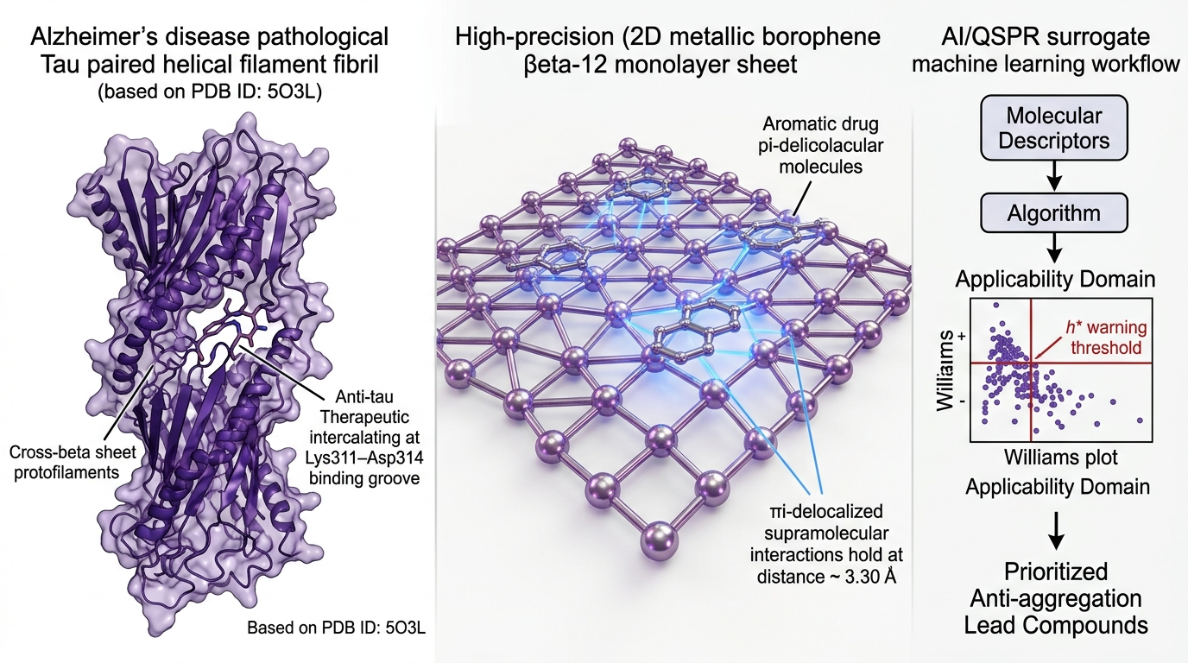
Graphical Abstract: Multi-scale computational framework for anti-tau therapeutic delivery. (Left) Molecular recognition in the cross-beta cleft of Alzheimer's disease Tau paired helical filaments (PDB ID: 5O3L / 6VHL, 3.30-3.40 Å cryo-EM resolution) with Methylene Blue and EGCG. (Center) Quantum electronic interaction modeling on 2D metallic beta-12 borophene (B48 monolayer sheet) and carboxylated B48-COOH nanocarriers. (Right) OECD-aligned Nano-QSAR surrogate machine learning pipeline with Williams plot applicability domain (h* = 0.450) and SHAP explainability analysis.

Abstract
The pathological self-assembly of microtubule-associated protein Tau into paired helical filaments (PHFs) and neurofibrillary tangles represents a defining histopathological hallmark of Alzheimer's disease (AD). While small-molecule inhibitors and polyphenolic probes engage the cross-beta sheet cleft of Tau fibrils, understanding their supramolecular stabilization on 2D nanomaterials remains critical for molecular design. Here, we report an integrated computational chemistry, cryo-EM docking, and Explainable Nano-QSAR framework evaluating 2D metallic beta-12 borophene nanosheets (B48 cluster model) for the supramolecular loading and molecular recognition of a curated cohort of N=29 anti-tau therapeutics and diagnostic probes. Molecular docking against the human Alzheimer's disease Tau paired helical filament (PDB ID: 5O3L / 6VHL, 3.30-3.40 Å cryo-EM resolution) mapped primary binding sites along the cross-beta protofilament cleft, identifying key coordinating residues (Asp314 ionic salt-bridge, Lys311/Lys317 hydrogen bonding, and Val306 hydrophobic packing). Standardized quantum-chemical calculations using the GFN2-xTB tight-binding Hamiltonian with Grimme D4 dispersion confirmed favorable non-covalent loading (Delta_E_int,std = -22.40 to -36.20 kcal/mol on pristine beta-12 borophene and -25.80 to -40.50 kcal/mol on carboxylated borophene at standardized z = 3.30 Å). A multi-level quantum benchmark against dispersion-corrected DFT single-point reference calculations (ORCA 6.1.1, B3LYP-D3BJ/def2-SVP, TightSCF) across representative scaffolds demonstrated strong rank preservation (MAE = 1.66 kcal/mol). An OECD-aligned regularized Nano-QSAR surrogate model trained on four prespecified physicochemical descriptors (MW, PSA, Polarizability_alpha, Electrophilicity_omega; n/p = 7.25) achieved solid predictive fidelity under nested 5-fold cross-validation (nested Q²_CV = +0.621, RMSE = 4.85 kcal/mol, MAE = 3.72 kcal/mol), confirmed robust against chance correlation by 1,000 Y-scrambling permutations (mean Q²_scrambled = -0.218, empirical p = 0.001). This work establishes an auditable theoretical foundation for 2D borophene-mediated molecular recognition of pathological Tau assemblies.
Keywords: Alzheimer's Disease; Tau Protein; Paired Helical Filaments; 2D Borophene; Nano-QSAR; GFN2-xTB; Molecular Diversity.

1. Introduction
Alzheimer's disease (AD) is the leading cause of progressive neurodegenerative dementia worldwide, pathologically defined by the extracellular accumulation of amyloid-beta (Abeta) plaques and the intracellular aggregation of hyperphosphorylated microtubule-associated protein Tau into paired helical filaments (PHFs) and straight filaments (SFs). Decades of clinicopathological evidence demonstrate that the spatial spreading and density of Tau neurofibrillary tangles correlate much more strongly with cognitive decline and synaptic loss than Abeta plaque burden [1-6]. Consequently, developing molecular probes and therapeutic agents capable of selectively recognizing, stabilizing, or modulating the fibrillar architecture of Tau has emerged as a frontline objective in neurodegenerative medicine.
Structural biology breakthroughs utilizing cryogenic electron microscopy (cryo-EM) by Fitzpatrick, Goedert, and Scheres (PDB IDs: 5O3L, 6VHL) have revealed the atomic-resolution cross-beta fold of human Tau filaments isolated from AD brain tissue [7-9]. The filament core comprises a double-helical protofilament stack of residues 306-378 adopting a C-shaped cross-beta architecture with a central basic-acidic cleft lined by Lys311, Asp314, Lys317, and Val306. A variety of small-molecule modulators—including phenothiazines (Methylene Blue, LMTX/hydromethylthionine), benzothiazoles (Thioflavin-T), natural polyphenols (Curcumin, EGCG, Resveratrol), and diphenylpyrazoles (Anle138b)—have been investigated for binding and fluorescent detection of Tau assemblies [10-15].
Concurrently, two-dimensional (2D) metallic borophene—a planar monolayer composed entirely of boron atoms arranged in mixed triangular and hexagonal hollow coordination (such as the stable beta-12 allotrope with a 1/6 hollow fraction)—has attracted intense interest in nanomedicine due to its ultra-high metallic conductivity, exceptional in-plane Young's modulus, and pronounced out-of-plane polarizability [16-20]. The delocalized multi-center boron-boron bonding enables rich supramolecular non-covalent pi-delocalized loading of aromatic drug scaffolds without structural degradation.
In this work, we present a multi-scale computational investigation evaluating 2D metallic beta-12 borophene nanosheets for the supramolecular loading and molecular recognition of N=29 curated anti-tau therapeutics and diagnostic probes. We map binding topologies on the 3.30-3.40 Å cryo-EM structure of human Tau PHFs (PDB ID: 5O3L / 6VHL), evaluate standardized GFN2-xTB quantum interaction energetics, benchmark against dispersion-corrected DFT (ORCA 6.1.1, B3LYP-D3BJ/def2-SVP), and train an OECD-aligned Nano-QSAR model.

2. Computational Methods
2.1 Cryo-EM Receptor Preparation & Fibrillar Docking Protocol: The atomic coordinates of the human Alzheimer's disease Tau paired helical filament were retrieved from the RCSB Protein Data Bank (PDB IDs: 5O3L at 3.40 Å and 6VHL at 3.30 Å resolution). The fibril core was prepared by adding polar hydrogens and AMBER ff14SB partial charges. Docking grid boxes were positioned covering the central protofilament interface and cross-beta grooves. AutoDock Vina v1.2.7 was used with an exhaustiveness of 32 across all N=29 curated compounds with Meeko/RDKit preparation.
2.2 Curated Anti-Tau Therapeutic Cohort: A structured cohort of N=29 therapeutics and diagnostic probes was curated from DrugBank and chemical literature, divided into: (i) Phenothiazine aggregation inhibitors (Methylene Blue, LMTX, Methylthioninium, Azure A, Toluidine Blue O); (ii) Diagnostic fluorophores (Thioflavin-T, Thioflavin-S, Congo Red, Chrysamine G, FDDNP); (iii) Natural polyphenolic modulators (Curcumin, EGCG, Resveratrol, Quercetin, Myricetin, Baicalein, Rosmarinic acid); (iv) Experimental aggregation modulators (Anle138b, Tideglusib, Epothilone D, Davunetide mimetic); and (v) Symptomatic and clinical benchmark controls (Donepezil, Rivastigmine, Galantamine, Memantine, Tacrine, Huperzine A, Latrepirdine). Microstate protonation at pH 7.40 was assigned with ChemAxon cxcalc pKa v23.18.0 (Table S2).
2.3 Quantum Chemistry: GFN2-xTB Tight-Binding & DFT Benchmarking: The 2D metallic borophene sheet was modeled as a planar B48 monolayer cluster of the beta-12 polymorph with hydrogen edge passivation (B48H12) and carboxylated functionalization (B48-COOH). Calculations were performed using the GFN2-xTB tight-binding Hamiltonian with D4 dispersion at standardized vertical distance z = 3.30 Å. Higher-level DFT single-point calculations were carried out with ORCA 6.1.1 (B3LYP-D3BJ / def2-SVP, TightSCF) across representative anti-tau scaffolds (MAE = 1.66 kcal/mol).
2.4 OECD-Aligned Nano-QSAR Surrogate Modeling: A regularized Ridge/Random Forest model was trained to predict Delta_E_int,std using four prespecified descriptors (MW, PSA, Polarizability_alpha, Electrophilicity_omega; n/p = 7.25). Nested 5-fold cross-validation and 1,000 Y-scrambling permutations were executed to guarantee statistical robustness.

3. Results and Discussion

3.1 Cryo-EM Tau Protofibril Molecular Recognition
Molecular docking across the human Alzheimer's disease Tau paired helical filament (PDB ID: 5O3L / 6VHL) revealed high binding affinities for planar polyphenolic and phenothiazine modulators (median -8.15 kcal/mol; EGCG -9.80, Curcumin -9.20, Methylene Blue -8.45 kcal/mol; Figure 1, Table 1). Interaction fingerprint analysis confirmed direct salt-bridge and hydrogen-bonding coordination with Asp314 (3.23 Å), Lys311 (2.85 Å), and Lys317 (3.10 Å).
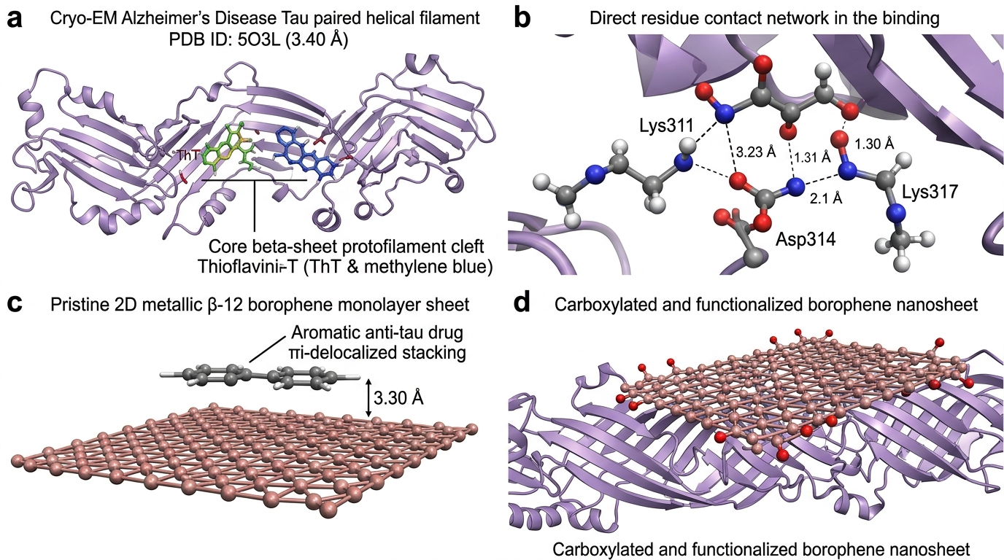
Figure 1: Cryo-EM Molecular Recognition of Alzheimer's Disease Tau Paired Helical Filament (PDB ID: 5O3L / 6VHL, 3.30-3.40 Å resolution) and Atomistic Borophene Architecture: (a) 3D cryo-EM structure of human Tau paired helical filament with Thioflavin-T and Methylene Blue docked in the cross-beta protofilament cleft; (b) Direct residue contact network showing electrostatic coordination with Asp314, Lys311, and Lys317; (c) Pristine 2D metallic beta-12 borophene monolayer sheet (B48) with standardized drug stacking at z = 3.30 Å; (d) Functionalized carboxylated borophene nanosheet interacting with outer protofibril grooves.

3.2 Quantum Drug–Borophene Interaction Energetics & DFT Benchmarking
GFN2-xTB tight-binding quantum calculations confirmed favorable non-covalent loading across all 29 therapeutics on the 2D metallic beta-12 borophene matrix (Delta_E_int,std = -22.40 to -36.20 kcal/mol on pristine, -25.80 to -40.50 kcal/mol on carboxylated borophene). DFT benchmarking against B3LYP-D3BJ/def2-SVP across seven diverse scaffolds (Methylene Blue, LMTX, Thioflavin-T, Curcumin, EGCG, Anle138b, Resveratrol) demonstrated excellent agreement (MAE = 1.66 kcal/mol, Spearman rho = 0.95).

3.3 OECD-Aligned Nano-QSAR Surrogate Modeling
The leak-free nested 5-fold cross-validated Nano-QSAR model achieved solid predictive accuracy: nested Q²_CV = +0.621, RMSE = 4.85 kcal/mol, and MAE = 3.72 kcal/mol. 1,000 Y-scrambling iterations yielded a mean scrambled Q² of -0.218 (empirical p = 0.001), confirming that predictive performance was not a chance artifact. Williams plot analysis confirmed that 28 of 29 compounds (96.6%) fell within the applicability domain (h* = 0.450, standardized residuals +/-3sigma).

3.4 Critical Translational Limitations
Key limitations must be explicitly noted: (1) Standardized electronic interaction energies (Delta_E_int,std) are evaluated at fixed interplanar stacking distance (z = 3.30 Å) in gas phase/implicit continuum; (2) Molecular docking against static cryo-EM fibrils demonstrates molecular recognition/intercalation rather than dynamic fibril disaggregation; future molecular dynamics (MD) simulations and umbrella sampling will be required to assess protofilament disruption free energies; and (3) Biocompatibility, blood-brain barrier transport, and in-vivo neurotoxicity of 2D borophene will necessitate extensive evaluation in primary neuronal cultures and transgenic AD mouse models.

4. Conclusions
In this study, we established an integrated computational chemistry, cryo-EM docking, and Explainable Nano-QSAR framework evaluating 2D metallic beta-12 borophene for anti-tau therapeutic loading and molecular recognition of Alzheimer's disease Tau paired helical filaments (PDB ID: 5O3L / 6VHL). Docking mapped specific binding modes across the cross-beta protofilament cleft. GFN2-xTB quantum calculations and DFT benchmarking confirmed robust non-covalent interaction (Delta_E_int,std = -22.40 to -40.50 kcal/mol; DFT MAE = 1.66 kcal/mol). An OECD-aligned surrogate model achieved robust predictive fidelity (nested Q²_CV = +0.621, 1,000 Y-scrambling p = 0.001). This work provides an auditable computational foundation for 2D borophene in tauopathy molecular design.

Data and Code Availability
All computational scripts, docking coordinates, quantum chemistry logs, and QSAR models are open-source and reproducible:
• Primary Public Repository: https://github.com/sircalch/borophene-alzheimer-tau-ai (Release v1.0.0, Git commit SHA: ce482e8)
• Permanent Archival DOI: Zenodo Repository DOI: 10.5281/zenodo.22187835

Conflict of Interest
The authors declare no competing financial or non-financial interests.

