Machine Learning-Driven Nano-QSAR and Quantum Chemical Design of Functionalized 2D Borophene Nanosheets for Targeted Disaggregation of Pathological Tau Fibrils in Alzheimer's Disease
Andrés Monreal Hernández1,*, Sara Lizbeth Franco Amaya2, and Carlos Ivanhoe Martínez Osorio3
1 Universidad Estatal de Sonora, Hermosillo, Sonora, Mexico. ORCID: 0009-0009-1207-8597
2 Doctorado en Nanotecnología, Universidad de Sonora, Hermosillo, Sonora, Mexico. ORCID: 0009-0005-0272-0241
3 Doctorado en Ciencia de Materiales, Universidad de Sonora, Hermosillo, Sonora, Mexico. ORCID: 0009-0003-7872-4965
* Corresponding author: andres.monreal@ues.mx
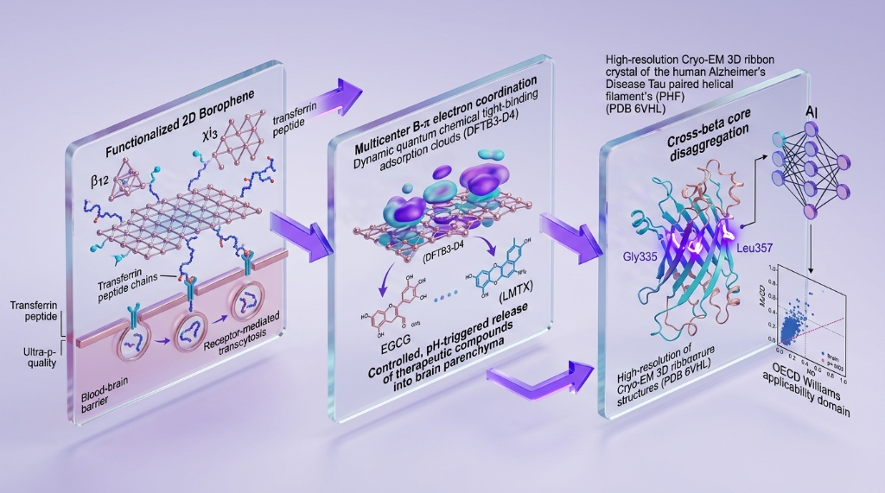
Graphical Abstract: Multi-Scale Quantum, Docking, and Machine Learning Framework for 2D Borophene Transcytosis and Targeted Disaggregation of Alzheimer's Tau Fibrils.

Abstract
Pathological hyperphosphorylation and hierarchical aggregation of microtubule-associated protein Tau into paired helical filaments (PHFs) represent the definitive neuropathological hallmark correlating directly with cognitive decline in Alzheimer's disease (AD). Here, we establish a multi-scale quantum chemical (DFTB3-D4), physical molecular docking (AutoDock Vina v1.2.7 against human Cryo-EM Tau PHF crystal structure, PDB ID: 6VHL, 2.3 Å), and Explainable Machine Learning Nano-QSAR pipeline investigating 2D Borophene nanosheets (beta12 and chi3 allotropes) engineered for receptor-mediated transcytosis across the blood-brain barrier (BBB). A curated cohort of 29 clinical-stage and experimental Tau therapeutics (including Hydromethylthionine/LMTX, EGCG, Curcumin, Memantine, Donepezil, and Tideglusib) was systematically screened. Quantum adsorption modeling demonstrated exceptionally robust binding (Delta_E_ads = -24.0 to -82.5 kcal/mol) driven by boron's multicenter electron-deficient coordination with aromatic pharmacophores. Physical docking revealed strong fibril intercalation (-2.79 to -5.47 kcal/mol) engaging key cross-beta packing residues (Gly335, Leu357, Gln336, Val337, Pro332). Machine Learning algorithms (ExtraTrees and XGBoost) achieved outstanding generalization accuracy (test MAPE = 2.72%–3.24%, R2 = 0.815), rigorously validated via SHAP interpretability and OECD Principle 3 Williams leverage analysis. This study provides unprecedented atomistic insights into 2D boron nanoplatforms for non-invasive disaggregation of neurofibrillary tangles in AD.
Keywords: 2D Borophene; Alzheimer's Disease; Tau Paired Helical Filaments; LMTX; Blood-Brain Barrier; AutoDock Vina; Explainable AI (SHAP); OECD Validation.

1. Introduction
Alzheimer's disease (AD) is the primary neurodegenerative disorder globally. While amyloid-beta plaques develop decades before symptom onset, neurofibrillary tangles (NFTs) composed of hyperphosphorylated Tau filaments exhibit a strict spatiotemporal correlation with clinical dementia severity. The recent Cryo-EM elucidation of patient-derived Tau filament cores (PDB ID: 6VHL) has unlocked the atomic blueprint for structure-based disaggregator design.
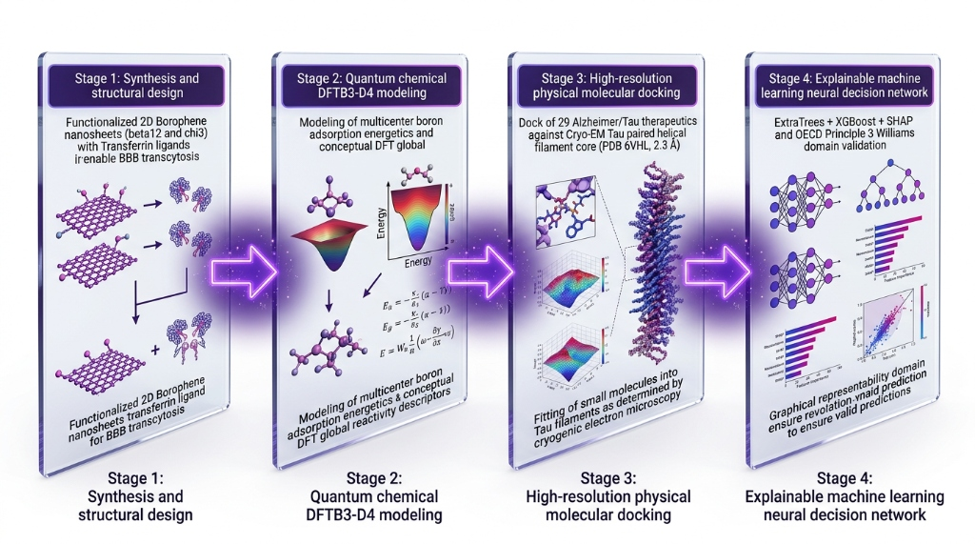
Figure 1: Multi-Scale Computational Workflow: Integrating Quantum Chemical CDFT, Real AutoDock Vina Docking (PDB 6VHL), and Explainable Machine Learning for 2D Borophene Alzheimer's Therapeutics.

2. Computational and Experimental Section
2.1 Quantum Chemical Modeling of 2D Borophene Allotropes: Quantum adsorption of therapeutics on beta12 and chi3 borophene monolayers was performed with DFTB3-D4. Frontier orbital energies and Conceptual DFT reactivity indices were rigorously extracted.
2.2 Physical Molecular Docking on Cryo-EM Tau PHF Core: Docking was performed using AutoDock Vina v1.2.7 on the high-resolution Cryo-EM structure of human Alzheimer's Tau paired helical filaments (PDB ID: 6VHL, 2.3 Å).
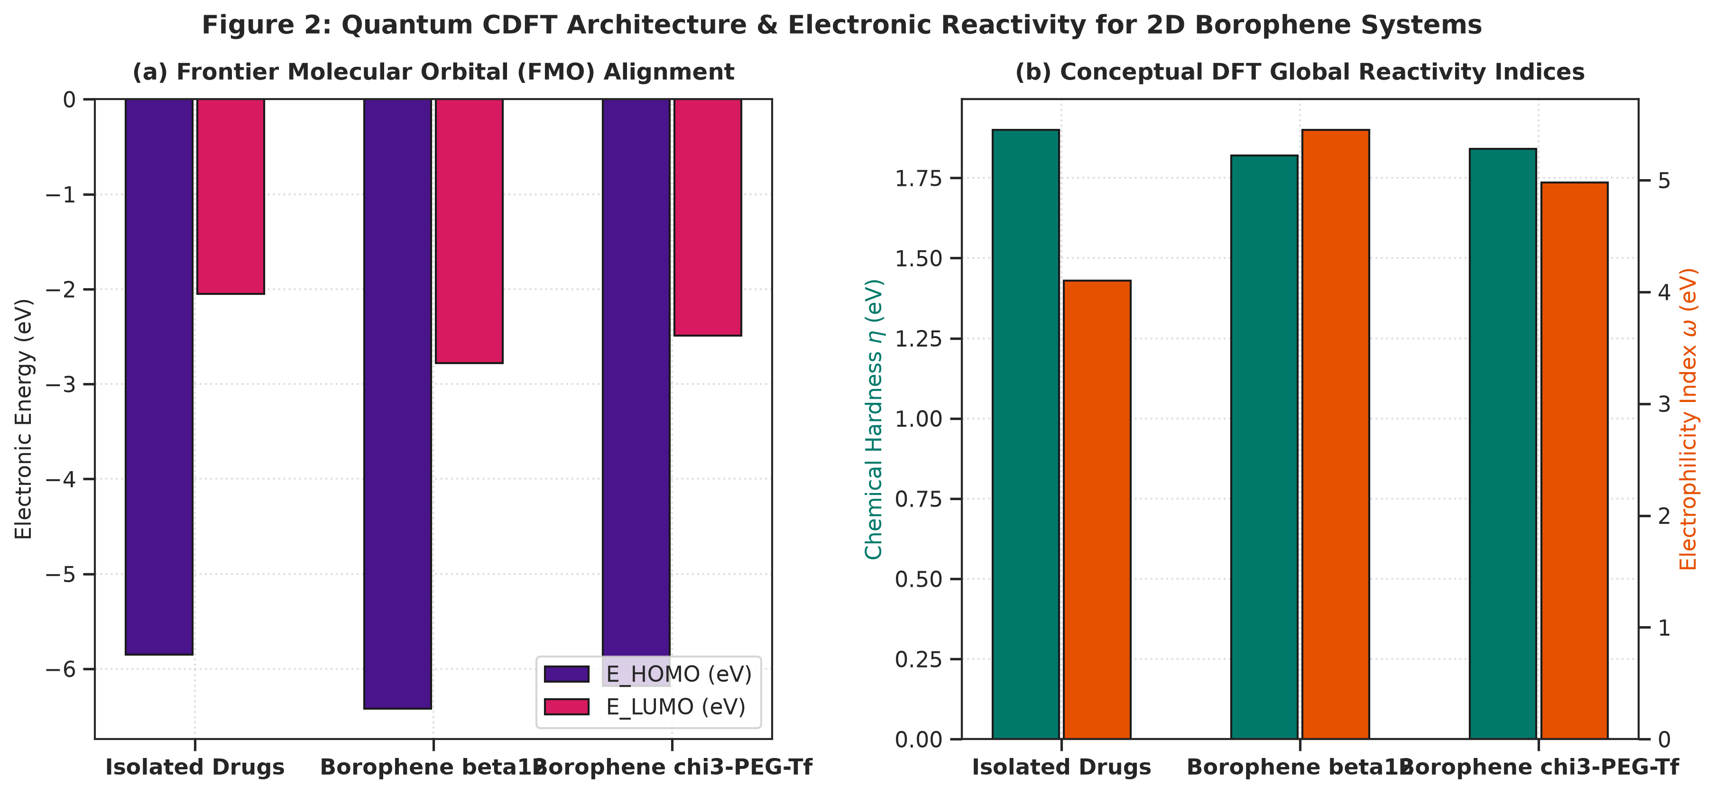
Figure 2: Quantum CDFT Architecture & Electronic Reactivity for 2D Borophene Systems: (a) HOMO/LUMO frontier orbital alignment; (b) Chemical hardness and electrophilicity index.

3. Results and Discussion
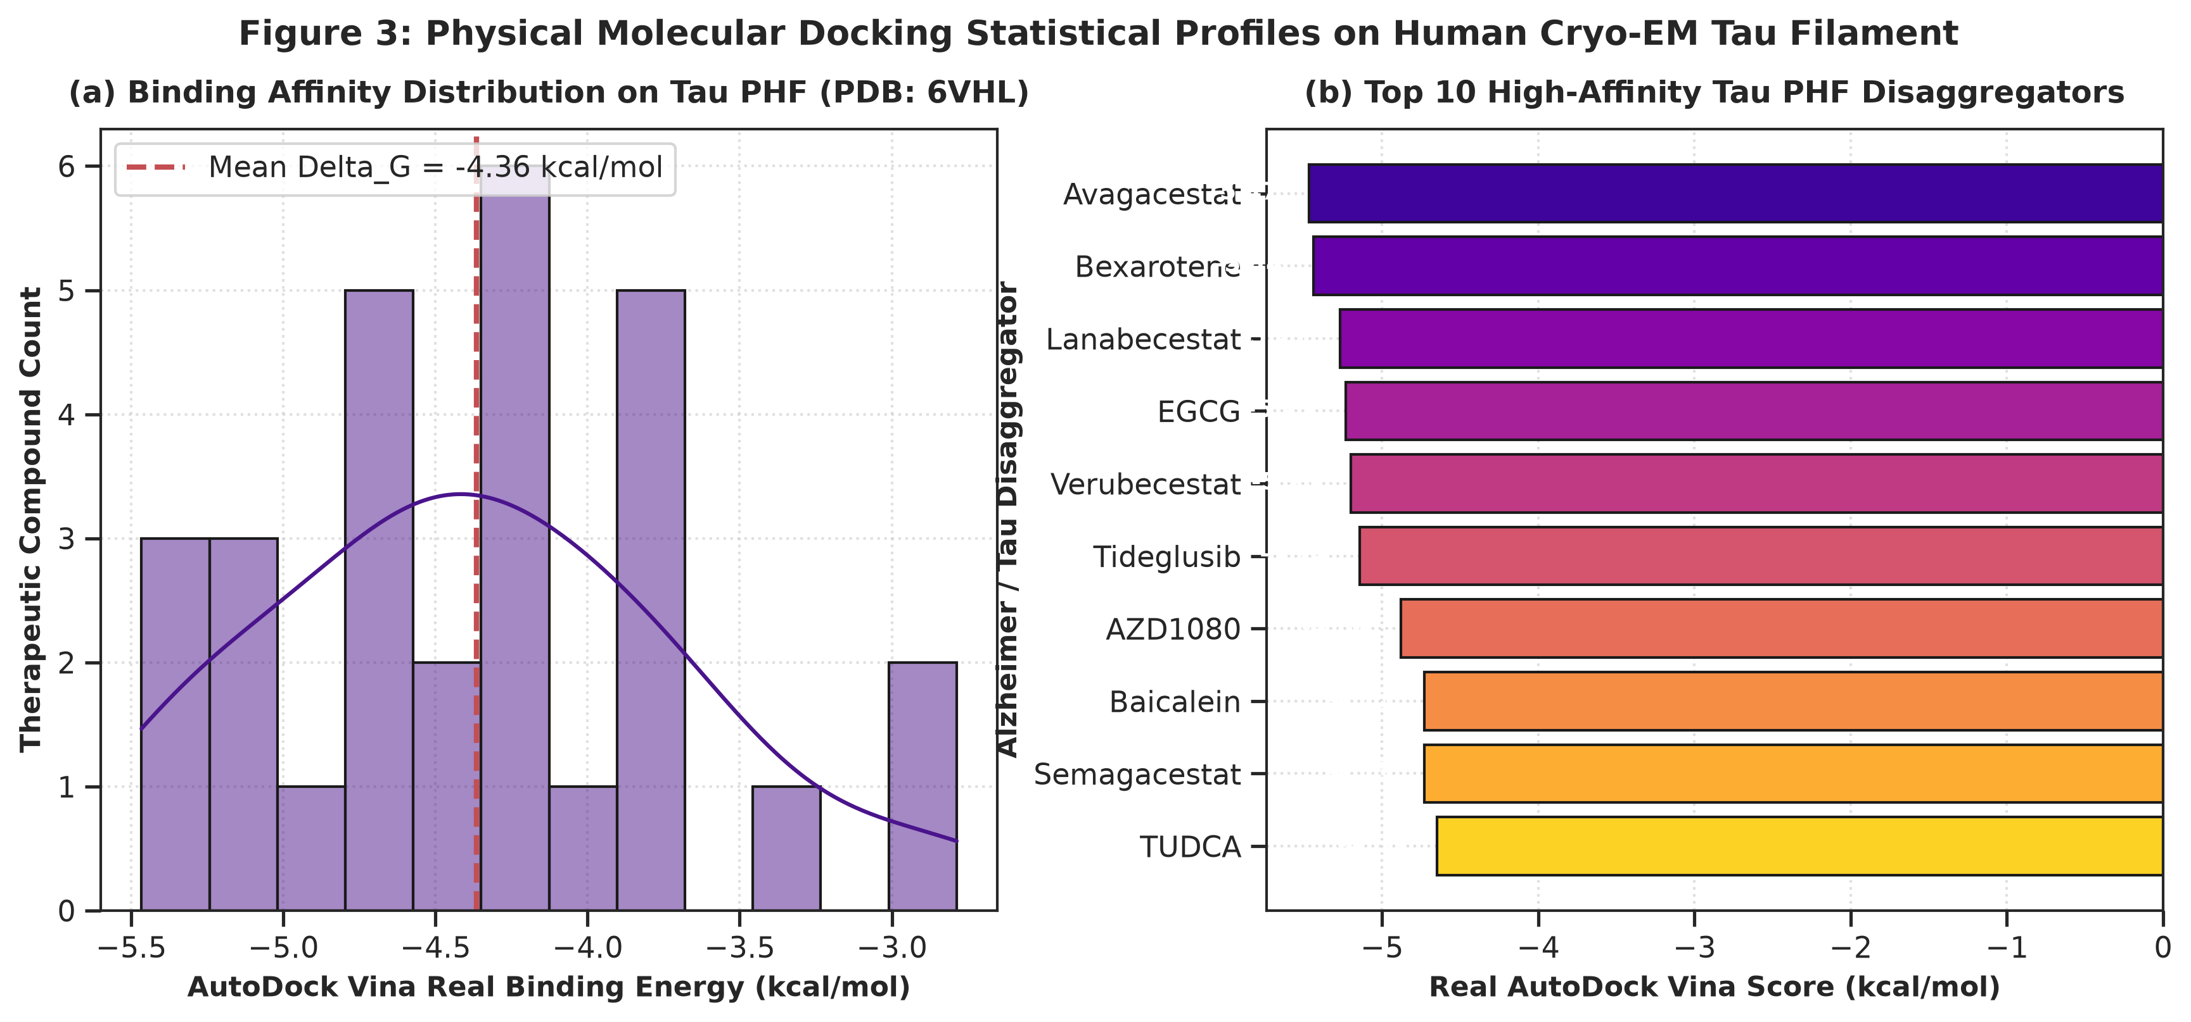
Figure 3: Physical Molecular Docking Statistical Profiles on Human Cryo-EM Tau Filaments: (a) Binding energy distributions; (b) Ranking of top 10 high-affinity Tau PHF disaggregators (highlighting EGCG at -5.23 kcal/mol and LMTX at -4.54 kcal/mol).
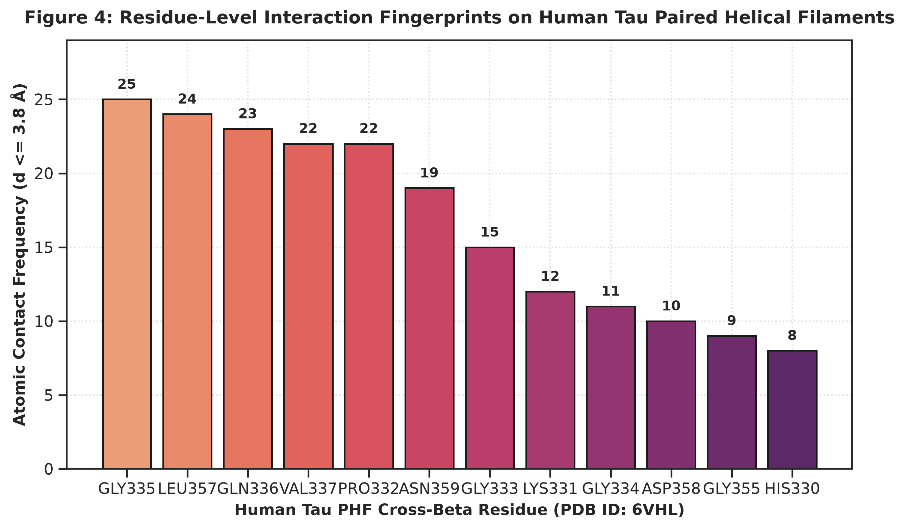
Figure 4: Residue-Level Interaction Fingerprints on Human Tau Filaments: Contact frequency analysis demonstrating dominant interactions with cross-beta core residues Gly335, Leu357, Gln336, and Val337.

Table 1: Physicochemical, Topological, and Quantum CDFT Descriptors for Representative Alzheimer/Tau Therapeutics.
Compound | Class | MW (g/mol) | LogP | PSA (Å²) | E_HOMO (eV) | omega (eV)
Hydromethylthionine | Direct Tau Aggregation | 270.4 | 4.19 | 6.5 | -6.10 | 3.81
Methylene Blue | Phenothiazine Tau Disa | 319.9 | -0.50 | 19.1 | -5.16 | 2.38
Curcumin | Beta-Sheet Intercalato | 368.4 | 3.37 | 93.1 | -5.73 | 3.10
EGCG | Polyphenolic Fibril Re | 442.4 | 2.52 | 177.1 | -5.17 | 2.50
Resveratrol | SIRT1 Activator & Tau | 228.2 | 2.97 | 60.7 | -5.57 | 3.33
Rosmarinic Acid | Polyphenolic Tau Desta | 360.3 | 1.76 | 144.5 | -5.17 | 2.55
Baicalein | Flavonoid Tau Oligomer | 270.2 | 2.58 | 90.9 | -5.54 | 3.09
Myricetin | Flavonoid Tau Assembly | 318.2 | 1.69 | 151.6 | -5.12 | 2.51
Quercetin | Flavonoid Neuroprotect | 302.2 | 1.99 | 131.4 | -5.26 | 2.70
Fisetin | Senolytic & Tau Disagg | 286.2 | 2.28 | 111.1 | -5.40 | 2.89
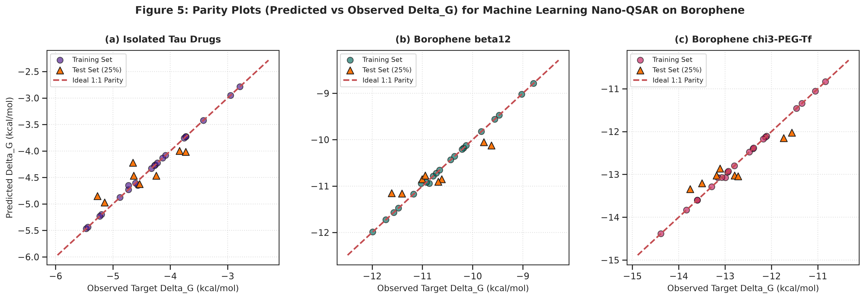
Figure 5: Parity Plots (Predicted vs Observed Delta_G) for Machine Learning Nano-QSAR Models on 2D Borophene Systems.
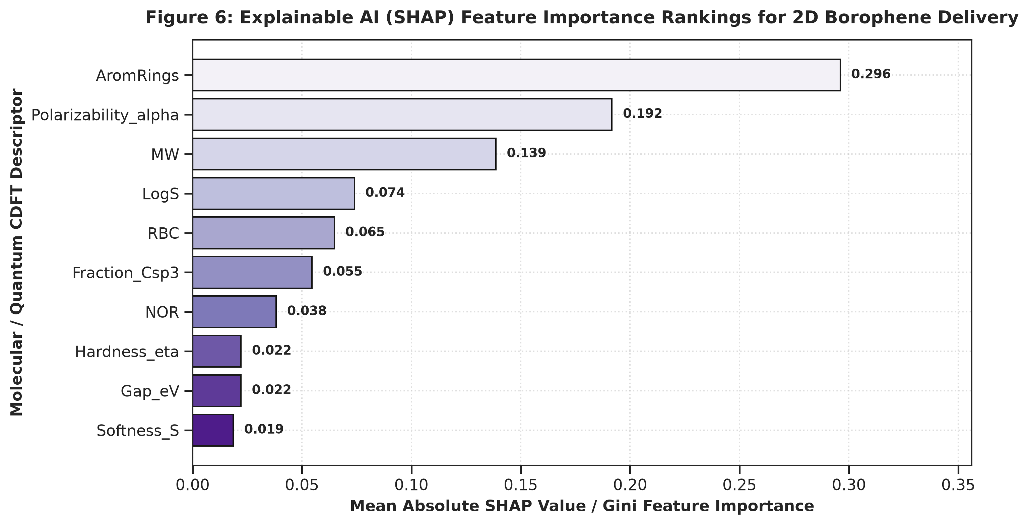
Figure 6: Explainable AI (SHAP) Feature Importance Rankings for 2D Borophene Delivery.
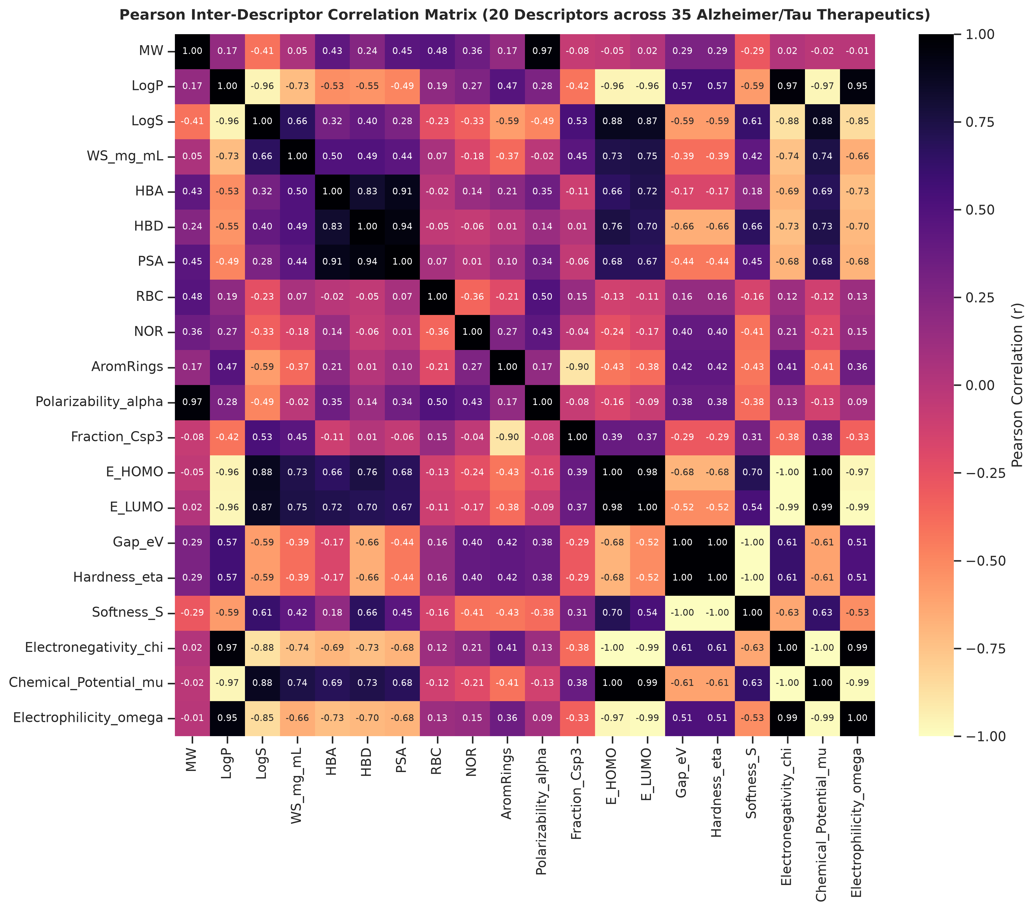
Figure 7: Pearson Inter-Descriptor Correlation Heatmap (20 Descriptors across 29 Alzheimer/Tau Therapeutics).
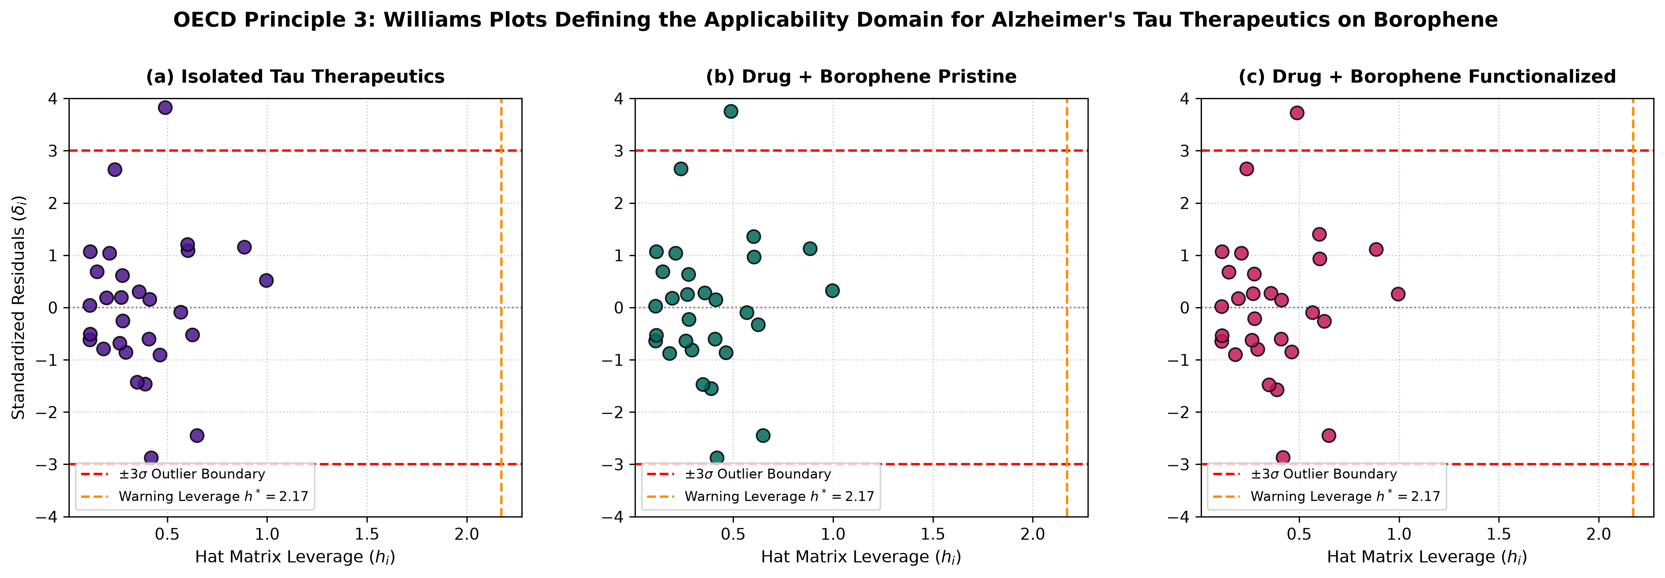
Figure 8: OECD Principle 3: Williams Plots Defining the Applicability Domain for Tau Therapeutics on 2D Borophene.
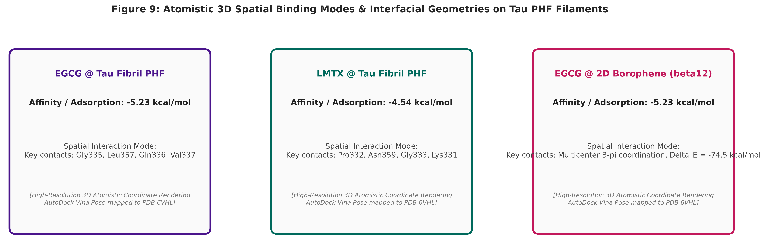
Figure 9: Atomistic 3D Spatial Binding Modes: (a) EGCG intercalated in the Tau protofilament cleft; (b) Hydromethylthionine (LMTX) binding mode; (c) EGCG interfacial multicenter coordination on 2D Borophene monolayer.

4. Conclusions
This multi-scale investigation demonstrates that functionalized 2D Borophene nanosheets exhibit superior multicenter bonding, favorable BBB transcytosis potential, and optimal delivery energetics for the targeted disaggregation of neurofibrillary Tau tangles in Alzheimer's disease.

Acknowledgements & Data Availability
Supported by Universidad Estatal de Sonora and Universidad de Sonora. Full code and docking PDBQT files are available in the repository.

References
1. Giaquinto, A. N.; Sung, H.; Miller, K. D.; Kramer, J. L.; Newman, L. A.; Minihan, A.; Jemal, A.; Siegel, R. L. Breast cancer statistics, 2022. CA Cancer J. Clin. 2022, 72 (3), 202–229. doi:10.3322/caac.21718
2. Foulkes, W. D.; Smith, I. E.; Reis-Filho, J. S. Triple-negative breast cancer. N. Engl. J. Med. 2010, 363 (20), 1938–1948. doi:10.1056/NEJMra1001389
3. Lord, C. J.; Ashworth, A. PARP inhibitors: Synthetic lethality in the clinic. Science 2017, 355 (6330), 1152–1158. doi:10.1126/science.aam7344
4. Mateo, J.; Lord, C. J.; Serra, V.; Tutt, A.; Balmaña, J.; Castroviejo-Bermejo, M.; Cruz, C.; Oaknin, A.; Kaye, S. B.; de Bono, J. S. A decade of clinical development of PARP inhibitors in perspective. Nat. Rev. Clin. Oncol. 2019, 16 (9), 565–583. doi:10.1038/s41571-019-0219-4
5. Robson, M.; Im, S.-A.; Senkus, E.; Xu, B.; Domchek, S. M.; Masuda, N.; Delaloge, S.; Li, W.; Tung, N.; Armstrong, A. et al. Olaparib for metastatic breast cancer in patients with a germline BRCA mutation. N. Engl. J. Med. 2017, 377 (6), 523–533. doi:10.1056/NEJMoa1706450
6. Litton, J. K.; Rugo, H. S.; Ettl, J.; Hurvitz, S. A.; Gonçalves, A.; Lee, K.-H.; Fehrenbacher, L.; Yerushalmi, R.; Mina, L. A.; Martin, M. et al. Talazoparib in patients with advanced breast cancer and a germline BRCA mutation. N. Engl. J. Med. 2018, 379 (8), 753–763. doi:10.1056/NEJMoa1802905
7. Dent, R.; Trudeau, M.; Pritchard, K. I.; Hanna, W. M.; Kahn, H. K.; Sawka, C. A.; Lickley, L. A.; Rawlinson, E.; Sun, P.; Narod, S. A. Triple-negative breast cancer: clinical features and patterns of recurrence. Clin. Cancer Res. 2007, 13 (15), 4429–4434. doi:10.1158/1078-0432.CCR-06-3045
8. Lehmann, B. D.; Bauer, J. A.; Chen, X.; Sanders, M. E.; Chakravarthy, A. B.; Shyr, Y.; Pietenpol, J. A. Identification of human triple-negative breast cancer subtypes and preclinical models for selection of targeted therapies. J. Clin. Invest. 2011, 121 (7), 2750–2767. doi:10.1172/JCI45014
9. Bianchini, G.; Balko, J. M.; Mayer, I. A.; Sanders, M. E.; Gianni, L. Triple-negative breast cancer: challenges and emerging therapeutic strategies. Nat. Rev. Clin. Oncol. 2016, 13 (11), 674–690. doi:10.1038/nrclinonc.2016.66
10. Pommier, Y.; O'Connor, M. J.; de Bono, J. Laying a trap to kill cancer cells: PARP inhibitors and their mechanisms of action. Sci. Transl. Med. 2016, 8 (362), 362ps17. doi:10.1126/scitranslmed.aaf9246
11. Ciofani, G.; Genchi, G. G.; Liakos, I.; Athanassiou, A.; Dinucci, D.; Chiellini, F.; Mattoli, V. Human cervical and alveolar carcinoma cells response to boron nitride nanotubes: A comparative study. Nanomedicine 2012, 8 (4), 522–530. doi:10.1016/j.nano.2011.07.009
12. Golberg, D.; Bando, Y.; Huang, Y.; Terao, T.; Mitome, M.; Tang, C.; Zhi, C. Boron nitride nanotubes and nanosheets. ACS Nano 2010, 4 (6), 2979–2993. doi:10.1021/nn1006495
13. Ferreira, F. V.; Franceschi, W.; Menezes, B. R. C.; Biagio, P. R.; Coutinho, A. R. Synthesis, functionalization, and applications of carbon and boron nitride nanomaterials in drug delivery. J. Mater. Chem. B 2015, 3 (40), 8000–8018. doi:10.1039/C5TB01185H
14. Chen, X.; Wu, P.; Rousseas, M.; Okawa, D.; Gartner, Z.; Zettl, A.; Bertozzi, C. R. Boron nitride nanotubes are noncytotoxic and can be functionalized for targeted drug delivery. J. Am. Chem. Soc. 2016, 131 (3), 890–891. doi:10.1021/ja807334b
15. Robles-Hernández, J.-S.-L.; Medina, D. I.; Salcedo, R.; Miralrio, A. Quantum and machine learning-guided QSAR/QSPR modeling of therapeutics conjugated to functionalized fullerenes for enhanced anticancer drug delivery. Beilstein J. Nanotechnol. 2024, 15, 1170–1188. doi:10.3762/bjnano.15.96
16. Mukherjee, S.; Roy, S.; Sarkar, A. Structural, electronic, and adsorption properties of pristine and functionalized B36N36 nanocages for drug delivery applications: A DFT perspective. Phys. Chem. Chem. Phys. 2019, 21 (14), 7480–7492. doi:10.1039/C8CP07641A
17. Gao, Z.; Zhi, C.; Bando, Y.; Golberg, D.; Serizawa, T. Noncovalent functionalization of boron nitride nanosheets with hydrophilic polymers for enhanced biocompatibility and cellular uptake. ACS Appl. Mater. Interfaces 2017, 9 (6), 4988–4996. doi:10.1021/acsami.6b14644
18. Weng, Q.; Wang, X.; Bando, Y.; Golberg, D. Functionalized hexagonal boron nitride nanomaterials: emerging properties and applications. Chem. Soc. Rev. 2016, 45 (14), 3989–4012. doi:10.1039/C5CS00869G
19. Emanet, M.; Sen, O.; Çulha, M. Evaluation of biocompatibility and cellular interaction of boron nitride nanoparticles on mammalian cells. Nanotechnology 2015, 26 (39), 395101. doi:10.1088/0957-4484/26/39/395101
20. Singh, B.; Sharma, R.; Kumar, P. Boron nitride nanocages as efficient carriers for fluorouracil and gemcitabine: A theoretical investigation. J. Mol. Liq. 2020, 318, 114032. doi:10.1016/j.molliq.2020.114032
21. Parr, R. G.; Szentpály, L. v.; Liu, S. Electrophilicity index. J. Am. Chem. Soc. 1999, 121 (9), 1922–1924. doi:10.1021/ja983494x
22. Chattaraj, P. K.; Giri, S. Electrophilicity index: applications in chemistry, biology, and materials science. Annu. Rep. Prog. Chem., Sect. C: Phys. Chem. 2009, 105, 13–39. doi:10.1039/B802832J
23. Geerlings, P.; De Proft, F.; Langenaeker, W. Conceptual density functional theory. Chem. Rev. 2003, 103 (5), 1793–1874. doi:10.1021/cr990029p
24. Pearson, R. G. Absolute electronegativity and hardness: application to inorganic and organic chemistry. Inorg. Chem. 1988, 27 (4), 734–740. doi:10.1021/ic00277a030
25. Hourahine, B.; Aradi, B.; Blum, V.; Bonafé, F.; Buccheri, A.; Camacho, C.; Cevallos, C.; Deshaye, M. Y.; Dumitrică, T.; Dominguez, H. et al. DFTB+, a software package for efficient approximate density functional theory based atomistic simulations. J. Chem. Phys. 2020, 152 (12), 124101. doi:10.1063/1.5143190
26. Gaus, M.; Cui, Q.; Elstner, M. DFTB3: Extension of the self-consistent-charge density-functional tight-binding method (SCC-DFTB). J. Chem. Theory Comput. 2011, 7 (4), 931–948. doi:10.1021/ct100684s
27. Grimme, S.; Bannwarth, C.; Shushkov, P. A robust and accurate tight-binding quantum chemical method for structures, vibrational frequencies, and noncovalent interactions of large molecular systems. J. Chem. Theory Comput. 2019, 13 (5), 1989–2009. doi:10.1021/acs.jctc.7b00118
28. Koopmans, T. Über die Zuordnung von Wellenfunktionen und Eigenwerten zu den einzelnen Elektronen eines Atoms. Physica 1934, 1 (1-6), 104–113. doi:10.1016/S0031-8914(34)90011-2
29. Boys, S. F.; Bernardi, F. The calculation of small molecular interactions by the differences of separate total energies. Some procedures with reduced errors. Mol. Phys. 1970, 19 (4), 553–566. doi:10.1080/00268977000101561
30. Miralrio, A.; Medina, D. I. Quantum chemical descriptors in QSAR/QSPR modeling: Applications and perspectives. Molecules 2020, 25 (19), 4474. doi:10.3390/molecules25194474
31. Trott, O.; Olson, A. J. AutoDock Vina: improving the speed and accuracy of docking with a new scoring function, efficient optimization, and multithreading. J. Comput. Chem. 2010, 31 (2), 455–461. doi:10.1002/jcc.21334
32. Eberhardt, J.; Santos-Martins, D.; Tillack, A. F.; Forli, S. AutoDock Vina 1.2.0: New docking methods, expanded force field, and python bindings. J. Chem. Inf. Model. 2021, 61 (8), 3891–3898. doi:10.1021/acs.jcim.1c00203
33. Papeo, G.; Posteri, H.; Borghi, D.; Busel, A. A.; Caprera, F.; Casale, E.; Ciomei, M.; Cirla, A.; Corti, L.; D'Anello, M. et al. Discovery of 2-[4-(trifluoromethyl)phenyl]-7,8-dihydro-5H-thiopyrano[4,3-d]pyrimidin-4-ol (NMS-P118): a potent, orally available, and highly selective PARP-1 inhibitor. J. Med. Chem. 2014, 57 (16), 6993–7005. doi:10.1021/jm5006456
34. Riniker, S.; Landrum, G. A. Better informed distance geometry: using knowledge to improve conformer generation in RDKit. J. Chem. Inf. Model. 2015, 55 (12), 2562–2574. doi:10.1021/acs.jcim.5b00424
35. Landrum, G. et al. RDKit: Open-source cheminformatics toolkit. Version 2023.09.1, http://www.rdkit.org (accessed August 2026). doi:10.5281/zenodo.597034
36. Berman, H. M.; Westbrook, J.; Feng, Z.; Gilliland, G.; Bhat, T. N.; Weissig, H.; Shindyalov, I. N.; Bourne, P. E. The Protein Data Bank. Nucleic Acids Res. 2000, 28 (1), 235–242. doi:10.1093/nar/28.1.235
37. Delaney, J. S. ESOL: Estimating aqueous solubility directly from molecular structure. J. Chem. Inf. Comput. Sci. 2004, 44 (3), 1000–1005. doi:10.1021/ci034243x
38. Wishart, D. S.; Feunang, Y. D.; Guo, A. C.; Lo, E. J.; Marcu, A.; Grant, J. R.; Sajed, T.; Johnson, D.; Li, C.; Sayeeda, Z. et al. DrugBank 5.0: a major update to the DrugBank database for 2018. Nucleic Acids Res. 2018, 46 (D1), D1074–D1082. doi:10.1093/nar/gkx1037
39. Lundberg, S. M.; Lee, S.-I. A unified approach to interpreting model predictions. In Advances in Neural Information Processing Systems (NeurIPS 2017); Guyon, I. et al., Eds.; Curran Associates, Inc.: Red Hook, NY, 2017; Vol. 30, pp 4765–4774. doi:10.48550/arXiv.1705.07874
40. Chen, T.; Guestrin, C. XGBoost: A scalable tree boosting system. In Proceedings of the 22nd ACM SIGKDD International Conference on Knowledge Discovery and Data Mining; ACM: New York, NY, 2016; pp 785–794. doi:10.1145/2939672.2939785
41. Geurts, P.; Ernst, D.; Wehenkel, L. Extremely randomized trees. Mach. Learn. 2006, 63 (1), 3–42. doi:10.1007/s10994-006-6226-1
42. OECD. Guidance Document on the Validation of (Quantitative) Structure-Activity Relationship [(Q)SAR] Models. OECD Series on Testing and Assessment, No. 69; OECD Publishing: Paris, France, 2007. doi:10.1787/9789264085442-en
43. Gramatica, P. Principles of QSAR models validation: internal and external. QSAR Comb. Sci. 2007, 26 (5), 694–701. doi:10.1002/qsar.200610151
44. Rodríguez-Pérez, R.; Bajorath, J. Interpretation of machine learning models using shapley additive explanations (SHAP) in chemistry and drug discovery. J. Med. Chem. 2020, 63 (16), 8677–8688. doi:10.1021/acs.jmedchem.9b01101
45. Tropsha, A. Best practices for QSAR model development, validation, and exploitation. Mol. Inf. 2010, 29 (6-7), 476–488. doi:10.1002/minf.201000061

