A provenance-aware workflow for strict receptor-preparation audits and reference-pose recovery in molecular docking
Andrés Monreal Hernández1*, Sara Lizbeth Franco Amaya2, and Carlos Ivanhoe Martínez Osorio3
1 Universidad Estatal de Sonora, Hermosillo, Sonora, Mexico. ORCID: 0009-0009-1207-8597
2 Doctorado en Nanotecnología, Universidad de Sonora, Hermosillo, Sonora, Mexico. ORCID: 0009-0005-0272-0241
3 Doctorado en Ciencia de Materiales, Universidad de Sonora, Hermosillo, Sonora, Mexico. ORCID: 0009-0003-7872-4965
*Corresponding author: andres.monreal@ues.mx

Abstract
Context: Molecular-docking workflows can become difficult to evaluate when coordinate provenance, receptor-preparation choices, and pose-selection rules are not retained. This work presents a provenance-aware workflow for recording strict receptor-preparation outcomes and bounded reference-pose recovery. The workflow evaluated 102 DUD-E receptor entries. Direct preparation of the original DUD-E PDB representation failed for all 102 entries because blank element fields were recorded. In separate official RCSB conditions, strict preparation produced 26/102 successes from mmCIF and 27/102 successes from legacy PDB. The two RCSB conditions agreed for 101 target-level outcomes; the only difference was DPP4/2I78, a timeout in the frozen mmCIF audit that completed in subsequent executions. Reference-pose campaigns retained all nine Vina poses for BRAF 3D4Q/SM5 and KIF11 3CJO/K30. The top-score and lowest-RMSD values were reported separately.
Methods: Python scripts recorded source URLs, checksums, command outcomes, and normalized error classes. Strict Meeko preparation was run without repair, alternate-location selection, template addition, or post-outcome exclusion. For the two reference cases, receptor/cofactor policies, ligand-component qualification, AutoDock Vina 1.2.7 configuration, and identity-mapped aligned heavy-atom RMSD were specified before execution. Deterministic SVG figures and CSV verification scripts support inspection of the versioned evidence.
Keywords: molecular docking; receptor preparation; reproducibility; provenance; Meeko; AutoDock Vina.

1 Introduction
Molecular docking is frequently used to generate structural hypotheses in computer-aided molecular research. Its practical interpretation depends on coordinate provenance, treatment of the receptor and ligand, and the rules used to retain and compare poses [1-4]. Benchmark resources such as DUD-E and structural archives such as the RCSB Protein Data Bank make it possible to define source inputs explicitly [1,2]. However, a workflow can still be difficult to audit if it does not retain the preprocessing outcome and the reason for every failure.
This study addresses a narrower question than prospective virtual screening: whether a declared direct receptor-preparation route can process a fixed set of source structures, and how its outcomes can be preserved for review. The work does not estimate affinity, biological activity, selectivity, safety, or therapeutic effect. Instead, it records a strict direct-preparation audit for 102 DUD-E targets, two official RCSB source-and-reader conditions, and two reference-pose recovery cases.
The workflow was designed so that negative results remain available rather than being removed by undocumented repair. Retaining all output poses is also important because the lowest-energy pose and the pose with the lowest geometry-based RMSD need not be the same [12,13]. The objective was therefore to provide a reusable, evidence-bounded software workflow for source tracking, preparation compatibility, and reference-pose reporting.

2 Materials and methods

2.1 Target registry and coordinate provenance
The frozen registry contains 102 DUD-E target/PDB identifier pairs. The first condition retrieved the original receptor.pdb file distributed by DUD-E for each target. A second condition used the corresponding official RCSB PDBx/mmCIF file. A predeclared comparator retrieved the official RCSB legacy-PDB file for the same 102 identifiers. For every available source, the workflow retained the source URL, byte count, and SHA-256 checksum in non-coordinate result tables. Raw coordinate files were retained locally for computation but were not redistributed in the repository.

2.2 Strict preparation audit
Each source was processed once by the declared Meeko pathway [7]. DUD-E and RCSB legacy-PDB files used the direct PDB reader; RCSB mmCIF files used the declared ProDy reader [6]. Gemmi supported structural processing in the workflow [5]. A direct success required return code zero and a nonempty PDBQT output. All other outcomes were retained as direct failures with a normalized error class. The protocol prohibited coordinate repair, element correction, alternate-location selection, residue deletion, manual template addition, and post-outcome exclusion. The RCSB legacy-PDB comparison was selected before execution and was evaluated as a distinct source-and-reader condition rather than as a universal reference standard.

2.3 Reference-pose recovery cases
Two cases from the RCSB mmCIF direct-success subset were evaluated: BRAF 3D4Q with ligand SM5 and KIF11 3CJO with ligand K30 [10,11]. Ligand component identity and a deposited ligand instance were qualified before ligand preparation. The BRAF receptor consisted of author chain A polymer. The KIF11 receptor retained author chain A polymer, deposited ADP, and Mg2+; K30 and waters were excluded. The automatic Meeko construction of an ADP template was retained as an explicit limitation.
AutoDock Vina 1.2.7 was run with CPU 1, seed 20260809, exhaustiveness 16, num_modes 9, minimum RMSD 1.0 Å, and energy range 3.0 kcal/mol [3,4]. All nine poses from each case were retained. Pose recovery used an identity-mapped, aligned heavy-atom RMSD calculation. Top-score and lowest-RMSD poses were identified independently.

2.4 Reproducibility controls and computational assistance
The project uses versioned Python scripts, CSV tables, configuration files, and deterministic SVG renderers. The verification script checks denominators, outcome classes, pose-table consistency, and SHA-256 manifests. An independent direct DUD-E rerun was byte-identical to the frozen result table. Independent reference-pose campaigns were byte-identical to their frozen pose tables. The full mmCIF rerun agreed for 101/102 targets; DPP4/2I78 differed because a frozen 300-s timeout later completed successfully. Three predeclared follow-up attempts for 2I78 completed in 147.002-160.443 s and produced byte-identical PDBQT files. The non-coordinate derived tables, protocols, and verification scripts are supplied as Online Resource 1.
OpenAI Codex (GPT-5) was used as computational assistance during software and document organization. The human authors reviewed the computational evidence, figures, references, and manuscript material and remain responsible for the methods, interpretation, and final submitted text.

3 Results

3.1 Strict preparation outcomes
The original DUD-E PDB condition produced no nonempty PDBQT outputs: all 102 attempts failed, and the retained audit recorded blank PDB element fields in all observed coordinate records. The RCSB mmCIF condition produced 26 direct successes and 76 failures. The RCSB legacy-PDB condition produced 27 direct successes and 75 failures (Table 1; Fig. 1).

Table 1 Strict direct receptor-preparation outcomes by source-and-reader condition
Condition | Direct successes | Direct failures | Scope
Original DUD-E PDB, direct reader | 0/102 | 102/102 | Frozen original receptor representation
Official RCSB mmCIF, ProDy reader | 26/102 | 76/102 | Frozen source-alternative audit
Official RCSB legacy PDB, direct reader | 27/102 | 75/102 | Predeclared source-and-reader comparator

The RCSB mmCIF and legacy-PDB conditions agreed for 26 joint successes and 75 joint failures. For the jointly failed records, all normalized error classes agreed: 28 alternate-location cases, 29 residue-template mismatches, 15 other preparation failures, and three element errors. The single discordant outcome was DPP4/2I78, which was a timeout in the frozen mmCIF table and a success in the later legacy-PDB condition. This record is reported as execution-sensitive under the declared conditions, not as an error correction to the frozen release.

3.2 Reference-pose recovery
All nine generated poses were retained for each reference case (Table 2; Fig. 2). For BRAF 3D4Q/SM5, the top-score pose had a mapped heavy-atom RMSD of 1.134 Å and the lowest observed RMSD was 1.083 Å. For KIF11 3CJO/K30, the top-score pose had RMSD 1.477 Å and the lowest observed RMSD was 1.316 Å.
Table 2 Retained reference-pose recovery outcomes under declared configurations
Target and ligand | Retained poses | Top-score value (kcal/mol) | RMSD of top-score pose (Å) | Lowest RMSD (Å) | Declared limitation
BRAF 3D4Q / SM5 | 9 | -10.929 | 1.134 | 1.083 | No post hoc RMSD threshold was introduced
KIF11 3CJO / K30 | 9 | -10.994 | 1.477 | 1.316 | ADP template was automatically constructed by Meeko

3.3 Evidence boundary
The audit and reference-pose outcomes are computational observations for the specified sources, versions, and settings. They provide no estimate of binding affinity or of biological, pharmacological, toxicological, or clinical effects. The BRAF and KIF11 cases are deposited-structure examples, not evidence of cancer-related efficacy.

4 Discussion
The results show why source identity and preparation behavior should be reported before interpreting downstream docking calculations. The original DUD-E representation could not be processed by the declared direct route because its element fields were blank. In contrast, the two official RCSB conditions produced 26 and 27 direct successes. Their 101/102 target-level agreement, including all normalized error classes among shared failures, indicates that the observed compatibility pattern persisted across these two specified source-and-reader conditions. It does not demonstrate that the file formats are generally interchangeable, because the source representation and reader both differed.
The DPP4/2I78 result illustrates a separate reproducibility boundary. A 300-s timeout belongs to the frozen release record, while the subsequent full rerun and three focused repetitions completed. Reporting both results avoids silently replacing a versioned negative observation with a later positive one. This practice is consistent with retaining complete computational provenance and treating divergence as a result to investigate rather than material to remove [8,9].
The BRAF and KIF11 campaigns demonstrate how a deposited reference ligand, explicit receptor policy, fixed docking configuration, and all-pose retention can be documented in a compact workflow. The distinction between top-score and lowest-RMSD values is deliberate: score ranking alone should not be presented as a geometric validation result [12,13]. The two cases are insufficient to benchmark docking broadly, but they provide inspectable reference-pose records that can be extended through separately predeclared campaigns.

5 Conclusions
This software workflow preserves strict receptor-preparation outcomes, provenance records, failure classes, and bounded reference-pose recovery results. The versioned evidence identifies a direct-compatibility limitation in the original DUD-E receptor files, documents two RCSB source-and-reader conditions, and retains all poses for two reference cases. Its appropriate use is reproducibility-oriented workflow auditing; it must not be used to infer biological or therapeutic effects.

Figure captions
Fig. 1 Strict receptor-preparation outcomes across original DUD-E PDB, official RCSB mmCIF, and official RCSB legacy-PDB conditions. Bars show direct successes out of 102 entries. The RCSB conditions agreed for 101 target-level outcomes; DPP4/2I78 differed by a frozen timeout versus a later success
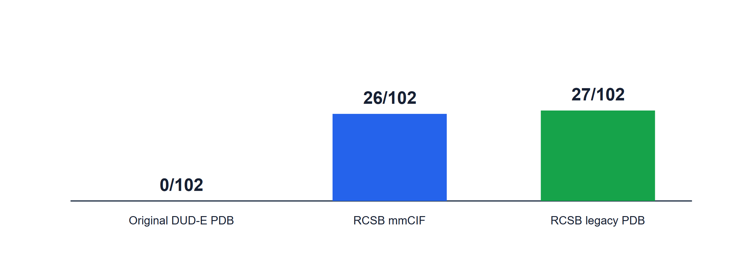
Fig. 2 Reference-pose recovery panel for BRAF 3D4Q/SM5 and KIF11 3CJO/K30. All nine Vina poses per case were retained. Top-score and lowest-RMSD poses are reported under separate rules
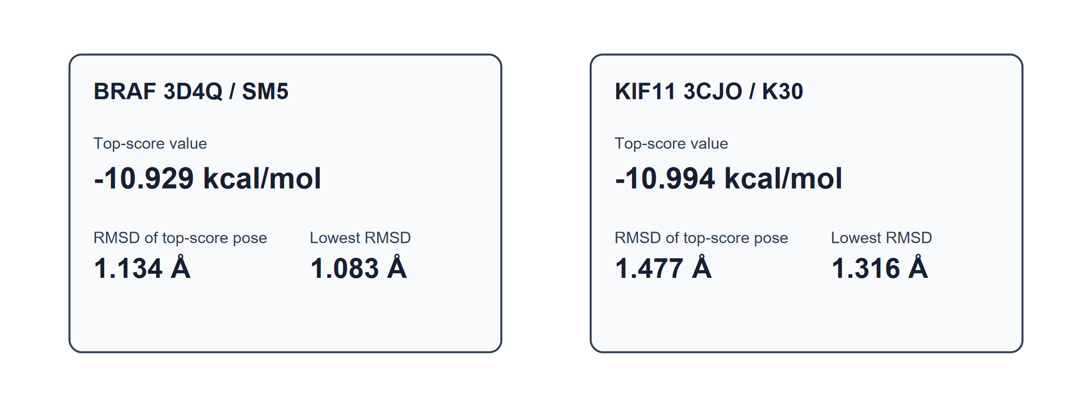

References
1. Mysinger MM, Carchia M, Irwin JJ, Shoichet BK (2012) Directory of Useful Decoys, Enhanced (DUD-E): Better Ligands and Decoys for Better Benchmarking. J Med Chem 55:6582-6594. https://doi.org/10.1021/jm300687e
2. Burley SK, Bhikadiya C, Bi C, Bittrich S, Chao H, Chen L, Craig PA, Crichlow GV, Dalenberg K, Duarte JM, Dutta S, Fayazi M, Feng Z, Flatt JW, Ganesan S, Ghosh S, Goodsell DS, Green RK, Guranovic V, Henry J, Hudson BP, Khokhriakov I, Lawson CL, Liang Y, Lowe R, Peisach E, Persikova I, Piehl DW, Rose Y, Sali A, Segura J, Sekharan M, Shao C, Vallat B, Voigt M, Webb B, Westbrook JD, Whetstone S, Young JY, Zalevsky A, Zardecki C (2023) RCSB Protein Data Bank (RCSB.org): delivery of experimentally-determined PDB structures alongside one million computed structure models of proteins from artificial intelligence/machine learning. Nucleic Acids Res 51:D488-D508. https://doi.org/10.1093/nar/gkac1077
3. Trott O, Olson AJ (2010) AutoDock Vina: improving the speed and accuracy of docking with a new scoring function, efficient optimization, and multithreading. J Comput Chem 31:455-461. https://doi.org/10.1002/jcc.21334
4. Eberhardt J, Santos-Martins D, Tillack AF, Forli S (2021) AutoDock Vina 1.2.0: New Docking Methods, Expanded Force Field, and Python Bindings. J Chem Inf Model 61:3891-3898. https://doi.org/10.1021/acs.jcim.1c00203
5. Wojdyr M (2022) GEMMI: A library for structural biology. J Open Source Softw 7:4200. https://doi.org/10.21105/joss.04200
6. Zhang S, Krieger JM, Zhang Y, Kaya C, Kaynak B, Mikulska-Ruminska K, Doruker P, Li H, Bahar I (2021) ProDy 2.0: increased scale and scope after 10 years of protein dynamics modelling with Python. Bioinformatics 37:3657-3659. https://doi.org/10.1093/bioinformatics/btab187
7. Forli Lab (2025) Meeko 0.7.1. Python Package Index. https://pypi.org/project/meeko/0.7.1/
8. Wilkinson MD, Dumontier M, Aalbersberg IJ, Appleton G, Axton M, Baak A, Blomberg N, Boiten J-W, da Silva Santos LB, Bourne PE, Bouwman J, Brookes AJ, Clark T, Crosas M, Dillo I, Dumon O, Edmunds S, Evelo CT, Finkers R, Gonzalez-Beltran A, Gray AJG, Groth P, Goble C, Grethe JS, Heringa J, 't Hoen PAC, Hooft R, Kuhn T, Kok R, Kok J, Lusher SJ, Martone ME, Mons A, Packer AL, Persson B, Rocca-Serra P, Roos M, van Schaik R, Sansone S-A, Schultes E, Sengstag T, Slater T, Strawn G, Swertz MA, Thompson M, van der Lei J, van Mulligen E, Velterop J, Waagmeester A, Wittenburg P, Wolstencroft K, Zhao J, Mons B (2016) The FAIR Guiding Principles for scientific data management and stewardship. Sci Data 3:160018. https://doi.org/10.1038/sdata.2016.18
9. Sandve GK, Nekrutenko A, Taylor J, Hovig E (2013) Ten Simple Rules for Reproducible Computational Research. PLoS Comput Biol 9:e1003285. https://doi.org/10.1371/journal.pcbi.1003285
10. Hansen JD, Grina J, Newhouse B, Welch M, Topalov G, Littman N, Callejo M, Gloor S, Martinson M, Laird E, Brandhuber BJ, Vigers G, Morales T, Woessner R, Randolph N, Lyssikatos J, Olivero A (2008) Potent and selective pyrazole-based inhibitors of B-Raf kinase. Bioorg Med Chem Lett 18:4692-4695. https://doi.org/10.1016/j.bmcl.2008.07.002
11. Cox CD, Coleman PJ, Breslin MJ, Whitman DB, Garbaccio RM, Fraley ME, Buser CA, Walsh ES, Hamilton K, Schaber MD, Lobell RB, Tao W, Davide JP, Diehl RE, Abrams MT, South VJ, Huber HE, Torrent M, Prueksaritanont T, Li C, Slaughter DE, Mahan E, Fernandez-Metzler C, Yan Y, Kuo LC, Kohl NE, Hartman GD (2008) Kinesin spindle protein (KSP) inhibitors. 9. Discovery of MK-0731 for the treatment of taxane-refractory cancer. J Med Chem 51:4239-4252. https://doi.org/10.1021/jm800386y
12. Mukherjee S, Balius TE, Rizzo RC (2010) Docking validation resources: protein family and ligand flexibility experiments. J Chem Inf Model 50:1986-2000. https://doi.org/10.1021/ci1001982
13. Ramírez D, Caballero J (2018) Is It Reliable to Take the Molecular Docking Top Scoring Position as the Best Solution without Considering Available Structural Data? Molecules 23:1038. https://doi.org/10.3390/molecules23051038
14. Allen WJ, Rizzo RC (2014) Implementation of the Hungarian algorithm to account for ligand symmetry and similarity in structure-based design. J Chem Inf Model 54:518-529. https://doi.org/10.1021/ci400534h
15. Stanzione F, Giangreco I, Cole JC (2021) Use of molecular docking computational tools in drug discovery. Prog Med Chem 60:273-343. https://doi.org/10.1016/bs.pmch.2021.01.004

Statements and declarations

Funding
The authors declare that no funds, grants, or other support were received during the preparation of this manuscript. The work used available local computing resources.

Competing interests
The authors have no relevant financial or non-financial interests to disclose.

Author contributions
Sara Lizbeth Franco Amaya: Conceptualization; Writing - review and editing. Carlos Ivanhoe Martínez Osorio: Methodology. Andrés Monreal Hernández: Data curation; Formal analysis; Investigation; Software; Visualization; Writing - original draft. All authors reviewed the evidence, contributed to manuscript review, and must approve the final submitted version.

Data availability
Versioned code, derived non-coordinate result tables, protocols, validation artefacts, and deterministic figures are available from the public project repository. Supporting non-coordinate derived tables, protocols, and verification scripts are supplied as Online Resource 1. The frozen v0.2.0 evidence archive is available at https://doi.org/10.5281/zenodo.21866318. Original coordinates and local PDBQT/log files are not redistributed; source identifiers, URLs, and checksums are provided to support retrieval and verification.

