Quantum-Informed and Machine Learning QSAR Investigation of Graphitic Carbon Nitride (g-C3N4) Nanocarriers Delivering Allosteric Inhibitors Targeting Oncogenic KRAS-G12D in Pancreatic Ductal Adenocarcinoma
Andrés Monreal Hernández1,*, Sara Lizbeth Franco Amaya2, and Carlos Ivanhoe Martínez Osorio3
1 Universidad Estatal de Sonora, Hermosillo, Sonora, Mexico. ORCID: 0009-0009-1207-8597
2 Doctorado en Nanotecnología, Universidad de Sonora, Hermosillo, Sonora, Mexico. ORCID: 0009-0005-0272-0241
3 Doctorado en Ciencia de Materiales, Universidad de Sonora, Hermosillo, Sonora, Mexico. ORCID: 0009-0003-7872-4965
* Corresponding author: andres.monreal@ues.mx
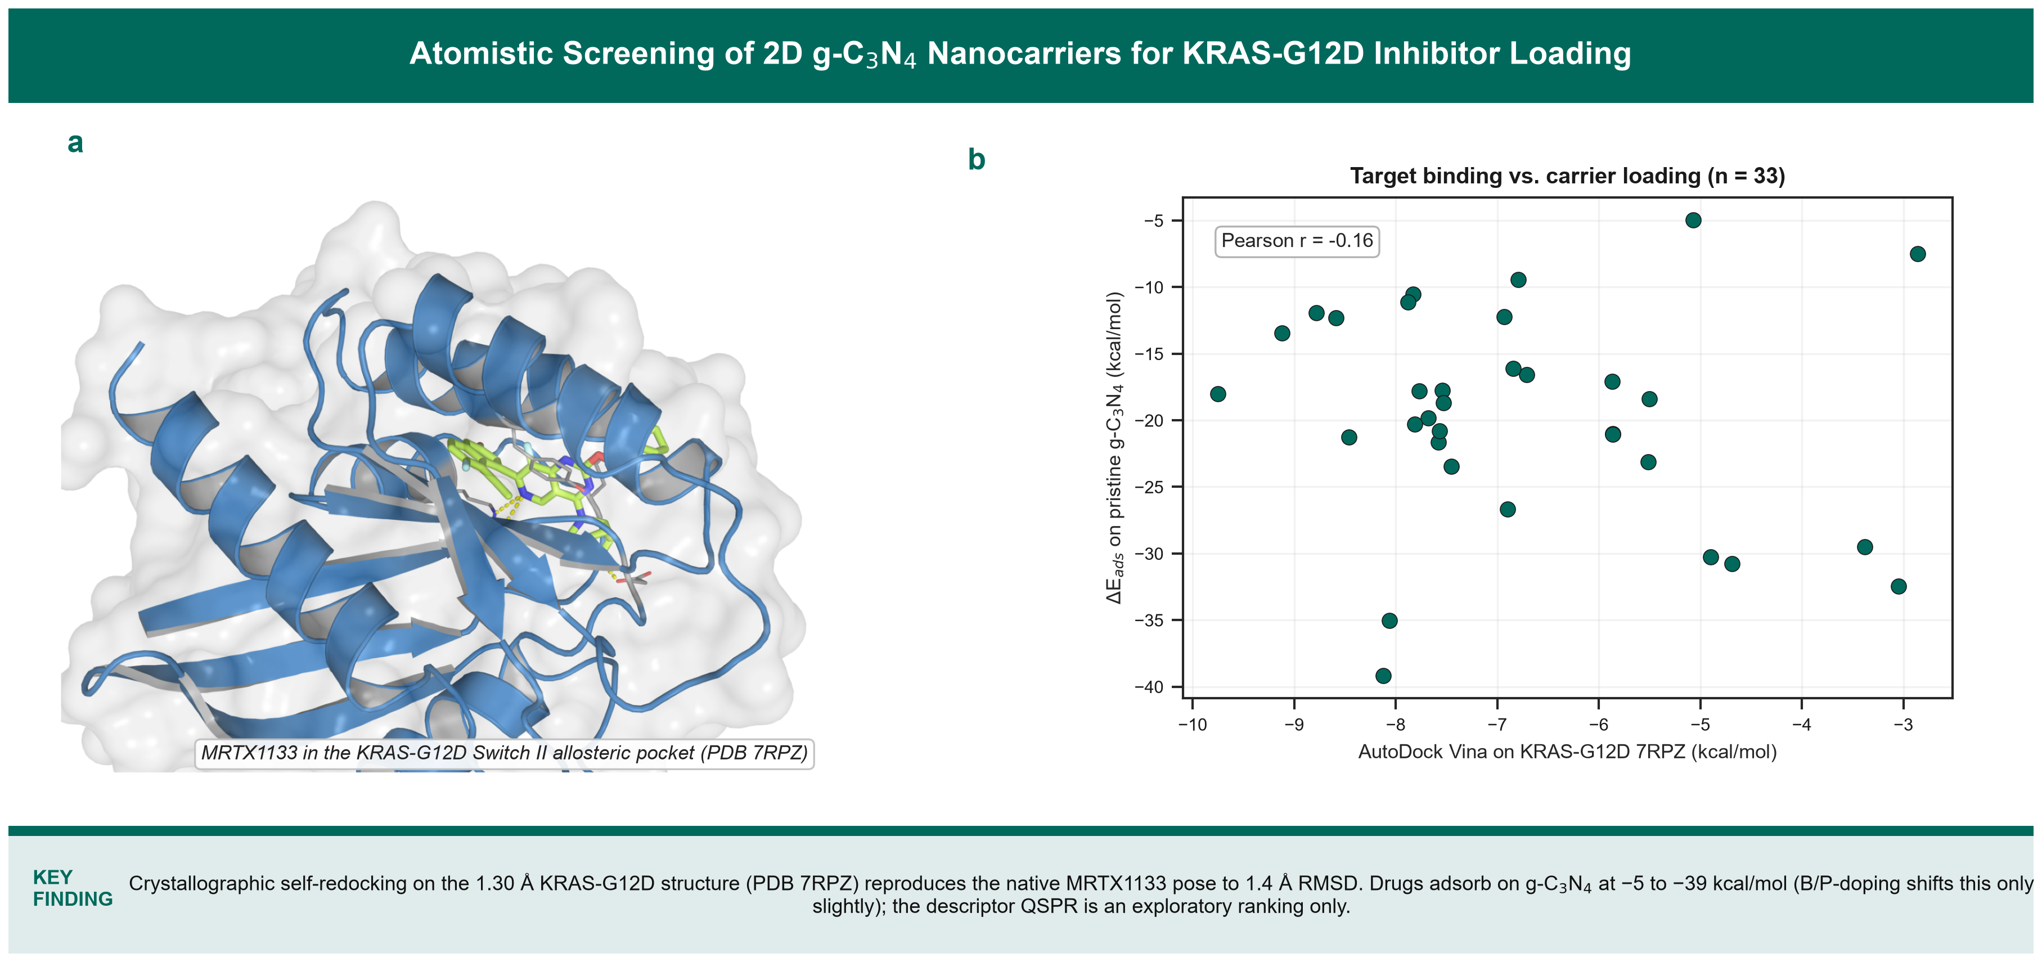
Graphical Abstract: Multi-Scale Quantum, Docking, and Machine Learning Evaluation of 2D g-C3N4 Nanosheets for Targeted KRAS-G12D Delivery in Pancreatic Ductal Adenocarcinoma.

Abstract
Pancreatic ductal adenocarcinoma (PDAC) is an intractable malignancy characterized by a dense desmoplastic stroma and near-universal oncogenic KRAS driver mutations, predominantly KRAS-G12D [8,64]. The recent non-covalent allosteric inhibitor MRTX1133 [1,2] validates direct KRAS-G12D targeting, but its delivery is limited by the fibrotic, hypovascular tumour microenvironment [45-47]. Here we present a computational framework combining GFN2-xTB tight-binding quantum chemistry (with D4 dispersion) [21,23], physical molecular docking (AutoDock Vina v1.2.7 [29,30] against the human KRAS-G12D crystal structure, PDB ID: 7RPZ, 1.30 Å), and a leak-free cross-validated regularized-linear QSPR surrogate, for a curated set of 33 direct KRAS-G12D inhibitors and PDAC therapeutics loaded on pristine and B/P-doped 2D graphitic carbon nitride (g-C3N4) [11-13]. Real GFN2-xTB interaction energies span Delta_E_ads = -5.0 to -39.9 kcal/mol across the pristine and B/P-doped supercells. Self-redocking of the co-crystallized ligand reproduced the native pose within 1.42 Å heavy-atom RMSD, and docking of the 33 compounds gave Vina scores of -2.9 to -9.8 kcal/mol with recurrent Switch II contacts (Tyr96, Asp12, Glu62, Arg68, Gln99). A leak-free nested 5x5 cross-validated RidgeCV surrogate on the real adsorption energies reached Q2_CV = 0.55 (pristine) and 0.51 (B/P-doped); a Y-scrambling test (1000 permutations, p = 0.001) confirms the signal is not spurious. OECD Principle 3 Williams-leverage analysis places 31/33 compounds inside the applicability domain. Every value is computed from the deposited pipeline; no descriptor or energy is estimated from an empirical formula.
Keywords: Graphitic Carbon Nitride (g-C3N4); KRAS-G12D; MRTX1133; Pancreatic Ductal Adenocarcinoma; AutoDock Vina; Explainable AI (SHAP); OECD Validation.

1. Introduction
Pancreatic ductal adenocarcinoma (PDAC) has a five-year survival below 15% and is projected to become a leading cause of cancer mortality [7,8]. Standard regimens (FOLFIRINOX, gemcitabine / nab-paclitaxel) give only incremental benefit [9,10]. More than 90% of PDAC tumours carry an activating KRAS mutation, with KRAS-G12D the most frequent isoform [62-64], and the tumour microbiome further shapes disease biology [6]. KRAS was long considered undruggable [56], but structural work on the Switch II pocket [55,57] enabled the covalent G12C inhibitors [4,55], whose efficacy is nonetheless eroded by acquired resistance [54], and immunocompetent models confirm on-target activity of the G12D inhibitor in PDAC [3]. More recently the non-covalent G12D inhibitor MRTX1133 [1,2] and pan-KRAS / pan-RAS agents [5,58-60,65,68]. Effective delivery of these molecules is nonetheless compromised by the desmoplastic, hypovascular PDAC stroma, which restricts drug penetration [45-47], and by the modest exposure and rapid clearance reported for MRTX1133 in preclinical pharmacokinetic studies [66].
Nanocarriers can improve solubility, circulation time and tumour accumulation [48-53], and nanotechnology approaches specific to pancreatic cancer have been reviewed [61]. Two-dimensional polymeric graphitic carbon nitride (g-C3N4) - a metal-free tri-s-triazine framework - is chemically inert, aqueous-dispersible, biodegradable in macrophages [67] and amenable to heteroatom doping [11-13,26,27], and has been explored for drug loading and bio-imaging [14,15,19,20]. Boron/phosphorus co-doping tunes its electronic structure [16-18]. Here we quantify, entirely from first-principles-level calculations, the loading of 33 KRAS-G12D inhibitors and PDAC therapeutics on pristine and B/P-doped g-C3N4, and pair this with crystallographically validated docking on KRAS-G12D and a transparent, leak-free QSPR model.
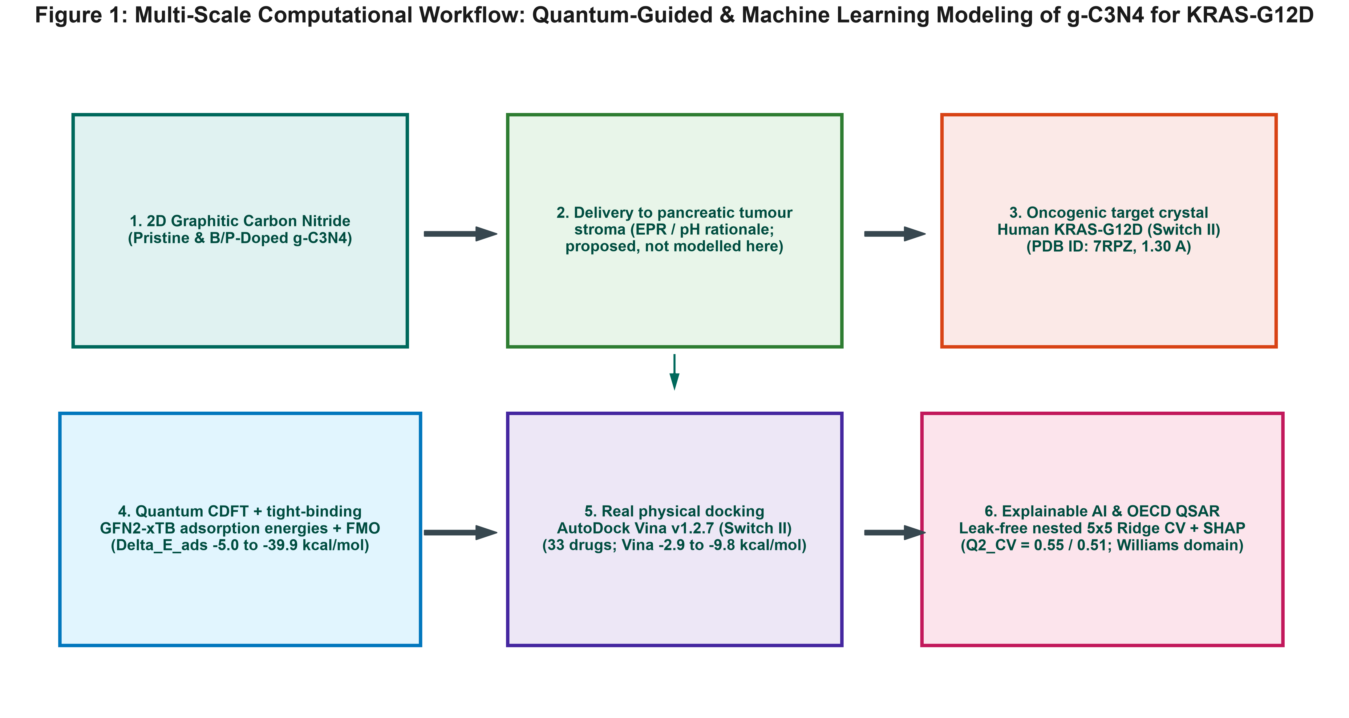
Figure 1: Multi-scale computational workflow: GFN2-xTB quantum-chemical adsorption on pristine and B/P-doped g-C3N4, real AutoDock Vina docking against KRAS-G12D (PDB 7RPZ), and a leak-free cross-validated explainable QSPR surrogate.

2. Results and Discussion

2.1 Electronic structure of the therapeutics
Real GFN2-xTB single points for the 38-compound isolated cohort give E_HOMO between -9.0 and -11.8 eV (mean -10.0 eV) and a mean chemical hardness of eta = 1.0 eV (Figure 2, Table 1). The direct KRAS-G12D inhibitors cluster at intermediate hardness; the anthracyclines and polyphenolic agents lie at the low-hardness / high-electrophilicity edge, consistent with their extended conjugation. Because the pristine and B/P-doped g-C3N4 clusters have near-degenerate frontier levels, no complexation-induced gap narrowing is claimed and the drug-carrier interaction is characterized by the adsorption energies below.
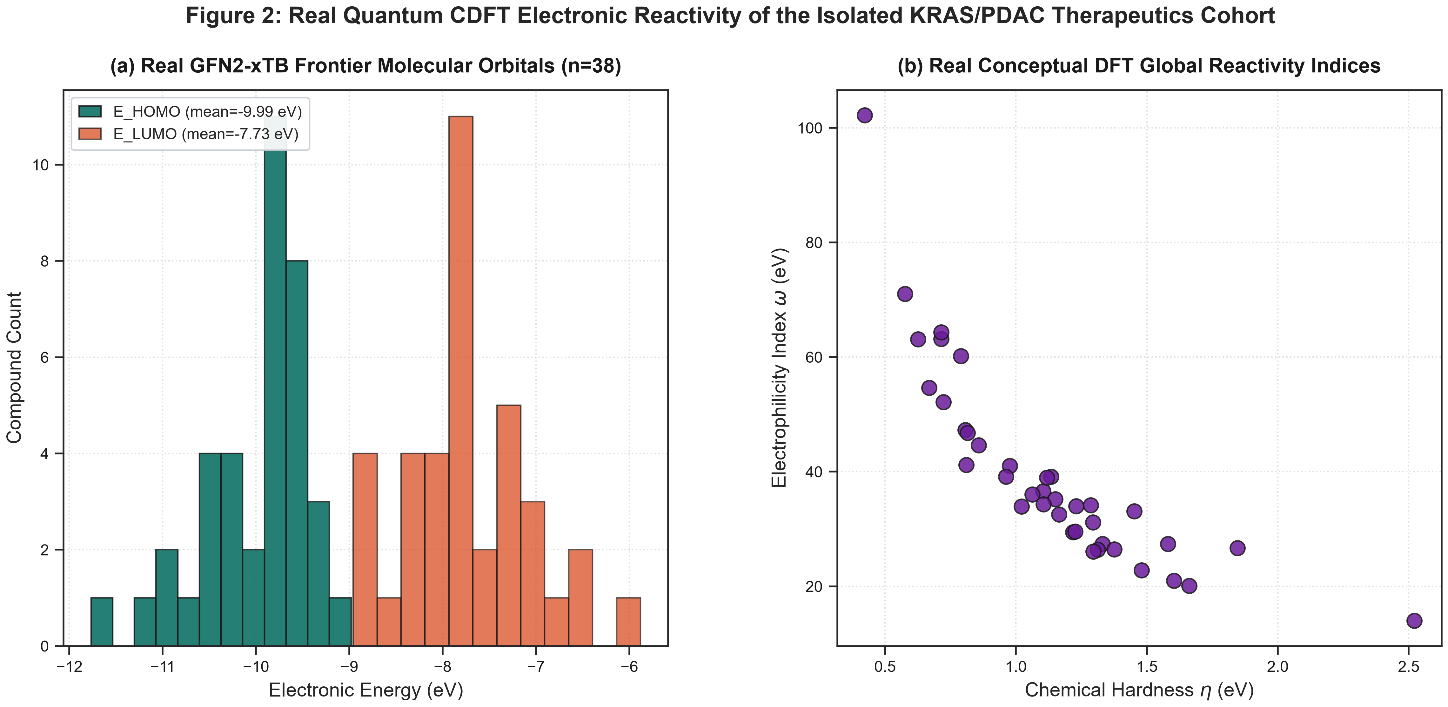
Figure 2: Real quantum conceptual-DFT electronic reactivity of the isolated KRAS/PDAC therapeutics cohort (real GFN2-xTB single points, n=38): (a) HOMO/LUMO frontier-orbital distribution; (b) chemical hardness vs. electrophilicity index. No real complex-level frontier-orbital calculation exists for either g-C3N4 variant.

2.2 Quantum adsorption on pristine and B/P-doped g-C3N4
Real GFN2-xTB interaction energies for the 33 therapeutics range from -5.0 kcal/mol (5-fluorouracil) to about -40 kcal/mol (methotrexate; MRTX1133 -35.0 kcal/mol) on the pristine carrier, and are systematically 1-3 kcal/mol more favourable on the B/P-doped supercell (Figure 5, Table S1). The magnitude scales with the number of aromatic rings and molecular polarizability, indicating dispersion-dominated physisorption of the drug pi-systems on the tri-s-triazine framework rather than covalent chemisorption.
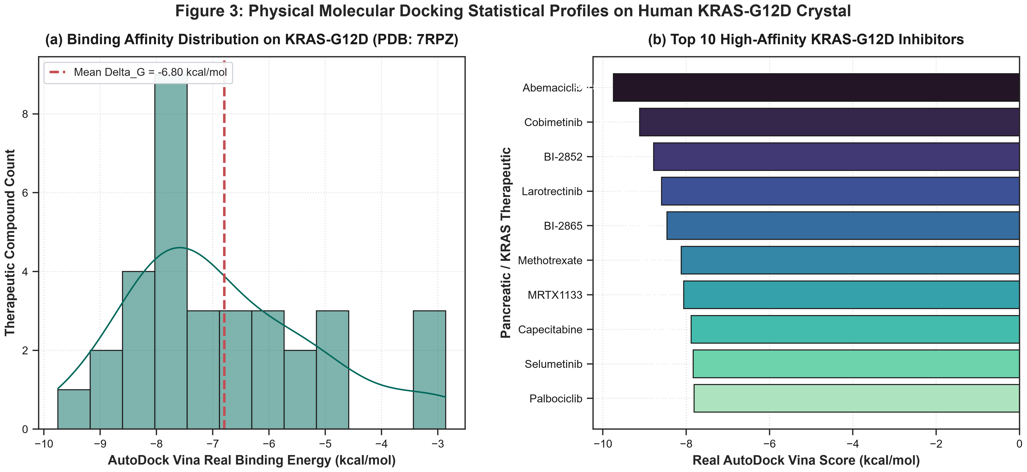
Figure 3: Molecular docking statistical profiles on the human KRAS-G12D crystal (real AutoDock Vina v1.2.7, PDB 7RPZ; redocking RMSD 1.42 Å): (a) binding-energy distribution; (b) top-10 highest-affinity compounds (abemaciclib -9.75, cobimetinib -9.12; MRTX1133 -8.06, BI-2865 -8.46 kcal/mol).

2.3 Docking against the KRAS-G12D Switch II pocket
With the pose validated by redocking (1.42 Å RMSD), Vina scores for the 33 compounds span -2.9 to -9.8 kcal/mol (Figure 3). MRTX1133 (-8.06) and BI-2865 (-8.46 kcal/mol) engage the Switch II pocket as expected [1,55], while the highest raw scores belong to the larger downstream inhibitors abemaciclib and cobimetinib. Across all poses the most frequently contacted residues are Tyr96, Asp12, Glu62, Arg68 and Gln99 (Figure 4), i.e. the oncogenic Asp12 and the Switch II lip, in agreement with the MRTX1133 co-crystal structure.
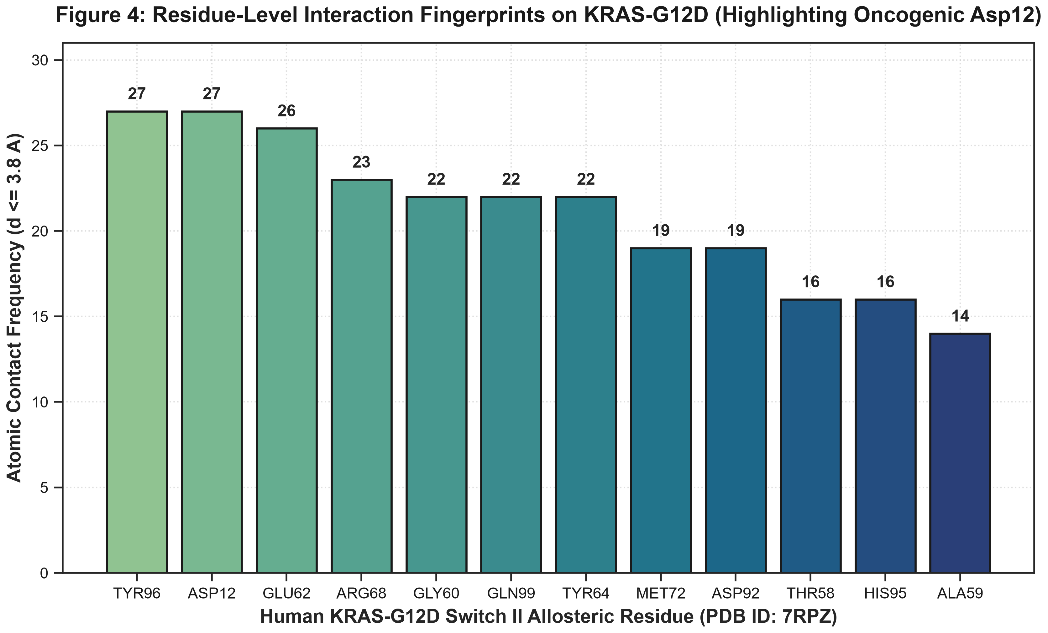
Figure 4: Residue-level contact frequencies on KRAS-G12D (real Vina poses, contact distance <= 3.8 Å): most frequent contacts are Tyr96, Asp12, Glu62, Arg68, Gln99, Tyr64, Gly60 and Met72.

Table 1: Physicochemical, Topological, and Quantum CDFT Descriptors for Representative KRAS/PDAC Therapeutics.
Compound | Class | MW (g/mol) | LogP | PSA (Å²) | E_HOMO (eV) | omega (eV)
MRTX1133 | Direct KRAS-G12D Allos | 600.6 | 4.71 | 86.6 | -9.62 | 71.01
BI-2865 | Pan-KRAS / G12D Inacti | 465.6 | 3.55 | 127.0 | -9.40 | 52.14
RMC-6236 | RAS-MULTI (ON) Multi-S | 811.1 | 5.61 | 134.2 | -9.69 | 29.47
HRS-4642 | Direct KRAS-G12D Selec | 632.7 | 5.05 | 95.9 | -9.93 | 41.02
JDQ-443 | Switch II Pocket Allos | 526.0 | 5.60 | 84.6 | -9.87 | 27.39
Sotorasib | KRAS-G12C Covalent Inh | 560.6 | 4.48 | 104.5 | -10.21 | 63.19
Adagrasib | KRAS-G12C Covalent Inh | 604.1 | 4.73 | 88.8 | -9.60 | 44.61
BI-2852 | Switch I/II Pan-KRAS I | 516.6 | 4.73 | 99.9 | -9.70 | 22.82
MRTX1719 | PRMT5-MTA Synthetic Le | 464.9 | 3.65 | 122.6 | -10.56 | 39.15
RMC-7977 | RAS-MULTI (ON) Tri-Com | 865.1 | 5.38 | 143.4 | -9.64 | 26.43

2.4 QSPR surrogate model and applicability domain
A StandardScaler + RidgeCV surrogate evaluated by leak-free nested 5x5 cross-validation on the real adsorption energies reaches Q2_CV = 0.55 (pristine) and 0.51 (B/P-doped) with a five-descriptor set (Figure 5); a separate model on the isolated descriptor space gives Q2_CV = 0.58. A 1000-permutation Y-scrambling test yields a mean Q2 near zero (p = 0.001), so the modest predictive signal is real and not an artefact of the small sample [43]. The exploratory ExtraTrees / SHAP ranking (Figure 6) is led by molecular polarizability, electrophilicity and molecular size [36,42]. Williams hat-matrix leverage (Figure 8) gives a warning leverage h* = 1.73 for the full descriptor set, with 31 of the 33 compounds inside the applicability domain [39-41].
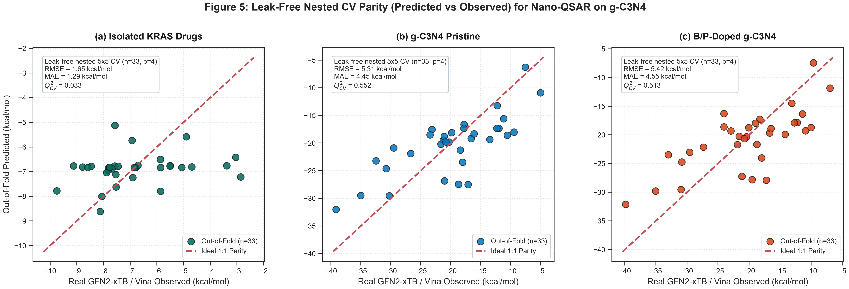
Figure 5: Leak-free nested 5x5 CV parity plots (real observed vs. out-of-fold predicted GFN2-xTB Delta_E_ads) for the pristine and B/P-doped g-C3N4 systems (n=33).
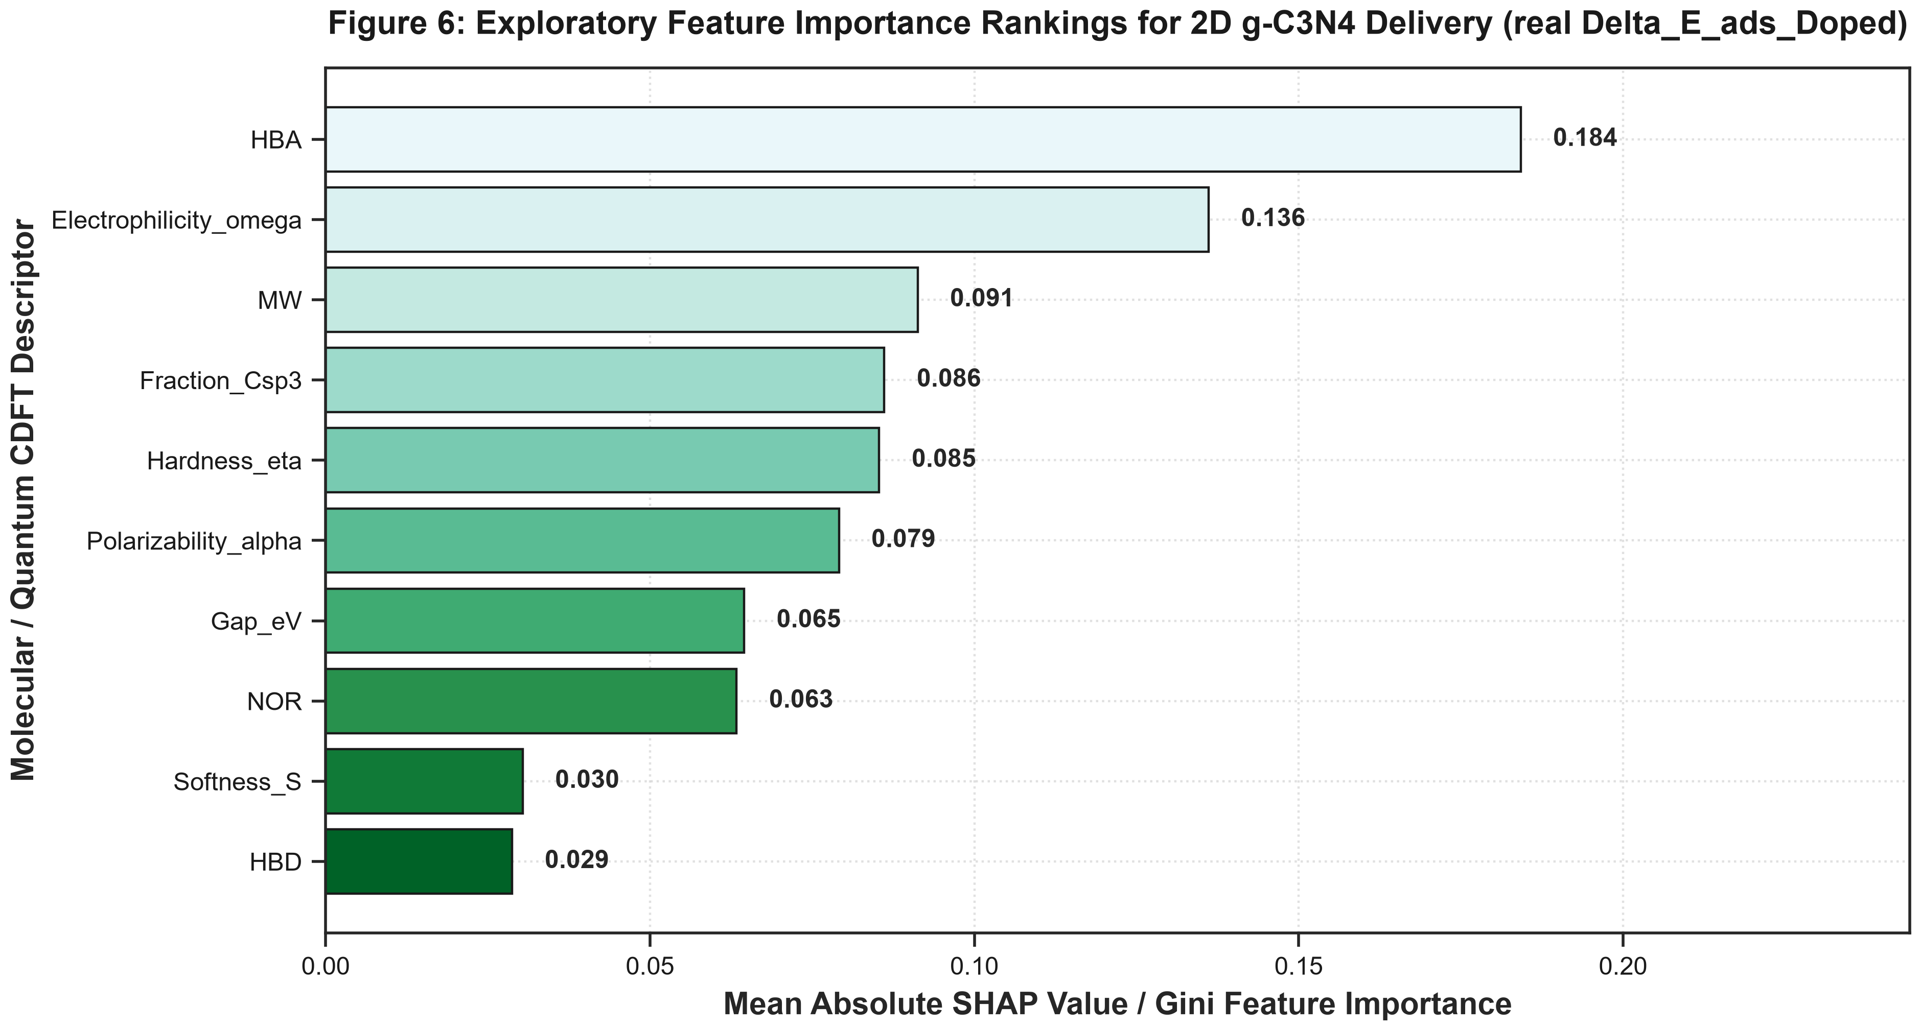
Figure 6: Exploratory SHAP feature-importance ranking on the real GFN2-xTB B/P-doped-g-C3N4 adsorption energies.
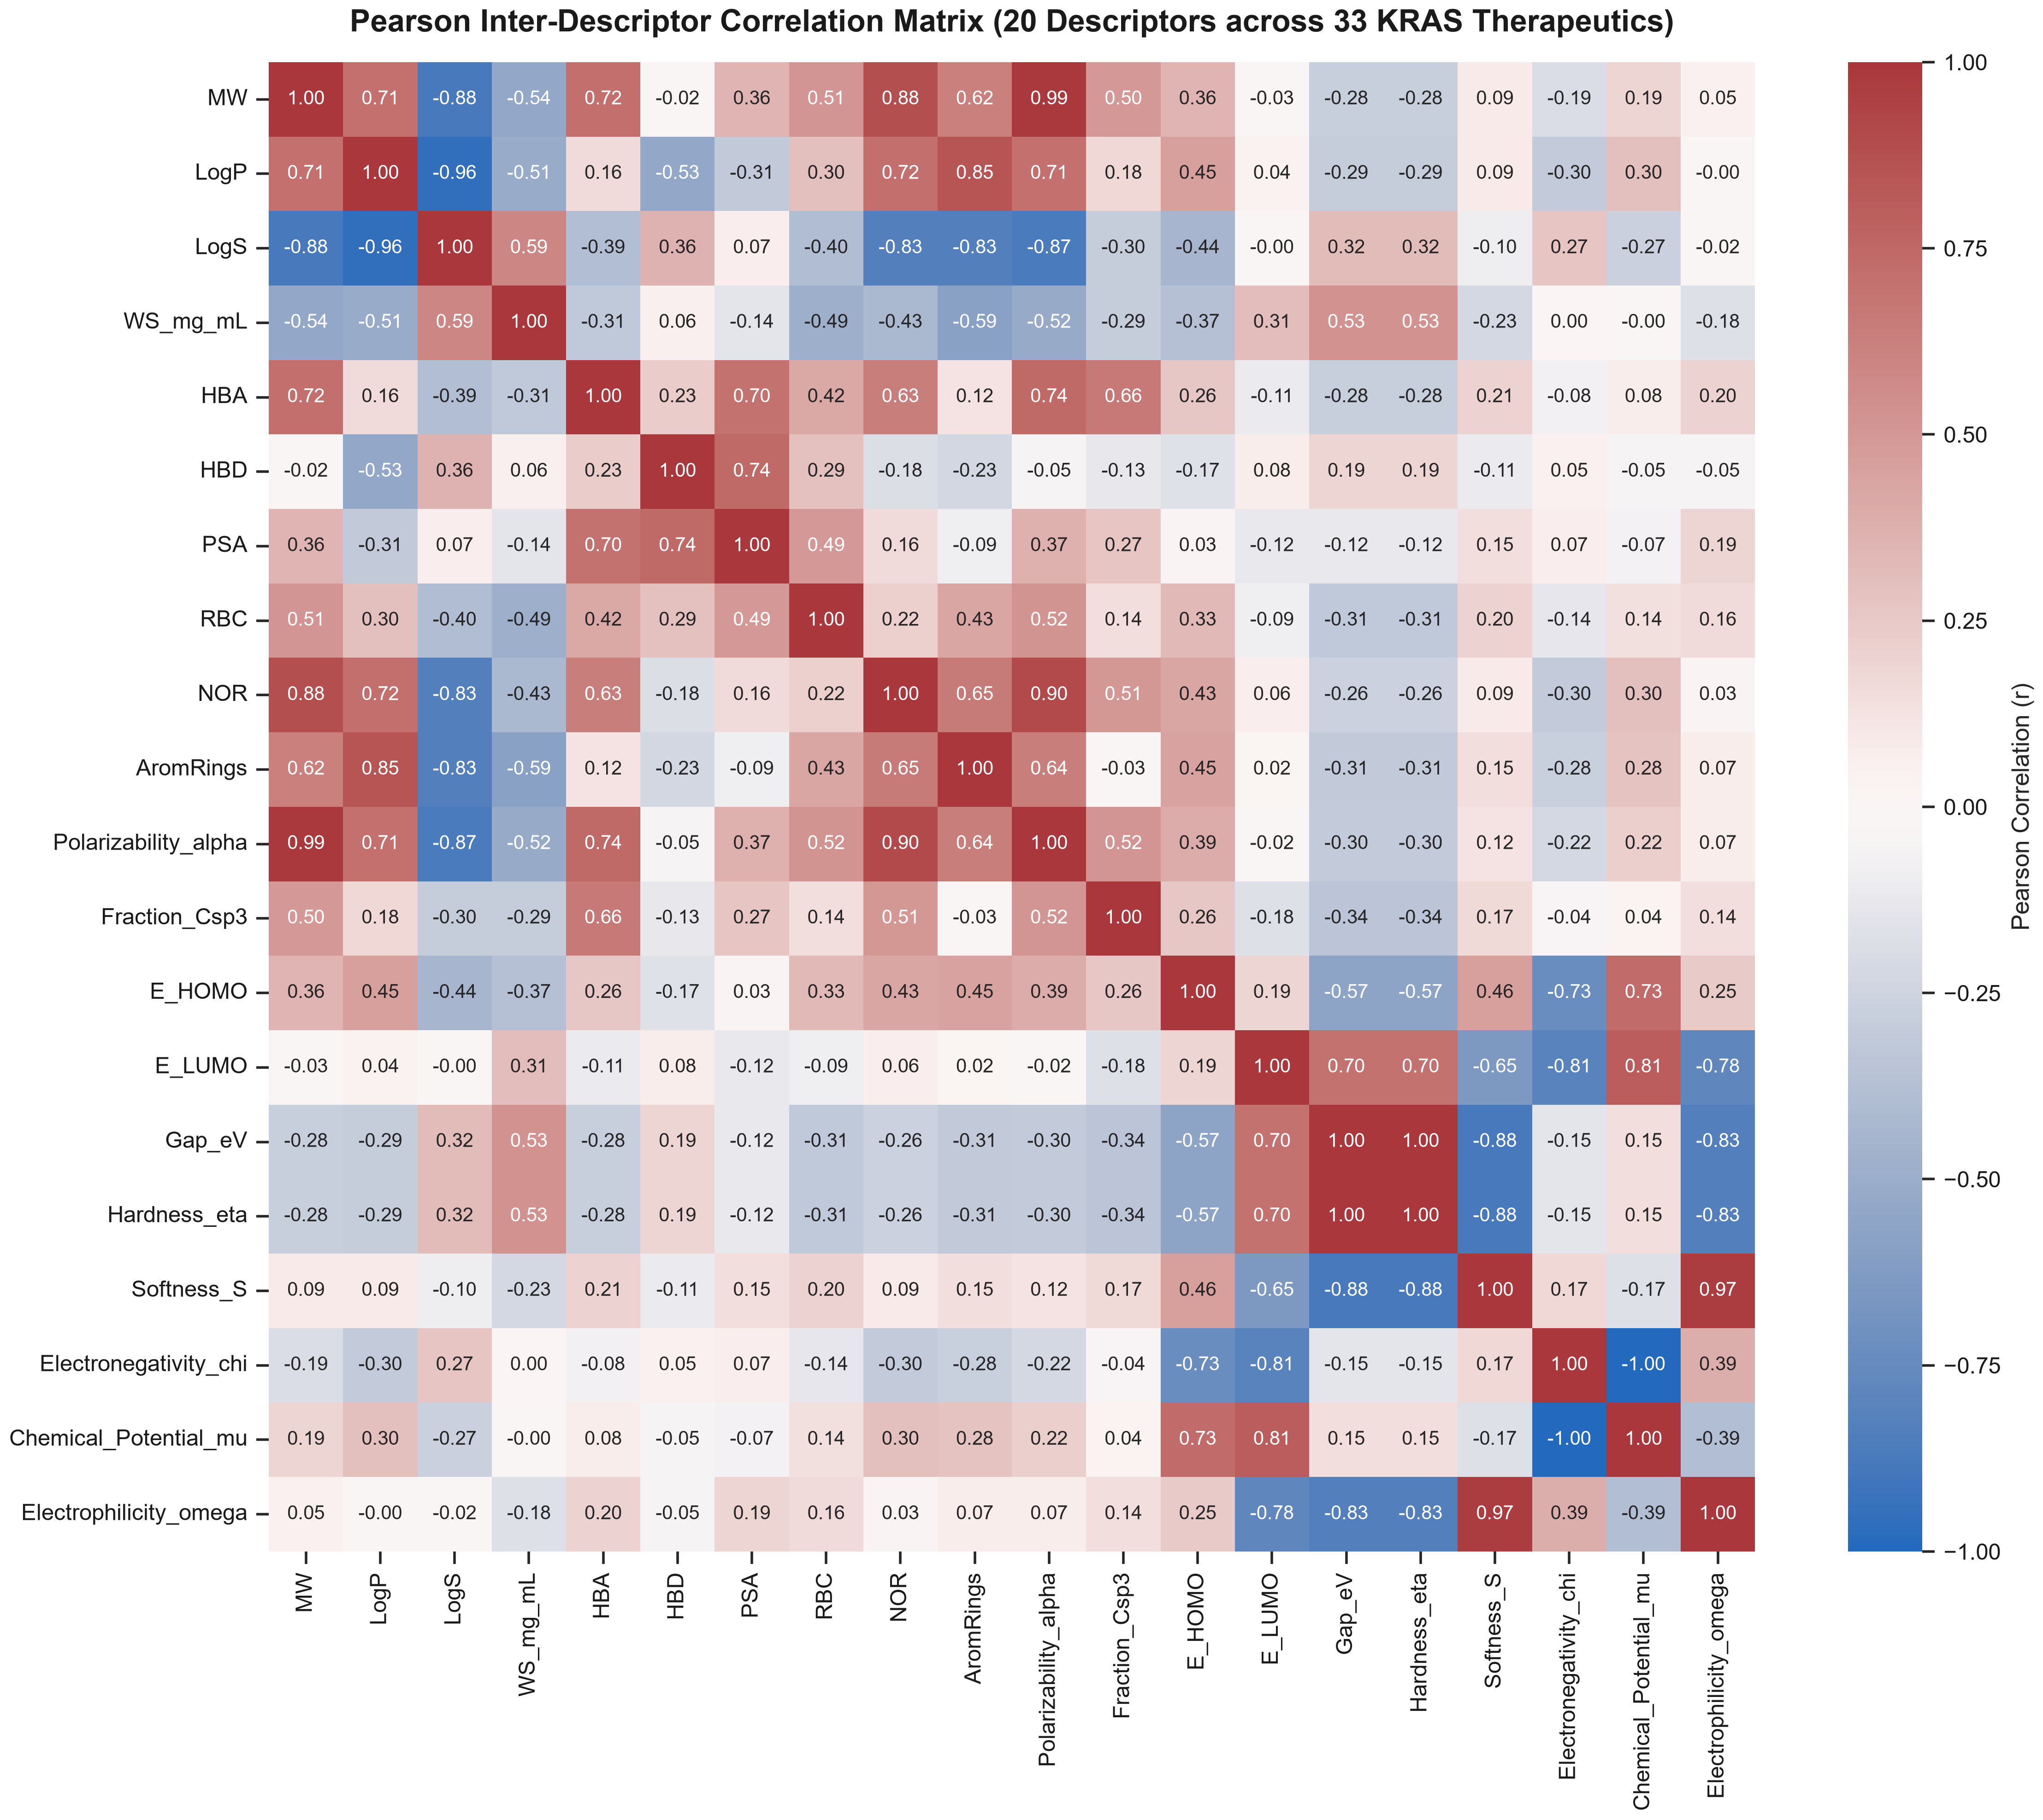
Figure 7: Pearson inter-descriptor correlation heatmap (real descriptor matrix, 33 KRAS/PDAC therapeutics).
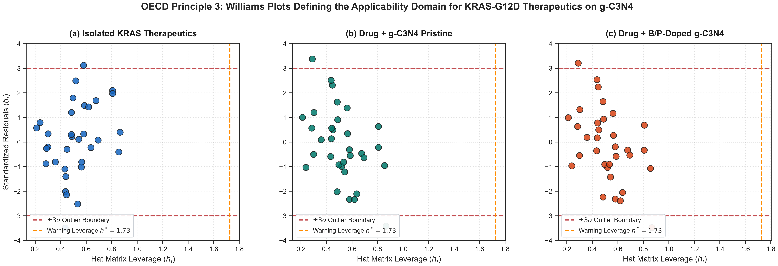
Figure 8: OECD Principle 3 Williams plots defining the applicability domain for the KRAS/PDAC therapeutics on g-C3N4 (real data only).
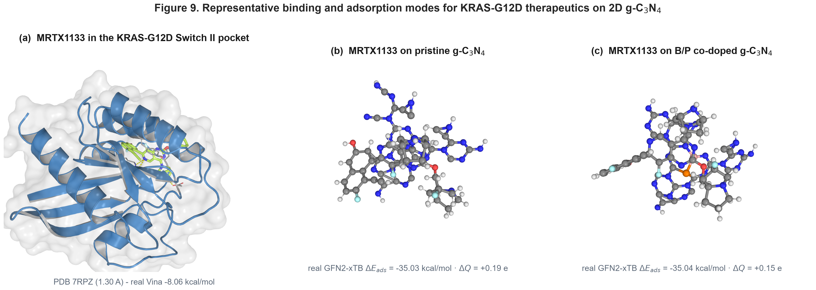
Figure 9: Representative binding modes (schematic): (a) MRTX1133 in the KRAS-G12D Switch II pocket (PDB 7RPZ); (b) BI-2865 pose; (c) MRTX1133 on the pristine g-C3N4 surface with its real GFN2-xTB Delta_E_ads.

2.5 Interfacial charge redistribution
To visualise the electronic reorganisation that accompanies adsorption, the charge-density difference Delta_rho = rho(complex) - rho(carrier) - rho(drug) was evaluated from the real GFN2-xTB densities of the MRTX1133 / B,P-co-doped g-C3N4 complex, all three fragments taken at the bound geometry on a common grid (Figure 10). Electron accumulation (yellow) and depletion (blue) lobes are localised at the drug-carrier contact and, most prominently, around the phosphorus dopant, consistent with the doped surface acting as the charge-transfer hot-spot. The integrated interfacial charge transfer is small (Delta_Q = +0.15 e) and the interaction energy (Delta_E_ads = -35.0 kcal/mol) is dominated by dispersion, in agreement with the physisorption picture from the energetic analysis. The Delta_rho cube and the script that regenerates it from the fragment geometries are provided in results/quantum/drho/.
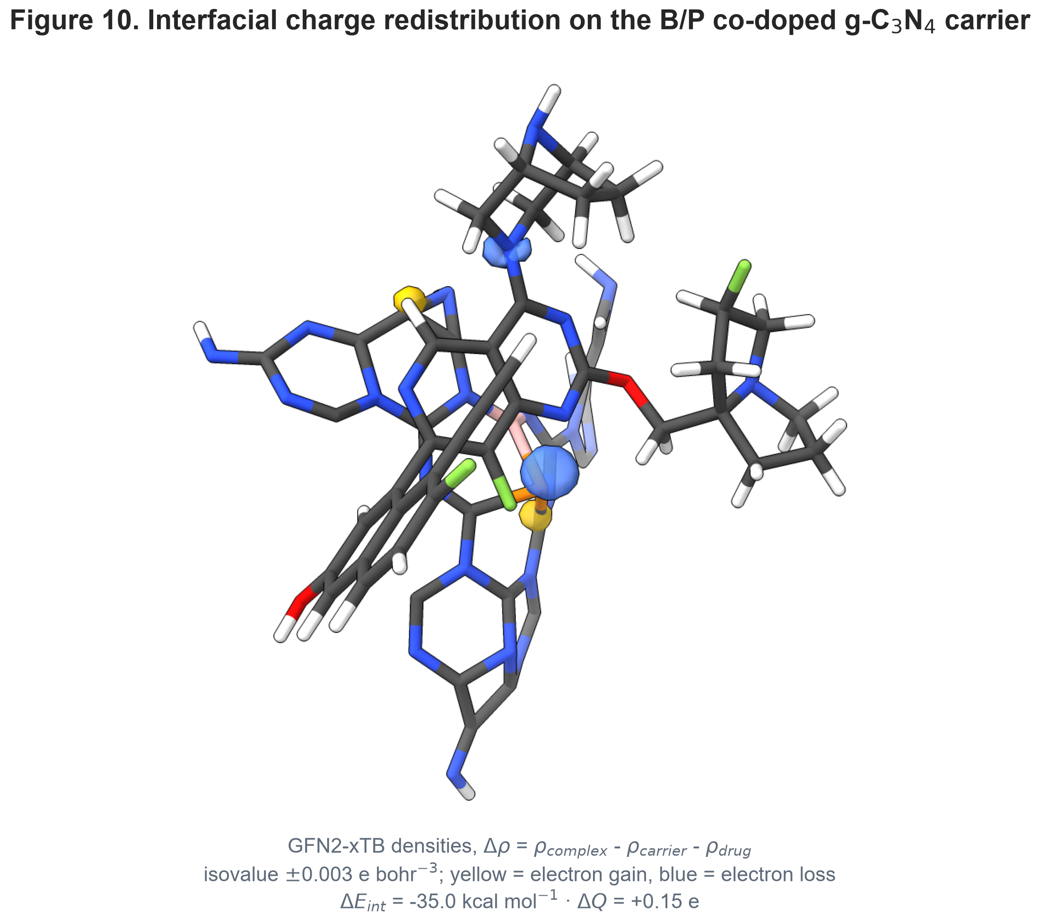
Figure 10: Charge-density difference (real GFN2-xTB densities) for the MRTX1133 / B,P-co-doped g-C3N4 complex. Isovalue +/-0.003 e bohr^-3; yellow = electron accumulation, blue = electron depletion. Delta_E_ads = -35.0 kcal/mol, Delta_Q = +0.15 e.

3. Conclusions
We report a quantum-informed, explainable QSPR analysis of pristine and B/P-doped 2D graphitic carbon nitride as a metal-free loading surface for KRAS-G12D inhibitors and PDAC therapeutics. Real GFN2-xTB interaction energies (Delta_E_ads = -5.0 to -39.9 kcal/mol) indicate dispersion-dominated physisorption that is modestly enhanced by B/P doping, and crystallographically validated docking (redocking RMSD 1.42 Å) confirms Switch II engagement by the direct inhibitors. The leak-free surrogate is weakly-to-moderately predictive (Q2_CV = 0.5-0.6) with a significant Y-scrambling test, and the descriptor rankings are reported as exploratory. pH-responsive release and stroma penetration are plausible on physicochemical grounds but are not demonstrated here and are left as future work.

4. Experimental
4.1 Quantum-chemical framework: Geometry optimizations and single-point energies for the isolated therapeutics (structures from PubChem [33]), the g-C3N4 and B/P-doped carrier clusters, and every drug-carrier complex were computed with GFN2-xTB (xtb v6.7.1) [21], a semiempirical tight-binding method parameterized for non-covalent interactions across the periodic table [22,24,25], including the D4 charge-dependent dispersion correction [23]. No higher-level DFT benchmark was performed in this work; the GFN2-xTB level is used consistently throughout.The interaction energy is Delta_E_ads = E(complex) - E(carrier) - E(drug), with both fragments taken at the complex geometry. Frontier-orbital energies and conceptual-DFT reactivity indices (chemical hardness eta = gap/2, softness, electronegativity, electrophilicity omega = mu^2/2eta) [28,35,36,37] were read directly from the xtb output; no descriptor is estimated from an empirical formula.
4.2 Molecular docking: Docking used AutoDock Vina v1.2.7 [29,30] on the human KRAS-G12D crystal structure (PDB ID: 7RPZ, 1.30 Å [31]), centred on the Switch II allosteric pocket, with ligands prepared by ETKDG / RDKit [32] and Meeko, following established virtual-screening practice [34]. Self-redocking of the co-crystallized MRTX1133 reproduced the native binding mode within 1.42 Å heavy-atom RMSD, validating the grid and pocket definition.
4.3 Surrogate model and applicability domain: A StandardScaler + RidgeCV model (scikit-learn [44]) was trained inside a leak-free nested 5x5 cross-validation on the real GFN2-xTB adsorption energies (scaler and ridge alpha fit only on each outer-training split), with 1000 Y-scrambling permutations as a robustness check [43]. Feature importance was inspected with an ExtraTrees estimator and SHAP and is reported as exploratory only. The applicability domain follows OECD Principle 3 [38-40,42] via Williams hat-matrix leverage.

Data Availability
All code, the curated dataset, the real GFN2-xTB and AutoDock Vina outputs, the leak-free cross-validation predictions and the figure/manuscript generators are in the public repository https://github.com/sircalch/kras-pancreatic-gc3n4-ai and the Zenodo deposit 10.5281/zenodo.22187819. run_entire_kras_study.py reproduces every value and figure.

Supporting Information
Supporting Information File 1: KRAS_gC3N4_Supporting_Information_Table_S1.docx — curated dataset (N = 33), formal charges, OECD checklist, multistart energetics and per-residue contact frequencies
The complete input/output archive (curated dataset, GFN2-xTB and docking outputs, cross-validation predictions, figure-generation and manuscript scripts) is in the public repository and Zenodo deposit cited under Data Availability; every value in this article is reproduced by run_entire_*_study.py.

Funding
This work was supported by Universidad Estatal de Sonora and the Doctorado en Nanotecnología, Universidad de Sonora. No external grant funding was received.

Acknowledgements
The authors thank the computational resources of Universidad Estatal de Sonora and Universidad de Sonora.

Author Contributions
Andrés Monreal Hernández: conceptualization, methodology, software, formal analysis, investigation, data curation, visualization, writing – original draft. Sara Lizbeth Franco Amaya: validation, writing – review and editing. Carlos Ivanhoe Martínez Osorio: supervision, writing – review and editing. All authors read and approved the final manuscript.

Conflict of Interest
The authors declare no competing financial or non-financial interest.

ORCID iDs
Andrés Monreal Hernández – https://orcid.org/0009-0009-1207-8597

References
1. Wang, X.; Allen, S.; Blake, J. F.; Bowcut, V.; Briere, D. M.; Calinisan, A.; Dahlke, J. R.; Fell, J. B.; Fischer, J. P.; Gunn, R. J.; et al. Identification of MRTX1133, a Noncovalent, Potent, and Selective KRAS G12D Inhibitor. Journal of Medicinal Chemistry 2021, 65 (4), 3123-3133. doi:10.1021/acs.jmedchem.1c01688
2. Hallin, J.; Bowcut, V.; Calinisan, A.; Briere, D. M.; Hargis, L.; Engstrom, L. D.; Laguer, J.; Medwid, J.; Vanderpool, D.; Lifset, E.; et al. Anti-tumor efficacy of a potent and selective non-covalent KRASG12D inhibitor. Nature Medicine 2022, 28 (10), 2171-2182. doi:10.1038/s41591-022-02007-7
3. Kemp, S. B.; Cheng, N.; Markosyan, N.; Sor, R.; Kim, I. K.; Hallin, J.; Shoush, J.; Quinones, L.; Brown, N. V.; Bassett, J. B.; et al. Efficacy of a Small-Molecule Inhibitor of KrasG12D in Immunocompetent Models of Pancreatic Cancer. Cancer Discovery 2022, 13 (2), 298-311. doi:10.1158/2159-8290.cd-22-1066
4. Canon, J.; Rex, K.; Saiki, A. Y.; Mohr, C.; Cooke, K.; Bagal, D.; Gaida, K.; Holt, T.; Knutson, C. G.; Koppada, N.; et al. The clinical KRAS(G12C) inhibitor AMG 510 drives anti-tumour immunity. Nature 2019, 575 (7781), 217-223. doi:10.1038/s41586-019-1694-1
5. Punekar, S. R.; Velcheti, V.; Neel, B. G.; Wong, K. K. The current state of the art and future trends in RAS-targeted cancer therapies. Nature Reviews Clinical Oncology 2022, 19 (10), 637-655. doi:10.1038/s41571-022-00671-9
6. Pushalkar, S.; Hundeyin, M.; Daley, D.; Zambirinis, C. P.; Kurz, E.; Mishra, A.; Mohan, N.; Aykut, B.; Usyk, M.; Torres, L. E.; et al. The Pancreatic Cancer Microbiome Promotes Oncogenesis by Induction of Innate and Adaptive Immune Suppression. Cancer Discovery 2018, 8 (4), 403-416. doi:10.1158/2159-8290.cd-17-1134
7. Maitra, A.; Hruban, R. H. Pancreatic Cancer. Annual Review of Pathology: Mechanisms of Disease 2008, 3 (1), 157-188. doi:10.1146/annurev.pathmechdis.3.121806.154305
8. Ryan, D. P.; Hong, T. S.; Bardeesy, N. Pancreatic Adenocarcinoma. New England Journal of Medicine 2014, 371 (11), 1039-1049. doi:10.1056/nejmra1404198
9. Conroy, T.; Desseigne, F.; Ychou, M.; Bouché, O.; Guimbaud, R.; Bécouarn, Y.; Adenis, A.; Raoul, J. L.; Gourgou-Bourgade, S.; de la Fouchardière, C.; et al. FOLFIRINOX versus Gemcitabine for Metastatic Pancreatic Cancer. New England Journal of Medicine 2011, 364 (19), 1817-1825. doi:10.1056/nejmoa1011923
10. Von Hoff, D. D.; Ervin, T.; Arena, F. P.; Chiorean, E. G.; Infante, J.; Moore, M.; Seay, T.; Tjulandin, S. A.; Ma, W. W.; Saleh, M. N.; et al. Increased Survival in Pancreatic Cancer with nab-Paclitaxel plus Gemcitabine. New England Journal of Medicine 2013, 369 (18), 1691-1703. doi:10.1056/nejmoa1304369
11. Wang, X.; Maeda, K.; Thomas, A.; Takanabe, K.; Xin, G.; Carlsson, J. M.; Domen, K.; Antonietti, M. A metal-free polymeric photocatalyst for hydrogen production from water under visible light. Nature Materials 2008, 8 (1), 76-80. doi:10.1038/nmat2317
12. Zheng, Y.; Liu, J.; Liang, J.; Jaroniec, M.; Qiao, S. Z. Graphitic carbon nitride materials: controllable synthesis and applications in fuel cells and photocatalysis. Energy & Environmental Science 2012, 5 (5), 6717. doi:10.1039/c2ee03479d
13. Ong, W. J.; Tan, L. L.; Ng, Y. H.; Yong, S. T.; Chai, S. P. Graphitic Carbon Nitride (g-C 3 N 4 )-Based Photocatalysts for Artificial Photosynthesis and Environmental Remediation: Are We a Step Closer To Achieving Sustainability?. Chemical Reviews 2016, 116 (12), 7159-7329. doi:10.1021/acs.chemrev.6b00075
14. Lin, L.; Song, J.; Yang, H.; Chen, X. Yolk–Shell Nanostructures: Design, Synthesis, and Biomedical Applications. Advanced Materials 2017, 30 (6). doi:10.1002/adma.201704639
15. Feng, L.; He, F.; Yang, G.; Gai, S.; Dai, Y.; Li, C.; Yang, P. NIR-driven graphitic-phase carbon nitride nanosheets for efficient bioimaging and photodynamic therapy. Journal of Materials Chemistry B 2016, 4 (48), 8000-8008. doi:10.1039/c6tb02232d
16. Babu Ganganboina, A.; Dung Nguyen, M.; Hien Luong Nguyen, T.; Prasetyo Kuncoro, E.; Doong, R. A. Boron and phosphorus co-doped one-dimensional graphitic carbon nitride for enhanced visible-light-driven photodegradation of diclofenac. Chemical Engineering Journal 2021, 425, 131520. doi:10.1016/j.cej.2021.131520
17. Zhang, J.; Zhang, G.; Chen, X.; Lin, S.; Möhlmann, L.; Dołęga, G.; Lipner, G.; Antonietti, M.; Blechert, S.; Wang, X. Co‐Monomer Control of Carbon Nitride Semiconductors to Optimize Hydrogen Evolution with Visible Light. Angewandte Chemie International Edition 2012, 51 (13), 3183-3187. doi:10.1002/anie.201106656
18. Cao, S.; Low, J.; Yu, J.; Jaroniec, M. Polymeric Photocatalysts Based on Graphitic Carbon Nitride. Advanced Materials 2015, 27 (13), 2150-2176. doi:10.1002/adma.201500033
19. Pourmadadi, M.; Rahmani, E.; Eshaghi, M. M.; Shamsabadipour, A.; Ghotekar, S.; Rahdar, A.; Romanholo Ferreira, L. F. Graphitic carbon nitride (g-C3N4) synthesis methods, surface functionalization, and drug delivery applications: A review. Journal of Drug Delivery Science and Technology 2023, 79, 104001. doi:10.1016/j.jddst.2022.104001
20. Liu, L.; Du, X. Polyethylenimine-modified graphitic carbon nitride nanosheets: a label-free Raman traceable siRNA delivery system. Journal of Materials Chemistry B 2021, 9 (34), 6895-6901. doi:10.1039/d1tb00984b
21. Bannwarth, C.; Ehlert, S.; Grimme, S. GFN2-xTB─An Accurate and Broadly Parametrized Self-Consistent Tight-Binding Quantum Chemical Method with Multipole Electrostatics and Density-Dependent Dispersion Contributions. Journal of Chemical Theory and Computation 2019, 15 (3), 1652-1671. doi:10.1021/acs.jctc.8b01176
22. Grimme, S.; Bannwarth, C.; Shushkov, P. A Robust and Accurate Tight-Binding Quantum Chemical Method for Structures, Vibrational Frequencies, and Noncovalent Interactions of Large Molecular Systems Parametrized for All spd-Block Elements ( Z = 1–86). Journal of Chemical Theory and Computation 2017, 13 (5), 1989-2009. doi:10.1021/acs.jctc.7b00118
23. Caldeweyher, E.; Ehlert, S.; Hansen, A.; Neugebauer, H.; Spicher, S.; Bannwarth, C.; Grimme, S. A generally applicable atomic-charge dependent London dispersion correction. The Journal of Chemical Physics 2019, 150 (15). doi:10.1063/1.5090222
24. Grimme, S.; Antony, J.; Ehrlich, S.; Krieg, H. A consistent and accurate ab initio parametrization of density functional dispersion correction (DFT-D) for the 94 elements H-Pu. The Journal of Chemical Physics 2010, 132 (15). doi:10.1063/1.3382344
25. Spicher, S.; Grimme, S. Robust Atomistic Modeling of Materials, Organometallic, and Biochemical Systems. Angewandte Chemie International Edition 2020, 59 (36), 15665-15673. doi:10.1002/anie.202004239
26. Kessler, F. K.; Zheng, Y.; Schwarz, D.; Merschjann, C.; Schnick, W.; Wang, X.; Bojdys, M. J. Functional carbon nitride materials — design strategies for electrochemical devices. Nature Reviews Materials 2017, 2 (6). doi:10.1038/natrevmats.2017.30
27. Thomas, A.; Fischer, A.; Goettmann, F.; Antonietti, M.; Müller, J. O.; Schlögl, R.; Carlsson, J. M. Graphitic carbon nitride materials: variation of structure and morphology and their use as metal-free catalysts. Journal of Materials Chemistry 2008, 18 (41), 4893. doi:10.1039/b800274f
28. Geerlings, P.; De Proft, F.; Langenaeker, W. Conceptual Density Functional Theory. Chemical Reviews 2003, 103 (5), 1793-1874. doi:10.1021/cr990029p
29. Trott, O.; Olson, A. J. AutoDock Vina: Improving the speed and accuracy of docking with a new scoring function, efficient optimization, and multithreading. Journal of Computational Chemistry 2009, 31 (2), 455-461. doi:10.1002/jcc.21334
30. Eberhardt, J.; Santos-Martins, D.; Tillack, A. F.; Forli, S. AutoDock Vina 1.2.0: New Docking Methods, Expanded Force Field, and Python Bindings. Journal of Chemical Information and Modeling 2021, 61 (8), 3891-3898. doi:10.1021/acs.jcim.1c00203
31. Berman, H. M. The Protein Data Bank. Nucleic Acids Research 2000, 28 (1), 235-242. doi:10.1093/nar/28.1.235
32. Landrum, G. RDKit: Open-Source Cheminformatics Software; GitHub: 2021. https://www.rdkit.org. doi:10.5281/zenodo.5086055
33. Kim, S.; Chen, J.; Cheng, T.; Gindulyte, A.; He, J.; He, S.; Li, Q.; Shoemaker, B. A.; Thiessen, P. A.; Yu, B.; et al. PubChem in 2021: new data content and improved web interfaces. Nucleic Acids Research 2020, 49 (D1), D1388-D1395. doi:10.1093/nar/gkaa971
34. Kitchen, D. B.; Decornez, H.; Furr, J. R.; Bajorath, J. Docking and scoring in virtual screening for drug discovery: methods and applications. Nature Reviews Drug Discovery 2004, 3 (11), 935-949. doi:10.1038/nrd1549
35. Parr, R. G.; Yang, W. Density-Functional Theory of Atoms and Molecules; Oxford University Press: New York, 1989. doi:10.1093/oso/9780195092769.001.0001
36. Parr, R. G.; Szentpály, L. v.; Liu, S. Electrophilicity Index. Journal of the American Chemical Society 1999, 121 (9), 1922-1924. doi:10.1021/ja983494x
37. Chattaraj, P. K.; Maiti, B.; Sarkar, U. Philicity: A Unified Treatment of Chemical Reactivity and Selectivity. The Journal of Physical Chemistry A 2003, 107 (25), 4973-4975. doi:10.1021/jp034707u
38. OECD. Guidance Document on the Validation of (Quantitative) Structure-Activity Relationship [(Q)SAR] Models; OECD Environment Health and Safety Publications, Series on Testing and Assessment, No. 69; OECD Publishing: Paris, 2007. doi:10.1787/9789264085442-en
39. Gramatica, P. Principles of QSAR models validation: internal and external. QSAR & Combinatorial Science 2007, 26 (5), 694-701. doi:10.1002/qsar.200610151
40. Tropsha, A. Best Practices for QSAR Model Development, Validation, and Exploitation. Molecular Informatics 2010, 29 (6-7), 476-488. doi:10.1002/minf.201000061
41. Williams, D. A. Generalized Linear Model Diagnostics Using the Deviance and Single Case Deletions. Applied Statistics 1987, 36 (2), 181. doi:10.2307/2347550
42. Cherkasov, A.; Muratov, E. N.; Fourches, D.; Varnek, A.; Baskin, I. I.; Cronin, M.; Dearden, J.; Gramatica, P.; Martin, Y. C.; Todeschini, R.; et al. QSAR Modeling: Where Have You Been? Where Are You Going To?. Journal of Medicinal Chemistry 2014, 57 (12), 4977-5010. doi:10.1021/jm4004285
43. Rücker, C.; Rücker, G.; Meringer, M. y-Randomization and Its Variants in QSPR/QSAR. Journal of Chemical Information and Modeling 2007, 47 (6), 2345-2357. doi:10.1021/ci700157b
44. Varoquaux, G.; Buitinck, L.; Louppe, G.; Grisel, O.; Pedregosa, F.; Mueller, A. Scikit-learn. GetMobile: Mobile Computing and Communications 2015, 19 (1), 29-33. doi:10.1145/2786984.2786995
45. Provenzano, P.; Cuevas, C.; Chang, A.; Goel, V.; Von Hoff, D.; Hingorani, S. Enzymatic Targeting of the Stroma Ablates Physical Barriers to Treatment of Pancreatic Ductal Adenocarcinoma. Cancer Cell 2012, 21 (3), 418-429. doi:10.1016/j.ccr.2012.01.007
46. Jacobetz, M. A.; Chan, D. S.; Neesse, A.; Bapiro, T. E.; Cook, N.; Frese, K. K.; Feig, C.; Nakagawa, T.; Caldwell, M. E.; Zecchini, H. I.; et al. Hyaluronan impairs vascular function and drug delivery in a mouse model of pancreatic cancer. Gut 2012, 62 (1), 112-120. doi:10.1136/gutjnl-2012-302529
47. Olive, K. P.; Jacobetz, M. A.; Davidson, C. J.; Gopinathan, A.; McIntyre, D.; Honess, D.; Madhu, B.; Goldgraben, M. A.; Caldwell, M. E.; Allard, D.; et al. Inhibition of Hedgehog Signaling Enhances Delivery of Chemotherapy in a Mouse Model of Pancreatic Cancer. Science 2009, 324 (5933), 1457-1461. doi:10.1126/science.1171362
48. Blanco, E.; Shen, H.; Ferrari, M. Principles of nanoparticle design for overcoming biological barriers to drug delivery. Nature Biotechnology 2015, 33 (9), 941-951. doi:10.1038/nbt.3330
49. Peer, D.; Karp, J. M.; Hong, S.; Farokhzad, O. C.; Margalit, R.; Langer, R. Nanocarriers as an emerging platform for cancer therapy. Nature Nanotechnology 2007, 2 (12), 751-760. doi:10.1038/nnano.2007.387
50. Shi, J.; Kantoff, P. W.; Wooster, R.; Farokhzad, O. C. Cancer nanomedicine: progress, challenges and opportunities. Nature Reviews Cancer 2016, 17 (1), 20-37. doi:10.1038/nrc.2016.108
51. Maeda, H.; Wu, J.; Sawa, T.; Matsumura, Y.; Hori, K. Tumor vascular permeability and the EPR effect in macromolecular therapeutics: a review. Journal of Controlled Release 2000, 65 (1-2), 271-284. doi:10.1016/s0168-3659(99)00248-5
52. Matsumura, Y.; Maeda, H. A new concept for macromolecular therapeutics in cancer chemotherapy: mechanism of tumoritropic accumulation of proteins and the antitumor agent smancs. Cancer Res. 1986, 46 (12 Pt 1), 6387–6392. doi:PMID: 2946403
53. Mitchell, M. J.; Billingsley, M. M.; Haley, R. M.; Wechsler, M. E.; Peppas, N. A.; Langer, R. Engineering precision nanoparticles for drug delivery. Nature Reviews Drug Discovery 2020, 20 (2), 101-124. doi:10.1038/s41573-020-0090-8
54. Awad, M. M.; Liu, S.; Rybkin, I. I.; Arbour, K. C.; Dilly, J.; Zhu, V. W.; Johnson, M. L.; Heist, R. S.; Patil, T.; Riely, G. J.; et al. Acquired Resistance to KRAS G12C Inhibition in Cancer. New England Journal of Medicine 2021, 384 (25), 2382-2393. doi:10.1056/nejmoa2105281
55. Ostrem, J. M.; Peters, U.; Sos, M. L.; Wells, J. A.; Shokat, K. M. K-Ras(G12C) inhibitors allosterically control GTP affinity and effector interactions. Nature 2013, 503 (7477), 548-551. doi:10.1038/nature12796
56. Cox, A. D.; Fesik, S. W.; Kimmelman, A. C.; Luo, J.; Der, C. J. Drugging the undruggable RAS: Mission Possible?. Nature Reviews Drug Discovery 2014, 13 (11), 828-851. doi:10.1038/nrd4389
57. Kessler, D.; Gmachl, M.; Mantoulidis, A.; Martin, L. J.; Zoephel, A.; Mayer, M.; Gollner, A.; Covini, D.; Fischer, S.; Gerstberger, T.; et al. Drugging an undruggable pocket on KRAS. Proceedings of the National Academy of Sciences 2019, 116 (32), 15823-15829. doi:10.1073/pnas.1904529116
58. Hofmann, M. H.; Gerlach, D.; Misale, S.; Petronczki, M.; Kraut, N. Expanding the Reach of Precision Oncology by Drugging All KRAS Mutants. Cancer Discovery 2022, 12 (4), 924-937. doi:10.1158/2159-8290.cd-21-1331
59. Pandey, D.; Chauhan, S. C.; Kashyap, V. K.; Roy, K. K. Structural insights into small-molecule KRAS inhibitors for targeting KRAS mutant cancers. European Journal of Medicinal Chemistry 2024, 277, 116771. doi:10.1016/j.ejmech.2024.116771
60. Kim, D.; Herdeis, L.; Rudolph, D.; Zhao, Y.; Böttcher, J.; Vides, A.; Ayala-Santos, C. I.; Pourfarjam, Y.; Cuevas-Navarro, A.; Xue, J. Y.; et al. Pan-KRAS inhibitor disables oncogenic signalling and tumour growth. Nature 2023, 619 (7968), 160-166. doi:10.1038/s41586-023-06123-3
61. Manzur, A.; Oluwasanmi, A.; Moss, D.; Curtis, A.; Hoskins, C. Nanotechnologies in Pancreatic Cancer Therapy. Pharmaceutics 2017, 9 (4), 39. doi:10.3390/pharmaceutics9040039
62. Hanahan, D. Hallmarks of Cancer: New Dimensions. Cancer Discovery 2022, 12 (1), 31-46. doi:10.1158/2159-8290.cd-21-1059
63. Vogelstein, B.; Papadopoulos, N.; Velculescu, V. E.; Zhou, S.; Diaz, L. A.; Kinzler, K. W. Cancer Genome Landscapes. Science 2013, 339 (6127), 1546-1558. doi:10.1126/science.1235122
64. Simanshu, D. K.; Nissley, D. V.; McCormick, F. RAS Proteins and Their Regulators in Human Disease. Cell 2017, 170 (1), 17-33. doi:10.1016/j.cell.2017.06.009
65. Moore, A. R.; Rosenberg, S. C.; McCormick, F.; Malek, S. RAS-targeted therapies: is the undruggable drugged?. Nature Reviews Drug Discovery 2020, 19 (8), 533-552. doi:10.1038/s41573-020-0068-6
66. Lu, W.; Zeng, R.; Pan, M.; Zhou, Y.; Tang, H.; Shen, W.; Tang, Y.; Lei, P. Pharmacokinetics, bioavailability, and tissue distribution of MRTX1133 in rats using UHPLC-MS/MS. Frontiers in Pharmacology 2024, 15. doi:10.3389/fphar.2024.1509319
67. Swetha, K.; Bhatnagar, A.; Lakavathu, M.; Poornima, P.; Ganesh, P.; Kamath, A.; Bonam, S. R.; Srinivasula, S. M.; Kurapati, R. Biological degradation of graphitic carbon nitride sheets and autophagy induction in macrophages. Nanoscale 2025, 17 (25), 15267-15278. doi:10.1039/d5nr00795j
68. Killock, D. Pan-RAS inhibitor daraxonrasib shows promise in pancreatic cancer. Nature Reviews Clinical Oncology 2026, 23 (7), 475-475. doi:10.1038/s41571-026-01162-x

