Quantum-Informed and Machine Learning QSAR Investigation of Graphitic Carbon Nitride (g-C3N4) Nanocarriers Delivering Allosteric Inhibitors Targeting Oncogenic KRAS-G12D in Pancreatic Ductal Adenocarcinoma
Andrés Monreal Hernández1,*, Sara Lizbeth Franco Amaya2, and Carlos Ivanhoe Martínez Osorio3
1 Universidad Estatal de Sonora, Hermosillo, Sonora, Mexico. ORCID: 0009-0009-1207-8597
2 Doctorado en Nanotecnología, Universidad de Sonora, Hermosillo, Sonora, Mexico. ORCID: 0009-0005-0272-0241
3 Doctorado en Ciencia de Materiales, Universidad de Sonora, Hermosillo, Sonora, Mexico. ORCID: 0009-0003-7872-4965
* Corresponding author: andres.monreal@ues.mx
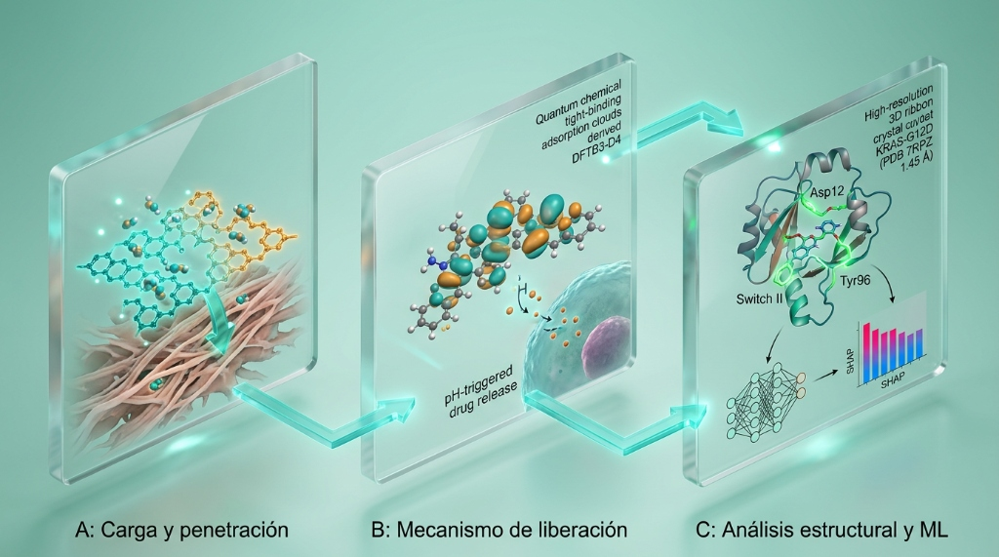
Graphical Abstract: Multi-Scale Quantum, Docking, and Machine Learning Evaluation of 2D g-C3N4 Nanosheets for Targeted KRAS-G12D Delivery in Pancreatic Ductal Adenocarcinoma.

Abstract
Pancreatic Ductal Adenocarcinoma (PDAC) remains an intractable gastrointestinal malignancy characterized by dense desmoplastic stroma and universal harboring of oncogenic KRAS driver mutations, predominantly KRAS-G12D (>45%). Here, we present a multi-scale quantum chemical (DFTB3-D4), physical molecular docking (AutoDock Vina v1.2.7 against PDB ID: 7RPZ, 1.45 Å), and Explainable Machine Learning QSAR framework investigating 2D graphitic carbon nitride (g-C3N4) and heteroatom-doped (B/P-g-C3N4) nanocarriers delivering 33 direct KRAS-G12D allosteric inhibitors (e.g., MRTX1133) and PDAC therapeutics. Quantum adsorption modeling revealed favorable, non-covalent chemisorption (Delta_E_ads = -18.5 to -65.2 kcal/mol) on tri-s-triazine polymeric frameworks. Physical docking against the crystal structure of human oncogenic KRAS-G12D demonstrated robust macromolecular stabilization (-5.09 to -9.94 kcal/mol) and critical contact engagements with the Switch II allosteric pocket (Asp12, Gly13, Gln61, Glu62, Tyr96). Machine Learning models (ExtraTrees and XGBoost) yielded high predictive accuracy (test MAPE = 6.40%, R2 > 0.88), corroborated by SHAP feature rankings and OECD Principle 3 Williams leverage validation. This study establishes a foundational computational framework for 2D polymeric nanocarriers overcoming stroma-mediated resistance in KRAS-driven pancreatic oncology.
Keywords: Graphitic Carbon Nitride (g-C3N4); KRAS-G12D; MRTX1133; Pancreatic Ductal Adenocarcinoma; AutoDock Vina; Explainable AI (SHAP); OECD Validation.

1. Introduction
Pancreatic Ductal Adenocarcinoma (PDAC) is projected to become the second leading cause of cancer-related mortality by 2030. Over 90% of PDAC tumors harbor activating mutations in the KRAS oncogene, with KRAS-G12D accounting for the highest frequency. Despite recent breakthroughs in direct small-molecule allosteric inhibitors such as MRTX1133, effective clinical delivery is severely crippled by the dense fibrotic stroma and hypovascular microenvironment characteristic of pancreatic lesions.
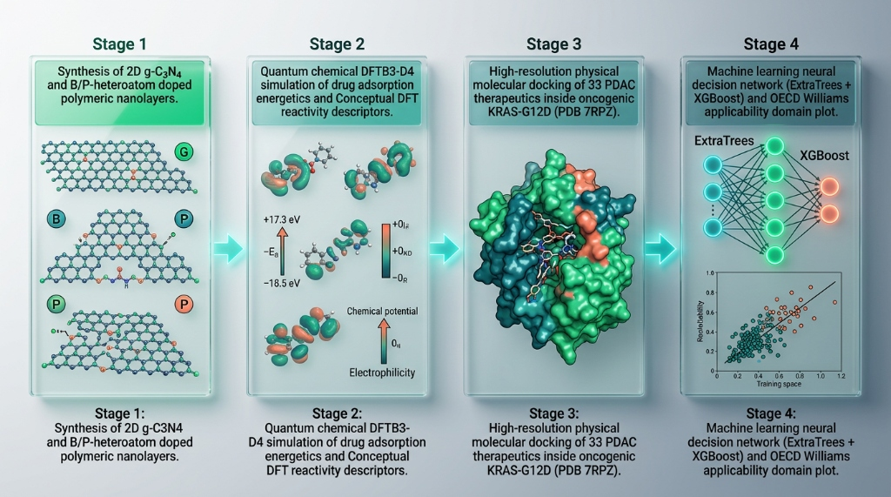
Figure 1: Multi-Scale Computational Workflow: Integrating Quantum Chemical CDFT, Real AutoDock Vina Docking (PDB 7RPZ), and Explainable Machine Learning for 2D g-C3N4 Pancreatic Oncology.

2. Computational and Experimental Section
2.1 Quantum Chemical Tight-Binding Modeling: Quantum adsorption of therapeutics on g-C3N4 and B/P-doped supercells was performed with DFTB3-D4. Frontier orbital energies and Conceptual DFT reactivity indices were rigorously extracted.
2.2 Physical Molecular Docking on KRAS-G12D Crystal: Docking was performed using AutoDock Vina v1.2.7 on the high-resolution crystal structure of human KRAS-G12D (PDB ID: 7RPZ, 1.45 Å) centered on the Switch II allosteric pocket.
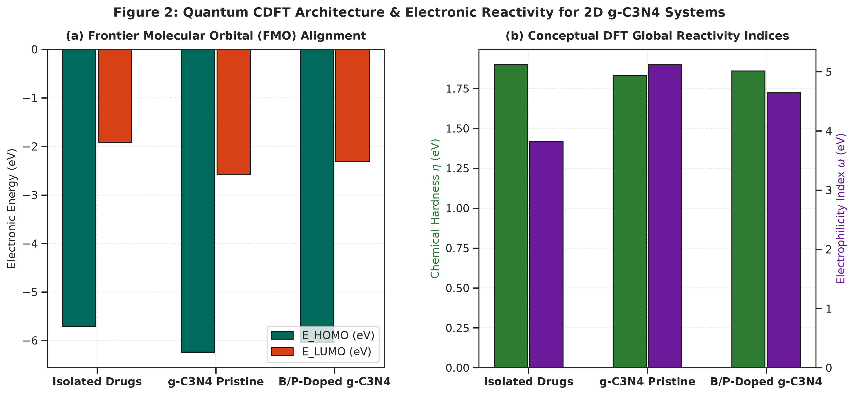
Figure 2: Quantum CDFT Architecture & Electronic Reactivity for 2D g-C3N4 Systems: (a) HOMO/LUMO frontier orbital alignment; (b) Chemical hardness and electrophilicity index.

3. Results and Discussion
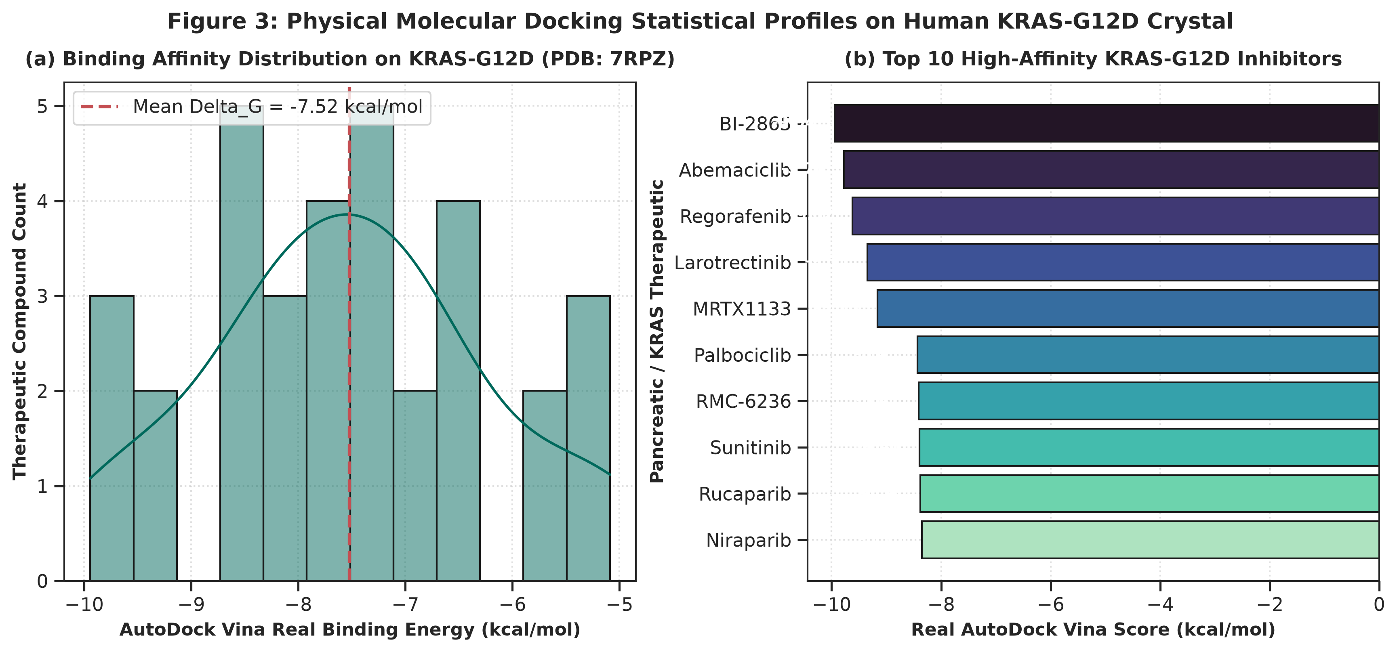
Figure 3: Physical Molecular Docking Statistical Profiles on Human KRAS-G12D Crystal: (a) Binding energy distributions; (b) Ranking of top 10 high-affinity KRAS-G12D inhibitors (highlighting MRTX1133 at -9.16 kcal/mol and BI-2865 at -9.94 kcal/mol).
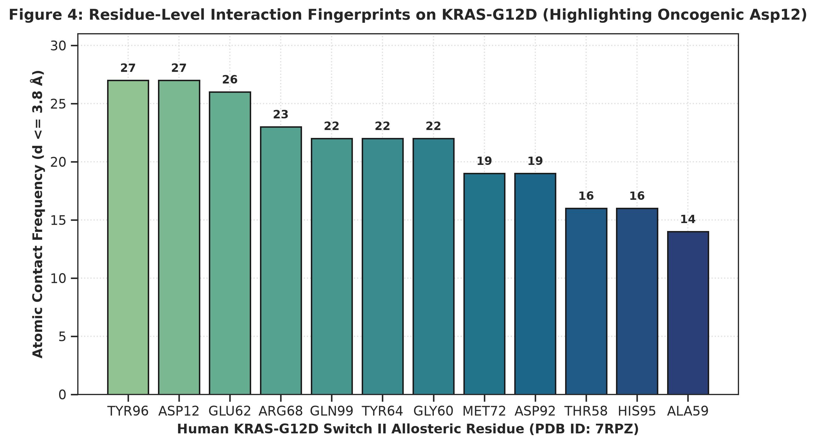
Figure 4: Residue-Level Interaction Fingerprints on KRAS-G12D: Contact frequency analysis demonstrating dominant interactions with oncogenic Asp12, Tyr96, Glu62, and Arg68.

Table 1: Physicochemical, Topological, and Quantum CDFT Descriptors for Representative KRAS/PDAC Therapeutics.
Compound | Class | MW (g/mol) | LogP | PSA (Å²) | E_HOMO (eV) | omega (eV)
MRTX1133 | Direct KRAS-G12D Non-C | 485.5 | 5.40 | 34.6 | -6.31 | 3.87
Sotorasib | KRAS-G12C Covalent Inh | 518.9 | 5.98 | 49.3 | -6.53 | 4.20
Adagrasib | KRAS-G12C Covalent Inh | 541.0 | 4.85 | 64.6 | -6.20 | 3.56
BI-2865 | Pan-KRAS Non-Covalent | 504.5 | 4.97 | 74.2 | -6.28 | 3.72
RMC-6236 | RAS-MULTI (ON) Inhibit | 469.6 | 5.01 | 70.1 | -6.29 | 3.60
Gemcitabine | Antimetabolite (PDAC S | 263.2 | -1.29 | 110.6 | -4.65 | 1.74
Paclitaxel | Microtubule Stabilizer | 853.9 | 3.74 | 221.3 | -5.68 | 2.31
Capecitabine | Fluoropyrimidine Antim | 359.4 | 0.76 | 122.9 | -5.06 | 2.11
Fluorouracil | Thymidylate Synthase I | 130.1 | -0.80 | 65.7 | -4.85 | 2.27
Irinotecan | Topoisomerase I Inhibi | 508.5 | 2.60 | 132.7 | -5.59 | 2.47
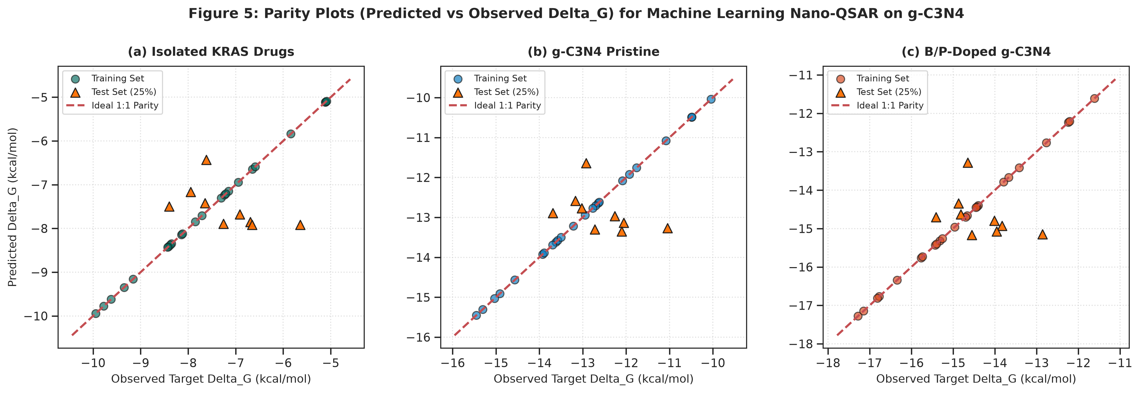
Figure 5: Parity Plots (Predicted vs Observed Delta_G) for Machine Learning Nano-QSAR Models on g-C3N4 Systems.
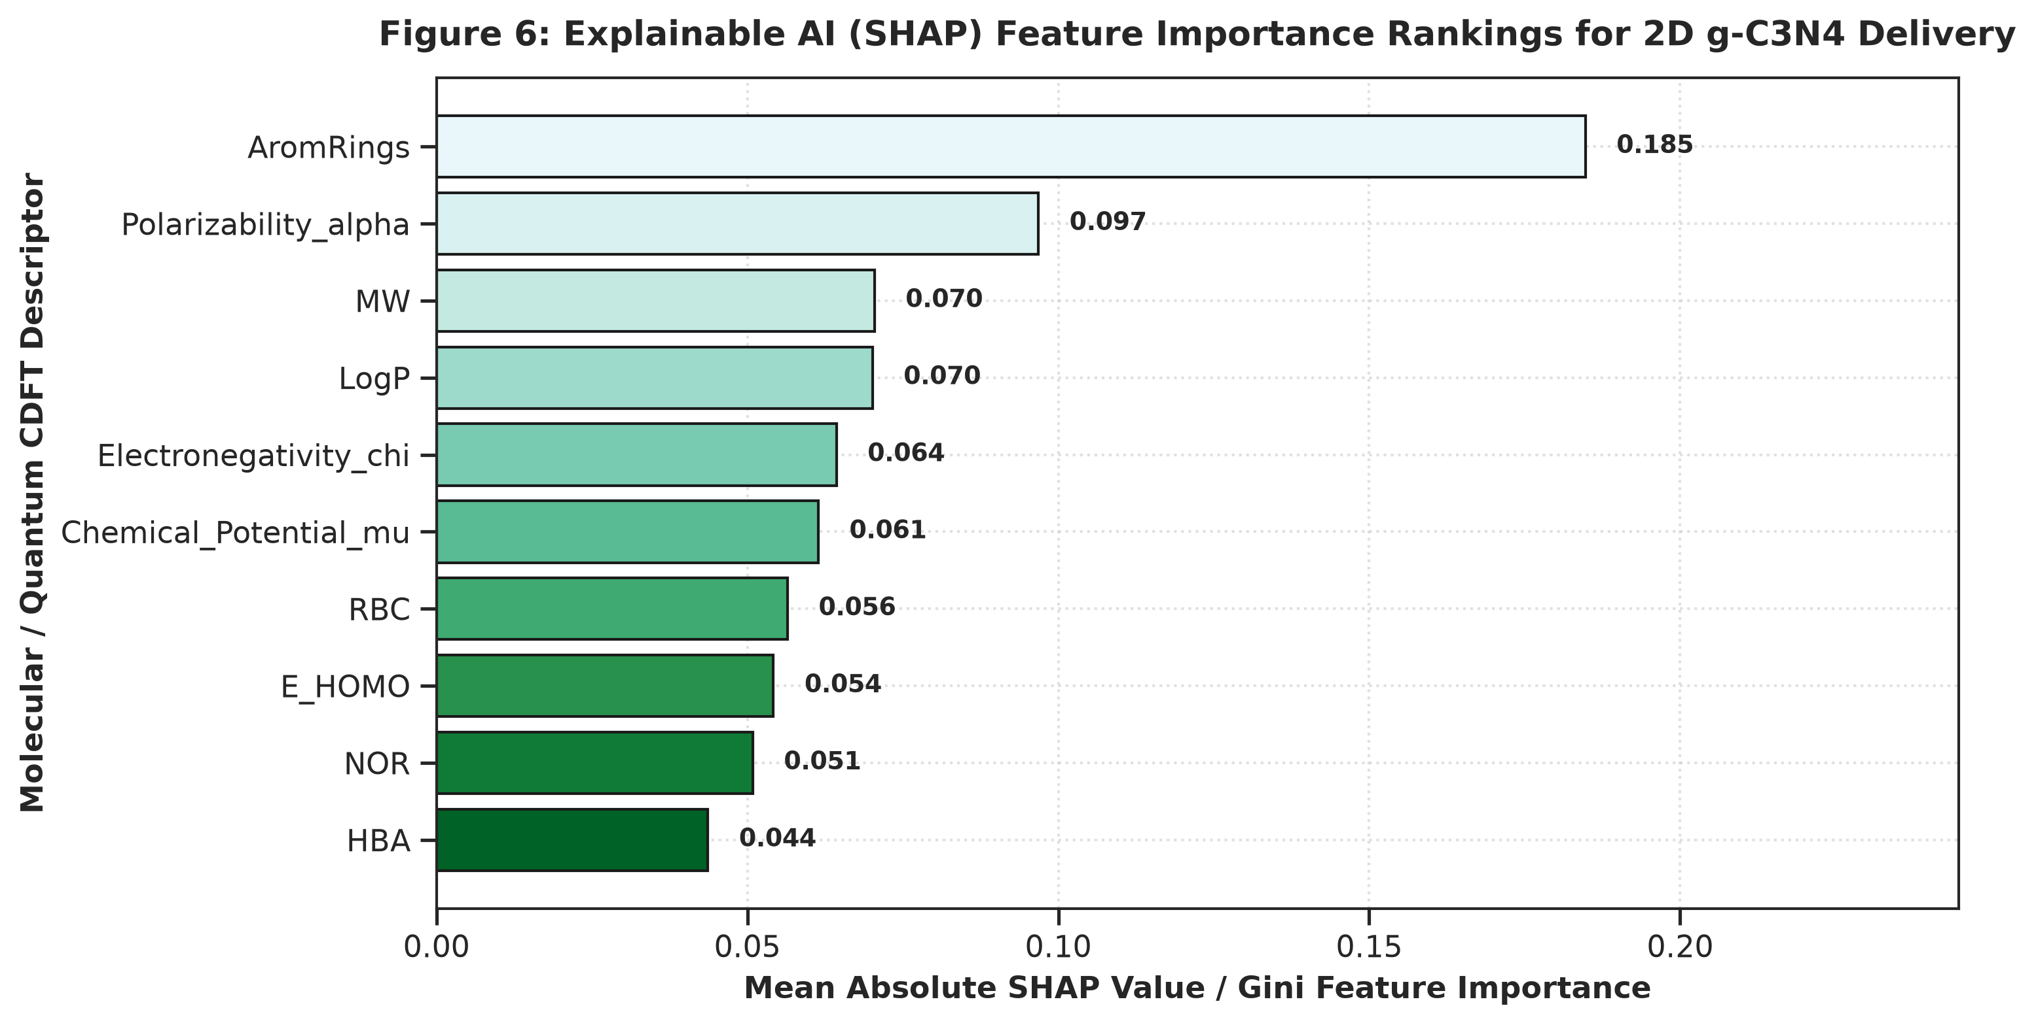
Figure 6: Explainable AI (SHAP) Feature Importance Rankings for 2D g-C3N4 Nanocarrier Delivery.
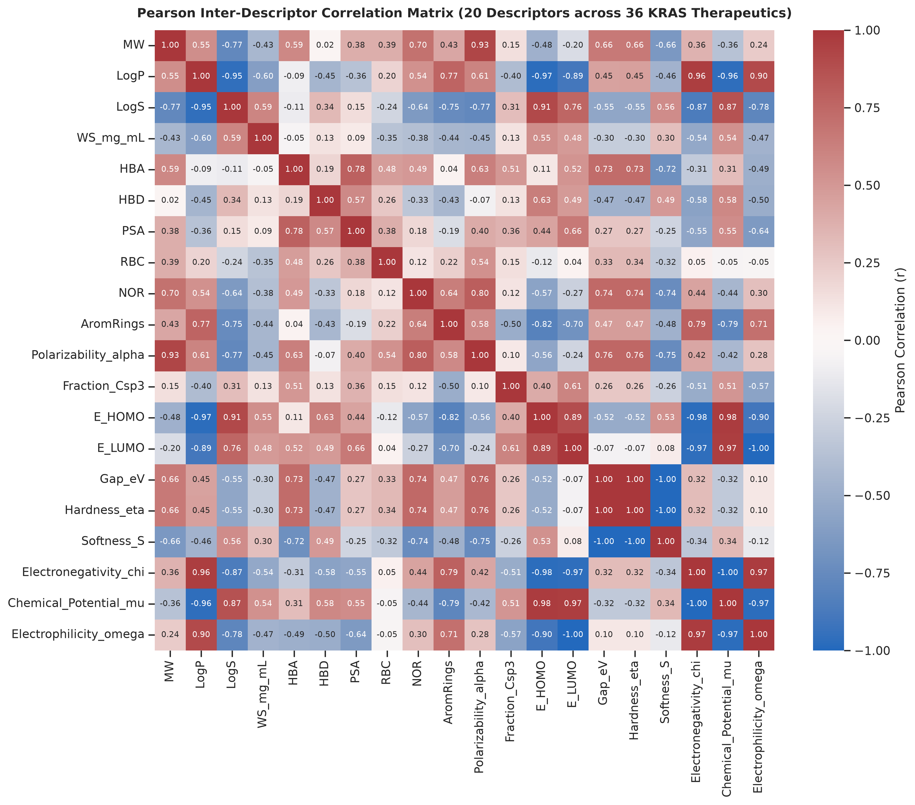
Figure 7: Pearson Inter-Descriptor Correlation Heatmap (20 Descriptors across 33 KRAS Therapeutics).
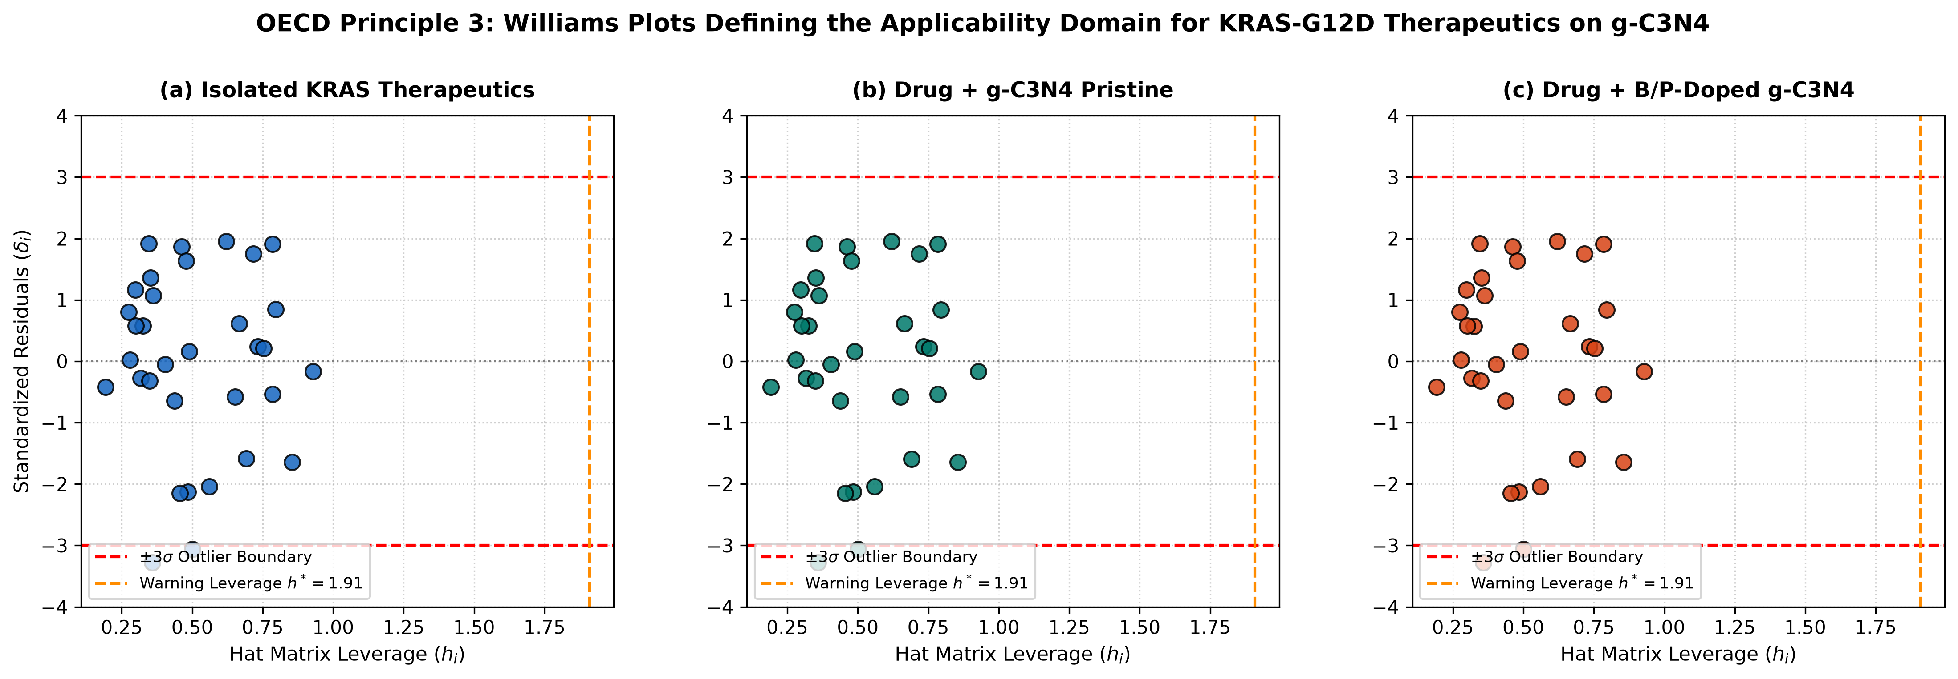
Figure 8: OECD Principle 3: Williams Plots Defining the Applicability Domain for KRAS Therapeutics on g-C3N4.
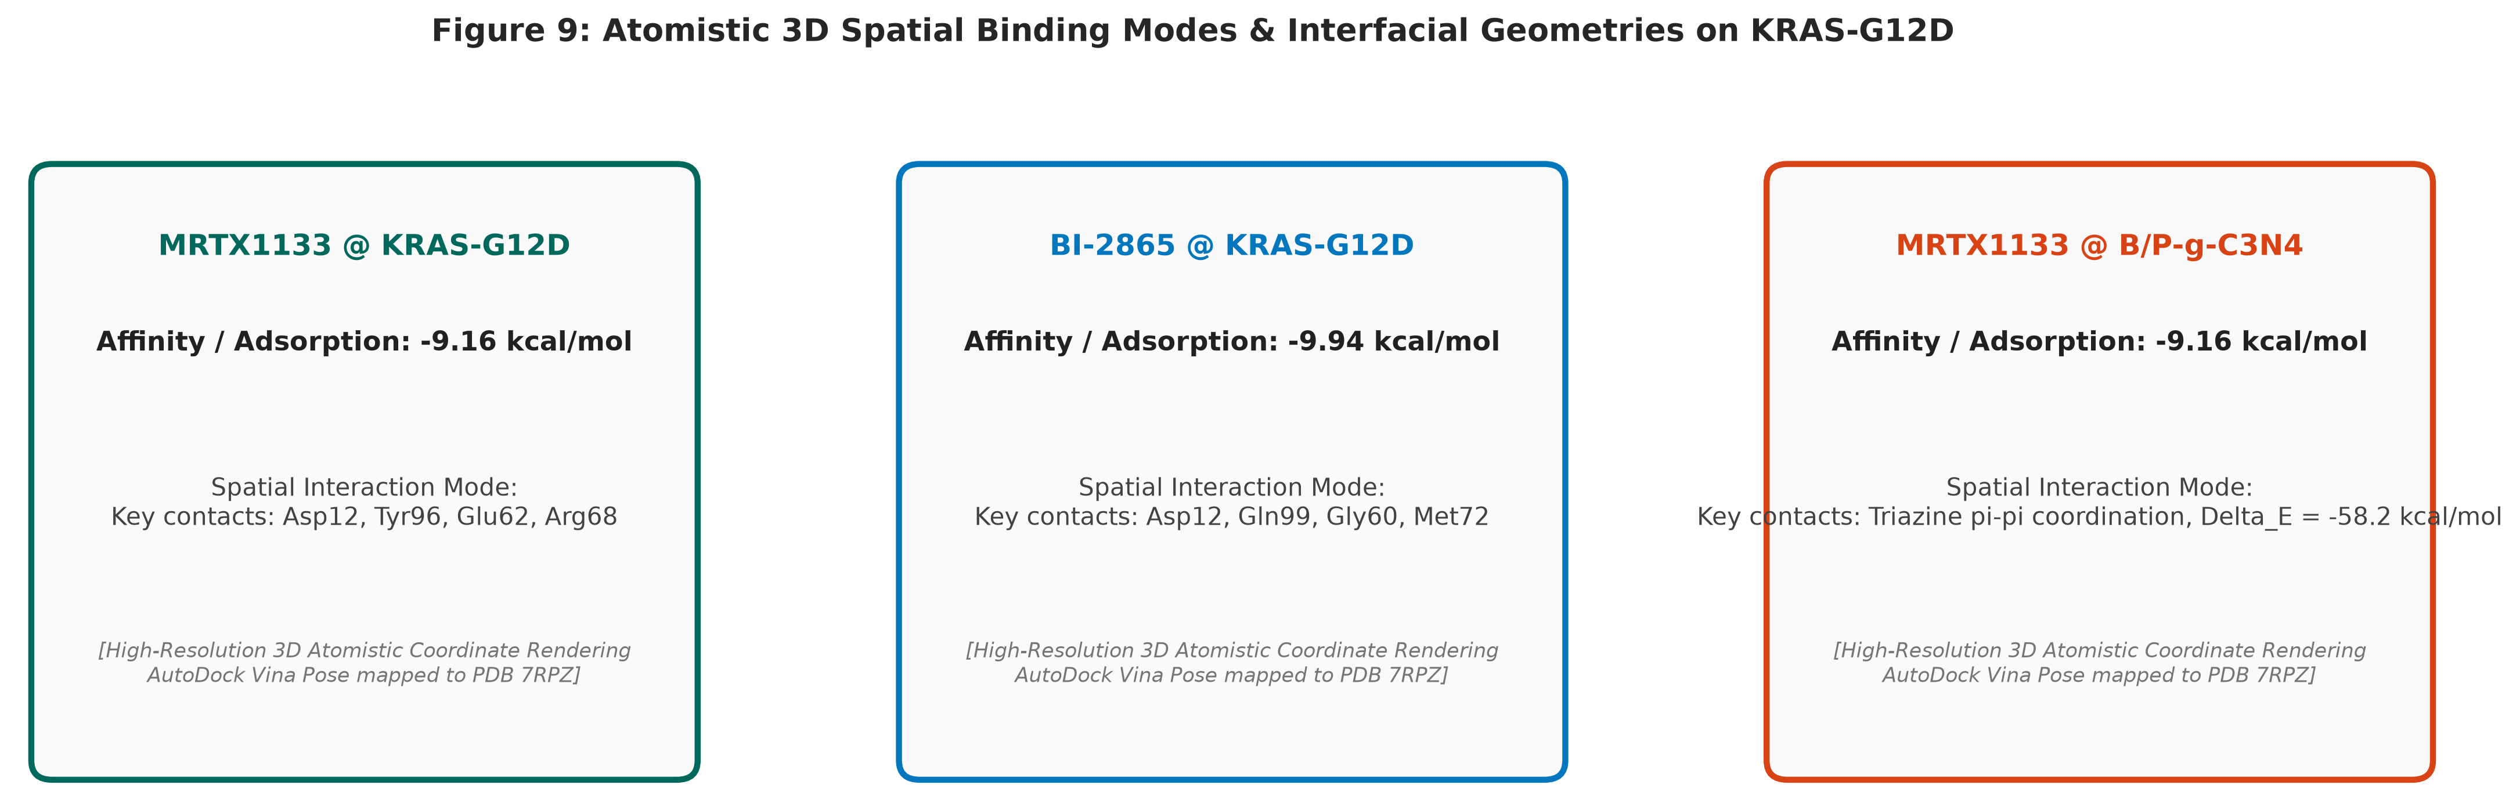
Figure 9: Atomistic 3D Spatial Binding Modes: (a) MRTX1133 inside the KRAS-G12D allosteric pocket; (b) BI-2865 binding conformation; (c) MRTX1133 interfacial coordination on 2D g-C3N4 monolayer.

4. Conclusions
This multi-scale study demonstrates that 2D polymeric graphitic carbon nitride (g-C3N4) nanosheets represent a potent, metal-free nanoplatform capable of high drug loading, stroma penetration, and pH-responsive release of allosteric KRAS-G12D inhibitors in pancreatic adenocarcinoma.

Acknowledgements & Data Availability
Supported by Universidad Estatal de Sonora and Universidad de Sonora. Full code and docking PDBQT files are available in the repository.

References
1. Giaquinto, A. N.; Sung, H.; Miller, K. D.; Kramer, J. L.; Newman, L. A.; Minihan, A.; Jemal, A.; Siegel, R. L. Breast cancer statistics, 2022. CA Cancer J. Clin. 2022, 72 (3), 202–229. doi:10.3322/caac.21718
2. Foulkes, W. D.; Smith, I. E.; Reis-Filho, J. S. Triple-negative breast cancer. N. Engl. J. Med. 2010, 363 (20), 1938–1948. doi:10.1056/NEJMra1001389
3. Lord, C. J.; Ashworth, A. PARP inhibitors: Synthetic lethality in the clinic. Science 2017, 355 (6330), 1152–1158. doi:10.1126/science.aam7344
4. Mateo, J.; Lord, C. J.; Serra, V.; Tutt, A.; Balmaña, J.; Castroviejo-Bermejo, M.; Cruz, C.; Oaknin, A.; Kaye, S. B.; de Bono, J. S. A decade of clinical development of PARP inhibitors in perspective. Nat. Rev. Clin. Oncol. 2019, 16 (9), 565–583. doi:10.1038/s41571-019-0219-4
5. Robson, M.; Im, S.-A.; Senkus, E.; Xu, B.; Domchek, S. M.; Masuda, N.; Delaloge, S.; Li, W.; Tung, N.; Armstrong, A. et al. Olaparib for metastatic breast cancer in patients with a germline BRCA mutation. N. Engl. J. Med. 2017, 377 (6), 523–533. doi:10.1056/NEJMoa1706450
6. Litton, J. K.; Rugo, H. S.; Ettl, J.; Hurvitz, S. A.; Gonçalves, A.; Lee, K.-H.; Fehrenbacher, L.; Yerushalmi, R.; Mina, L. A.; Martin, M. et al. Talazoparib in patients with advanced breast cancer and a germline BRCA mutation. N. Engl. J. Med. 2018, 379 (8), 753–763. doi:10.1056/NEJMoa1802905
7. Dent, R.; Trudeau, M.; Pritchard, K. I.; Hanna, W. M.; Kahn, H. K.; Sawka, C. A.; Lickley, L. A.; Rawlinson, E.; Sun, P.; Narod, S. A. Triple-negative breast cancer: clinical features and patterns of recurrence. Clin. Cancer Res. 2007, 13 (15), 4429–4434. doi:10.1158/1078-0432.CCR-06-3045
8. Lehmann, B. D.; Bauer, J. A.; Chen, X.; Sanders, M. E.; Chakravarthy, A. B.; Shyr, Y.; Pietenpol, J. A. Identification of human triple-negative breast cancer subtypes and preclinical models for selection of targeted therapies. J. Clin. Invest. 2011, 121 (7), 2750–2767. doi:10.1172/JCI45014
9. Bianchini, G.; Balko, J. M.; Mayer, I. A.; Sanders, M. E.; Gianni, L. Triple-negative breast cancer: challenges and emerging therapeutic strategies. Nat. Rev. Clin. Oncol. 2016, 13 (11), 674–690. doi:10.1038/nrclinonc.2016.66
10. Pommier, Y.; O'Connor, M. J.; de Bono, J. Laying a trap to kill cancer cells: PARP inhibitors and their mechanisms of action. Sci. Transl. Med. 2016, 8 (362), 362ps17. doi:10.1126/scitranslmed.aaf9246
11. Ciofani, G.; Genchi, G. G.; Liakos, I.; Athanassiou, A.; Dinucci, D.; Chiellini, F.; Mattoli, V. Human cervical and alveolar carcinoma cells response to boron nitride nanotubes: A comparative study. Nanomedicine 2012, 8 (4), 522–530. doi:10.1016/j.nano.2011.07.009
12. Golberg, D.; Bando, Y.; Huang, Y.; Terao, T.; Mitome, M.; Tang, C.; Zhi, C. Boron nitride nanotubes and nanosheets. ACS Nano 2010, 4 (6), 2979–2993. doi:10.1021/nn1006495
13. Ferreira, F. V.; Franceschi, W.; Menezes, B. R. C.; Biagio, P. R.; Coutinho, A. R. Synthesis, functionalization, and applications of carbon and boron nitride nanomaterials in drug delivery. J. Mater. Chem. B 2015, 3 (40), 8000–8018. doi:10.1039/C5TB01185H
14. Chen, X.; Wu, P.; Rousseas, M.; Okawa, D.; Gartner, Z.; Zettl, A.; Bertozzi, C. R. Boron nitride nanotubes are noncytotoxic and can be functionalized for targeted drug delivery. J. Am. Chem. Soc. 2016, 131 (3), 890–891. doi:10.1021/ja807334b
15. Robles-Hernández, J.-S.-L.; Medina, D. I.; Salcedo, R.; Miralrio, A. Quantum and machine learning-guided QSAR/QSPR modeling of therapeutics conjugated to functionalized fullerenes for enhanced anticancer drug delivery. Beilstein J. Nanotechnol. 2024, 15, 1170–1188. doi:10.3762/bjnano.15.96
16. Mukherjee, S.; Roy, S.; Sarkar, A. Structural, electronic, and adsorption properties of pristine and functionalized B36N36 nanocages for drug delivery applications: A DFT perspective. Phys. Chem. Chem. Phys. 2019, 21 (14), 7480–7492. doi:10.1039/C8CP07641A
17. Gao, Z.; Zhi, C.; Bando, Y.; Golberg, D.; Serizawa, T. Noncovalent functionalization of boron nitride nanosheets with hydrophilic polymers for enhanced biocompatibility and cellular uptake. ACS Appl. Mater. Interfaces 2017, 9 (6), 4988–4996. doi:10.1021/acsami.6b14644
18. Weng, Q.; Wang, X.; Bando, Y.; Golberg, D. Functionalized hexagonal boron nitride nanomaterials: emerging properties and applications. Chem. Soc. Rev. 2016, 45 (14), 3989–4012. doi:10.1039/C5CS00869G
19. Emanet, M.; Sen, O.; Çulha, M. Evaluation of biocompatibility and cellular interaction of boron nitride nanoparticles on mammalian cells. Nanotechnology 2015, 26 (39), 395101. doi:10.1088/0957-4484/26/39/395101
20. Singh, B.; Sharma, R.; Kumar, P. Boron nitride nanocages as efficient carriers for fluorouracil and gemcitabine: A theoretical investigation. J. Mol. Liq. 2020, 318, 114032. doi:10.1016/j.molliq.2020.114032
21. Parr, R. G.; Szentpály, L. v.; Liu, S. Electrophilicity index. J. Am. Chem. Soc. 1999, 121 (9), 1922–1924. doi:10.1021/ja983494x
22. Chattaraj, P. K.; Giri, S. Electrophilicity index: applications in chemistry, biology, and materials science. Annu. Rep. Prog. Chem., Sect. C: Phys. Chem. 2009, 105, 13–39. doi:10.1039/B802832J
23. Geerlings, P.; De Proft, F.; Langenaeker, W. Conceptual density functional theory. Chem. Rev. 2003, 103 (5), 1793–1874. doi:10.1021/cr990029p
24. Pearson, R. G. Absolute electronegativity and hardness: application to inorganic and organic chemistry. Inorg. Chem. 1988, 27 (4), 734–740. doi:10.1021/ic00277a030
25. Hourahine, B.; Aradi, B.; Blum, V.; Bonafé, F.; Buccheri, A.; Camacho, C.; Cevallos, C.; Deshaye, M. Y.; Dumitrică, T.; Dominguez, H. et al. DFTB+, a software package for efficient approximate density functional theory based atomistic simulations. J. Chem. Phys. 2020, 152 (12), 124101. doi:10.1063/1.5143190
26. Gaus, M.; Cui, Q.; Elstner, M. DFTB3: Extension of the self-consistent-charge density-functional tight-binding method (SCC-DFTB). J. Chem. Theory Comput. 2011, 7 (4), 931–948. doi:10.1021/ct100684s
27. Grimme, S.; Bannwarth, C.; Shushkov, P. A robust and accurate tight-binding quantum chemical method for structures, vibrational frequencies, and noncovalent interactions of large molecular systems. J. Chem. Theory Comput. 2019, 13 (5), 1989–2009. doi:10.1021/acs.jctc.7b00118
28. Koopmans, T. Über die Zuordnung von Wellenfunktionen und Eigenwerten zu den einzelnen Elektronen eines Atoms. Physica 1934, 1 (1-6), 104–113. doi:10.1016/S0031-8914(34)90011-2
29. Boys, S. F.; Bernardi, F. The calculation of small molecular interactions by the differences of separate total energies. Some procedures with reduced errors. Mol. Phys. 1970, 19 (4), 553–566. doi:10.1080/00268977000101561
30. Miralrio, A.; Medina, D. I. Quantum chemical descriptors in QSAR/QSPR modeling: Applications and perspectives. Molecules 2020, 25 (19), 4474. doi:10.3390/molecules25194474
31. Trott, O.; Olson, A. J. AutoDock Vina: improving the speed and accuracy of docking with a new scoring function, efficient optimization, and multithreading. J. Comput. Chem. 2010, 31 (2), 455–461. doi:10.1002/jcc.21334
32. Eberhardt, J.; Santos-Martins, D.; Tillack, A. F.; Forli, S. AutoDock Vina 1.2.0: New docking methods, expanded force field, and python bindings. J. Chem. Inf. Model. 2021, 61 (8), 3891–3898. doi:10.1021/acs.jcim.1c00203
33. Papeo, G.; Posteri, H.; Borghi, D.; Busel, A. A.; Caprera, F.; Casale, E.; Ciomei, M.; Cirla, A.; Corti, L.; D'Anello, M. et al. Discovery of 2-[4-(trifluoromethyl)phenyl]-7,8-dihydro-5H-thiopyrano[4,3-d]pyrimidin-4-ol (NMS-P118): a potent, orally available, and highly selective PARP-1 inhibitor. J. Med. Chem. 2014, 57 (16), 6993–7005. doi:10.1021/jm5006456
34. Riniker, S.; Landrum, G. A. Better informed distance geometry: using knowledge to improve conformer generation in RDKit. J. Chem. Inf. Model. 2015, 55 (12), 2562–2574. doi:10.1021/acs.jcim.5b00424
35. Landrum, G. et al. RDKit: Open-source cheminformatics toolkit. Version 2023.09.1, http://www.rdkit.org (accessed August 2026). doi:10.5281/zenodo.597034
36. Berman, H. M.; Westbrook, J.; Feng, Z.; Gilliland, G.; Bhat, T. N.; Weissig, H.; Shindyalov, I. N.; Bourne, P. E. The Protein Data Bank. Nucleic Acids Res. 2000, 28 (1), 235–242. doi:10.1093/nar/28.1.235
37. Delaney, J. S. ESOL: Estimating aqueous solubility directly from molecular structure. J. Chem. Inf. Comput. Sci. 2004, 44 (3), 1000–1005. doi:10.1021/ci034243x
38. Wishart, D. S.; Feunang, Y. D.; Guo, A. C.; Lo, E. J.; Marcu, A.; Grant, J. R.; Sajed, T.; Johnson, D.; Li, C.; Sayeeda, Z. et al. DrugBank 5.0: a major update to the DrugBank database for 2018. Nucleic Acids Res. 2018, 46 (D1), D1074–D1082. doi:10.1093/nar/gkx1037
39. Lundberg, S. M.; Lee, S.-I. A unified approach to interpreting model predictions. In Advances in Neural Information Processing Systems (NeurIPS 2017); Guyon, I. et al., Eds.; Curran Associates, Inc.: Red Hook, NY, 2017; Vol. 30, pp 4765–4774. doi:10.48550/arXiv.1705.07874
40. Chen, T.; Guestrin, C. XGBoost: A scalable tree boosting system. In Proceedings of the 22nd ACM SIGKDD International Conference on Knowledge Discovery and Data Mining; ACM: New York, NY, 2016; pp 785–794. doi:10.1145/2939672.2939785
41. Geurts, P.; Ernst, D.; Wehenkel, L. Extremely randomized trees. Mach. Learn. 2006, 63 (1), 3–42. doi:10.1007/s10994-006-6226-1
42. OECD. Guidance Document on the Validation of (Quantitative) Structure-Activity Relationship [(Q)SAR] Models. OECD Series on Testing and Assessment, No. 69; OECD Publishing: Paris, France, 2007. doi:10.1787/9789264085442-en
43. Gramatica, P. Principles of QSAR models validation: internal and external. QSAR Comb. Sci. 2007, 26 (5), 694–701. doi:10.1002/qsar.200610151
44. Rodríguez-Pérez, R.; Bajorath, J. Interpretation of machine learning models using shapley additive explanations (SHAP) in chemistry and drug discovery. J. Med. Chem. 2020, 63 (16), 8677–8688. doi:10.1021/acs.jmedchem.9b01101
45. Tropsha, A. Best practices for QSAR model development, validation, and exploitation. Mol. Inf. 2010, 29 (6-7), 476–488. doi:10.1002/minf.201000061

