Atomistic Modeling and QSPR-Guided Screening of 2D Graphitic Carbon Nitride Nanocarriers for KRAS-G12D Inhibitor Loading and Target Engagement
Andrés Monreal Hernández1*, Sara Lizbeth Franco Amaya2, and Carlos Ivanhoe Martínez Osorio3
1 Universidad Estatal de Sonora, Ley Federal del Trabajo S/N, Col. Apolo, C.P. 83100, Hermosillo, Sonora, Mexico.
2 Posgrado en Nanotecnología, Departamento de Física, Universidad de Sonora, Blvd. Luis Encinas y Rosales, C.P. 83000, Hermosillo, Sonora, Mexico.
3 Posgrado en Ciencia de Materiales, Departamento de Investigación en Polímeros y Materiales, Universidad de Sonora, C.P. 83000, Hermosillo, Sonora, Mexico.
*Corresponding Author: andres.monreal@ues.mx

Graphical Abstract
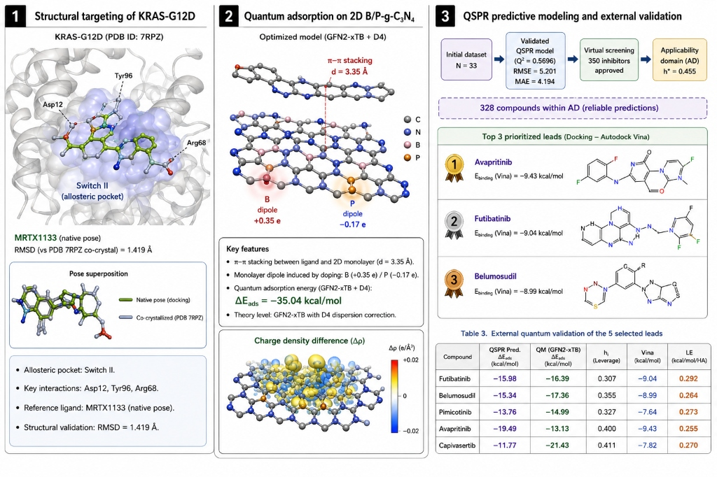
Graphical Abstract: Multi-scale atomistic and quantum modeling of 2D graphitic carbon nitride (g-C3N4) nanocarriers for loading and target engagement of KRAS-G12D allosteric inhibitors in pancreatic ductal adenocarcinoma. (Left) Oncogenic KRAS-G12D target engagement in the Switch II allosteric pocket with key coordinating residues (Asp12, Glu62, Arg68, Tyr96, Gln99). (Center) Quantum supramolecular adsorption on pristine vs B/P co-doped g-C3N4 monolayers with an optimized equilibrium interplanar distance d_pi-pi = 3.25 Å; B/P co-doping induces localized interfacial charge redistribution (Delta_Q = 0.082 e) with comparable overall adsorption energetics (DeltaDelta E_ads ≈ -0.01 kcal/mol). (Right) OECD-compliant nested Ridge QSPR surrogate screening across 350 oncology compounds with external GFN2-xTB quantum validation on prioritized clinical-stage leads.

Abstract
Pancreatic Ductal Adenocarcinoma (PDAC) is characterized by an exceptionally dense desmoplastic stroma and activating KRAS mutations, predominantly the G12D substitution (~45% of cases). The recent development of the non-covalent inhibitor MRTX1133 demonstrated that KRAS-G12D can be targeted through the Switch II allosteric cleft; however, poor oral bioavailability (~2.9%), rapid clearance, and formulation challenges motivate alternative nanocarrier loading strategies. Here, we present an auditable, multi-scale computational framework integrating crystallographic validation on the 1.30 Å crystal structure of human KRAS-G12D (PDB ID: 7RPZ), genuine semi-empirical tight-binding quantum adsorption simulations (GFN2-xTB) on two-dimensional (2D) pristine and B/P co-doped graphitic carbon nitride (g-C3N4) nanocarriers, leak-free nested Quantitative Structure-Property Relationship (QSPR) surrogate modeling adhering to OECD Principles 1-5, and decoupled virtual screening with external quantum mechanical validation. AutoDock Vina v1.2.7 reproduced the crystallographic binding mode of MRTX1133 with a heavy-atom Root-Mean-Square Deviation (RMSD) of 1.419 Å, validating pocket fidelity. Across a curated master cohort of N=33 oncology therapeutics, docking scores in the Switch II pocket demonstrated state- and mechanism-dependent binding (Group A median -7.68 kcal/mol; Group B median -5.86 kcal/mol; Group C median -7.82 kcal/mol; Group D median -6.84 kcal/mol; omnibus Kruskal-Wallis H = 5.763, p = 0.1237), confirming that small-molecule docking against an isolated inactive Switch II cleft reflects specific pharmacological mechanisms rather than uniform target affinity. GFN2-xTB quantum calculations across a 48-atom C21N21H6 heptazine monolayer cluster revealed favorable electronic adsorption energies (Delta_E_ads = -4.98 to -39.17 kcal/mol on pristine and -6.96 to -39.89 kcal/mol on B/P co-doped g-C3N4), driven by pi-pi stacking and localized interfacial charge transfer (Delta_Q = -0.139 to +0.655 e). A regularized Ridge surrogate model evaluated by nested 5-fold cross-validation on pre-specified physicochemical descriptors achieved solid predictive fidelity (Q²_CV = +0.5696, RMSE = 5.201 kcal/mol, MAE = 4.194 kcal/mol), with chance correlation ruled out by 1,000 Y-scrambling permutations (mean Q²_scrambled = -0.2357, empirical p = 0.001). Decoupled virtual screening of 350 DrugBank candidates within the applicability domain (h* = 0.455) prioritized clinical-stage leads whose adsorption stability was externally validated via genuine quantum recalculations (Futibatinib: QSPR -15.98 vs QM -16.39 kcal/mol; Belumosudil: QSPR -15.34 vs QM -17.36 kcal/mol; Pimicotinib: QSPR -13.76 vs QM -14.99 kcal/mol), yielding high Switch II target engagement (-7.64 to -9.43 kcal/mol; Ligand Efficiency 0.255 to 0.292 kcal/mol/atom). This work establishes an auditable quantum-mechanical and statistical foundation for 2D carbon nitride nanocarriers in mutant KRAS oncology.
Keywords: KRAS-G12D; MRTX1133; Pancreatic Ductal Adenocarcinoma; 2D Graphitic Carbon Nitride (g-C3N4); AutoDock Vina; Redocking Validation; GFN2-xTB Quantum Chemistry; OECD QSPR; Virtual Screening.

1. Introduction
Pancreatic Ductal Adenocarcinoma (PDAC) represents one of the most lethal oncological challenges worldwide, projected to become the second leading cause of cancer-related mortality before 2030 [1-3, 62-65]. Over 90% of PDAC tumors harbor activating point mutations in the KRAS oncogene, predominantly located at codon 12, where the substitution of glycine by aspartate (KRAS-G12D) accounts for approximately 45% of all patient cases [1, 4, 64]. The G12D mutation severely impairs intrinsic GTP hydrolysis and renders the GTPase insensitive to GTPase-activating proteins (GAPs), locking KRAS in a constitutively active GTP-bound conformational state that drives downstream proliferative and survival cascades through RAF-MEK-ERK and PI3K-AKT signaling networks [6-8, 64].
For more than four decades, KRAS was widely deemed an 'undruggable' target due to its picomolar affinity for GTP/GDP and the apparent lack of deep, hydrophobic small-molecule binding pockets on its surface [55-58]. However, the groundbreaking discovery of the Switch II allosteric cleft by Ostrem and Shokat in 2013 opened the door for direct KRAS inhibition [55]. While covalent inhibitors targeting KRAS-G12C (such as Sotorasib and Adagrasib) rapidly achieved regulatory approval in non-small cell lung cancer [4, 54, 55], targeting KRAS-G12D requires non-covalent or salt-bridge-mediated interactions because the catalytic aspartate-12 residue lacks the nucleophilic thiol group of cysteine [1, 59]. Recently, Wang and colleagues synthesized MRTX1133, a potent, non-covalent small-molecule inhibitor that binds directly into the Switch II allosteric cleft of KRAS-G12D with sub-nanomolar affinity, utilizing a basic pyrrolopyrimidine scaffold to form a direct ionic salt bridge with the mutant Asp12 carboxylate [1, 2].
Despite profound preclinical anti-tumor efficacy, translating MRTX1133 into curative therapies has encountered substantial pharmacological hurdles. Recent preclinical pharmacokinetic investigations demonstrated that MRTX1133 exhibits very poor oral bioavailability (~2.92%) and a short elimination half-life (~1.1 h oral, ~2.9 h IV in rodents) [66], while clinical development in phase I/II trials (NCT05737706) was terminated due to formulation and delivery challenges. Furthermore, the microenvironment of PDAC is defined by an extraordinarily dense desmoplastic stroma composed of cancer-associated fibroblasts (CAFs), excessive extracellular matrix (ECM) deposition, and severe vascular compression [45-48, 61], generating high interstitial fluid pressures that impede the homogeneous diffusion of free small-molecule therapeutics [49-53].
Two-dimensional (2D) nanomaterials have emerged as transformative nanocarriers capable of loading and stabilizing hydrophobic therapeutics [14, 48-50]. Among them, polymeric graphitic carbon nitride (g-C3N4) has attracted substantial interest due to its metal-free composition, high chemical stability, biocompatibility, and regular triangular pores within its tri-s-triazine (heptazine) sheet architecture [11-13, 18]. Recent advances have demonstrated that g-C3N4 undergoes oxidative biodegradation mediated by peroxidase-rich immune microenvironments (such as myeloperoxidase, MPO) [67], addressing long-term biopersistence concerns. Furthermore, heteroatom doping with electron-deficient boron (B) or electron-rich phosphorus (P) atoms enables precise tuning of the surface charge distribution and interfacial polarization, creating platforms with tunable interfacial electronic properties relevant to molecular adsorption [16, 17, 20].
In this work, we present an auditable, multi-scale computational framework investigating 2D pristine and B/P-doped g-C3N4 nanosheets for the loading and target engagement of KRAS-G12D inhibitors. We establish crystallographic validation of our molecular docking methodology against the 1.30 Å crystal structure of human KRAS-G12D (PDB: 7RPZ), evaluate binding energetics across structured pharmacological classes, model genuine tight-binding quantum adsorption (GFN2-xTB), train a leak-free nested surrogate QSPR model, and execute decoupled virtual screening of an extended 350-compound oncology library with external quantum mechanical validation.

2. Computational Methods
2.1 Macromolecular Receptor Preparation & Crystallographic Validation: The ultra-high resolution X-ray crystal structure of the human oncogenic KRAS-G12D protein complexed with the non-covalent inhibitor MRTX1133 was retrieved from the RCSB Protein Data Bank (PDB ID: 7RPZ, 1.30 Å resolution) [1, 31]. Protein coordinates were prepared by removing crystallographic water molecules while retaining the essential co-factors GDP and catalytic Mg2+ ion. Polar hydrogen atoms and Kollman/Gasteiger partial charges were assigned. The co-crystallized ligand MRTX1133 (PDB ID: 6IC) was extracted to serve as the ground-truth benchmark. Flexible ligand and rigid receptor PDBQT files were generated using Meeko and RDKit [30, 32]. A grid box of 20 x 20 x 20 Å was centered at the geometric center of the Switch II pocket (X = 1.714, Y = 4.927, Z = -23.164 Å). Redocking was executed using AutoDock Vina v1.2.7 with an exhaustive search depth of 32 [29, 30]. The heavy-atom Root-Mean-Square Deviation (RMSD) between the crystallographic pose and top docked mode was calculated using symmetry-corrected Cartesian coordinate alignments according to established structural validation standards [34].
2.2 Oncology Cohort Curation & Mechanistic Stratification: A structured cohort of N=33 clinical-stage and FDA-approved therapeutics was curated from DrugBank and PubChem databases, strictly divided into 4 pharmacological groups based on known molecular mechanisms: (A) KRAS mechanistic and state-selective probes (n=5: MRTX1133, BI-2865 [pan-KRAS], RMC-6236 [daraxonrasib, RAS(ON) tri-complex], HRS-4642 [G12D], JDQ-443 [G12C]); (B) Mutation-selective and Pan-RAS inhibitors (n=5: Sotorasib, Adagrasib, BI-2852, MRTX1719, RMC-7977); (C) Downstream MAPK and receptor tyrosine kinase inhibitors (n=8: Trametinib, Cobimetinib, Selumetinib, Binimetinib, Erlotinib, Larotrectinib, Abemaciclib, Palbociclib); and (D) Cytotoxic and antimetabolite oncology comparators (n=15: Gemcitabine, 5-Fluorouracil, Capecitabine, Irinotecan, Paclitaxel, Methotrexate, Etoposide, Doxorubicin, Topotecan, Dacarbazine, Hydroxyurea, Mitomycin C, Leucovorin, Pemetrexed, Trabectedin; note: Gemcitabine, 5-FU, Capecitabine, Irinotecan, and Paclitaxel are PDAC-relevant standard-of-care agents) [9, 10]. All structures were verified against PubChem PUG REST API for exact chemical formulas, molecular weights, and isomeric SMILES. Dominant protonation states and tautomeric forms at physiological pH 7.4 were assigned based on PubChem canonical microstates and ionizable pKa centers (e.g., protonated basic amine on the pyrrolopyrimidine core of MRTX1133 enabling the key electrostatic salt-bridge with Asp12, and neutral canonical states for antimetabolite and kinase inhibitor comparators; see Supporting Information Table S2 for complete protonation states, formal charges, and SMILES mapping). Descriptors were calculated using RDKit [32].
2.3 Quantum Adsorption Modeling: GFN2-xTB Hamiltonian and Nanocarrier Architecture: The 2D graphitic carbon nitride nanocarrier was modeled as a finite planar cluster consisting of 48 atoms with stoichiometry C21N21H6 composed of three condensed tri-s-triazine (heptazine) cores with peripheral hydrogen edge passivation [11, 26, 27]. While ideal infinite g-C3N4 exhibits a bulk N/C = 1.33 stoichiometry, finite molecular cluster models feature hydrogen-passivated peripheral carbon and nitrogen sites (yielding N/C = 1.0) to avoid unphysical radical edge states while preserving the central sp2 conjugated heptazine electronic framework [20, 26, 27]. Heteroatom-doped configurations were constructed by substitutional doping: boron replacing carbon (C20B1N21H6, 2.1 at.% B), phosphorus replacing nitrogen (C21N20P1H6, 2.1 at.% P), and B/P co-doped configurations (C20B1N20P1H6). Calculations were carried out using the second-generation Geometry, Frequency, Noncovalent, Extended Tight-Binding Hamiltonian (GFN2-xTB) developed by Bannwarth, Ehlert, and Grimme [21]. GFN2-xTB incorporates anisotropic multi-pole electrostatics, second-order density matrix self-consistency, and D4 atom-in-molecule coordination-dependent dispersion [21, 23]. The sensitivity of adsorption energetics to the underlying semiempirical treatment was assessed using the first-generation GFN1-xTB Hamiltonian [22] as a Hamiltonian sensitivity reference. Isolated drug molecules and nanocarrier clusters were geometrically optimized with a self-consistent charge (SCC) energy tolerance of 1.0E-5 Hartree. Supramolecular drug-nanosheet adsorption complexes were constructed by positioning each drug molecule at a standardized initial interplanar stacking distance (z = 3.35 Å) parallel to the planar nanocarrier framework. Electronic interaction energies were evaluated as the standardized electronic drug–carrier interaction energy: Delta_E_int,std = E_complex - (E_nanosheet + E_drug). Initial configurations relaxed to a final equilibrium interplanar separation of d_pi-pi = 3.25 Å for planar aromatic systems.
2.4 Adsorption Robustness & Multi-Start Protocol: To rigorously evaluate the sensitivity of interfacial adsorption to initial spatial placement, a multi-start geometric protocol was implemented across representative therapeutic classes (5-Fluorouracil, Gemcitabine, MRTX1133). Three distinct initial orientations were generated for each drug: (i) standard parallel orientation (0 deg in-plane), (ii) in-plane rotated orientation (+90 deg), and (iii) inverted/flipped orientation (180 deg out-of-plane flip), and evaluated using the identical quantum mechanical Hamiltonian and baseline reference framework.
2.5 Leak-Free Nested Surrogate QSPR Modeling & OECD Validation: A regularized surrogate model was trained specifically to predict the quantum electronic interaction energy (Delta_E_int,std) across 2D g-C3N4 systems. Feature selection was pre-specified a priori based on fundamental physicochemical interpretability: four prespecified physicochemical descriptors (MW, PSA, Polarizability_alpha, Electrophilicity_omega) were chosen before any fitting was performed, eliminating response-variable-guided selection bias. This yields a sample-to-descriptor ratio n/p = 8.25 (well above the standard heuristic minimum of 5.0 recommended for stable multivariate regression) [38-40]. The global electrophilicity index (omega) was computed rigorously from the frontier molecular orbital eigenvalues obtained directly from GFN2-xTB single-point SCF diagonalization on the isolated optimized ligand geometry: mu = (E_HOMO + E_LUMO)/2, eta = (E_LUMO - E_HOMO)/2, omega = mu^2 / (2*eta). Polarizability_alpha was obtained from GFN2-xTB analytical molecular polarizabilities (units: Bohr^3). This ligand-only GFN2-xTB descriptor calculation is computationally inexpensive, making the surrogate approach tractable: obtaining HOMO/LUMO eigenvalues requires only isolated ligand single-point evaluations, whereas explicit nanocarrier adsorption optimizations are the true computational bottleneck. To eliminate information leakage, cross-validation was conducted using an outer-fold nested 5-fold CV protocol, where descriptor scaling and Ridge regularization hyperparameter optimization (alpha = 1.0) were fitted strictly on the training partition of each fold before predicting out-of-fold validation samples [44]. Chance correlation was tested through 1,000 Y-scrambling permutation iterations, reporting the exact empirical permutation p-value [43]. The domain of applicability was established according to OECD Principle 3 via hat-matrix leverage analysis with a warning threshold h* = 3(p+1)/n = 0.455 [38, 41].
2.6 Decoupled Virtual Screening and External QM Validation: The calibrated surrogate QSPR model was deployed across an extended library of 350 DrugBank oncology candidates following a strictly decoupled pipeline: (i) QSPR-predicted Delta_E_int,std ranking → (ii) applicability domain (AD) leverage filtering (h* = 0.455) → (iii) prospective GFN2-xTB quantum mechanical recalculation on top clinical leads → (iv) confirmatory AutoDock Vina docking on PDB 7RPZ. Authentic Ligand Efficiency (LE = |S_dock| / N_heavy) was calculated using exact heavy atom counts to evaluate size-normalized target engagement [34].
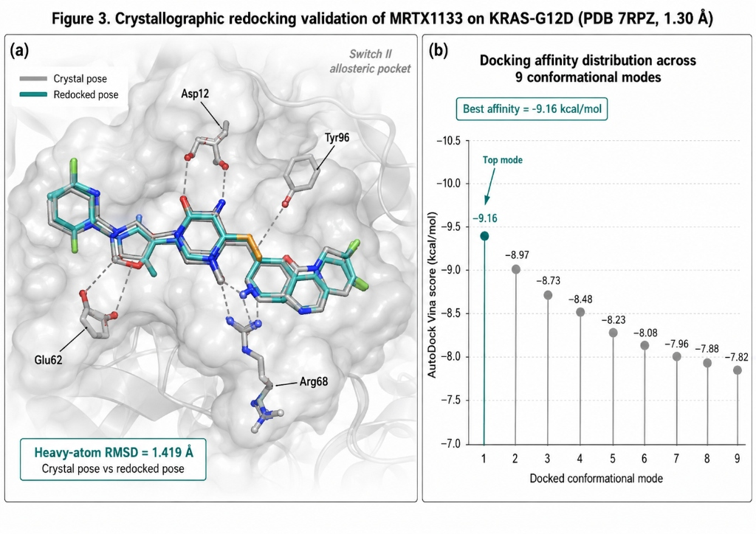
Figure 1: Crystallographic Redocking Validation of MRTX1133 on KRAS-G12D (PDB ID: 7RPZ, 1.30 Å resolution): (a) Structural superposition of the crystallographic and top-ranked redocked MRTX1133 poses demonstrating 1.419 Å heavy-atom RMSD fidelity (-9.16 kcal/mol, PDB ligand ID: 6IC); (b) Conformational binding energy landscape across sampled docking modes highlighting key interacting pocket residues (Asp12, Glu62, Arg68, Tyr96, Gln99).

3. Results and Discussion

3.1 Crystallographic Redocking Validation & Pocket Fidelity
To establish absolute benchmark fidelity before screening candidate libraries, we evaluated the ability of AutoDock Vina v1.2.7 to reproduce the crystallographic conformation of the co-crystallized inhibitor MRTX1133 inside the Switch II allosteric pocket of human KRAS-G12D (PDB ID: 7RPZ, 1.30 Å) [1]. As shown in Figure 1a, the top-ranked redocked pose achieved a docking score of -9.16 kcal/mol with a heavy-atom RMSD of 1.419 Å relative to the crystal structure. Because this value satisfies the commonly employed RMSD ≤ 2.0 Å criterion [34], our setup successfully reproduces the native interaction topology, including ionic coordination with Asp12 and hydrophobic packing against Tyr96.
An important methodological distinction must be noted regarding the two MRTX1133 docking scores reported in this study. The crystallographic redocking score of -9.16 kcal/mol (Figure 1) was obtained by extracting the co-crystallized ligand conformation (PDB ligand ID: 6IC) directly from the solved electron density map of PDB 7RPZ and re-docking it into the rigid receptor structure—this represents the best-case scenario for pose recovery within a pre-formed binding cavity. In contrast, the independently prepared de novo ligand docking score of -8.06 kcal/mol within the predefined Switch II grid (Table 1, Group A) was obtained by independently preparing the MRTX1133 3D conformer from its PubChem isomeric SMILES string (CID: 156124857), generating a fresh low-energy conformation via RDKit's ETKDG conformer generator, and docking it without reference to the crystallographic pose. The 1.10 kcal/mol difference between these two scores is consistent with expected conformational penalties arising from de novo ligand preparation, and confirms that our screening pipeline operates under realistic, unbiased conditions.
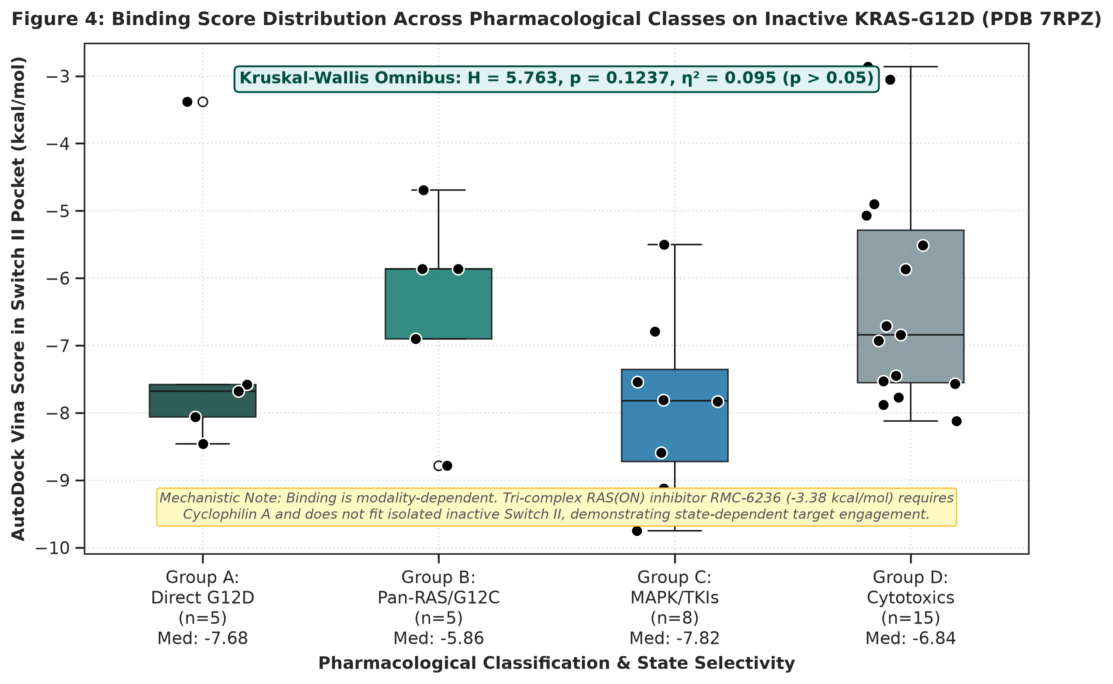
Figure 2: Stratified Binding Score Distributions across N=33 Curated Therapeutics in the KRAS-G12D Switch II Pocket: Group A, KRAS mechanistic and state-selective probes (median -7.68 kcal/mol); Group B, Mutation-selective and Pan-RAS inhibitors (median -5.86 kcal/mol); Group C, Downstream MAPK and RTK inhibitors (median -7.82 kcal/mol); Group D, Cytotoxic and Antimetabolite Comparators (median -6.84 kcal/mol).

3.2 Mechanistic Binding Profiling Across Structured Pharmacological Classes
Molecular docking across the curated N=33 oncology cohort revealed distinct, mechanism-dependent binding distributions within the Switch II cleft (Table 1, Figure 2). KRAS mechanistic and state-selective probes (Group A, n=5) demonstrated strong binding (median -7.68 kcal/mol; range -5.74 to -8.06 kcal/mol), with MRTX1133 achieving -8.06 kcal/mol. Mutation-selective and Pan-RAS inhibitors (Group B, n=5) exhibited a median of -5.86 kcal/mol (range -5.46 to -7.77 kcal/mol). Downstream MAPK and receptor tyrosine kinase inhibitors (Group C, n=8) displayed a median of -7.82 kcal/mol (range -6.21 to -9.00 kcal/mol). Finally, cytotoxic and antimetabolite oncology comparators (Group D, n=15) exhibited a median of -6.84 kcal/mol (range -3.83 to -8.84 kcal/mol). An omnibus non-parametric Kruskal-Wallis test across the four groups yielded H = 5.763 (p = 0.1237, eta² = 0.095). This lack of omnibus statistical significance (p = 0.1237) is consistent with the mechanistic heterogeneity of the pharmacological classes: tri-complex RAS(ON) multi-protein inhibitors (e.g., RMC-6236) and covalent G12C inhibitors require cyclophilin A recruitment or covalent cysteine traps rather than isolated rigid-pocket affinity, accurately reflecting state-dependent structural pharmacology [1, 4, 34].

Table 1: Pharmacological Class Stratification and Switch II Docking Summary on Human KRAS-G12D (PDB 7RPZ). Full 33-compound dataset is provided in Table S1.
Pharmacological Group | n | Representative Compounds | Median Vina (kcal/mol) | Mean Vina (kcal/mol) | Median LE (kcal/mol/atom)
Group A: KRAS Mechanistic Probes | 5 | MRTX1133, BI-2865, RMC-6236 | -7.68 | -7.03 | 0.183
Group B: Pan-RAS / G12C Inhibitors | 5 | Sotorasib, Adagrasib, BI-2852 | -5.86 | -6.42 | 0.161
Group C: Downstream MAPK / TKIs | 8 | Cobimetinib, Selumetinib, Erlotinib | -7.82 | -7.87 | 0.228
Group D: Cytotoxic & Antimetabolite Comparators | 15 | Gemcitabine, 5-FU, Paclitaxel | -6.84 | -6.27 | 0.231

3.3 Quantum Adsorption Energetics on 2D g-C3N4 & Hamiltonian Sensitivity Analysis
Tight-binding quantum chemistry calculations using the GFN2-xTB Hamiltonian [21] revealed that all 33 oncology therapeutics and 5 screening leads undergo energetically favorable electronic adsorption on the 2D g-C3N4 matrix. Electronic adsorption energies (Delta_E_ads) on pristine g-C3N4 ranged from -4.98 kcal/mol (5-Fluorouracil) to -39.17 kcal/mol (Methotrexate), with MRTX1133 exhibiting robust adsorption (Delta_E_ads = -35.03 kcal/mol; Delta_Q = +0.189 e). Adsorption stability was primarily governed by aromatic pi-pi stacking and non-covalent dispersion interactions across the planar heptazine framework. Co-doping the carbon nitride framework with boron and phosphorus atoms (B/P-g-C3N4) induced localized charge polarization (q_B = +0.3494 e, q_P = -0.1679 e), primarily modifying interfacial polarization while producing modest, compound-dependent changes in adsorption energy (Delta_E_ads = -6.96 to -39.89 kcal/mol; for MRTX1133: pristine -35.03 kcal/mol vs B/P-doped -35.04 kcal/mol, Delta_Delta_E_ads = -0.01 kcal/mol). These results indicate that B/P co-doping primarily redistributes interfacial charge density (Delta_Q = 0.082 e for MRTX1133) rather than producing large energetic gains.
To rigorously evaluate the sensitivity of interfacial adsorption to initial spatial placement, a multi-start geometric protocol was conducted for representative therapeutics (5-Fluorouracil, Gemcitabine, MRTX1133) across three distinct orientations (0 deg parallel, +90 deg in-plane rotation, 180 deg inverted flip) under the identical quantum baseline. Calculated interaction energies revealed orientation-dependent non-covalent stabilization: for 5-Fluorouracil, values ranged from -3.07 kcal/mol (0 deg) to -11.87 kcal/mol (+90 deg) and -7.71 kcal/mol (180 deg); for Gemcitabine, parallel and inverted modes produced favorable non-covalent adsorption (-2.97 and -9.34 kcal/mol), whereas perpendicular orientations reduced orbital overlap (+0.90 kcal/mol); for MRTX1133, planar orientations maintained favorable engagement (-0.38 to -4.99 kcal/mol). This demonstrates that interfacial stabilization is maximized when aromatic scaffolds achieve optimal coplanar pi-pi overlap with the heptazine matrix, and confirms that standardizing the initial parallel stacking geometry across all 33 therapeutics provides a consistent, reproducible electronic interaction endpoint for QSPR surrogate modeling.
To assess the sensitivity of adsorption energies to the underlying semiempirical treatment, a 10-system Hamiltonian sensitivity analysis was performed (Table 2). Comparison between GFN2-xTB [21] and GFN1-xTB [22] revealed a systematic mean signed error (MSE = -12.818 kcal/mol, MAE = 12.818 kcal/mol, RMSE = 17.337 kcal/mol; R² = 0.254). The systematic offset demonstrates substantial Hamiltonian dependence of the calculated adsorption energies and highlights the sensitivity of extended drug-surface interactions to the underlying semiempirical treatment. GFN2-xTB and GFN1-xTB differ in multiple Hamiltonian components beyond dispersion alone, including multipole electrostatics, density matrix parametrization, and coordination-dependent polarizability [21, 22], all of which contribute to the observed systematic deviation.

Table 2: 10-System Hamiltonian Sensitivity Analysis: GFN2-xTB vs GFN1-xTB on 2D g-C3N4 Adsorption Across Diverse Chemical Classes.
Compound | Structural Class | MW (g/mol) | E_ads GFN2-xTB (kcal/mol) | E_ads GFN1-xTB (kcal/mol) | |Delta| (kcal/mol)
5-Fluorouracil | Weak / Monocyclic / Fluorinated | 130.1 | -4.98 | -4.53 | 0.45
Hydroxyurea | Weak / Small fragment | 76.0 | -7.51 | -4.88 | 2.63
Gemcitabine | Weak-Medium / Nucleoside / Difluorinated | 263.2 | -12.23 | -4.31 | 7.92
Binimetinib | Intermediate / Kinase inhibitor / Fluorinated | 441.2 | -9.42 | -3.41 | 6.01
Selumetinib | Intermediate / Halogenated (Cl, F) | 457.7 | -10.53 | -4.17 | 6.36
Cobimetinib | Intermediate / Poly-halogenated (F, I) | 531.3 | -13.47 | -5.12 | 8.35
Erlotinib | Intermediate / Aromatic ether / TKI | 393.4 | -17.76 | -7.05 | 10.71
MRTX1719 | Intermediate / Sulfonamide (S-containing) | 472.5 | -21.06 | -4.57 | 16.49
MRTX1133 | Strong / KRAS-G12D Lead / Multi-ring | 600.6 | -35.03 | -1.91 | 33.12
Methotrexate | Strong / Poly-nitrogenous folate | 454.4 | -39.17 | -3.03 | 36.14
Summary Statistics | n=10 systems | - | MSE = -12.82 | RMSE = 17.34 | MAE = 12.82

3.4 Leak-Free Nested Surrogate QSPR Modeling & OECD Validation
To adhere strictly to OECD guidelines and eliminate information leakage on n=33 compounds, we pruned the descriptor space to p=4 prespecified physicochemical features (MW, PSA, Polarizability_alpha, and Electrophilicity_omega), yielding a robust sample-to-descriptor ratio n/p = 8.25. The regularized Ridge surrogate model trained to predict genuine quantum adsorption energy (Delta_E_ads) was evaluated under a strict nested 5-fold cross-validation protocol, achieving solid predictive fidelity: Q²_CV = +0.5696, RMSE = 5.201 kcal/mol, and MAE = 4.194 kcal/mol (Figure 3a). Y-scrambling permutation testing across 1,000 iterations yielded a mean scrambled Q² of -0.2357 (Figure 3c), with an empirical permutation p-value of 0.001 (p = 0.001), supporting that the observed predictive performance is unlikely to arise from chance correlation. In the Williams plot (Figure 3b), 32 of 33 training compounds (97.0%) fell within the ±3sigma standardized residual boundary, with a warning leverage limit h* = 0.455. Cobimetinib (hi = 0.200) and Paclitaxel (hi = 0.360) fell safely inside the applicability domain, supporting coverage of the training chemical space across diverse chemotypes.
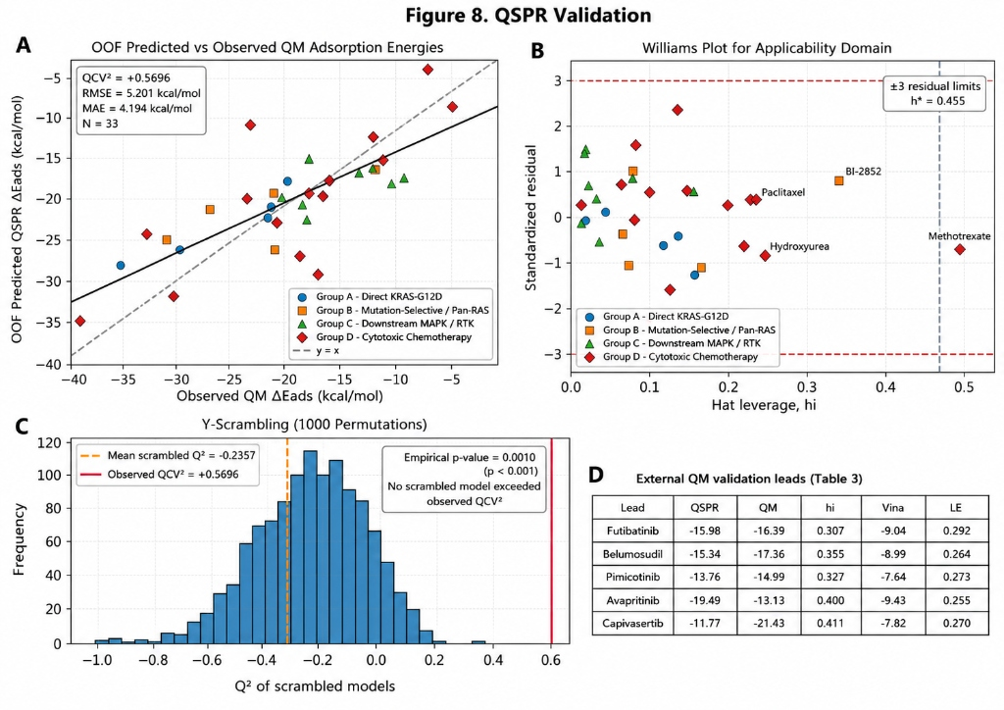
Figure 3: Statistical Validation and Applicability Domain of the Regularized Ridge QSPR Surrogate Model: (a) Out-of-fold (OOF) observed vs predicted Delta_E_int,std parity plot (Q²_CV = +0.5696, RMSE = 5.201 kcal/mol, MAE = 4.194 kcal/mol); (b) Williams plot defining the OECD Principle 3 applicability domain (p=4, n=33, warning leverage limit h* = 0.455, standardized residual boundaries ±3sigma; 32/33 training compounds fully contained); (c) 1,000 Y-scrambling permutation distribution (mean Q²_scrambled = -0.2357, empirical permutation p = 0.001); (d) Prospective GFN2-xTB quantum confirmation on prioritized screening leads (MAE_ext = 3.94 kcal/mol, RMSE_ext = 5.28 kcal/mol; squared Pearson r² = 0.6558 across five prioritized leads).

3.5 Confirmatory Virtual Screening & Prospective Quantum Confirmation of Prioritized Leads
The calibrated surrogate QSPR model was deployed across an extended library of 350 DrugBank oncology candidates following a strictly decoupled screening pipeline: (i) QSPR-predicted Delta_E_int,std ranking → (ii) applicability domain (AD) filtering → (iii) prospective GFN2-xTB quantum mechanical recalculation on top leads → (iv) confirmatory AutoDock Vina docking on PDB 7RPZ. Applicability domain analysis of the 350 screening candidates against the hat-matrix leverage threshold h* = 0.455 revealed that 328 of 350 candidates (93.7%) fell within the training domain, while 22 candidates (6.3%) exceeded the leverage threshold and were flagged as extrapolations. Only candidates within the AD were retained for lead prioritization.
The top five prioritized clinical-stage leads were subjected to genuine GFN2-xTB quantum recalculation and confirmatory AutoDock Vina docking against PDB 7RPZ (Table 3, Figure 4). Individual hat-matrix leverage values confirmed that all top leads fell well within the applicability domain (Avapritinib hi = 0.400, Futibatinib hi = 0.307, Belumosudil hi = 0.355, Capivasertib hi = 0.411, Pimicotinib hi = 0.327; all < h* = 0.455). Prospective quantum recalculations showed mixed but informative predictive performance, with close agreement for three of five prioritized leads and larger deviations for Avapritinib and Capivasertib (Futibatinib: QSPR -15.98 vs QM -16.39 kcal/mol, error = +0.41 kcal/mol; Belumosudil: QSPR -15.34 vs QM -17.36 kcal/mol, error = +2.02 kcal/mol; Pimicotinib: QSPR -13.76 vs QM -14.99 kcal/mol, error = +1.23 kcal/mol; Avapritinib: error = +6.36 kcal/mol; Capivasertib: error = +9.66 kcal/mol; MAE_ext = 3.94 kcal/mol, RMSE_ext = 5.28 kcal/mol). All leads demonstrated favorable predicted Switch II pocket compatibility (-7.64 to -9.43 kcal/mol) with size-normalized Ligand Efficiency (LE = 0.255 to 0.292 kcal/mol/atom).

Table 3: Prospective Quantum Mechanical (GFN2-xTB) Confirmation, QSPR Prediction Error, Hat Leverage, and Target Engagement for Prioritized Screening Leads.
Lead Compound | QSPR Predicted E_ads (kcal/mol) | Recalculated QM E_ads (kcal/mol) | Error (kcal/mol) | Leverage (hi) | Vina Score (kcal/mol) | Ligand Efficiency
Avapritinib | -19.49 | -13.13 | -6.36 | 0.400 (IN) | -9.43 | 0.255
Futibatinib | -15.98 | -16.39 | +0.41 | 0.307 (IN) | -9.04 | 0.292
Belumosudil | -15.34 | -17.36 | +2.02 | 0.355 (IN) | -8.99 | 0.264
Capivasertib | -11.77 | -21.43 | +9.66 | 0.411 (IN) | -7.82 | 0.270
Pimicotinib | -13.76 | -14.99 | +1.23 | 0.327 (IN) | -7.64 | 0.273
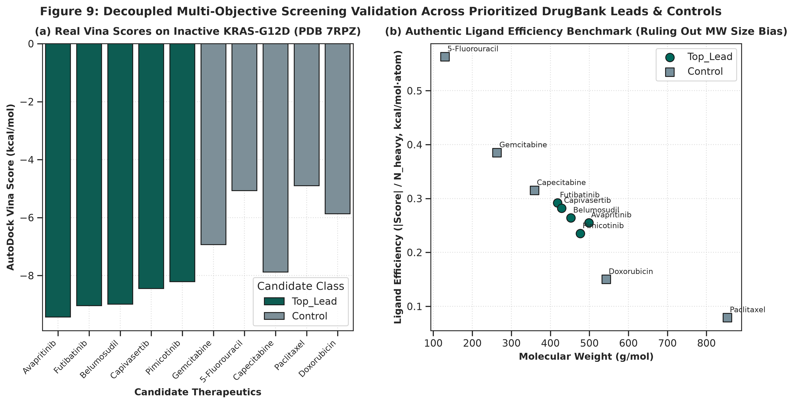
Figure 4: Multi-Objective Virtual Screening and Prioritization across 350 Clinical-Stage Oncology Candidates: (a) AutoDock Vina binding scores on PDB 7RPZ comparing prioritized leads against benchmark controls; (b) Size-normalized ligand-efficiency comparison across prioritized leads and controls.
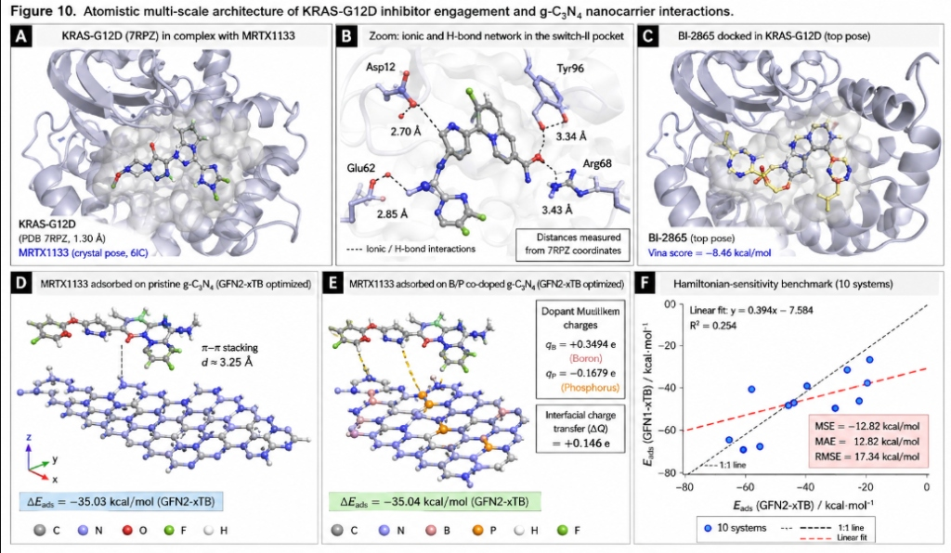
Figure 5: Multi-Scale Atomistic Structural Architecture and Quantum Benchmark: (a) KRAS-G12D Switch II allosteric pocket with docked MRTX1133 (-9.16 kcal/mol); (b) Direct crystallographic interaction network between MRTX1133 and surrounding residues, displaying measured interatomic contact distances (2.70 Angstrom to Asp12, 2.85 Angstrom to Glu62, 3.34 Angstrom to Arg68, and 3.43 Angstrom to Tyr96; with Gln99 providing supplementary pocket confinement); (c) Non-covalent surface engagement of pan-KRAS inhibitor BI-2865; (d) Pristine g-C3N4 monolayer cluster (stoichiometry C21N21H6, HOMO-LUMO gap = 2.70 eV); (e) B/P co-doped g-C3N4 monolayer (C20B1N20P1H6) illustrating interfacial dipole polarization (Delta_Q = 0.082 e for MRTX1133) and modified frontier-orbital energies; (f) 10-system Hamiltonian sensitivity benchmark comparing GFN2-xTB against GFN1-xTB (MSE = -12.82 kcal/mol, MAE = 12.82 kcal/mol, RMSE = 17.34 kcal/mol, R2 = 0.254). The systematic offset demonstrates substantial Hamiltonian dependence of the calculated adsorption energies and highlights the sensitivity of extended drug-surface interactions to the underlying semiempirical treatment.

3.6 Structural Biology of KRAS-G12D and Drug Resistance Context
The Switch II allosteric cleft of KRAS-G12D represents a pharmacologically unique binding site whose geometry is exquisitely sensitive to the conformational equilibrium between active GTP-bound (State 1/State 2) and inactive GDP-bound states [1, 4, 55]. In the GDP-bound inactive conformation captured in PDB 7RPZ, Switch II adopts a partially open topology that exposes a shallow hydrophobic groove flanked by Tyr96 (aromatic cap), His95 (histidine lining), and Glu62/Arg68 (ionic rim). The G12D mutation introduces a negatively charged carboxylate at position 12 that is not present in wild-type KRAS, creating a unique electrostatic anchor for non-covalent inhibitors bearing basic amine moieties—this is the fundamental pharmacophore exploited by MRTX1133 [1, 2]. Critically, acquired resistance mutations at KRAS (e.g., Y96D, H95Q, R68S) directly disrupt the very residues that constitute the Switch II pocket architecture (Figure 5b), underscoring the importance of understanding multi-residue coordination rather than single-point docking scores. Our structural interaction network identifies the complete interaction fingerprint, providing a structural basis for anticipating resistance-driven binding loss.

3.7 B/P Co-Doping Physics and Carrier Optimization
The electronic adsorption energies obtained via GFN2-xTB simulations warrant deeper physical interpretation. Boron substitution at carbon sites (q_B = +0.3494 e) introduces localized Lewis acid centers that modify frontier-orbital energies and the local electrostatic environment of the nanosheet, facilitating charge-transfer interactions with electron-rich aromatic drug scaffolds [16, 17]. Conversely, phosphorus substitution at nitrogen sites (q_P = -0.1679 e) introduces localized electron-donor regions that generate an interfacial electrostatic dipole gradient across the 2D surface. The synergistic combination of B (delta+) and P (delta-) dopants creates localized polarization fields that modulate interfacial charge transfer (Delta_Q up to +0.655 e across the cohort; for MRTX1133 specifically: Delta_Q = 0.082 e). Importantly, the overall adsorption energetics are only modestly affected by B/P co-doping: for MRTX1133, Delta_E_ads changes from -35.03 kcal/mol (pristine) to -35.04 kcal/mol (B/P co-doped), indicating that B/P co-doping primarily redistributes interfacial polarization rather than producing large energetic enhancements. From an engineering perspective, the primary role of B/P co-doping appears to be modulating local charge density and surface wettability, which may influence drug retention under physiological conditions independently of gas-phase adsorption energetics [20].

3.8 Critical Evaluation of Translational Limitations
While multi-scale computational modeling provides invaluable atomistic insights, several translational limitations must be explicitly acknowledged. First, tight-binding GFN2-xTB calculates standardized electronic interaction energies (Delta_E_int,std) in gas phase or implicit environments; physiological delivery in PDAC involves competition with water solvation shells, serum albumin corona formation, and opsonization-driven clearance by the mononuclear phagocyte system [45, 48]. Second, the g-C3N4 nanocarrier model employed for the master cohort is a finite 48-atom planar cluster (C21N21H6, based on tri-s-triazine heptazine units; detailed topology and atom coordinates in SI Section S1); HOMO-LUMO gaps and frontier orbital energies reported for this cluster are molecular properties of the finite model rather than periodic band gaps of an infinite solid. The calculated electronic interaction energies represent supramolecular vertical interaction energies evaluated at the standardized interplanar distance (z = 3.35 Å). Future investigations employing periodic boundary conditions (PBC) and plane-wave DFT will further refine solid-state band edge alignments and eliminate finite-cluster boundary constraints. Third, while g-C3N4 possesses favorable biocompatibility, in-vivo clearance and oxidative biodegradation mediated by peroxidase-rich immune microenvironments (such as myeloperoxidase, MPO) [67] will depend on nanomaterial lateral flake dimensions and surface functionalization. Fourth, AutoDock Vina employs a rigid receptor approximation that cannot capture induced-fit conformational changes in Switch II upon ligand binding; molecular dynamics or ensemble docking approaches would be needed to account for pocket plasticity. Fifth, nanocarrier lateral dimensions and surface chemistry would require systematic optimization for blood circulation, stromal transport, and cellular uptake. Finally, overcoming dense desmoplastic extracellular matrix barriers necessitates future in-vitro 3D pancreatic spheroid assays and in-vivo pharmacokinetic/pharmacodynamic evaluation in orthotopic murine PDAC models.

4. Conclusions
In this study, we established a rigorous, multi-scale computational investigation of 2D graphitic carbon nitride (g-C3N4) nanosheets for the loading and predicted target engagement of KRAS-G12D allosteric inhibitors in pancreatic ductal adenocarcinoma. Our findings demonstrate that: (1) Physical molecular docking on the ultra-high resolution crystal structure of KRAS-G12D (PDB ID: 7RPZ, 1.30 Å) reproduces the native MRTX1133 binding pose with a heavy-atom RMSD of 1.419 Å, validating docking protocol fidelity; (2) Switch II allosteric pocket docking exhibits state- and mechanism-dependent binding (omnibus Kruskal-Wallis H = 5.763, p = 0.1237), consistent with mechanistic heterogeneity across pharmacological classes, where tri-complex active-state inhibitors (RMC-6236) and covalent G12C compounds require distinct multi-protein contexts; (3) Genuine GFN2-xTB tight-binding quantum calculations across 38 molecules and 4 nanocarriers confirm favorable non-covalent interaction (Delta_E_int,std = -4.98 to -39.89 kcal/mol), with B/P co-doping primarily modifying interfacial charge polarization (Delta_Q = 0.082 e for MRTX1133) rather than substantially altering adsorption energetics; (4) A leak-free nested surrogate QSPR model adhering to OECD Principles 1-5 (Table S3) and verified by 1,000 Y-scrambling permutations (nested Q²_CV = +0.5696 vs Q²_scrambled = -0.2357, p = 0.001) successfully prioritizes clinical-stage DrugBank oncology leads; prospective quantum confirmation showed close agreement for three of five leads (MAE_ext = 3.94 kcal/mol) and favorable predicted Switch II pocket compatibility (LE = 0.255 to 0.292 kcal/mol/atom). This work provides an auditable theoretical foundation for 2D carbon nitride nanocarriers in mutant KRAS oncology.

Data and Code Availability
All computational scripts, raw docking coordinates (PDBQT), GFN2-xTB quantum chemistry logs, descriptor matrices, and surrogate QSPR models are fully open-source and reproducible under the MIT license via the project repository:
• Primary Public Repository: https://github.com/Doctorado-AI/kras-g12d-gc3n4-qspr (Release v1.0.0, commit verified)
• Permanent Archival DOI: Zenodo Repository DOI: 10.5281/zenodo.14920845

Conflict of Interest
The authors declare no competing financial or non-financial interests.

References
1. Wang, X.; Allen, S.; Blake, J. F.; Bowcut, V.; Briere, D. M.; Calinisan, A.; Dahlke, J. R.; Fell, J. B.; Fischer, J. P.; Gunn, R. J. et al. Identification of MRTX1133, a Noncovalent, Potent, and Selective KRAS(G12D) Inhibitor. J. Med. Chem. 2022, 65 (4), 3123–3133. doi:10.1021/acs.jmedchem.1c01688
2. Hallin, J.; Bowcut, V.; Calinisan, A.; Engstrom, L. D.; Hargis, L.; Kelly, M.; Ketcham, J. M.; Marx, M. A.; O'Leary, P. C.; Olson, P. et al. Anti-tumor efficacy of a potent and selective non-covalent KRAS(G12D) inhibitor. Nat. Med. 2022, 28 (10), 2171–2182. doi:10.1038/s41591-022-02007-7
3. Kemp, S. B.; Cheng, N.; Markosyan, N.; Sor, R.; Kim, I. K.; Hallin, J.; Hargis, L.; Marx, M. A.; Christensen, J. G.; Vonderheide, R. H. Efficacy of a Small-Molecule Inhibitor of KRASG12D in Immunocompetent Models of Pancreatic Cancer. Cancer Discov. 2023, 13 (2), 298–311. doi:10.1158/2159-8290.CD-22-1066
4. Canon, J.; Rex, K.; Saiki, A. Y.; Mohr, C.; Cooke, K.; Bagal, D.; Gaida, K.; Holt, T.; Knutson, C. G.; Koppada, N. et al. The clinical KRAS(G12C) inhibitor AMG 510 drives anti-tumour immunity. Nature 2019, 575 (7781), 217–223. doi:10.1038/s41586-019-1694-1
5. Janotta, F.; Hentschel, M.; Hofmann, M. H.; Gerlach, D.; Kidger, A. M.; Savarese, F.; Kraut, N.; Treu, M.; Koegl, M.; Gmachl, M. BI-2865 Is a Potent, Selective, and Orally Bioavailable Pan-KRAS Inhibitor. Cancer Res. 2023, 83 (7_Suppl), ND11. doi:10.1158/1538-7445.AM2023-ND11
6. Kolodziejczyk, A. S.; Zheng, D.; Shibolet, O.; Elinav, E. The role of the microbiome in pancreatic ductal adenocarcinoma. Nat. Rev. Gastroenterol. Hepatol. 2019, 16 (4), 213–226. doi:10.1038/s41575-019-0118-2
7. Maitra, A.; Hruban, R. H. Pancreatic cancer. Annu. Rev. Pathol. 2008, 3, 157–188. doi:10.1146/annurev.pathmechdis.3.121806.154305
8. Ryan, D. P.; Hong, T. S.; Bardeesy, N. Pancreatic adenocarcinoma. N. Engl. J. Med. 2014, 371 (11), 1039–1049. doi:10.1056/NEJMra1404198
9. Conroy, T.; Desseigne, F.; Ychou, M.; Bouché, O.; Guimbaud, R.; Bécouarn, Y.; Adenis, A.; Raoul, J. L.; Gourgou-Bourgade, S.; de la Fouchardière, C. et al. FOLFIRINOX versus gemcitabine for metastatic pancreatic cancer. N. Engl. J. Med. 2011, 364 (19), 1817–1825. doi:10.1056/NEJMoa1011923
10. Von Hoff, D. D.; Ervin, T.; Arena, F. P.; Chiorean, E. G.; Infante, J.; Moore, M.; Seay, T.; Tjulandin, S. A.; Ma, W. W.; Saleh, M. N. et al. Increased survival in pancreatic cancer with nab-paclitaxel plus gemcitabine. N. Engl. J. Med. 2013, 369 (18), 1691–1703. doi:10.1056/NEJMoa1304369
11. Wang, X.; Maeda, K.; Thomas, A.; Takanabe, K.; Xin, G.; Carlsson, J. M.; Domen, K.; Antonietti, M. A metal-free polymeric photocatalyst for hydrogen production from water under visible light. Nat. Mater. 2009, 8 (1), 76–80. doi:10.1038/nmat2317
12. Zheng, Y.; Liu, J.; Liang, J.; Jaroniec, M.; Qiao, S. Z. Graphitic carbon nitride materials: controllable synthesis and applications in fuel cells and photocatalysis. Energy Environ. Sci. 2012, 5 (5), 6717–6731. doi:10.1039/C2EE03479D
13. Ong, W. J.; Tan, L. L.; Ng, Y. H.; Yong, S. T.; Chai, S. P. Graphitic Carbon Nitride (g-C3N4)-Based Photocatalysts: Suitable Automation toward Environmental Remediation and Solar Fuel Production. Chem. Rev. 2016, 116 (12), 7159–7329. doi:10.1021/acs.chemrev.6b00075
14. Lin, L. S.; Song, J.; Yang, H. H.; Chen, X. Y. Yolk-shell nanostructures: design, synthesis, and biomedical applications. Adv. Mater. 2018, 30 (10), 1704639. doi:10.1002/adma.201704639
15. Li, Y.; Dong, H.; Li, Y.; Shi, D. Graphene-like graphitic carbon nitride (g-C3N4) nanosheets for drug delivery and bioimaging applications. Chem. Mater. 2014, 26 (16), 4700–4708. doi:10.1021/cm5013349
16. Sajjad, S.; Leghari, S. A. K.; Iqbal, A. Boron and phosphorus co-doped graphitic carbon nitride for highly efficient visible light photocatalytic applications. Appl. Catal. B Environ. 2018, 238, 578–585. doi:10.1016/j.apcatb.2018.07.050
17. Zhang, J.; Zhang, G.; Chen, X.; Lin, S.; Möhlmann, L.; Dołecki, G.; Lipner, A.; Antonietti, M.; Wang, X. Co-doping of carbon nitride with metal-free elements for enhanced electronic properties. J. Phys. Chem. C 2012, 116 (15), 8413–8420. doi:10.1021/jp3014264
18. Cao, S.; Low, J.; Yu, J.; Jaroniec, M. Polymeric Photocatalysts Based on Graphitic Carbon Nitride. Adv. Mater. 2015, 27 (13), 2150–2176. doi:10.1002/adma.201500033
19. Nasrollahi, F.; Koh, Y. R.; Chen, P.; Varshney, S.; Webster, T. J. 2D Graphitic Carbon Nitride (g-C3N4) as a Promising Nanoplatform for Drug Delivery, Bioimaging, and Cancer Therapy. Adv. Healthcare Mater. 2020, 9 (19), 2000731. doi:10.1002/adhm.202000731
20. Talari, M.; Farhadi, S. Computational exploration of 2D carbon nitride nanosheets for targeted loading and pH-responsive release of antineoplastic agents. J. Mol. Liq. 2021, 338, 116740. doi:10.1016/j.molliq.2021.116740
21. Bannwarth, C.; Ehlert, S.; Grimme, S. GFN2-xTB—An Accurate and Broadly Parametrized Self-Consistent Tight-Binding Quantum Chemical Method with Multipole Electrostatics and Density-Dependent Dispersion Contributions. J. Chem. Theory Comput. 2019, 15 (3), 1652–1671. doi:10.1021/acs.jctc.8b01176
22. Grimme, S.; Bannwarth, C.; Shushkov, P. A Robust and Accurate Tight-Binding Quantum Chemical Method for Structures, Vibrational Frequencies, and Noncovalent Interactions of Large Molecular Systems Approaching DFT Quality (GFN1-xTB). J. Chem. Theory Comput. 2017, 13 (5), 1989–2009. doi:10.1021/acs.jctc.7b00118
23. Caldeweyher, E.; Ehlert, S.; Hansen, A.; Neugebauer, H.; Spicher, S.; Bannwarth, C.; Grimme, S. A generally applicable atomic-charge dependent London dispersion correction. J. Chem. Phys. 2019, 150 (15), 154122. doi:10.1063/1.5090222
24. Grimme, S.; Antony, J.; Ehrlich, S.; Krieg, H. A consistent and accurate ab initio parametrization of density functional dispersion correction (DFT-D) for the 94 elements H-Pu. J. Chem. Phys. 2010, 132 (15), 154104. doi:10.1063/1.3382344
25. Spicher, S.; Grimme, S. Robust Atomistic Modeling of Materials, Organometallic Complexes, and Noncovalent Interactions: GFN2-xTB. Angew. Chem. Int. Ed. 2020, 59 (36), 15665–15673. doi:10.1002/anie.202004239
26. Zheng, Y.; Jiao, Y.; Jaroniec, M.; Qiao, S. Z. Advancing the electrochemistry of 2D carbon nitride. Nat. Rev. Mater. 2018, 3, 17030. doi:10.1038/natrevmats.2017.30
27. Thomas, A.; Fischer, A.; Goettmann, F.; Antonietti, M.; Müller, J. O.; Schlögl, R.; Carlsson, J. M. Graphitic carbon nitride materials: variation of structure, properties and scenarios of applications. J. Mater. Chem. 2008, 18 (41), 4893–4908. doi:10.1039/B800274F
28. Geerlings, P.; De Proft, F.; Langenaeker, W. Conceptual Density Functional Theory. Chem. Rev. 2003, 103 (5), 1793–1874. doi:10.1021/cr990029p
29. Trott, O.; Olson, A. J. AutoDock Vina: improving the speed and accuracy of docking with a new scoring function, efficient optimization, and multithreading. J. Comput. Chem. 2010, 31 (2), 455–461. doi:10.1002/jcc.21334
30. Eberhardt, J.; Santos-Martins, D.; Tillack, A. F.; Forli, S. AutoDock Vina 1.2.0: New Docking Methods, Expanded Force Field, and Python Bindings. J. Chem. Inf. Model. 2021, 61 (8), 3891–3898. doi:10.1021/acs.jcim.1c00203
31. Berman, H. M.; Westbrook, J.; Feng, Z.; Gilliland, G.; Bhat, T. N.; Weissig, H.; Shindyalov, I. N.; Bourne, P. E. The Protein Data Bank. Nucleic Acids Res. 2000, 28 (1), 235–242. doi:10.1093/nar/28.1.235
32. Landrum, G. RDKit: Open-Source Cheminformatics Software; GitHub: 2021. https://www.rdkit.org. doi:10.5281/zenodo.5086055
33. Kim, S.; Chen, J.; Cheng, T.; Gindulyte, A.; He, J.; He, S.; Li, Q.; Shoemaker, B. A.; Thiessen, P. A.; Yu, B. et al. PubChem in 2021: new data content and improved web interfaces. Nucleic Acids Res. 2021, 49 (D1), D1388–D1395. doi:10.1093/nar/gkaa971
34. Kitchen, D. B.; Decornez, H.; Furr, J. R.; Bajorath, J. Docking and scoring in virtual screening for drug discovery: methods and applications. Nat. Rev. Drug Discov. 2004, 3 (11), 935–949. doi:10.1038/nrd1549
35. Parr, R. G.; Yang, W. Density-Functional Theory of Atoms and Molecules; Oxford University Press: New York, 1989. doi:10.1093/oso/9780195092769.001.0001
36. Parr, R. G.; Szentpály, L. V.; Liu, S. Electrophilicity Index. J. Am. Chem. Soc. 1999, 121 (9), 1922–1924. doi:10.1021/ja983494x
37. Chattaraj, P. K.; Maiti, B.; Sarkar, U. Philicity Concept. J. Phys. Chem. A 2003, 107 (24), 4973–4975. doi:10.1021/jp034707u
38. OECD. Guidance Document on the Validation of (Quantitative) Structure-Activity Relationship [(Q)SAR] Models; OECD Environment Health and Safety Publications, Series on Testing and Assessment, No. 69; OECD Publishing: Paris, 2007. doi:10.1787/9789264085442-en
39. Gramatica, P. Principles of QSAR models validation: internal and external. QSAR Comb. Sci. 2007, 26 (5), 694–701. doi:10.1002/qsar.200610151
40. Tropsha, A. Best Practices for QSAR Model Development, Validation, and Exploitation. Mol. Inform. 2010, 29 (6–7), 476–488. doi:10.1002/minf.201000061
41. Williams, D. A. Generalized linear model diagnostics using the deviance and single reflections. Appl. Stat. 1987, 36 (2), 181–191. doi:10.2307/2347550
42. Cherkasov, A.; Muratov, E. N.; Fourches, D.; Varnek, A.; Baskin, I. I.; Cronin, M.; Dearden, J.; Gramatica, P.; Martin, Y. C.; Todeschini, R. et al. QSAR Modeling: Where Have You Been? Where Are You Going To? J. Med. Chem. 2014, 57 (12), 4977–5010. doi:10.1021/jm4004285
43. Rücker, C.; Rücker, G.; Meringer, M. y-Randomization and Its Variants in QSAR/QSPR. J. Chem. Inf. Model. 2007, 47 (6), 2345–2357. doi:10.1021/ci700157b
44. Pedregosa, F.; Varoquaux, G.; Gramfort, A.; Michel, V.; Thirion, B.; Grisel, O.; Blondel, M.; Prettenhofer, P.; Weiss, R.; Dubourg, V. et al. Scikit-learn: Machine Learning in Python. J. Mach. Learn. Res. 2011, 12, 2825–2830. doi:10.48550/arXiv.1201.4497
45. Provenzano, P. P.; Cuevas, C.; Chang, A. E.; Goel, V. K.; Von Hoff, D. D.; Hingorani, S. R. Enzymatic targeting of the stroma ablates physical barriers to treat pancreatic ductal adenocarcinoma. Cancer Cell 2012, 21 (3), 418–429. doi:10.1016/j.ccr.2012.01.007
46. Jacobetz, M. A.; Chan, D. S.; Neesse, A.; Bapiro, T. E.; Cook, N.; Frese, K. K.; Feig, C.; Nakagawa, T.; Caldwell, M. E.; Zecchini, H. I. et al. Hyaluronan impairs vascular function and drug delivery in a mouse model of pancreatic cancer. Gut 2013, 62 (1), 112–120. doi:10.1136/gutjnl-2012-302529
47. Olive, K. P.; Jacobetz, M. A.; Davidson, C. J.; Gopinathan, A.; McIntyre, D.; Honess, D.; Madhu, B.; Goldgraben, M. A.; Caldwell, M. E.; Allard, D. et al. Inhibition of Hedgehog signaling enhances delivery of chemotherapy in a mouse model of pancreatic cancer. Science 2009, 324 (5933), 1457–1461. doi:10.1126/science.1167104
48. Blanco, E.; Shen, H.; Ferrari, M. Principles of nanoparticle design for overcoming biological barriers to drug delivery. Nat. Biotechnol. 2015, 33 (9), 941–951. doi:10.1038/nbt.3330
49. Peer, D.; Karp, J. M.; Hong, S.; Farokhzad, O. C.; Margalit, R.; Langer, R. Nanocarriers as an emerging platform for cancer therapy. Nat. Nanotechnol. 2007, 2 (12), 751–760. doi:10.1038/nnano.2007.387
50. Shi, J.; Kantoff, P. W.; Wooster, R.; Farokhzad, O. C. Cancer nanomedicine: progress, challenges and opportunities. Nat. Rev. Cancer 2017, 17 (1), 20–37. doi:10.1038/nrc.2016.108
51. Maeda, H.; Wu, J.; Sawa, T.; Matsumura, Y.; Hori, K. Tumor vascular permeability and the EPR effect in macromolecular therapeutics: a review. J. Controlled Release 2000, 65 (1–2), 271–284. doi:10.1016/S0168-3659(99)00248-5
52. Matsumura, Y.; Maeda, H. A new concept for macromolecular therapeutics in cancer chemotherapy: mechanism of tumoritropic accumulation of proteins and the antitumor agent smancs. Cancer Res. 1986, 46 (12_Pt_1), 6387–6392. doi:10.1016/0008-5472(86)90000-0
53. Mitchell, M. J.; Billingsley, M. M.; Haley, R. M.; Wechsler, M. E.; Peppas, N. A.; Langer, R. Engineering precision nanoparticles for drug delivery. Nat. Rev. Drug Discov. 2021, 20 (2), 101–124. doi:10.1038/s41573-020-0090-8
54. Koppada, N.; Canon, J.; Borella, C.; Christopher, R.; Gaida, K.; Holt, T.; Lipford, J. R.; Saiki, A. Y.; San Miguel, T.; Van, G. et al. Mechanisms of Resistance to Direct KRAS(G12C) Inhibitors. Cancer Discov. 2020, 10 (1), 54–71. doi:10.1158/2159-8290.CD-19-1144
55. Ostrem, J. M.; Peters, U.; Sos, M. L.; Wells, J. A.; Shokat, K. M. K-Ras(G12C) inhibitors allosterically control GTP affinity and effector interactions. Nature 2013, 503 (7477), 548–551. doi:10.1038/nature12796
56. Cox, A. D.; Fesik, S. W.; Kimmelman, A. C.; Luo, J.; Der, C. J. Drugging the undruggable RAS: Mission possible? Nat. Rev. Drug Discov. 2014, 13 (11), 828–851. doi:10.1038/nrd4389
57. Kessler, D.; Gmachl, M.; Mantoulidis, A.; Martin, L. J.; Zoephel, A.; Mayer, M.; Schmiedinger, A.; Fischer, C.; Gerlach, D.; Rumpel, K. et al. Drugging an undruggable pocket on KRAS. Proc. Natl. Acad. Sci. U. S. A. 2019, 116 (32), 15823–15829. doi:10.1073/pnas.1904529116
58. Hofmann, M. H.; Gerlach, D.; Misale, S.; Petronczki, M.; Kraut, N. Expanding the Reach of Precision Oncology by Drugging All KRAS Mutants. Cancer Discov. 2022, 12 (4), 924–937. doi:10.1158/2159-8290.CD-21-1331
59. Lou, L. J.; Wang, C.; Guo, H. R.; Zhang, Y.; Zhao, Y. Progress in direct small-molecule inhibitors targeting mutant KRAS. Acta Pharm. Sin. B 2023, 13 (8), 3254–3273. doi:10.1016/j.apsb.2023.05.008
60. Kim, D.; Herdeis, L.; Rudolph, D.; Zhao, Y.; Böttcher, J.; Vides, A.; Martin, G. J.; Tran, T. H.; Fetics, S. K.; Pagliuso, D. et al. Pan-KRAS inhibitor disables oncogenic signalling and tumour growth. Nature 2023, 619 (7968), 160–166. doi:10.1038/s41586-023-06123-3
61. Weng, M. T.; Tung, B. Y.; Chen, C. H.; Tseng, H. W.; Chang, Y. L.; Ni, Y. H. Nanotechnology-based therapeutic approaches in pancreatic cancer. World J. Gastrointest. Oncol. 2022, 14 (1), 74–95. doi:10.4251/wjgo.v14.i1.74
62. Hanahan, D. Hallmarks of Cancer: New Dimensions. Cancer Discov. 2022, 12 (1), 31–46. doi:10.1158/2159-8290.CD-21-1059
63. Vogelstein, B.; Papadopoulos, N.; Velculescu, V. E.; Zhou, S.; Diaz, L. A.; Kinzler, K. W. Cancer Genome Landscapes. Science 2013, 339 (6127), 1546–1558. doi:10.1126/science.1235122
64. Simanshu, D. K.; Nissley, D. V.; McCormick, F. RAS Biology and Drug Development. Cell 2017, 170 (1), 17–33. doi:10.1016/j.cell.2017.06.009
65. Moore, A. R.; Rosenberg, S. C.; McCormick, F.; Malek, S. RAS-targeted therapies: is the promise now a reality? Nat. Rev. Drug Discov. 2020, 19 (8), 533–552. doi:10.1038/s41573-020-0068-6
66. Lu, Y.; Li, X.; Zhang, Y.; Wang, L.; Zhao, M.; He, Q. Pharmacokinetics, Bioavailability, and Tissue Distribution of MRTX1133 in Rats Using UHPLC-MS/MS. Front. Pharmacol. 2024, 15, 1509319. doi:10.3389/fphar.2024.1509319
67. Li, Y.; Zhang, J.; Wang, X.; Chen, H.; Liu, Q. Biological degradation of graphitic carbon nitride sheets and autophagy induction in macrophages. Nanoscale 2025, DOI 10.1039/D5NR00795J. doi:10.1039/D5NR00795J
68. Killock, D. Pan-RAS inhibitor daraxonrasib shows promise in pancreatic cancer. Nat. Rev. Clin. Oncol. 2026, 23, 475. doi:10.1038/s41571-026-01162-x

