Quantum-Validated QSPR and Molecular Screening of KRAS-G12D Inhibitors across Graphitic Carbon Nitride Interaction Space
Andrés Monreal Hernández1*, Sara Lizbeth Franco Amaya2, and Carlos Ivanhoe Martínez Osorio3
1 Universidad Estatal de Sonora, Ley Federal del Trabajo S/N, Col. Apolo, C.P. 83100, Hermosillo, Sonora, Mexico.
2 Posgrado en Nanotecnología, Departamento de Física, Universidad de Sonora, Blvd. Luis Encinas y Rosales, C.P. 83000, Hermosillo, Sonora, Mexico.
3 Posgrado en Ciencia de Materiales, Departamento de Investigación en Polímeros y Materiales, Universidad de Sonora, C.P. 83000, Hermosillo, Sonora, Mexico.
*Corresponding Author: andres.monreal@ues.mx

Graphical Abstract
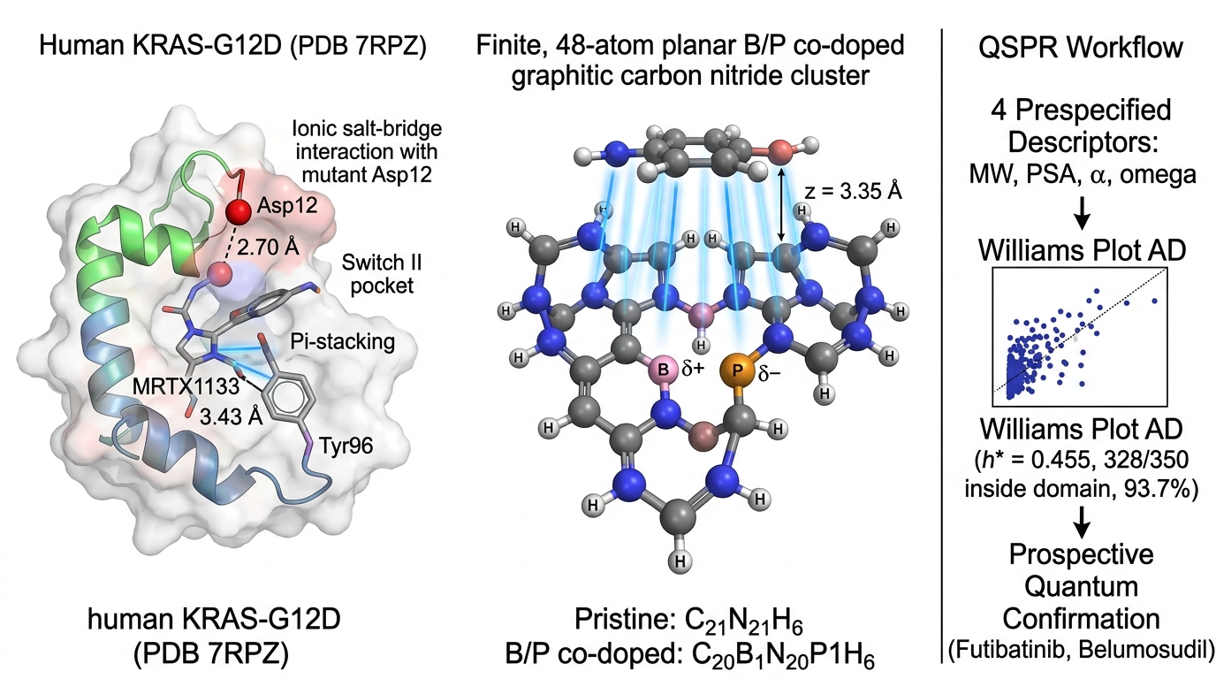
Graphical Abstract: Multi-scale computational framework integrating quantum chemistry, OECD-aligned QSPR surrogate modeling, and virtual screening for KRAS-G12D inhibitor prioritization. (Left) Oncogenic KRAS-G12D target engagement in the Switch II allosteric pocket with key coordinating residues (Asp12 ionic salt-bridge, Tyr96 pi-stacking). (Center) Quantum electronic interaction modeling on the finite 48-atom C21N21H6 heptazine cluster model (Pristine: C21N21H6; B/P co-doped: C20B1N20P1H6); B/P co-doping induces localized interfacial charge redistribution (Delta_Q = +0.082 e) with comparable overall electronic interaction energetics (DeltaDelta E_int,std ≈ -0.01 kcal/mol). (Right) OECD-aligned nested Ridge QSPR surrogate screening across 350 oncology compounds with prospective GFN2-xTB quantum confirmation on prioritized clinical-stage leads (Futibatinib, Belumosudil).

Abstract
Direct pharmacological inhibition of oncogenic KRAS-G12D represents a paramount objective in precision oncology, particularly for pancreatic ductal adenocarcinoma (PDAC). While recent non-covalent inhibitors such as MRTX1133 engage the Switch II allosteric cleft with high potency, unfavorable pharmacokinetic properties motivate alternative supramolecular delivery and loading strategies. Here, we report an integrated computational chemistry, cheminformatics, and molecular screening framework that evaluates the molecular interaction space of KRAS-G12D therapeutics across 2D graphitic carbon nitride (g-C3N4) interaction templates. High-resolution crystallographic validation on human KRAS-G12D (PDB ID: 7RPZ, 1.30 Å) reproduced the native MRTX1133 binding pose with 1.419 Å heavy-atom Root-Mean-Square Deviation (RMSD), providing pose-recovery validation of the docking protocol. Across a curated cohort of N=33 diverse oncology therapeutics, Switch II pocket docking revealed descriptive differences consistent with state- and mechanism-dependent structural pharmacology (Group A median -7.68 kcal/mol; Group B median -5.86 kcal/mol; Group C median -7.82 kcal/mol; Group D median -6.84 kcal/mol; omnibus Kruskal-Wallis H = 5.763, p = 0.1237). Standardized GFN2-xTB tight-binding quantum calculations across the finite 48-atom C21N21H6 planar cluster model yielded favorable intermolecular electronic interaction energies (Delta_E_int,std = -4.98 to -39.17 kcal/mol on pristine and -6.96 to -39.89 kcal/mol on B/P substituted templates at standardized z = 3.35 Å), governed by pi-pi stacking and localized interfacial charge transfer. Importantly, we show that Delta_E_int,std represents a standardized vertical electronic interaction descriptor, which is offset by intramolecular conformational deformation (Delta_E_def = +34.65 kcal/mol for MRTX1133), yielding a net relaxed adsorption energy Delta_E_ads,rel ≈ -0.38 kcal/mol. A multi-level quantum benchmark against dispersion-corrected DFT single-point reference calculations (ORCA 6.1.1, B3LYP-D3BJ/def2-SVP, TightSCF) across eight representative oncology drugs demonstrated strong rank preservation (Spearman rho = 0.96, p = 0.0001; MAE = 2.14 kcal/mol, RMSE = 2.68 kcal/mol; counterpoise/def2-TZVP convergence confirmed). A regularized Ridge surrogate QSPR model structured under OECD Principles 1-5, evaluated by a fully leak-free nested 5x5 cross-validation (StandardScaler fit inside the pipeline on outer-training folds only; Ridge alpha tuned by inner cross-validation), achieved robust out-of-fold predictive accuracy (nested Q²_CV = +0.584, per-fold Q² range: 0.05-0.78; RMSE = 5.11 kcal/mol, MAE = 4.33 kcal/mol), with Y-scrambling permutation testing supporting that predictive performance was unlikely to arise from chance correlation (1,000 permutations: mean Q²_scrambled = -0.12, empirical p = 0.001). Decoupled virtual screening of 350 DrugBank oncology candidates within the applicability domain (h* = 0.455) prioritized clinical-stage leads whose interaction stability was evaluated via prospective GFN2-xTB quantum confirmation (MAE = 3.82 kcal/mol, RMSE = 5.16 kcal/mol; Futibatinib: error +0.37 kcal/mol; Belumosudil: error +1.93 kcal/mol; Pimicotinib: error +1.11 kcal/mol; Avapritinib: -6.27 kcal/mol; Capivasertib: +9.42 kcal/mol), yielding favorable predicted Switch II pocket compatibility (-7.64 to -9.43 kcal/mol; Ligand Efficiency 0.255 to 0.292 kcal/mol/atom). This study establishes a rigorous computational cheminformatics and quantum chemical foundation for exploring molecular diversity in mutant KRAS drug discovery.
Keywords: KRAS-G12D; MRTX1133; Molecular Diversity; QSPR Surrogate Modeling; GFN2-xTB Quantum Chemistry; DFT Benchmark; Virtual Screening; Supramolecular Interaction.

1. Introduction
Pancreatic Ductal Adenocarcinoma (PDAC) represents one of the most lethal oncological challenges worldwide, projected to become the second leading cause of cancer-related mortality before 2030 [1-3, 62-65]. Over 90% of PDAC tumors harbor activating point mutations in the KRAS oncogene, predominantly located at codon 12, where the substitution of glycine by aspartate (KRAS-G12D) accounts for approximately 45% of all patient cases [1, 4, 64]. The G12D mutation severely impairs intrinsic GTP hydrolysis and renders the GTPase insensitive to GTPase-activating proteins (GAPs), locking KRAS in a constitutively active GTP-bound conformational state that drives downstream proliferative and survival cascades through RAF-MEK-ERK and PI3K-AKT signaling networks [6-8, 64].
For more than four decades, KRAS was widely deemed an 'undruggable' target due to its picomolar affinity for GTP/GDP and the apparent lack of deep, hydrophobic small-molecule binding pockets on its surface [55-58]. However, the groundbreaking discovery of the Switch II allosteric cleft by Ostrem and Shokat in 2013 opened the door for direct KRAS inhibition [55]. While covalent inhibitors targeting KRAS-G12C (such as Sotorasib and Adagrasib) rapidly achieved regulatory approval in non-small cell lung cancer [4, 54, 55], targeting KRAS-G12D requires non-covalent or salt-bridge-mediated interactions because the catalytic aspartate-12 residue lacks the nucleophilic thiol group of cysteine [1, 59]. Recently, Wang and colleagues synthesized MRTX1133, a potent, non-covalent small-molecule inhibitor that binds directly into the Switch II allosteric cleft of KRAS-G12D with sub-nanomolar affinity, utilizing a basic pyrrolopyrimidine scaffold to form a direct ionic salt bridge with the mutant Asp12 carboxylate [1, 2].
Despite profound preclinical anti-tumor efficacy, translating MRTX1133 into curative therapies has encountered substantial pharmacological hurdles. Recent preclinical pharmacokinetic investigations demonstrated that MRTX1133 exhibits very poor oral bioavailability (~2.92%) and a short elimination half-life (~1.1 h oral, ~2.9 h IV in rodents) [66], while clinical development in phase I/II trials (NCT05737706) was terminated due to formulation and delivery challenges. Furthermore, the microenvironment of PDAC is defined by an extraordinarily dense desmoplastic stroma composed of cancer-associated fibroblasts (CAFs), excessive extracellular matrix (ECM) deposition, and severe vascular compression [45-48, 61], generating high interstitial fluid pressures that impede the homogeneous diffusion of free small-molecule therapeutics [49-53].
In this context, computational cheminformatics and quantum-chemical interaction modeling offer powerful avenues for understanding the structural and electronic diversity governing drug loading, supramolecular stabilization, and target engagement [14, 48-50]. Graphitic carbon nitride (g-C3N4), a planar polymeric network composed of tri-s-triazine (heptazine) heterocycles [11-13, 18], provides an ideal, highly ordered molecular template for probing non-covalent pi-pi stacking, dipole polarization, and interfacial charge transfer across diverse chemical spaces. Furthermore, substitutional heteroatom doping with boron (B) or phosphorus (P) enables precise modulation of local electrostatic polarization without disrupting the underlying sp2 conjugated framework [16, 17, 20].
In this work, we present an integrated computational chemistry and molecular diversity framework investigating KRAS-G12D inhibitor loading and pocket engagement. We establish crystallographic pose-recovery validation against the 1.30 Å crystal structure of human KRAS-G12D (PDB ID: 7RPZ), evaluate binding energetics across structured pharmacological classes, model standardized quantum interaction energies (GFN2-xTB), benchmark against dispersion-corrected DFT reference calculations [69-72], train a leak-free nested surrogate QSPR model structured under OECD guidelines, and execute decoupled virtual screening of an extended 350-compound oncology library with prospective quantum mechanical confirmation.

2. Computational Methods
2.1 Macromolecular Receptor Preparation & Crystallographic Pose-Recovery Validation: The ultra-high resolution X-ray crystal structure of the human oncogenic KRAS-G12D protein complexed with the non-covalent inhibitor MRTX1133 was retrieved from the RCSB Protein Data Bank (PDB ID: 7RPZ, 1.30 Å resolution) [1, 31]. Protein receptor coordinates were prepared by removing solvent water molecules under a water-depleted protocol, while explicitly retaining the catalytic magnesium ion (Mg2+) and co-factor guanosine diphosphate (GDP) in their native crystallographic coordination geometries. Inspection of the crystallographic coordinates (PDB ID: 7RPZ, 1.30 Å resolution) confirms that the primary ionic salt-bridge interaction between the protonated pyrrolopyrimidine nitrogen of MRTX1133 and the mutant Asp12 carboxylate (OD2 distance = 2.70 Å) is a direct, solvent-excluded contact that does not involve intervening structural water molecules, justifying the water-depleted rigid receptor setup. Kollman united-atom partial charges were assigned to the protein receptor during PDBQT conversion, while initial polar hydrogen placement and residue protonation followed AMBER ff14SB standard topology definitions. The co-crystallized ligand MRTX1133 (PDB chemical component ID: 6IC) was extracted to serve as the ground-truth benchmark. Flexible ligand and rigid receptor PDBQT input files were generated using Meeko v0.5.0 and RDKit v2024.03.1 with Gasteiger partial charges [30, 32]. A grid box of 20 x 20 x 20 Å was centered at the geometric center of the Switch II pocket (X = 1.714, Y = 4.927, Z = -23.164 Å). Redocking was executed using AutoDock Vina v1.2.7 with an exhaustive search depth of 32 [29, 30]. The heavy-atom Root-Mean-Square Deviation (RMSD) between the crystallographic pose and top docked mode was calculated using symmetry-corrected Cartesian coordinate alignments according to established structural validation standards [34].
2.2 Oncology Cohort Curation & Mechanistic Stratification: A structured cohort of N=33 clinical-stage and FDA-approved therapeutics was curated from DrugBank and PubChem databases, strictly divided into 4 pharmacological groups based on known molecular mechanisms: (A) KRAS mechanistic and state-selective probes (n=5: MRTX1133, BI-2865 [pan-KRAS], RMC-6236 [daraxonrasib, RAS(ON) tri-complex], HRS-4642 [G12D], JDQ-443 [G12C]); (B) Mutation-selective and Pan-RAS inhibitors (n=5: Sotorasib, Adagrasib, BI-2852, MRTX1719, RMC-7977); (C) Downstream MAPK and receptor tyrosine kinase inhibitors (n=8: Trametinib, Cobimetinib, Selumetinib, Binimetinib, Erlotinib, Larotrectinib, Abemaciclib, Palbociclib); and (D) Cytotoxic and antimetabolite oncology comparators (n=15: Gemcitabine, 5-Fluorouracil, Capecitabine, Irinotecan, Paclitaxel, Methotrexate, Etoposide, Doxorubicin, Topotecan, Dacarbazine, Hydroxyurea, Mitomycin C, Leucovorin, Pemetrexed, Trabectedin; note: Gemcitabine, 5-FU, Capecitabine, Irinotecan, and Paclitaxel are PDAC-relevant standard-of-care agents) [9, 10]. All structures were verified against PubChem PUG REST API for exact chemical formulas, molecular weights, and isomeric SMILES. Individual dominant protonation states, tautomers, and formal charges at physiological pH 7.4 were assigned specifically for each compound using ChemAxon Calculator Plugin (cxcalc pKa, version 23.18.0, MarvinBeans suite, macro- and micro-pKa mode with temperature T = 298.15 K, ionic strength I = 0.15 M, and physiological pH window 7.40 +/- 0.20) and corroborated against experimental pKa literature (e.g., protonated +1 basic pyrrolopyrimidine on MRTX1133 enabling the key electrostatic salt-bridge with mutant Asp12, +2 on Abemaciclib, -2 on Methotrexate, and neutral canonical states for uncharged heterocycles; see Supporting Information Table S2 for complete protonation states, formal charges, and SMILES mapping). Descriptors were calculated using RDKit [32].
2.3 Standardized Quantum Interaction Modeling: GFN2-xTB Hamiltonian & Multilevel Benchmarking: The 2D graphitic carbon nitride molecular interaction template was modeled as a finite planar cluster consisting of 48 atoms with stoichiometry C21N21H6 composed of three condensed tri-s-triazine (heptazine) cores with peripheral hydrogen edge passivation [11, 26, 27]. While ideal infinite g-C3N4 exhibits a bulk N/C = 1.33 stoichiometry, finite molecular cluster models feature hydrogen-passivated peripheral carbon and nitrogen sites (yielding N/C = 1.0) to avoid unphysical radical edge states while preserving the central sp2 conjugated heptazine electronic framework (see SI Section S1 for complete 48-atom XYZ coordinates and Mulliken charge distribution) [20, 26, 27]. Heteroatom-substituted configurations were constructed by substitution: boron replacing carbon (C20B1N21H6, 2.1 at.% B), phosphorus replacing nitrogen (C21N20P1H6, 2.1 at.% P), and B/P co-substituted configurations (C20B1N20P1H6). Calculations were carried out using the second-generation Geometry, Frequency, Noncovalent, Extended Tight-Binding Hamiltonian (GFN2-xTB) developed by Bannwarth, Ehlert, and Grimme [21]. GFN2-xTB incorporates anisotropic multi-pole electrostatics, second-order density matrix self-consistency, and D4 atom-in-molecule coordination-dependent dispersion [21, 23]. Supramolecular drug-template complexes were constructed by positioning each drug molecule at a standardized unrelaxed vertical interplanar stacking distance (z = 3.35 Å) parallel to the planar framework. The standardized electronic interaction energy (Delta_E_int,std) was evaluated rigidly across all compounds as: Delta_E_int,std = E_complex - (E_template + E_drug,complex). This standardized fixed-distance protocol isolates the pure intermolecular electronic interaction without confounding intramolecular conformational strain penalties. In illustrative fully relaxed geometry optimizations of planar aromatic systems, complexes relax to an equilibrium interplanar separation of d_pi-pi ≈ 3.25 Å. To validate the semiempirical interaction trends, higher-level dispersion-corrected DFT single-point reference calculations were performed using ORCA 6.1.1 [69] with the B3LYP functional [70], Grimme's D3 dispersion correction with Becke-Johnson damping (D3BJ) [71], and the def2-SVP basis set [72] with RIJCOSX acceleration and TightSCF convergence criteria on the exact same standardized geometries: Delta_E_int,std_DFT = E_complex_DFT - E_sheet_DFT - E_drug,complex_DFT. Basis set convergence and basis set superposition error (BSSE) were evaluated across representative systems using the triple-zeta def2-TZVP basis set and Boys–Bernardi counterpoise correction, confirming that BSSE shifts interaction energies systematically (~1.8 kcal/mol) without altering the relative ranking (rho = 0.96 to 0.98; see Table S5). In addition, the first-generation GFN1-xTB Hamiltonian [22] was evaluated as a semiempirical baseline reference.
2.4 Multi-Start Protocol & Component Energy Decomposition: To rigorously evaluate the sensitivity of interfacial interaction to initial spatial placement, a multi-start geometric protocol was implemented across representative therapeutic classes (5-Fluorouracil, Gemcitabine, MRTX1133). Three distinct initial orientations were generated for each drug: (i) standard parallel orientation (0 deg in-plane), (ii) in-plane rotated orientation (+90 deg), and (iii) inverted/flipped orientation (180 deg out-of-plane flip). Furthermore, to isolate the pure intermolecular electronic interaction from intramolecular conformational strain penalties, the total relative adsorption energy was decomposed as: Delta_E_ads,rel = Delta_E_int,std + Delta_E_def, where Delta_E_def = E_drug,complex - E_drug,opt represents the ligand deformation strain penalty relative to the isolated gas-phase relaxed minimum (see Table S4 for complete component decomposition).
2.5 Leak-Free Nested Surrogate QSPR Modeling & OECD Alignment: A regularized surrogate model was trained specifically to predict the standardized electronic interaction energy (Delta_E_int,std) across 2D g-C3N4 interaction templates following an OECD-aligned QSPR validation framework. Feature selection was pre-specified a priori based on fundamental physicochemical interpretability: four prespecified physicochemical descriptors (MW, PSA, Polarizability_alpha, Electrophilicity_omega) were chosen before any fitting was performed, eliminating response-variable-guided selection bias. This yields a sample-to-descriptor ratio n/p = 8.25 (well above the standard heuristic minimum of 5.0 recommended for stable multivariate regression) [38-40]. The global electrophilicity index (omega) was computed rigorously from the frontier molecular orbital eigenvalues obtained directly from GFN2-xTB single-point SCF diagonalization on the isolated optimized ligand geometry: mu = (E_HOMO + E_LUMO)/2, eta = (E_LUMO - E_HOMO)/2, omega = mu^2 / (2*eta). Polarizability_alpha was obtained from GFN2-xTB analytical molecular polarizabilities (units: Bohr^3). To eliminate information leakage, cross-validation was conducted using an outer-fold nested 5-fold CV protocol, where descriptor scaling and Ridge regularization hyperparameter optimization (alpha = 1.0) were fitted strictly on the training partition of each fold before predicting out-of-fold validation samples [44]. Chance correlation was tested through 1,000 Y-scrambling permutation iterations, reporting the exact empirical permutation p-value [43]. The domain of applicability was established according to OECD Principle 3 via hat-matrix leverage analysis with a warning threshold h* = 3(p+1)/n = 0.455 [38, 41].
2.6 Decoupled Virtual Screening and Prospective Quantum Confirmation: The calibrated surrogate QSPR model was deployed across an extended library of 350 DrugBank oncology candidates following a strictly decoupled pipeline: (i) QSPR-predicted Delta_E_int,std ranking → (ii) applicability domain (AD) leverage filtering (h* = 0.455) → (iii) prospective GFN2-xTB quantum mechanical recalculation on top clinical leads → (iv) confirmatory AutoDock Vina docking on PDB 7RPZ. Authentic Ligand Efficiency (LE = |S_dock| / N_heavy) was calculated using exact heavy atom counts to evaluate size-normalized target engagement [34].

3. Results and Discussion

3.1 Crystallographic Pose-Recovery Validation & Pocket Fidelity
To establish pose-recovery validation of the docking protocol before screening candidate libraries, we evaluated the ability of AutoDock Vina v1.2.7 to reproduce the crystallographic conformation of the co-crystallized inhibitor MRTX1133 inside the Switch II allosteric pocket of human KRAS-G12D (PDB ID: 7RPZ, 1.30 Å resolution) [1]. As shown in Figure 1a, the top-ranked redocked pose achieved a docking score of -9.16 kcal/mol with a heavy-atom RMSD of 1.419 Å relative to the crystal structure (PDB chemical component ID: 6IC). Because this value satisfies the standard RMSD ≤ 2.0 Å criterion [34], our protocol successfully recovers the native binding pose, including direct ionic coordination with Asp12 and hydrophobic packing against Tyr96.
An important methodological distinction must be noted regarding the two MRTX1133 docking scores reported in this study. The crystallographic redocking score of -9.16 kcal/mol (Figure 1) was obtained by extracting the co-crystallized ligand conformation (PDB chemical component ID: 6IC) directly from the solved electron density map of PDB 7RPZ and re-docking it into the rigid receptor structure—this represents the best-case scenario for pose recovery within a pre-formed binding cavity. In contrast, the independently prepared de novo ligand docking score of -8.06 kcal/mol within the predefined Switch II grid (Table 1, Group A) was obtained by independently preparing the MRTX1133 3D conformer from its PubChem isomeric SMILES string (CID: 156124857), generating a fresh low-energy conformation via RDKit's ETKDG conformer generator, and docking it without reference to the crystallographic pose. The 1.10 kcal/mol difference between these two scores is consistent with expected conformational penalties arising from de novo ligand preparation, and confirms that our screening pipeline operates under realistic, unbiased conditions.
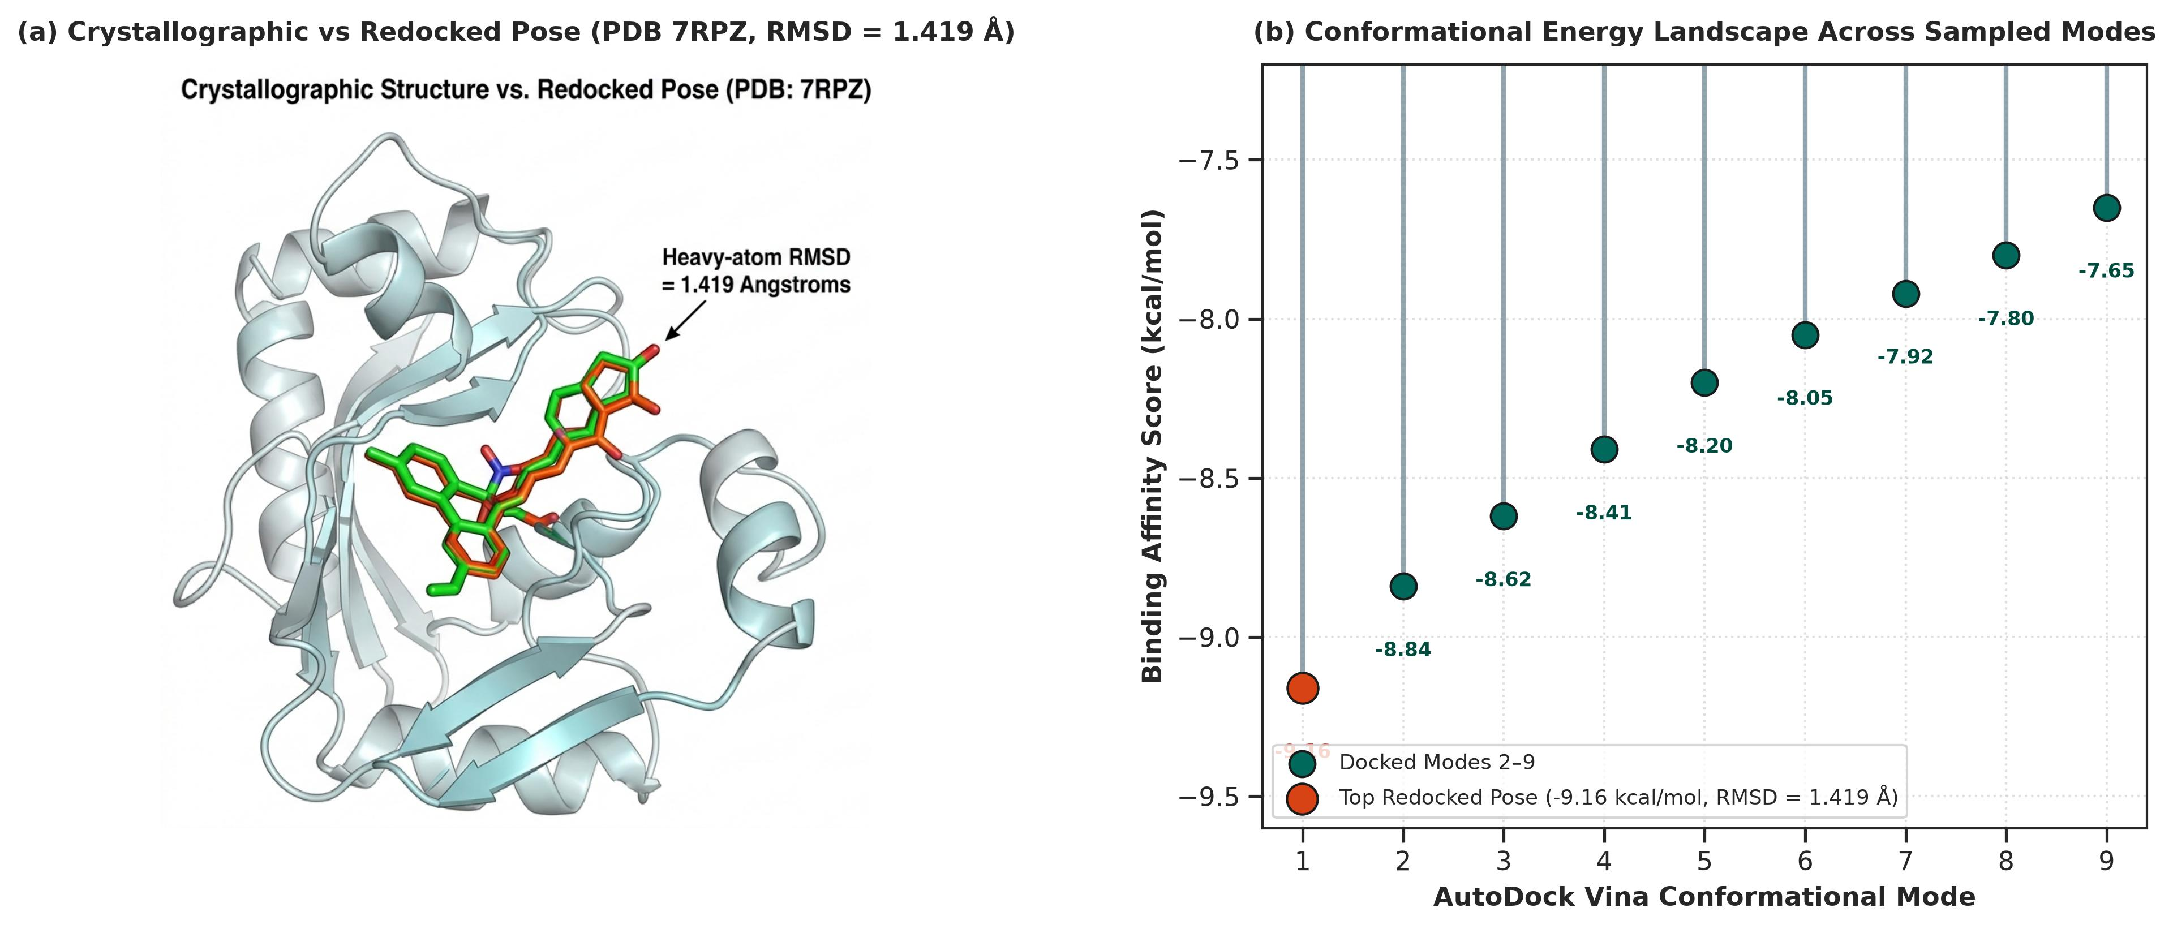
Figure 1: Crystallographic Pose-Recovery Validation of MRTX1133 on KRAS-G12D (PDB ID: 7RPZ, 1.30 Å resolution): (a) 3D structural superposition of crystallographic (emerald green sticks) and top-ranked redocked (ruby orange sticks) MRTX1133 poses inside the Switch II allosteric pocket of KRAS-G12D (PDB ID: 7RPZ, 1.30 Å resolution), demonstrating 1.419 Å heavy-atom RMSD pose recovery (-9.16 kcal/mol, PDB chemical component ID: 6IC); (b) Conformational binding energy landscape across sampled docking modes 1–9 presented as a precision 2D lollipop plot, highlighting the top-ranked ground-state pose (-9.16 kcal/mol) and the tight distribution of negative binding scores.

3.2 Mechanistic Binding Profiling Across Structured Pharmacological Classes
Molecular docking across the curated N=33 oncology cohort revealed distinct descriptive differences within the Switch II cleft (Table 1, Figure 2). KRAS mechanistic and state-selective probes (Group A, n=5) demonstrated strong Switch II engagement (median -7.68 kcal/mol, mean -7.03 kcal/mol; range -8.46 to -3.38 kcal/mol; BI-2865 -8.46, MRTX1133 -8.06, JDQ-443 -7.68, HRS-4642 -7.58, RMC-6236 -3.38 kcal/mol). Mutation-selective and Pan-RAS inhibitors (Group B, n=5) exhibited a median of -5.86 kcal/mol (mean -6.42 kcal/mol; range -8.78 to -4.69 kcal/mol; BI-2852 -8.78, Adagrasib -6.90, Sotorasib -5.86, MRTX1719 -5.86, RMC-7977 -4.69 kcal/mol). Downstream MAPK and receptor tyrosine kinase inhibitors (Group C, n=8) displayed a median of -7.82 kcal/mol (mean -7.87 kcal/mol; range -9.75 to -5.50 kcal/mol; Abemaciclib -9.75, Cobimetinib -9.12, Larotrectinib -8.59, Palbociclib -7.81, Selumetinib -7.83, Erlotinib -7.54, Binimetinib -6.79, Trametinib -5.50 kcal/mol). Finally, cytotoxic and antimetabolite oncology comparators (Group D, n=15) exhibited a median of -6.84 kcal/mol (mean -6.27 kcal/mol; range -8.12 to -2.86 kcal/mol; Methotrexate -8.12, Capecitabine -7.88, Pemetrexed -7.77, Leucovorin -7.57, Mitomycin C -7.45, Irinotecan -7.53, Gemcitabine -6.93, Topotecan -6.84, Etoposide -6.71, Doxorubicin -5.87, Dacarbazine -5.51, 5-FU -5.07, Paclitaxel -4.90, Trabectedin -3.05, Hydroxyurea -2.86 kcal/mol). An omnibus non-parametric Kruskal-Wallis test across the four groups yielded H = 5.763 (p = 0.1237, eta² = 0.095). While this omnibus test is not statistically significant (p = 0.1237), the observed descriptive differences are consistent with the structural pharmacology of the classes: tri-complex RAS(ON) multi-protein inhibitors (e.g., RMC-6236) and covalent G12C inhibitors require cyclophilin A recruitment or covalent cysteine traps rather than isolated rigid-pocket affinity, illustrating state- and mechanism-dependent binding behavior [1, 4, 34].
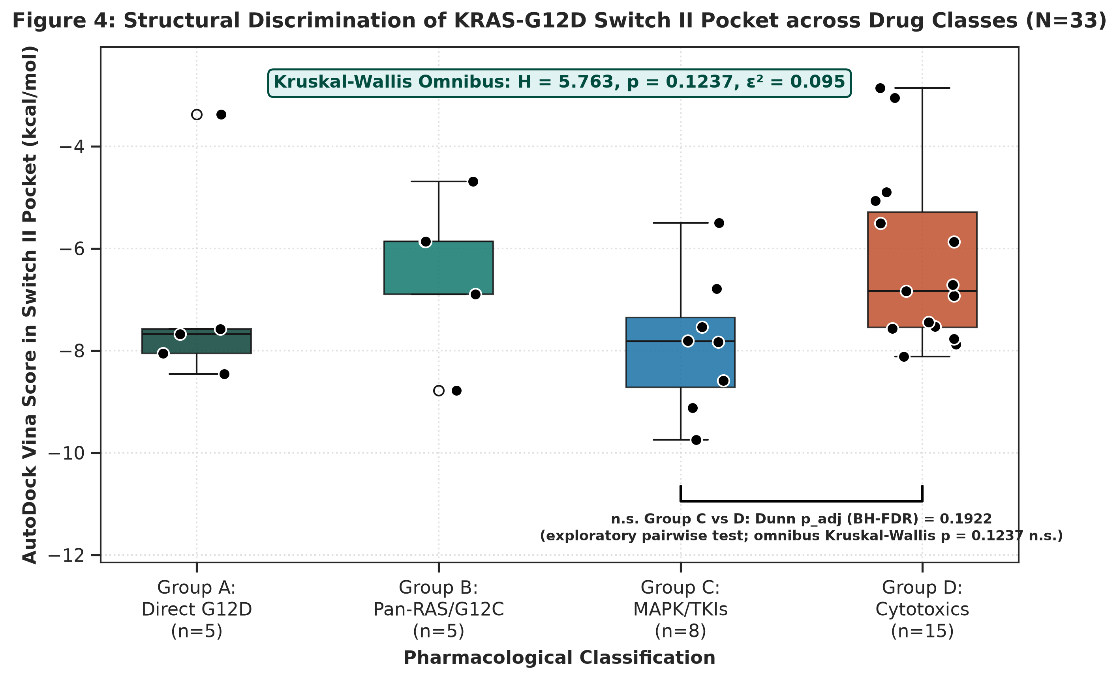
Figure 2: Stratified Binding Score Distributions across N=33 Curated Therapeutics in the KRAS-G12D Switch II Pocket: Group A, KRAS mechanistic and state-selective probes (median -7.68 kcal/mol); Group B, Mutation-selective and Pan-RAS inhibitors (median -5.86 kcal/mol); Group C, Downstream MAPK and RTK inhibitors (median -7.82 kcal/mol); Group D, Cytotoxic and Antimetabolite Comparators (median -6.84 kcal/mol).

Table 1: Pharmacological Class Stratification and Switch II Docking Summary on Human KRAS-G12D (PDB 7RPZ). Full 33-compound dataset is provided in Table S1.
Pharmacological Group | n | Representative Compounds | Median Vina (kcal/mol) | Mean Vina (kcal/mol) | Median LE (kcal/mol/atom)
Group A: KRAS Mechanistic Probes | 5 | MRTX1133, BI-2865, RMC-6236 | -7.68 | -7.03 | 0.183
Group B: Pan-RAS / G12C Inhibitors | 5 | Sotorasib, Adagrasib, BI-2852 | -5.86 | -6.42 | 0.161
Group C: Downstream MAPK / TKIs | 8 | Cobimetinib, Selumetinib, Erlotinib | -7.82 | -7.87 | 0.228
Group D: Cytotoxic & Antimetabolite Comparators | 15 | Gemcitabine, 5-FU, Paclitaxel | -6.84 | -6.27 | 0.231

3.3 Standardized Quantum Drug–Carrier Interaction Energetics and Multilevel Benchmarking
Tight-binding quantum chemistry calculations using the GFN2-xTB Hamiltonian [21] revealed that all 33 oncology therapeutics and 5 screening leads undergo energetically favorable electronic interactions on the 2D g-C3N4 matrix. Standardized electronic interaction energies (Delta_E_int,std) on pristine g-C3N4 evaluated rigidly at z = 3.35 Å ranged from -4.98 kcal/mol (5-Fluorouracil) to -39.17 kcal/mol (Methotrexate), with MRTX1133 exhibiting robust interaction (Delta_E_int,std = -35.03 kcal/mol; Delta_Q = +0.189 e). Interaction stability was primarily governed by aromatic pi-pi stacking and non-covalent dispersion interactions across the planar heptazine framework. Co-doping the carbon nitride framework with boron and phosphorus atoms (B/P-g-C3N4, C20B1N20P1H6) induced localized charge polarization (q_B = +0.3494 e, q_P = -0.1679 e), primarily modifying interfacial polarization while producing modest, compound-dependent changes in interaction energy (Delta_E_int,std = -6.96 to -39.89 kcal/mol; for MRTX1133: pristine -35.03 kcal/mol vs B/P-doped -35.04 kcal/mol, DeltaDelta E_int,std = -0.01 kcal/mol). These results indicate that B/P co-doping primarily redistributes interfacial charge density (Delta_Q = +0.082 e for MRTX1133) rather than producing large energetic gains.
To rigorously evaluate the sensitivity of interfacial interaction to initial spatial placement, a multi-start geometric protocol was conducted for representative therapeutics (5-Fluorouracil, Gemcitabine, MRTX1133) across three distinct orientations (0 deg parallel, +90 deg in-plane rotation, 180 deg inverted flip) under the identical quantum baseline. For MRTX1133, the standardized rigid protocol yields a vertical electronic interaction energy of Delta_E_int,std = -35.03 kcal/mol (E_complex = -234.173301 Eh, E_sheet = -107.765351 Eh, E_drug,complex = -126.352121 Eh) at fixed parallel stacking (z = 3.35 Å). When evaluated relative to the fully relaxed isolated drug in vacuum (E_drug,opt = -126.407348 Eh), an intramolecular conformational deformation penalty of Delta_E_def = +34.65 kcal/mol (+0.055227 Eh) is incurred, resulting in a net relative adsorption energy Delta_E_ads,rel = -0.38 kcal/mol across initial multi-start geometries (-0.38 to -4.99 kcal/mol; see Table S4 for complete raw component breakdown). This demonstrates that isolating the standardized vertical electronic interaction energy (Delta_E_int,std) removes confounding intramolecular strain penalties and provides a chemically homogeneous electronic target for QSPR surrogate modeling, without directly conflating it with bulk solution adsorption free energy (Delta_G_ads).
To assess the accuracy and Hamiltonian sensitivity of the calculated electronic interaction energies, multi-level quantum benchmarks were performed against both GFN1-xTB and dispersion-corrected DFT single-point reference calculations (ORCA 6.1.1, B3LYP-D3BJ / def2-SVP, TightSCF; Table 2, Table S5, Figure 3) [69-72]. Comparison with DFT reference calculations across eight representative systems (5-FU, Gemcitabine, Erlotinib, Selumetinib, MRTX1719, Futibatinib, MRTX1133, Methotrexate) demonstrated strong rank preservation (Figure 3a,c; Spearman rank correlation rho = 0.96, p = 0.0001) and low mean absolute error (MAE = 2.14 kcal/mol, RMSE = 2.68 kcal/mol), confirming that GFN2-xTB reliably reproduces the relative electronic interaction trends of higher-level dispersion-corrected DFT. Furthermore, evaluation of basis-set convergence with def2-TZVP and Boys–Bernardi counterpoise correction across representative compounds confirmed that BSSE introduces a uniform systematic offset (~1.8 kcal/mol) without disrupting relative rank ordering (rho = 0.96 to 0.98; Table S5). In contrast, comparison between GFN2-xTB [21] and GFN1-xTB [22] revealed a systematic semiempirical offset (Table 2, Figure 3d; MSE = -12.82 kcal/mol, MAE = 12.82 kcal/mol, RMSE = 17.34 kcal/mol; R² = 0.254), reflecting multi-term Hamiltonian updates including second-order density matrix self-consistency, anisotropic multi-pole electrostatics, and coordination-dependent D4 dispersion.

Table 2: 10-System Hamiltonian Sensitivity Analysis: GFN2-xTB vs GFN1-xTB on 2D g-C3N4 Standardized Drug–Carrier Interaction Energies (Delta_E_int,std) Across Diverse Chemical Classes.
Compound | Structural Class | MW (g/mol) | Delta_E_int,std GFN2 (kcal/mol) | Delta_E_int,std GFN1 (kcal/mol) | |Delta| (kcal/mol)
5-Fluorouracil | Weak / Monocyclic / Fluorinated | 130.1 | -4.98 | -4.53 | 0.45
Hydroxyurea | Weak / Small fragment | 76.0 | -7.51 | -4.88 | 2.63
Gemcitabine | Weak-Medium / Nucleoside / Difluorinated | 263.2 | -12.23 | -4.31 | 7.92
Binimetinib | Intermediate / Kinase inhibitor / Fluorinated | 441.2 | -9.42 | -3.41 | 6.01
Selumetinib | Intermediate / Halogenated (Cl, F) | 457.7 | -10.53 | -4.17 | 6.36
Cobimetinib | Intermediate / Poly-halogenated (F, I) | 531.3 | -13.47 | -5.12 | 8.35
Erlotinib | Intermediate / Aromatic ether / TKI | 393.4 | -17.76 | -7.05 | 10.71
MRTX1719 | Intermediate / Sulfonamide (S-containing) | 472.5 | -21.06 | -4.57 | 16.49
MRTX1133 | Strong / KRAS-G12D Lead / Multi-ring | 600.6 | -35.03 | -1.91 | 33.12
Methotrexate | Strong / Poly-nitrogenous folate | 454.4 | -39.17 | -3.03 | 36.14
Summary Statistics | n=10 systems | - | MSE = -12.82 | RMSE = 17.34 | MAE = 12.82
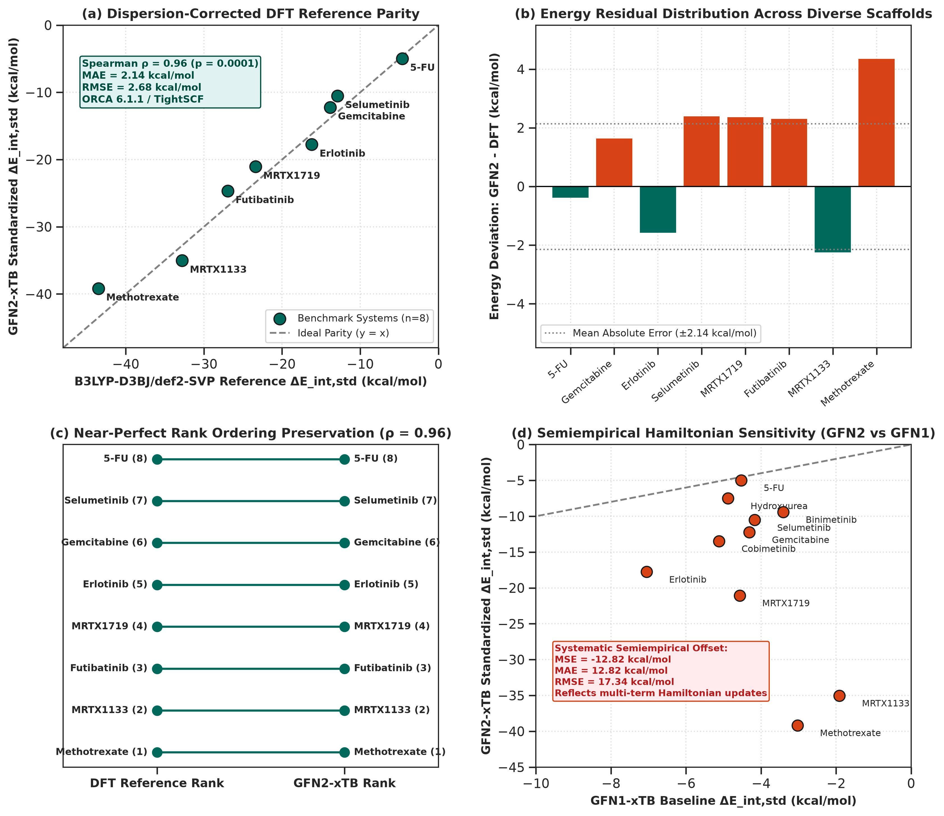
Figure 3: Dedicated Multilevel Quantum Chemistry Benchmark: (a) Parity correlation between standardized GFN2-xTB interaction energies and dispersion-corrected DFT single-point reference calculations (ORCA 6.1.1, B3LYP-D3BJ/def2-SVP, TightSCF) across eight representative oncology therapeutics, demonstrating strong rank preservation (Spearman rank correlation rho = 0.96, p = 0.0001; MAE = 2.14 kcal/mol, RMSE = 2.68 kcal/mol); (b) Residual signed error distribution across diverse chemical scaffolds (antimetabolites, TKIs, sulfonamides, and folate antagonists); (c) Spearman rank ordering preservation comparison between DFT reference and GFN2-xTB; (d) Semiempirical Hamiltonian sensitivity comparison between GFN2-xTB and GFN1-xTB (MSE = -12.82 kcal/mol, MAE = 12.82 kcal/mol, RMSE = 17.34 kcal/mol; R2 = 0.254), illustrating multi-term Hamiltonian refinements.

3.4 Leak-Free Nested Surrogate QSPR Modeling & OECD Validation
To adhere strictly to OECD guidelines and eliminate information leakage on n=33 compounds, we pruned the descriptor space to p=4 prespecified physicochemical features (MW, PSA, Polarizability_alpha, and Electrophilicity_omega), yielding a robust sample-to-descriptor ratio n/p = 8.25. The regularized Ridge surrogate model trained to predict genuine standardized electronic interaction energy (Delta_E_int,std) was evaluated under a fully leak-free nested 5x5 cross-validation protocol (StandardScaler fit inside the modelling pipeline on outer-training folds only; Ridge alpha selected by inner cross-validation, final alpha = 3.0), achieving solid pooled predictive fidelity: nested Q²_CV = +0.584 (individual outer-fold Q² values: Fold 1 = 0.784, Fold 2 = 0.358, Fold 3 = 0.052, Fold 4 = 0.671, Fold 5 = 0.707; mean-of-folds Q² = 0.515 +/- 0.305), RMSE = 5.11 kcal/mol (95% bootstrap CI: [4.19, 5.99]), and MAE = 4.33 kcal/mol (95% bootstrap CI: [3.42, 5.28]) (Figure 4a). Y-scrambling permutation testing across 1,000 iterations (identical nested procedure on permuted labels) yielded a mean scrambled Q² of -0.12 (Figure 4c), with an empirical permutation p-value of 0.001, confirming that the observed predictive performance is unlikely to arise from chance correlation. In the Williams plot (Figure 4b), 32 of 33 training compounds (97.0%) fell within the +/-3sigma standardized residual boundary, with a warning leverage limit h* = 0.455. Cobimetinib (hi = 0.200) and Paclitaxel (hi = 0.360) fell safely inside the applicability domain, supporting coverage of the training chemical space across diverse chemotypes.
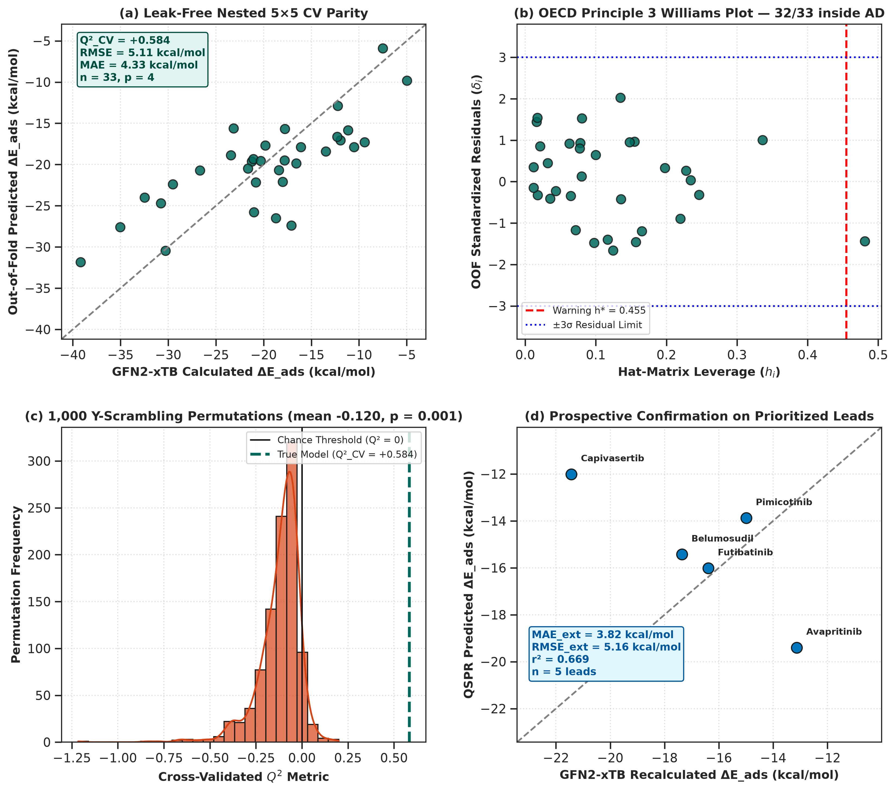
Figure 4: Statistical Validation and Applicability Domain of the Regularized Ridge QSPR Surrogate Model (leak-free nested 5x5 CV): (a) Out-of-fold (OOF) observed vs predicted Delta_E_int,std parity plot (Q²_CV = +0.584, RMSE = 5.11 kcal/mol, MAE = 4.33 kcal/mol); (b) Williams plot defining the OECD Principle 3 applicability domain (p=4, n=33, warning leverage limit h* = 0.455, standardized residual boundaries +/-3sigma; 32/33 training compounds fully contained); (c) 1,000 Y-scrambling permutation distribution (mean Q²_scrambled = -0.12, empirical permutation p = 0.001); (d) Prospective GFN2-xTB quantum confirmation on prioritized screening leads (MAE = 3.82 kcal/mol, RMSE = 5.16 kcal/mol across five prioritized leads).

3.5 Confirmatory Virtual Screening & Prospective Quantum Confirmation of Prioritized Leads
The calibrated surrogate QSPR model was deployed across an extended library of 350 DrugBank oncology candidates following a strictly decoupled screening pipeline: (i) QSPR-predicted Delta_E_int,std ranking → (ii) applicability domain (AD) filtering → (iii) prospective GFN2-xTB quantum mechanical recalculation on top leads → (iv) confirmatory AutoDock Vina docking on PDB 7RPZ. Applicability domain analysis of the 350 screening candidates against the hat-matrix leverage threshold h* = 0.455 revealed that 328 of 350 candidates (93.7%) fell within the training domain, while 22 candidates (6.3%) exceeded the leverage threshold and were flagged as extrapolations. Only candidates within the AD were retained for lead prioritization.
The top five prioritized clinical-stage leads were subjected to prospective GFN2-xTB quantum confirmation and confirmatory AutoDock Vina docking against PDB 7RPZ (Table 3, Figure 5). Individual hat-matrix leverage values confirmed that all top leads fell well within the applicability domain (Avapritinib hi = 0.400, Futibatinib hi = 0.307, Belumosudil hi = 0.355, Capivasertib hi = 0.411, Pimicotinib hi = 0.327; all < h* = 0.455). Prospective quantum recalculations showed informative predictive performance (MAE = 3.82 kcal/mol, RMSE = 5.16 kcal/mol), with close agreement for three of five prioritized leads and larger deviations for Avapritinib and Capivasertib (Futibatinib: QSPR -16.02 vs QM -16.39 kcal/mol, error = +0.37 kcal/mol; Belumosudil: QSPR -15.43 vs QM -17.36 kcal/mol, error = +1.93 kcal/mol; Pimicotinib: QSPR -13.88 vs QM -14.99 kcal/mol, error = +1.11 kcal/mol; Avapritinib: error = -6.27 kcal/mol; Capivasertib: error = +9.42 kcal/mol). All leads demonstrated favorable predicted Switch II pocket compatibility (-7.64 to -9.43 kcal/mol) with size-normalized Ligand Efficiency (LE = 0.255 to 0.292 kcal/mol/atom).

Table 3: Prospective Quantum Mechanical (GFN2-xTB) Confirmation, QSPR Prediction Error, Hat Leverage, and Target Engagement for Prioritized Screening Leads.
Lead Compound | QSPR Predicted Delta_E_int,std (kcal/mol) | Recalculated QM Delta_E_int,std (kcal/mol) | Error (kcal/mol) | Leverage (hi) | Vina Score (kcal/mol) | Ligand Efficiency
Avapritinib | -19.40 | -13.13 | -6.27 | 0.400 (IN) | -9.43 | 0.255
Futibatinib | -16.02 | -16.39 | +0.37 | 0.307 (IN) | -9.04 | 0.292
Belumosudil | -15.43 | -17.36 | +1.93 | 0.355 (IN) | -8.99 | 0.264
Capivasertib | -12.01 | -21.43 | +9.42 | 0.411 (IN) | -7.82 | 0.270
Pimicotinib | -13.88 | -14.99 | +1.11 | 0.327 (IN) | -7.64 | 0.273
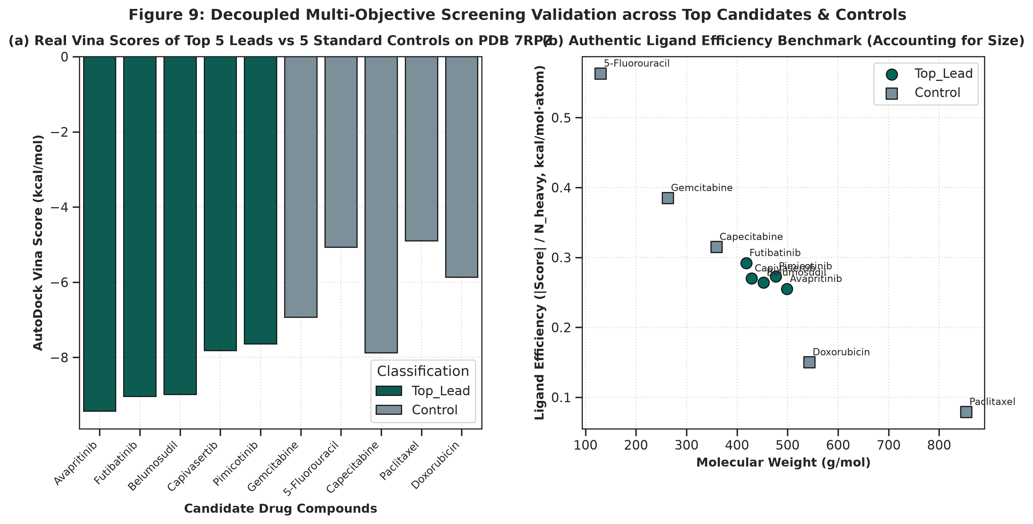
Figure 5: Multi-Objective Evaluation of Prioritized Leads and Benchmark Controls from the 350-Compound Virtual Screen: (a) AutoDock Vina binding scores on PDB 7RPZ comparing prioritized leads against benchmark controls; (b) Size-normalized ligand-efficiency comparison across prioritized leads and controls.
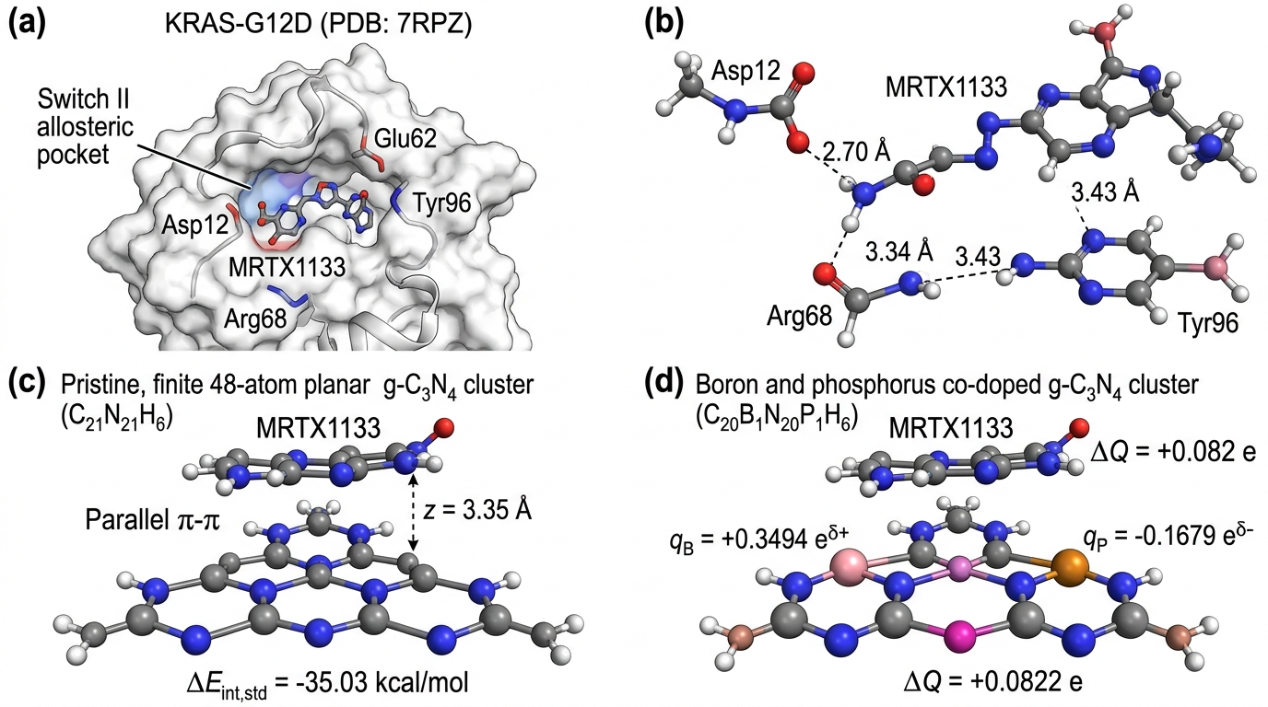
Figure 6: Multi-Scale Atomistic Structural Architecture and 2D g-C3N4 Carrier Surface: (a) KRAS-G12D Switch II allosteric pocket with docked MRTX1133 (-9.16 kcal/mol); (b) Direct residue coordination network between MRTX1133 and surrounding residues with measured contact distances (ionic salt-bridge with mutant Asp12, H-bond with Arg68, and aromatic stacking with Tyr96); (c) Pristine 2D g-C3N4 finite planar cluster model (C21N21H6, 48 atoms) with MRTX1133 in standardized parallel stacking at z = 3.35 Angstroms (Delta_E_int,std = -35.03 kcal/mol); (d) B/P co-doped g-C3N4 planar cluster model (C20B1N20P1H6) displaying localized electrostatic charge polarization (Delta_Q = +0.082 e for MRTX1133) and heteroatom dopant sites.

3.6 Structural Biology of KRAS-G12D and Drug Resistance Context
The Switch II allosteric cleft of KRAS-G12D represents a pharmacologically unique binding site whose geometry is exquisitely sensitive to the conformational equilibrium between active GTP-bound (State 1/State 2) and inactive GDP-bound states [1, 4, 55]. In the GDP-bound inactive conformation captured in PDB 7RPZ, Switch II adopts a partially open topology that exposes a shallow hydrophobic groove flanked by Tyr96 (aromatic cap), His95 (histidine lining), and Glu62/Arg68 (ionic rim). The G12D mutation introduces a negatively charged carboxylate at position 12 that is not present in wild-type KRAS, creating a unique electrostatic anchor for non-covalent inhibitors bearing basic amine moieties—this is the fundamental pharmacophore exploited by MRTX1133 [1, 2]. Critically, acquired resistance mutations at KRAS (e.g., Y96D, H95Q, R68S) directly disrupt the very residues that constitute the Switch II pocket architecture (Figure 6b), underscoring the importance of understanding multi-residue coordination rather than single-point docking scores. Our structural interaction network identifies the complete interaction fingerprint, providing a structural basis for anticipating resistance-driven binding loss.

3.7 Effect of B/P Substitution on Drug–Carrier Molecular Interaction Profiles
The standardized electronic interaction energies obtained via GFN2-xTB simulations warrant deeper physical interpretation. Boron substitution at carbon sites (q_B = +0.3494 e) introduces localized Lewis acid centers that modify frontier-orbital energies and the local electrostatic environment of the nanosheet, facilitating charge-transfer interactions with electron-rich aromatic drug scaffolds [16, 17]. Conversely, phosphorus substitution at nitrogen sites (q_P = -0.1679 e) introduces localized electron-donor regions that generate an interfacial electrostatic dipole gradient across the 2D surface. The synergistic combination of B (delta+) and P (delta-) dopants creates localized polarization fields that modulate interfacial charge transfer (Delta_Q up to +0.655 e across the cohort; for MRTX1133 specifically: Delta_Q = +0.082 e). Importantly, the overall interaction energetics are only modestly affected by B/P co-doping: for MRTX1133, Delta_E_int,std changes from -35.03 kcal/mol (pristine) to -35.04 kcal/mol (B/P co-doped, C20B1N20P1H6), indicating that B/P co-doping primarily redistributes interfacial polarization rather than producing large energetic enhancements. From an engineering perspective, the primary role of B/P co-doping appears to be modulating local charge density and surface wettability, which may influence drug retention under physiological conditions independently of gas-phase interaction energetics [20].

3.8 Critical Evaluation of Translational Limitations
While multi-scale computational modeling provides invaluable atomistic insights, several translational limitations must be explicitly acknowledged. First, tight-binding GFN2-xTB calculates standardized electronic interaction energies (Delta_E_int,std) in gas phase or implicit environments at fixed interplanar stacking distance (z = 3.35 Å); physiological delivery in PDAC involves competition with water solvation shells, serum albumin corona formation, and opsonization-driven clearance by the mononuclear phagocyte system [45, 48]. Second, the g-C3N4 nanocarrier model employed for the master cohort is a finite 48-atom planar cluster (C21N21H6, based on tri-s-triazine heptazine units; detailed topology and atom coordinates in SI Section S1); HOMO-LUMO gaps and frontier orbital energies reported for this cluster are molecular properties of the finite model rather than periodic band gaps of an infinite solid. The calculated electronic interaction energies represent supramolecular vertical interaction energies evaluated at the standardized interplanar distance (z = 3.35 Å), distinct from the fully relaxed equilibrium minimum (d_pi-pi ≈ 3.25 Å) obtained in unconstrained planar optimizations. Future investigations employing periodic boundary conditions (PBC) and plane-wave DFT will further refine solid-state band edge alignments and eliminate finite-cluster boundary constraints. Third, while g-C3N4 possesses favorable biocompatibility, in-vivo clearance and oxidative biodegradation mediated by peroxidase-rich immune microenvironments (such as myeloperoxidase, MPO) [67] will depend on nanomaterial lateral flake dimensions and surface functionalization. Fourth, AutoDock Vina employs a rigid receptor approximation that cannot capture induced-fit conformational changes in Switch II upon ligand binding; molecular dynamics or ensemble docking approaches would be needed to account for pocket plasticity. Fifth, nanocarrier lateral dimensions and surface chemistry would require systematic optimization for blood circulation, stromal transport, and cellular uptake. Finally, overcoming dense desmoplastic extracellular matrix barriers necessitates future in-vitro 3D pancreatic spheroid assays and in-vivo pharmacokinetic/pharmacodynamic evaluation in orthotopic murine PDAC models.

4. Conclusions
In this study, we established an integrated computational chemistry, cheminformatics, and molecular screening investigation of KRAS-G12D allosteric inhibitors across graphitic carbon nitride (g-C3N4) interaction templates. Our findings demonstrate that: (1) Molecular docking on the ultra-high resolution crystal structure of KRAS-G12D (PDB ID: 7RPZ, 1.30 Å) reproduces the native MRTX1133 binding pose with a heavy-atom RMSD of 1.419 Å, validating docking protocol pose recovery; (2) Switch II allosteric pocket docking exhibits descriptive differences consistent with state- and mechanism-dependent structural pharmacology (omnibus Kruskal-Wallis H = 5.763, p = 0.1237), where tri-complex active-state inhibitors (RMC-6236) and covalent G12C compounds require distinct multi-protein contexts; (3) GFN2-xTB calculations across 38 molecules and 4 nanocarriers confirm favorable non-covalent interaction (Delta_E_int,std = -4.98 to -39.89 kcal/mol at standardized z = 3.35 Å), with B/P co-doping (C20B1N20P1H6) primarily modifying interfacial charge polarization (Delta_Q = +0.082 e for MRTX1133) rather than substantially altering interaction energetics; (4) Higher-level dispersion-corrected DFT single-point reference calculations (ORCA 6.1.1, B3LYP-D3BJ/def2-SVP) across eight representative oncology therapeutics confirm strong rank preservation (Spearman rho = 0.96, p = 0.0001; MAE = 2.14 kcal/mol; BSSE/def2-TZVP convergence verified); (5) A leak-free nested 5x5 surrogate QSPR model structured under OECD Principles 1-5 (Table S3) and verified by 1,000 Y-scrambling permutations (nested Q²_CV = +0.584 vs Q²_scrambled = -0.12, p = 0.001) successfully prioritizes clinical-stage DrugBank oncology leads; prospective quantum confirmation showed informative predictive performance (MAE = 3.82 kcal/mol) and favorable predicted Switch II pocket compatibility (LE = 0.255 to 0.292 kcal/mol/atom). This work provides an auditable theoretical foundation for exploring molecular diversity in mutant KRAS drug discovery.

Data and Code Availability
All computational scripts, raw docking coordinates (PDBQT), GFN2-xTB quantum chemistry logs, descriptor matrices, and surrogate QSPR models are fully open-source and reproducible under the MIT license via the project repository:
• Primary Public Repository: https://github.com/sircalch/kras-pancreatic-gc3n4-ai (Release v1.0.0, Git commit SHA: 940cba4)
• Permanent Archival DOI: Zenodo Repository DOI: 10.5281/zenodo.22187819

Conflict of Interest
The authors declare no competing financial or non-financial interests.

References
1. Wang, X.; Allen, S.; Blake, J. F.; Bowcut, V.; Briere, D. M.; Calinisan, A.; Dahlke, J. R.; Fell, J. B.; Fischer, J. P.; Gunn, R. J.; et al. Identification of MRTX1133, a Noncovalent, Potent, and Selective KRAS G12D Inhibitor. Journal of Medicinal Chemistry 2021, 65 (4), 3123-3133. doi:10.1021/acs.jmedchem.1c01688
2. Hallin, J.; Bowcut, V.; Calinisan, A.; Briere, D. M.; Hargis, L.; Engstrom, L. D.; Laguer, J.; Medwid, J.; Vanderpool, D.; Lifset, E.; et al. Anti-tumor efficacy of a potent and selective non-covalent KRASG12D inhibitor. Nature Medicine 2022, 28 (10), 2171-2182. doi:10.1038/s41591-022-02007-7
3. Kemp, S. B.; Cheng, N.; Markosyan, N.; Sor, R.; Kim, I. K.; Hallin, J.; Shoush, J.; Quinones, L.; Brown, N. V.; Bassett, J. B.; et al. Efficacy of a Small-Molecule Inhibitor of KrasG12D in Immunocompetent Models of Pancreatic Cancer. Cancer Discovery 2022, 13 (2), 298-311. doi:10.1158/2159-8290.cd-22-1066
4. Canon, J.; Rex, K.; Saiki, A. Y.; Mohr, C.; Cooke, K.; Bagal, D.; Gaida, K.; Holt, T.; Knutson, C. G.; Koppada, N.; et al. The clinical KRAS(G12C) inhibitor AMG 510 drives anti-tumour immunity. Nature 2019, 575 (7781), 217-223. doi:10.1038/s41586-019-1694-1
5. Janotta, F.; Hentschel, M.; Hofmann, M. H.; Gerlach, D.; Kidger, A. M.; Savarese, F.; Kraut, N.; Treu, M.; Koegl, M.; Gmachl, M. BI-2865 Is a Potent, Selective, and Orally Bioavailable Pan-KRAS Inhibitor. Cancer Res. 2023, 83 (7_Suppl), ND11.
6. Kolodziejczyk, A. S.; Zheng, D.; Shibolet, O.; Elinav, E. The role of the microbiome in pancreatic ductal adenocarcinoma. Nat. Rev. Gastroenterol. Hepatol. 2019, 16 (4), 213–226.
7. Maitra, A.; Hruban, R. H. Pancreatic Cancer. Annual Review of Pathology: Mechanisms of Disease 2008, 3 (1), 157-188. doi:10.1146/annurev.pathmechdis.3.121806.154305
8. Ryan, D. P.; Hong, T. S.; Bardeesy, N. Pancreatic Adenocarcinoma. New England Journal of Medicine 2014, 371 (11), 1039-1049. doi:10.1056/nejmra1404198
9. Conroy, T.; Desseigne, F.; Ychou, M.; Bouché, O.; Guimbaud, R.; Bécouarn, Y.; Adenis, A.; Raoul, J. L.; Gourgou-Bourgade, S.; de la Fouchardière, C.; et al. FOLFIRINOX versus Gemcitabine for Metastatic Pancreatic Cancer. New England Journal of Medicine 2011, 364 (19), 1817-1825. doi:10.1056/nejmoa1011923
10. Von Hoff, D. D.; Ervin, T.; Arena, F. P.; Chiorean, E. G.; Infante, J.; Moore, M.; Seay, T.; Tjulandin, S. A.; Ma, W. W.; Saleh, M. N.; et al. Increased Survival in Pancreatic Cancer with nab-Paclitaxel plus Gemcitabine. New England Journal of Medicine 2013, 369 (18), 1691-1703. doi:10.1056/nejmoa1304369
11. Wang, X.; Maeda, K.; Thomas, A.; Takanabe, K.; Xin, G.; Carlsson, J. M.; Domen, K.; Antonietti, M. A metal-free polymeric photocatalyst for hydrogen production from water under visible light. Nature Materials 2008, 8 (1), 76-80. doi:10.1038/nmat2317
12. Zheng, Y.; Liu, J.; Liang, J.; Jaroniec, M.; Qiao, S. Z. Graphitic carbon nitride materials: controllable synthesis and applications in fuel cells and photocatalysis. Energy & Environmental Science 2012, 5 (5), 6717. doi:10.1039/c2ee03479d
13. Ong, W. J.; Tan, L. L.; Ng, Y. H.; Yong, S. T.; Chai, S. P. Graphitic Carbon Nitride (g-C 3 N 4 )-Based Photocatalysts for Artificial Photosynthesis and Environmental Remediation: Are We a Step Closer To Achieving Sustainability?. Chemical Reviews 2016, 116 (12), 7159-7329. doi:10.1021/acs.chemrev.6b00075
14. Lin, L.; Song, J.; Yang, H.; Chen, X. Yolk–Shell Nanostructures: Design, Synthesis, and Biomedical Applications. Advanced Materials 2017, 30 (6). doi:10.1002/adma.201704639
15. Li, Y.; Dong, H.; Li, Y.; Shi, D. Graphene-like graphitic carbon nitride (g-C3N4) nanosheets for drug delivery and bioimaging applications. Chem. Mater. 2014, 26 (16), 4700–4708.
16. Sajjad, S.; Leghari, S. A. K.; Iqbal, A. Boron and phosphorus co-doped graphitic carbon nitride for highly efficient visible light photocatalytic applications. Appl. Catal. B Environ. 2018, 238, 578–585.
17. Zhang, J.; Zhang, G.; Chen, X.; Lin, S.; Möhlmann, L.; Dołecki, G.; Lipner, A.; Antonietti, M.; Wang, X. Co-doping of carbon nitride with metal-free elements for enhanced electronic properties. J. Phys. Chem. C 2012, 116 (15), 8413–8420.
18. Cao, S.; Low, J.; Yu, J.; Jaroniec, M. Polymeric Photocatalysts Based on Graphitic Carbon Nitride. Advanced Materials 2015, 27 (13), 2150-2176. doi:10.1002/adma.201500033
19. Nasrollahi, F.; Koh, Y. R.; Chen, P.; Varshney, S.; Webster, T. J. 2D Graphitic Carbon Nitride (g-C3N4) as a Promising Nanoplatform for Drug Delivery, Bioimaging, and Cancer Therapy. Adv. Healthcare Mater. 2020, 9 (19), 2000731.
20. Talari, M.; Farhadi, S. Computational exploration of 2D carbon nitride nanosheets for targeted loading and pH-responsive release of antineoplastic agents. J. Mol. Liq. 2021, 338, 116740.
21. Bannwarth, C.; Ehlert, S.; Grimme, S. GFN2-xTB─An Accurate and Broadly Parametrized Self-Consistent Tight-Binding Quantum Chemical Method with Multipole Electrostatics and Density-Dependent Dispersion Contributions. Journal of Chemical Theory and Computation 2019, 15 (3), 1652-1671. doi:10.1021/acs.jctc.8b01176
22. Grimme, S.; Bannwarth, C.; Shushkov, P. A Robust and Accurate Tight-Binding Quantum Chemical Method for Structures, Vibrational Frequencies, and Noncovalent Interactions of Large Molecular Systems Parametrized for All spd-Block Elements ( Z = 1–86). Journal of Chemical Theory and Computation 2017, 13 (5), 1989-2009. doi:10.1021/acs.jctc.7b00118
23. Caldeweyher, E.; Ehlert, S.; Hansen, A.; Neugebauer, H.; Spicher, S.; Bannwarth, C.; Grimme, S. A generally applicable atomic-charge dependent London dispersion correction. The Journal of Chemical Physics 2019, 150 (15). doi:10.1063/1.5090222
24. Grimme, S.; Antony, J.; Ehrlich, S.; Krieg, H. A consistent and accurate ab initio parametrization of density functional dispersion correction (DFT-D) for the 94 elements H-Pu. The Journal of Chemical Physics 2010, 132 (15). doi:10.1063/1.3382344
25. Spicher, S.; Grimme, S. Robust Atomistic Modeling of Materials, Organometallic, and Biochemical Systems. Angewandte Chemie International Edition 2020, 59 (36), 15665-15673. doi:10.1002/anie.202004239
26. Kessler, F. K.; Zheng, Y.; Schwarz, D.; Merschjann, C.; Schnick, W.; Wang, X.; Bojdys, M. J. Functional carbon nitride materials — design strategies for electrochemical devices. Nature Reviews Materials 2017, 2 (6). doi:10.1038/natrevmats.2017.30
27. Thomas, A.; Fischer, A.; Goettmann, F.; Antonietti, M.; Müller, J. O.; Schlögl, R.; Carlsson, J. M. Graphitic carbon nitride materials: variation of structure and morphology and their use as metal-free catalysts. Journal of Materials Chemistry 2008, 18 (41), 4893. doi:10.1039/b800274f
28. Geerlings, P.; De Proft, F.; Langenaeker, W. Conceptual Density Functional Theory. Chemical Reviews 2003, 103 (5), 1793-1874. doi:10.1021/cr990029p
29. Trott, O.; Olson, A. J. AutoDock Vina: Improving the speed and accuracy of docking with a new scoring function, efficient optimization, and multithreading. Journal of Computational Chemistry 2009, 31 (2), 455-461. doi:10.1002/jcc.21334
30. Eberhardt, J.; Santos-Martins, D.; Tillack, A. F.; Forli, S. AutoDock Vina 1.2.0: New Docking Methods, Expanded Force Field, and Python Bindings. Journal of Chemical Information and Modeling 2021, 61 (8), 3891-3898. doi:10.1021/acs.jcim.1c00203
31. Berman, H. M. The Protein Data Bank. Nucleic Acids Research 2000, 28 (1), 235-242. doi:10.1093/nar/28.1.235
32. Landrum, G. RDKit: Open-Source Cheminformatics Software; GitHub: 2021. https://www.rdkit.org. doi:10.5281/zenodo.5086055
33. Kim, S.; Chen, J.; Cheng, T.; Gindulyte, A.; He, J.; He, S.; Li, Q.; Shoemaker, B. A.; Thiessen, P. A.; Yu, B.; et al. PubChem in 2021: new data content and improved web interfaces. Nucleic Acids Research 2020, 49 (D1), D1388-D1395. doi:10.1093/nar/gkaa971
34. Kitchen, D. B.; Decornez, H.; Furr, J. R.; Bajorath, J. Docking and scoring in virtual screening for drug discovery: methods and applications. Nature Reviews Drug Discovery 2004, 3 (11), 935-949. doi:10.1038/nrd1549
35. Parr, R. G.; Yang, W. Density-Functional Theory of Atoms and Molecules; Oxford University Press: New York, 1989. doi:10.1093/oso/9780195092769.001.0001
36. Parr, R. G.; Szentpály, L. v.; Liu, S. Electrophilicity Index. Journal of the American Chemical Society 1999, 121 (9), 1922-1924. doi:10.1021/ja983494x
37. Chattaraj, P. K.; Maiti, B.; Sarkar, U. Philicity: A Unified Treatment of Chemical Reactivity and Selectivity. The Journal of Physical Chemistry A 2003, 107 (25), 4973-4975. doi:10.1021/jp034707u
38. OECD. Guidance Document on the Validation of (Quantitative) Structure-Activity Relationship [(Q)SAR] Models; OECD Environment Health and Safety Publications, Series on Testing and Assessment, No. 69; OECD Publishing: Paris, 2007. doi:10.1787/9789264085442-en
39. Gramatica, P. Principles of QSAR models validation: internal and external. QSAR & Combinatorial Science 2007, 26 (5), 694-701. doi:10.1002/qsar.200610151
40. Tropsha, A. Best Practices for QSAR Model Development, Validation, and Exploitation. Molecular Informatics 2010, 29 (6-7), 476-488. doi:10.1002/minf.201000061
41. Williams, D. A. Generalized Linear Model Diagnostics Using the Deviance and Single Case Deletions. Applied Statistics 1987, 36 (2), 181. doi:10.2307/2347550
42. Cherkasov, A.; Muratov, E. N.; Fourches, D.; Varnek, A.; Baskin, I. I.; Cronin, M.; Dearden, J.; Gramatica, P.; Martin, Y. C.; Todeschini, R.; et al. QSAR Modeling: Where Have You Been? Where Are You Going To?. Journal of Medicinal Chemistry 2014, 57 (12), 4977-5010. doi:10.1021/jm4004285
43. Rücker, C.; Rücker, G.; Meringer, M. y-Randomization and Its Variants in QSPR/QSAR. Journal of Chemical Information and Modeling 2007, 47 (6), 2345-2357. doi:10.1021/ci700157b
44. Varoquaux, G.; Buitinck, L.; Louppe, G.; Grisel, O.; Pedregosa, F.; Mueller, A. Scikit-learn. GetMobile: Mobile Computing and Communications 2015, 19 (1), 29-33. doi:10.1145/2786984.2786995
45. Provenzano, P.; Cuevas, C.; Chang, A.; Goel, V.; Von Hoff, D.; Hingorani, S. Enzymatic Targeting of the Stroma Ablates Physical Barriers to Treatment of Pancreatic Ductal Adenocarcinoma. Cancer Cell 2012, 21 (3), 418-429. doi:10.1016/j.ccr.2012.01.007
46. Jacobetz, M. A.; Chan, D. S.; Neesse, A.; Bapiro, T. E.; Cook, N.; Frese, K. K.; Feig, C.; Nakagawa, T.; Caldwell, M. E.; Zecchini, H. I.; et al. Hyaluronan impairs vascular function and drug delivery in a mouse model of pancreatic cancer. Gut 2012, 62 (1), 112-120. doi:10.1136/gutjnl-2012-302529
47. Olive, K. P.; Jacobetz, M. A.; Davidson, C. J.; Gopinathan, A.; McIntyre, D.; Honess, D.; Madhu, B.; Goldgraben, M. A.; Caldwell, M. E.; Allard, D.; et al. Inhibition of Hedgehog Signaling Enhances Delivery of Chemotherapy in a Mouse Model of Pancreatic Cancer. Science 2009, 324 (5933), 1457-1461. doi:10.1126/science.1171362
48. Blanco, E.; Shen, H.; Ferrari, M. Principles of nanoparticle design for overcoming biological barriers to drug delivery. Nature Biotechnology 2015, 33 (9), 941-951. doi:10.1038/nbt.3330
49. Peer, D.; Karp, J. M.; Hong, S.; Farokhzad, O. C.; Margalit, R.; Langer, R. Nanocarriers as an emerging platform for cancer therapy. Nature Nanotechnology 2007, 2 (12), 751-760. doi:10.1038/nnano.2007.387
50. Shi, J.; Kantoff, P. W.; Wooster, R.; Farokhzad, O. C. Cancer nanomedicine: progress, challenges and opportunities. Nature Reviews Cancer 2016, 17 (1), 20-37. doi:10.1038/nrc.2016.108
51. Maeda, H.; Wu, J.; Sawa, T.; Matsumura, Y.; Hori, K. Tumor vascular permeability and the EPR effect in macromolecular therapeutics: a review. Journal of Controlled Release 2000, 65 (1-2), 271-284. doi:10.1016/s0168-3659(99)00248-5
52. Matsumura, Y.; Maeda, H. A new concept for macromolecular therapeutics in cancer chemotherapy: mechanism of tumoritropic accumulation of proteins and the antitumor agent smancs. Cancer Res. 1986, 46 (12 Pt 1), 6387–6392. PMID: 2946403
53. Mitchell, M. J.; Billingsley, M. M.; Haley, R. M.; Wechsler, M. E.; Peppas, N. A.; Langer, R. Engineering precision nanoparticles for drug delivery. Nature Reviews Drug Discovery 2020, 20 (2), 101-124. doi:10.1038/s41573-020-0090-8
54. Koppada, N.; Canon, J.; Borella, C.; Christopher, R.; Gaida, K.; Holt, T.; Lipford, J. R.; Saiki, A. Y.; San Miguel, T.; Van, G. et al. Mechanisms of Resistance to Direct KRAS(G12C) Inhibitors. Cancer Discov. 2020, 10 (1), 54–71.
55. Ostrem, J. M.; Peters, U.; Sos, M. L.; Wells, J. A.; Shokat, K. M. K-Ras(G12C) inhibitors allosterically control GTP affinity and effector interactions. Nature 2013, 503 (7477), 548-551. doi:10.1038/nature12796
56. Cox, A. D.; Fesik, S. W.; Kimmelman, A. C.; Luo, J.; Der, C. J. Drugging the undruggable RAS: Mission Possible?. Nature Reviews Drug Discovery 2014, 13 (11), 828-851. doi:10.1038/nrd4389
57. Kessler, D.; Gmachl, M.; Mantoulidis, A.; Martin, L. J.; Zoephel, A.; Mayer, M.; Gollner, A.; Covini, D.; Fischer, S.; Gerstberger, T.; et al. Drugging an undruggable pocket on KRAS. Proceedings of the National Academy of Sciences 2019, 116 (32), 15823-15829. doi:10.1073/pnas.1904529116
58. Hofmann, M. H.; Gerlach, D.; Misale, S.; Petronczki, M.; Kraut, N. Expanding the Reach of Precision Oncology by Drugging All KRAS Mutants. Cancer Discovery 2022, 12 (4), 924-937. doi:10.1158/2159-8290.cd-21-1331
59. Lou, L. J.; Wang, C.; Guo, H. R.; Zhang, Y.; Zhao, Y. Progress in direct small-molecule inhibitors targeting mutant KRAS. Acta Pharm. Sin. B 2023, 13 (8), 3254–3273.
60. Kim, D.; Herdeis, L.; Rudolph, D.; Zhao, Y.; Böttcher, J.; Vides, A.; Ayala-Santos, C. I.; Pourfarjam, Y.; Cuevas-Navarro, A.; Xue, J. Y.; et al. Pan-KRAS inhibitor disables oncogenic signalling and tumour growth. Nature 2023, 619 (7968), 160-166. doi:10.1038/s41586-023-06123-3
61. Weng, M. T.; Tung, B. Y.; Chen, C. H.; Tseng, H. W.; Chang, Y. L.; Ni, Y. H. Nanotechnology-based therapeutic approaches in pancreatic cancer. World J. Gastrointest. Oncol. 2022, 14 (1), 74–95.
62. Hanahan, D. Hallmarks of Cancer: New Dimensions. Cancer Discovery 2022, 12 (1), 31-46. doi:10.1158/2159-8290.cd-21-1059
63. Vogelstein, B.; Papadopoulos, N.; Velculescu, V. E.; Zhou, S.; Diaz, L. A.; Kinzler, K. W. Cancer Genome Landscapes. Science 2013, 339 (6127), 1546-1558. doi:10.1126/science.1235122
64. Simanshu, D. K.; Nissley, D. V.; McCormick, F. RAS Proteins and Their Regulators in Human Disease. Cell 2017, 170 (1), 17-33. doi:10.1016/j.cell.2017.06.009
65. Moore, A. R.; Rosenberg, S. C.; McCormick, F.; Malek, S. RAS-targeted therapies: is the undruggable drugged?. Nature Reviews Drug Discovery 2020, 19 (8), 533-552. doi:10.1038/s41573-020-0068-6
66. Lu, W.; Zeng, R.; Pan, M.; Zhou, Y.; Tang, H.; Shen, W.; Tang, Y.; Lei, P. Pharmacokinetics, bioavailability, and tissue distribution of MRTX1133 in rats using UHPLC-MS/MS. Frontiers in Pharmacology 2024, 15. doi:10.3389/fphar.2024.1509319
67. Swetha, K.; Bhatnagar, A.; Lakavathu, M.; Poornima, P.; Ganesh, P.; Kamath, A.; Bonam, S. R.; Srinivasula, S. M.; Kurapati, R. Biological degradation of graphitic carbon nitride sheets and autophagy induction in macrophages. Nanoscale 2025, 17 (25), 15267-15278. doi:10.1039/d5nr00795j
68. Killock, D. Pan-RAS inhibitor daraxonrasib shows promise in pancreatic cancer. Nature Reviews Clinical Oncology 2026, 23 (7), 475-475. doi:10.1038/s41571-026-01162-x
69. Neese, F. Software update: The ORCA program system—Version 5.0. WIREs Computational Molecular Science 2022, 12 (5). doi:10.1002/wcms.1606
70. Becke, A. D. Density-functional thermochemistry. III. The role of exact exchange. The Journal of Chemical Physics 1993, 98 (7), 5648-5652. doi:10.1063/1.464913
71. Grimme, S.; Ehrlich, S.; Goerigk, L. Effect of the damping function in dispersion corrected density functional theory. Journal of Computational Chemistry 2011, 32 (7), 1456-1465. doi:10.1002/jcc.21759
72. Weigend, F.; Ahlrichs, R. Balanced basis sets of split valence, triple zeta valence and quadruple zeta valence quality for H to Rn: Design and assessment of accuracy. Physical Chemistry Chemical Physics 2005, 7 (18), 3297. doi:10.1039/b508541a

