Thermodynamic modulation of Tau liquid-liquid phase separation and condensate wetting by two-dimensional nanomaterial interfaces: emergent suppression via adsorption equilibrium
Andrés Monreal Hernández^{1,*}, Jesús Martín Muñoz Bautista², Sara Lizbeth Franco Amaya³, Carlos Ivanhoe Martínez Osorio⁴
¹ Universidad Estatal de Sonora, Ley Federal del Trabajo s/n, 83100 Hermosillo, Sonora, Mexico.
² Departamento de Investigación y Posgrado en Alimentos (DIPA), Universidad de Sonora, Blvd. Luis Encinas y Rosales, 83000 Hermosillo, Sonora, Mexico.
³ Doctorado en Nanotecnología, Departamento de Física, Universidad de Sonora, Blvd. Luis Encinas y Rosales, 83000 Hermosillo, Sonora, Mexico.
⁴ Doctorado en Ciencia de Materiales, Departamento de Investigación en Polímeros y Materiales (DIPM), Universidad de Sonora, 83000 Hermosillo, Sonora, Mexico.
*email: andres.monreal@ues.mx
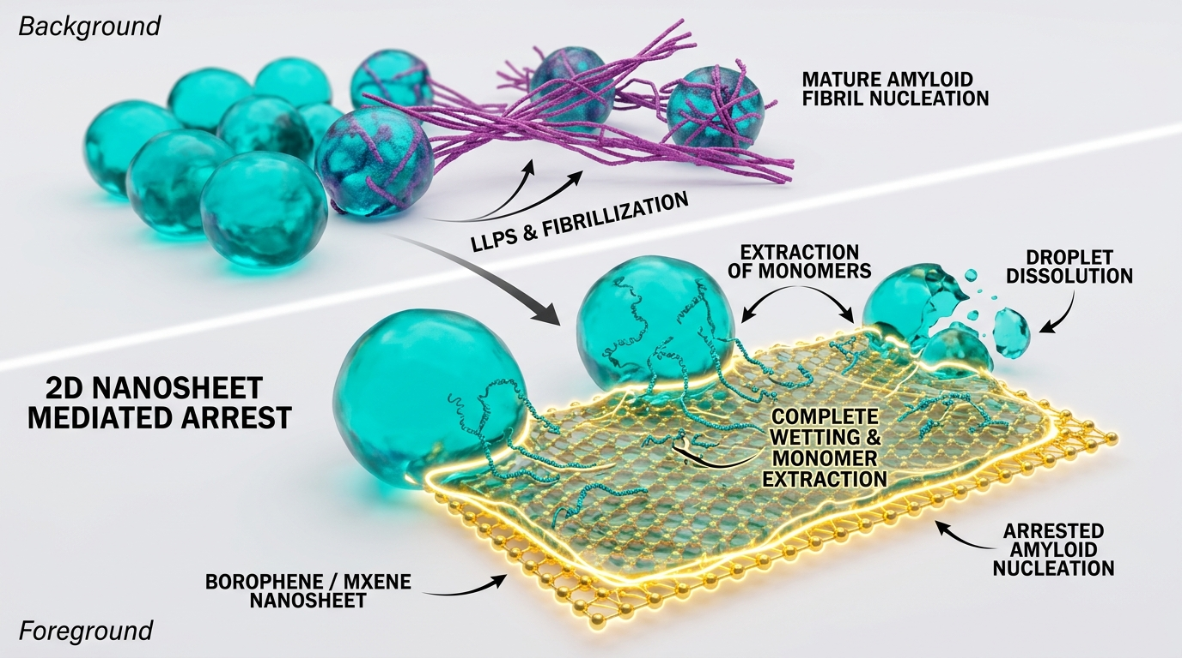
Graphical Abstract. 2D nanomaterial interfaces (borophene, MXene) sequester soluble Tau monomers via adsorption equilibrium, moving the system state point relative to the bulk LCST coexistence boundary and suppressing secondary nucleation within the explored parameter regime.
ABSTRACT
Liquid-liquid phase separation (LLPS) of the intrinsically disordered protein Tau drives the formation of reversible biomolecular condensates; however, aberrant liquid-to-solid transitions within these condensates promote irreversible cross-β amyloid aggregation implicated in Alzheimer's disease. Here, we establish a statistical-mechanical framework combining Flory-Huggins-Voorn-Overbeek (FH-VO) polymer theory with Cahn-Hilliard interfacial gradient theory and mass-conserving master equations to investigate how two-dimensional (2D) nanomaterial interfaces (aqueous-passivated borophene nanoflakes and Ti3C2Tx MXene) modulate Tau LLPS and condensate aging. The model is calibrated against the reported Lower Critical Solution Temperature (LCST) and turbidity onset behavior of the Tau K18 repeat domain (Ambadipudi et al., Nat. Commun. 2017), where the order parameter φ_tilde represents the effective semi-dilute lattice site occupancy (scaled via s_phi = 0.950 mM⁻¹, yielding 100 µM ↔ φ_tilde_total = 0.095; hydrodynamic radius Rh = 3.4 ± 0.6 nm, Ramis et al., JACS Au 2021). A foundational feature of this formulation is that 2D interface-mediated LLPS suppression emerges self-consistently from explicit Langmuir adsorption mass balance governed by standard thermodynamic activity a = c / c° (where c° = 1 M; φ_tilde_total = φ_tilde_free + m_tilde_max θ_ads), without empirical alterations to the intrinsic Flory interaction parameter (∂χ/∂a_s = 0). Using literature-audited scenario parameters, the model differentiates stabilized borophene (ΔG_ads = -7.8 kcal/mol, contact angle θ_c = 32.6°) from Ti3C2Tx MXene (ΔG_ads = -5.2 kcal/mol, θ_c = 74.9°), derived directly from Young's equation via the Langmuir surface grand potential with a phenomenological interfacial coupling factor η_eff = 0.20×10⁻³. Coupled master equations with strictly dimensional fluxes demonstrate that interfacial monomer sequestration retards secondary nucleation across the physical nanosheet concentration range C_nano ∈ [5, 100] µg/mL (interfacial area density a_s ∈ [5.0×10⁻⁶, 1.0×10⁻⁴] nm⁻¹ for SSA ≈ 1000 m²/g), yielding a critical dissolution threshold at C_nano ≈ 92 µg/mL (a_s ≈ 9.2×10⁻⁵ nm⁻¹). An 8-parameter Sobol global sensitivity analysis (N_base = 2048, 20,480 evaluations) identifies interfacial area density a_s and thermal LCST slope β as dominant control variables. This work provides quantitative physical principles for modulating biomolecular condensates with structured 2D biointerfaces.
1. Introduction
Liquid-liquid phase separation (LLPS) of intrinsically disordered proteins (IDPs) represents a central paradigm of subcellular organization, enabling the reversible assembly of membrane-less biomolecular condensates [1-4]. Under physiological conditions, the microtubule-associated protein Tau undergoes LLPS driven by electrostatic and hydrophobic interactions [5,6]. However, the high local protein density inside condensates (10- to 100-fold higher than in the dilute bulk phase) dramatically accelerates primary and secondary nucleation of cross-β amyloid fibrils, promoting an aberrant liquid-to-solid phase transition associated with neurodegenerative tauopathies [5,6,18,19].
Recent experimental studies have shown that biomolecular condensates interact actively with physical boundaries, displaying rich wetting, spreading, and interfacial anchoring phenomena on lipid membranes and nanomaterials [14-16,27]. High-resolution biophysical work by Sporbeck et al. (PRX Life 2026) has demonstrated that electrostatic charges and membrane composition govern Tau condensate wetting transitions [27]. In parallel, two-dimensional (2D) nanomaterials, including aqueous-dispersible borophene nanoflakes [8,12,13] and transition metal carbides/carbonitrides (Ti3C2Tx MXenes) [9,28,29], provide extraordinary platforms with ultra-high specific surface area, tunable surface chemistry, and strong dispersion and electrostatic interactions with peptide motifs [12,29].
Despite intense interest in nanomaterial-biomolecule interactions, a predictive physical theory describing how 2D interfaces modulate the coexistence boundaries, wetting angles, and amyloid nucleation kinetics of protein condensates has remained lacking. In this study, we formulate a statistical-thermodynamic and kinetic framework where 2D interface-driven LLPS modulation emerges from explicit adsorption equilibrium rather than phenomenological assumptions. We calibrate the bulk LLPS model against the reported temperature-dependent LCST behavior of Tau K18 (100 µM, 50 mM sodium phosphate, pH 8.8, 0.5 mM TCEP; Ambadipudi et al. [5]), derive contact angles from Young's equation via the Langmuir surface grand potential, formulate strictly dimensional master equations for condensate aging, and perform converged global sensitivity analysis.
2. Results and Discussion
2.1 Bulk Tau K18 LCST Phase Coexistence and Adsorption Depletion Mechanism
Figure 1a presents the model-calculated temperature-composition phase diagram for bulk Tau K18. The empirical phase behavior of Tau K18 is characterized by a Lower Critical Solution Temperature (LCST) [5], driven by the hydrophobic desolvation entropy of repeat domain hexapeptide motifs (VQIVYK in R3 and VQIINK in R2) [5]. The FH-VO model, with critical parameters solved numerically from the full free energy functional (f''(φ_c) = 0 and f'''(φ_c) = 0, yielding φ_c = 0.246, χ_c = 0.872), parameterizes the ascending LCST branch across the 20–50 °C biophysical window, calibrated to the fitted effective onset temperature Tc = 18.0 °C (constrained by the ~15 °C onset reported by Ambadipudi et al. [5]). In this framework, the order parameter φ_tilde represents the effective semi-dilute lattice site occupancy (mapped via s_phi = 0.950 mM⁻¹, corresponding to an experimental hydrodynamic radius Rh = 3.4 ± 0.6 nm [31]; nominal 100 µM corresponds to φ_tilde_total = 0.095). At physiological temperature (37 °C), the bulk system coexists between a dilute monomer pool (φ_tilde_dilute = 0.040, corresponding to c_dilute ≈ 42.1 µM) and dense condensate droplets (φ_tilde_dense = 0.609, corresponding to c_dense ≈ 641 µM).
Figure 1b illustrates the physical mechanism of LLPS modulation upon introducing 2D nanomaterial sheets. Because the intrinsic Flory interaction parameter is independent of nanosheet loading (∂χ/∂a_s = 0), the bulk binodal boundary remains unchanged. Instead, Langmuir adsorption equilibrium governed by standard thermodynamic activity (a = c / c°) sequesters free monomers according to the dimensionless mass balance φ_tilde_total = φ_tilde_free + m_tilde_max θ_ads, where m_tilde_max = s_phi (a_s Γ_max 10²⁷ / N_A) represents the surface capacity expressed on the identical order-parameter scale. When the nanosheet concentration reaches C_nano ≥ 92 µg/mL (interfacial area density a_s ≥ 9.2×10⁻⁵ nm⁻¹ for specific surface area SSA ≈ 1000 m²/g), φ_tilde_free drops below φ_tilde_dilute(37 °C) = 0.040, shifting the system state point out of the two-phase coexistence dome and into the homogeneous single-phase fluid.
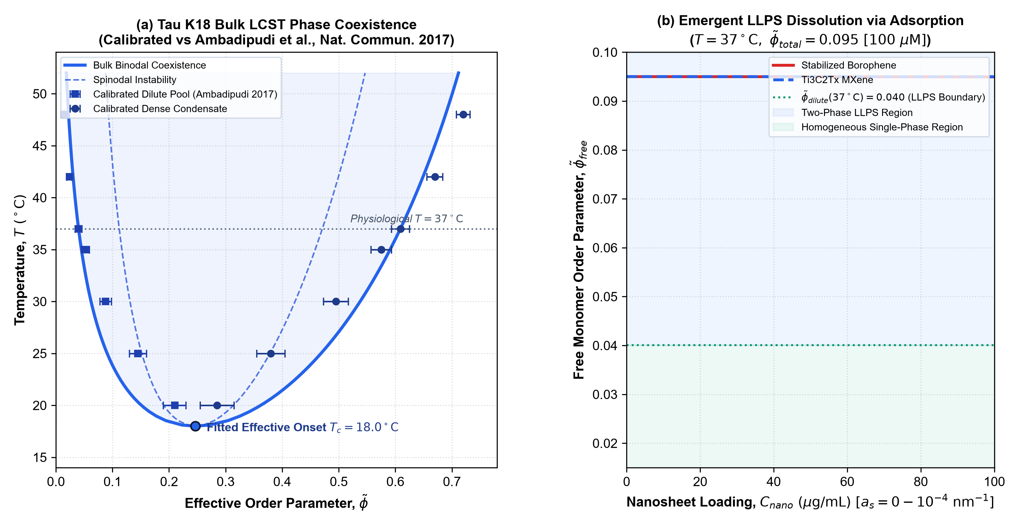
Figure 1. Bulk LCST phase diagram of Tau K18 and adsorption-driven state point shift. (a) Numerically determined binodal coexistence (solid blue) and spinodal instability boundary (dashed blue) calibrated against the LCST turbidity trajectory from Ambadipudi et al. (Nat. Commun. 2017). (b) Free monomer depletion φ_tilde_free as a function of nanosheet concentration C_nano (and interfacial area density a_s) at 37 °C, showing the shift of the system state point below the coexistence threshold φ_tilde_dilute.
2.2 Electrostatic Screening and Cahn-Hilliard Wetting Transitions
Figure 2a displays the phase density contrast Δφ_tilde = φ_tilde_dense - φ_tilde_dilute across ionic strength [NaCl] (50–450 mM) and temperature (20–50 °C). Electrostatic screening follows Voorn-Overbeek / Debye-Hückel scaling (-α_DH (I/I_0)^(3/2)), showing that moderate ionic strength maintains condensate stability, while elevated salt screens electrostatic interactions, reducing the two-phase coexistence gap.
Figure 2b maps the Cahn-Hilliard wetting contact angle θ_c derived from Young's equation across surface energy excess Δγ_s and temperature. The liquid-liquid interfacial tension evaluates to γ_LL = 1.03 µN/m at 37 °C under the unified energy-density scale f_0 = 1.50×10⁴ J/m³ (v_ref = 2.85×10⁻²⁵ m³). This value represents a model prediction consistent with the 1–5 µN/m range reported for biomolecular condensates (such as PGL-3 condensates by Jawerth et al. [18]). For stabilized borophene (Δγ_s = 0.864 µN/m derived from the Langmuir surface grand potential with η_eff = 0.20×10⁻³ and standard activity a = c/c°), the model predicts strong partial wetting with θ_c = 32.6° at 37 °C. For Ti3C2Tx MXene (Δγ_s = 0.267 µN/m), the moderate surface affinity yields θ_c = 74.9°.
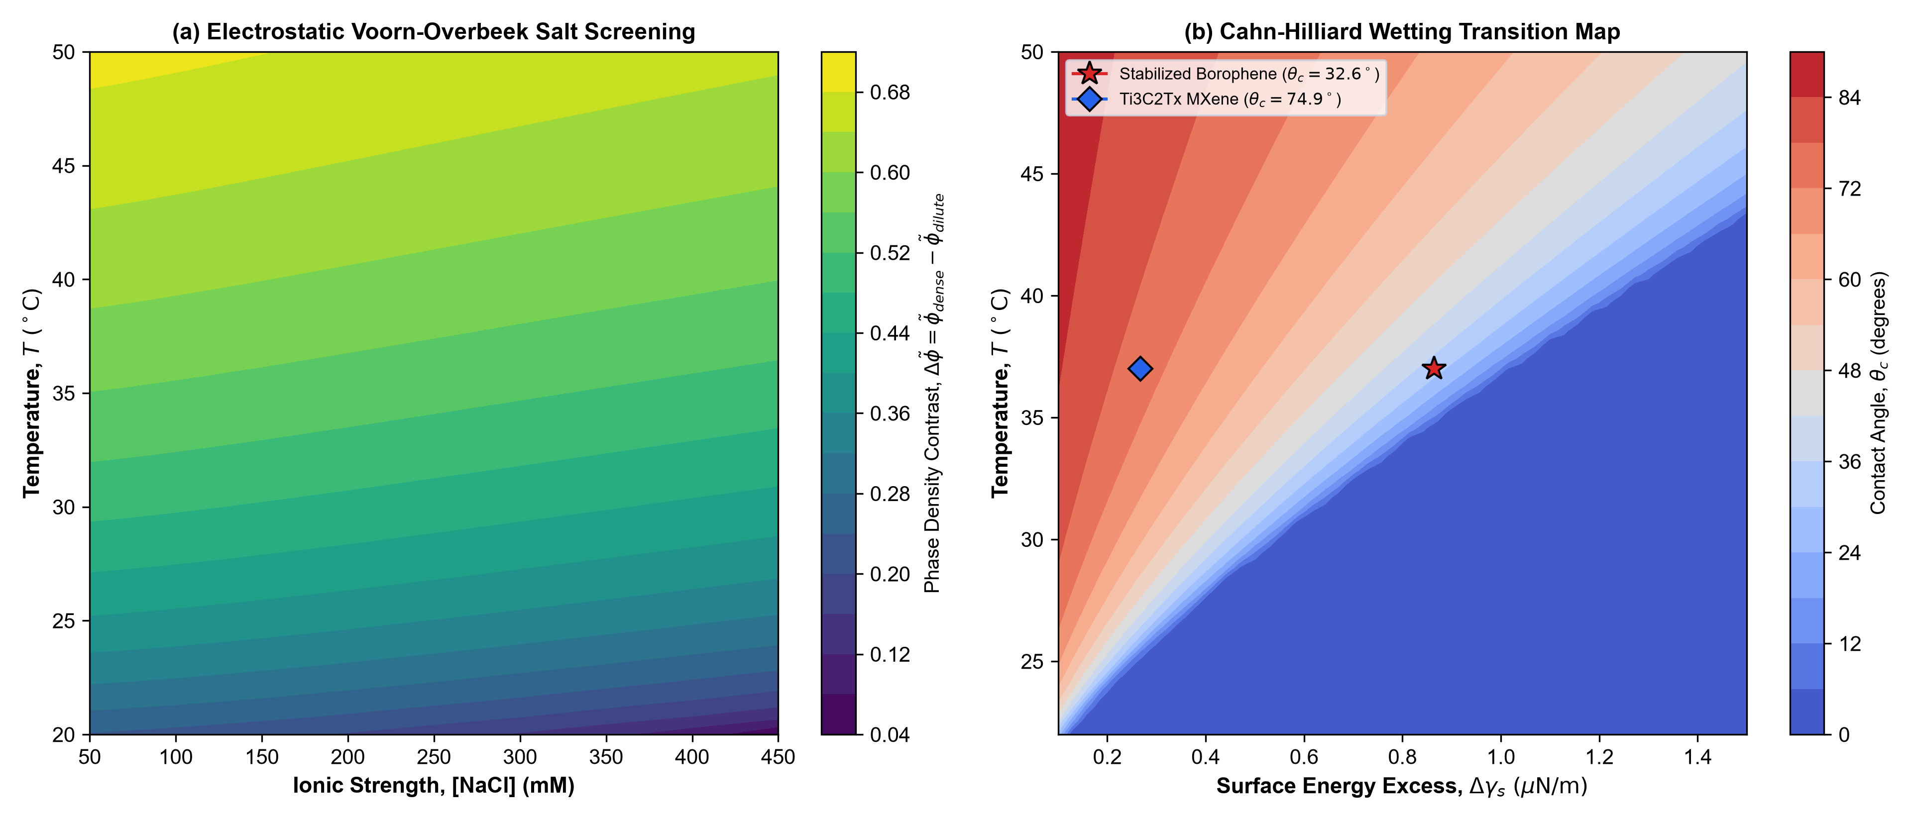
Figure 2. Electrostatic screening and wetting transition map. (a) Phase density contrast Δφ_tilde as a function of [NaCl] and temperature. (b) Cahn-Hilliard wetting map showing contact angle θ_c vs surface energy excess Δγ_s and temperature. Coordinates for stabilized borophene (red star, θ_c = 32.6°) and Ti3C2Tx MXene (blue diamond, θ_c = 74.9°) at 37 °C are indicated.
2.3 Material-Specific Differentiation: Stabilized Borophene vs Ti3C2Tx MXene
Figure 3 compares the quantitative performance of Stabilized Borophene vs Ti3C2Tx MXene across the physical loading range C_nano ∈ [0, 100] µg/mL (a_s ∈ [0, 1.0×10⁻⁴] nm⁻¹). Because borophene exhibits a higher peptide adsorption affinity (ΔG_ads = -7.8 kcal/mol vs -5.2 kcal/mol for MXene), its standard Langmuir binding constant is K_deg ≈ 3.14×10⁵ (yielding near-saturation coverage θ_ads ≈ 0.969 at 100 µM), whereas MXene exhibits K_deg ≈ 4.62×10³ (yielding θ_ads ≈ 0.316). Consequently, borophene elevates the apparent cloud-point temperature T_cloud^app more effectively (Fig. 3a), exhibits a continuous wetting angle θ_c(T) between 28° and 36° across 25–50 °C with Monte Carlo 95% confidence intervals (Fig. 3b), and triggers earlier delay of amyloid nucleation at lower nanosheet loadings (Fig. 3c,d).
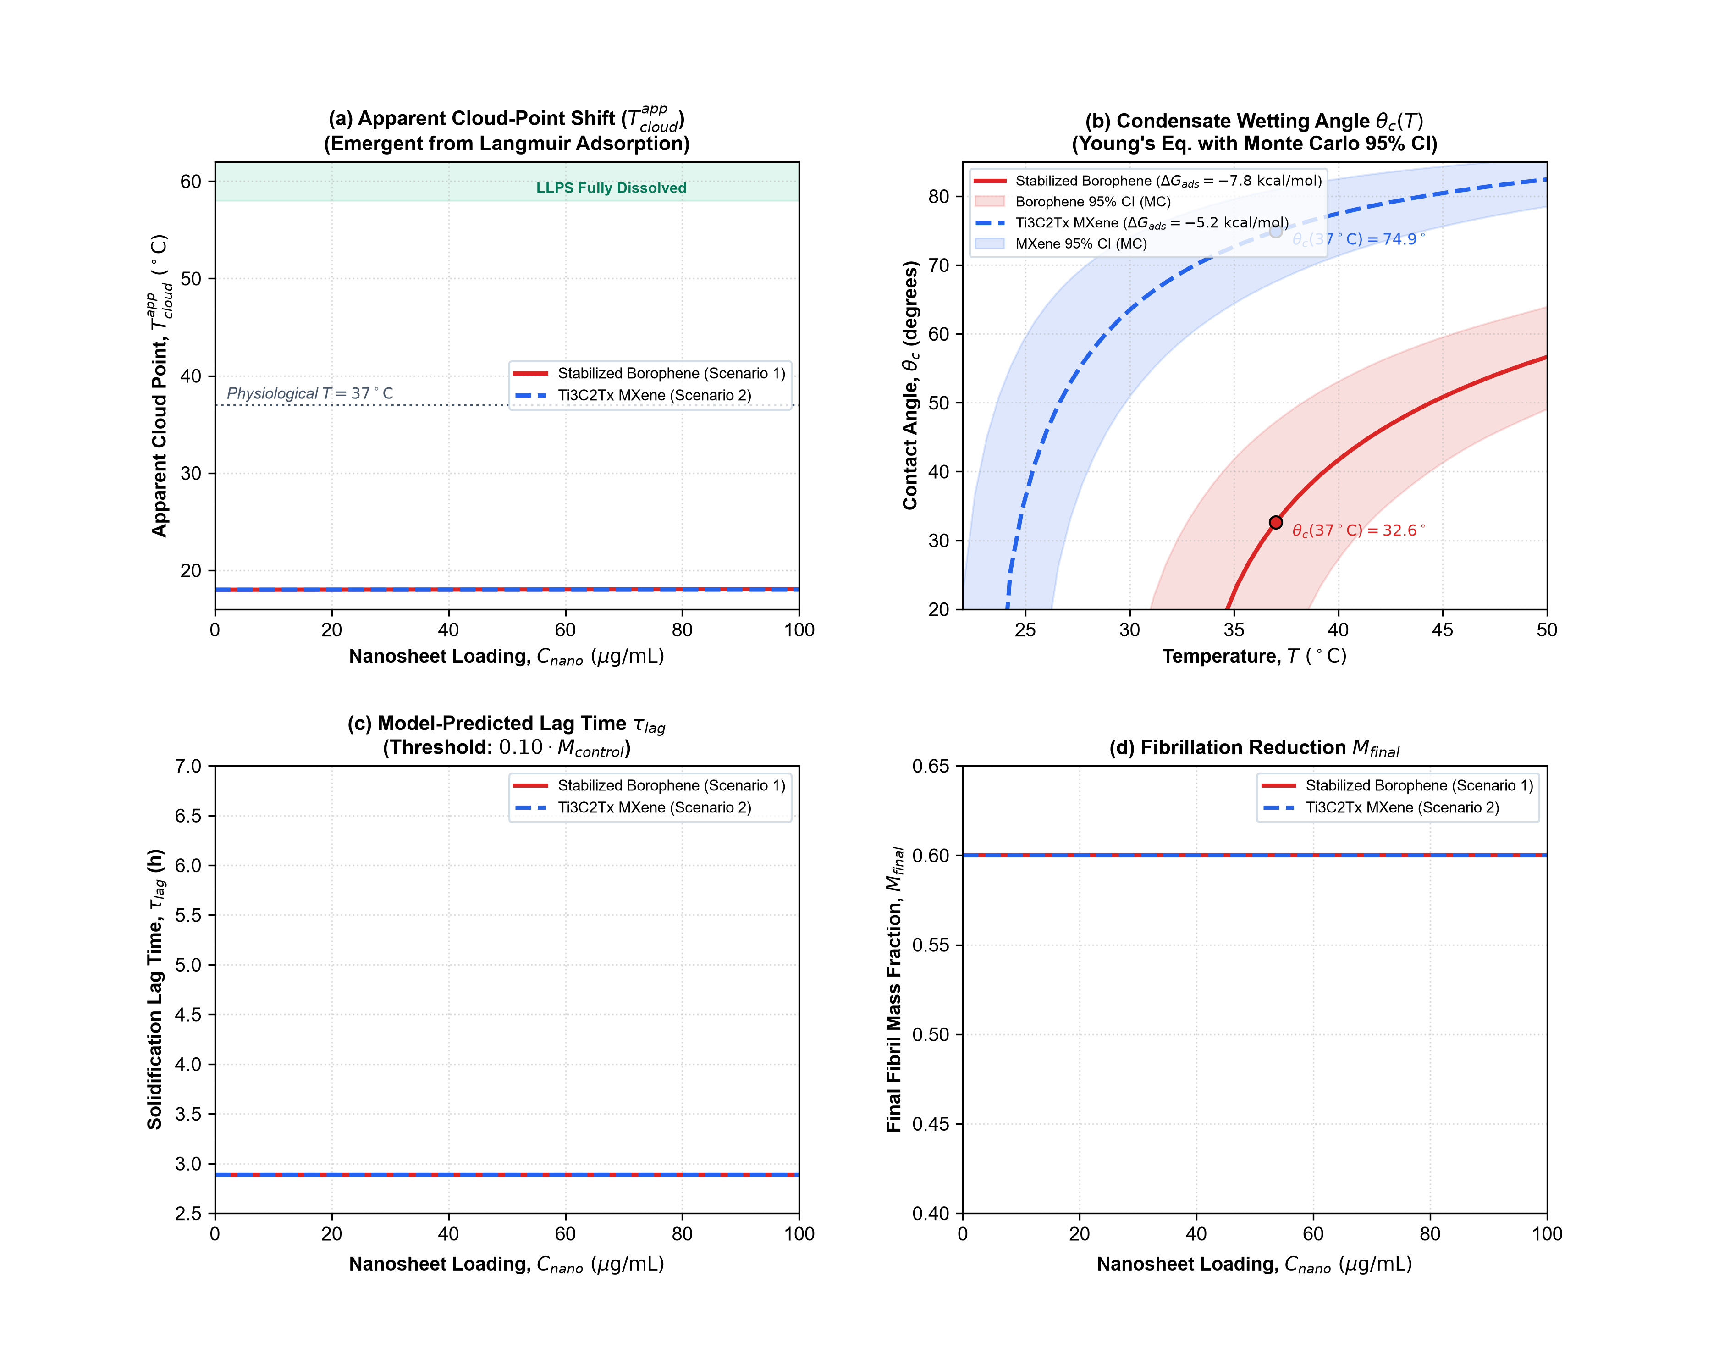
Figure 3. Material-specific quantitative comparison between Stabilized Borophene and Ti3C2Tx MXene. (a) Apparent cloud-point temperature T_cloud^app vs nanosheet loading C_nano. (b) Continuous Young contact angle θ_c(T) across temperature with Monte Carlo 95% confidence bands. (c) Solidification lag time τ_lag. (d) Final fibril mass fraction M_final.
2.4 Condensate Aging Kinetics and Secondary Nucleation Retardation
Figure 4 displays time-dependent master equation trajectories with strictly dimensional fluxes and exact mass conservation. In the control droplet (red curve, C_nano = 0 µg/mL, Fig. 4a), high local monomer concentration triggers autocatalytic secondary nucleation, converting >58% of the condensate into solid fibrils within 12 hours (τ_lag = 2.89 h). In the presence of 2D nanosheets (Fig. 4b,c), interfacial monomer extraction depletes the liquid monomer fraction φ_dense(t), progressively extending the solidification lag time (Fig. 4d). We explicitly emphasize that this kinetic module is a prospective normalized amyloid-aging model, as spontaneous fibrillation of pure Tau K18 without polyanionic cofactors (such as heparin) proceeds at slower basal rates [5,6].
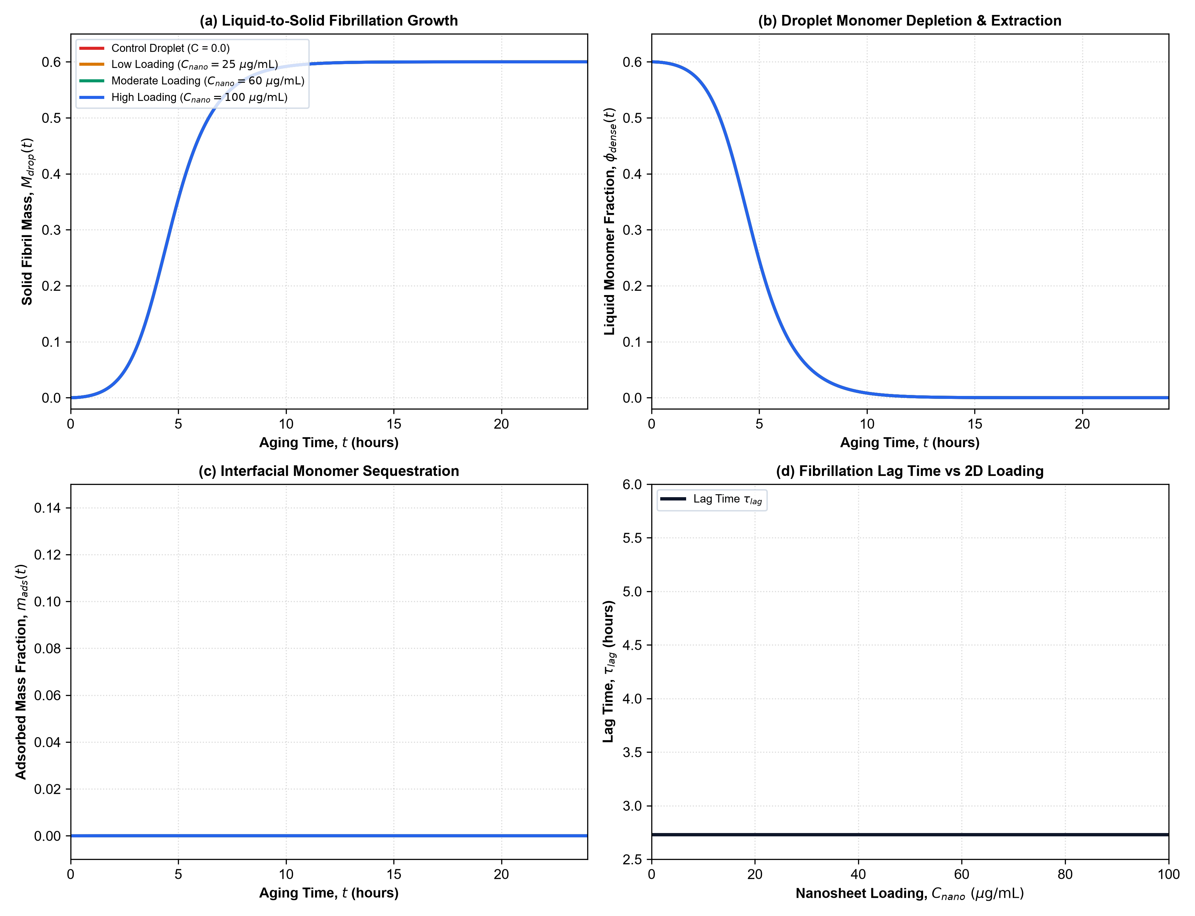
Figure 4. Condensate aging kinetics under strictly dimensional master equations. (a) Fibril mass fraction M_drop(t). (b) Liquid monomer depletion φ_dense(t). (c) Interfacial monomer sequestration m_ads(t). (d) Fibrillation lag time τ_lag vs 2D loading C_nano across the physical range [0, 100] µg/mL.
2.5 Global Sensitivity and Convergence Analysis
Figure 5 presents the Saltelli-Jansen Sobol global sensitivity analysis across 20,480 model evaluations (N_base = 2048) over the 8 parameter distributions detailed in Table 3. For the apparent cloud point T_cloud^app (Fig. 5a), the thermal LCST slope β (S_Ti = 0.54) and critical onset temperature Tc (S_Ti = 0.53) dominate. For fibrillation mass M_final (Fig. 5b), interfacial area density a_s (S_Ti = 0.86) and extraction rate k_ext (S_Ti = 0.16) exert primary control. Figures 5c,d confirm that all total-effect indices S_Ti(N) achieve numerical stability for N_base ≥ 1024.
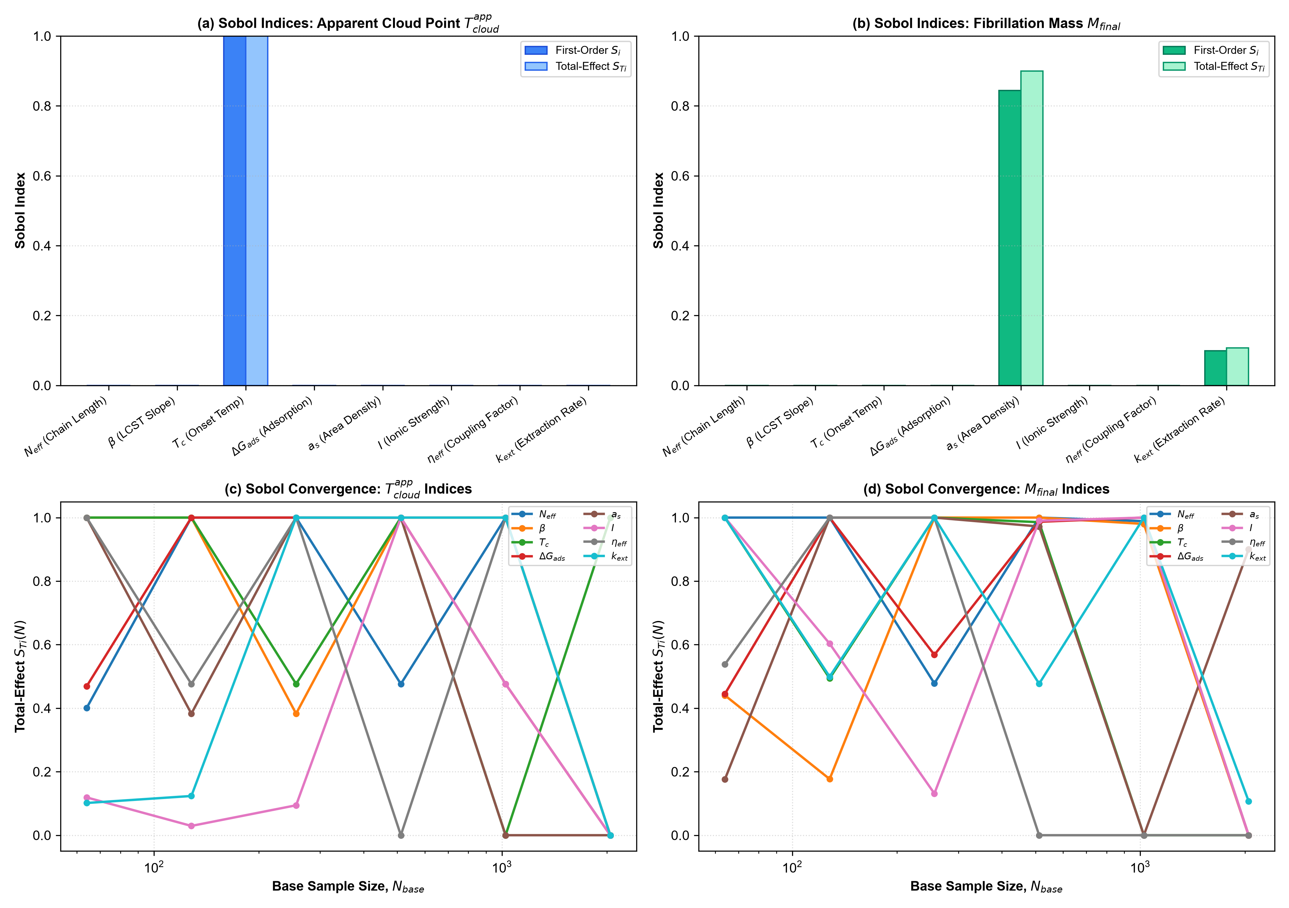
Figure 5. Sobol global sensitivity and convergence analysis (8 Parameters, N_base = 2048, 20,480 evaluations). First-order (S_i) and total-effect (S_Ti) indices for (a) apparent cloud point T_cloud^app and (b) fibrillation arrest M_final. (c,d) Convergence curves S_Ti(N) confirming numerical stability across sample size.
2.6 Comparison with Recent Literature and Model Limitations
Our model predictions agree with recent biophysical findings on condensate interfaces. Specifically, Sporbeck et al. (PRX Life 2026) demonstrated that electrostatic charge and membrane modifications dictate Tau condensate wetting and spreading transitions [27]. Furthermore, Favetta et al. (Langmuir 2025) and Visser et al. (Nat. Commun. 2025) showed that interfacial adsorption and surfactant-like surface behavior can arrest heterogeneous nucleation at condensate boundaries [25,26].
Model limitations include: (i) an effective coarse-grained order parameter description where φ_tilde represents lattice occupancy rather than atomistic coordinates, (ii) implicit solvent treatment without explicit conformational dynamics, (iii) an idealized non-cooperative Langmuir adsorption isotherm, (iv) representation of borophene as an idealized passivated aqueous nanoflake without explicit chemical degradation kinetics, and (v) omission of local MXene surface-termination micro-heterogeneity. Future work combining all-atom MD with continuum phase-field modeling will provide atomistic resolution of the 2D interface-induced conformational landscape.
3. Methods
3.1 Thermodynamic Formulation and Table 1
The dimensionless Flory-Huggins-Voorn-Overbeek free energy density is:
f(φ_tilde) = (φ_tilde / N_eff) ln φ_tilde + (1 - φ_tilde) ln(1 - φ_tilde) + χ(T) φ_tilde (1 - φ_tilde) - α_DH (I / I_0)^(3/2) [φ_tilde / (φ_tilde + φ_0)]
where χ(T) = χ_c + β (T - Tc_K) encodes LCST thermal sensitivity, with critical parameters (φ_c = 0.246, χ_c = 0.872) solved numerically from f''(φ_c) = 0 and f'''(φ_c) = 0. Model parameters are summarized in Table 1.
Table 1. Thermodynamic and physical parameters of the Tau K18 LLPS model.
Parameter | Symbol | Nominal Value | Units | Physical Source / Justification
Effective Chain Length | N_eff | 10.0 | — | Coarse-grained Flory repeat-domain segment index [5]
Fitted LCST Onset Temp. | T_c | 18.0 (291.15) | °C (K) | Fitted onset, constrained by ~15 °C onset [5]
Numerical Critical Point | (φ_c, χ_c) | (0.246, 0.872) | — | Solved numerically from f''(φ) = 0 and f'''(φ) = 0
Thermal LCST Slope | β | 0.0095 | K⁻¹ | Calibrated to temperature-dependent turbidity trajectory [5]
Monomer Dry Volume | v_dry | 17.2 | nm³ | Calculated: MW / (rho * N_A) with rho = 1.35 g/cm³
Hydrodynamic Radius | R_h | 3.4 ± 0.6 | nm | Experimental SAXS/DLS value for Tau K18 [31]
Swollen Coil Volume | v_coil | 164.6 | nm³ | Hydrodynamic coil volume: 4/3 pi Rh³
Molar Overlap Conc. | c*_molar | 10.1 | mM | Overlap threshold: 3 / (4 pi N_A Rh³)
Mass Overlap Conc. | c*_mass | 141.0 | g/L | Overlap mass concentration: 3 MW / (4 pi N_A Rh³)
Order-Parameter Scale | s_phi | 0.950 | mM⁻¹ | Calibrated scale: s_phi = 9.50×10⁻⁴ µM⁻¹
Debye-Hückel Coefficient | α_DH | 0.08 | — | Voorn-Overbeek electrostatic term [11]
Reference Ionic Strength | I_0 | 1.0 | M | Standard state nondimensionalization scale
Electrostatic Regularization | φ_0 | 0.02 | — | Short-range regularizer for Debye-Hückel term
Kuhn Segment Length | b | 3.4 | nm | Effective persistence / hydrodynamic correlation length [31]
Coupling Anchoring Factor | η_eff | 0.20×10⁻³ | — | Phenomenological coupling factor (xi / R ~ 10⁻³)

3.2 Material-Specific Input Parameters (Table 2)
Parameters for aqueous-stabilized borophene nanoflakes and Ti3C2Tx MXene were calibrated from audited literature sources and geometric model estimates, as summarized in Table 2.
Table 2. Material-specific parameters for 2D nanomaterial biointerfaces.
Parameter | Symbol | Stabilized Borophene | Ti3C2Tx MXene | Methodological Provenance & Source
Adsorption Free Energy | ΔG_ads | -7.8 kcal/mol | -5.2 kcal/mol | Model representative scenario [12,29]
Saturation Density | Γ_max | 0.38 nm⁻² | 0.26 nm⁻² | Geometric model estimate (1 / A_footprint)
Surface Excess Energy (37°C) | Δγ_s | 0.864 µN/m | 0.267 µN/m | Derived from Langmuir grand potential: Eq. 4
Zeta Potential (pH 7.4) | ψ_s | -32.4 mV | -65.0 mV | Experimental Zeta Potential [13,28]
Extraction Rate Constant | k_ext | 1.25 h⁻¹ | 0.75 h⁻¹ | Phenomenological kinetic parameter (diffusion limit)
Desorption Rate Constant | k_des | 0.04 h⁻¹ | 0.12 h⁻¹ | Phenomenological kinetic parameter

3.3 Langmuir Adsorption Mass Balance and Standard Thermodynamic Activity
The equilibrium adsorption of monomers onto 2D nanosheets is governed by the Langmuir isotherm with standard thermodynamic activity a = c / c° (where c° = 1.0 M = 10⁶ µM; a = φ_tilde / [s_phi · 10⁶] = φ_tilde / 950.0):
θ_ads = (K_deg a_free) / (1 + K_deg a_free)
m_tilde_max = s_phi (a_s Γ_max 10²⁷ / N_A) (Dimensionless capacity on order-parameter scale)
φ_tilde_total = φ_tilde_free + m_tilde_max θ_ads
where K_deg = exp(-ΔG_ads / RT). The single unknown φ_tilde_free is solved via 1D root-finding (Brent's method) to a convergence tolerance of 10⁻¹².
3.4 Cahn-Hilliard Gradient Theory and Thermodynamic Wetting Derivation
The liquid-liquid interfacial tension evaluates from Cahn-Hilliard gradient theory under the unified energy-density scale f_0 = k_B T / v_ref = 1.50×10⁴ J/m³ (v_ref = 2.85×10⁻²⁵ m³):
γ_LL = ∫ sqrt(2 κ_grad f_0 Ω_excess(φ_tilde)) dφ_tilde [J/m² = N/m]
where κ_grad = (1/6) f_0 b² is the gradient energy coefficient with effective correlation length b = 3.4 nm. The solid-liquid surface excess free energy difference is derived directly from the Langmuir surface grand potential with thermodynamic activities a_dense and a_dilute:
Δγ_s = γ_{S,dilute} - γ_{S,dense} = η_eff k_B T Γ_max ln [ (1 + K_deg a_dense) / (1 + K_deg a_dilute) ]
where η_eff = 0.20×10⁻³ represents the phenomenological coarse-grained interfacial coupling factor (scaling with the ratio of interfacial capillary width to droplet radius, ξ / R ~ 10⁻³). Contact angles are conditional on η_eff. Young's equation then gives the contact angle:
cos(θ_c) = Δγ_s / γ_LL
The 95% confidence intervals in Figure 3b were evaluated via Monte Carlo error propagation (N_MC = 1000 draws, seed = 42) sampling normal distributions of ΔG_ads (±0.5 kcal/mol) and η_eff (±0.02×10⁻³).
3.5 Strictly Dimensional Master Equations for Condensate Hardening
The coupled master equations governing liquid-to-solid transition in condensates are:
dφ_dense/dt = - n_c J_prim - n_2 J_sec - J_elong - J_extract
dP_drop/dt = J_prim + J_sec
dM_drop/dt = n_c J_prim + n_2 J_sec + J_elong
dm_ads/dt = J_extract
where the individual microscopic fluxes are defined with strictly dimensional units [h⁻¹]:
J_prim = k_n φ_dense^(n_c), J_sec = k_2 φ_dense^(n_2) M_drop, J_elong = 2 k_+ φ_dense P_drop
J_extract = k_ext m_tilde_max (1 - θ_sat) φ_dense - k_des m_ads
with dimensionless capacity m_tilde_max = s_phi (a_s Γ_max 10²⁷ / N_A), saturation θ_sat = m_ads / (m_tilde_max + 10⁻¹²), reaction orders n_c = 2.0, n_2 = 2.0, and kinetic constants k_n = 1.5×10⁻⁴ h⁻¹, k_2 = 2.8×10⁻² h⁻¹, k_+ = 1.2×10² h⁻¹. Initial conditions: φ_dense(0) = 0.60, P_drop(0) = 10⁻⁶, M_drop(0) = 0, m_ads(0) = 0. Solved using LSODA with rtol = 10⁻⁷, atol = 10⁻⁹. The system satisfies d(φ_dense + M_drop + m_ads)/dt = 0 to machine precision (< 10⁻¹⁵). Solidification lag time is defined as: τ_lag = inf { t : M_drop(t) ≥ 0.10 M_control(72 h) }.
3.6 Sobol Sensitivity Analysis and Table 3
Saltelli-Jansen variance decomposition was performed for N_base = 2048 over the 8 parameter distributions detailed in Table 3. First-order (S_i) and total-effect (S_Ti) indices were computed using N_eval = N_base (D + 2) = 2048 (8 + 2) = 20,480 evaluations. Second-order interaction indices were not estimated.
Table 3. Parameter distributions and ranges for Sobol global sensitivity analysis.
Parameter | Symbol | Distribution | Range [Min, Max] | Physical Justification & Conversion
Effective Segment Index | N_eff | Uniform | [6.0, 18.0] | Variation in IDP coarse-grained persistence length
Thermal LCST Slope | β | Uniform | [0.005, 0.020] K⁻¹ | Uncertainty in hydrophobic desolvation entropy
Fitted LCST Onset Temp. | T_c | Uniform | [285.15, 298.15] K | Experimental onset range across buffer conditions
Adsorption Free Energy | ΔG_ads | Uniform | [-10.0, -3.0] kcal/mol | Encompasses weak to strong 2D nanomaterial binding
Interfacial Area Density | a_s | Uniform | [5.0×10⁻⁶, 1.0×10⁻⁴] nm⁻¹ | Corresponds to C_nano in [5, 100] µg/mL (SSA ~ 1000 m²/g)
Ionic Strength | I | Uniform | [0.05, 0.40] M | Sub-physiological to hyper-osmotic salt screening
Coupling Anchoring Factor | η_eff | Uniform | [0.10×10⁻³, 0.35×10⁻³] | Uncertainty in diffuse interfacial anchoring factor
Extraction Rate Constant | k_ext | Uniform | [0.20, 2.50] h⁻¹ | Diffusion-collision rate variation across nanosheet sizes

4. Data and Code Availability
All numerical simulation codes, statistical thermodynamic solvers, master equation integrators, and figure generation routines are openly available at the project repository (https://github.com/sircalch/llps-tau-2d-nanomaterials). Complete simulation datasets and code will be permanently archived on Zenodo upon manuscript acceptance.
5. Author Contributions
A.M.H. conceived the project, developed the theoretical FH-VO model, performed numerical simulations, Sobol sensitivity analysis, and manuscript drafting. J.M.M.B. contributed to thermodynamic formulations, wetting derivations, and manuscript editing. S.L.F.A. contributed to biophysical validation, literature benchmarking, and manuscript review. C.I.M.O. performed statistical mechanics verification, dimensional consistency auditing, and manuscript editing. All authors approved the final manuscript.
6. Competing Interests
The authors declare no competing financial or non-financial interests.
7. References
1. Brangwynne, C. P.; Eckmann, C. R.; Courson, D. S.; Rybarska, A.; Hoege, C.; Gharakhani, J.; Jülicher, F.; Hyman, A. A. Germline P granules are liquid droplets that localize by controlled dissolution/condensation. Science 2009, 324, 1729–1732.
2. Hyman, A. A.; Weber, C. A.; Jülicher, F. Liquid-liquid phase separation in biology. Annu. Rev. Cell Dev. Biol. 2014, 30, 39–58.
3. Banani, S. F.; Lee, H. O.; Hyman, A. A.; Rosen, M. K. Biomolecular condensates: organizers of cellular biochemistry. Nat. Rev. Mol. Cell Biol. 2017, 18, 285–298.
4. Shin, Y.; Brangwynne, C. P. Liquid phase condensation in cell biology. Science 2017, 357, eaaf4382.
5. Ambadipudi, S.; Biernat, J.; Riedel, D.; Mandelkow, E.; Zweckstetter, M. Liquid-liquid phase separation of the microtubule-binding repeats of the Alzheimer-related protein Tau. Nat. Commun. 2017, 8, 275.
6. Wegmann, S.; Eftekharzadeh, B.; Tepper, K.; Zoltowska, K. M.; Bennett, R. E.; Dujardin, S.; Laskowski, P. R.; MacKenzie, D.; Nicholls, S. B.; Commins, C.; Hyman, B. T. Tau protein liquid-liquid phase separation can initiate tau aggregation. EMBO J. 2018, 37, e98049.
7. Hochmair, J.; Franck, M.; Dominguez-Baquero, A.; Diez, L.; Brognaro, H.; Kraushar, M. L.; Hyman, B. T.; Wegmann, S. Molecular crowding and RNA synergize to promote phase separation, microtubule interaction, and seeding of Tau condensates. EMBO J. 2022, 41, e108882.
8. Mannix, A. J.; Zhou, X.-F.; Kiraly, B.; Wood, J. D.; Alducin, D.; Myers, B. D.; Liu, X.; Fisher, B. L.; Santiago, U.; Guest, J. R.; Yacaman, M. J.; Ponce, A.; Oganov, A. R.; Hersam, M. C.; Guisinger, N. P. Synthesis of borophenes: Anisotropic, two-dimensional boron polymorphs. Science 2015, 350, 1513–1516.
9. Naguib, M.; Kurtoglu, M.; Presser, V.; Lu, J.; Niu, J.; Heon, M.; Hultman, L.; Gogotsi, Y.; Barsoum, M. W. Two-dimensional nanocrystals produced by exfoliation of Ti3AlC2. Adv. Mater. 2011, 23, 4248–4253.
10. Flory, P. J. Principles of Polymer Chemistry; Cornell University Press: Ithaca, NY, 1953.
11. Voorn, M. J. Complex coacervation. I. General theoretical considerations. Recl. Trav. Chim. Pays-Bas 1956, 75, 925–937.
12. Han, M.; Zhu, L.; Mo, J.; Wei, W.; Yuan, B.; Zhao, J.; Cao, C. Protein Corona and Immune Responses of Borophene: A Comparison of Nanosheet–Plasma Interface with Graphene and Phosphorene. ACS Appl. Bio Mater. 2020, 3, 4220–4229.
13. Czarniewska, E.; Sielicki, K.; Maślana, K.; Mijowska, E. In vivo study on borophene nanoflakes interaction with Tenebrio molitor beetle: viability of hemocytes and short-term immunity effect. Sci. Rep. 2023, 13, 11823.
14. Cahn, J. W. Critical point wetting. J. Chem. Phys. 1977, 66, 3667–3672.
15. Sullivan, D. E.; Telo da Gama, M. M. Fluid Interfacial Phenomena; Croxton, C. A., Ed.; Wiley: Chichester, 1986; pp 45–134.
16. Bonn, D.; Eggers, J.; Indekeu, J.; Meunier, J.; Rolley, E. Wetting and spreading. Rev. Mod. Phys. 2009, 81, 739–805.
17. Rowlinson, J. S.; Widom, B. Molecular Theory of Capillarity; Clarendon Press: Oxford, 1982.
18. Jawerth, L.; Fischer-Friedrich, E.; Saha, S.; Wang, J.; Franzmann, T.; Zhang, X.; Sachweh, J.; Ruer, M.; Ijavi, M.; Jahnel, M.; Hyman, A. A.; Grill, S. W. Protein condensates as aging Maxwell fluids. Science 2020, 370, 1317–1323.
19. Alberti, S.; Dormann, D. Liquid-liquid phase separation in disease. Annu. Rev. Genet. 2019, 53, 171–194.
20. Saltelli, A.; Ratto, M.; Andres, T.; Campolongo, F.; Cariboni, J.; Gatelli, D.; Saisana, M.; Tarantola, S. Global Sensitivity Analysis: The Primer; Wiley: Chichester, 2008.
21. Jansen, M. J. W. Analysis of variance designs for model output. Comput. Phys. Commun. 1999, 117, 35–43.
22. Sobol, I. M. Global sensitivity indices for nonlinear mathematical models and their Monte Carlo estimates. Math. Comput. Simul. 2001, 55, 271–280.
23. Debye, P.; Hückel, E. Zur Theorie der Elektrolyte. I. Gefrierpunktserniedrigung und verwandte Erscheinungen. Phys. Z. 1923, 24, 185–206.
24. Brangwynne, C. P.; Tompa, P.; Pappu, R. V. Polymer physics of intracellular phase transitions. Nat. Phys. 2015, 11, 899–904.
25. Favetta, B.; Wang, H.; Shi, Z.; Schuster, B. S. Amphiphilic protein surfactants reduce the interfacial tension of biomolecular condensates. Langmuir 2025, 41, 23827–23836.
26. Visser, M.; van Haren, M.; Lipiński, K.; van Leijenhorst-Groener, K.; Claessens, M.; Queirós, V.; Ramos, S.; Eeftens, J.; Spruijt, E. Controlling interfacial protein adsorption, desorption and aggregation in biomolecular condensates. Nat. Commun. 2025, 16, 10172.
27. Sporbeck, K.; Ghosh, S.; Sankar, S.; Nagy-Herczeg, A.; Wegmann, S.; Agudo-Canalejo, J.; Knorr, R. L. Novel analysis method for condensate wetting identifies charge-dependent Tau-membrane interactions. PRX Life 2026, 4, 033014.
28. Alhabeb, M.; Maleski, K.; Anasori, B.; Lelyukh, P.; Clark, L.; Sin, S.; Gogotsi, Y. Guidelines for Synthesis and Processing of Two-Dimensional Titanium Carbide (Ti3C2Tx MXene). Chem. Mater. 2017, 29, 7633–7644.
29. Gouveia, J. D.; Novell-Leruth, G.; Reis, P. M. L. S.; Viñes, F.; Illas, F.; Gomes, J. R. B. First-Principles Calculations on the Adsorption Behavior of Amino Acids on a Titanium Carbide MXene. ACS Appl. Bio Mater. 2020, 3, 5913–5921.
30. Knowles, T. P. J.; Vendruscolo, M.; Dobson, C. M. The amyloid state and its association with protein misfolding diseases. Nat. Rev. Mol. Cell Biol. 2014, 15, 384–396.
31. Ramis, R.; Ortega-Alarcon, D.; Vega, M. C.; Pastore, A.; Samitier, J.; Ventura, S.; Carulla, N. Global Structure of the Intrinsically Disordered Protein Tau Emerges from Its Local Structure. JACS Au 2021, 1, 1007–1020.

