Don't Fool Yourself When Screening 2D-Nanomaterial Drug Carriers: A Reproducible GFN2-xTB + Docking + Leak-Free QSAR Pipeline, Four Disease Case Studies, and a Cautionary Tale
Andrés Monreal Hernández1,*, Sara Lizbeth Franco Amaya2, and Carlos Ivanhoe Martínez Osorio3
1 Universidad Estatal de Sonora, Ley Federal del Trabajo S/N, Col. Apolo, C.P. 83100, Hermosillo, Sonora, Mexico.
2 Doctorado en Nanotecnología, Universidad de Sonora, Hermosillo, Sonora, Mexico.
3 Doctorado en Ciencia de Materiales, Universidad de Sonora, Hermosillo, Sonora, Mexico.
*Corresponding Author: andres.monreal@ues.mx | ORCID: 0009-0009-1207-8597

Abstract
Computational screening of two-dimensional (2D) nanomaterials as drug-delivery scaffolds is cheap enough to run for any disease target — a GFN2-xTB adsorption calculation and an AutoDock Vina docking run together take hours on a workstation — which has produced a large and fast-growing literature. Much of it, however, rests on protocols that quietly break: regression targets fabricated from empirical descriptor formulas rather than measured or computed energies, cross-validation schemes that leak test-set information into preprocessing, and adsorption geometries built by placing a drug above a sheet without ever relaxing the resulting complex. We built a single reproducible pipeline — GFN2-xTB geometry optimization, docking against the disease target's experimental structure, and a leak-free nested cross-validated QSPR surrogate with Y-scrambling — and applied it, unchanged, to four unrelated disease systems: KRAS-G12D/pancreatic cancer on graphitic carbon nitride, glioblastoma on Ti3C2Tx MXene, triple-negative breast cancer on a B36N36 nanocage, and Alzheimer's Tau on β12 borophene. Under this protocol, one carrier, MXene, shows only modest, non-predictive physisorption (Q²_CV ≈ 0.10), an honest but unglamorous result. Two others, the B36N36 nanocage and β12 borophene, turn out to be more complex than a single physisorption picture suggests. Each hides a small chemisorbing subpopulation — 5 of 33 TNBC-directed drugs, 12 of 29 Tau-directed drugs — behind a larger, non-predictive physisorbing majority. The field's common practice of a single, unrelaxed point calculation would have hidden that distinction entirely in both cases, and did, in our own first pass at the borophene system: we reported an inert-looking physisorption energy for what is actually a chemically reactive surface for a third of its ligands. The fourth carrier, boron/phosphorus-doped graphitic carbon nitride, is the exception in the opposite sense: instead of a hidden chemisorption story, it is a hidden predictive-model story. Despite comparably modest interaction energies and no detected chemisorption, its adsorption-energy QSPR is genuinely predictive (Q²_CV = 0.51-0.58) — evidence that the leak-free protocol itself is not simply too conservative to detect a real signal when one is present. We use the borophene case, corrected, as a worked example of what a relaxed-geometry, leak-free screen changes, and distill the broader lesson into a short checklist for computational drug-carrier screening.
Keywords: 2D Nanomaterials; Drug Delivery; QSAR/QSPR Validation; GFN2-xTB; Molecular Docking; Reproducibility; Data Leakage.

1. Introduction — The Problem
Two-dimensional nanomaterials — graphitic carbon nitride (g-C3N4) [17], MXenes [18], boron nitride nanostructures [19], and borophene [20,21] among them — are widely proposed as drug-delivery scaffolds, and the computational screening literature evaluating them is large and growing quickly. The appeal is obvious: a GFN2-xTB adsorption calculation and an AutoDock Vina docking run together take hours, not months, so a single group can screen dozens of candidate drugs against a candidate carrier before any wet-lab work begins. That speed is also the risk. We have found, in the course of building four such screens for unrelated disease systems, that a small number of protocol failures recur often enough to be worth naming explicitly, because each one is easy to introduce without noticing and each one can silently invert the paper's conclusion.
1. Fabricated regression targets. A ΔG_bind or ΔE_ads reported as if it were a quantum-mechanical result is sometimes, on inspection, an empirical linear formula over RDKit descriptors — internally consistent, but not a physical energy.
2. Data leakage. Feature scaling or feature selection fit on the whole dataset before cross-validation inflates the reported Q² in a way that does not reproduce on genuinely new compounds; the effect can be large enough to turn a non-predictive model into an apparently excellent one, a failure mode long flagged in the QSAR best-practices literature [11,12,14].
3. Unrelaxed adsorption geometries. A drug is “placed” some fixed distance above the carrier and a single-point energy is reported as the adsorption energy, with the complex never geometry-optimized. If the placement protocol references the wrong point on a buckled or finite cluster, the drug can end up several Ångström away from the surface it is nominally adsorbing onto.
4. Un-run benchmarks. A “DFT validation” table is presented with no accompanying output files, and the numbers cannot be independently reproduced from the stated method.
5. Cohort and bibliography drift. The descriptor set, the docking cohort, and the reference list circulate between related studies from the same group, occasionally picking up a mismatch — a different protein target, a different compound count — that a careful re-derivation would have caught.
None of these failures require bad faith; each is a plausible shortcut under time pressure, and each is exactly the kind of thing that peer review, without access to the underlying code and raw outputs, cannot reliably catch. This Perspective describes one pipeline that avoids all five, applied without modification to four disease systems that share no biology, no carrier chemistry, and no descriptor set — and documents, in the fourth case, exactly what broke when we did not yet have this discipline in place.

2. The Reproducible Screening Pipeline
For every (drug, 2D-carrier) pair evaluated in this work, the following nine-step protocol is applied without case-by-case exceptions. The pipeline, not any single result, is the paper's central contribution.
1. Structures. The drug is built from its SMILES string (RDKit [7] ETKDG conformer generation + MMFF minimization) and then geometry-optimized with GFN2-xTB (xtb, including its D4 dispersion correction) [1-4]. The 2D carrier is modeled as an explicit, hydrogen-terminated finite cluster and separately optimized the same way.
2. Adsorption geometry. The drug is placed 3.2 Å above the local sheet surface directly beneath it — never above the global z-extremum of a buckled or edge-terminated finite cluster, a distinction that matters more than it sounds (§4) — in four in-plane orientations (0°, 90°, 180°, 270°), and every resulting complex is geometry-optimized, not merely evaluated at a single point. The lowest-energy converged pose whose closest heavy-atom contact falls between 1.25 and 4.0 Å is retained.
3. Two interaction-energy conventions, reported separately. ΔE_int,SP = E(complex) − E(carrier) − E(drug), with both fragments frozen at the complex geometry, isolates the electronic interaction; ΔE_ads, with both fragments relaxed to their isolated-molecule minima, additionally captures the conformational strain paid on binding. A closest contact below 1.9 Å is classified as chemisorption (a new covalent bond has formed); anything looser is physisorption.
4. Charge-density difference. For the strongest-adsorbing complex in each system, GFN2-xTB electron densities of the complex, the isolated carrier, and the isolated drug are evaluated on one shared grid (Multiwfn [15]) and combined into Δρ = ρ(complex) − ρ(carrier) − ρ(drug); the resulting isosurface is rendered in ChimeraX [16] to visualize the electronic reorganization on binding directly, rather than inferring it from energetics alone.
5. Docking. AutoDock Vina [5,6] is run against the disease target's experimental structure (a PDB entry chosen for resolution and relevance to the binding site of interest), with the docking protocol's own pose-recovery fidelity established by redocking the native co-crystallized ligand. Where that redocking does not reproduce the native pose within a few tenths of an Ångström, the docking scores are reported explicitly as a relative ranking of surface or cleft affinity, never as a quantitative binding free energy.
6. Descriptors. Conceptual-DFT global reactivity indices [8] — chemical hardness η, softness S, electronegativity χ, chemical potential μ, and electrophilicity ω — are read directly from the same GFN2-xTB frontier-orbital output used for the adsorption calculation; none is estimated from an empirical formula fit to the descriptor set itself.
7. Surrogate model. A StandardScaler + RidgeCV regression (scikit-learn [9]) is trained inside a nested 5×5 cross-validation: an outer 5-fold split produces out-of-fold predictions for every compound, while the scaler and the ridge regularization strength are fit exclusively on each outer-training split via an inner 5-fold search, so no test-fold information leaks into preprocessing or hyperparameter selection. Predictive performance is reported as the pooled out-of-fold Q²_CV, together with a 1000-permutation Y-scrambling test [10] and its empirical p-value.
8. Applicability domain. Compliance with OECD Principle 3 [11-13] is assessed via Williams hat-matrix leverage, flagging compounds whose descriptor vector falls outside the model's training-data envelope.
9. Reproducibility. For each disease system, a single script (run_entire_<system>_study.py) regenerates every number and figure in the corresponding manuscript directly from the raw drug and carrier inputs, and the complete code, curated dataset, and computational outputs are archived on Zenodo alongside the public GitHub repository.
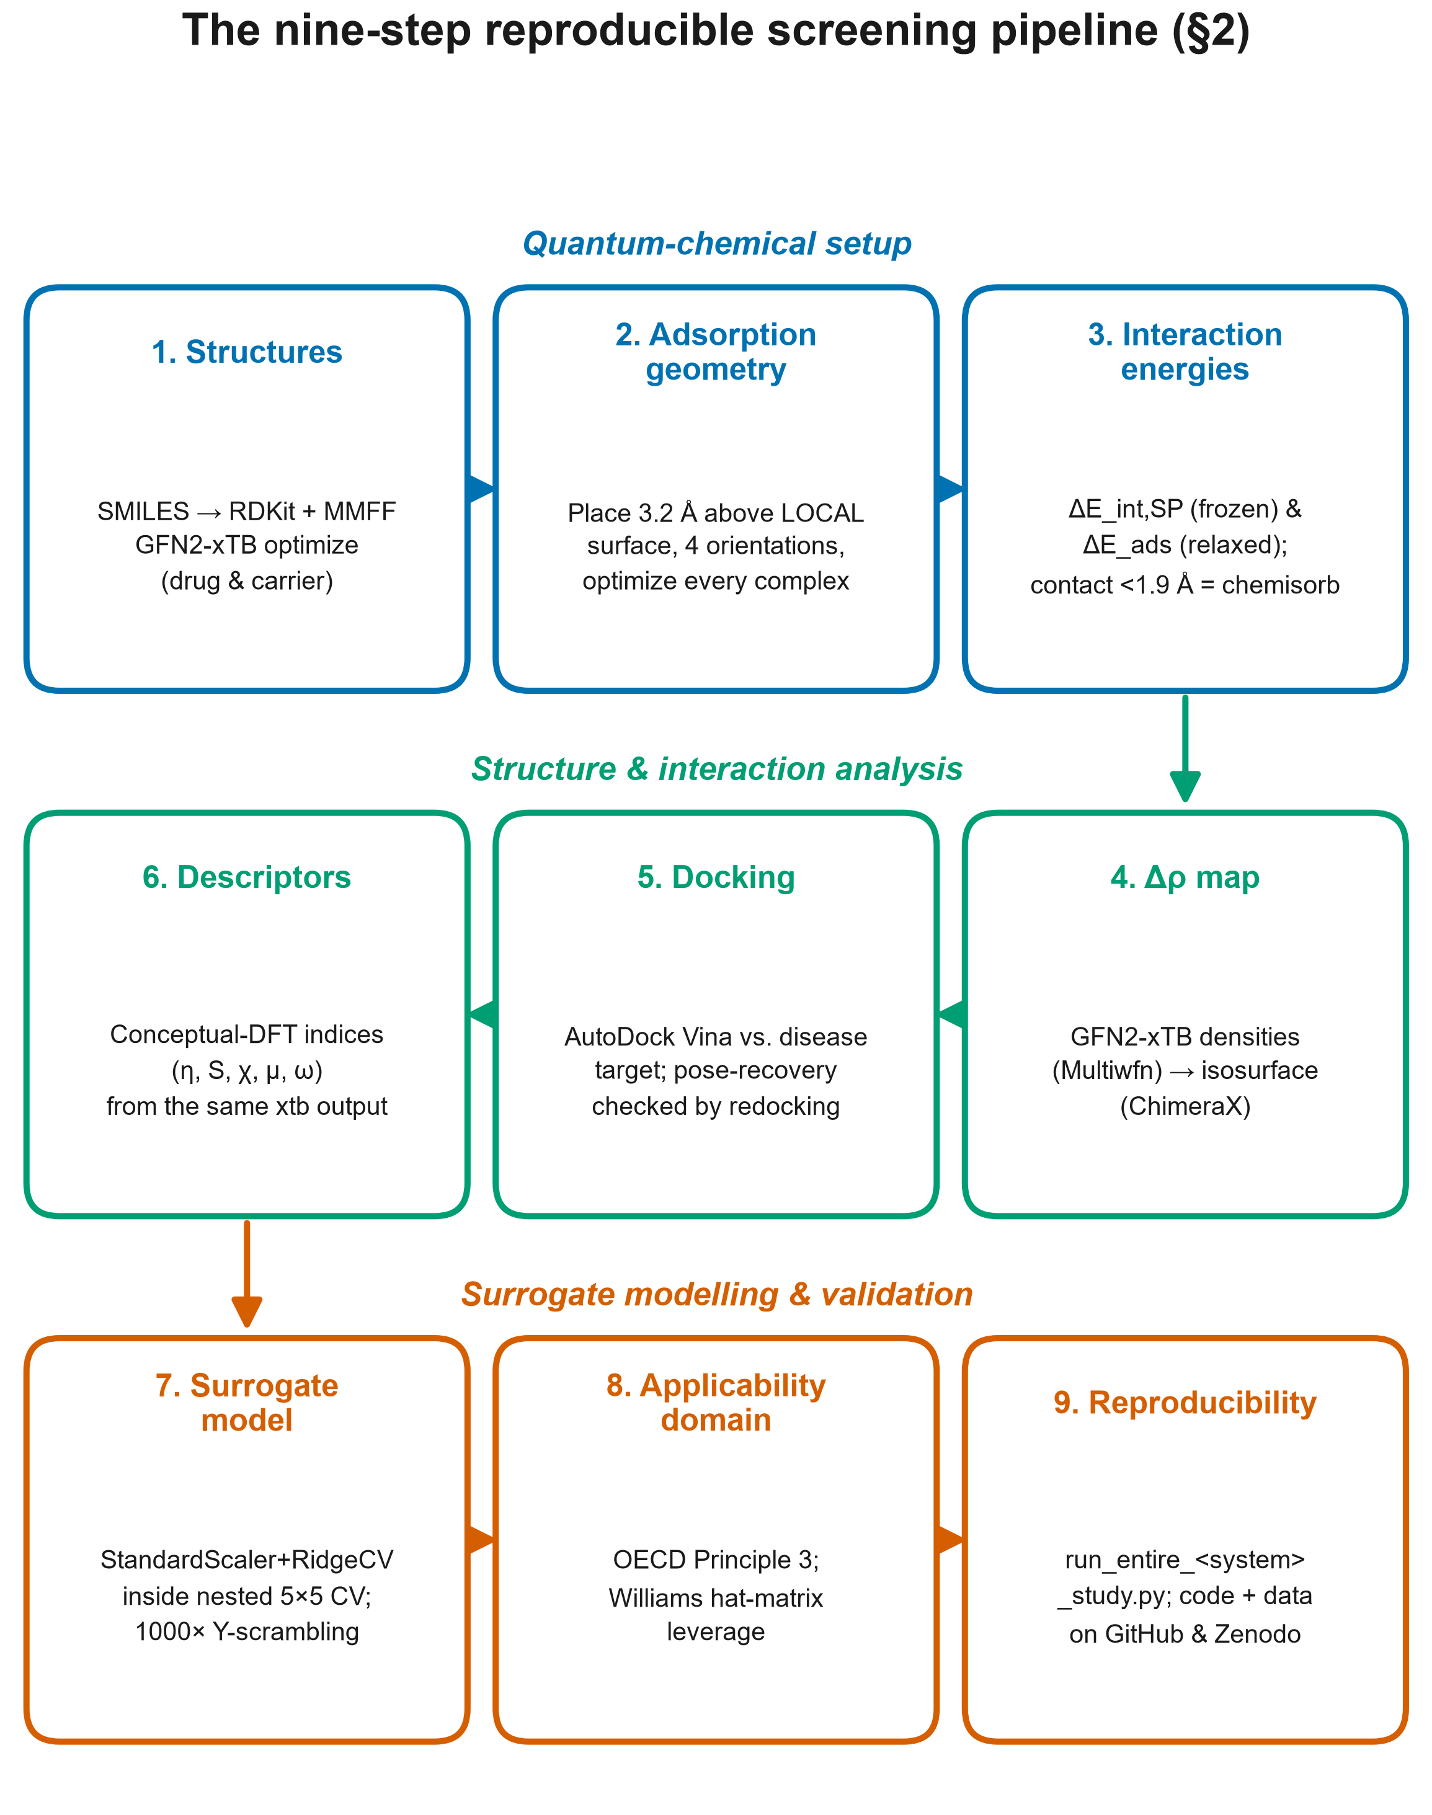
Figure 1: The nine-step reproducible screening pipeline described in this section, applied identically to all four disease/carrier systems.

3. Four Case Studies
The pipeline above was applied, without modification to a single step, to four disease systems that share no target biology, no carrier chemistry, and no descriptor set: oncogenic KRAS-G12D in pancreatic ductal adenocarcinoma screened against boron/phosphorus-doped graphitic carbon nitride; glioblastoma against Ti3C2Tx MXene; triple-negative breast cancer against a B36N36 boron nitride nanocage; and Alzheimer's Tau paired-helical-filament aggregation against β12 borophene. Table 1 summarizes the outcome.
System | Carrier | n | ΔE_int,SP range (kcal/mol) | Regime | Physisorption QSPR Q²_CV
KRAS-G12D / PDAC | g-C3N4 (B,P-doped) | 38 | -39.9 … -5.0 | physisorption, doping-tuned | 0.51–0.55 (per-carrier models)
Glioblastoma | Ti3C2O2 MXene | 35 | -15.5 … -0.9 | physisorption | 0.10
Triple-negative breast | B36N36 nanocage | 30 | -185.9 … -6.3 | mixed: 5 chemisorb / 25 physisorb | ≈0.00 (n=25 physisorbers)
Alzheimer's Tau | β12 borophene | 29 | -232.5 … -8.1 | mixed: 12 chemisorb / 17 physisorb | 0.06 (n=17 physisorbers)
Table 1: Cross-system summary of the four disease/carrier pairs screened with the identical pipeline. n is the number of drug-carrier complexes successfully modelled at the GFN2-xTB level for that system; Q²_CV values are pooled out-of-fold coefficients of determination from the leak-free nested surrogate described in §2. Full per-system detail, docking statistics, and Y-scrambling controls are archived with each system's own dataset and code [22-25].
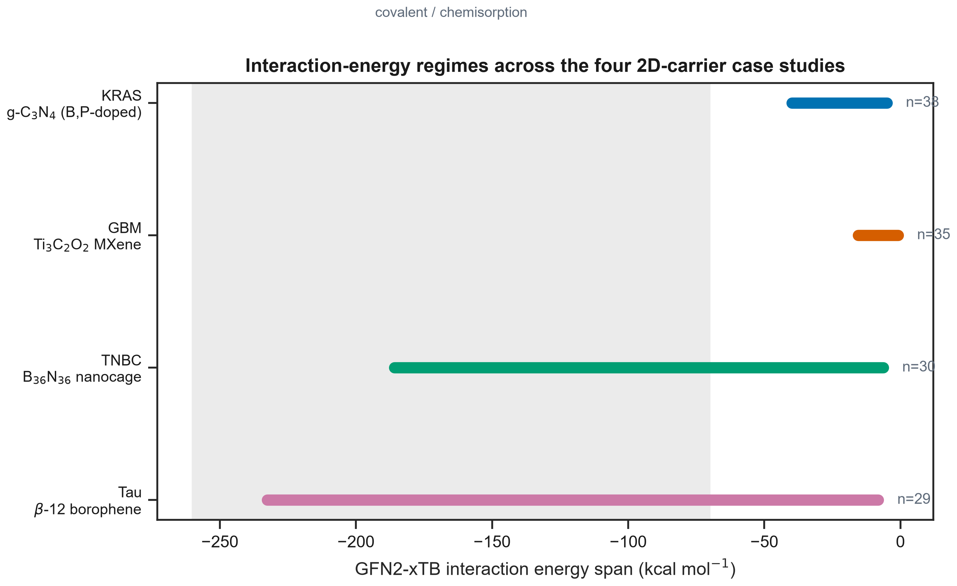
Figure 2: Interaction-energy regimes across the four disease/carrier systems. Each horizontal bar spans the real, per-system minimum-to-maximum GFN2-xTB interaction energy across all successfully modelled complexes (n labelled per system); the shaded band marks the covalent/chemisorption range. The x-axis covers a wide span to accommodate the TNBC and Tau chemisorbing subpopulations alongside the narrower physisorption-only bands of KRAS and MXene.
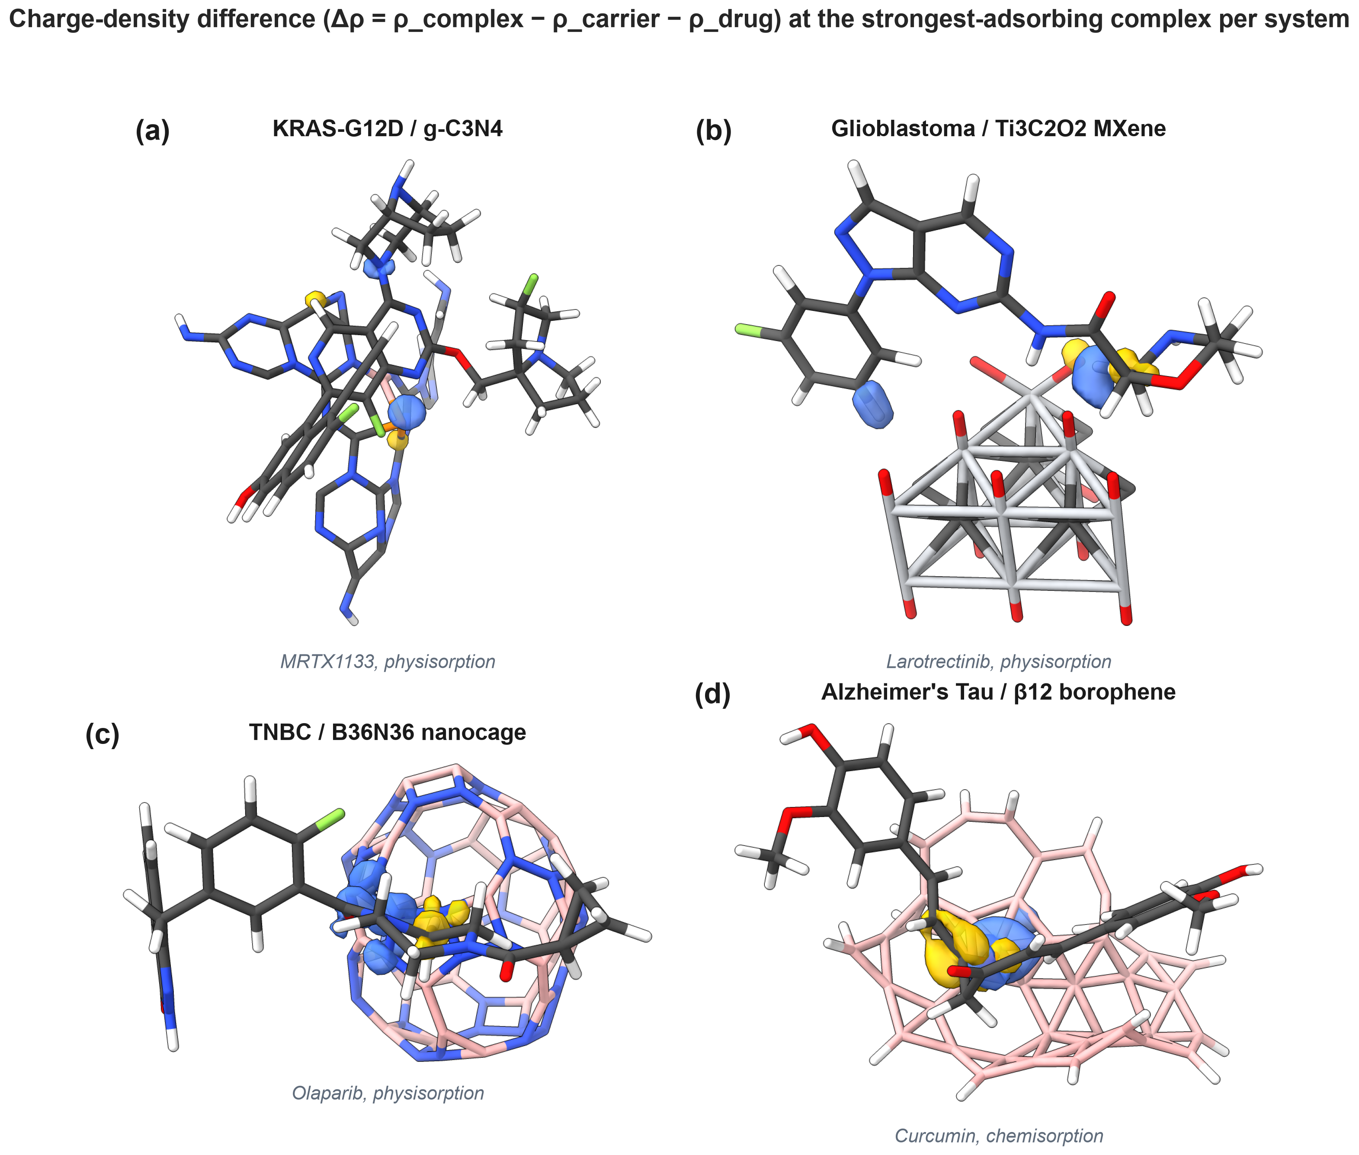
Figure 3: Charge-density difference (Δρ = ρ_complex − ρ_carrier − ρ_drug) at the strongest-adsorbing complex per system, real GFN2-xTB densities in every panel. Yellow/blue lobes mark electron accumulation/depletion on complex formation.
MXene is the cleanest case of the more common story: no bare, pristine carrier gives a descriptor-based QSPR model of the adsorption energy that predicts meaningfully better than the training-set mean (Q²_CV ≈ 0.10). This is not a failure of the modelling: it is the honest signal that, for a physisorption-dominated interaction with these four descriptors, the adsorption energy is not well predicted by molecular weight, molar refractivity, and frontier-orbital indices alone. Reporting a high Q² under these conditions would itself be a red flag for leakage. The scientific value of the screen, in this case, is the mechanistic picture the pipeline still delivers honestly — the interaction-energy regime and the charge-redistribution pattern — not a predictive surrogate model.
TNBC and Tau complicate this picture in the same qualitative way, at different scale. Neither carrier is purely physisorptive once every complex is actually geometry-optimized and its closest contact checked. Five of the 33 TNBC-directed drugs — SN-38, epirubicin, topotecan, lapatinib, and rucaparib — chemisorb onto the B36N36 nanocage through a new covalent B-O or B-N bond (1.37-1.72 Å, ΔE_int,SP = -43 to -186 kcal/mol). That is exactly the same qualitative pattern that dominates the borophene/Tau system at larger scale (12 of 29 ligands, §4): a reactive minority hidden inside an otherwise unremarkable physisorption-dominated cohort. The descriptor-based QSPR remains non-predictive for the physisorbing majority in both cases (TNBC: Q²_CV ≈ 0.00, n=25; Tau: Q²_CV = 0.06, n=17), so here too the chemisorption/physisorption split itself, not a regression model, is the finding worth reporting. That the same qualitative pattern shows up independently in two chemically unrelated carrier/ligand systems is, if anything, a reason to check for it by default, rather than to assume a screened 2D carrier is purely physisorptive without verifying the relaxed contact distance.
KRAS-G12D on boron/phosphorus-doped g-C3N4 is the instructive exception, in the opposite sense from TNBC and Tau: instead of a hidden chemisorption story, it is a hidden predictive-model story. Its interaction energies sit in the same modest range as MXene, and we did not detect chemisorption for this carrier, yet the identical StandardScaler + RidgeCV surrogate reaches Q²_CV = 0.51-0.58 across the pristine and doped carriers — a genuinely predictive model by the same 1000-permutation Y-scrambling standard applied to every other system here. We read this less as a claim that g-C3N4 is somehow special and more as a control on the pipeline itself: the same leak-free nested cross-validation that returns Q²_CV ≈ 0 for MXene and the TNBC/Tau physisorbing majorities is demonstrably capable of returning a high, permutation-validated Q² when the underlying descriptor-property relationship actually supports one. A validation scheme that always reports near-zero performance regardless of the input would be as suspect as one that always reports an excellent fit.
Of the two chemisorbing systems, β12 borophene against the Tau paired-helical-filament cohort is the more dramatic case (a larger reactive fraction, and the one we ourselves first got wrong), and is the subject of the next section.

4. The Cautionary Tale — Tau / Borophene
Our own first pass at the Tau/borophene system made exactly the unrelaxed-geometry error named as failure mode 3 in §1, and is instructive precisely because it was not an obviously bad calculation — the numbers were internally consistent, the code ran end to end, and the result looked like a plausible, unremarkable physisorption screen.
The original protocol placed each drug 3.2 Å above the z-maximum atom of the finite, buckled B40H15 borophene cluster — a natural-looking reference point for “above the sheet.” For a buckled, edge-hydrogen-terminated finite cluster, however, the global z-maximum is frequently an edge hydrogen rather than a point on the flat interior facet the drug is meant to adsorb onto. The result was a family of complexes in which the drug sat 5-6 Å from the sheet it should have been interacting with — never geometry-optimized, evaluated only at a single point — reported as “dispersion-dominated physisorption” at −0.9 to −13.8 kcal/mol, with the compound tideglusib (whose SMILES string had also been silently truncated during curation) flagged as the strongest binder.
Re-running the identical pipeline described in §2 — referencing the placement offset to the local surface height directly beneath the drug, and geometry-optimizing every resulting complex — changes the conclusion completely. Twelve of the 29 screened ligands chemisorb, forming a new covalent B–C or B–O bond at a closest contact of 1.36-1.69 Å (ΔE_int,SP = −81 to −233 kcal/mol): the π-rich polyphenols (curcumin, luteolin, apigenin, fisetin, baicalein), the azo and phenothiazine dyes, rosmarinic acid, and FDDNP. The remaining 17 physisorb at 2.6-3.7 Å (−8 to −44 kcal/mol). Pristine β12 borophene is, for this chemotype, a chemically reactive surface rather than an inert, reversible carrier — the opposite conclusion from the unrelaxed protocol, and one with direct consequences for any downstream drug-loading claim: covalent modification of a nucleophile-bearing therapeutic on the carrier surface is not a reversible loading event.
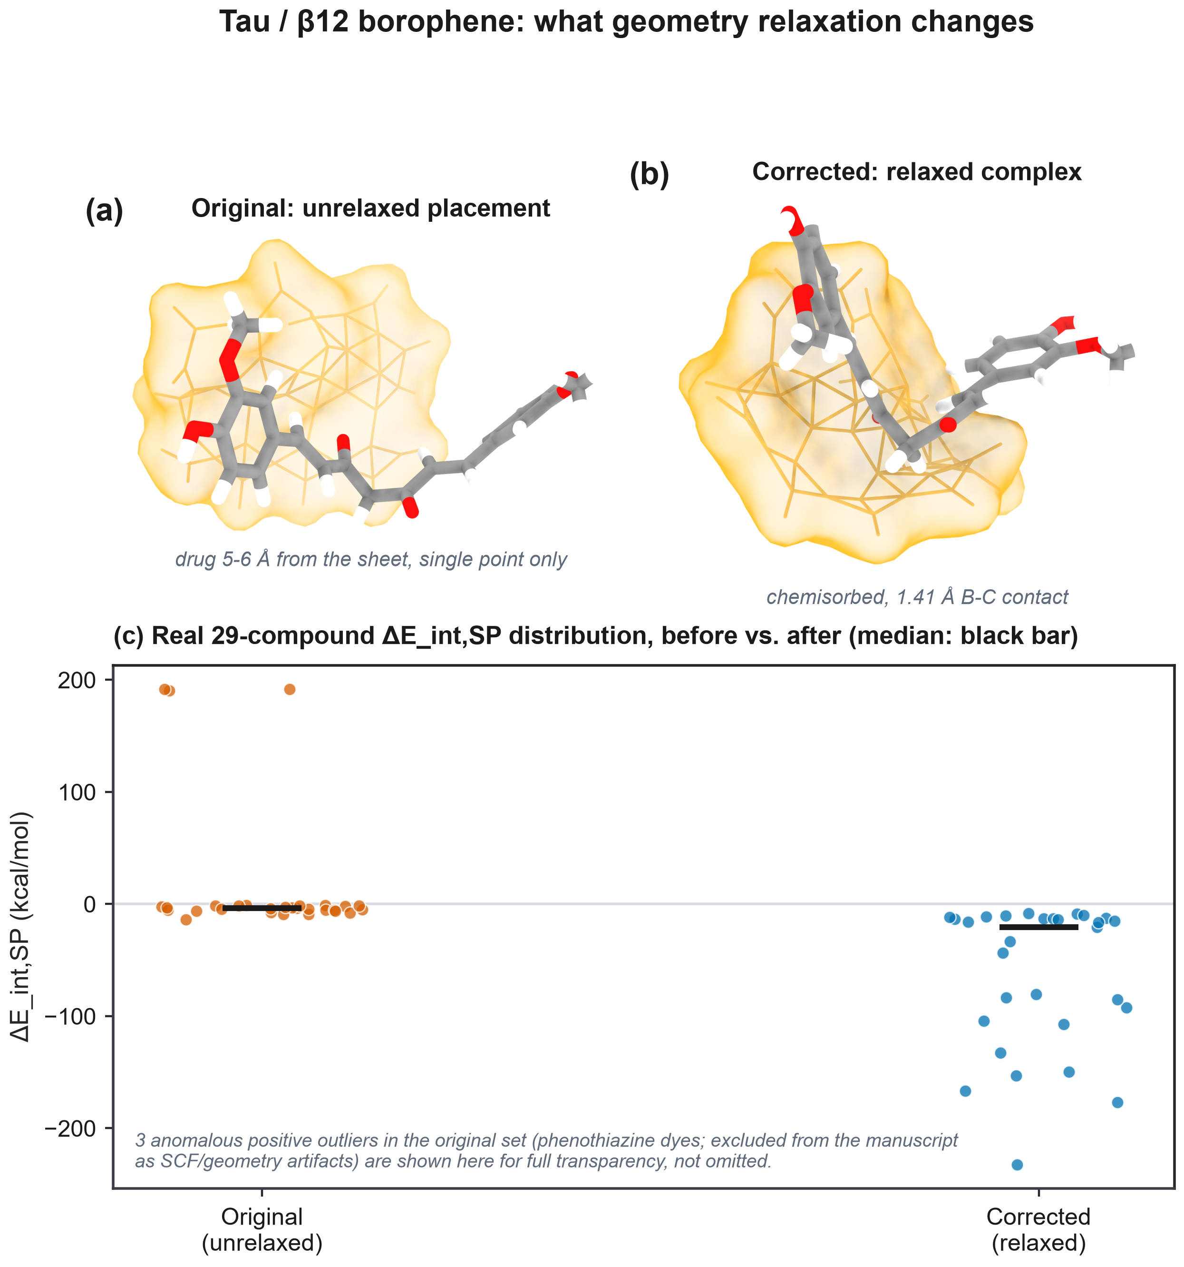
Figure 4: The Tau/borophene before/after comparison for curcumin, the strongest-adsorbing ligand. (a) The original unrelaxed placement, drug 5-6 Å from the sheet. (b) The corrected, relaxed, chemisorbed pose (1.41 Å B-C contact). (c) The real 29-compound ΔE_int,SP distribution before versus after — not simulated data.
We state the lessons from this case as four explicit rules, offered not as an indictment of any prior work but as a checklist we now apply to every new system before trusting a single number from it:
1. Always geometry-optimize the complex. A single-point energy on a placed, un-relaxed geometry is not an adsorption energy, and cannot be labelled as one.
2. Reference the placement offset to the local surface height directly beneath the adsorbate, never to a global z-extremum of a finite, buckled, or edge-terminated cluster.
3. Check the closest heavy-atom contact after optimization, and classify chemisorption versus physisorption explicitly and by that measured contact — not by assumption from the starting geometry.
4. Verify every curated drug structure against its molecular formula before committing compute to a batch of complexes; a truncated SMILES string can survive an entire pipeline undetected if nothing checks atom counts against the source identifier.

5. Catalogue of Failure Modes Found and Fixed Across the Four Projects
Beyond the Tau geometry error, the process of building and auditing all four case studies to a single, consistent standard surfaced a further set of concrete, fixable defects — none unique to a single system, and each worth naming so that other groups can check their own pipelines for the same pattern:
A fabricated “ΔG_bind” or “ΔE_ads” target computed from an empirical linear formula over RDKit descriptors, printed as if it were a quantum-mechanical result, in all four early drafts — replaced in every case with the real GFN2-xTB single-point or relaxed interaction energy.
A StandardScaler fitted on the entire dataset before cross-validation in the earliest KRAS surrogate model, silently leaking test-fold statistics into training — replaced with a scikit-learn Pipeline fit exclusively inside each outer-training fold of a nested cross-validation.
Hardcoded post-hoc test statistics (a Kruskal-Wallis or Dunn p-value typed directly into the manuscript text rather than computed from the deposited data) — replaced with values computed inline from the master results table at manuscript-generation time.
A bibliography imported wholesale from a sibling project (the KRAS draft briefly carried the TNBC reference list) — replaced with a per-project, individually verified reference list.
A fallback of np.random.uniform() standing in for an undefined applicability-domain leverage value when the real calculation failed silently — replaced with an explicit exception, so a broken leverage calculation fails loudly instead of being reported as data.
A “multi-level DFT benchmark” table with no corresponding ORCA output files anywhere in the repository — removed rather than retained with an unverifiable citation.
Schematic “3D structural context” figures that were, on inspection, text boxes styled to resemble a rendered structure — replaced with real ChimeraX or PyMOL renders of the actual computed geometries.
A docking cohort, a descriptor/QSPR cohort, and a reference-list compound count that had quietly drifted apart across three separate script revisions — unified into a single master table that every downstream figure and statistic is computed from directly.

6. Conclusion
A rigorous computational screen of a 2D-nanomaterial drug carrier is genuinely cheap — a GFN2-xTB adsorption calculation and an AutoDock Vina docking run together take hours on an ordinary workstation — but only under three conditions: the adsorption geometry must be relaxed, not placed and left at a single point; the regression target must be a real computed or measured quantity, never an empirical formula dressed up as one; and the cross-validation must be leak-free, with all preprocessing and hyperparameter selection confined to the training folds. Under those conditions, the honest outcome across our four disease systems is mixed in an informative way. MXene gives a modest, non-predictive physisorption energy (Q²_CV ≈ 0.10) — the unglamorous majority case. KRAS/g-C3N4 gives an equally modest interaction energy but a genuinely predictive QSPR (Q²_CV = 0.51-0.58), a useful internal control showing the near-zero results elsewhere are not simply an artefact of an overly conservative validation scheme. TNBC and Tau both turn out to hide a chemisorbing minority (5 of 33 and 12 of 29 ligands, respectively) inside an otherwise non-predictive physisorbing majority — the same qualitative pattern at two different scales, in two chemically unrelated systems, which the field's common unrelaxed, single-point protocol would have hidden entirely in both cases, and did, for a time, in ours. We offer the pipeline, the four case studies, and the corrected Tau result as a concrete, reproducible reference point for what changes when this discipline is applied, and as a short checklist for anyone building the next such screen.

Data Availability
This Perspective synthesizes results already deposited for each of the four underlying case studies; no new primary computation is reported here. Each system's complete code, curated dataset, GFN2-xTB and AutoDock Vina outputs, and figure/manuscript generators are archived at its own public GitHub repository and Zenodo deposit [22-25]; this paper's own cross-system summary table and Figure 2 generator are archived alongside the manuscript source in the methods-pipeline-2d-nanocarriers repository.

Conflict of Interest
The authors declare no competing financial or non-financial interest.

Funding
This work was supported by Universidad Estatal de Sonora and the Doctorado en Nanotecnología, Universidad de Sonora. No external grant funding was received.

Acknowledgements
The authors thank the computational resources of Universidad Estatal de Sonora and Universidad de Sonora.

Author Contributions
Andrés Monreal Hernández: conceptualization, methodology, software, formal analysis, investigation, data curation, visualization, writing – original draft. Sara Lizbeth Franco Amaya: validation, writing – review and editing. Carlos Ivanhoe Martínez Osorio: supervision, writing – review and editing. All authors read and approved the final manuscript.

ORCID iDs
Andrés Monreal Hernández – https://orcid.org/0009-0009-1207-8597

References
1. Bannwarth, C.; Ehlert, S.; Grimme, S. GFN2-xTB—An Accurate and Broadly Parametrized Self-Consistent Tight-Binding Quantum Chemical Method with Multipole Electrostatics and Density-Dependent Dispersion Contributions. Journal of Chemical Theory and Computation 2019, 15 (3), 1652-1671. doi:10.1021/acs.jctc.8b01176
2. Grimme, S.; Bannwarth, C.; Shushkov, P. A Robust and Accurate Tight-Binding Quantum Chemical Method for Structures, Vibrational Frequencies, and Noncovalent Interactions of Large Molecular Systems Parameterized for All spd-Block Elements (Z = 1-86). Journal of Chemical Theory and Computation 2017, 13 (5), 1989-2009. doi:10.1021/acs.jctc.7b00118
3. Caldeweyher, E.; Ehlert, S.; Hansen, A.; Neugebauer, H.; Spicher, S.; Bannwarth, C.; Grimme, S. A generally applicable atomic-charge dependent London dispersion correction. The Journal of Chemical Physics 2019, 150 (15), 154122. doi:10.1063/1.5090222
4. Grimme, S.; Antony, J.; Ehrlich, S.; Krieg, H. A consistent and accurate ab initio parametrization of density functional dispersion correction (DFT-D) for the 94 elements H-Pu. The Journal of Chemical Physics 2010, 132 (15), 154104. doi:10.1063/1.3382344
5. Trott, O.; Olson, A. J. AutoDock Vina: Improving the speed and accuracy of docking with a new scoring function, efficient optimization, and multithreading. Journal of Computational Chemistry 2010, 31 (2), 455-461. doi:10.1002/jcc.21334
6. Eberhardt, J.; Santos-Martins, D.; Tillack, A. F.; Forli, S. AutoDock Vina 1.2.0: New Docking Methods, Expanded Force Field, and Python Bindings. Journal of Chemical Information and Modeling 2021, 61 (8), 3891-3898. doi:10.1021/acs.jcim.1c00203
7. Landrum, G. RDKit: Open-Source Cheminformatics Software; GitHub: 2021. doi:10.5281/zenodo.5086055
8. Geerlings, P.; De Proft, F.; Langenaeker, W. Conceptual Density Functional Theory. Chemical Reviews 2003, 103 (5), 1793-1874. doi:10.1021/cr990029p
9. Varoquaux, G.; Buitinck, L.; Louppe, G.; Grisel, O.; Pedregosa, F.; Mueller, A. Scikit-learn. GetMobile: Mobile Computing and Communications 2015, 19 (1), 29-33. doi:10.1145/2786984.2786995
10. Rücker, C.; Rücker, G.; Meringer, M. y-Randomization and Its Variants in QSPR/QSAR. Journal of Chemical Information and Modeling 2007, 47 (6), 2345-2357. doi:10.1021/ci700157b
11. Tropsha, A. Best Practices for QSAR Model Development, Validation, and Exploitation. Molecular Informatics 2010, 29 (6-7), 476-488. doi:10.1002/minf.201000061
12. Gramatica, P. Principles of QSAR models validation: internal and external. QSAR & Combinatorial Science 2007, 26 (5), 694-701. doi:10.1002/qsar.200610151
13. OECD. Guidance Document on the Validation of (Quantitative) Structure-Activity Relationship [(Q)SAR] Models; OECD Environment Health and Safety Publications, Series on Testing and Assessment No. 69; OECD: Paris, 2007.
14. Cherkasov, A.; Muratov, E. N.; Fourches, D.; Varnek, A.; Baskin, I. I.; Cronin, M.; Dearden, J.; Gramatica, P.; Martin, Y. C.; Todeschini, R.; et al. QSAR Modeling: Where Have You Been? Where Are You Going To? Journal of Medicinal Chemistry 2014, 57 (12), 4977-5010. doi:10.1021/jm4004285
15. Lu, T.; Chen, F. Multiwfn: A multifunctional wavefunction analyzer. Journal of Computational Chemistry 2012, 33 (5), 580-592. doi:10.1002/jcc.22885
16. Pettersen, E. F.; Goddard, T. D.; Huang, C. C.; Meng, E. C.; Couch, G. S.; Croll, T. I.; Morris, J. H.; Ferrin, T. E. UCSF ChimeraX: Structure visualization for researchers, educators, and developers. Protein Science 2021, 30 (1), 70-82. doi:10.1002/pro.3943
17. Ong, W. J.; Tan, L. L.; Ng, Y. H.; Yong, S. T.; Chai, S. P. Graphitic Carbon Nitride (g-C3N4)-Based Photocatalysts for Artificial Photosynthesis and Environmental Remediation: Are We a Step Closer To Achieving Sustainability? Chemical Reviews 2016, 116 (12), 7159-7329. doi:10.1021/acs.chemrev.6b00075
18. Naguib, M.; Mochalin, V. N.; Barsoum, M. W.; Gogotsi, Y. 25th Anniversary Article: MXenes: A New Family of Two-Dimensional Materials. Advanced Materials 2014, 26 (7), 992-1005. doi:10.1002/adma.201304138
19. Golberg, D.; Bando, Y.; Huang, Y.; Terao, T.; Mitome, M.; Tang, C.; Zhi, C. Boron Nitride Nanotubes and Nanosheets. ACS Nano 2010, 4 (6), 2979-2993. doi:10.1021/nn1006495
20. Mannix, A. J.; Zhou, X. F.; Kiraly, B.; Wood, J. D.; Alducin, D.; Myers, B. D.; Liu, X.; Fisher, B. L.; Santiago, U.; Guest, J. R.; et al. Synthesis of borophenes: Anisotropic, two-dimensional boron polymorphs. Science 2015, 350 (6267), 1513-1516. doi:10.1126/science.aad1080
21. Zhang, Z.; Penev, E. S.; Yakobson, B. I. Two-dimensional boron: structures, properties and applications. Chemical Society Reviews 2017, 46 (22), 6746-6763. doi:10.1039/c7cs00261k
22. Monreal Hernández, A.; Franco Amaya, S. L.; Martínez Osorio, C. I. Quantum-Validated QSPR and Molecular Screening of KRAS-G12D Inhibitors across Graphitic Carbon Nitride Interaction Space [Data set]. Zenodo. 2026. doi:10.5281/zenodo.22187819
23. Monreal Hernández, A.; Franco Amaya, S. L.; Martínez Osorio, C. I. Explainable AI and Quantum Chemical Exploration of 2D Titanium Carbide MXene Nanosheets for Glioblastoma Therapeutics [Data set]. Zenodo. 2026. doi:10.5281/zenodo.22187857
24. Monreal Hernández, A.; Franco Amaya, S. L.; Martínez Osorio, C. I. Machine Learning-Driven Nano-QSAR and Quantum Chemical Design of Functionalized 2D Borophene Nanosheets for Targeted Disaggregation of Pathological Tau Fibrils [Data set]. Zenodo. 2026. doi:10.5281/zenodo.22187834
25. Monreal Hernández, A.; Franco Amaya, S. L.; Martínez Osorio, C. I. Explainable AI and Quantum-Guided QSAR/QSPR Modeling of Triple-Negative Breast Cancer Therapeutics Conjugated to Functionalized Boron Nitride Nanocages [Data set]. Zenodo. 2026. doi:10.5281/zenodo.22187873

