Auditing Computational Screens of Two-Dimensional Drug Carriers: Eight Failure Modes Found by Rebuilding Four Case Studies, and a Checklist to Catch Them
Andrés Monreal Hernández*
Universidad Estatal de Sonora, Ley Federal del Trabajo S/N, Col. Apolo, 83100 Hermosillo, Sonora, Mexico
*E-mail: andres.monreal@ues.mx. ORCID: 0009-0009-1207-8597
Running title: Auditing 2D drug-carrier screens

Abstract
Computational screens of two-dimensional materials as drug carriers combine semiempirical adsorption energies, docking and quantitative structure–property relationship (QSPR) models, and they are usually validated with cross-validation and Y-randomization. We rebuilt four such screens from raw inputs — KRAS-G12D with graphitic carbon nitride, PARP1 with a B₃₆N₃₆ cage, EGFR with a Ti₃C₂O₂ MXene and tau filaments with β₁₂ borophene — and found eight failure modes that this validation cannot detect. Of 128 drug structures, 55 encoded a different compound; three of the four carrier models contained bonds the material cannot have; a borophene flake reconstructed during adsorption, and on it 17 of 28 drugs appeared to chemisorb, against 3 on a stable sheet; GFN2-xTB and GFN1-xTB could not describe the metallic MXene; two docking protocols failed or could not fail their controls; a virtual screen contained no structures; a drug overlapped its periodic image; and a leak-free QSPR model that was significant on energies from an invalid carrier (Q²_{CV} = 0.58, p = 0.001) had no predictive power on energies from a valid one (−0.32). Each failure mode is caught by a check that costs less than the calculation it protects. We describe the evidence for each and collect the checks into a list to apply before any model is fitted.
Keywords: structure curation; molecular docking; tight binding; nested cross-validation; reproducibility

Introduction
Two-dimensional materials and nanoclusters such as graphitic carbon nitride, MXenes, borophene and boron nitride cages are frequently proposed as carriers for drugs^{1–5}. A computational screen of such a carrier is inexpensive: the drug and the carrier are optimized with a semiempirical method such as GFN2-xTB,⁶ the drug is docked into its biological target with AutoDock Vina,^{7,8} and a quantitative structure–property relationship (QSPR) model is fitted to the computed energies. For a few dozen drugs the whole workflow runs in days on a workstation, and the statistical side of it is well codified: nested cross-validation, Y-randomization and an applicability domain are standard^{9–13}, and the ways in which information leaks from test to training data are well documented¹⁴.
Statistical validation, however, can only test the numbers it is given. It cannot tell whether a SMILES string encodes the molecule named in the table, whether a carrier model is a chemically possible structure, whether it stays intact during the calculation, or whether the quantum-chemical method is valid for the material at all. Errors of this kind are known in cheminformatics, where structure curation has been shown to change the outcome of QSAR studies^{15–17}, and in docking, where the ability of a program to reproduce known poses has to be demonstrated for each target^{18,19} and data sets can carry hidden biases²⁰. For carrier screens, which add a materials model and an adsorption calculation to the usual chain, they have received less attention.
Here we report an audit of four such screens, carried out by the author on the author's own earlier work. Each study combined a disease target, a cohort of about 30 drugs and a two-dimensional carrier: KRAS-G12D with graphitic carbon nitride, triple-negative breast cancer (PARP1) with a B₃₆N₃₆ cage, glioblastoma (EGFR) with a Ti₃C₂O₂ MXene, and Alzheimer's disease (tau paired helical filaments) with β₁₂ borophene. All four had been written up for publication, with QSPR models validated by the protocol described above. Rebuilding each one from raw inputs with scripts revealed eight distinct failure modes, from the identity of the molecules (55 of 128 structures encoded a different compound) to the validity of the carrier models and of the methods applied to them. The most instructive case is the QSPR model of the KRAS study: the same leak-free nested cross-validation, with the same four descriptors and the same 33 drugs, gives Q²_{CV} = 0.58 (Y-randomization p = 0.001) on adsorption energies computed on a chemically invalid carrier and -0.32 (p = 0.99) on energies computed on a valid one. The validation was correct; the data were not.
The paper documents each failure mode with the evidence from the four studies and the check that catches it, and collects the checks into a list that can be applied before any statistics are computed. All scripts, the files from before and after the rebuild, and the code that extracts every number quoted here are openly available.

Methods

The four case studies
Each study paired a disease target with a cohort of drugs and a carrier model (Table I). Before the audit, each existed as a code repository, a data set and a manuscript; the supporting files of all four, and a methods description built on them, had been deposited on Zenodo^{21–25}. Those records are the pre-audit state that this paper corrects. The audit rebuilt every study from its raw inputs (drug names, Protein Data Bank structures, carrier lattices) with scripts that regenerate every number and figure. Files from before the rebuild were moved to an archive and never deleted, so that each failure mode can be shown with the original files.

Checks
Eight checks were applied, each at the step of the workflow that it protects (Fig. 1). They are described below in the order of the failure modes they address.
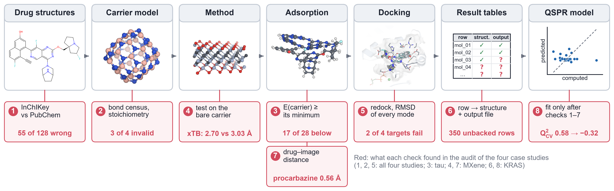
Fig. 1. Workflow of a computational carrier screen and the eight checks of the audit. Each check is attached to the step it protects, and its number corresponds to the failure mode in the Results and to the checklist in Table II; the red line gives what the check found in the audit of the four studies. Images, from the rebuilt studies: MRTX1133; the B₃₆N₃₆ cage; the Ti₃C₂O₂ MXene; MRTX1133 adsorbed on g-C₃N₄ (GFN2-xTB); MRTX1133 docked in KRAS-G12D; a result table in which every row must point to an input structure and an output file; and out-of-fold predictions of the QSPR model of the KRAS interaction energy.
Compound identity. The SMILES string of every drug was compared with the PubChem²⁶ record retrieved by name, through the InChIKey. A structure was counted as wrong when its molecular formula or its connectivity (first InChIKey block) differed from PubChem; differences only in stereochemistry, salt form or charge state were accepted.
Carrier validity. For each carrier model the formula and a census of bonds were computed, a bond being any atom pair closer than 1.15 times the sum of the covalent radii. Bonds that the ideal material cannot contain were counted: C–C and N–N in heptazine carbon nitride, B–B and N–N in boron nitride, and C–C, C–O and O–O in Ti₃C₂O₂. In boron nitride cages the transannular B···B contact across a four-membered B₂N₂ ring (about 1.86 Å) falls inside the bond criterion; such pairs, recognized because they share two nitrogen neighbours, were counted separately and not as bonds. Pairs closer than 0.6 times the sum of the covalent radii, which no chemical bond reaches, were counted as overlapping atoms.
Carrier stability. A carrier model is only useful if it keeps its structure during the adsorption calculation. For every complex, the energy of the carrier fragment frozen at its geometry in the complex was compared with the energy of the isolated relaxed carrier. Distortion away from the relaxed minimum raises that energy; a value below the relaxed reference means that the carrier has moved to a different, lower-energy structure. The bond census of the carrier was also repeated in every complex.
Method applicability. Before adsorption was computed on the metallic MXene, the tight-binding methods were tested on the material alone: the energy of a periodic Ti₃C₂O₂ slab was scanned against the in-plane lattice constant with GFN2-xTB⁶ and GFN1-xTB²⁷, and finite flakes were computed in several charge and spin states and electronic temperatures.
Docking controls. In each target the crystallographic or cryo-EM ligand was redocked from its experimental conformation and, rebuilt from SMILES, through the same protocol used for the cohort. The heavy-atom root-mean-square deviation (RMSD) to the experimental pose was computed with RDKit,²⁸ symmetry-aware and without re-alignment, for the top-ranked pose and, where it failed, for every output mode. The placement of the docking box was also checked.
Provenance. Every row of every table was traced back to an input structure and an output file of the program that produced it.
Periodic images. In the periodic calculations, the shortest distance between each drug and its own in-plane images was computed for the starting geometry of every complex.
QSPR. The rebuilt studies share one QSPR implementation: a ridge-regression pipeline (scikit-learn²⁹) with standardization inside the pipeline, nested five-fold cross-validation (five inner folds for the penalty), 1,000 Y-randomizations of the whole nested procedure¹², and a leverage applicability domain^{9,10}. To separate the effect of the data from that of the protocol, the same code was also applied to the adsorption energies of the pre-rebuild KRAS study.

Software and data
The rebuilt studies used xtb 6.7.1 and tblite (GFN2-xTB, GFN1-xTB), AutoDock Vina 1.2.7⁸ with Meeko and PDBFixer, RDKit, scikit-learn and, for the MXene, Quantum ESPRESSO 7.5³⁰ with the PBE functional³¹ and D3 dispersion³². The scripts that extract the evidence for this paper from the four repositories and from the archive of the pre-rebuild files are part of its own repository.
Table I The four case studies after the rebuild.
Target (disease) | PDB | Carrier model | Drugs | Adsorption method
KRAS-G12D (pancreatic cancer) | 7RPZ | g-C₃N₄ pore flake, pristine and B/P-doped | 33 | GFN2-xTB
PARP1 (triple-negative breast cancer) | 4UND | B₃₆N₃₆ cage | 30 | GFN2-xTB
EGFR (glioblastoma) | 1M17 | Ti₃C₂O₂ MXene, periodic slab | 33 | PBE-D3
Tau paired helical filaments (Alzheimer's disease) | 8FUG | β₁₂ borophene, supported sheet | 28 | GFN2-xTB
Drugs, number in the rebuilt cohort (organic compounds with a structure that could be docked and adsorbed). For the MXene, adsorption of the alkylating agents is computed with periodic DFT (PBE-D3), because the tight-binding methods fail for it.

Results

1. The molecule is not the one named
Of the 128 drug structures in the four data sets, 55 encoded a different compound from the one named (Fig. 2a, Table S1): none of 33 in the KRAS study, but 24 of 33 for TNBC, 17 of 33 for glioblastoma and 14 of 29 for tau. Some errors changed the molecule beyond recognition: everolimus in the glioblastoma set was stored as C₁₀H₁₈O₃ (13 heavy atoms) instead of C₅₃H₈₃NO₁₄ (68). Others were invisible to a formula check: 6 structures had the correct formula and the wrong connectivity, among them doxorubicin and epirubicin, and were found only through the InChIKey. Every descriptor, docking score and adsorption energy computed from these structures belonged to another molecule. This failure mode is well known in cheminformatics^{15,17}; it went unnoticed here because the SMILES strings had never been checked against a chemical database, and no later step of the workflow depends on the name of a compound.

2. The carrier is not the material
Three of the four carrier models were not the materials they were named after (Fig. 2b, Table S2). The B₃₆N₃₆ cage of the TNBC study had the right formula but 36 B–B and 24 N–N bonds and only 60 B–N bonds, whereas in a boron nitride cage every bond joins boron to nitrogen⁵. Worse, 36 of those B–N pairs were atoms placed almost on top of each other, as close as 0.57 Å. The graphitic carbon nitride model of the KRAS study, C₂₁N₂₁H₆, had the wrong stoichiometry for heptazine-based g-C₃N₄¹ and 4 C–C bonds. The MXene of the glioblastoma study, Ti₁₂C₇O₁₄, did not have the Ti₃C₂O₂ composition and contained 4 C–C bonds. The rebuilt models — a heptazine pore flake (C₁₈N₂₇H₉), a cage with 108 B–N bonds, and a periodic Ti₃C₂O₂ slab — contain no forbidden bond. A bond census of this kind takes seconds and would have rejected all three models before any adsorption was computed.
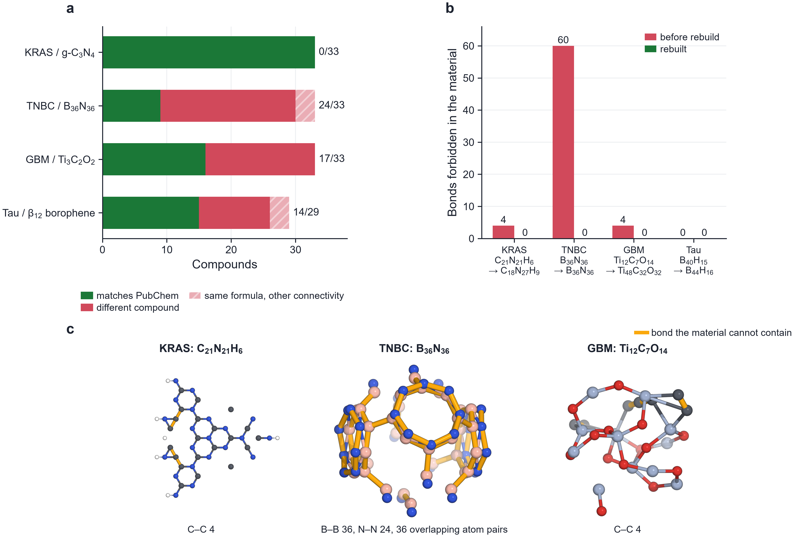
Fig. 2. Identity of the drugs and validity of the carriers before the rebuild. (a) Drug structures that match PubChem and structures that encode a different compound, per study; hatched, same formula but different connectivity. (b) Bonds that the ideal material cannot contain, in the carrier models before and after the rebuild; formulas below each study. (c) The three invalid carrier models, drawn with the bond criterion of the audit; bonds that the material cannot contain in amber. In the B₃₆N₃₆ model, pairs of boron and nitrogen atoms sit almost on top of each other.

3. The carrier changes during the calculation
A carrier can be chemically valid and still not survive the adsorption calculation. The β₁₂ borophene flake of the tau study (B₄₀H₁₅) was a true minimum with no imaginary frequencies, but in 17 of 28 complexes the carrier fragment ended below that minimum, by up to 110.7 kcal mol⁻¹ (Fig. 3a, Table S3): the free flake contracted toward a compact boron cluster, and the computed binding energies contained the energy of that reconstruction. The classification of the drugs was affected as well: on the free flake 17 of 28 drugs appeared to chemisorb (Fig. 3b), and the version of the study deposited before the audit²⁴ had reported 12 of 29 ligands as chemisorbed on the same flake. Borophene exists only on a supporting metal^{3,4}, which keeps it planar; a flat β₁₂ sheet with its boron atoms restrained to the lattice does not reconstruct (carrier energy in the complexes 3.8 to 29.9 kcal mol⁻¹ above its reference), and on it only 3 of 28 drugs chemisorb. The rebuilt B₃₆N₃₆ cage passes the same test (0.0 to 31.6 kcal mol⁻¹).
The same test applies to doped carriers. In a scan of boron/phosphorus co-doping sites in g-C₃N₄, 19 of 42 configurations were lower in energy than the substitutional one finally used, by up to 40.1 kcal mol⁻¹, but in none of them were both dopants still three-coordinate and bonded only to nitrogen, as substitution requires. Ranking by energy alone would have selected a structure that is no longer the doped material; the bond census of the carrier has to accompany the energy.
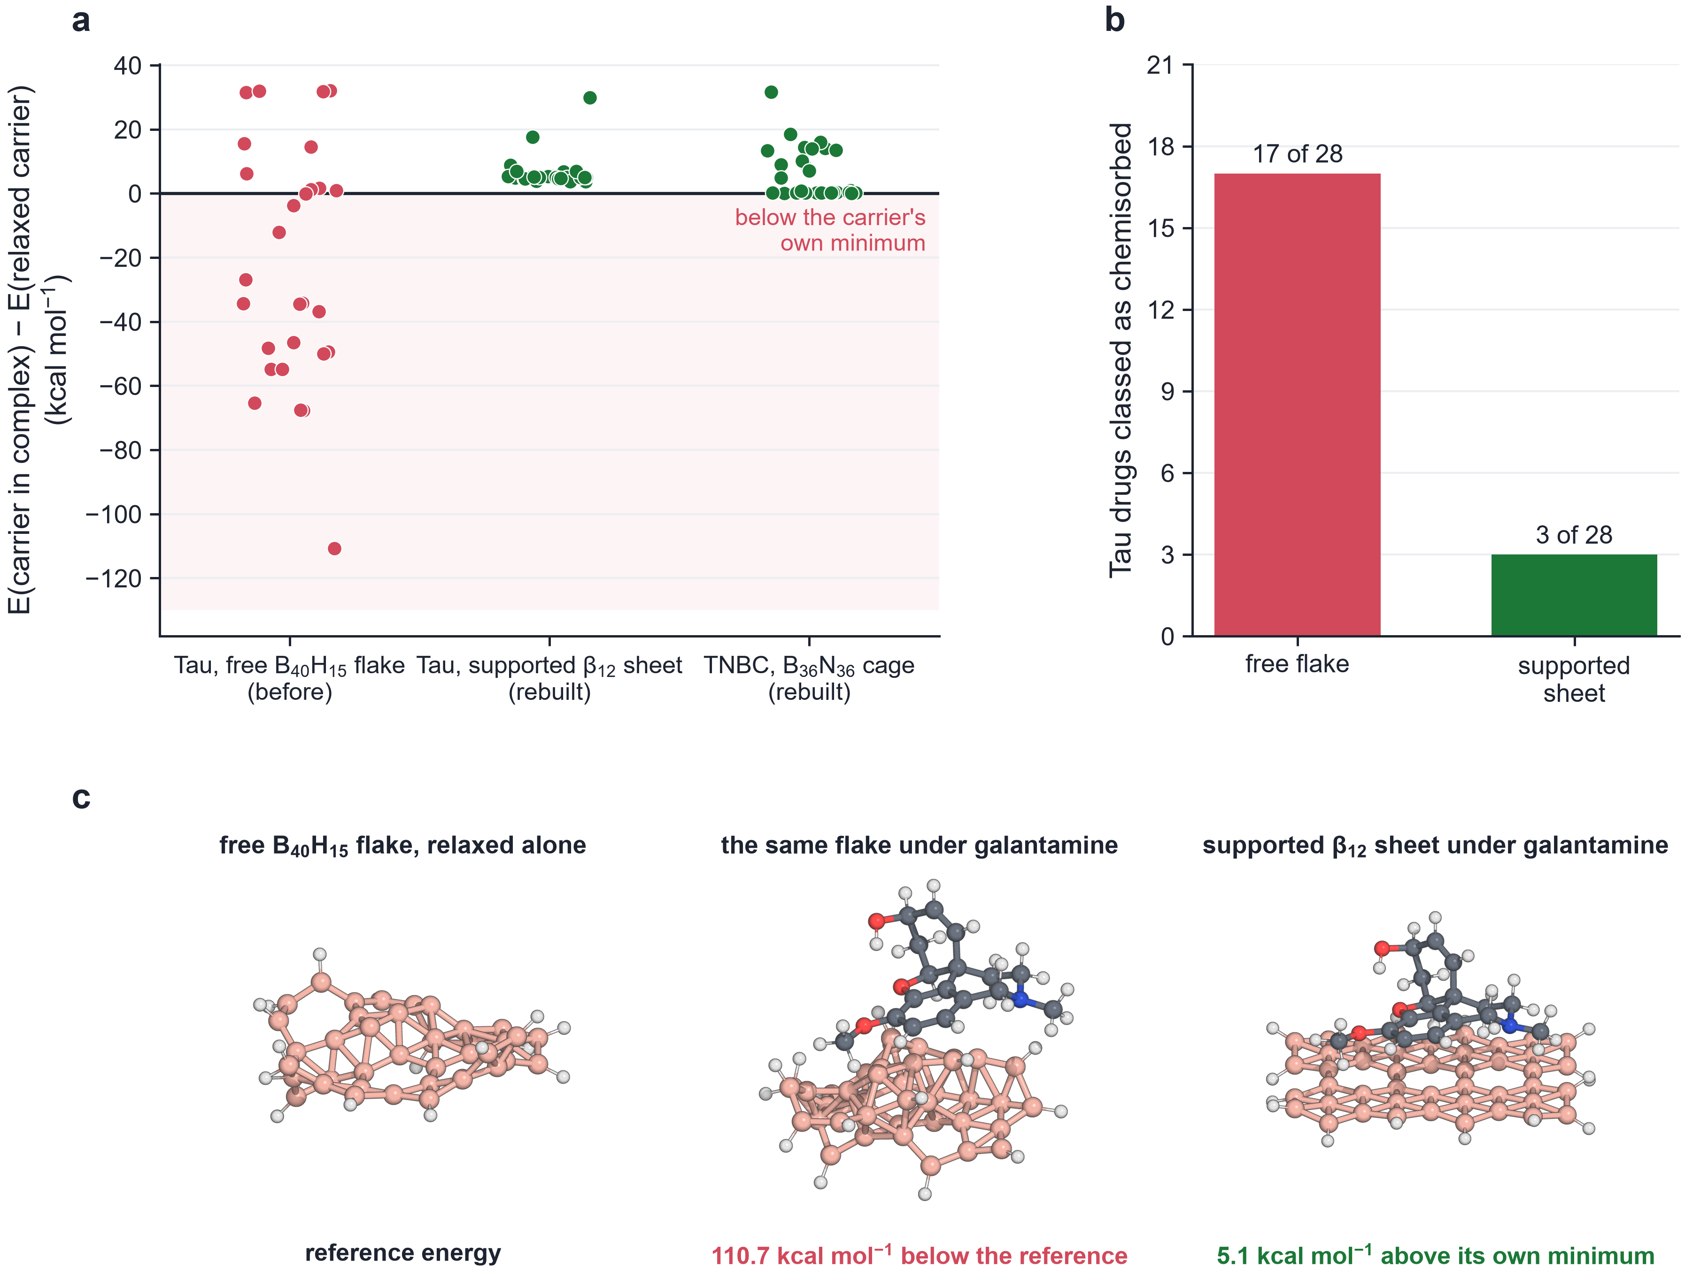
Fig. 3. Carrier reconstruction during adsorption. (a) Energy of the carrier fragment frozen at its geometry in each complex, relative to the relaxed carrier; negative values (shaded) mean that the carrier reached a structure below its own minimum. (b) Number of tau drugs classified as chemisorbed on the free flake and on the supported sheet. (c) Galantamine, the extreme case: the free B₄₀H₁₅ flake relaxed alone, the same flake in the relaxed complex, which has collapsed into a three-dimensional cluster, and the supported β₁₂ sheet in the relaxed complex (GFN2-xTB, side views).

4. The method cannot describe the carrier
For the MXene, the problem was the method rather than the model. GFN2-xTB places the energy minimum of periodic Ti₃C₂O₂ at a = 2.70 Å, 11% below the lattice constant of the material (3.03 Å³³), with a jump of 31.0 eV per formula unit between neighbouring points; GFN1-xTB failed to converge at 6 of 14 lattice constants and gave unphysical energies at 2 more (Fig. 4a). Finite flakes fared no better: 1 of 18 calculations on neutral flakes converged (Fig. 4b). Both methods were parametrized mainly on molecular data^{6,27}, and a metallic transition-metal carbide lies outside that domain. A lattice scan of the bare carrier, which costs minutes, is enough to see it; the glioblastoma study was therefore moved to periodic density functional theory.
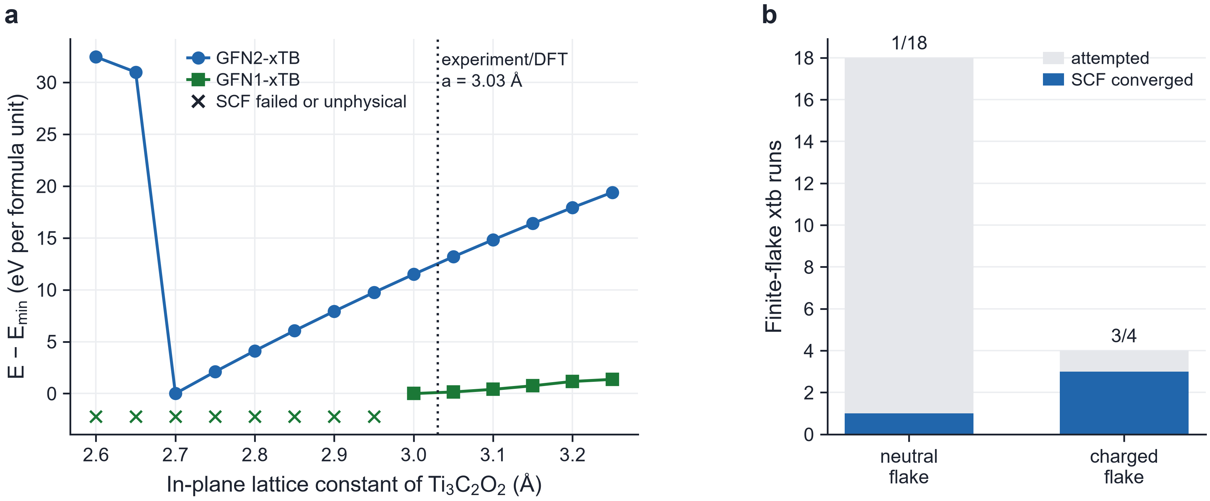
Fig. 4. Tight-binding methods applied to Ti₃C₂O₂. (a) Energy of a periodic 4×4 slab against the in-plane lattice constant with GFN2-xTB and GFN1-xTB; crosses, failed or unphysical SCF; dotted line, experimental and DFT lattice constant. (b) Calculations on finite flakes attempted and converged, for neutral and charged flakes.

5. The docking control fails, or tests the wrong thing
Two of the four docking protocols reproduced the experimental ligand pose from both its crystal conformation and from SMILES: KRAS-G12D (0.51 and 1.25 Å) and PARP1 (0.51 and 1.27 Å) (Fig. 5a, Table S4). The other two did not, and each failure carried information. The tau study had first docked into a fibril structure without any ligand, with a box centred on previously docked poses, so that the protocol could not fail; in a cryo-EM structure with a bound tracer³⁴, the tracer is not reproduced in the ligand-free fibril (6.7 and 6.3 Å) and only partly when the stacked neighbouring copies are kept (0.71 and 2.81 Å). The glioblastoma study had first validated against a covalent inhibitor, which a non-covalent program is not designed to place (8.6 and 5.4 Å). With the non-covalent erlotinib complex³⁵, the top-ranked pose still failed (5.9 and 7.6 Å), yet the crystal-like pose was present as mode 6 (1.13 Å), and all nine modes lay within 0.45 kcal mol⁻¹ (Fig. 5b): the search found the pose, and the score could not rank it. Inspecting every mode, not only the first, distinguishes these cases^{18,19}.
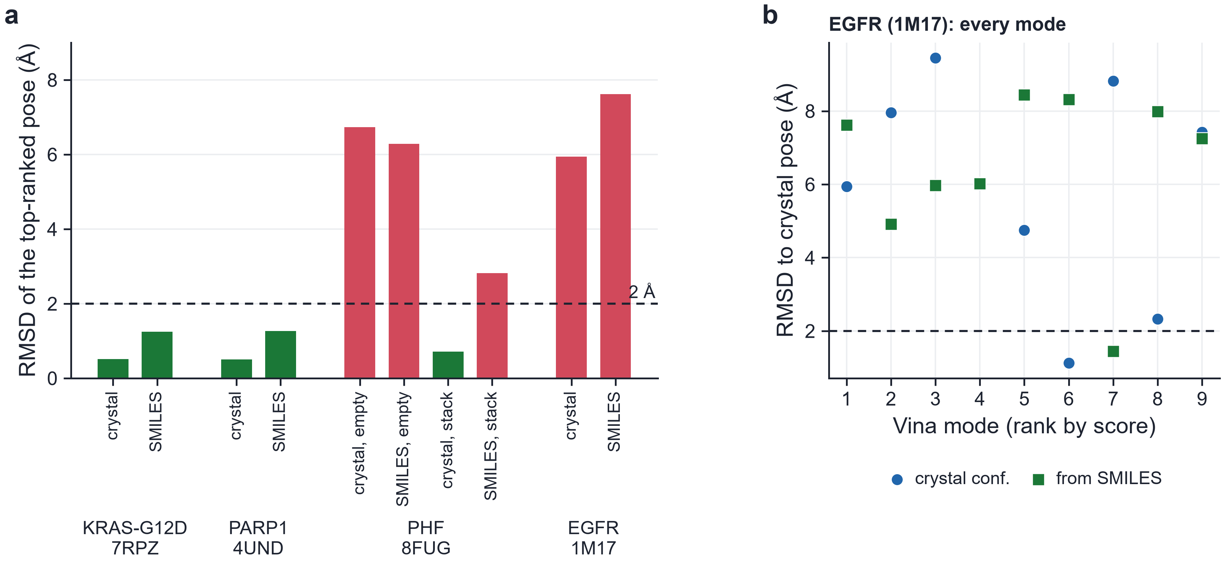
Fig. 5. Redocking controls. (a) RMSD of the top-ranked pose to the experimental pose for each control and target; crystal, ligand redocked from its experimental conformation; SMILES, ligand rebuilt through the production protocol; empty and stack, tau fibril without ligands or with the neighbouring tracer copies. (b) RMSD of every Vina mode for erlotinib in EGFR.

6. Data that were never computed
The KRAS study reported a virtual screen of 350 candidate molecules. The file contains no structure: no SMILES, InChI or InChIKey, only a compound identifier, a parent scaffold and descriptor values. The script that produced it generated those values by adding random numbers to the descriptors of a few parent scaffolds (7 of them appear in the final table), and a 'predicted' binding energy was then computed from the random descriptors. Such a table can pass every statistical test, because it is internally consistent by construction. The only check that exposes it is provenance: each row must lead to an input structure and to an output file of the program that computed its value.

7. The drug meets itself
In periodic calculations the drug interacts with its own images. In the 12.1 Å cell of the MXene slab, procarbazine, 13.8 Å long, overlapped its image (0.56 Å between atoms) and was removed from the calculation; the other drugs were rotated where necessary so that their closest image contact was 3.25–4.26 Å. The check is a distance calculation on the starting geometry.

8. Statistics that look like a result
The QSPR model of the KRAS study illustrates why none of the checks above can be left to the statistics. With the same code, the same four descriptors and the same 33 drugs, nested cross-validation gives Q²_{CV} = 0.58 with a Y-randomization p of 0.001 on adsorption energies computed on the invalid carrier, and −0.32 (p = 0.99) on energies computed on the valid one (Fig. 6a, b). The first model is leak-free and significant, and it describes a material that does not exist. Across the rebuilt studies, no descriptor model predicts its target usefully: the TNBC models give Q²_{CV} = −0.08 for the interaction energy and −0.08 for the docking score, and the only positive values, 0.23 for tau and 0.17 for the glioblastoma docking score, are carried by the formal charge of four cationic dyes and by molecular size, respectively (Fig. 6c, Table S5). These negative results are the honest outcome of the screens.
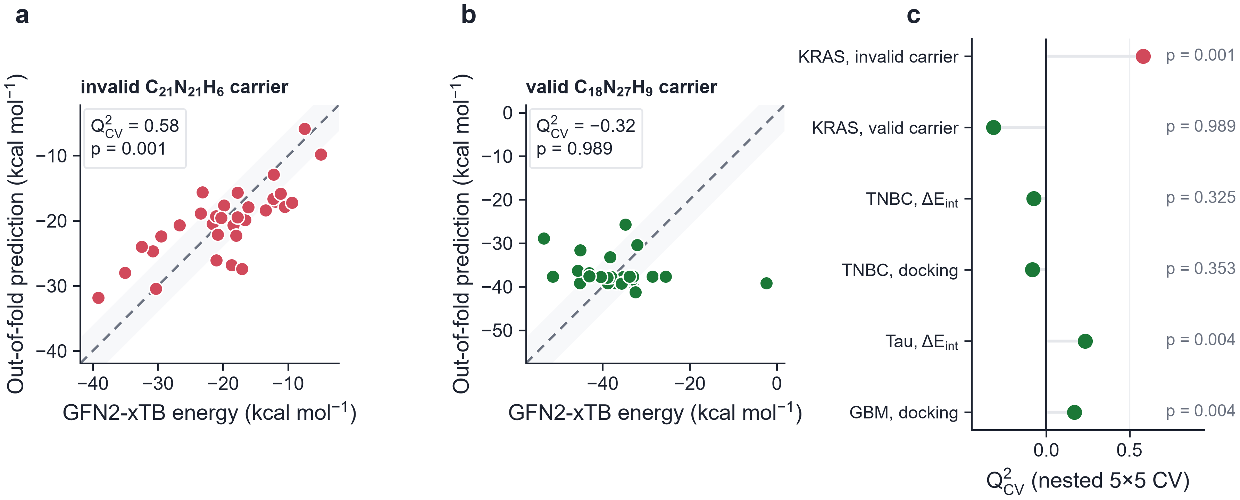
Fig. 6. The same QSPR protocol on data from an invalid and from a valid carrier. (a, b) Out-of-fold predictions of nested 5×5 cross-validation for the KRAS drugs, with adsorption energies computed on the invalid C₂₁N₂₁H₆ carrier and interaction energies on the valid C₁₈N₂₇H₉ carrier. (c) Q²_{CV} of the rebuilt models of the four studies and of the model on the invalid carrier, with Y-randomization p values.

Discussion
The eight failure modes fall into two groups. Five of them — the identity of the drugs, the composition and bonding of the carrier, its stability during the calculation, the applicability of the method and the periodic images — concern whether the system being computed is the system being described. The other three concern evidence: whether the docking protocol has been shown to work for the target, whether every number has a source, and whether a statistical result reflects the chemistry or the data. None of the eight is detected by the validation that screening studies usually report, because that validation is internal to the data set. A cross-validated, Y-randomized model built on the wrong molecules or on an impossible carrier is still cross-validated and Y-randomized. In the four studies examined here, every failure mode was found by a check that is cheaper than the calculation it protects.
The checks are collected in Table II, in the order in which they can be applied. Most take seconds or minutes: a database query, a bond census, a comparison of two energies, a distance. The most expensive, the redocking controls and the method test on the bare carrier, take hours, which is still less than the screen itself. Two points deserve emphasis. First, the stability check needs no extra calculation, because the energy of the carrier fragment at the complex geometry is already computed for the interaction energy; it only has to be compared with the relaxed carrier. Second, the docking control should be read mode by mode: a protocol that finds the experimental pose but ranks it sixth has a scoring problem, not a search problem, and its scores should be reported as an exploratory ranking.
Table II Checklist for computational screens of drug carriers. Each item corresponds to one failure mode in the Results.
Check | What to do | Failure mode
Compound identity | Retrieve every structure from a database by name or identifier; compare InChIKeys, not formulas | 1
Carrier composition and bonding | Formula and bond census of the carrier; no bond that the material cannot contain | 2
Carrier stability | Energy of the carrier at its geometry in each complex never below the relaxed carrier; bond census repeated in every complex; dopant sites checked for reconstruction | 3
Method applicability | Test the method on the bare carrier (lattice constant, SCF convergence) before any adsorption | 4
Docking controls | Redock the experimental ligand from its conformation and from SMILES; box from the experimental ligand; RMSD of every mode, not only the first | 5
Provenance | Every table row traceable to an input structure and an output file | 6
Periodic images | Drug–image distance of every starting geometry | 7
Statistics last | Nested cross-validation and Y-randomization only after checks 1–7; report negative results | 8

The audit also changed what the four studies report. With valid structures and carriers, the screens describe physisorption on pristine carbon nitride and, for part of the drugs, chemisorption where the carrier offers a reactive site (the phosphorus of B/P-doped carbon nitride, the boron atoms of the nitride cage and, for 3 drugs, the borophene sheet), docking scores that are a ranking of fit rather than affinities, and descriptor models that predict their targets weakly or not at all. These are modest results, and they are the ones the calculations support.

Limitations
The audit covers four studies by one author, so the frequencies reported here — for instance, 55 of 128 wrong structures — describe these data sets and not the literature. The checks were chosen because they caught real errors; they are not exhaustive, and other failure modes, such as the neglect of solvent or of conformational sampling, are not addressed. The rebuilt studies still rest on gas-phase GFN2-xTB energies for three of the carriers.

Conclusions
Rebuilding four computational screens of drug carriers from raw inputs exposed eight failure modes, none of which statistical validation can detect: wrong molecules, impossible carriers, carriers that reconstruct, methods outside their domain, docking controls that fail or cannot fail, data that were never computed, drugs overlapping their periodic images, and statistics that reflect these errors. The clearest illustration is a leak-free QSPR model that is significant on energies from an invalid carrier (Q²_{CV} = 0.58) and has no predictive power on energies from a valid one (-0.32). Each failure mode is caught by a check that costs less than the calculation it protects, and the checks are simple enough to be applied routinely before any model is fitted.

Supporting Information
The Supporting Information contains the identity of the 128 drug structures (Table S1), bond census of the carrier models (Table S2), carrier energy in each tau complex before and after the rebuild (Table S3), redocking controls of the four studies (Table S4) and the QSPR models before and after the rebuild (Table S5) (PDF).

Data and Software Availability
The scripts that extract every number and figure of this paper from the four case-study repositories and from the archive of the pre-rebuild files are available at https://github.com/sircalch/methods-pipeline-2d-nanocarriers under the MIT licence, together with the extracted evidence (audit_evidence.json, carrier_audit.csv).

Conflict of Interest
The author declares no competing interests.

Use of AI Tools
[AUTHOR TO COMPLETE BEFORE SUBMISSION: statement on the use of AI tools, as required by the journal.]

References
(1) Kroke, E.; Schwarz, M.; Horath-Bordon, E.; Kroll, P.; Noll, B.; Norman, A. D. Tri-s-triazine derivatives. Part I. From trichloro-tri-s-triazine to graphitic C3N4 structures. New J. Chem. 2002, 26, 508–512. https://doi.org/10.1039/b111062b
(2) Naguib, M.; Kurtoglu, M.; Presser, V.; Lu, J.; Niu, J.; Heon, M.; Hultman, L.; Gogotsi, Y.; Barsoum, M. W. Two-Dimensional Nanocrystals Produced by Exfoliation of Ti3AlC2. Adv. Mater. 2011, 23, 4248–4253. https://doi.org/10.1002/adma.201102306
(3) Mannix, A. J.; Zhou, X.-F.; Kiraly, B.; Wood, J. D.; Alducin, D.; Myers, B. D.; Liu, X.; Fisher, B. L.; Santiago, U.; Guest, J. R.; Yacaman, M. J.; Ponce, A.; Oganov, A. R.; Hersam, M. C.; Guisinger, N. P. Synthesis of borophenes: Anisotropic, two-dimensional boron polymorphs. Science 2015, 350, 1513–1516. https://doi.org/10.1126/science.aad1080
(4) Feng, B.; Zhang, J.; Zhong, Q.; Li, W.; Li, S.; Li, H.; Cheng, P.; Meng, S.; Chen, L.; Wu, K. Experimental realization of two-dimensional boron sheets. Nat. Chem. 2016, 8, 563–568. https://doi.org/10.1038/nchem.2491
(5) Strout, D. L. Structure and Stability of Boron Nitrides: Isomers of B12N12. J. Phys. Chem. A 2000, 104, 3364–3366. https://doi.org/10.1021/jp994129a
(6) Bannwarth, C.; Ehlert, S.; Grimme, S. GFN2-xTB─An Accurate and Broadly Parametrized Self-Consistent Tight-Binding Quantum Chemical Method with Multipole Electrostatics and Density-Dependent Dispersion Contributions. J. Chem. Theory Comput. 2019, 15, 1652–1671. https://doi.org/10.1021/acs.jctc.8b01176
(7) Trott, O.; Olson, A. J. AutoDock Vina: Improving the speed and accuracy of docking with a new scoring function, efficient optimization, and multithreading. J. Comput. Chem. 2010, 31, 455–461. https://doi.org/10.1002/jcc.21334
(8) Eberhardt, J.; Santos-Martins, D.; Tillack, A. F.; Forli, S. AutoDock Vina 1.2.0: New Docking Methods, Expanded Force Field, and Python Bindings. J. Chem. Inf. Model. 2021, 61, 3891–3898. https://doi.org/10.1021/acs.jcim.1c00203
(9) OECD. Guidance Document on the Validation of (Quantitative) Structure-Activity Relationship [(Q)SAR] Models; OECD Series on Testing and Assessment, No. 69; OECD Publishing: Paris, 2007.
(10) Tropsha, A. Best Practices for QSAR Model Development, Validation, and Exploitation. Mol. Inf. 2010, 29, 476–488. https://doi.org/10.1002/minf.201000061
(11) Gramatica, P. Principles of QSAR models validation: internal and external. QSAR Comb. Sci. 2007, 26, 694–701. https://doi.org/10.1002/qsar.200610151
(12) Rücker, C.; Rücker, G.; Meringer, M. y-Randomization and Its Variants in QSPR/QSAR. J. Chem. Inf. Model. 2007, 47, 2345–2357. https://doi.org/10.1021/ci700157b
(13) Cherkasov, A.; Muratov, E. N.; Fourches, D.; Varnek, A.; Baskin, I. I.; Cronin, M.; Dearden, J.; Gramatica, P.; Martin, Y. C.; Todeschini, R.; Consonni, V.; Kuz’min, V. E.; Cramer, R.; Benigni, R.; Yang, C.; Rathman, J.; Terfloth, L.; Gasteiger, J.; Richard, A.; Tropsha, A. QSAR Modeling: Where Have You Been? Where Are You Going To?. J. Med. Chem. 2014, 57, 4977–5010. https://doi.org/10.1021/jm4004285
(14) Kapoor, S.; Narayanan, A. Leakage and the reproducibility crisis in machine-learning-based science. Patterns 2023, 4, 100804. https://doi.org/10.1016/j.patter.2023.100804
(15) Fourches, D.; Muratov, E.; Tropsha, A. Trust, But Verify: On the Importance of Chemical Structure Curation in Cheminformatics and QSAR Modeling Research. J. Chem. Inf. Model. 2010, 50, 1189–1204. https://doi.org/10.1021/ci100176x
(16) Fourches, D.; Muratov, E.; Tropsha, A. Trust, but Verify II: A Practical Guide to Chemogenomics Data Curation. J. Chem. Inf. Model. 2016, 56, 1243–1252. https://doi.org/10.1021/acs.jcim.6b00129
(17) Williams, A. J.; Ekins, S. A quality alert and call for improved curation of public chemistry databases. Drug Discovery Today 2011, 16, 747–750. https://doi.org/10.1016/j.drudis.2011.07.007
(18) Warren, G. L.; Andrews, C. W.; Capelli, A.-M.; Clarke, B.; LaLonde, J.; Lambert, M. H.; Lindvall, M.; Nevins, N.; Semus, S. F.; Senger, S.; Tedesco, G.; Wall, I. D.; Woolven, J. M.; Peishoff, C. E.; Head, M. S. A Critical Assessment of Docking Programs and Scoring Functions. J. Med. Chem. 2006, 49, 5912–5931. https://doi.org/10.1021/jm050362n
(19) Bender, B. J.; Gahbauer, S.; Luttens, A.; Lyu, J.; Webb, C. M.; Stein, R. M.; Fink, E. A.; Balius, T. E.; Carlsson, J.; Irwin, J. J.; Shoichet, B. K. A practical guide to large-scale docking. Nat. Protoc. 2021, 16, 4799–4832. https://doi.org/10.1038/s41596-021-00597-z
(20) Sieg, J.; Flachsenberg, F.; Rarey, M. In Need of Bias Control: Evaluating Chemical Data for Machine Learning in Structure-Based Virtual Screening. J. Chem. Inf. Model. 2019, 59, 947–961. https://doi.org/10.1021/acs.jcim.8b00712
(21) Monreal Hernández, A. Atomistic Modeling and QSPR-Guided Screening of 2D Graphitic Carbon Nitride Nanocarriers for KRAS-G12D Inhibitor Loading and Target Engagement, version 2.0.0. Zenodo, 2026. https://doi.org/10.5281/zenodo.22700431
(22) Monreal Hernández, A. Explainable AI and Quantum-Guided QSAR/QSPR Modeling of Triple-Negative Breast Cancer Therapeutics Loading on 2D Nanomaterials, version 2.0.0. Zenodo, 2026. https://doi.org/10.5281/zenodo.22700597
(23) Monreal Hernández, A. Explainable AI and Quantum Chemical Exploration of 2D Titanium Carbide MXene (Ti3C2Tx) Nanocarriers for Glioblastoma Therapeutics, version 2.0.0. Zenodo, 2026. https://doi.org/10.5281/zenodo.22700227
(24) Monreal Hernández, A. Machine Learning-Driven Nano-QSAR and Quantum Chemical Design of Functionalized 2D Borophene Nanocarriers for Alzheimer's Tau-Targeted Therapeutics, version 2.0.1. Zenodo, 2026. https://doi.org/10.5281/zenodo.22700723
(25) Monreal Hernández, A. Don't Fool Yourself When Screening 2D-Nanomaterial Drug Carriers: A Reproducible GFN2-xTB + Docking + Leak-Free QSAR Pipeline, Four Disease Case Studies, and a Cautionary Tale, version 1.0.1. Zenodo, 2026. https://doi.org/10.5281/zenodo.22760388
(26) Kim, S.; Chen, J.; Cheng, T.; Gindulyte, A.; He, J.; He, S.; Li, Q.; Shoemaker, B. A.; Thiessen, P. A.; Yu, B.; Zaslavsky, L.; Zhang, J.; Bolton, E. E. PubChem in 2021: new data content and improved web interfaces. Nucleic Acids Res. 2021, 49, D1388–D1395. https://doi.org/10.1093/nar/gkaa971
(27) Grimme, S.; Bannwarth, C.; Shushkov, P. A Robust and Accurate Tight-Binding Quantum Chemical Method for Structures, Vibrational Frequencies, and Noncovalent Interactions of Large Molecular Systems Parametrized for All spd-Block Elements ( Z = 1–86). J. Chem. Theory Comput. 2017, 13, 1989–2009. https://doi.org/10.1021/acs.jctc.7b00118
(28) RDKit: Open-Source Cheminformatics, version 2024.03. https://www.rdkit.org (accessed 2026-09-26).
(29) Pedregosa, F.; Varoquaux, G.; Gramfort, A.; Michel, V.; Thirion, B.; Grisel, O.; Blondel, M.; Prettenhofer, P.; Weiss, R.; Dubourg, V.; Vanderplas, J.; Passos, A.; Cournapeau, D.; Brucher, M.; Perrot, M.; Duchesnay, E. Scikit-learn: Machine Learning in Python. J. Mach. Learn. Res. 2011, 12, 2825–2830.
(30) Giannozzi, P.; Andreussi, O.; Brumme, T.; Bunau, O.; Buongiorno Nardelli, M.; Calandra, M.; Car, R.; Cavazzoni, C.; Ceresoli, D.; Cococcioni, M.; Colonna, N.; Carnimeo, I.; Dal Corso, A.; de Gironcoli, S.; Delugas, P.; DiStasio, R. A.; Ferretti, A.; Floris, A.; Fratesi, G.; Fugallo, G.; Gebauer, R.; Gerstmann, U.; Giustino, F.; Gorni, T.; Jia, J.; Kawamura, M.; Ko, H.-Y.; Kokalj, A.; Küçükbenli, E.; Lazzeri, M.; Marsili, M.; Marzari, N.; Mauri, F.; Nguyen, N. L.; Nguyen, H.-V.; Otero-de-la-Roza, A.; Paulatto, L.; Poncé, S.; Rocca, D.; Sabatini, R.; Santra, B.; Schlipf, M.; Seitsonen, A. P.; Smogunov, A.; Timrov, I.; Thonhauser, T.; Umari, P.; Vast, N.; Wu, X.; Baroni, S. Advanced capabilities for materials modelling with Quantum ESPRESSO. J. Phys.: Condens. Matter 2017, 29, 465901. https://doi.org/10.1088/1361-648x/aa8f79
(31) Perdew, J. P.; Burke, K.; Ernzerhof, M. Generalized Gradient Approximation Made Simple. Phys. Rev. Lett. 1996, 77, 3865–3868. https://doi.org/10.1103/physrevlett.77.3865
(32) Grimme, S.; Antony, J.; Ehrlich, S.; Krieg, H. A consistent and accurate ab initio parametrization of density functional dispersion correction (DFT-D) for the 94 elements H-Pu. J. Chem. Phys. 2010, 132, 154104. https://doi.org/10.1063/1.3382344
(33) Khazaei, M.; Arai, M.; Sasaki, T.; Chung, C.; Venkataramanan, N. S.; Estili, M.; Sakka, Y.; Kawazoe, Y. Novel Electronic and Magnetic Properties of Two‐Dimensional Transition Metal Carbides and Nitrides. Adv. Funct. Mater. 2013, 23, 2185–2192. https://doi.org/10.1002/adfm.201202502
(34) Merz, G. E.; Chalkley, M. J.; Tan, S. K.; Tse, E.; Lee, J.; Prusiner, S. B.; Paras, N. A.; DeGrado, W. F.; Southworth, D. R. Stacked binding of a PET ligand to Alzheimer’s tau paired helical filaments. Nat. Commun. 2023, 14, 3048. https://doi.org/10.1038/s41467-023-38537-y
(35) Stamos, J.; Sliwkowski, M. X.; Eigenbrot, C. Structure of the Epidermal Growth Factor Receptor Kinase Domain Alone and in Complex with a 4-Anilinoquinazoline Inhibitor. J. Biol. Chem. 2002, 277, 46265–46272. https://doi.org/10.1074/jbc.m207135200

