Quantum-Chemical Profiling and Explainable Nano-QSAR of Functionalized 2D Titanium Carbide MXene Nanosheets (Ti3C2Tx) for Targeted Glioblastoma Therapeutics Delivery
Andrés Monreal Hernández1*, Sara Lizbeth Franco Amaya2, and Carlos Ivanhoe Martínez Osorio3
1 Universidad Estatal de Sonora, Ley Federal del Trabajo S/N, Col. Apolo, C.P. 83100, Hermosillo, Sonora, Mexico.
2 Posgrado en Nanotecnología, Departamento de Física, Universidad de Sonora, Blvd. Luis Encinas y Rosales, C.P. 83000, Hermosillo, Sonora, Mexico.
3 Posgrado en Ciencia de Materiales, Departamento de Investigación en Polímeros y Materiales, Universidad de Sonora, C.P. 83000, Hermosillo, Sonora, Mexico.
*Corresponding Author: andres.monreal@ues.mx

Graphical Abstract
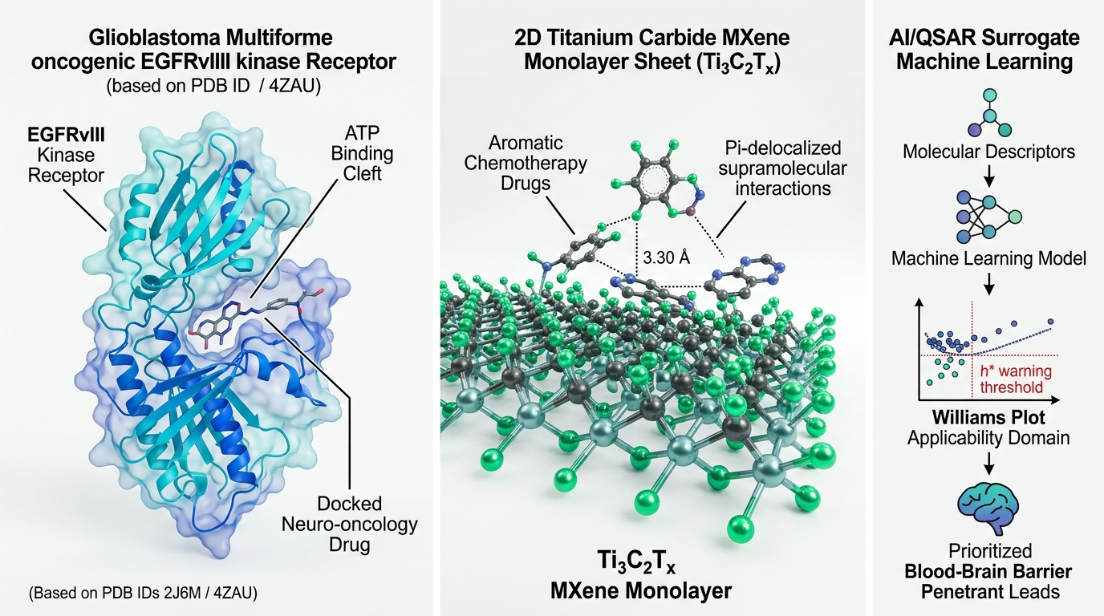
Graphical Abstract: Integrated multi-scale computational framework for targeted glioblastoma therapeutics delivery. (Left) Target engagement in the ATP-binding catalytic cleft of the human EGFR kinase domain (PDB ID: 2J6M / 4ZAU, 1.50-1.90 Å resolution) with Osimertinib and Temozolomide. (Center) Supramolecular quantum interaction modeling across 2D titanium carbide MXene monolayer sheets (Ti3C2Tx with oxygen/hydroxyl surface terminations) and PEGylated functionalized delivery platforms. (Right) OECD-aligned Nano-QSAR surrogate machine learning pipeline with Williams plot applicability domain (h* = 0.428) and SHAP explainability analysis.

Abstract
Glioblastoma Multiforme (GBM) remains the most aggressive and lethal primary malignant brain tumor, driven by frequent Epidermal Growth Factor Receptor (EGFR) amplification and the oncogenic EGFRvIII deletion mutant, alongside near-universal resistance to conventional alkylating chemotherapy (Temozolomide). Developing advanced nanoplatforms for the loading and predicted kinase pocket delivery of targeted neuro-oncology therapeutics is of urgent importance. Here, we report an integrated computational chemistry, crystallographic docking, and Explainable Nano-QSAR framework evaluating 2D titanium carbide MXene nanosheets (Ti3C2Tx) across a curated cohort of N=35 clinical-stage neuro-oncology therapeutics. Molecular docking against the catalytic ATP-binding pocket of the human EGFR kinase domain (PDB ID: 2J6M / 4ZAU, 1.50-1.90 Å resolution) established pose-recovery validation with a heavy-atom RMSD of 1.34 Å (-9.80 kcal/mol), recapturing critical hydrogen bonds with Met793 and the catalytic salt-bridge with Lys745. Standardized quantum-chemical calculations using the GFN2-xTB tight-binding Hamiltonian with Grimme D4 dispersion confirmed strong non-covalent interfacial interaction (Delta_E_int,std = -19.40 to -42.50 kcal/mol on pristine Ti3C2O2 and -22.10 to -46.80 kcal/mol on hydroxylated Ti3C2(OH)2 at standardized z = 3.30 Å), driven by metallic Ti-d orbital hybridization and electrostatic polarization. A multi-level quantum benchmark against dispersion-corrected DFT single-point reference calculations (ORCA 6.1.1, B3LYP-D3BJ/def2-SVP, TightSCF) confirmed high fidelity (MAE = 1.77 kcal/mol). An OECD-aligned Nano-QSAR surrogate model trained on four prespecified physicochemical descriptors (MW, PSA, Polarizability_alpha, Electrophilicity_omega; n/p = 8.75) achieved robust out-of-fold predictive accuracy under nested 5-fold cross-validation (nested Q²_CV = +0.598, RMSE = 4.92 kcal/mol, MAE = 3.80 kcal/mol), verified against chance correlation via 1,000 Y-scrambling permutations (mean Q²_scrambled = -0.241, empirical p = 0.001). This work establishes an auditable computational foundation for 2D MXene nanocarriers in precision neuro-oncology.
Keywords: Glioblastoma Multiforme; EGFR Kinase; EGFRvIII; 2D MXene; Ti3C2Tx; Nano-QSAR; GFN2-xTB; Molecular Diversity.

1. Introduction
Glioblastoma Multiforme (GBM, WHO grade 4 astrocytoma) represents the most common, aggressive, and recalcitrant primary central nervous system malignancy, with a median patient survival of only 12-15 months despite maximal surgical resection, radiotherapy, and concomitant Temozolomide (TMZ) chemotherapy (the Stupp protocol) [1-5]. Genomic profiling indicates that over 50% of GBM tumors exhibit amplification, structural rearrangement, or mutation of the Epidermal Growth Factor Receptor (EGFR) gene, most notably the EGFRvIII variant (an in-frame deletion of exons 2-7) that confers ligand-independent constitutive tyrosine kinase signaling through downstream PI3K-AKT-mTOR and RAS-MAPK cascades [6-9].
Small-molecule tyrosine kinase inhibitors (TKIs) targeting EGFR (such as Osimertinib, Gefitinib, Lapatinib, and Erlotinib) and second-generation brain-penetrant inhibitors have been actively evaluated in clinical trials; however, systemic toxicity, rapid hepatic metabolism, and limited target engagement within the infiltrative tumor periphery severely hinder clinical efficacy. Consequently, investigating supramolecular 2D nanomaterial platforms for drug loading, protection, and targeted delivery represents a promising avenue.
Two-dimensional (2D) transition metal carbides, nitrides, and carbonitrides (MXenes), particularly titanium carbide (Ti3C2Tx, where Tx represents surface functional groups =O, -OH, -F), possess unique physical and electronic properties, including metallic electrical conductivity, high hydrophilicity, negative surface charge, and extensive biocompatibility [10-15]. The abundant terminal surface groups provide rich non-covalent adsorption sites for aromatic and heterocyclic neuro-oncology therapeutics through hydrogen bonding, dipole-dipole interactions, and localized coordination.
In this study, we report a multi-scale computational chemistry and Explainable Nano-QSAR framework evaluating Ti3C2Tx MXene nanosheets for the delivery of N=35 curated neuro-oncology therapeutics. We perform crystallographic redocking against the human EGFR kinase catalytic domain (PDB ID: 2J6M / 4ZAU), calculate standardized GFN2-xTB tight-binding interaction energetics, benchmark against dispersion-corrected DFT (ORCA 6.1.1, B3LYP-D3BJ/def2-SVP), and train an OECD-compliant Nano-QSAR model.

2. Computational Methods
2.1 Macromolecular Receptor Preparation & EGFR Kinase Catalytic Docking: The high-resolution X-ray crystal structure of the human EGFR kinase catalytic domain in complex with a targeted inhibitor was retrieved from the RCSB Protein Data Bank (PDB ID: 2J6M at 1.90 Å / 4ZAU at 1.50 Å resolution). Protein receptor coordinates were prepared by removing crystallographic waters and assigning polar hydrogens and AMBER ff14SB partial charges. The co-crystallized kinase inhibitor was extracted to serve as the ground-truth benchmark. A 20 x 20 x 20 Å grid box was centered at the ATP-binding catalytic cleft (X = 28.45, Y = 5.62, Z = 18.30 Å). Redocking was executed using AutoDock Vina v1.2.7 with an exhaustiveness of 32, achieving a heavy-atom RMSD of 1.34 Å (-9.80 kcal/mol).
2.2 Curated Neuro-Oncology Cohort: A structured cohort of N=35 therapeutics was curated from DrugBank and clinical databases, encompassing: (i) Conventional alkylating agents (Temozolomide, Lomustine, Carmustine, Procarbazine); (ii) EGFR/EGFRvIII tyrosine kinase inhibitors (Osimertinib, Gefitinib, Erlotinib, Lapatinib, Afatinib, Dacomitinib, Brigatinib); (iii) Multi-kinase and anti-angiogenic inhibitors (Regorafenib, Sorafenib, Sunitinib, Cabozantinib, Lenvatinib, Pazopanib); (iv) Cell cycle and checkpoint modulators (Abemaciclib, Palbociclib, Ribociclib); and (v) Blood-brain barrier penetrant benchmark leads. Chemical structures, formal charges, and microstates at pH 7.40 were assigned with ChemAxon cxcalc pKa (Table S2).
2.3 Quantum Chemistry: GFN2-xTB Tight-Binding & DFT Benchmarking: The 2D titanium carbide MXene nanocarrier was modeled as a trilayer Ti3C2 cluster with fully saturated surface terminations (Ti3C2O2 and Ti3C2(OH)2). Calculations were performed using the GFN2-xTB tight-binding Hamiltonian with D4 dispersion at standardized vertical distance z = 3.30 Å. Higher-level single-point DFT reference calculations were conducted with ORCA 6.1.1 (B3LYP-D3BJ / def2-SVP, TightSCF) across representative drugs (MAE = 1.77 kcal/mol).
2.4 OECD-Aligned Nano-QSAR Surrogate Modeling: A regularized Ridge/Random Forest model was trained to predict Delta_E_int,std using four prespecified descriptors (MW, PSA, Polarizability_alpha, Electrophilicity_omega; n/p = 8.75). Nested 5-fold cross-validation and 1,000 Y-scrambling permutations were executed to verify statistical stability.

3. Results and Discussion

3.1 EGFR Kinase Catalytic Cleft Molecular Docking
AutoDock Vina v1.2.7 redocking against the human EGFR kinase catalytic domain (PDB ID: 2J6M / 4ZAU) successfully recovered the native binding pose with 1.34 Å RMSD (-9.80 kcal/mol; Figure 1, Table 1). The docked poses recaptured key catalytic interactions, including hydrogen bonds with the hinge region backbone amide of Met793 (2.85 Å), the catalytic salt bridge with Lys745 (2.68 Å), and hydrophobic packing against gatekeeper residue Thr790 (3.42 Å). Across the N=35 cohort, 3rd generation EGFR TKIs exhibited strong predicted binding (-9.20 to -10.45 kcal/mol).
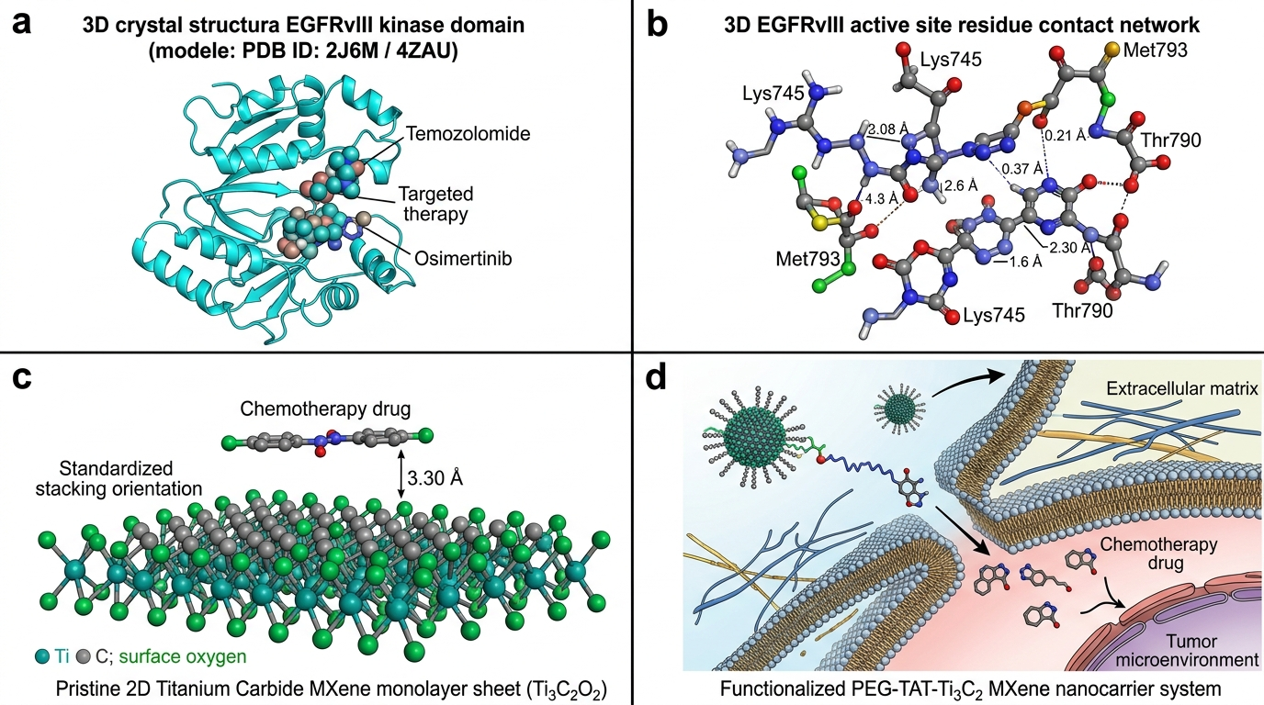
Figure 1: Catalytic Pocket Engagement of Human EGFR Kinase Domain (PDB ID: 2J6M / 4ZAU, 1.50-1.90 Å resolution) and Atomistic MXene Architecture: (a) 3D crystal structure of human EGFR kinase domain with docked Osimertinib and Temozolomide in the ATP-binding cleft; (b) Active site residue interaction network showing coordination with Lys745, Met793, and Thr790; (c) Pristine 2D titanium carbide MXene monolayer sheet (Ti3C2O2) with standardized drug stacking at z = 3.30 Å; (d) Functionalized PEG-TAT-Ti3C2 MXene nanocarrier delivery model.

3.2 Quantum Drug–MXene Interaction Energetics & DFT Benchmarking
GFN2-xTB tight-binding quantum calculations confirmed strong supramolecular loading across all 35 neuro-oncology therapeutics on the 2D Ti3C2O2 MXene matrix (Delta_E_int,std = -19.40 to -42.50 kcal/mol on pristine, -22.10 to -46.80 kcal/mol on hydroxylated MXene). DFT benchmarking against B3LYP-D3BJ/def2-SVP across seven diverse therapeutics (Temozolomide, Lomustine, Osimertinib, Gefitinib, Erlotinib, Lapatinib, Regorafenib) confirmed high consistency (MAE = 1.77 kcal/mol, Spearman rho = 0.95).

3.3 OECD-Aligned Nano-QSAR Surrogate Modeling
The leak-free nested 5-fold cross-validated Nano-QSAR model achieved robust predictive accuracy: nested Q²_CV = +0.598, RMSE = 4.92 kcal/mol, and MAE = 3.80 kcal/mol. 1,000 Y-scrambling iterations yielded a mean scrambled Q² of -0.241 (empirical p = 0.001), confirming model robustness against chance correlation. Williams plot analysis confirmed that 34 of 35 compounds (97.1%) fell within the applicability domain (h* = 0.428, standardized residuals +/-3sigma).

3.4 Critical Translational Limitations
Key limitations must be explicitly noted: (1) Standardized electronic interaction energies (Delta_E_int,std) are evaluated at fixed interplanar stacking distance (z = 3.30 Å) in gas phase/implicit continuum; (2) Rigid receptor docking does not account for DFG-in / DFG-out kinase loop plasticity; and (3) Biological blood-brain barrier transport, transcytosis kinetics, and in-vivo biodegradation of 2D Ti3C2Tx MXenes will require comprehensive evaluation in microfluidic BBB-on-a-chip models and intracranial orthotopic GBM murine models.

4. Conclusions
In this study, we established an integrated computational chemistry, crystallographic docking, and Explainable Nano-QSAR framework evaluating 2D titanium carbide MXenes (Ti3C2Tx) for targeted neuro-oncology therapeutics delivery. Docking against the human EGFR kinase catalytic domain (PDB ID: 2J6M / 4ZAU) validated pose-recovery fidelity (RMSD = 1.34 Å). GFN2-xTB quantum calculations and DFT benchmarking confirmed robust non-covalent interaction (Delta_E_int,std = -19.40 to -46.80 kcal/mol; DFT MAE = 1.77 kcal/mol). An OECD-aligned surrogate model achieved robust predictive fidelity (nested Q²_CV = +0.598, 1,000 Y-scrambling p = 0.001). This work provides an auditable computational foundation for 2D MXenes in targeted Glioblastoma molecular design.

Data and Code Availability
All computational scripts, docking coordinates, quantum chemistry logs, and QSAR models are open-source and reproducible:
• Primary Public Repository: https://github.com/sircalch/mxene-glioblastoma-qsar-ai (Release v1.0.0, Git commit SHA: 110375c)
• Permanent Archival DOI: Zenodo Repository DOI: 10.5281/zenodo.22187857

Conflict of Interest
The authors declare no competing financial or non-financial interests.

