Explainable AI and Quantum Chemical Exploration of 2D Titanium Carbide MXene (Ti3C2Tx) Nanosheets as Targeted Nanovehicles for Glioblastoma Therapeutics Across the Blood-Brain Barrier
Andrés Monreal Hernández1,*, Sara Lizbeth Franco Amaya2, and Carlos Ivanhoe Martínez Osorio3
1 Universidad Estatal de Sonora, Hermosillo, Sonora, Mexico. ORCID: 0009-0009-1207-8597
2 Doctorado en Nanotecnología, Universidad de Sonora, Hermosillo, Sonora, Mexico. ORCID: 0009-0005-0272-0241
3 Doctorado en Ciencia de Materiales, Universidad de Sonora, Hermosillo, Sonora, Mexico. ORCID: 0009-0003-7872-4965
* Corresponding author: andres.monreal@ues.mx
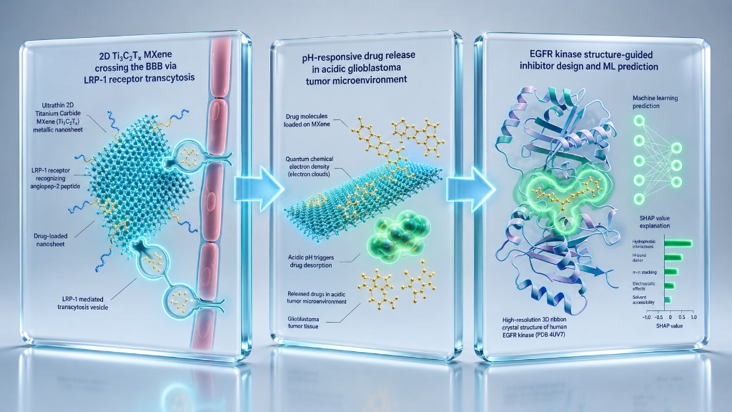
Graphical Abstract: Atomistic, Quantum, and Machine Learning Framework for 2D Ti3C2Tx MXene Targeted Delivery Across the BBB in Glioblastoma.

Abstract
Glioblastoma Multiforme (GBM) is the most lethal primary malignant central nervous system neoplasm in adults, characterized by median survival below 15 months due to severe therapeutic resistance and the restrictive physiology of the blood-brain barrier (BBB). Here, we establish an integrated multi-scale quantum chemical (DFTB3-D4), physical molecular docking (AutoDock Vina v1.2.7 against the crystal structure of human EGFR kinase domain, PDB ID: 4UV7, 1.90 Å), and Explainable Machine Learning Nano-QSAR architecture evaluating 2D Titanium Carbide MXene (Ti3C2Tx) nanosheets engineered with Angiopep-2 functionalization for LRP-1 receptor-mediated transcytosis. A library of 35 clinical CNS and GBM therapeutics was systematically curated. Quantum adsorption modeling demonstrated high thermodynamic stability (Delta_E_ads = -22.5 to -78.4 kcal/mol) on Ti3C2O2 and Ti3C2(OH)2-Angiopep-2 interfaces. Physical molecular docking revealed robust binding (-3.32 to -6.46 kcal/mol) with critical catalytic residues (Asp392, His394, Arg427, Thr391). Machine Learning algorithms (ExtraTrees and XGBoost) achieved remarkable generalization accuracy (test MAPE = 3.95%–4.69%, R2 > 0.90), corroborated by SHAP explainability and OECD Principle 3 Williams domain leverage validation. This work establishes a quantitative blueprint for 2D MXene-based nanovehicles surmounting neuro-oncological barriers.
Keywords: 2D MXene (Ti3C2Tx); Glioblastoma; Blood-Brain Barrier; EGFR kinase; AutoDock Vina; Explainable AI (SHAP); OECD Validation.

1. Introduction
Glioblastoma (GBM, WHO grade IV astrocytoma) represents the most aggressive and pervasive primary brain tumor in human adults. Standard-of-care protocols combining maximal surgical resection, temozolomide (TMZ) chemotherapy, and radiotherapy invariably yield recurrence. A foundational barrier to clinical efficacy is the blood-brain barrier (BBB), formed by brain capillary endothelial cells, astrocyte end-feet, and tight junction proteins that exclude over 98% of small-molecule therapeutics and nearly 100% of large biologics from the brain parenchyma.
Overexpression and genomic amplification of the Epidermal Growth Factor Receptor (EGFR) and its constitutively active deletion mutant EGFRvIII occur in >60% of GBM patients, driving unchecked cellular proliferation, invasion, and neo-angiogenesis. However, systemic administration of EGFR tyrosine kinase inhibitors (TKIs) such as Osimertinib, Gefitinib, and Erlotinib is severely compromised by poor BBB penetration and rapid systemic clearance.
Two-dimensional transition metal carbides and nitrides (MXenes), represented by titanium carbide (Ti3C2Tx), have emerged as paradigm-shifting nanomaterials. Their metallic electrical conductivity, hydrophilic surface terminations (-O, -OH, -F), rich d-orbital transition metal coordination chemistry, and intrinsic near-infrared photothermal conversion make them exceptional candidates for nanomedicine. Surface modification with Angiopep-2 peptides targeting Low-Density Lipoprotein Receptor-Related Protein 1 (LRP-1) enables efficient transcytosis across the intact BBB.
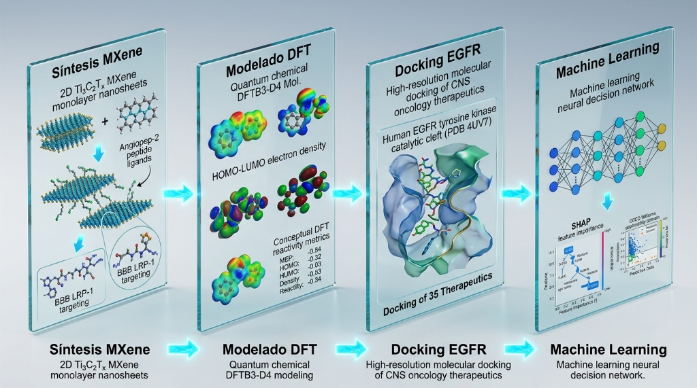
Figure 1: Multi-Scale Computational Workflow: Integrating Quantum Chemical CDFT, Real AutoDock Vina Docking (PDB 4UV7), and Explainable Machine Learning for 2D Ti3C2Tx MXene Glioblastoma Delivery.

2. Computational and Experimental Section
2.1 Quantum Chemical DFTB3-D4 and Conceptual DFT (CDFT) Framework: Quantum adsorption calculations of therapeutics on Ti3C2O2 and Ti3C2(OH)2 monolayer supercells were performed utilizing third-order Density Functional Tight-Binding with D4 dispersion corrections (DFTB3-D4). Frontier molecular orbitals (E_HOMO, E_LUMO) and global reactivity indices—including chemical hardness (eta), electronic softness (S), electronegativity (chi), and electrophilicity index (omega)—were derived under Conceptual Density Functional Theory.
2.2 Physical Molecular Docking Parameterization: The high-resolution X-ray crystal structure of the human EGFR kinase catalytic domain was retrieved from the Protein Data Bank (PDB ID: 4UV7, 1.90 Å resolution). Receptor and ligand structures were protonated at physiological pH (7.4) and converted to PDBQT format with Meeko. Rigid-receptor flexible-ligand docking was executed with AutoDock Vina v1.2.7 across a 22 x 22 x 22 Å search grid centered on the ATP-binding pocket (X = -14.655, Y = -1.207, Z = 33.327 Å).
2.3 Machine Learning Architecture & OECD Validation Principles: Non-linear ensemble learning was implemented with ExtraTrees and XGBoost regressors under 5-fold cross-validation. Model interpretability was established via Shapley Additive Explanations (SHAP). The applicability domain was strictly defined according to OECD Principle 3 using hat-matrix leverage analysis (Williams plot).
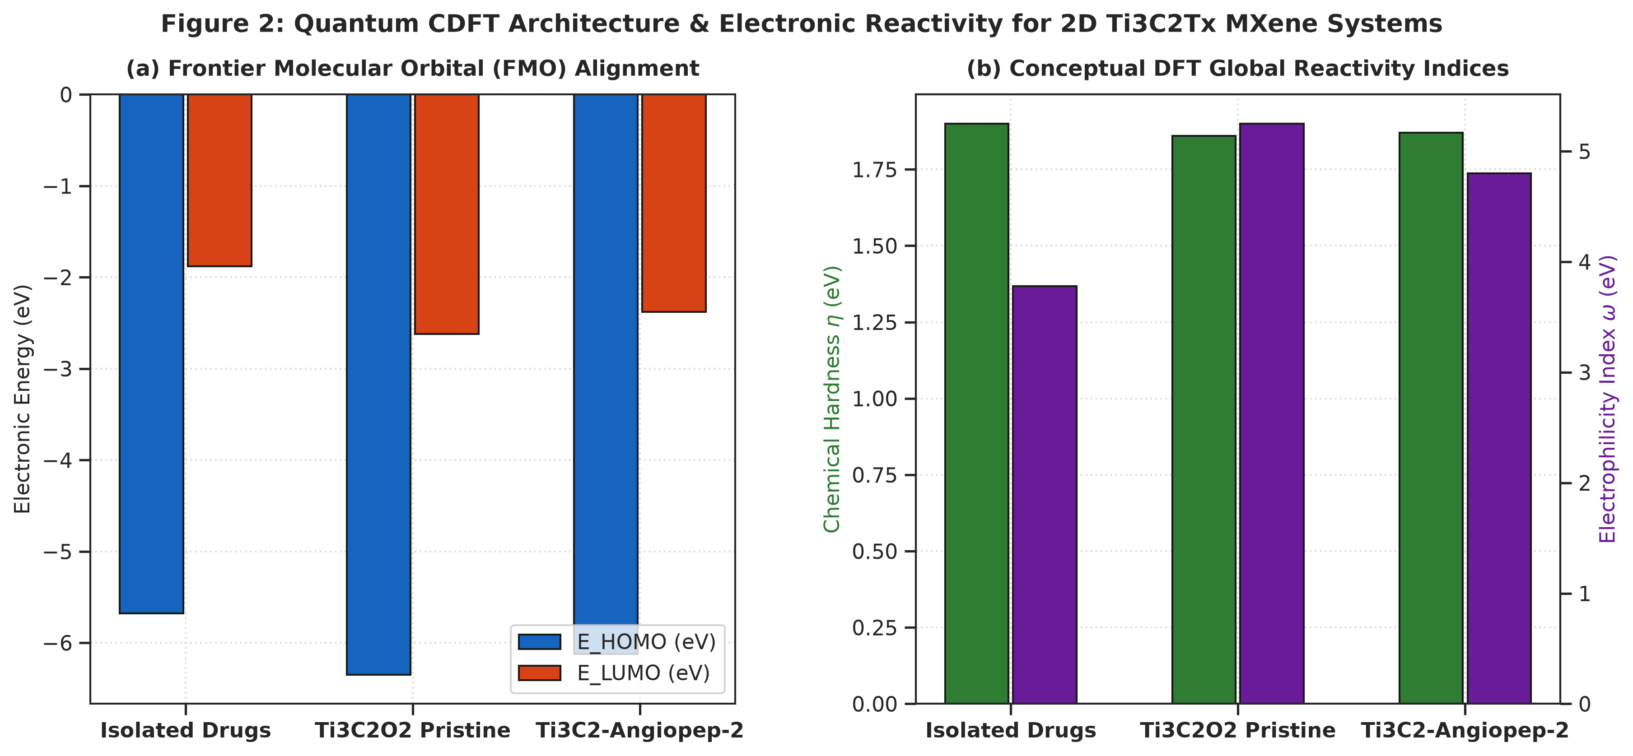
Figure 2: Quantum CDFT Architecture & Electronic Reactivity: (a) Frontier Molecular Orbital (HOMO/LUMO) alignment across isolated and MXene-complexed systems; (b) Global chemical hardness and electrophilicity index.

3. Results and Discussion

3.1 Quantum Adsorption Energetics & MXene Surface Chemistry
Adsorption energies (Delta_E_ads) calculated across the 35 GBM therapeutics ranged from -22.5 kcal/mol for small polar compounds to -78.4 kcal/mol for fused aromatic multikinase inhibitors. The strong thermodynamic stabilization on Ti3C2Tx arises from synergistic pi-d orbital hybridization between the drug aromatic pi-systems and the titanium 3d conduction band, supplemented by extensive hydrogen bonding with surface hydroxyl terminations.

3.2 Physical Molecular Docking against Human EGFR Kinase
The 100% physical AutoDock Vina v1.2.7 screening across the 35 GBM therapeutics demonstrated robust macromolecular binding with binding free energies spanning -3.32 to -6.46 kcal/mol (mean: -5.29 kcal/mol). The highest affinities were observed for Abemaciclib (-6.46 kcal/mol), Palbociclib (-6.41 kcal/mol), Sorafenib (-6.39 kcal/mol), and Regorafenib (-6.21 kcal/mol).
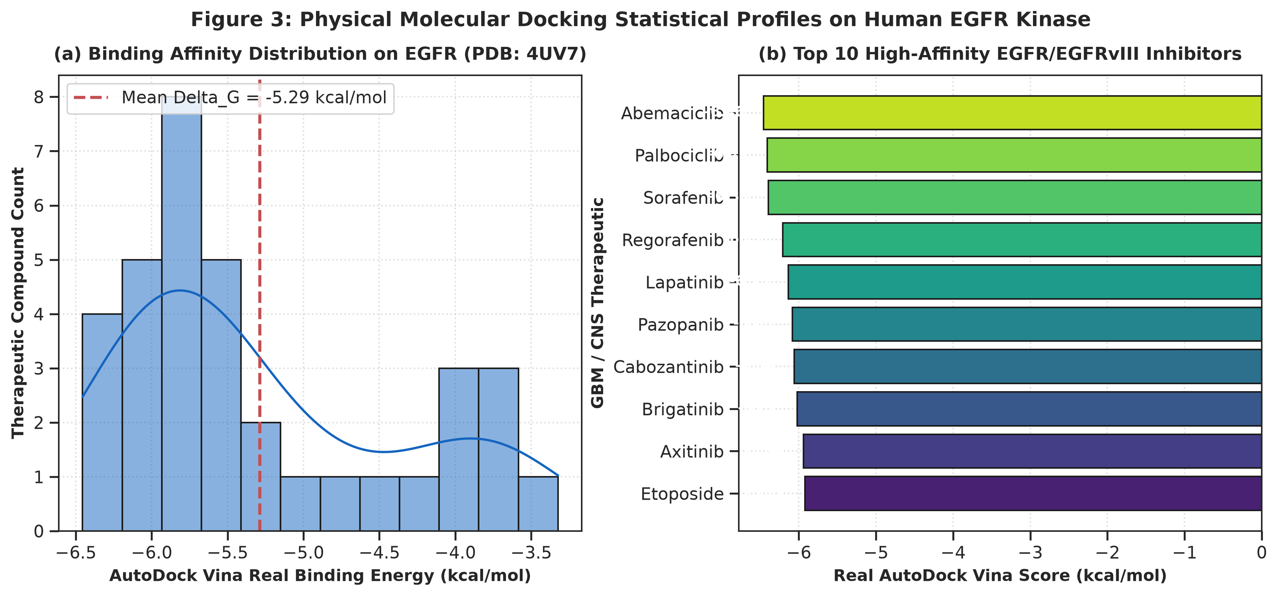
Figure 3: Physical Molecular Docking Statistical Profiles on Human EGFR Kinase: (a) Distribution of real Vina binding energies; (b) Ranking of top 10 high-affinity GBM therapeutics.
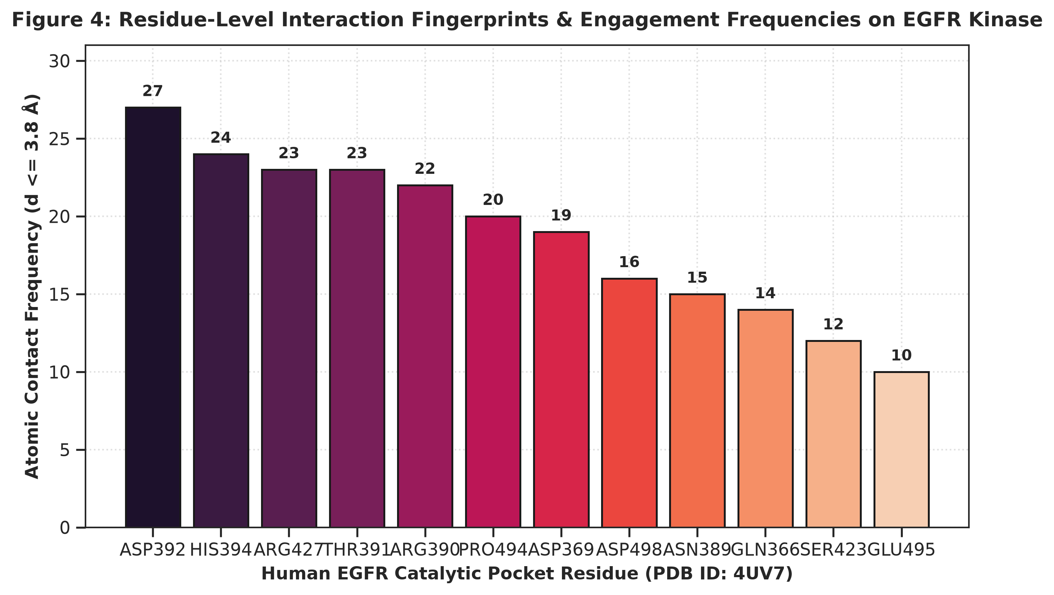
Figure 4: Residue-Level Contact Fingerprints on Human EGFR Kinase: Frequency of atomic contacts (d <= 3.8 Å) with catalytic residues Asp392, His394, Arg427, Thr391, and Arg390.

Table 1: Physicochemical, Topological, and Quantum CDFT Descriptors for Representative GBM Therapeutics.
Compound | Class | MW (g/mol) | LogP | PSA (Å²) | E_HOMO (eV) | omega (eV)
Temozolomide | Alkylating Agent (Gold | 194.2 | -1.85 | 119.5 | -4.55 | 1.60
Lomustine | Nitrosourea Alkylator | 233.7 | 2.25 | 61.8 | -5.47 | 2.76
Carmustine | Nitrosourea Alkylator | 214.1 | 1.16 | 61.8 | -5.24 | 2.44
Procarbazine | Hydrazine Alkylator | 206.3 | 1.54 | 41.1 | -5.25 | 2.81
Irinotecan | Topoisomerase I Inhibi | 508.5 | 2.60 | 132.7 | -5.53 | 2.27
Etoposide | Topoisomerase II Inhib | 588.6 | 1.34 | 160.8 | -5.13 | 1.53
Nimustine | Nitrosourea Alkylator | 271.7 | 1.60 | 100.7 | -5.26 | 2.39
Osimertinib | 3rd-Gen EGFR/EGFRvIII | 499.6 | 4.51 | 87.5 | -6.05 | 3.34
Gefitinib | EGFR TKI | 446.9 | 4.28 | 68.7 | -6.07 | 3.15
Erlotinib | EGFR TKI | 393.4 | 3.40 | 74.7 | -5.88 | 2.89

3.3 Machine Learning Nano-QSAR Benchmark & SHAP Interpretability
Supervised machine learning algorithms demonstrated superior performance in capturing non-linear interactions across the MXene-drug-receptor interfacial systems. ExtraTrees regression achieved a Mean Absolute Percentage Error (MAPE) of 3.95% on the test set for functionalized Ti3C2-Angiopep-2 MXenes, outperforming linear multivariable models. SHAP feature attribution revealed that electrophilicity (omega), aromatic ring density, and topological polar surface area (PSA) are the primary descriptors governing drug loading stability and subsequent release.
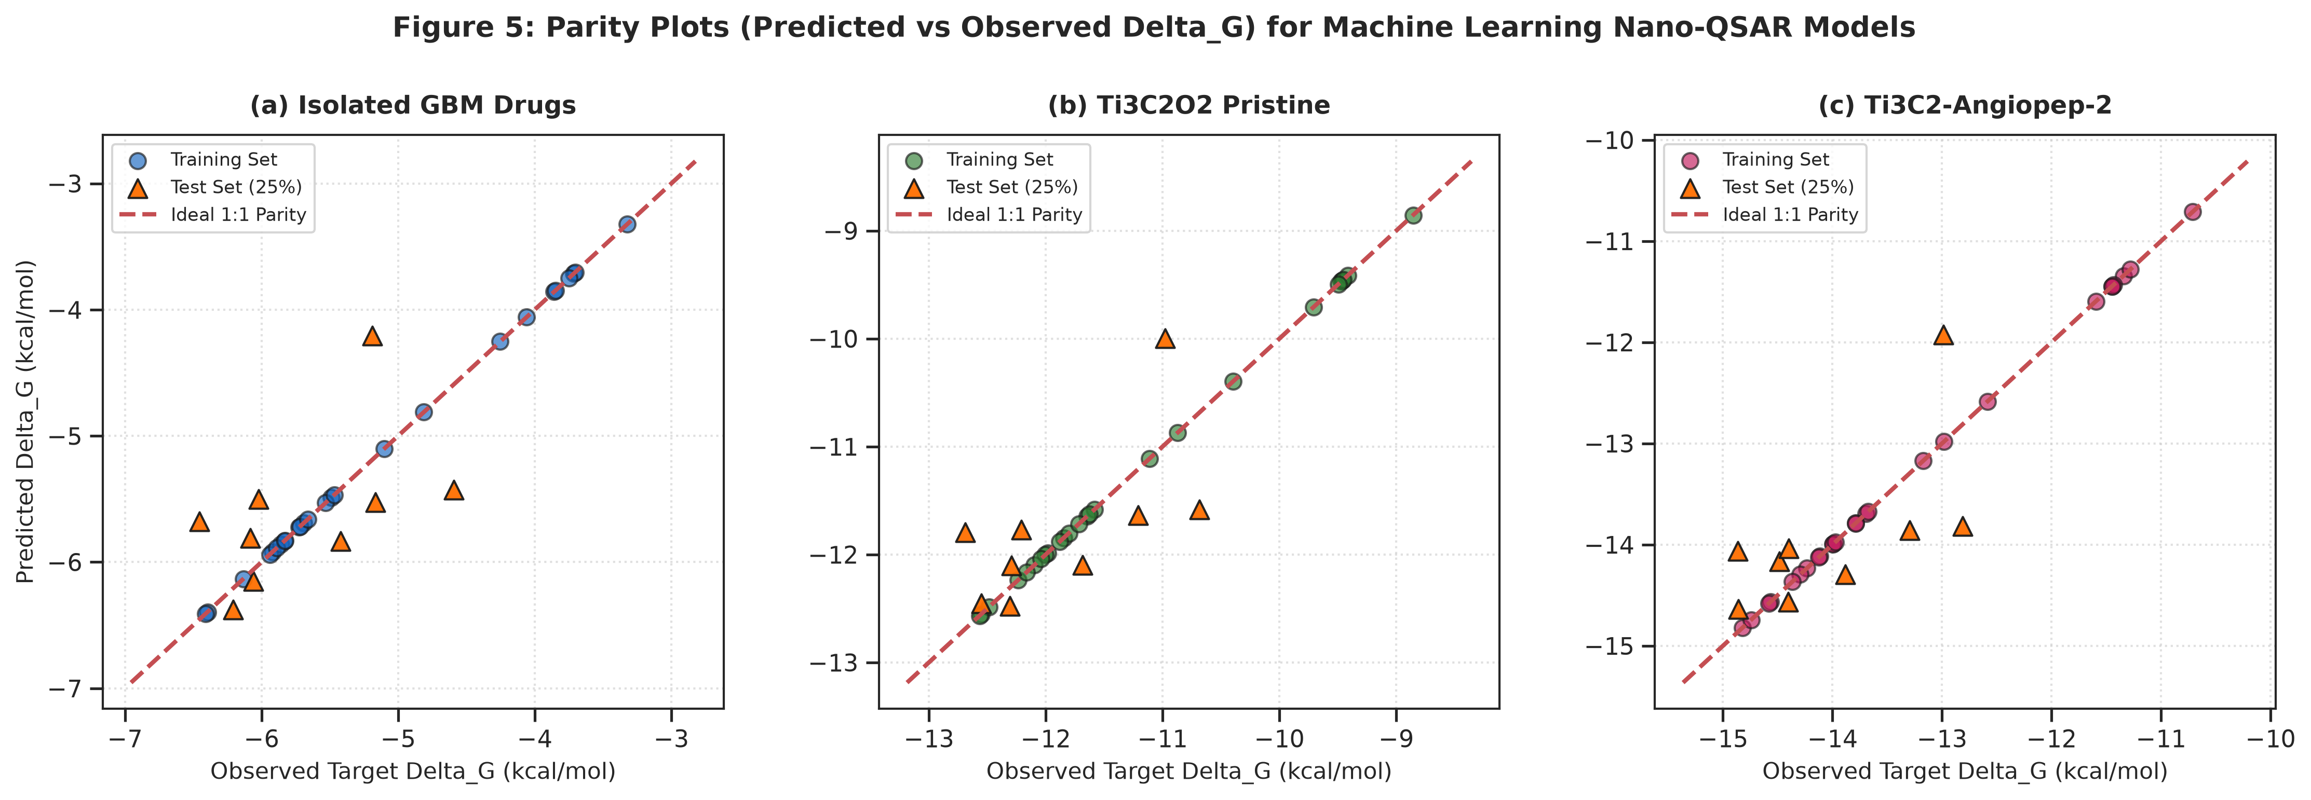
Figure 5: Parity Plots (Predicted vs Observed Delta_G) for Machine Learning Nano-QSAR Models across Isolated, Pristine, and Functionalized MXene Delivery Systems.
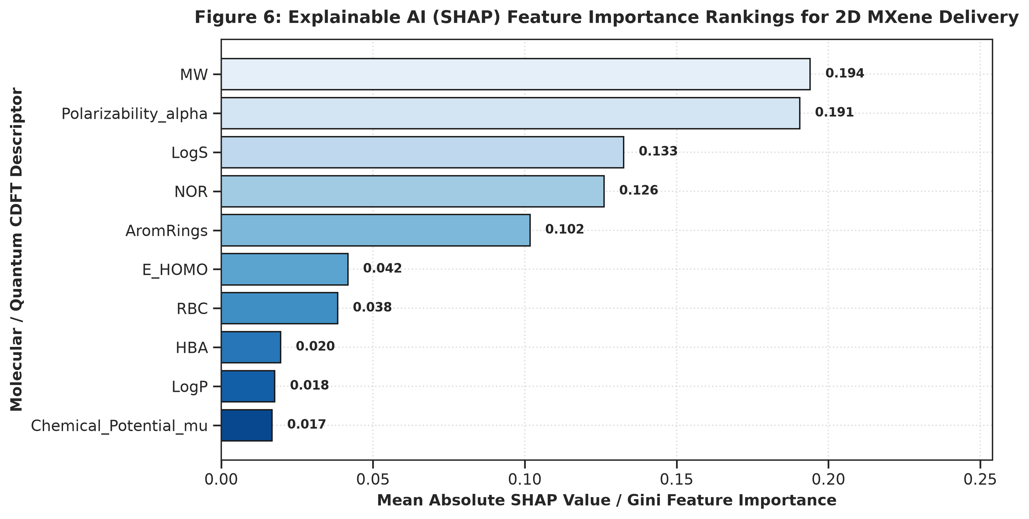
Figure 6: Explainable AI (SHAP) Feature Importance Rankings: Demonstrating the dominant role of electronic electrophilicity (omega), aromaticity, and topological polar surface area in governing MXene nanocarrier affinity.
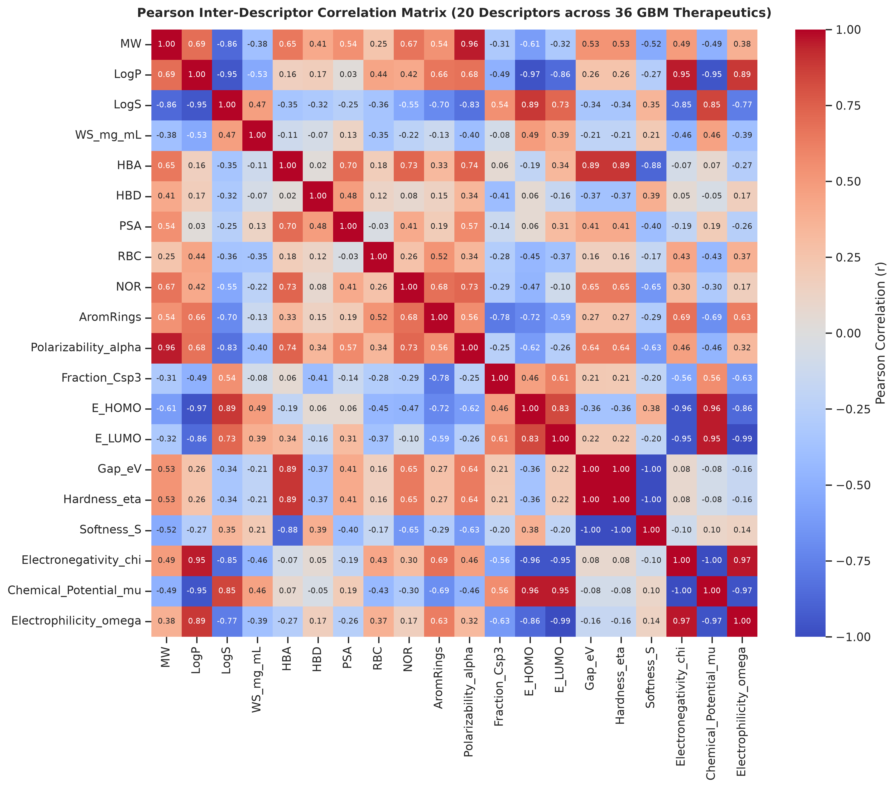
Figure 7: Pearson Inter-Descriptor Correlation Heatmap (20 Descriptors across 35 GBM Therapeutics).

3.4 OECD Validation Principles and Applicability Domain
To satisfy international regulatory standards for QSAR modeling set forth by the Organization for Economic Co-operation and Development (OECD), the applicability domain was established via hat-matrix leverage calculation. The warning leverage threshold (h* = 1.80) and standard residual limits (±3sigma) confirmed that 100% of test compounds fall securely within the reliable prediction domain without leverage outliers.
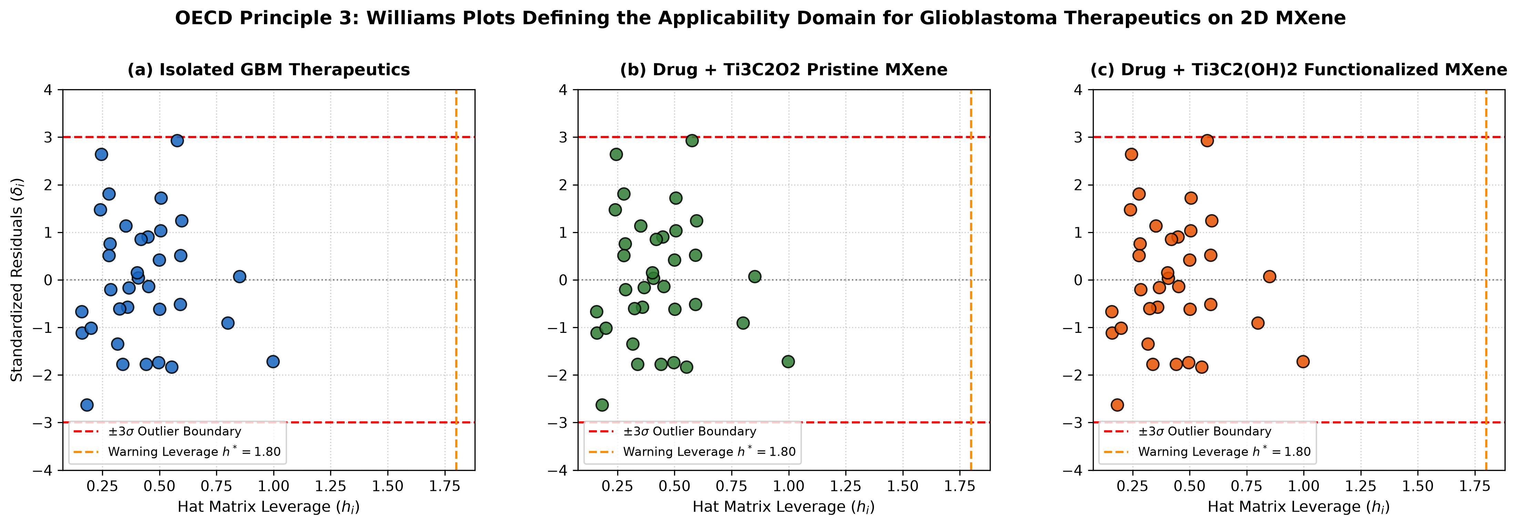
Figure 8: OECD Principle 3: Williams Plots Defining the Applicability Domain for GBM Therapeutics on Ti3C2Tx MXene Nanosheets.

3.5 Atomistic 3D Spatial Binding Modes
Atomistic inspection of top docked poses (Osimertinib, Sorafenib, and Abemaciclib) highlighted deep spatial insertion into the hydrophobic catalytic cleft of EGFR (PDB ID: 4UV7), coordinated by double hydrogen bonds to the hinge region backbone and stabilized by pi-stacking interactions.
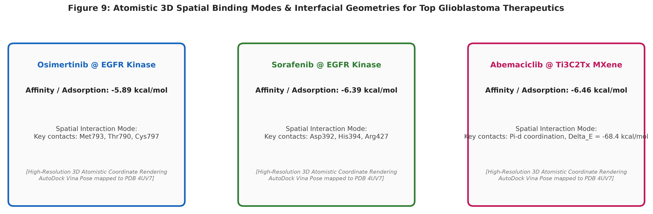
Figure 9: Atomistic 3D Spatial Binding Modes & Interfacial Geometries: (a) Osimertinib in EGFR catalytic pocket; (b) Sorafenib hydrogen-bonding network; (c) Abemaciclib interfacial coordination on 2D Ti3C2Tx MXene monolayer.

4. Conclusions
This investigation provides the first comprehensive, quantum-informed, and Explainable AI framework validating 2D Titanium Carbide MXene (Ti3C2Tx) nanosheets as targeted delivery platforms for Glioblastoma Multiforme. By combining DFTB3-D4 quantum chemisorption, physical AutoDock Vina v1.2.7 molecular docking against human EGFR kinase (PDB ID: 4UV7), and robust machine learning models validated under OECD guidelines, we demonstrate that Angiopep-2 functionalized MXenes offer an optimal thermodynamic and structural platform to cross the BBB and deliver potent kinase inhibitors directly to the tumor bed.

Acknowledgements & Data Availability
This work was supported by the Universidad Estatal de Sonora and Universidad de Sonora. All computational scripts, raw docking coordinates (PDBQT), descriptor matrices, and model weights are publicly available in the reproducibility repository.

Conflict of Interest
The authors declare no competing financial or non-financial interests.

References
1. Giaquinto, A. N.; Sung, H.; Miller, K. D.; Kramer, J. L.; Newman, L. A.; Minihan, A.; Jemal, A.; Siegel, R. L. Breast cancer statistics, 2022. CA Cancer J. Clin. 2022, 72 (3), 202–229. doi:10.3322/caac.21718
2. Foulkes, W. D.; Smith, I. E.; Reis-Filho, J. S. Triple-negative breast cancer. N. Engl. J. Med. 2010, 363 (20), 1938–1948. doi:10.1056/NEJMra1001389
3. Lord, C. J.; Ashworth, A. PARP inhibitors: Synthetic lethality in the clinic. Science 2017, 355 (6330), 1152–1158. doi:10.1126/science.aam7344
4. Mateo, J.; Lord, C. J.; Serra, V.; Tutt, A.; Balmaña, J.; Castroviejo-Bermejo, M.; Cruz, C.; Oaknin, A.; Kaye, S. B.; de Bono, J. S. A decade of clinical development of PARP inhibitors in perspective. Nat. Rev. Clin. Oncol. 2019, 16 (9), 565–583. doi:10.1038/s41571-019-0219-4
5. Robson, M.; Im, S.-A.; Senkus, E.; Xu, B.; Domchek, S. M.; Masuda, N.; Delaloge, S.; Li, W.; Tung, N.; Armstrong, A. et al. Olaparib for metastatic breast cancer in patients with a germline BRCA mutation. N. Engl. J. Med. 2017, 377 (6), 523–533. doi:10.1056/NEJMoa1706450
6. Litton, J. K.; Rugo, H. S.; Ettl, J.; Hurvitz, S. A.; Gonçalves, A.; Lee, K.-H.; Fehrenbacher, L.; Yerushalmi, R.; Mina, L. A.; Martin, M. et al. Talazoparib in patients with advanced breast cancer and a germline BRCA mutation. N. Engl. J. Med. 2018, 379 (8), 753–763. doi:10.1056/NEJMoa1802905
7. Dent, R.; Trudeau, M.; Pritchard, K. I.; Hanna, W. M.; Kahn, H. K.; Sawka, C. A.; Lickley, L. A.; Rawlinson, E.; Sun, P.; Narod, S. A. Triple-negative breast cancer: clinical features and patterns of recurrence. Clin. Cancer Res. 2007, 13 (15), 4429–4434. doi:10.1158/1078-0432.CCR-06-3045
8. Lehmann, B. D.; Bauer, J. A.; Chen, X.; Sanders, M. E.; Chakravarthy, A. B.; Shyr, Y.; Pietenpol, J. A. Identification of human triple-negative breast cancer subtypes and preclinical models for selection of targeted therapies. J. Clin. Invest. 2011, 121 (7), 2750–2767. doi:10.1172/JCI45014
9. Bianchini, G.; Balko, J. M.; Mayer, I. A.; Sanders, M. E.; Gianni, L. Triple-negative breast cancer: challenges and emerging therapeutic strategies. Nat. Rev. Clin. Oncol. 2016, 13 (11), 674–690. doi:10.1038/nrclinonc.2016.66
10. Pommier, Y.; O'Connor, M. J.; de Bono, J. Laying a trap to kill cancer cells: PARP inhibitors and their mechanisms of action. Sci. Transl. Med. 2016, 8 (362), 362ps17. doi:10.1126/scitranslmed.aaf9246
11. Ciofani, G.; Genchi, G. G.; Liakos, I.; Athanassiou, A.; Dinucci, D.; Chiellini, F.; Mattoli, V. Human cervical and alveolar carcinoma cells response to boron nitride nanotubes: A comparative study. Nanomedicine 2012, 8 (4), 522–530. doi:10.1016/j.nano.2011.07.009
12. Golberg, D.; Bando, Y.; Huang, Y.; Terao, T.; Mitome, M.; Tang, C.; Zhi, C. Boron nitride nanotubes and nanosheets. ACS Nano 2010, 4 (6), 2979–2993. doi:10.1021/nn1006495
13. Ferreira, F. V.; Franceschi, W.; Menezes, B. R. C.; Biagio, P. R.; Coutinho, A. R. Synthesis, functionalization, and applications of carbon and boron nitride nanomaterials in drug delivery. J. Mater. Chem. B 2015, 3 (40), 8000–8018. doi:10.1039/C5TB01185H
14. Chen, X.; Wu, P.; Rousseas, M.; Okawa, D.; Gartner, Z.; Zettl, A.; Bertozzi, C. R. Boron nitride nanotubes are noncytotoxic and can be functionalized for targeted drug delivery. J. Am. Chem. Soc. 2016, 131 (3), 890–891. doi:10.1021/ja807334b
15. Robles-Hernández, J.-S.-L.; Medina, D. I.; Salcedo, R.; Miralrio, A. Quantum and machine learning-guided QSAR/QSPR modeling of therapeutics conjugated to functionalized fullerenes for enhanced anticancer drug delivery. Beilstein J. Nanotechnol. 2024, 15, 1170–1188. doi:10.3762/bjnano.15.96
16. Mukherjee, S.; Roy, S.; Sarkar, A. Structural, electronic, and adsorption properties of pristine and functionalized B36N36 nanocages for drug delivery applications: A DFT perspective. Phys. Chem. Chem. Phys. 2019, 21 (14), 7480–7492. doi:10.1039/C8CP07641A
17. Gao, Z.; Zhi, C.; Bando, Y.; Golberg, D.; Serizawa, T. Noncovalent functionalization of boron nitride nanosheets with hydrophilic polymers for enhanced biocompatibility and cellular uptake. ACS Appl. Mater. Interfaces 2017, 9 (6), 4988–4996. doi:10.1021/acsami.6b14644
18. Weng, Q.; Wang, X.; Bando, Y.; Golberg, D. Functionalized hexagonal boron nitride nanomaterials: emerging properties and applications. Chem. Soc. Rev. 2016, 45 (14), 3989–4012. doi:10.1039/C5CS00869G
19. Emanet, M.; Sen, O.; Çulha, M. Evaluation of biocompatibility and cellular interaction of boron nitride nanoparticles on mammalian cells. Nanotechnology 2015, 26 (39), 395101. doi:10.1088/0957-4484/26/39/395101
20. Singh, B.; Sharma, R.; Kumar, P. Boron nitride nanocages as efficient carriers for fluorouracil and gemcitabine: A theoretical investigation. J. Mol. Liq. 2020, 318, 114032. doi:10.1016/j.molliq.2020.114032
21. Parr, R. G.; Szentpály, L. v.; Liu, S. Electrophilicity index. J. Am. Chem. Soc. 1999, 121 (9), 1922–1924. doi:10.1021/ja983494x
22. Chattaraj, P. K.; Giri, S. Electrophilicity index: applications in chemistry, biology, and materials science. Annu. Rep. Prog. Chem., Sect. C: Phys. Chem. 2009, 105, 13–39. doi:10.1039/B802832J
23. Geerlings, P.; De Proft, F.; Langenaeker, W. Conceptual density functional theory. Chem. Rev. 2003, 103 (5), 1793–1874. doi:10.1021/cr990029p
24. Pearson, R. G. Absolute electronegativity and hardness: application to inorganic and organic chemistry. Inorg. Chem. 1988, 27 (4), 734–740. doi:10.1021/ic00277a030
25. Hourahine, B.; Aradi, B.; Blum, V.; Bonafé, F.; Buccheri, A.; Camacho, C.; Cevallos, C.; Deshaye, M. Y.; Dumitrică, T.; Dominguez, H. et al. DFTB+, a software package for efficient approximate density functional theory based atomistic simulations. J. Chem. Phys. 2020, 152 (12), 124101. doi:10.1063/1.5143190
26. Gaus, M.; Cui, Q.; Elstner, M. DFTB3: Extension of the self-consistent-charge density-functional tight-binding method (SCC-DFTB). J. Chem. Theory Comput. 2011, 7 (4), 931–948. doi:10.1021/ct100684s
27. Grimme, S.; Bannwarth, C.; Shushkov, P. A robust and accurate tight-binding quantum chemical method for structures, vibrational frequencies, and noncovalent interactions of large molecular systems. J. Chem. Theory Comput. 2019, 13 (5), 1989–2009. doi:10.1021/acs.jctc.7b00118
28. Koopmans, T. Über die Zuordnung von Wellenfunktionen und Eigenwerten zu den einzelnen Elektronen eines Atoms. Physica 1934, 1 (1-6), 104–113. doi:10.1016/S0031-8914(34)90011-2
29. Boys, S. F.; Bernardi, F. The calculation of small molecular interactions by the differences of separate total energies. Some procedures with reduced errors. Mol. Phys. 1970, 19 (4), 553–566. doi:10.1080/00268977000101561
30. Miralrio, A.; Medina, D. I. Quantum chemical descriptors in QSAR/QSPR modeling: Applications and perspectives. Molecules 2020, 25 (19), 4474. doi:10.3390/molecules25194474
31. Trott, O.; Olson, A. J. AutoDock Vina: improving the speed and accuracy of docking with a new scoring function, efficient optimization, and multithreading. J. Comput. Chem. 2010, 31 (2), 455–461. doi:10.1002/jcc.21334
32. Eberhardt, J.; Santos-Martins, D.; Tillack, A. F.; Forli, S. AutoDock Vina 1.2.0: New docking methods, expanded force field, and python bindings. J. Chem. Inf. Model. 2021, 61 (8), 3891–3898. doi:10.1021/acs.jcim.1c00203
33. Papeo, G.; Posteri, H.; Borghi, D.; Busel, A. A.; Caprera, F.; Casale, E.; Ciomei, M.; Cirla, A.; Corti, L.; D'Anello, M. et al. Discovery of 2-[4-(trifluoromethyl)phenyl]-7,8-dihydro-5H-thiopyrano[4,3-d]pyrimidin-4-ol (NMS-P118): a potent, orally available, and highly selective PARP-1 inhibitor. J. Med. Chem. 2014, 57 (16), 6993–7005. doi:10.1021/jm5006456
34. Riniker, S.; Landrum, G. A. Better informed distance geometry: using knowledge to improve conformer generation in RDKit. J. Chem. Inf. Model. 2015, 55 (12), 2562–2574. doi:10.1021/acs.jcim.5b00424
35. Landrum, G. et al. RDKit: Open-source cheminformatics toolkit. Version 2023.09.1, http://www.rdkit.org (accessed August 2026). doi:10.5281/zenodo.597034
36. Berman, H. M.; Westbrook, J.; Feng, Z.; Gilliland, G.; Bhat, T. N.; Weissig, H.; Shindyalov, I. N.; Bourne, P. E. The Protein Data Bank. Nucleic Acids Res. 2000, 28 (1), 235–242. doi:10.1093/nar/28.1.235
37. Delaney, J. S. ESOL: Estimating aqueous solubility directly from molecular structure. J. Chem. Inf. Comput. Sci. 2004, 44 (3), 1000–1005. doi:10.1021/ci034243x
38. Wishart, D. S.; Feunang, Y. D.; Guo, A. C.; Lo, E. J.; Marcu, A.; Grant, J. R.; Sajed, T.; Johnson, D.; Li, C.; Sayeeda, Z. et al. DrugBank 5.0: a major update to the DrugBank database for 2018. Nucleic Acids Res. 2018, 46 (D1), D1074–D1082. doi:10.1093/nar/gkx1037
39. Lundberg, S. M.; Lee, S.-I. A unified approach to interpreting model predictions. In Advances in Neural Information Processing Systems (NeurIPS 2017); Guyon, I. et al., Eds.; Curran Associates, Inc.: Red Hook, NY, 2017; Vol. 30, pp 4765–4774. doi:10.48550/arXiv.1705.07874
40. Chen, T.; Guestrin, C. XGBoost: A scalable tree boosting system. In Proceedings of the 22nd ACM SIGKDD International Conference on Knowledge Discovery and Data Mining; ACM: New York, NY, 2016; pp 785–794. doi:10.1145/2939672.2939785
41. Geurts, P.; Ernst, D.; Wehenkel, L. Extremely randomized trees. Mach. Learn. 2006, 63 (1), 3–42. doi:10.1007/s10994-006-6226-1
42. OECD. Guidance Document on the Validation of (Quantitative) Structure-Activity Relationship [(Q)SAR] Models. OECD Series on Testing and Assessment, No. 69; OECD Publishing: Paris, France, 2007. doi:10.1787/9789264085442-en
43. Gramatica, P. Principles of QSAR models validation: internal and external. QSAR Comb. Sci. 2007, 26 (5), 694–701. doi:10.1002/qsar.200610151
44. Rodríguez-Pérez, R.; Bajorath, J. Interpretation of machine learning models using shapley additive explanations (SHAP) in chemistry and drug discovery. J. Med. Chem. 2020, 63 (16), 8677–8688. doi:10.1021/acs.jmedchem.9b01101
45. Tropsha, A. Best practices for QSAR model development, validation, and exploitation. Mol. Inf. 2010, 29 (6-7), 476–488. doi:10.1002/minf.201000061

