Glioblastoma drugs and a Ti₃C₂O₂ MXene carrier: docking controls, tight-binding tests and periodic DFT adsorption
Andrés Monreal Hernández*
Universidad Estatal de Sonora, Ley Federal del Trabajo S/N, Col. Apolo, 83100 Hermosillo, Sonora, Mexico
*Corresponding author: andres.monreal@ues.mx; ORCID 0009-0009-1207-8597

Abstract
Context Local delivery is one of the few routes by which drugs reach glioblastoma, and two-dimensional MXenes have been proposed as carriers. We examined 33 glioblastoma drugs against the erlotinib site of EGFR and against an O-terminated Ti₃C₂O₂ MXene. In both redocking controls the crystal-like erlotinib pose (root-mean-square deviation ≤ 1.44 Å) is found but not ranked first (top poses 5.9 and 7.6 Å), so the docking scores are exploratory. The GFN2-xTB and GFN1-xTB tight-binding methods fail for this metallic carrier: neutral finite flakes do not converge, GFN2-xTB places the lattice minimum 11% below the PBE-D3 lattice constant, and GFN1-xTB has no minimum. Adsorption of four alkylating agents was therefore computed with periodic density functional theory. A ridge model of the docking score on four descriptors is weak (Q²_{CV} = 0.17) and mainly reproduces the size dependence of the score.
[DFT sentence of the abstract is inserted automatically when the campaign is complete; word count to be rechecked (150–250).]
Methods Structures were taken from PubChem. Drugs were docked into EGFR (PDB 1M17) with AutoDock Vina 1.2.7, and every mode of two redocking controls was compared with the crystal pose. Finite and periodic Ti₃C₂O₂ models were tested with GFN2-xTB and GFN1-xTB. Adsorption was computed with PBE-D3 in Quantum ESPRESSO on a 4×4 slab. Quantitative structure–property relationship (QSPR) models were assessed by nested 5×5 cross-validation, 1,000-fold Y-scrambling and a leverage applicability domain.
Keywords Glioblastoma · MXene · Ti₃C₂O₂ · Density functional theory · Molecular docking · Temozolomide

Introduction
Glioblastoma is the most frequent malignant primary brain tumour in adults and remains largely incurable [1]. After surgery, the standard of care adds radiotherapy with concomitant and adjuvant temozolomide, an oral alkylating agent that raised median survival from about 12 to about 15 months in the pivotal trial [2]. Genomic profiling has shown that the receptor tyrosine kinase pathway, and EGFR in particular, is altered in most tumours [3], which motivated trials of EGFR and other kinase inhibitors.
A recurring obstacle is delivery. The blood–brain barrier excludes most small molecules from the brain [4], and one of the few approved ways around it is local release: biodegradable wafers loaded with carmustine are implanted in the resection cavity [5]. Two-dimensional materials with high surface area are being explored as carriers for this kind of local or targeted release.
MXenes are two-dimensional carbides and nitrides of early transition metals, obtained by selectively etching the A-group layer from MAX phases; Ti₃C₂T_{x}, where T denotes O, OH or F surface terminations, was the first to be isolated [6, 7]. Their strong near-infrared absorption and tunable surface chemistry have led to proposals for photothermal tumour therapy and drug loading [8, 9]. O-terminated Ti₃C₂O₂ is metallic (its PBE-D3 density of states at the Fermi level, computed here, is about 1 state eV⁻¹ per formula unit; Online Resource 1). This matters for modelling, because the GFN tight-binding methods often used to screen drug–carrier pairs were parametrised mainly on molecular reference data [10, 11], and their reliability for a metallic transition-metal carbide cannot be assumed.
This study examines a cohort of glioblastoma drugs from two sides. First, it docks them into the erlotinib site of EGFR and inspects every docking mode of two redocking controls, to establish how far the docking ranking can be trusted. Second, it tests whether the GFN tight-binding methods describe the Ti₃C₂O₂ carrier correctly, and, since they do not, it computes the adsorption of the alkylating agents used in glioblastoma with periodic density functional theory. Finally, a descriptor model of the docking score, validated without information leakage, shows what the score encodes.

Methods

Compound set
The cohort comprises 33 drugs approved for, or investigated in, glioblastoma. Every structure was retrieved from PubChem by name [12], standardised to the largest organic fragment in its neutral form, and checked by InChIKey (Table S1). By mechanism the drugs form four families: 5 alkylating agents, 5 EGFR inhibitors, 19 other kinase inhibitors and 4 other targeted agents (mTOR, proteasome and HDAC inhibitors).

Molecular docking
The receptor is chain A of the EGFR kinase domain in complex with erlotinib (PDB 1M17) [13, 14]. Waters and erlotinib were removed, missing side-chain atoms and hydrogens (pH 7.4) were added with PDBFixer [15], and the added atoms were relaxed by a short restrained minimisation (Amber14, deposited heavy atoms held fixed); unresolved loops were not modelled. AutoDock atom types were assigned with Meeko; two C-terminal residues that Meeko could not type (His964 and Leu977, 22 and 27 Å from erlotinib) were left out. Ligands were built from SMILES with RDKit [16]: 30 ETKDGv3 conformers [17] were minimised with MMFF94 [18], and because AutoDock Vina treats rings as rigid, up to five conformers with distinct ring geometries (ring-atom RMSD > 0.25 Å) were docked and the best score was kept. Docking used AutoDock Vina 1.2.7 [19, 20] in a 22 Å cubic box centred on erlotinib, with exhaustiveness 16, nine output modes and a fixed seed. Bortezomib, a boronic acid, was not docked, because AutoDock Vina has no atom type for boron. Two controls were run: erlotinib redocked from its crystal conformation, and erlotinib rebuilt from SMILES through the production protocol. For each control the heavy-atom RMSD of every output mode to the crystal pose was computed with RDKit, symmetry-aware and without re-alignment. Residues with any heavy atom within 4.0 Å of a top pose were counted as contacts, and N/O pairs within 3.5 Å as polar contacts. Ligand efficiency is the score divided by the number of heavy atoms [21].

Tight-binding tests of the carrier
Two tight-binding models of O-terminated Ti₃C₂O₂ were tested. The first was a finite, stoichiometric Ti₅₅C₂₄O₂₀ flake cut from the crystal lattice (and smaller cuts of it), computed with GFN2-xTB [11] and GFN1-xTB [10] (xtb 6.7.1) at electronic temperatures of 300–3000 K, in several charge and spin states, with damped SCF and alternative initial guesses (Table S2). The second was the periodic slab: a 4×4 cell with O above the Ti atoms of the middle layer in a 25 Å high cell (about 18 Å of vacuum), computed with GFN2-xTB and GFN1-xTB as implemented in tblite (Γ point, Fermi smearing at 1500 K) at in-plane lattice constants from 2.60 to 3.25 Å.

Periodic DFT adsorption
Adsorption was computed with Quantum ESPRESSO 7.5 [22, 23], using the PBE functional [24] with D3 dispersion [25], SSSP 1.3 efficiency pseudopotentials [26], plane-wave cutoffs of 50 Ry (wavefunctions) and 400 Ry (density), and Marzari–Vanderbilt smearing of 0.01 Ry [27]. The carrier is a 4×4 Ti₃C₂O₂ slab (112 atoms) at the lattice constant a = 3.03 Å, within 0.3% of the PBE-D3 optimum of the primitive cell computed with the same settings (3.022 Å, 12×12×1 k-points; Online Resource 1), with 20 Å of vacuum. Only the surface that meets the drug relaxed: the upper O layer and the outer Ti layer below it (32 of the 112 atoms), together with the drug (BFGS, residual forces below 2 × 10⁻³ Ry bohr⁻¹). The Ti₃C₂ core and the lower surface were held at the ideal lattice, at identical positions in the slab and in every complex, so that they cancel in the adsorption energy; symmetry was switched off. The Brillouin zone was sampled at the Γ point: a 2×2×1 grid needed about 23 GB of memory, more than was available, and because slab and complexes share the same cell, much of the sampling error cancels in the adsorption energy (the size of the remaining error is checked in Table S3).
Four alkylating agents were computed: temozolomide, carmustine, lomustine and nimustine. With procarbazine they are the five smallest drugs of the cohort, and carmustine is the drug already released locally from implanted wafers [5]. Procarbazine, the fifth alkylating agent, is 13.8 Å long and overlaps its own periodic image in the 12.1 Å cell, so it was not computed. Each drug started from its lowest-energy MMFF94 conformer (of eight ETKDG conformers) and was placed with its mean plane parallel to the surface and its lowest atom 2.6 Å above the top O layer. When this left less than 3.0 Å between the drug and its periodic images, the drug was rotated about the surface normal to the orientation that maximises that distance; in the starting geometries the closest drug–image contact is 3.3–4.3 Å. The complex was then relaxed, and the isolated drug was relaxed at the Γ point in a 22 Å cubic box. Two energies are reported. The adsorption energy ΔE_{ads} = E_{complex} − E_{slab} − E_{drug} refers to the separately relaxed slab and drug. The interaction energy ΔE_{int} refers to single points of the slab and of the drug frozen at their geometries in the complex, computed in the same cell; the lateral interaction of the drug with its periodic images cancels in ΔE_{int} but not in ΔE_{ads}. A complex was classed as chemisorbed when a drug–slab atom pair was closer than 1.15 times the sum of the covalent radii, and the drug's bond graph before and after adsorption was compared to detect reactions.

QSPR model of the docking score
Four RDKit descriptors were fixed before any fit: molecular weight, topological polar surface area, Crippen logP and the number of rotatable bonds. The target is the Vina score of the 32 docked drugs. A ridge-regression model (scikit-learn [28]; standardisation and ridge in one pipeline, penalty chosen from 25 values between 10⁻³ and 10³) was evaluated by nested cross-validation, with five outer folds for performance and five inner folds for the penalty [29]. Chance correlation was tested by repeating the whole procedure on 1,000 random permutations of the target [30], and the applicability domain follows OECD principle 3 [31–33] (warning leverage h* = 3(p + 1)/n, standardised residuals within ±3).

Use of AI tools
[AUTHOR TO COMPLETE BEFORE SUBMISSION: statement on the use of AI tools in this work, as required by the journal (Springer policy: use of large language models beyond copy editing must be documented in the Methods).]

Results and discussion
The workflow is summarised in Fig. 1. All quantities below are computed; none is fitted to experimental data.
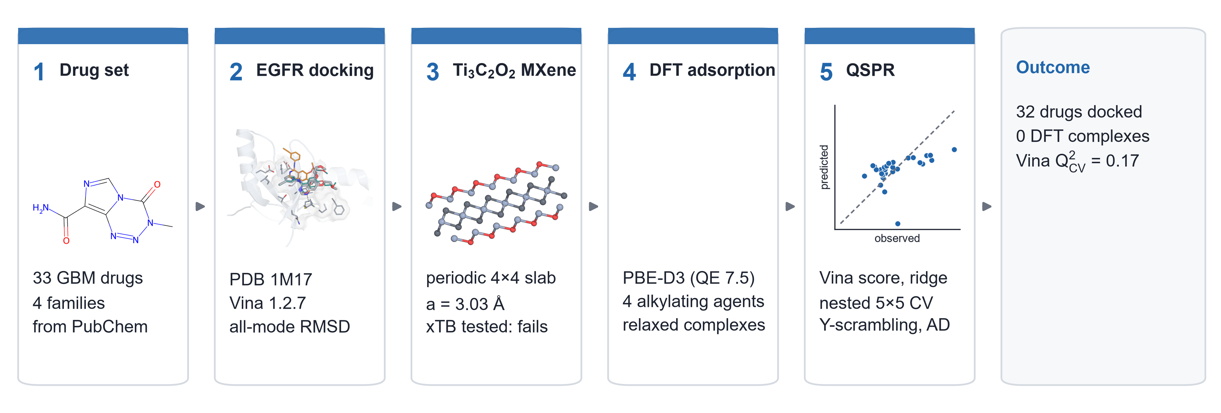
Fig. 1 Workflow of the study: the glioblastoma drug set, docking into EGFR with redocking controls, the Ti₃C₂O₂ carrier model and the tight-binding tests, periodic DFT adsorption of the alkylating agents, and the QSPR model of the docking score

Docking into the erlotinib site of EGFR
The redocking controls show a specific weakness of the score rather than of the search. The top-ranked pose of erlotinib redocked from its crystal conformation lies 5.9 Å from the crystal pose, and that of erlotinib rebuilt from SMILES 7.6 Å. The crystal-like pose is nevertheless found in both runs: mode 6 of the first control (1.13 Å) and mode 7 of the second (1.44 Å), scored only 0.21 and 0.27 kcal mol⁻¹ above the top poses (Fig. 2a, b; Table S4). All nine modes of each control fall within 0.46 kcal mol⁻¹, so the Vina score does not discriminate the crystal-like pose from the alternatives in this pocket. The ranking of the cohort is therefore an exploratory measure of fit in the ATP site, not a set of predicted binding modes.
The top poses of the 32 docked drugs occupy the ATP site. Leu820 and Val702 are contacted by every drug, the hinge residue Met769 by 75% and the gatekeeper Thr766 by 94%, with polar contacts to Thr766 in 66% of drugs (Fig. 2c). Scores range from −4.7 to −9.7 kcal mol⁻¹ (Fig. 3a). The best-scoring drugs are the kinase inhibitors abemaciclib, larotrectinib and palbociclib, and the worst are the small alkylating agents (family median −6.0 kcal mol⁻¹, against −8.6 for the other kinase inhibitors). Erlotinib itself scores −7.3 kcal mol⁻¹, ranking 25th of 32. The score becomes more favourable with molecular size (Spearman ρ = −0.66 between heavy-atom count and score). Ligand efficiency, which divides the score by the number of heavy atoms, is highest for the small alkylating agents (Fig. 3b), a known tendency of this metric for small ligands [21], even though these drugs do not act on EGFR. These trends describe how the drugs fit a kinase pocket, which is relevant to off-target binding, but they carry no information about the alkylating mechanism.
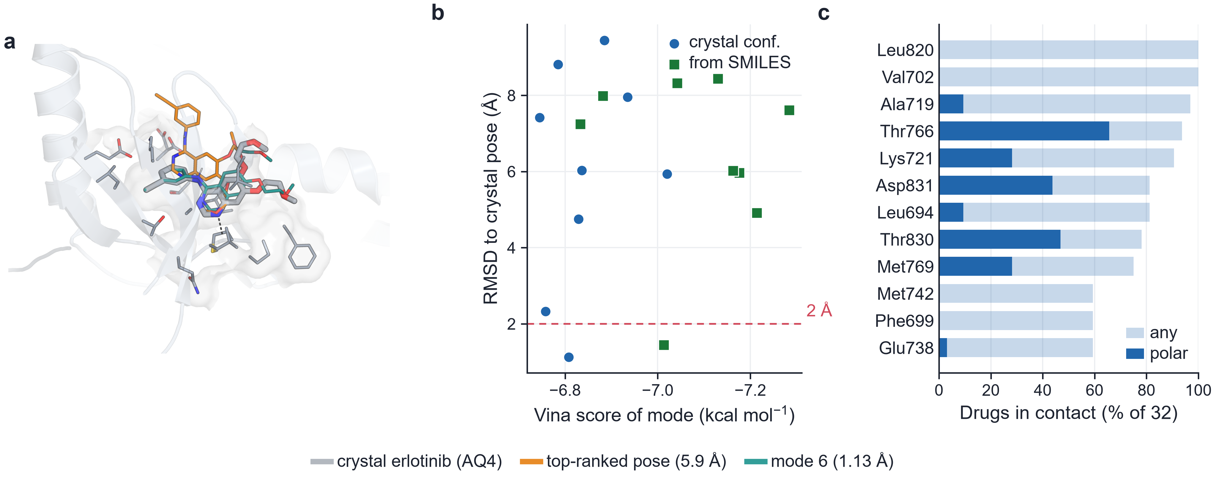
Fig. 2 Docking controls in EGFR (PDB 1M17, chain A). a Crystallographic erlotinib (grey), the top-ranked pose of the crystal-conformation redocking (orange, 5.9 Å) and its mode 6 (teal, 1.13 Å). b Heavy-atom RMSD to the crystal pose against the Vina score for every output mode of both controls; the dashed line marks 2 Å. c Percentage of the docked drugs whose top pose contacts each residue (light bars, any heavy atom within 4.0 Å; dark bars, N/O pairs within 3.5 Å); the 12 most frequent residues are shown
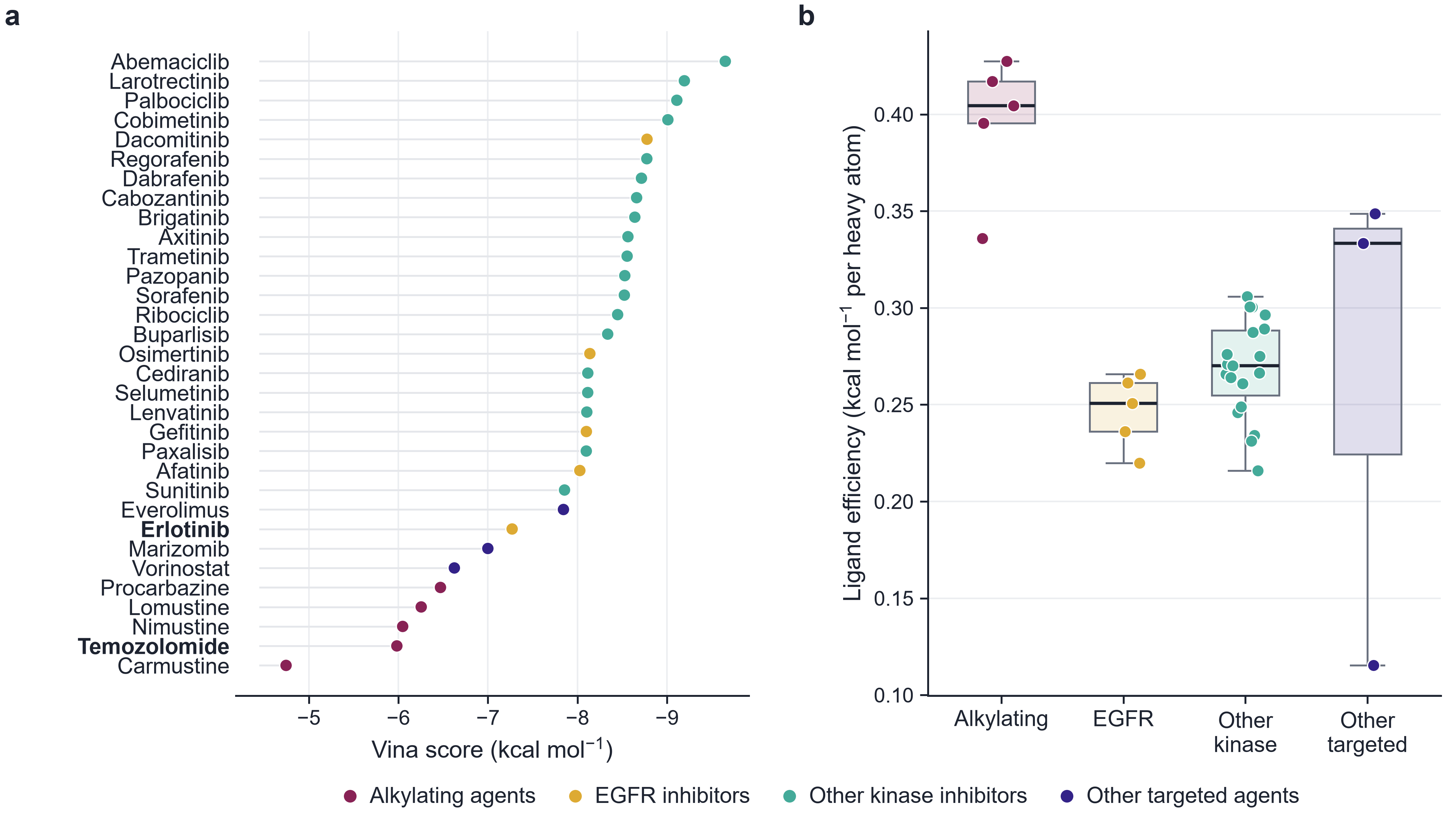
Fig. 3 Docking scores in EGFR. a Vina score of every docked drug, coloured by family; erlotinib and temozolomide are highlighted. b Ligand efficiency (score per heavy atom) by family; points are individual drugs

Tight-binding models of Ti₃C₂O₂
Neither tight-binding model described the carrier. Of 18 attempts on neutral finite flakes (Ti₅₅C₂₄O₂₀ and smaller cuts), 1 converged, and only as a single point restarted from the charges of the dianion; the geometry optimisation never converged (Table S2). Charged flakes converged, but they are not the physical system. In the periodic slab (Fig. 4b, Table S5), GFN2-xTB places the energy minimum at a = 2.70 Å, 11% below the lattice constant of Ti₃C₂O₂ used for the DFT slab (3.03 Å), which lies 12.5 eV per formula unit above that minimum, and the energy jumps by 31.0 eV per formula unit between 2.65 and 2.70 Å. GFN1-xTB did not converge at 6 of the 14 lattice constants (every value up to 2.85 Å), returned energies about 6 times too negative at 2.90 and 2.95 Å, and in its converged range (a ≥ 3.00 Å) decreases monotonically toward the smallest converged value, so it has no defined minimum. A description of adsorption on this carrier therefore needs density functional theory.
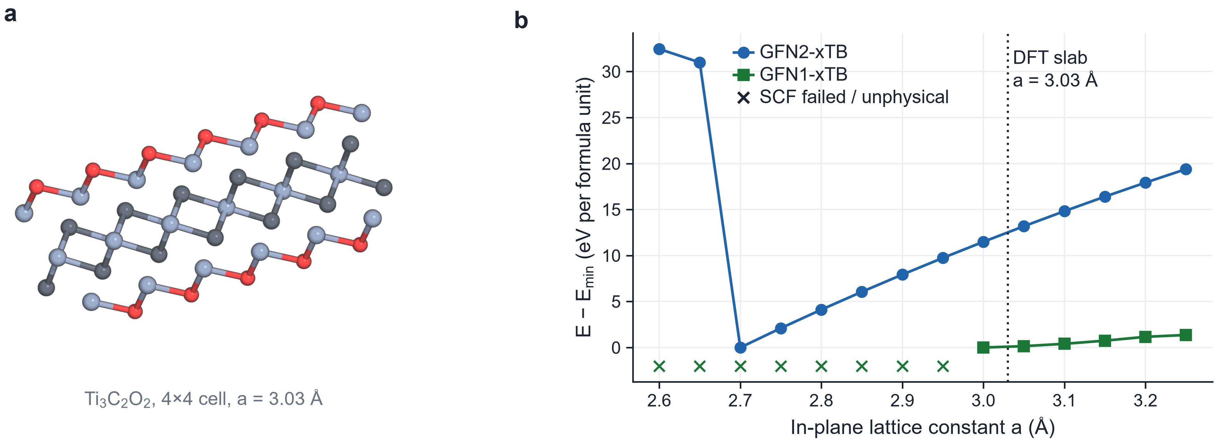
Fig. 4 The Ti₃C₂O₂ carrier. a The 4×4 periodic slab (a = 3.03 Å) used for the DFT calculations, top view. b Energy per formula unit of the periodic slab against the in-plane lattice constant with GFN2-xTB and GFN1-xTB (tblite, Γ point, 1500 K), relative to the lowest value of each method; crosses mark lattice constants at which the SCF failed or gave unphysical energies. The dotted line marks a = 3.03 Å, the lattice constant of the DFT slab (PBE-D3 optimum 3.022 Å)

Periodic DFT adsorption of the alkylating agents
[DFT RESULTS PENDING: the PBE-D3 campaign (slab, drugs, complexes, fragments and convergence checks) is running. This subsection, Fig. 5 and the DFT sentences of the abstract and conclusions are generated from results/quantum/dft_adsorption.csv once all four complexes are complete.]

QSPR model of the docking score
For the 32 docked drugs, the ridge model on four RDKit descriptors reaches an out-of-fold Q²_{CV} of 0.17 (RMSE 0.99 kcal mol⁻¹, against a standard deviation of the score of 1.10; Table 1, Fig. 6). Only 3 of 1,000 permuted targets gave a Q²_{CV} as high (p = 0.004), so the relation is not chance, but it is weak and fold-dependent: the outer-fold Q² values range from −2.02 to 0.57. The largest standardised coefficients are those of logP (−0.61) and molecular weight (−0.61), which reproduce the size dependence of the score. Everolimus, a 68-heavy-atom macrolide, lies outside the applicability domain (leverage 0.69 > h* = 0.47). Extrapolating from its size, the model predicts −11.0 kcal mol⁻¹, whereas Vina gives −7.8, consistent with a molecule too large to be accommodated fully in the pocket. The model summarises the size bias of the score and should not be used to rank new compounds.
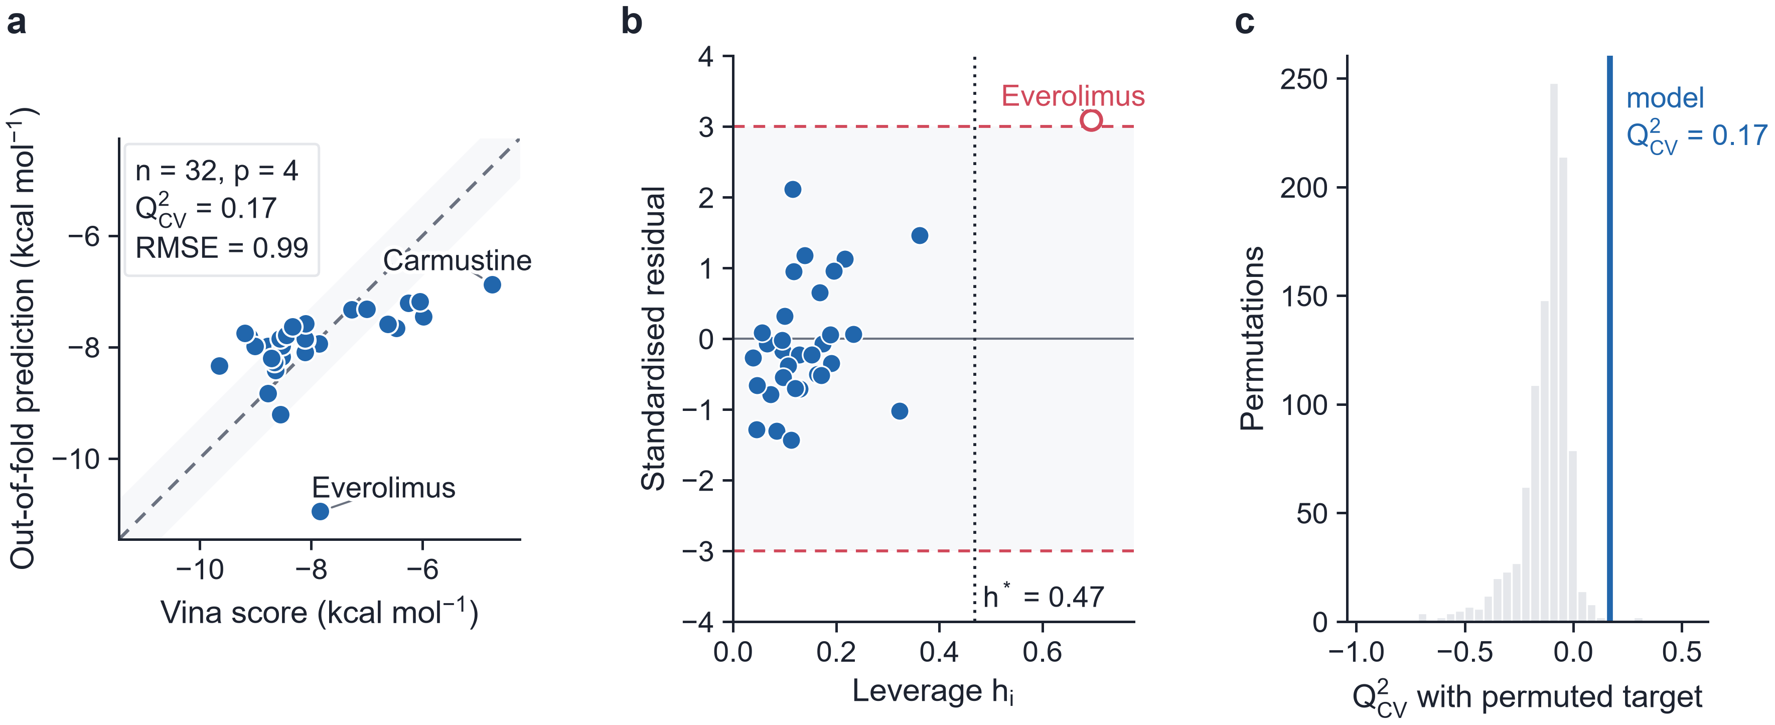
Fig. 6 Validation of the QSPR model of the Vina score. a Out-of-fold predictions from nested 5×5 cross-validation; the shaded band is ±10% of the range. b Williams plot (dotted line, h*; open symbol, outside the applicability domain). c Distribution of Q²_{CV} over 1,000 permuted targets, with the value of the model
Table 1 Ridge QSPR model of the Vina score (MW, TPSA, logP, rotatable bonds) under nested 5×5 cross-validation.
Quantity | Value
n, p | 32, 4
Q²_{CV} (out-of-fold) | 0.17
Q² of the outer folds | −2.02, 0.40, −0.31, −0.14, 0.57
RMSE / MAE (kcal mol⁻¹) | 0.99 / 0.73
Ridge penalty λ (inner CV) | 1
Standardised coefficients | MW −0.61, TPSA 0.30, logP −0.61, rotatable bonds 0.48
Y-scrambling, 1,000 runs: mean Q²; p | −0.13; 0.004
Applicability domain: h*; outside | 0.47; Everolimus

Limitations
The adsorption energies are for single drug molecules in vacuum, without water, counter-ions or the OH and F terminations present on real Ti₃C₂T_{x}. Each drug was relaxed from one starting orientation, which samples only part of the adsorption landscape. The Brillouin zone was sampled at the Γ point and only the upper surface of the slab relaxed; the effect of the Γ-point sampling is estimated for temozolomide in Table S3. The drugs were treated as neutral molecules. The docking used a rigid receptor and an empirical score that did not rank the crystal-like pose of erlotinib first. None of the results has been compared with experiment.

Conclusions
Docking of the glioblastoma cohort into EGFR places every drug in the ATP site, but the redocking controls show that the Vina score does not rank the crystal-like erlotinib pose first, so the scores serve only as an exploratory measure of fit. The GFN tight-binding methods do not describe metallic Ti₃C₂O₂, which is a warning for tight-binding screens of MXene carriers. The docking score can be modelled only weakly from four descriptors (Q²_{CV} = 0.17), and the model mainly reflects molecular size.
[Conclusion on the DFT adsorption added automatically when the campaign is complete; to be reread by the author.]

References
1. Louis DN, Perry A, Wesseling P, Brat DJ, Cree IA, Figarella-Branger D, Hawkins C, Ng HK, Pfister SM, Reifenberger G et al (2021) The 2021 WHO Classification of Tumors of the Central Nervous System: a summary. Neuro Oncol 23:1231–1251. https://doi.org/10.1093/neuonc/noab106
2. Stupp R, Mason WP, van den Bent MJ, Weller M, Fisher B, Taphoorn MJB, Belanger K, Brandes AA, Marosi C, Bogdahn U et al (2005) Radiotherapy plus concomitant and adjuvant temozolomide for glioblastoma. N Engl J Med 352:987–996. https://doi.org/10.1056/nejmoa043330
3. Brennan C, Verhaak RW, McKenna A, Campos B, Noushmehr H, Salama S, Zheng S, Chakravarty D, Sanborn J, Berman S et al (2013) The Somatic Genomic Landscape of Glioblastoma. Cell 155:462–477. https://doi.org/10.1016/j.cell.2013.09.034
4. Pardridge WM (2005) The blood-brain barrier: Bottleneck in brain drug development. NeuroRx 2:3–14. https://doi.org/10.1602/neurorx.2.1.3
5. Westphal M, Hilt DC, Bortey E, Delavault P, Olivares R, Warnke PC, Whittle IR, Jääskeläinen J, Ram Z (2003) A phase 3 trial of local chemotherapy with biodegradable carmustine (BCNU) wafers (Gliadel wafers) in patients with primary malignant glioma. Neuro Oncol 5:79–88. https://doi.org/10.1093/neuonc/5.2.79
6. Naguib M, Kurtoglu M, Presser V, Lu J, Niu J, Heon M, Hultman L, Gogotsi Y, Barsoum MW (2011) Two-dimensional nanocrystals produced by exfoliation of Ti₃AlC₂. Adv Mater 23:4248–4253. https://doi.org/10.1002/adma.201102306
7. Anasori B, Lukatskaya MR, Gogotsi Y (2017) 2D metal carbides and nitrides (MXenes) for energy storage. Nat Rev Mater 2:16098. https://doi.org/10.1038/natrevmats.2016.98
8. Lin H, Wang X, Yu L, Chen Y, Shi J (2017) Two-dimensional ultrathin MXene ceramic nanosheets for photothermal conversion. Nano Lett 17:384–391. https://doi.org/10.1021/acs.nanolett.6b04339
9. Huang K, Li Z, Lin J, Han G, Huang P (2018) Two-dimensional transition metal carbides and nitrides (MXenes) for biomedical applications. Chem Soc Rev 47:5109–5124. https://doi.org/10.1039/c7cs00838d
10. Grimme S, Bannwarth C, Shushkov P (2017) A Robust and Accurate Tight-Binding Quantum Chemical Method for Structures, Vibrational Frequencies, and Noncovalent Interactions of Large Molecular Systems Parametrized for All spd-Block Elements (Z = 1–86). J Chem Theory Comput 13:1989–2009. https://doi.org/10.1021/acs.jctc.7b00118
11. Bannwarth C, Ehlert S, Grimme S (2019) GFN2-xTB — an accurate and broadly parametrized self-consistent tight-binding quantum chemical method with multipole electrostatics and density-dependent dispersion contributions. J Chem Theory Comput 15:1652–1671. https://doi.org/10.1021/acs.jctc.8b01176
12. Kim S, Chen J, Cheng T, Gindulyte A, He J, He S, Li Q, Shoemaker BA, Thiessen PA, Yu B et al (2021) PubChem in 2021: new data content and improved web interfaces. Nucleic Acids Res 49:D1388–D1395. https://doi.org/10.1093/nar/gkaa971
13. Stamos J, Sliwkowski MX, Eigenbrot C (2002) Structure of the Epidermal Growth Factor Receptor Kinase Domain Alone and in Complex with a 4-Anilinoquinazoline Inhibitor. J Biol Chem 277:46265–46272. https://doi.org/10.1074/jbc.m207135200
14. Berman HM, Westbrook J, Feng Z, Gilliland G, Bhat TN, Weissig H, Shindyalov IN, Bourne PE (2000) The Protein Data Bank. Nucleic Acids Res 28:235–242. https://doi.org/10.1093/nar/28.1.235
15. Eastman P, Swails J, Chodera JD, McGibbon RT, Zhao Y, Beauchamp KA, Wang LP, Simmonett AC, Harrigan MP, Stern CD et al (2017) OpenMM 7: rapid development of high performance algorithms for molecular dynamics. PLoS Comput Biol 13:e1005659. https://doi.org/10.1371/journal.pcbi.1005659
16. Landrum G et al (2024) RDKit: open-source cheminformatics, version 2024.03. https://www.rdkit.org. https://doi.org/10.5281/zenodo.591637
17. Wang S, Witek J, Landrum GA, Riniker S (2020) Improving conformer generation for small rings and macrocycles based on distance geometry and experimental torsional-angle preferences. J Chem Inf Model 60:2044–2058. https://doi.org/10.1021/acs.jcim.0c00025
18. Halgren TA (1996) Merck molecular force field. I. Basis, form, scope, parameterization, and performance of MMFF94. J Comput Chem 17:490–519. https://doi.org/10.1002/(SICI)1096-987X(199604)17:5/6<490::AID-JCC1>3.0.CO;2-P
19. Trott O, Olson AJ (2010) AutoDock Vina: improving the speed and accuracy of docking with a new scoring function, efficient optimization, and multithreading. J Comput Chem 31:455–461. https://doi.org/10.1002/jcc.21334
20. Eberhardt J, Santos-Martins D, Tillack AF, Forli S (2021) AutoDock Vina 1.2.0: new docking methods, expanded force field, and Python bindings. J Chem Inf Model 61:3891–3898. https://doi.org/10.1021/acs.jcim.1c00203
21. Hopkins AL, Keserü GM, Leeson PD, Rees DC, Reynolds CH (2014) The role of ligand efficiency metrics in drug discovery. Nat Rev Drug Discov 13:105–121. https://doi.org/10.1038/nrd4163
22. Giannozzi P, Baroni S, Bonini N, Calandra M, Car R, Cavazzoni C, Ceresoli D, Chiarotti GL, Cococcioni M, Dabo I et al (2009) QUANTUM ESPRESSO: a modular and open-source software project for quantum simulations of materials. J Phys Condens Matter 21:395502. https://doi.org/10.1088/0953-8984/21/39/395502
23. Giannozzi P, Andreussi O, Brumme T, Bunau O, Buongiorno Nardelli M, Calandra M, Car R, Cavazzoni C, Ceresoli D, Cococcioni M et al (2017) Advanced capabilities for materials modelling with Quantum ESPRESSO. J Phys Condens Matter 29:465901. https://doi.org/10.1088/1361-648x/aa8f79
24. Perdew JP, Burke K, Ernzerhof M (1996) Generalized Gradient Approximation Made Simple. Phys Rev Lett 77:3865–3868. https://doi.org/10.1103/physrevlett.77.3865
25. Grimme S, Antony J, Ehrlich S, Krieg H (2010) A consistent and accurate ab initio parametrization of density functional dispersion correction (DFT-D) for the 94 elements H-Pu. J Chem Phys 132:154104. https://doi.org/10.1063/1.3382344
26. Prandini G, Marrazzo A, Castelli IE, Mounet N, Marzari N (2018) Precision and efficiency in solid-state pseudopotential calculations. npj Comput Mater 4:72. https://doi.org/10.1038/s41524-018-0127-2
27. Marzari N, Vanderbilt D, De Vita A, Payne MC (1999) Thermal Contraction and Disordering of the Al(110) Surface. Phys Rev Lett 82:3296–3299. https://doi.org/10.1103/physrevlett.82.3296
28. Pedregosa F, Varoquaux G, Gramfort A, Michel V, Thirion B, Grisel O, Blondel M, Prettenhofer P, Weiss R, Dubourg V et al (2011) Scikit-learn: machine learning in Python. J Mach Learn Res 12:2825–2830
29. Cawley GC, Talbot NLC (2010) On over-fitting in model selection and subsequent selection bias in performance evaluation. J Mach Learn Res 11:2079–2107
30. Rücker C, Rücker G, Meringer M (2007) y-Randomization and its variants in QSPR/QSAR. J Chem Inf Model 47:2345–2357. https://doi.org/10.1021/ci700157b
31. OECD (2007) Guidance document on the validation of (quantitative) structure-activity relationship [(Q)SAR] models. OECD Series on Testing and Assessment, No. 69. OECD Publishing, Paris. https://doi.org/10.1787/9789264085442-en
32. Gramatica P (2007) Principles of QSAR models validation: internal and external. QSAR Comb Sci 26:694–701. https://doi.org/10.1002/qsar.200610151
33. Tropsha A (2010) Best practices for QSAR model development, validation, and exploitation. Mol Inform 29:476–488. https://doi.org/10.1002/minf.201000061

Statements and Declarations
Author contribution Andrés Monreal Hernández conceived the study, performed all calculations and analyses, and wrote the manuscript.
Funding No funding was received for this work.
Data availability All input structures, docking poses, Quantum ESPRESSO inputs and outputs, relaxed geometries and result tables are available at https://github.com/sircalch/mxene-glioblastoma-qsar-ai.
Code availability The complete pipeline, which regenerates every number, table and figure of this article from the raw inputs, is available at https://github.com/sircalch/mxene-glioblastoma-qsar-ai under the MIT licence. Software: Quantum ESPRESSO 7.5, xtb 6.7.1, tblite, AutoDock Vina 1.2.7, Meeko, RDKit, PDBFixer/OpenMM, scikit-learn, PyMOL (open source).
Ethics approval Not applicable.
Consent to participate Not applicable.
Consent for publication Not applicable.
Competing interests The author declares no competing interests.

