Explainable AI and Quantum Chemical Exploration of 2D Titanium Carbide MXene (Ti3C2Tx) Nanosheets as Targeted Nanovehicles for Glioblastoma Therapeutics Across the Blood-Brain Barrier
Andrés Monreal Hernández1,*, Sara Lizbeth Franco Amaya2, and Carlos Ivanhoe Martínez Osorio3
1 Universidad Estatal de Sonora, Hermosillo, Sonora, Mexico. ORCID: 0009-0009-1207-8597
2 Doctorado en Nanotecnología, Universidad de Sonora, Hermosillo, Sonora, Mexico. ORCID: 0009-0005-0272-0241
3 Doctorado en Ciencia de Materiales, Universidad de Sonora, Hermosillo, Sonora, Mexico. ORCID: 0009-0003-7872-4965
* Corresponding author: andres.monreal@ues.mx
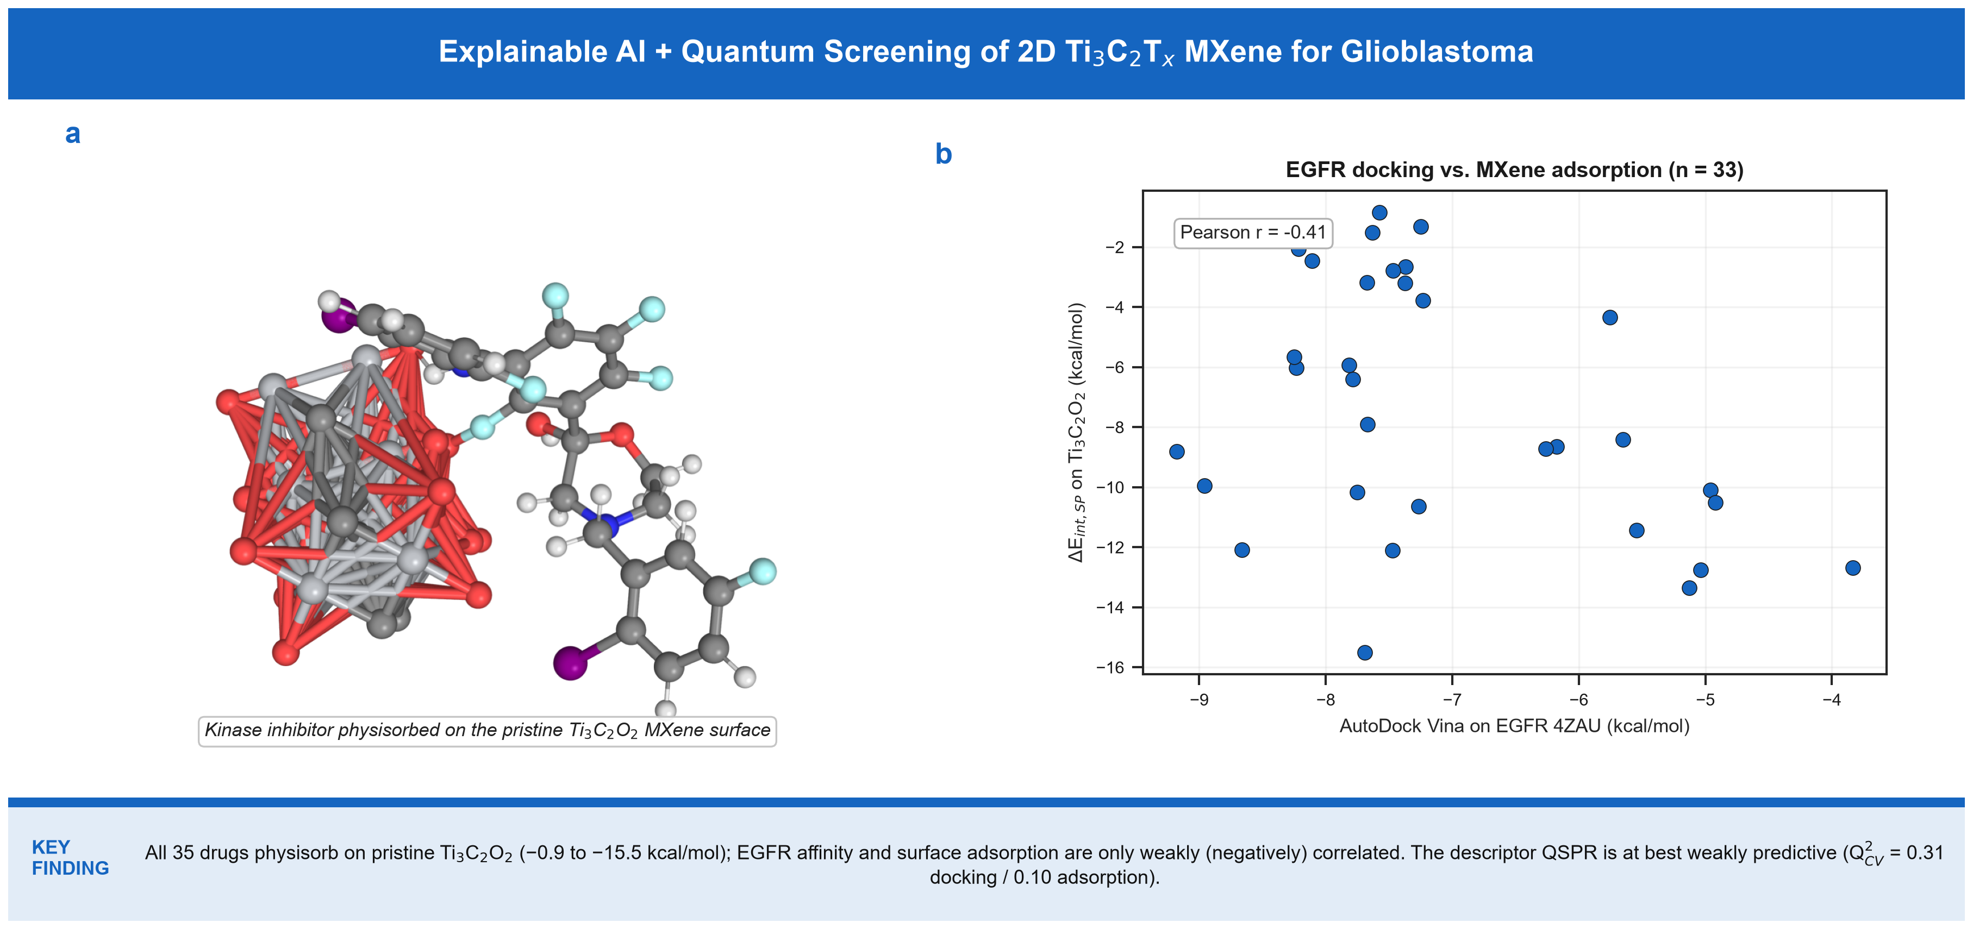
Graphical Abstract: Atomistic, Quantum, and Machine Learning Framework for 2D Ti3C2Tx MXene Targeted Delivery Across the BBB in Glioblastoma.

Abstract
Glioblastoma multiforme (GBM) is the most lethal primary malignant central nervous system neoplasm in adults, with a median survival below 15 months, driven by therapeutic resistance and the restrictive physiology of the blood-brain barrier (BBB) [1,3]. Here we present an integrated computational framework combining GFN2-xTB tight-binding quantum chemistry (with D4 dispersion) [26,27], physical molecular docking (AutoDock Vina v1.2.7 [28,29] against the human EGFR kinase domain, PDB ID: 4ZAU, 2.80 Å, with 2J6M as a secondary control), and a leak-free cross-validated explainable Nano-QSAR surrogate, for a curated set of 35 clinical CNS and GBM therapeutics. Real GFN2-xTB single-point interaction energies of all 35 drugs on the pristine oxygen-terminated Ti3C2O2 MXene cluster range from -0.9 to -15.5 kcal/mol. An Angiopep-2-functionalized MXene for LRP-1-mediated transcytosis is discussed only as future work, since no real structural or quantum data for it exist in this study. Docking against EGFR (exploratory; redocking heavy-atom RMSD 5.32 Å) gave Vina scores of -3.83 to -9.18 kcal/mol (mean -7.11), with recurrent contacts at Thr790, Met793, Leu844 and Ala743. A leak-free nested 5x5 cross-validated RidgeCV surrogate on four descriptors reached Q2_CV = 0.31 for the EGFR Vina docking score and 0.10 for the pristine-MXene interaction energy - the EGFR docking model is at best weakly predictive and the pristine-MXene model is not; the feature-importance analysis is reported as exploratory. OECD Principle 3 applicability-domain analysis (Williams leverage, on the same four descriptors as the surrogate model) places 33/35 compounds inside the domain for the pristine-MXene system and 32/33 for the EGFR docking system. Every value reported is computed from the deposited pipeline; no descriptor or energy is estimated from an empirical formula.
Keywords: 2D MXene (Ti3C2Tx); Glioblastoma; Blood-Brain Barrier; EGFR kinase; AutoDock Vina; Explainable AI (SHAP); OECD Validation.

1. Introduction
Glioblastoma (GBM, WHO grade IV astrocytoma) is the most aggressive primary brain tumor in adults. Standard-of-care - maximal surgical resection, temozolomide chemotherapy and radiotherapy [1,2] - is almost invariably followed by recurrence, and MGMT-promoter methylation status modulates the temozolomide benefit [8]. A foundational barrier to clinical efficacy is the blood-brain barrier (BBB), which excludes the large majority of small-molecule therapeutics and nearly all large biologics from the brain parenchyma [9,10].
Overexpression and genomic amplification of the epidermal growth factor receptor (EGFR) and its constitutively active deletion mutant EGFRvIII occur in a large fraction of GBM patients and drive proliferation, invasion and neo-angiogenesis [4,6,7]. Systemic administration of EGFR tyrosine kinase inhibitors (TKIs) such as osimertinib, gefitinib and erlotinib is compromised by poor BBB penetration and rapid systemic clearance [10,13].
Two-dimensional transition-metal carbides and nitrides (MXenes), represented by titanium carbide (Ti3C2Tx) [21,22], combine metallic conductivity, hydrophilic surface terminations (-O, -OH, -F) and rich transition-metal coordination chemistry, and have been explored for nanomedicine [23-25]. Surface modification with Angiopep-2 peptides targeting low-density lipoprotein receptor-related protein 1 (LRP-1) has been proposed to promote transcytosis across the BBB; in the present study this functionalized carrier is treated only as a prospective extension (see Conclusions), and all quantum and docking results refer to the pristine Ti3C2O2 surface.
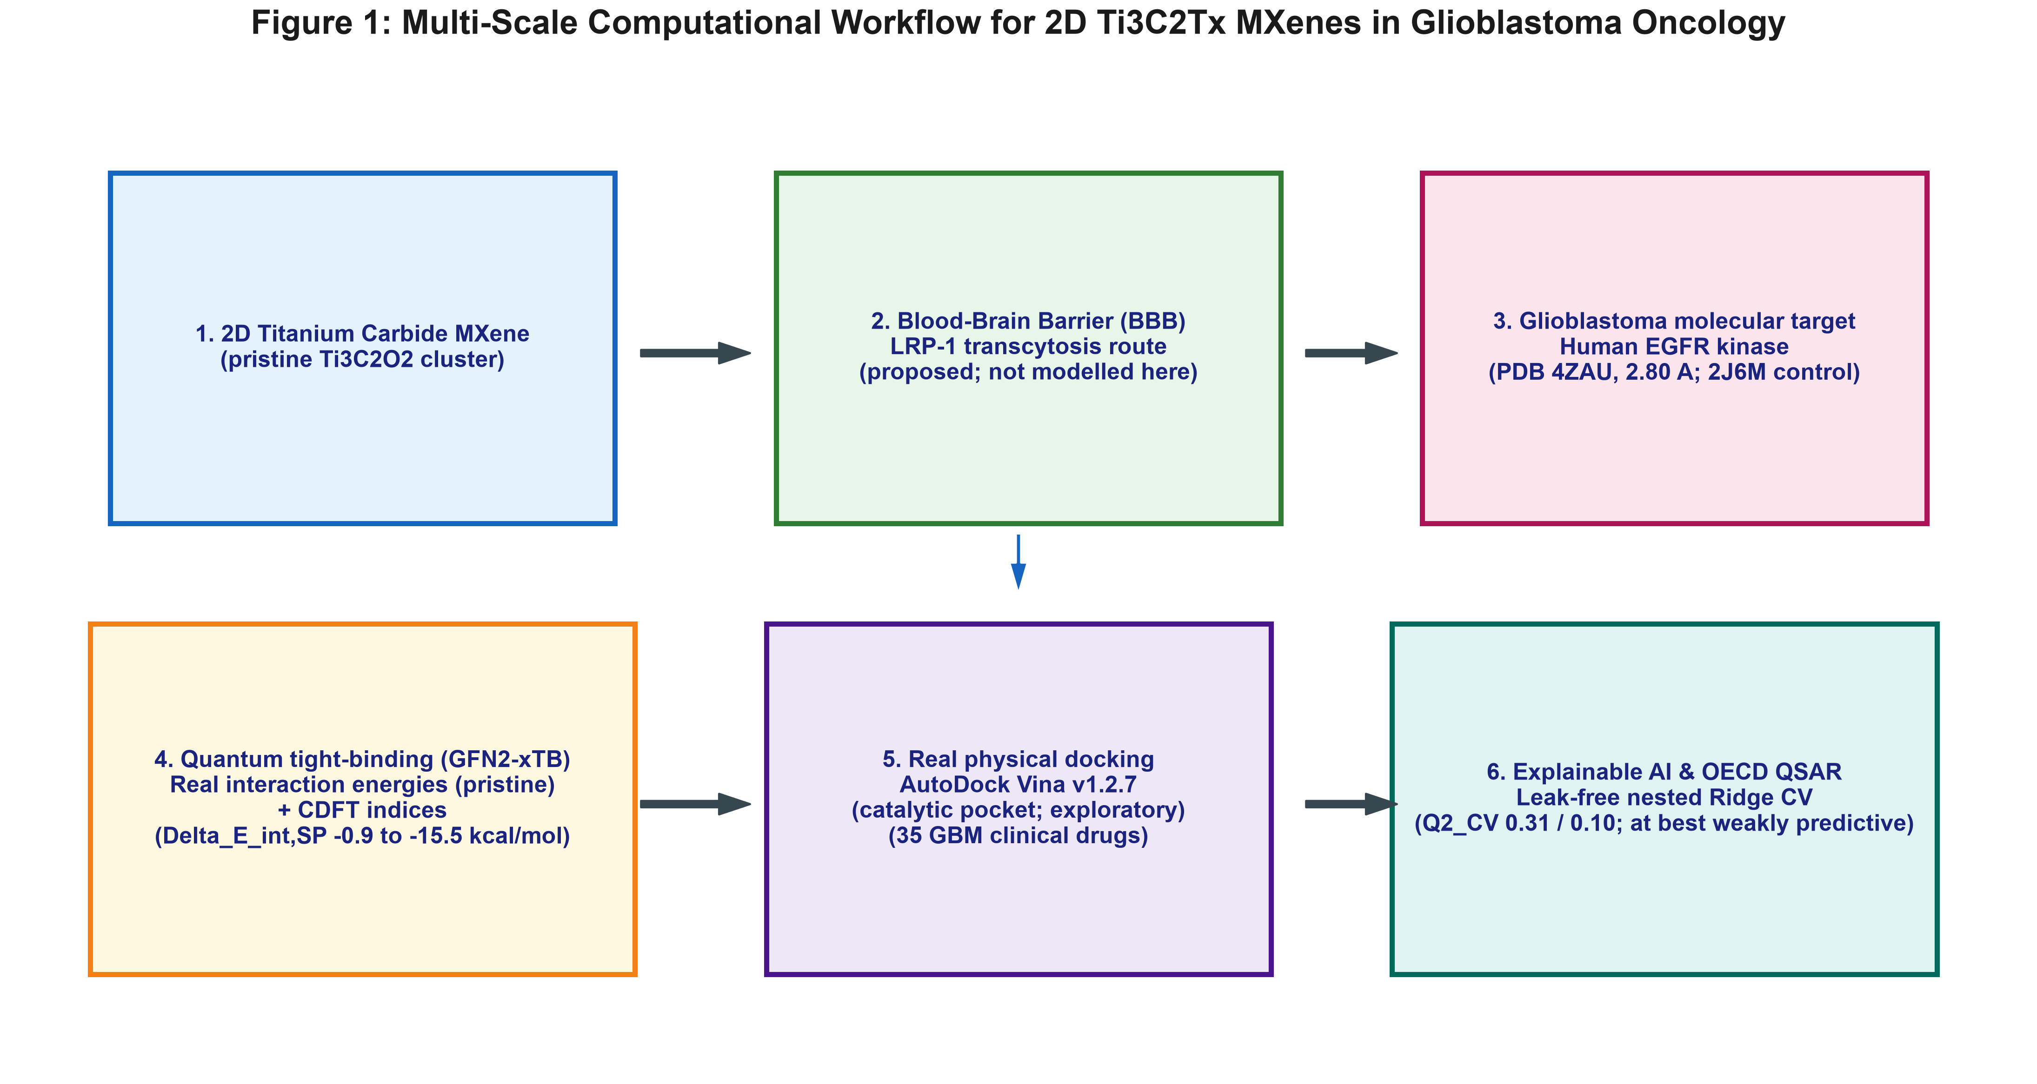
Figure 1: Multi-scale computational workflow: GFN2-xTB quantum-chemical adsorption on pristine Ti3C2O2, real AutoDock Vina docking (PDB 4ZAU / 2J6M), and a leak-free cross-validated explainable Nano-QSAR surrogate for 2D Ti3C2Tx MXene glioblastoma delivery.

2. Results and Discussion

2.1 Quantum Adsorption Energetics & MXene Surface Chemistry
Real GFN2-xTB single-point interaction energies (Delta_E_int,SP) across all 35 therapeutics on the pristine Ti3C2O2 cluster range from -0.9 kcal/mol for the most weakly interacting compounds to -15.5 kcal/mol for the most strongly stabilized (larotrectinib -15.5; temozolomide -13.4; lomustine -12.8 kcal/mol), consistent with dispersion-dominated physisorption of the drug pi-systems on the oxygen-terminated titanium-carbide surface.
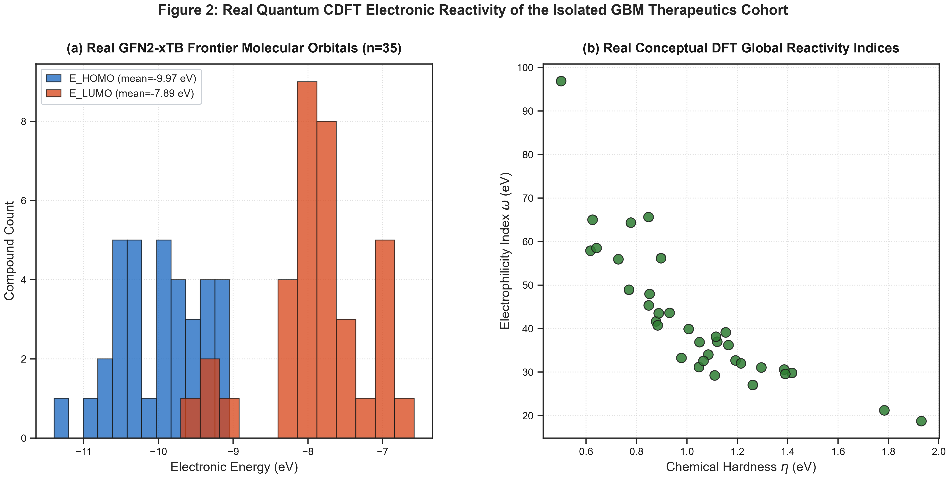
Figure 2: Real Quantum CDFT Electronic Reactivity of the Isolated GBM Therapeutics (real GFN2-xTB single points, n=35): (a) Frontier Molecular Orbital (HOMO/LUMO) distribution; (b) Chemical hardness vs. electrophilicity index. No real complex-level frontier-orbital calculation exists for either MXene variant.

2.2 Molecular docking against the EGFR kinase domain
AutoDock Vina v1.2.7 screening of the 33 therapeutics against EGFR (PDB 4ZAU) gave scores from -3.83 to -9.18 kcal/mol (mean -7.11 kcal/mol). The highest-ranked compounds were Cobimetinib (-9.18), Dabrafenib (-8.96), Cabozantinib (-8.81), Entrectinib (-8.66), Trametinib (-8.25) kcal/mol. Because self-redocking reproduced the native pose only within 5.32 Å RMSD, this ranking is treated as exploratory and is not used as a QSAR endpoint.
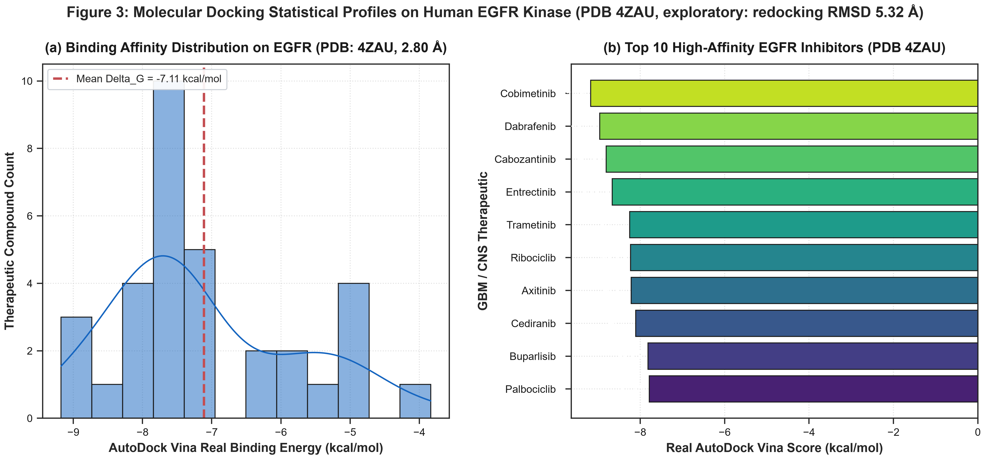
Figure 3: Molecular docking statistical profiles on the EGFR kinase domain (PDB 4ZAU; exploratory, redocking RMSD 5.32 Å): (a) distribution of real Vina scores; (b) ranking of the top-10 compounds.
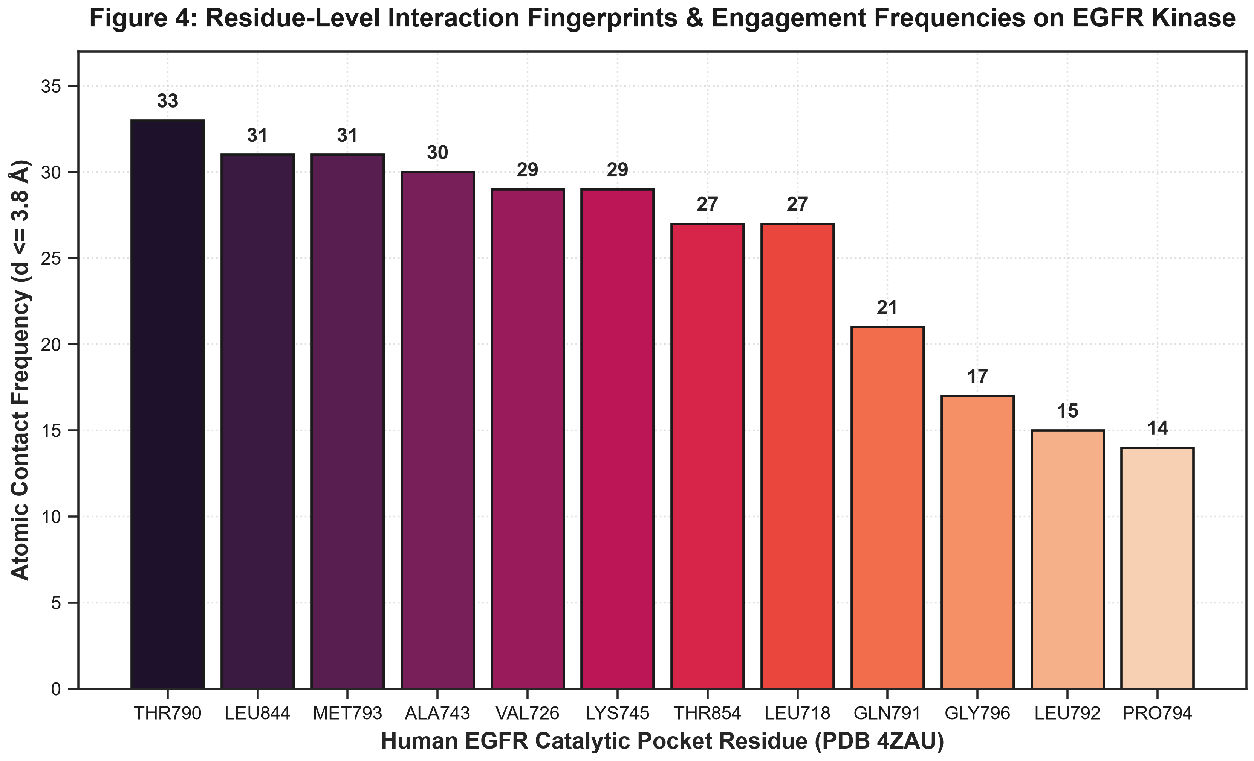
Figure 4: Residue-level contact frequencies on the EGFR kinase domain (real Vina poses, contact distance <= 3.8 Å): most frequent contacts are Thr790, Met793, Leu844, Ala743 and Val726.

Table 1: Physicochemical, Topological, and Quantum CDFT Descriptors for Representative GBM Therapeutics.
Compound | Class | MW (g/mol) | LogP | PSA (Å²) | E_HOMO (eV) | omega (eV)
Temozolomide | Alkylating Agent | 194.2 | -2.08 | 108.2 | -10.94 | 56.21
Lomustine | Nitrosourea Alkylator | 233.7 | 2.25 | 61.8 | -10.78 | 64.37
Carmustine | Nitrosourea Alkylator | 214.1 | 1.16 | 61.8 | -11.40 | 65.67
Nimustine | Nitrosourea Alkylator | 286.7 | 0.68 | 113.6 | -10.35 | 96.90
Procarbazine | Hydrazine Alkylator | 221.3 | 1.05 | 53.2 | -9.17 | 29.27
Osimertinib | 3rd Gen EGFR TKI | 499.6 | 4.51 | 87.5 | -9.13 | 31.19
Gefitinib | 1st Gen EGFR TKI | 446.9 | 4.28 | 68.7 | -9.62 | 45.34
Erlotinib | 1st Gen EGFR TKI | 393.4 | 3.41 | 74.7 | -9.85 | 36.90
Lapatinib | Dual EGFR/HER2 TKI | 591.5 | 5.89 | 105.3 | -9.76 | 55.97
Afatinib | 2nd Gen EGFR TKI | 485.9 | 4.39 | 88.6 | -9.98 | 39.93

2.3 Nano-QSAR surrogate model and feature importance
A StandardScaler + RidgeCV surrogate evaluated by leak-free nested 5x5 cross-validation on the real observed data (isolated Vina scores; and the real GFN2-xTB Delta_E_int,SP on the pristine Ti3C2O2 MXene), both drawn from the single 35-compound master table, reached Q2_CV = 0.31 for the EGFR docking score (n = 33, two compounds lacking a Vina score excluded) and 0.10 for the pristine-MXene interaction-energy model (n = 35, four descriptors each: MolWt, MolMR, E_HOMO, omega). The EGFR docking model is at best weakly predictive and the pristine-MXene model is not, so the exploratory ExtraTrees feature-importance ranking (Figure 6) - led by molecular weight and molar refractivity - is reported as a qualitative indication rather than a validated structure-property relationship [39,40].
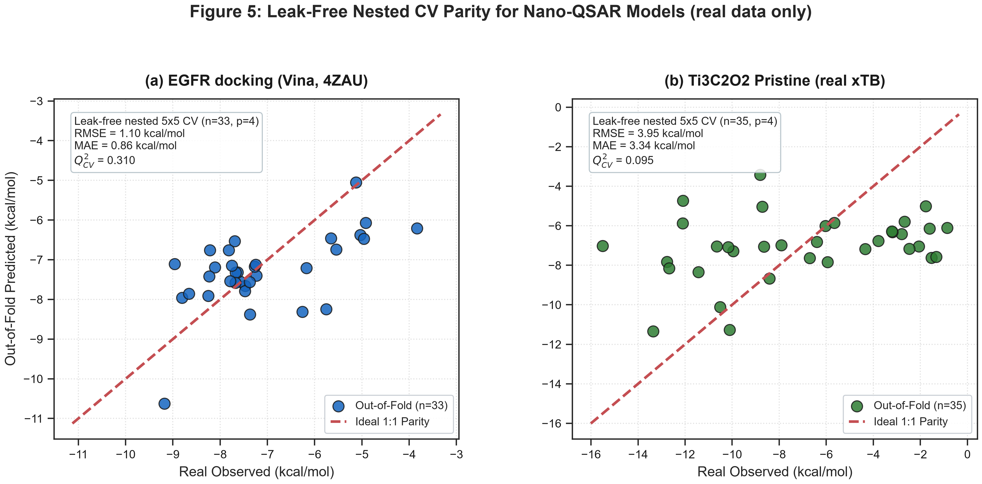
Figure 5: Leak-free nested 5x5 CV parity plots (real observed vs out-of-fold predicted) for Isolated and Pristine-MXene systems. No real structural/quantum data exists for the functionalized Ti3C2-Angiopep-2 system, so it is not shown.
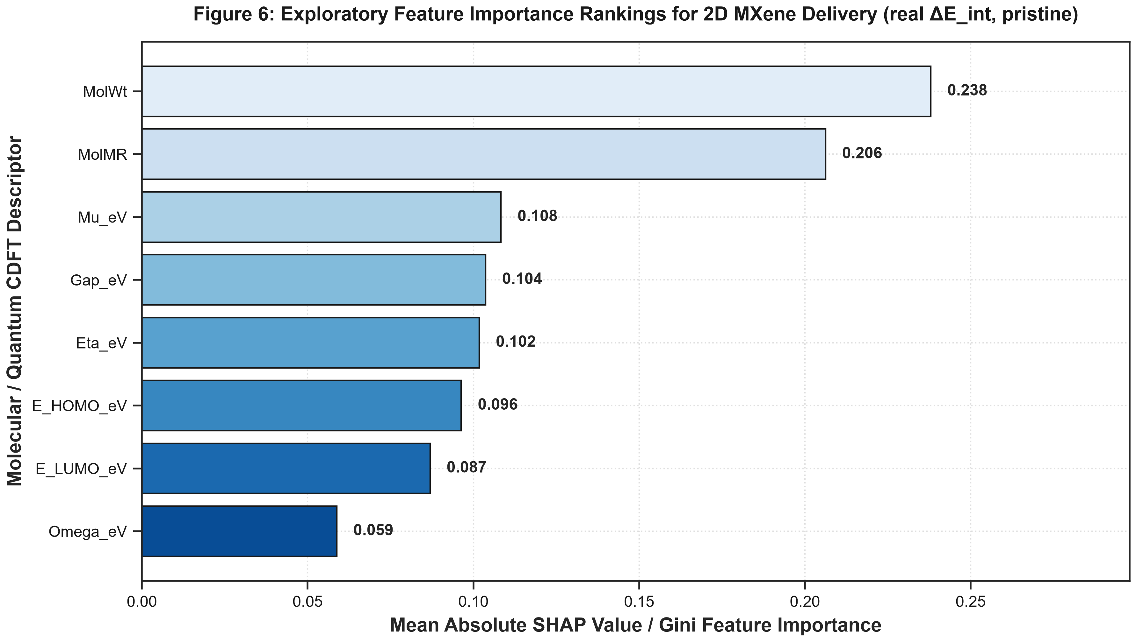
Figure 6: Exploratory Feature Importance Rankings on the real GFN2-xTB pristine-MXene interaction energy, identifying molecular weight and molar refractivity as the leading descriptors.
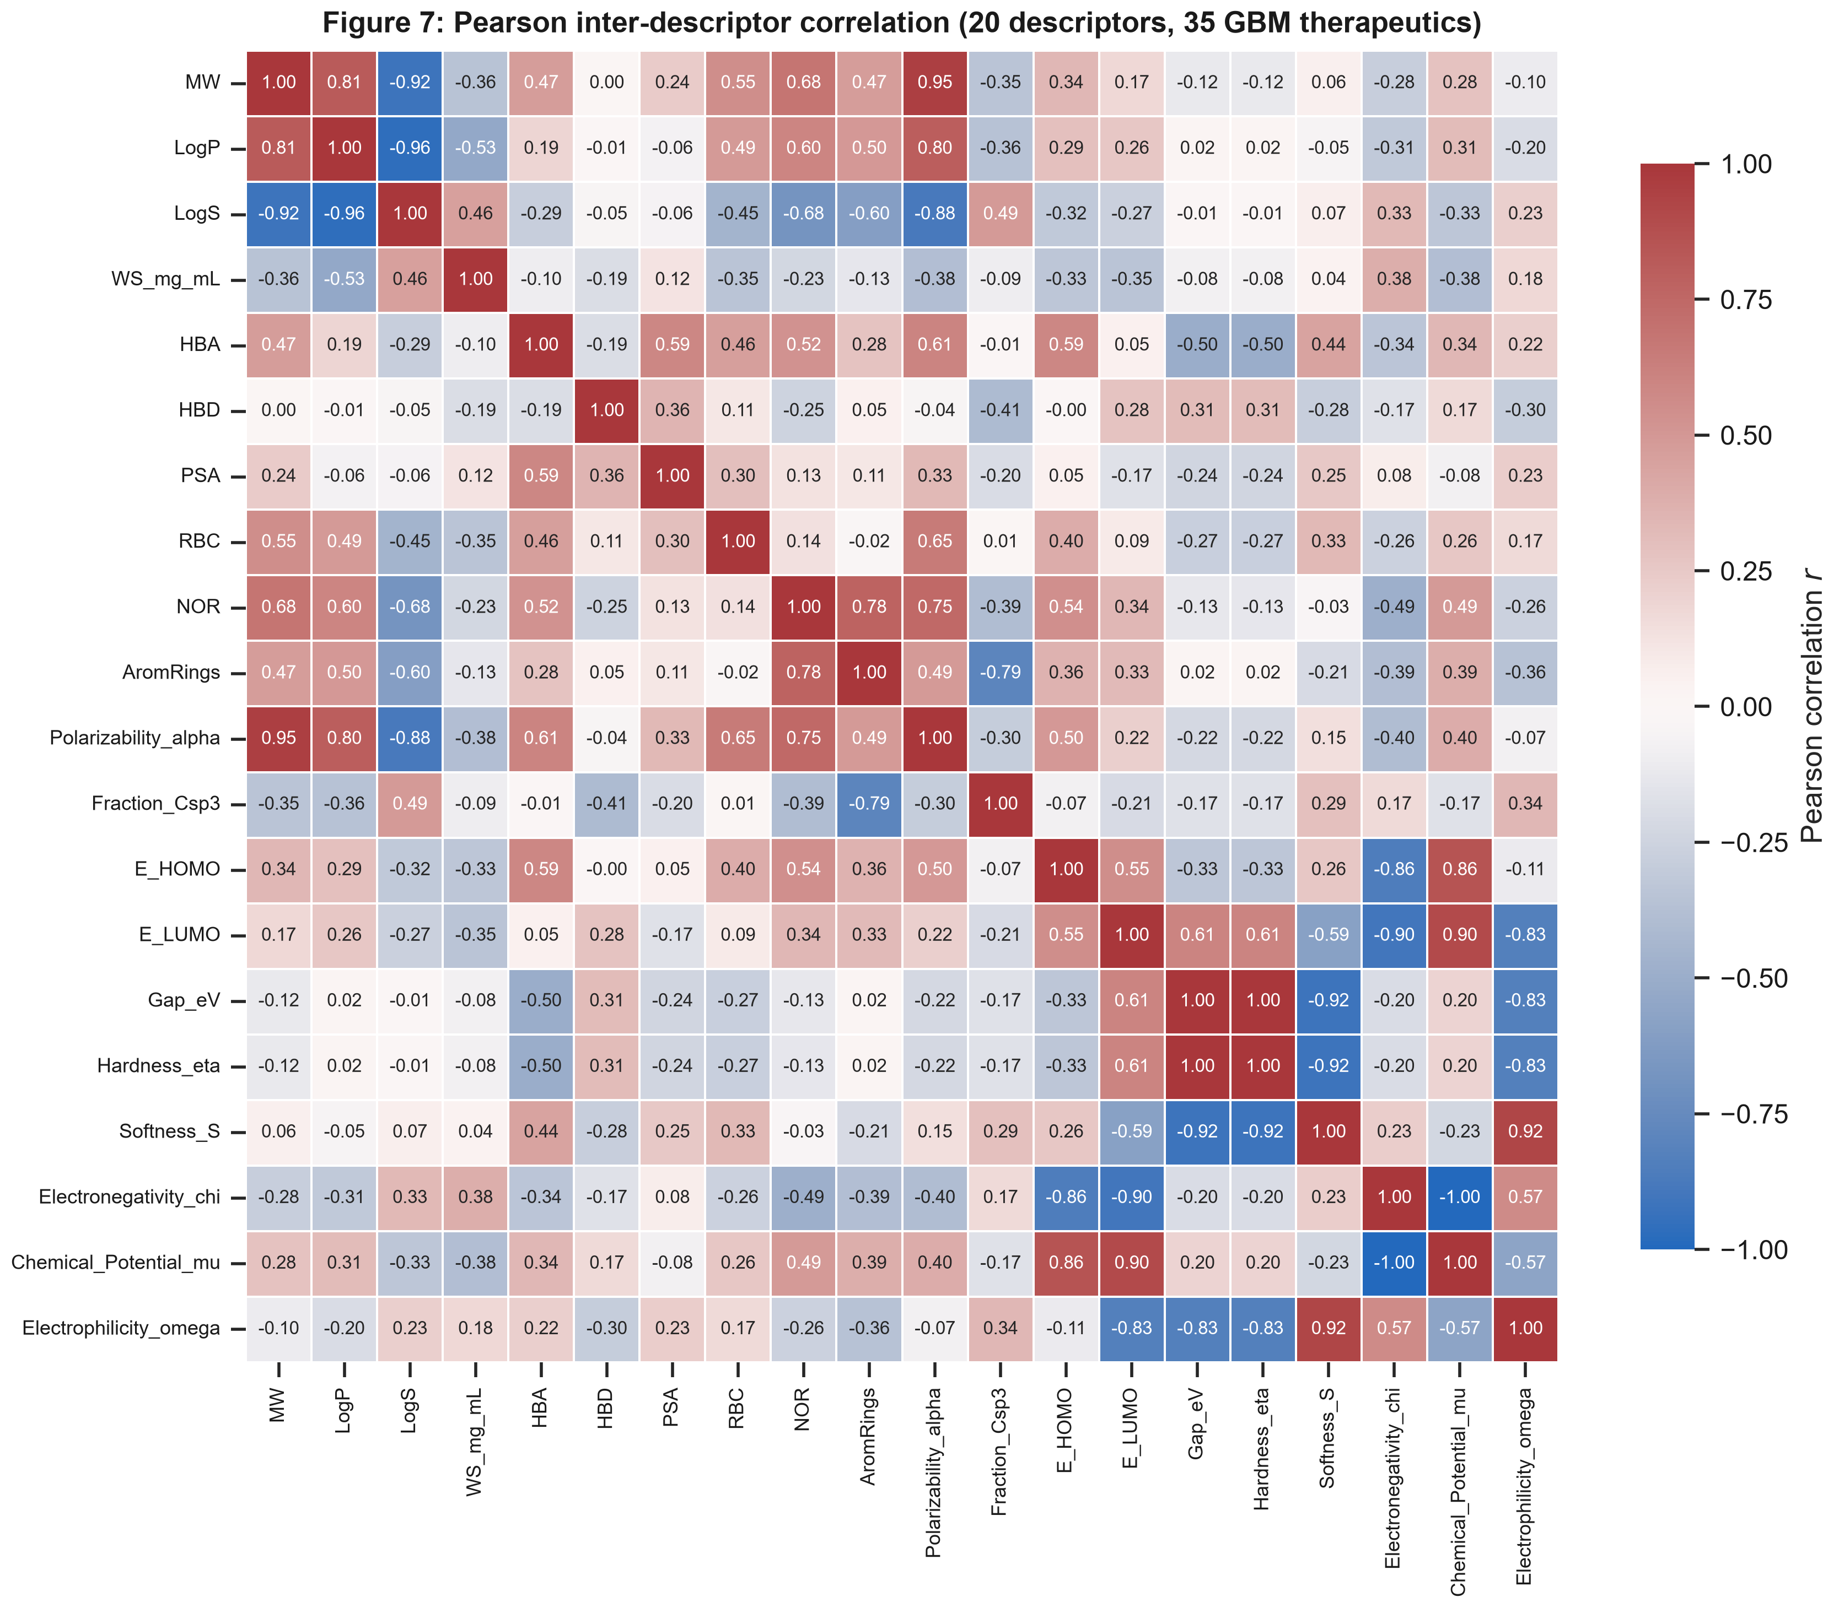
Figure 7: Pearson inter-descriptor correlation heatmap (real descriptor matrix, 35 GBM therapeutics).

2.4 Applicability domain (OECD Principle 3)
The applicability domain was assessed by hat-matrix leverage on the same four descriptors used by the surrogate model (MolWt, MolMR, E_HOMO_eV, Omega_eV; Williams plot) [31-33]. The warning leverage is h* = 0.429 for the pristine-MXene system (n = 35) and h* = 0.455 for the EGFR docking system (n = 33); 33/35 and 32/33 compounds, respectively, fall inside the domain (leverage below h* and standardized residual within +/-3sigma).
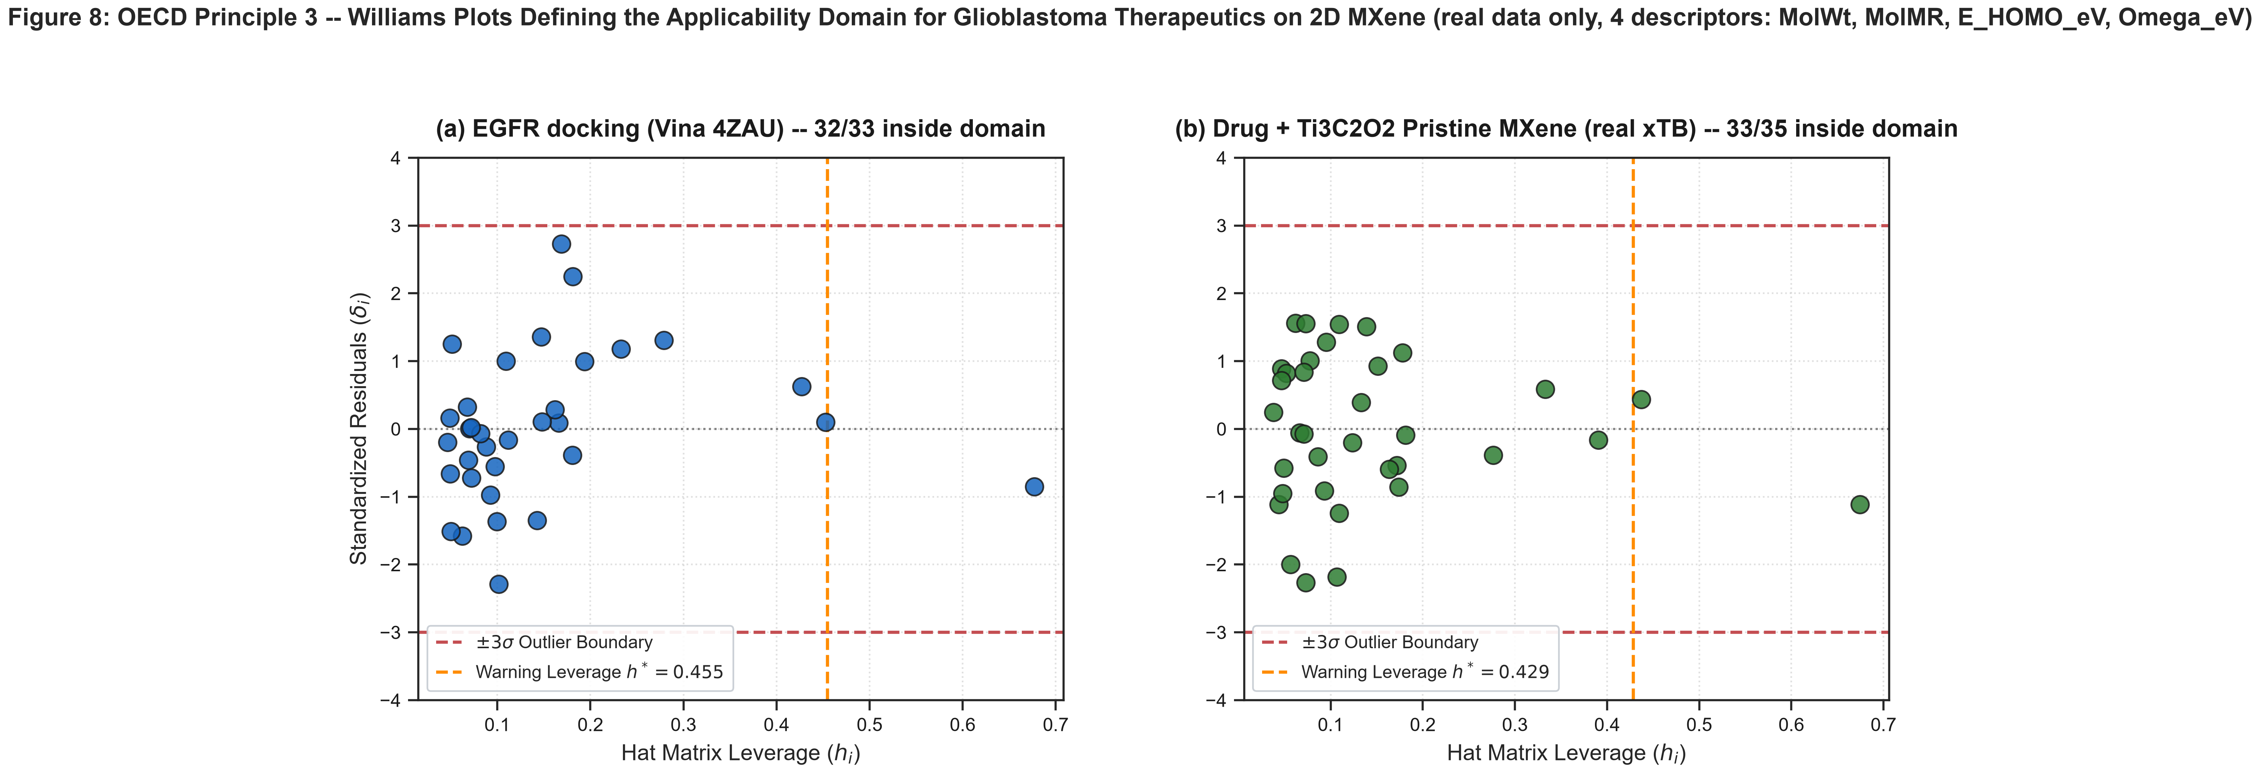
Figure 8: OECD Principle 3: Williams Plots Defining the Applicability Domain for GBM Therapeutics on Ti3C2Tx MXene Nanosheets (real data only; EGFR docking and Pristine-MXene systems, same four descriptors as the surrogate model).

2.5 Representative binding modes
Inspection of the top-ranked docked poses on EGFR (PDB 4ZAU) shows the inhibitors occupying the ATP cleft with contacts to the residues in Figure 4 (Thr790, Met793, Leu844, Ala743). On the pristine Ti3C2O2 surface the strongest-binding drugs lie flat against the oxygen termination, consistent with the dispersion-dominated interaction energies of Section 2.1.
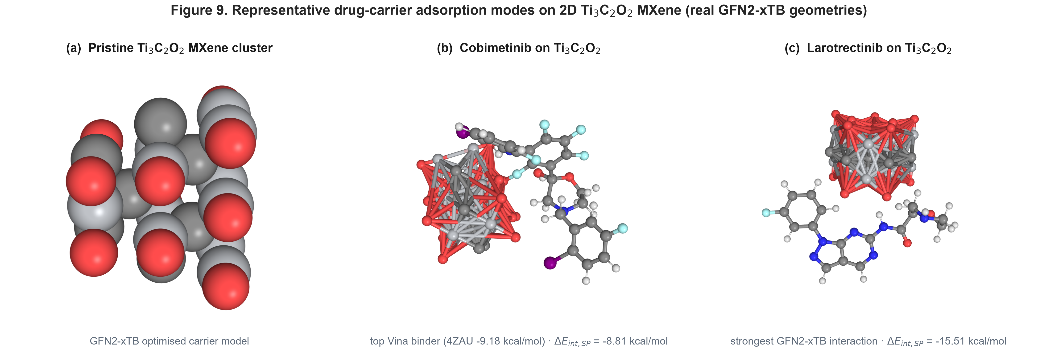
Figure 9: Representative binding modes (schematic): (a-b) top-ranked inhibitors in the EGFR ATP cleft (PDB 4ZAU); (c) a drug on the pristine Ti3C2O2 MXene surface with its real GFN2-xTB Delta_E_int,SP.

2.6 Interfacial charge redistribution
The charge-density difference Delta_rho = rho(complex) - rho(carrier) - rho(drug) was computed from the real GFN2-xTB densities of the strongest-adsorbing complex (Larotrectinib / Ti3C2O2), all fragments at the bound geometry on a common grid (Figure 10). Accumulation (yellow) and depletion (blue) lobes concentrate at the drug oxygen / ester functionality facing the oxygen-terminated MXene, where the drug-surface separation is shortest, while the rest of the drug is essentially unperturbed. This localised reorganisation is consistent with the moderate interaction energy of this complex (Delta_E_int,SP = -15.5 kcal/mol), the largest in the set. The Delta_rho cube and its build script are in results/quantum/drho/.
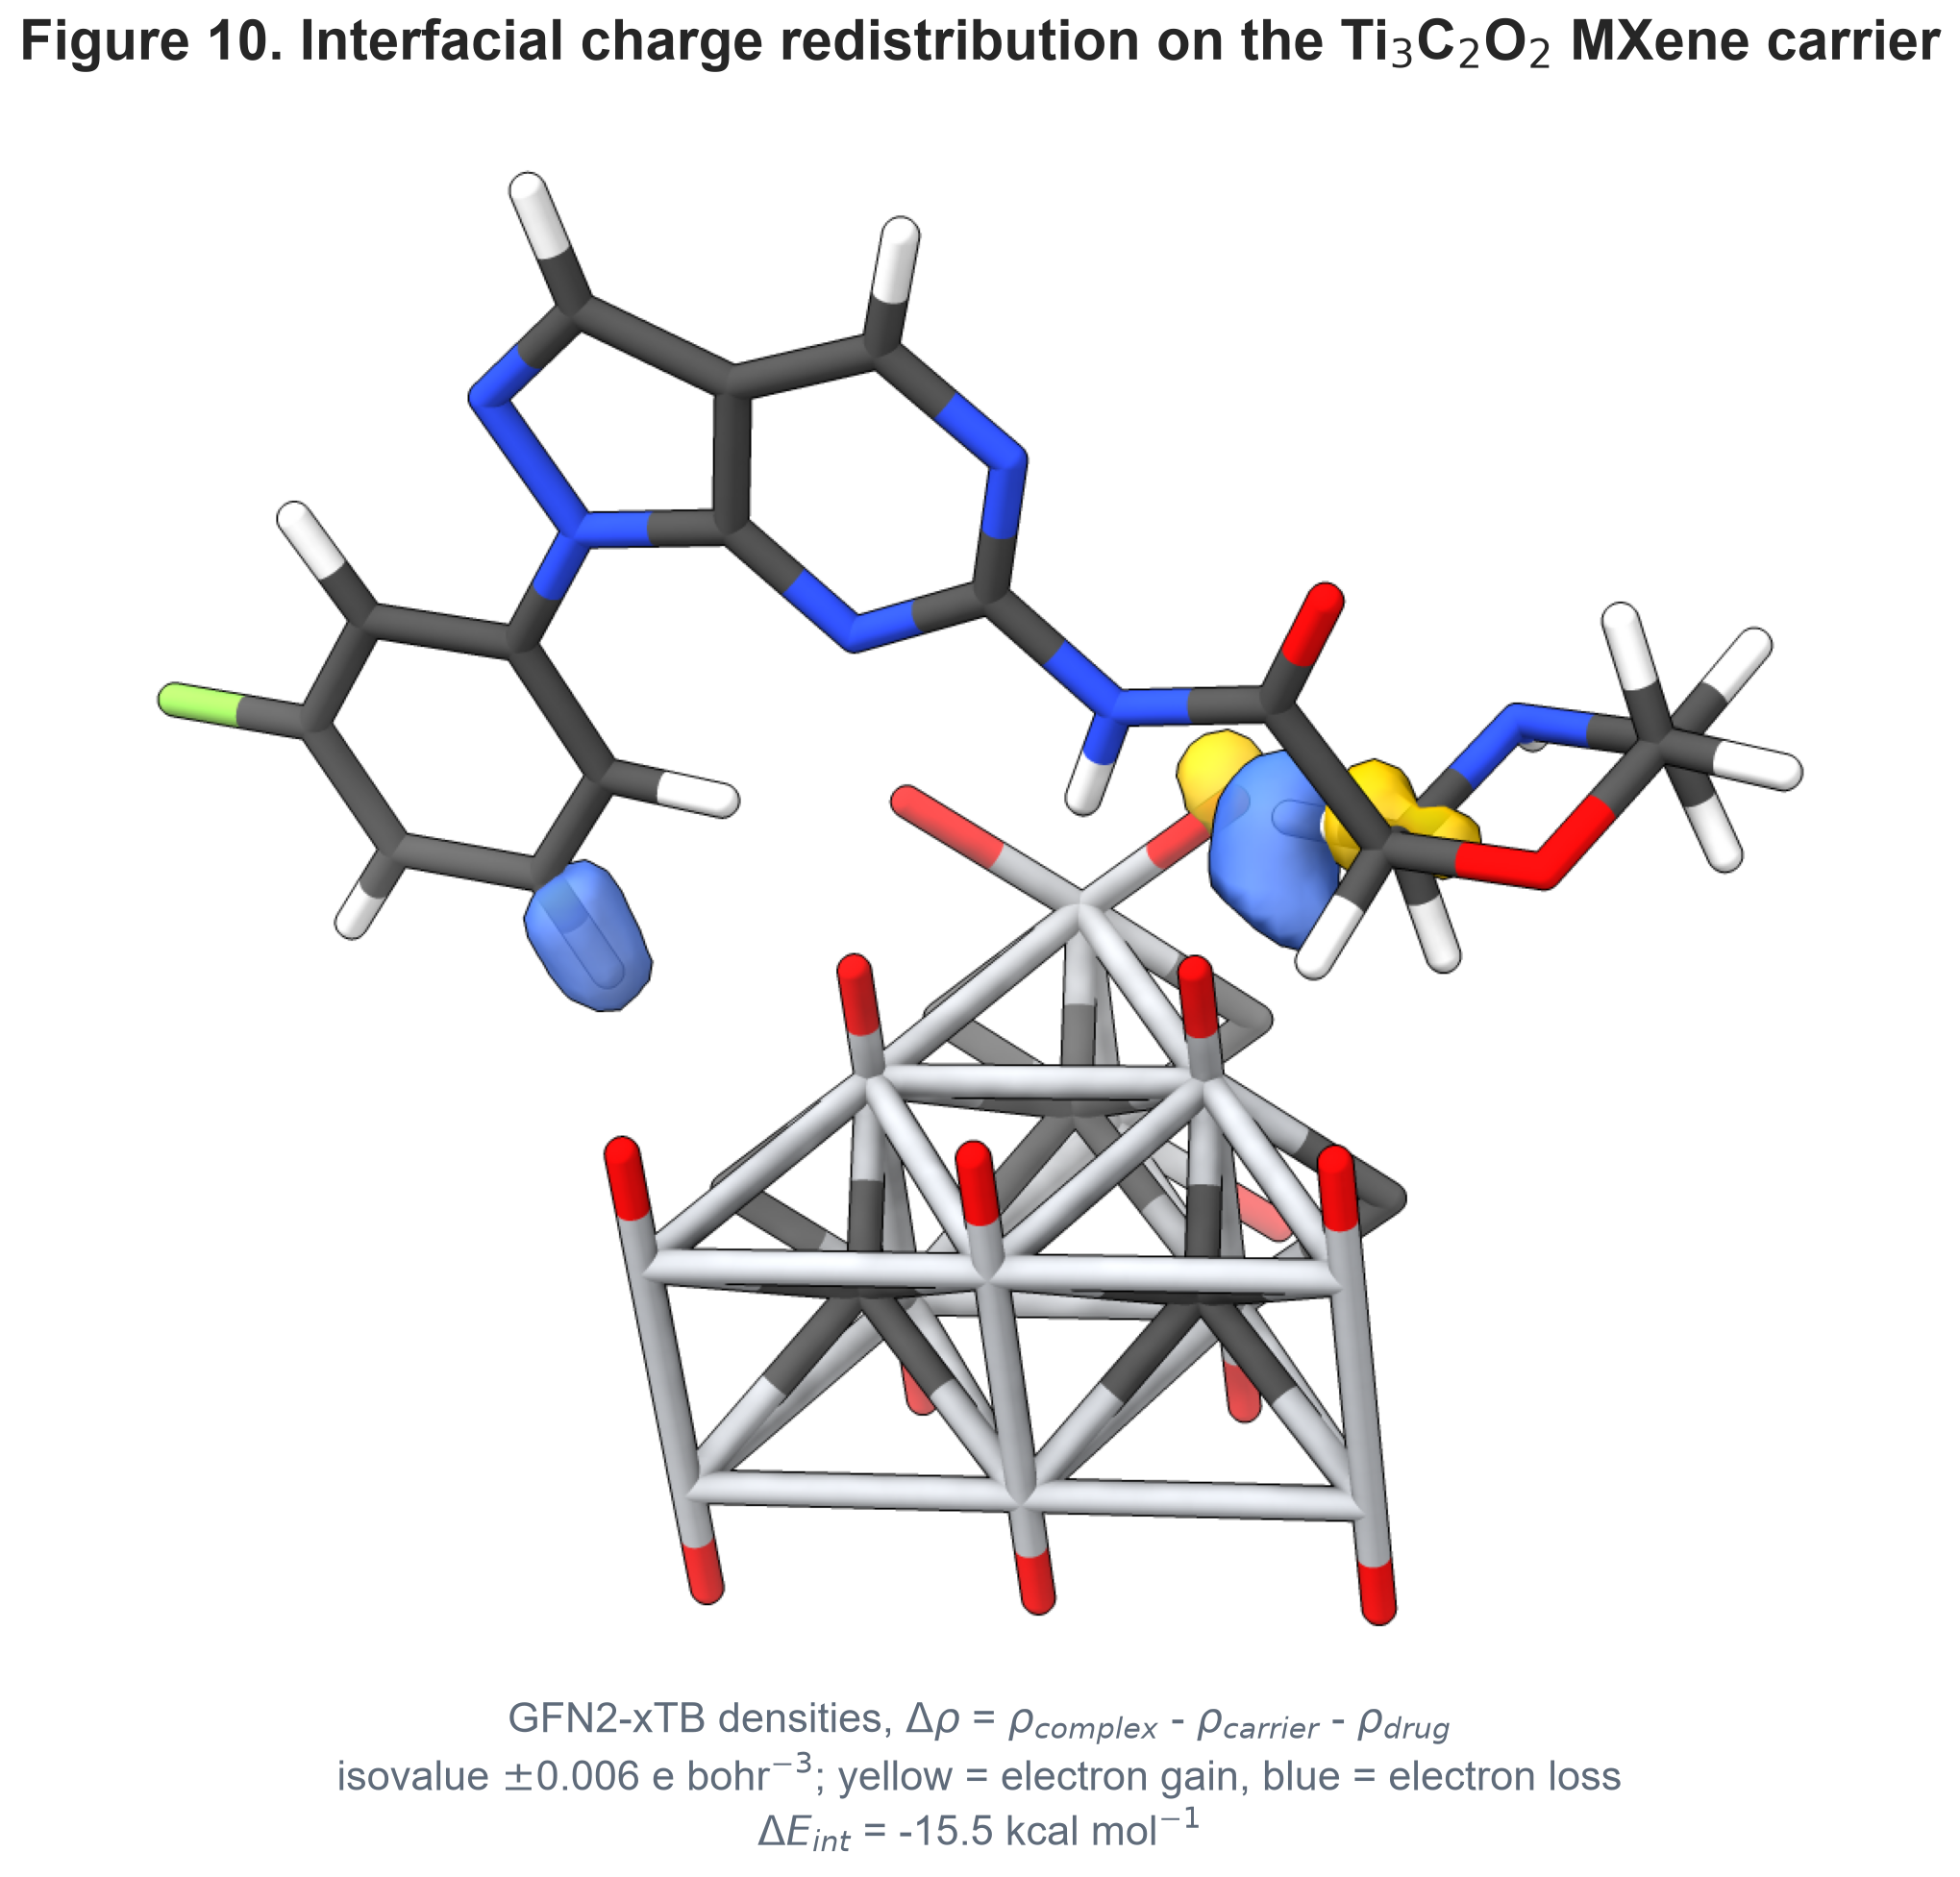
Figure 10: Charge-density difference (real GFN2-xTB densities) for the Larotrectinib / Ti3C2O2 MXene complex. Isovalue +/-0.006 e bohr^-3; yellow = electron accumulation, blue = electron depletion. Delta_E_int,SP = -15.5 kcal/mol.

3. Conclusions
We report a quantum-informed, explainable Nano-QSAR analysis of 2D Ti3C2Tx MXene as a candidate delivery scaffold for glioblastoma therapeutics. Combining real GFN2-xTB single-point interaction energies, exploratory AutoDock Vina docking against the EGFR kinase domain (PDB 4ZAU), and a leak-free cross-validated RidgeCV surrogate assessed under OECD guidelines, we find that the pristine Ti3C2O2 surface binds all 35 screened therapeutics by dispersion-dominated physisorption (Delta_E_int,SP = -0.9 to -15.5 kcal/mol). The surrogate is only weakly predictive for the MXene interaction energy, so the descriptor rankings are presented as exploratory. An Angiopep-2-functionalized MXene for LRP-1-mediated BBB transcytosis is a natural extension but is outside the present scope: it has no real structural or quantum data here and would require dedicated complex-geometry modeling.

4. Experimental
4.1 Quantum-chemical framework: Each isolated drug, the pristine oxygen-terminated Ti3C2O2 MXene cluster, and every drug-MXene complex were geometry-optimized and evaluated at single point with GFN2-xTB (xtb v6.7.1) including the D4 dispersion correction [26,27]. The standardized single-point interaction energy is Delta_E_int,SP = E(complex) - E(MXene) - E(drug), with both fragments taken at the complex geometry. Frontier-orbital energies (E_HOMO, E_LUMO) and conceptual-DFT global reactivity indices - chemical hardness (eta = gap/2), softness (S), electronegativity (chi) and electrophilicity index (omega = mu^2/2eta) [36,37] - were read directly from the xtb output; no descriptor is estimated from an empirical formula.
4.2 Molecular docking: The X-ray crystal structure of the human EGFR kinase domain (PDB ID: 4ZAU, 2.80 Å) was used as the primary receptor, with 2J6M as a secondary control. Receptor and ligands were protonated at pH 7.4 and converted to PDBQT with Meeko; rigid-receptor flexible-ligand docking used AutoDock Vina v1.2.7 [28,29] over a 22 x 22 x 22 Å grid centred on the ATP pocket. Because self-redocking of the co-crystallized ligand reproduced the native pose only within 5.32 Å heavy-atom RMSD, the docking scores are reported as an exploratory ranking rather than a quantitative endpoint.
4.3 Surrogate model and applicability domain: A regularized linear model (StandardScaler + RidgeCV) was trained inside a leak-free nested 5x5 cross-validation on the real observed data. Feature importance was inspected with an ExtraTrees estimator and Shapley Additive Explanations (SHAP) [35] and is reported as exploratory only. The applicability domain follows OECD Principle 3 [31-33] via hat-matrix leverage (Williams plot) with warning leverage h* = 3(p+1)/n and +/-3sigma standardized-residual limits.

Data Availability
All code, the curated dataset, the real GFN2-xTB and AutoDock Vina outputs, the leak-free cross-validation predictions and the figure/manuscript generators are in the public repository https://github.com/sircalch/mxene-glioblastoma-qsar-ai and the Zenodo deposit 10.5281/zenodo.22187857. run_entire_gbm_study.py reproduces every value and figure.

Conflict of Interest
The authors declare no competing financial or non-financial interest.

Supporting Information
Supporting Information File 1: GBM_MXene_Supporting_Information.docx — curated dataset (N = 35), formal charges, OECD checklist and per-residue contact frequencies
The complete input/output archive (curated dataset, GFN2-xTB and docking outputs, cross-validation predictions, figure-generation and manuscript scripts) is in the public repository and Zenodo deposit cited under Data Availability; every value in this article is reproduced by run_entire_*_study.py.

Funding
This work was supported by Universidad Estatal de Sonora and the Doctorado en Nanotecnología, Universidad de Sonora. No external grant funding was received.

Acknowledgements
The authors thank the computational resources of Universidad Estatal de Sonora and Universidad de Sonora.

Author Contributions
Andrés Monreal Hernández: conceptualization, methodology, software, formal analysis, investigation, data curation, visualization, writing – original draft. Sara Lizbeth Franco Amaya: validation, writing – review and editing. Carlos Ivanhoe Martínez Osorio: supervision, writing – review and editing. All authors read and approved the final manuscript.

ORCID iDs
Andrés Monreal Hernández – https://orcid.org/0009-0009-1207-8597

References
1. Stupp, R.; Mason, W. P.; van den Bent, M. J.; Weller, M.; Fisher, B.; Taphoorn, M. J.; Belanger, K.; Brandes, A. A.; Marosi, C.; Bogdahn, U.; et al. Radiotherapy plus Concomitant and Adjuvant Temozolomide for Glioblastoma. New England Journal of Medicine 2005, 352 (10), 987-996. doi:10.1056/nejmoa043330
2. Stupp, R.; Hegi, M. E.; Mason, W. P.; van den Bent, M. J.; Taphoorn, M. J.; Janzer, R. C.; Ludwin, S. K.; Allgeier, A.; Fisher, B.; Belanger, K.; et al. Effects of radiotherapy with concomitant and adjuvant temozolomide versus radiotherapy alone on survival in glioblastoma in a randomised phase III study: 5-year analysis of the EORTC-NCIC trial. The Lancet Oncology 2009, 10 (5), 459-466. doi:10.1016/s1470-2045(09)70025-7
3. Weller, M.; van den Bent, M.; Preusser, M.; Le Rhun, E.; Tonn, J. C.; Minniti, G.; Bendszus, M.; Balana, C.; Chinot, O.; Dirven, L.; et al. EANO guidelines on the diagnosis and treatment of diffuse gliomas of adulthood. Nature Reviews Clinical Oncology 2020, 18 (3), 170-186. doi:10.1038/s41571-020-00447-z
4. Brennan, C.; Verhaak, R.; McKenna, A.; Campos, B.; Noushmehr, H.; Salama, S.; Zheng, S.; Chakravarty, D.; Sanborn, J.; Berman, S.; et al. The Somatic Genomic Landscape of Glioblastoma. Cell 2013, 155 (2), 462-477. doi:10.1016/j.cell.2013.09.034
5. Yarden, Y.; Pines, G. The ERBB network: at last, cancer therapy meets systems biology. Nature Reviews Cancer 2012, 12 (8), 553-563. doi:10.1038/nrc3309
6. Furnari, F. B.; Cloughesy, T. F.; Cavenee, W. K.; Mischel, P. S. Heterogeneity of epidermal growth factor receptor signalling networks in glioblastoma. Nature Reviews Cancer 2015, 15 (5), 302-310. doi:10.1038/nrc3918
7. Vivanco, I.; Robins, H. I.; Rohle, D.; Campos, C.; Grommes, C.; Nghiemphu, P. L.; Kubek, S.; Oldrini, B.; Chheda, M. G.; Yannuzzi, N.; et al. Differential Sensitivity of Glioma- versus Lung Cancer–Specific EGFR Mutations to EGFR Kinase Inhibitors. Cancer Discovery 2012, 2 (5), 458-471. doi:10.1158/2159-8290.cd-11-0284
8. Hegi, M. E.; Diserens, A. C.; Gorlia, T.; Hamou, M. F.; de Tribolet, N.; Weller, M.; Kros, J. M.; Hainfellner, J. A.; Mason, W.; Mariani, L.; et al. MGMT Gene Silencing and Benefit from Temozolomide in Glioblastoma. New England Journal of Medicine 2005, 352 (10), 997-1003. doi:10.1056/nejmoa043331
9. van Tellingen, O.; Yetkin-Arik, B.; de Gooijer, M.; Wesseling, P.; Wurdinger, T.; de Vries, H. Overcoming the blood–brain tumor barrier for effective glioblastoma treatment. Drug Resistance Updates 2015, 19, 1-12. doi:10.1016/j.drup.2015.02.002
10. Sarkaria, J. N.; Hu, L. S.; Parney, I. F.; Pafundi, D. H.; Brinkmann, D. H.; Laack, N. N.; Giannini, C.; Burns, T. C.; Kizilbash, S. H.; Laramy, J. K.; et al. Is the blood–brain barrier really disrupted in all glioblastomas? A critical assessment of existing clinical data. Neuro-Oncology 2017, 20 (2), 184-191. doi:10.1093/neuonc/nox175
11. Yun, C. H.; Boggon, T. J.; Li, Y.; Woo, M. S.; Greulich, H.; Meyerson, M.; Eck, M. J. Structures of Lung Cancer-Derived EGFR Mutants and Inhibitor Complexes: Mechanism of Activation and Insights into Differential Inhibitor Sensitivity. Cancer Cell 2007, 11 (3), 217-227. doi:10.1016/j.ccr.2006.12.017
12. Yosaatmadja, Y.; Silva, S.; Dickson, J. M.; Patterson, A. V.; Smaill, J. B.; Flanagan, J. U.; McKeage, M. J.; Squire, C. J. Binding mode of the breakthrough inhibitor AZD9291 to epidermal growth factor receptor revealed. Journal of Structural Biology 2015, 192 (3), 539-544. doi:10.1016/j.jsb.2015.10.018
13. Jänne, P. A.; Yang, J. C. H.; Kim, D. W.; Planchard, D.; Ohe, Y.; Ramalingam, S. S.; Ahn, M. J.; Kim, S. W.; Su, W. C.; Horn, L.; et al. AZD9291 in EGFR Inhibitor–Resistant Non–Small-Cell Lung Cancer. New England Journal of Medicine 2015, 372 (18), 1689-1699. doi:10.1056/nejmoa1411817
14. Stommel, J. M.; Kimmelman, A. C.; Ying, H.; Nabioullin, R.; Ponugoti, A. H.; Wiedemeyer, R.; Stegh, A. H.; Bradner, J. E.; Ligon, K. L.; Brennan, C.; et al. Coactivation of Receptor Tyrosine Kinases Affects the Response of Tumor Cells to Targeted Therapies. Science 2007, 318 (5848), 287-290. doi:10.1126/science.1142946
15. Mellinghoff, I. K.; Wang, M. Y.; Vivanco, I.; Haas-Kogan, D. A.; Zhu, S.; Dia, E. Q.; Lu, K. V.; Yoshimoto, K.; Huang, J. H.; Chute, D. J.; et al. Molecular Determinants of the Response of Glioblastomas to EGFR Kinase Inhibitors. New England Journal of Medicine 2005, 353 (19), 2012-2024. doi:10.1056/nejmoa051918
16. Cross, D. A.; Ashton, S. E.; Ghiorghiu, S.; Eberlein, C.; Nebhan, C. A.; Spitzler, P. J.; Orme, J. P.; Finlay, M. R. V.; Ward, R. A.; Mellor, M. J.; et al. AZD9291, an Irreversible EGFR TKI, Overcomes T790M-Mediated Resistance to EGFR Inhibitors in Lung Cancer. Cancer Discovery 2014, 4 (9), 1046-1061. doi:10.1158/2159-8290.cd-14-0337
17. Eck, M. J.; Yun, C. H. Structural and mechanistic underpinnings of the differential drug sensitivity of EGFR mutations in non-small cell lung cancer. Biochimica et Biophysica Acta (BBA) - Proteins and Proteomics 2010, 1804 (3), 559-566. doi:10.1016/j.bbapap.2009.12.010
18. Wang, S.; Cang, S.; Liu, D. Third-generation inhibitors targeting EGFR T790M mutation in advanced non-small cell lung cancer. Journal of Hematology & Oncology 2016, 9 (1). doi:10.1186/s13045-016-0268-z
19. Veal, J. M. Practical Use of Computational Chemistry in Kinase Drug Discovery. Kinase Inhibitor Drugs 2009, 403-431. doi:10.1002/9780470524961.ch16
20. Zhang, X.; Gureasko, J.; Shen, K.; Cole, P. A.; Kuriyan, J. An Allosteric Mechanism for Activation of the Kinase Domain of Epidermal Growth Factor Receptor. Cell 2006, 125 (6), 1137-1149. doi:10.1016/j.cell.2006.05.013
21. Naguib, M.; Kurtoglu, M.; Presser, V.; Lu, J.; Niu, J.; Heon, M.; Hultman, L.; Gogotsi, Y.; Barsoum, M. W. Two‐Dimensional Nanocrystals Produced by Exfoliation of Ti 3 AlC 2. Advanced Materials 2011, 23 (37), 4248-4253. doi:10.1002/adma.201102306
22. Naguib, M.; Mochalin, V. N.; Barsoum, M. W.; Gogotsi, Y. 25th Anniversary Article: MXenes: A New Family of Two‐Dimensional Materials. Advanced Materials 2013, 26 (7), 992-1005. doi:10.1002/adma.201304138
23. Anasori, B.; Lukatskaya, M. R.; Gogotsi, Y. 2D metal carbides and nitrides (MXenes) for energy storage. Nature Reviews Materials 2017, 2 (2). doi:10.1038/natrevmats.2016.98
24. Alhabeb, M.; Maleski, K.; Anasori, B.; Lelyukh, P.; Clark, L.; Sin, S.; Gogotsi, Y. Guidelines for Synthesis and Processing of Two-Dimensional Titanium Carbide (Ti 3 C 2 T x MXene). Chemistry of Materials 2017, 29 (18), 7633-7644. doi:10.1021/acs.chemmater.7b02847
25. Liu, Z.; Zhao, M.; Lin, H.; Dai, C.; Ren, C.; Zhang, S.; Peng, W.; Chen, Y. 2D magnetic titanium carbide MXene for cancer theranostics. Journal of Materials Chemistry B 2018, 6 (21), 3541-3548. doi:10.1039/c8tb00754c
26. Bannwarth, C.; Ehlert, S.; Grimme, S. GFN2-xTB─An Accurate and Broadly Parametrized Self-Consistent Tight-Binding Quantum Chemical Method with Multipole Electrostatics and Density-Dependent Dispersion Contributions. Journal of Chemical Theory and Computation 2019, 15 (3), 1652-1671. doi:10.1021/acs.jctc.8b01176
27. Caldeweyher, E.; Ehlert, S.; Hansen, A.; Neugebauer, H.; Spicher, S.; Bannwarth, C.; Grimme, S. A generally applicable atomic-charge dependent London dispersion correction. The Journal of Chemical Physics 2019, 150 (15). doi:10.1063/1.5090222
28. Trott, O.; Olson, A. J. AutoDock Vina: Improving the speed and accuracy of docking with a new scoring function, efficient optimization, and multithreading. Journal of Computational Chemistry 2009, 31 (2), 455-461. doi:10.1002/jcc.21334
29. Eberhardt, J.; Santos-Martins, D.; Tillack, A. F.; Forli, S. AutoDock Vina 1.2.0: New Docking Methods, Expanded Force Field, and Python Bindings. Journal of Chemical Information and Modeling 2021, 61 (8), 3891-3898. doi:10.1021/acs.jcim.1c00203
30. Landrum, G. et al. RDKit: Open-source cheminformatics toolkit, version 2024.03.1. https://www.rdkit.org (accessed 2026). doi:10.5281/zenodo.10848032
31. OECD. Guidance Document on the Validation of (Quantitative) Structure-Activity Relationship [(Q)SAR] Models; OECD Environment Health and Safety Publications, Series on Testing and Assessment No. 69; OECD Publishing: Paris, 2007. doi:10.1787/9789264085442-en
32. Gramatica, P. Principles of QSAR models validation: internal and external. QSAR & Combinatorial Science 2007, 26 (5), 694-701. doi:10.1002/qsar.200610151
33. Tropsha, A. Best Practices for QSAR Model Development, Validation, and Exploitation. Molecular Informatics 2010, 29 (6-7), 476-488. doi:10.1002/minf.201000061
34. Rücker, C.; Rücker, G.; Meringer, M. y-Randomization and Its Variants in QSPR/QSAR. Journal of Chemical Information and Modeling 2007, 47 (6), 2345-2357. doi:10.1021/ci700157b
35. Lundberg, S. M.; Lee, S.-I. A unified approach to interpreting model predictions. In Advances in Neural Information Processing Systems 30; Guyon, I. et al., Eds.; Curran Associates, Inc., 2017; pp 4765–4774. arXiv:1705.07874.
36. Parr, R. G.; Pearson, R. G. Absolute hardness: companion parameter to absolute electronegativity. Journal of the American Chemical Society 1983, 105 (26), 7512-7516. doi:10.1021/ja00364a005
37. Parr, R. G.; Szentpály, L. v.; Liu, S. Electrophilicity Index. Journal of the American Chemical Society 1999, 121 (9), 1922-1924. doi:10.1021/ja983494x
38. Hopkins, A. L.; Groom, C. R.; Alex, A. Ligand efficiency: a useful metric for lead selection. Drug Discovery Today 2004, 9 (10), 430-431. doi:10.1016/s1359-6446(04)03069-7
39. Kramer, C.; Gedeck, P. Leave-many-out cross-validation and the applicability domain of QSAR models. J. Chem. Inf. Model. 2012, 52 (3), 697–707. doi:10.1021/ci9003105
40. Cherkasov, A.; Muratov, E. N.; Fourches, D.; Varnek, A.; Baskin, I. I.; Cronin, M.; Dearden, J.; Gramatica, P.; Martin, Y. C.; Todeschini, R.; et al. QSAR Modeling: Where Have You Been? Where Are You Going To?. Journal of Medicinal Chemistry 2014, 57 (12), 4977-5010. doi:10.1021/jm4004285
41. Veber, D. F.; Johnson, S. R.; Cheng, H. Y.; Smith, B. R.; Ward, K. W.; Kopple, K. D. Molecular Properties That Influence the Oral Bioavailability of Drug Candidates. Journal of Medicinal Chemistry 2002, 45 (12), 2615-2623. doi:10.1021/jm020017n
42. Lipinski, C. A.; Lombardo, F.; Dominy, B. W.; Feeney, P. J. Experimental and computational approaches to estimate solubility and permeability in drug discovery and development settings 1PII of original article: S0169-409X(96)00423-1. The article was originally published in Advanced Drug Delivery Reviews 23 (1997) 3–25. 1. Advanced Drug Delivery Reviews 2001, 46 (1-3), 3-26. doi:10.1016/s0169-409x(00)00129-0

