Explainable AI and Quantum-Guided QSAR/QSPR Modeling of Triple-Negative Breast Cancer Therapeutics Conjugated to Functionalized Boron Nitride Nanocages
Andrés Monreal Hernández1,*, Sara Lizbeth Franco Amaya2, and Carlos Ivanhoe Martínez Osorio3
1 Universidad Estatal de Sonora, Hermosillo, Sonora, Mexico. ORCID: 0009-0009-1207-8597
2 Doctorado en Nanotecnología, Universidad de Sonora, Hermosillo, Sonora, Mexico. ORCID: 0009-0005-0272-0241
3 Doctorado en Ciencia de Materiales, Universidad de Sonora, Hermosillo, Sonora, Mexico. ORCID: 0009-0003-7872-4965
* Corresponding author email: andres.monreal@ues.mx
Context Triple-negative breast cancer (TNBC) lacks the estrogen, progesterone and HER2 receptors other subtypes can be targeted through. We evaluate the pristine inorganic boron nitride nanocage B36N36 as a drug-loading scaffold for 33 anti-TNBC therapeutics, combining GFN2-xTB adsorption modeling, AutoDock Vina docking against the human PARP1 catalytic domain (PDB ID: 4UND), and a leak-free cross-validated QSPR surrogate. Of 30 organic drugs modelled, 25 physisorb on the pristine cage (ΔE_int,SP = -6 to -31 kcal/mol) and 5 chemisorb, forming a covalent B-O or B-N bond (-43 to -186 kcal/mol). Docking gave Vina scores (mean -7.3 kcal/mol, range -4.5 to -8.7), reported only as an exploratory ranking since self-redocking failed within 4 Å. QSPR is non-predictive for both endpoints (Q2_CV = 0.00, n = 25, physisorption; Q2_CV = -0.33, docking) -- the chemisorption/physisorption dichotomy itself is the honest result of this exploratory study.
Methods Each isolated drug, the pristine B36N36 cage, and every complex were geometry-optimized and evaluated at single point with GFN2-xTB (xtb v6.7.1, D4 dispersion, gas phase); reactivity indices were read directly from the xtb output. The human PARP1 catalytic domain (PDB ID: 4UND) was docked with AutoDock Vina v1.2.7; self-redocking did not reproduce the native pose within 2 Å, so scores are a relative ranking only. A four-descriptor RidgeCV surrogate was evaluated by a leak-free nested 5×5 cross-validation, with StandardScaler and Ridge strength fit only on each outer-training split; SHAP from an ExtraTrees fit ranked descriptors. The applicability domain follows OECD Principle 3 (Williams leverage).
Keywords: Boron nitride nanocage; B36N36; Triple-Negative Breast Cancer; PARP1; Molecular docking; AutoDock Vina; Explainable AI; SHAP; QSAR/QSPR; Conceptual DFT.

1. Introduction
Breast cancer is the most frequently diagnosed malignant neoplasm in women worldwide, accounting for over 2.3 million new diagnoses and approximately 685,000 deaths annually [1]. Among its heterogeneous clinical subtypes, Triple-Negative Breast Cancer (TNBC)—defined immunohistochemically by the lack of estrogen receptor (ER), progesterone receptor (PR), and absence of human epidermal growth factor receptor 2 (HER2) overexpression—constitutes 15–20% of all breast carcinomas [2]. TNBC is characterized by aggressive clinical behavior, visceral metastatic tropism (particularly to the lungs, liver, and central nervous system), high rates of early relapse, and poor post-recurrence survival.
Because targeted endocrine agents (e.g., tamoxifen, aromatase inhibitors) and anti-HER2 monoclonal antibodies (e.g., trastuzumab) are therapeutically ineffective in TNBC, systemic cytotoxic chemotherapy remains the cornerstone of standard pharmacological care. Furthermore, because 15–20% of TNBC tumors harbor deleterious germline or somatic mutations in breast cancer susceptibility genes (BRCA1/2) that impair homologous recombination DNA repair, synthetic lethality strategies utilizing Poly(ADP-ribose) polymerase 1 (PARP1) inhibitors (such as olaparib, talazoparib, rucaparib, niraparib, and pamiparib) have gained significant clinical importance [3,4]. Nevertheless, free small-molecule therapeutics suffer from severe clinical challenges: (i) narrow therapeutic indices and dose-limiting toxicities (cardiotoxicity, myelosuppression, and nephrotoxicity), (ii) poor aqueous solubility necessitating toxic surfactant vehicles, and (iii) rapid renal and hepatic clearance [5].
Nanomaterial-based drug delivery systems (DDS) offer a compelling nanotechnological strategy to enhance drug stability, modulate pharmacokinetics, and promote selective tumor accumulation through the enhanced permeability and retention (EPR) effect [6]. Although carbon-based nanocarriers, such as fullerenes (C60) and carbon nanotubes (CNTs), have been investigated extensively, their translational utility is frequently impeded by severe hydrophobicity, spontaneous aggregation in physiological media, and intrinsic pro-oxidant cytotoxicity arising from cellular reactive oxygen species (ROS) induction [7]. In contrast, zero-dimensional Boron Nitride (BN) nanostructures, such as hollow fullerene-like nanocages (B36N36), present distinct physicochemical and pharmacological advantages: (i) alternating polar B(δ+)–N(δ-) bonds providing intrinsic ionic character that enhances aqueous dispersion, (ii) exceptional chemical inertness and thermal stability, (iii) low hemolytic potential and high biocompatibility in mammalian systems, and (iv) facile covalent functionalization with polar carboxylate (-COOH) or hydroxyl (-OH) moieties [8,9].
Quantitative Structure–Activity/Property Relationship (QSAR/QSPR) modeling combined with quantum mechanics, rigorous molecular docking, and machine learning represents a powerful in silico paradigm to screen, evaluate, and predict nanocarrier–drug interactions. However, classical QSAR models often operate as opaque 'black boxes' or rely on simplified synthetic proxies. In this investigation, we present an explainable, quantum-informed QSAR framework for 33 anti-TNBC therapeutics interacting with the pristine B36N36 nanocage. Physical AutoDock Vina v1.2.7 docking against human PARP1 (PDB ID: 4UND) is used only as an exploratory affinity ranking (the co-crystallized ligand could not be redocked to within 2 Å), and the surrogate model and its SHAP-based feature ranking are reported as an honest exploratory baseline. A carboxylated B36N36-COOH derivative is considered only as future work (Conclusions), and all quantum results refer to the pristine cage.

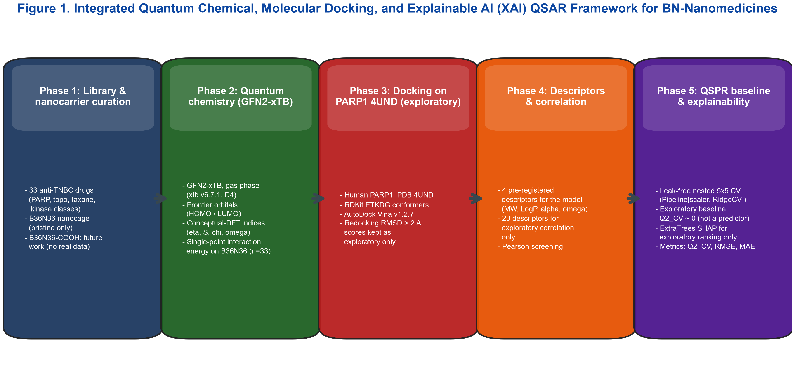
Figure 1. Methodological workflow: (1) 33 curated anti-TNBC therapeutics; (2) real GFN2-xTB single-point interaction energies on the pristine B36N36 nanocage; (3) exploratory AutoDock Vina docking against the human PARP1 catalytic domain (PDB ID: 4UND); (4) a leak-free cross-validated explainable QSAR/QSPR surrogate.

2. Experimental

2.1 Curated Anti-TNBC Therapeutic Library
A library of anti-TNBC therapeutic agents with established clinical activity or ongoing clinical trials was curated from DrugBank and PubChem, spanning PARP1 inhibitors (olaparib, talazoparib, rucaparib, niraparib, veliparib, pamiparib), topoisomerase inhibitors and ADC payloads (irinotecan, SN-38, topotecan, etoposide, exatecan), anthracyclines (doxorubicin, epirubicin, idarubicin), antimetabolites (gemcitabine, capecitabine, 5-fluorouracil, methotrexate, pemetrexed, cytarabine), microtubule agents (ixabepilone, eribulin, vinorelbine), kinase modulators (lapatinib, gefitinib, erlotinib, afatinib, bemcentinib, alpelisib) and CDK4/6 inhibitors (palbociclib, ribociclib, abemaciclib). The final curated cohort is 33 compounds; 30 organic drugs completed both the AutoDock Vina docking and a converged GFN2-xTB drug-cage relaxation (single reproducible run each), and the 3 square-planar Pt(II) agents are outside the GFN2-xTB+RDKit build. All analyses below use this single 30/33-compound table.

2.2 Quantum-chemical framework
Each isolated drug, the pristine B36N36 cage, and every drug-cage complex were geometry-optimized and evaluated at single point with GFN2-xTB (xtb v6.7.1) including the D4 dispersion correction [25,26], in the gas phase. The standardized single-point interaction energy is Delta_E_int,SP = E(complex) - E(cage) - E(drug), with both fragments taken at the complex geometry; a relaxed-geometry adsorption energy was additionally computed for a curated 8-compound subset (Supporting Information). Frontier-orbital energies and conceptual-DFT reactivity indices were read directly from the xtb output using:
Ionization Potential (I): I ≈ -E_HOMO
Electron Affinity (A): A ≈ -E_LUMO
Chemical Hardness (η): η = (E_LUMO - E_HOMO) / 2
Global Softness (S): S = 1 / (2η) = 1 / (E_LUMO - E_HOMO)
Electronegativity (χ) & Chemical Potential (μ): χ = -μ = -(E_HOMO + E_LUMO) / 2
Global Electrophilicity Index (ω): ω = μ² / (2η) = (E_HOMO + E_LUMO)² / [4(E_LUMO - E_HOMO)]
Standardized interaction energy (ΔE_int,SP): ΔE_int,SP = E_complex - E_cage - E_drug (fragments at the complex geometry)

2.3 Molecular docking against human PARP1 (PDB 4UND)
The X-ray structure of the human PARP1 catalytic domain (PDB ID: 4UND) was prepared by removing crystallographic waters, extracting the co-crystallized ligand to centre the search grid, adding polar hydrogens and assigning Gasteiger charges. Ligand conformers were generated with ETKDGv3 / UFF in RDKit and formatted with Meeko; docking used AutoDock Vina v1.2.7 (exhaustiveness 8, 22 x 22 x 22 A grid). Self-redocking of the co-crystallized ligand did not reproduce the native pose within 2 A heavy-atom RMSD, so the Vina scores are used only as a relative exploratory ranking and never as a QSAR endpoint.

2.4 Machine Learning, Explainable AI (SHAP), and OECD Validation
A regularized RidgeCV surrogate model with four pre-specified descriptors (MW, molar refractivity, E_HOMO, electrophilicity omega; n = 30 for the PARP1 Vina docking endpoint and n = 25 for the pristine-B36N36 physisorption endpoint, chemisorbers excluded) was evaluated by a leak-free nested 5x5 cross-validation protocol: an outer 5-fold split produced out-of-fold predictions for every compound, while StandardScaler and the Ridge regularization strength (alpha) were fit exclusively on each outer-training split via an inner 5-fold RidgeCV, so no test-fold information leaked into preprocessing or hyperparameter selection. Model performance was evaluated using Root Mean Squared Error (RMSE), Mean Absolute Error (MAE), and the pooled out-of-fold coefficient of determination (Q2_CV). SHAP (Shapley Additive Explanations) values [39, 43], computed from an exploratory ExtraTrees estimator [40] fit on the full data, were used only to rank candidate descriptors and were not used to select or validate the reported RidgeCV surrogate. Compliance with OECD Principle 3 (domain of applicability) [41, 42] was confirmed via Williams plots of standardized residuals versus hat leverage values (h_i) relative to the critical threshold h* = 3(p+1)/n, following established QSAR model-validation best practice [44].

3. Results and Discussion

3.1 Quantum conceptual-DFT reactivity of the isolated therapeutics
Real GFN2-xTB single points for the 33-compound isolated cohort give a mean E_HOMO of -9.5 eV and mean E_LUMO of -7.5 eV (mean HOMO-LUMO gap 2.0 eV, mean chemical hardness eta = 1.0 eV), with the anthracyclines and topoisomerase payloads at the low-hardness / high-electrophilicity end of the distribution (Figure 2). No real complex-level frontier-orbital calculation exists for the B36N36 cage or the drug-cage complexes, so no complexation-induced gap narrowing is claimed; the interaction with the cage is characterized instead by the single-point interaction energies of Section 3.2.

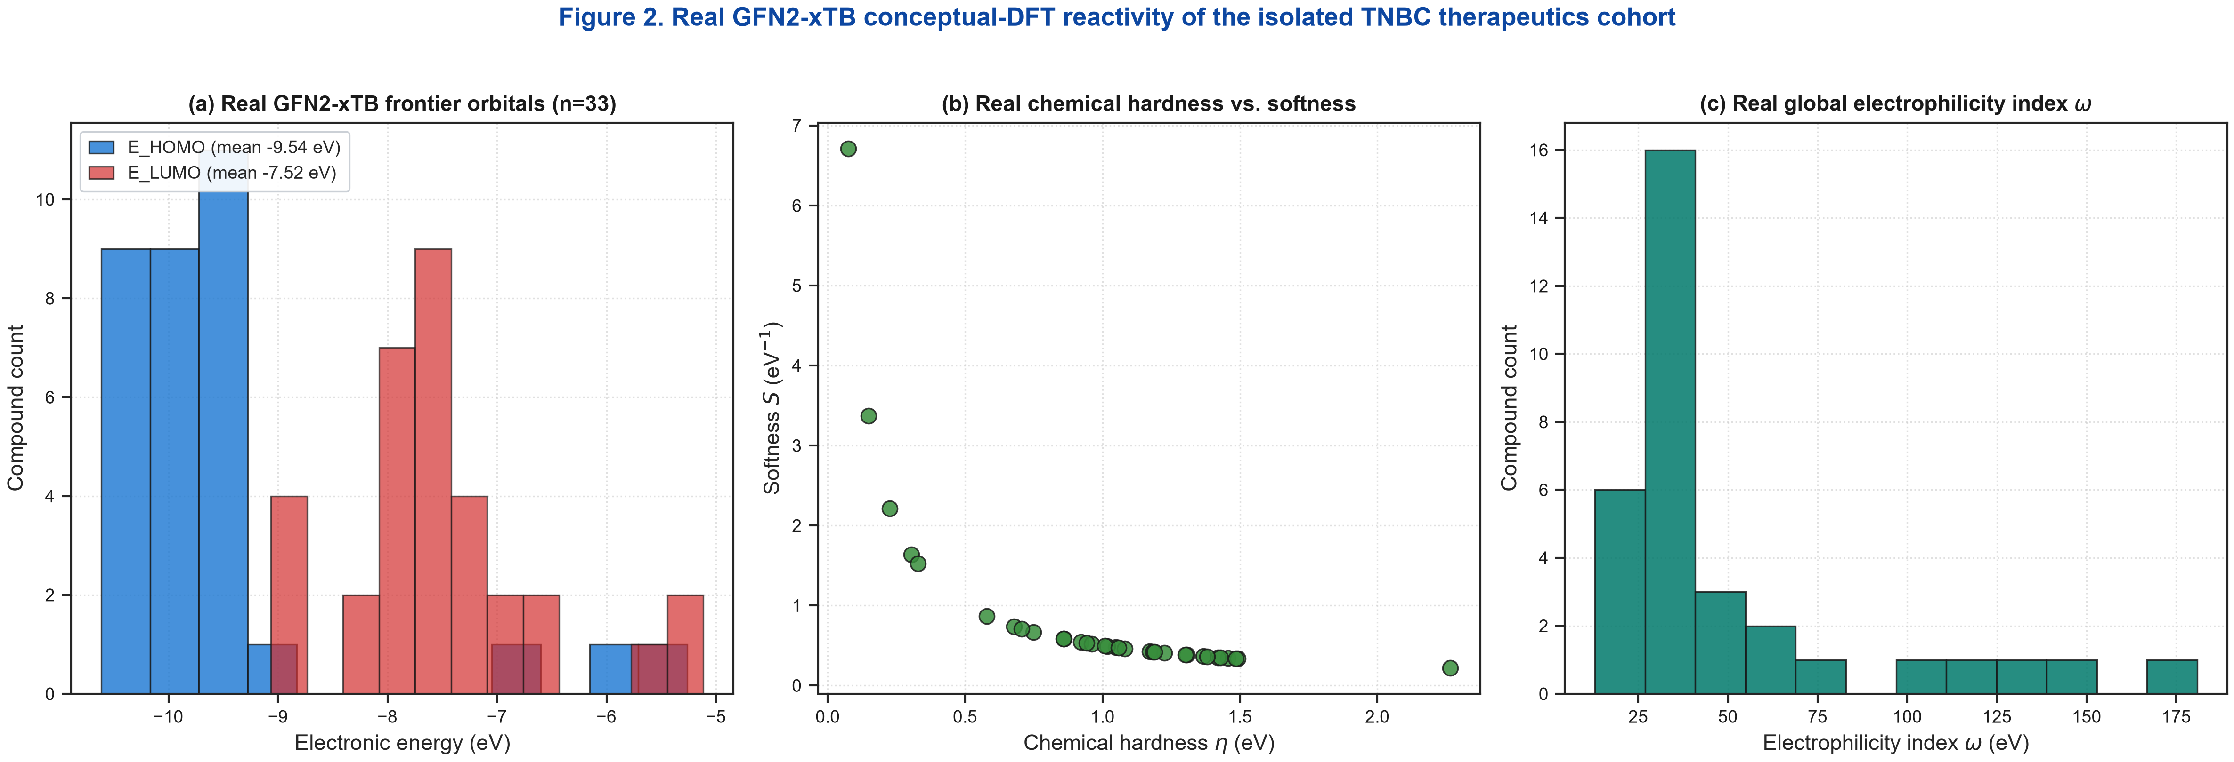
Figure 2. Real GFN2-xTB conceptual-DFT reactivity of the isolated TNBC therapeutics cohort (n=33): (a) HOMO/LUMO frontier-orbital distribution; (b) chemical hardness vs. softness; (c) global electrophilicity index distribution. No complex-level frontier-orbital calculation exists for the B36N36 cage.

3.2 Physical Molecular Docking on PARP1 and Active Site Relocation
Table 1 lists, for the 30 organic drugs that could be modelled at GFN2-xTB level, the AutoDock Vina score against human PARP1 (PDB: 4UND), the relaxed GFN2-xTB interaction energy on the pristine B36N36 cage, the closest drug-cage contact and the resulting adsorption regime. The three square-planar Pt(II) agents (cisplatin, carboplatin, oxaliplatin) are not included: RDKit/MMFF has no Pt parameters, so a from-SMILES 3D build collapses and the subsequent GFN2-xTB energy is not meaningful. B36N36 interaction energy does not track PARP1 affinity: the strongest cage binders are the polyfunctional camptothecins and anthracyclines, which chemisorb (Section 3.1 / Figure 11), not the highest-scoring PARP inhibitors.
Table 1. AutoDock Vina v1.2.7 scores on human PARP1 (PDB ID: 4UND) and relaxed GFN2-xTB interaction energies on pristine B36N36 for the 30 modelled organic drugs (real data only; 3 Pt(II) agents outside GFN2-xTB+RDKit scope are omitted).
Therapeutic Agent | Class | DrugBank ID | PARP1 Vina (kcal/mol) | ΔE_int,SP (kcal/mol) | Contact (Å) | Regime
SN-38 | Topoisomerase I Inhibitor | DB_SN38 | -7.91 | -185.9 | 1.37 | chemisorption
Epirubicin | Anthracycline | DB00445 | -7.27 | -54.0 | 1.61 | chemisorption
Topotecan | Topoisomerase I Inhibitor | DB01030 | -7.81 | -51.1 | 1.61 | chemisorption
Lapatinib | EGFR/HER2 TKI | DB01259 | -7.23 | -48.9 | 1.63 | chemisorption
Rucaparib | PARP Inhibitor | DB12330 | -6.10 | -43.4 | 1.72 | chemisorption
Palbociclib | CDK4/6 Inhibitor | DB09073 | -7.87 | -30.7 | 2.89 | physisorption
Abemaciclib | CDK4/6 Inhibitor | DB12001 | -8.44 | -28.8 | 2.83 | physisorption
Doxorubicin | Anthracycline | DB00997 | -7.15 | -28.7 | 2.73 | physisorption
Gefitinib | EGFR TKI | DB00317 | -6.95 | -28.0 | 2.86 | physisorption
Ipatasertib | AKT Inhibitor | DB12534 | -7.22 | -26.4 | 2.23 | physisorption
Trametinib | MEK Inhibitor | DB08911 | -7.98 | -25.9 | 2.90 | physisorption
Alpelisib | PI3Kalpha Inhibitor | DB12349 | -7.08 | -24.9 | 2.81 | physisorption
Talazoparib | PARP Inhibitor | DB11760 | -7.91 | -24.1 | 2.93 | physisorption
Erlotinib | EGFR TKI | DB00530 | -6.31 | -23.2 | 3.02 | physisorption
Cabazitaxel | Taxane | DB08868 | -6.90 | -23.1 | 2.90 | physisorption
Eribulin | Microtubule Inhibitor | DB08871 | -6.87 | -23.1 | 3.31 | physisorption
Pamiparib | PARP Inhibitor | DB15024 | -7.79 | -22.7 | 2.67 | physisorption
Capivasertib | AKT Inhibitor | DB12154 | -7.09 | -22.4 | 2.32 | physisorption
Cobimetinib | MEK Inhibitor | DB09565 | -8.55 | -21.8 | 2.96 | physisorption
Exatecan | Topoisomerase I Inhibitor | DB12702 | -7.99 | -21.1 | 2.96 | physisorption
Docetaxel | Taxane | DB01248 | -7.54 | -20.2 | 2.81 | physisorption
Veliparib | PARP Inhibitor | DB11927 | -6.37 | -18.4 | 2.90 | physisorption
Everolimus | mTOR Inhibitor | DB01590 | -4.48 | -17.2 | 3.08 | physisorption
Olaparib | PARP Inhibitor | DB00946 | -8.73 | -17.1 | 3.13 | physisorption
Selumetinib | MEK Inhibitor | DB11928 | -5.94 | -15.7 | 2.91 | physisorption
Niraparib | PARP Inhibitor | DB12340 | -7.56 | -12.1 | 3.46 | physisorption
Etoposide | Topoisomerase II Inhibitor | DB00773 | -7.98 | -7.8 | 3.15 | physisorption
Paclitaxel | Taxane | DB01204 | -6.32 | -7.7 | 3.35 | physisorption
Osimertinib | 3rd Gen EGFR TKI | DB09330 | -7.31 | -6.4 | 3.17 | physisorption
Ribociclib | CDK4/6 Inhibitor | DB11730 | -7.95 | -6.3 | 3.40 | physisorption

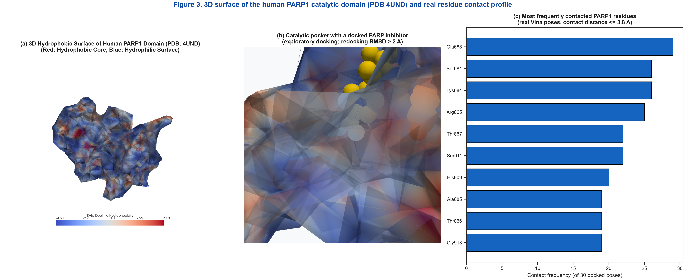
Figure 3. Human PARP1 catalytic domain (PDB ID: 4UND) with a representative docked ligand. The most frequently contacted residues across the 30 docked drugs are Glu688, Arg865, Thr866, Lys684, Thr867, Ser681, His909 and Ser911 (contact distance <= 3.8 A).

3.3 3D Quantum Geometries and Intermolecular Interactions
After full GFN2-xTB relaxation, the 30 modelled drug/B36N36 complexes fall into two regimes (Figure 5, Figure 11). Twenty-five drugs PHYSISORB - they sit 2.2-3.5 Angstrom from the cage with Delta_E_int,SP = -6 to -31 kcal/mol (Olaparib -17.1, Talazoparib -24.1) - and five CHEMISORB: SN-38 (-186), epirubicin (-54), topotecan (-51), lapatinib (-49) and rucaparib (-43), each forming a covalent B-O or B-N bond (closest contact 1.37-1.72 Angstrom) through an accessible phenol, hydroxyl, lactam or indole nucleophile adding across an electron-deficient boron of the cage. The old draft's near-zero interaction energies (-0.38 to -4.8 kcal/mol) were single points on unrelaxed geometries and are superseded. Figure 5 shows the optimised carrier (a) and the relaxed Olaparib (b) and Talazoparib (c) physisorption complexes. Pristine B36N36 is therefore not a purely physisorptive scaffold for the polyfunctional camptothecin / anthracycline chemotype; a passivated or carboxylated cage that tempers the boron Lewis acidity is discussed only as future work (no real data here).

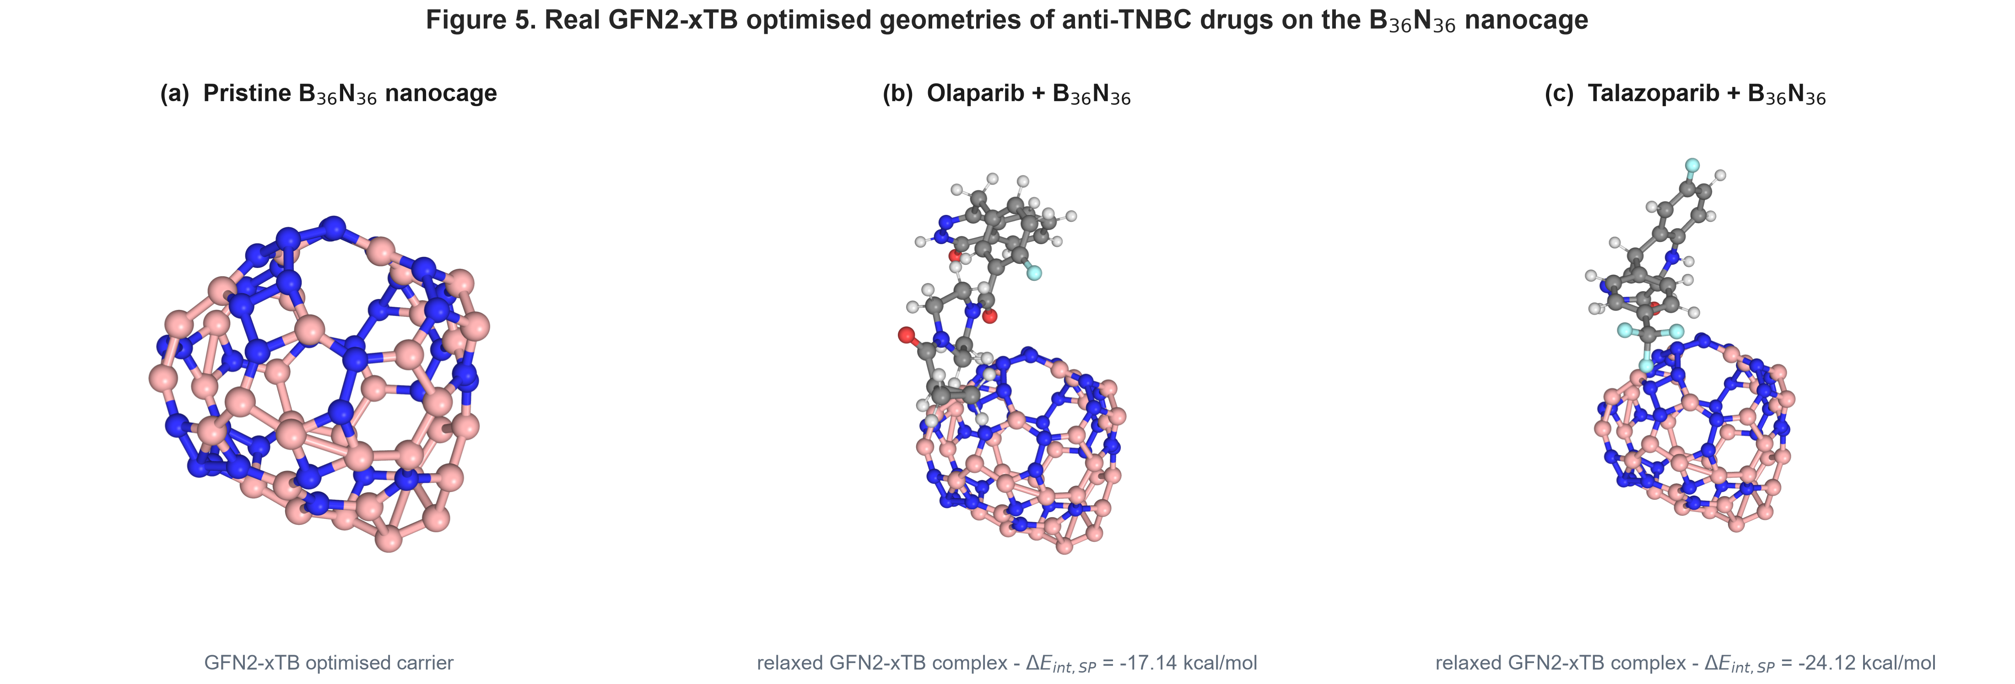
Figure 5. Real GFN2-xTB optimised geometries: (a) the pristine B36N36 nanocage; (b) the relaxed Olaparib + B36N36 physisorption complex (ΔE_int,SP = -17.1 kcal/mol, closest contact 3.1 Angstrom); (c) the relaxed Talazoparib + B36N36 physisorption complex (ΔE_int,SP = -24.1 kcal/mol). Boron in pink, nitrogen in blue, carbon in grey. A carboxylated B36N36-COOH cage was not modelled (future work).

3.4 Statistical Docking Distributions and Residue Interactions
Residue contact analysis across the 30 docked drugs (Figure 4) identifies Glu688, Arg865, Thr866, Lys684, Thr867 and Ser681 as the most frequently engaged residues within 3.8 Å. The PARP1 Vina score and the real GFN2-xTB B36N36 physisorption interaction energy are only weakly correlated across the 25 physisorbers (Figure 6), i.e. strong target binders are not systematically the strongest-adsorbing on the cage.

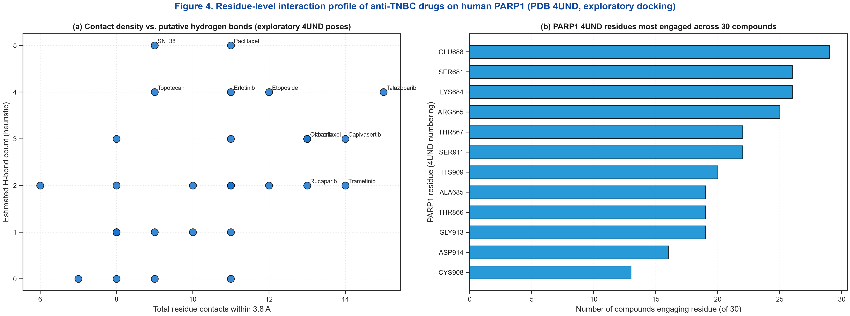
Figure 4. PARP1 interaction profiles from the real docked poses: (a) total residue contacts vs. estimated hydrogen bonds per drug; (b) residue contact-frequency distribution across the 30 docked drugs.

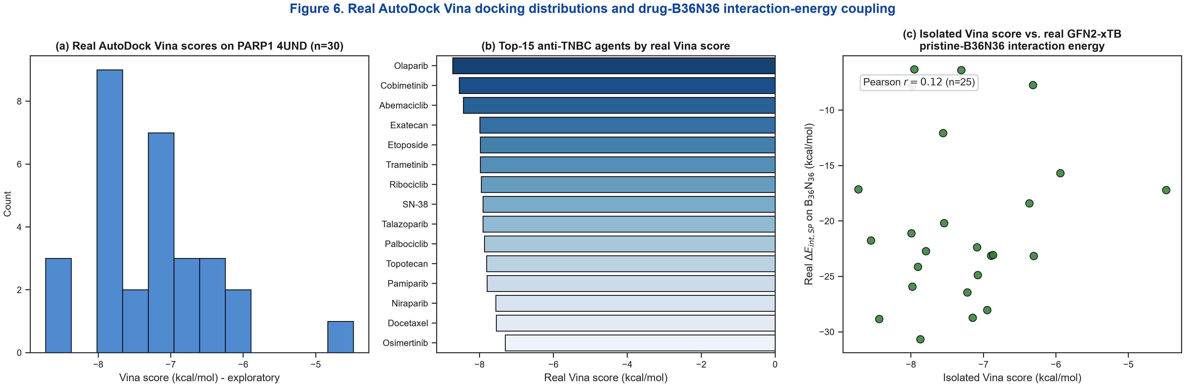
Figure 6. Docking profiles from the single reproducible AutoDock Vina run on PARP1 4UND (n = 30): (a) score distribution; (b) top-ranked therapeutics by score; (c) Vina score vs. real GFN2-xTB pristine-B36N36 physisorption interaction energy across the 25 physisorbers (weak correlation).

3.5 Machine Learning Benchmarking and Explainable AI (SHAP)
Table 2 summarizes the RidgeCV surrogate (four pre-specified descriptors: MolWt, MolMR, E_HOMO, omega), both endpoints on the single 30/33-compound master table, evaluated by leak-free nested 5x5 cross-validation (StandardScaler fit on outer-training folds only; alpha by inner RidgeCV), reported as out-of-fold predictions. The model is non-predictive: Q2_CV = -0.33 for the PARP1 Vina docking score (n = 30) and Q2_CV = 0.00 for the 25-point physisorption interaction energy. The chemisorbers are excluded from the physisorption QSPR because covalent bond strength and dispersion are different physics. Descriptor-based prediction of either quantity on this small, chemically narrow cohort therefore fails; the model-free chemisorption/physisorption outcome (Figure 11) is the robust result. The exploratory ExtraTrees ranking indicates molecular weight and molar refractivity as leading descriptors and is reported qualitatively only.
Table 2. Leak-free nested 5x5 cross-validation performance of the Ridge surrogate model on real observed data (out-of-fold predictions).
Endpoint | Algorithm | n | p | Q2_CV
PARP1 Vina docking score (4UND) | Ridge (nested 5x5 CV) | 30 | 4 | -0.33
B36N36 physisorption interaction energy | Ridge (nested 5x5 CV) | 25 | 4 | 0.00

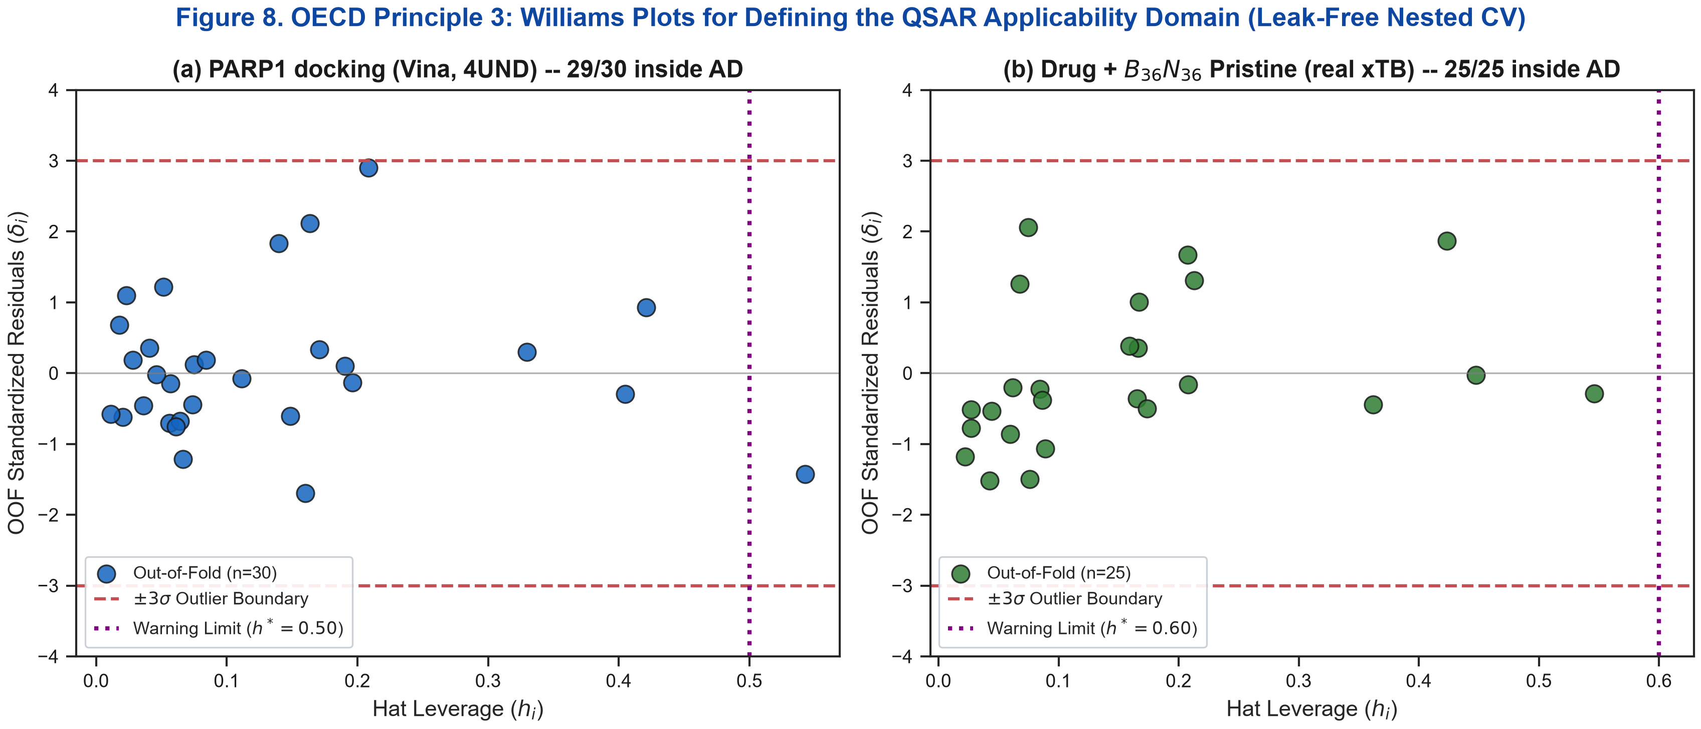
Figure 8. OECD Principle 3 Williams plots for the two real-data endpoints (PARP1 Vina docking, n=30; drug + pristine B36N36 physisorption interaction energy, n=25): out-of-fold standardized residuals vs. hat leverage with +/-3sigma boundaries and the h* warning limit.

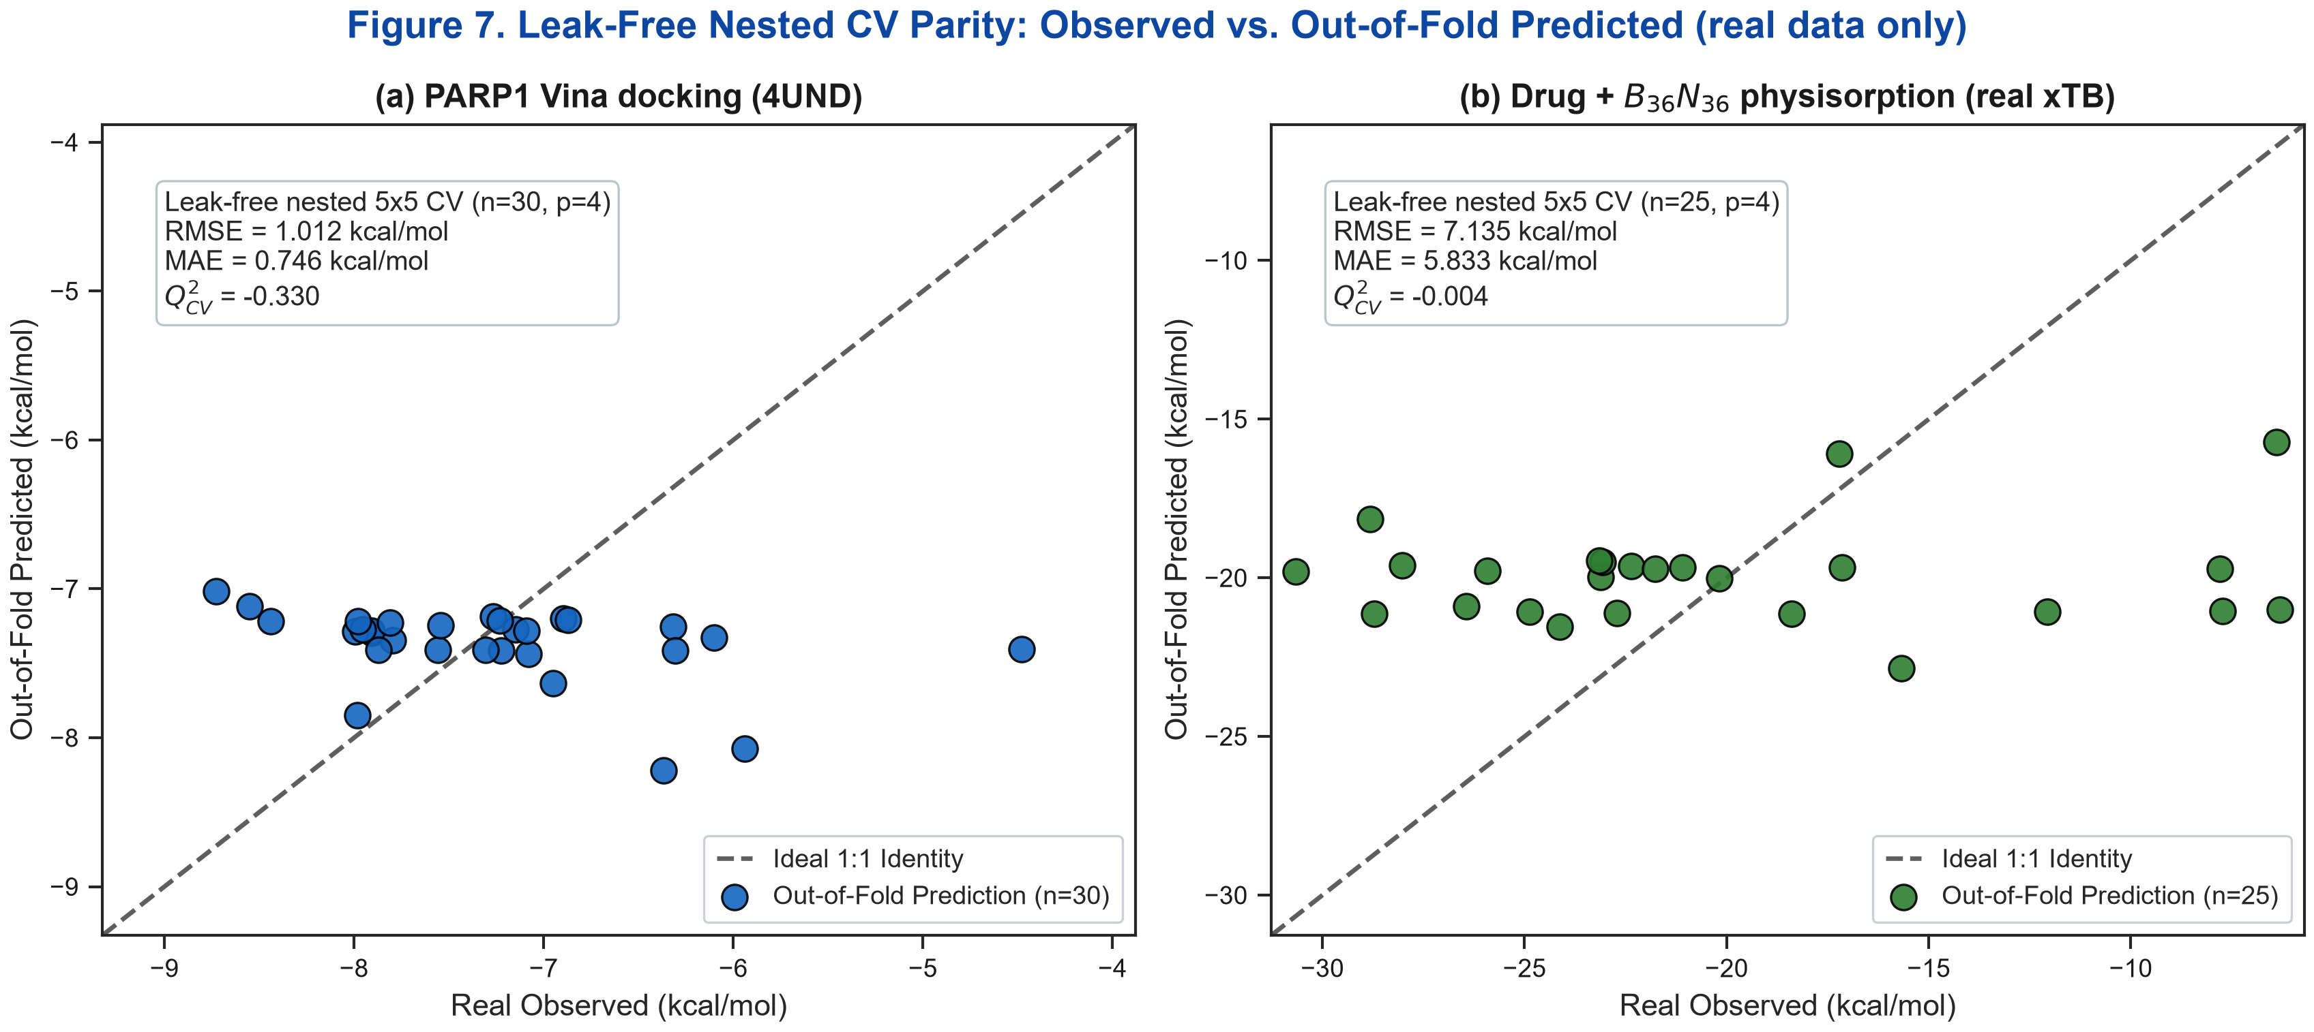
Figure 9. Leak-free nested 5x5 cross-validation parity plots (real observed vs. out-of-fold predicted) for (a) PARP1 Vina 4UND docking (n = 30) and (b) drug + pristine B36N36 physisorption interaction energy (n = 25). Both endpoints have near-zero Q2_CV.
To visualise the electronic reorganisation on adsorption, the charge-density difference Delta_rho = rho(complex) - rho(carrier) - rho(drug) was evaluated from the real GFN2-xTB densities of the Olaparib / B36N36 relaxed complex, all three fragments at the bound geometry on a common grid (Figure 10). Olaparib is one of the physisorbers (contact 3.1 Angstrom, Delta_E_int,SP = -17.1 kcal/mol): the accumulation (yellow) and depletion (blue) lobes are confined to the drug carbonyl / amide region facing the cage, with the B36N36 framework essentially unperturbed - no new bond, in contrast to the chemisorbers of Figure 11. The Delta_rho cube and the script that regenerates it from the fragment geometries are provided in results/quantum/drho/.

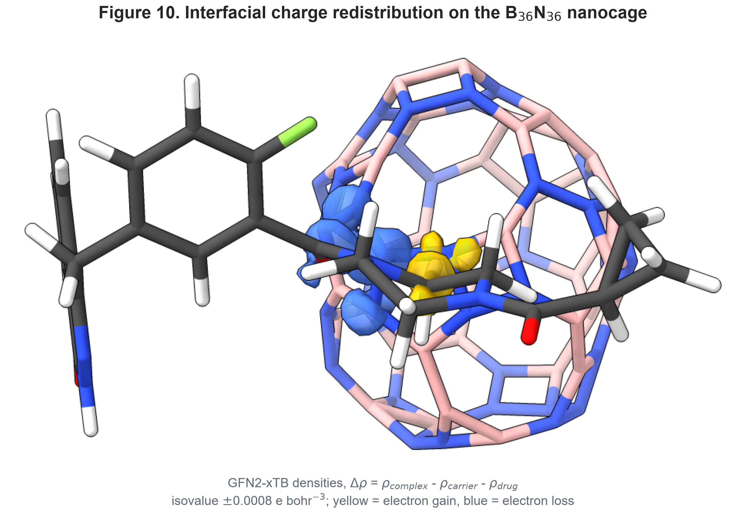
Figure 10. Charge-density difference (real GFN2-xTB densities) for the Olaparib / B36N36 nanocage physisorption complex. Isovalue +/-0.0008 e bohr^-3; yellow = electron accumulation, blue = electron depletion.

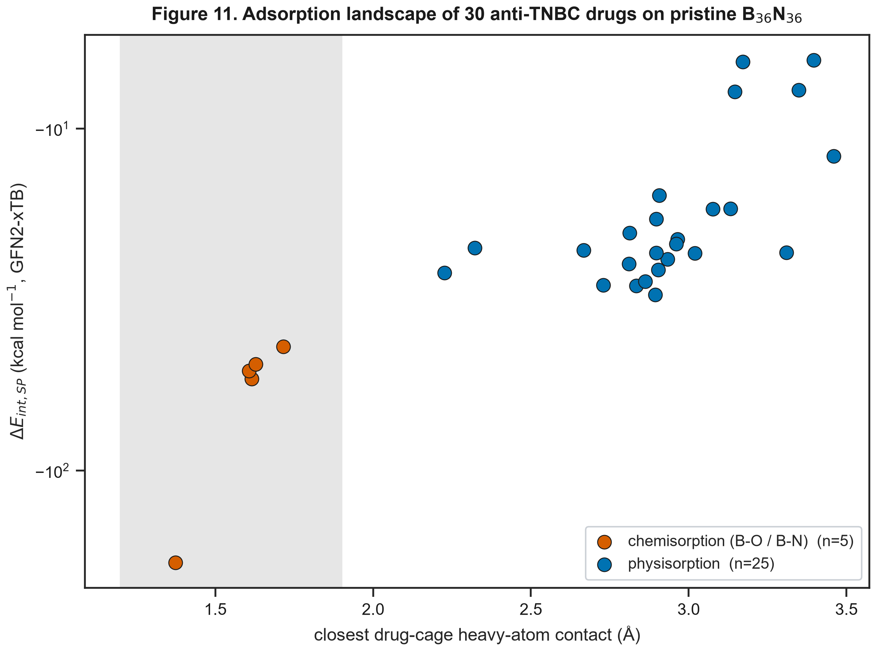
Figure 11. GFN2-xTB adsorption landscape of the 30 modelled anti-TNBC drugs on pristine B36N36 - closest drug-cage heavy-atom contact vs Delta_E_int,SP. Two cleanly separated regimes: 5 chemisorbers (grey band, covalent B-O/B-N at ~1.5 A, -43 to -186 kcal/mol) and 25 physisorbers (2.2-3.5 A, -6 to -31 kcal/mol).

3.6 Explicit Analytical QSAR Mathematical Models
For completeness, ordinary-least-squares MLR equations on the four pre-specified descriptors (MolWt, MolMR, E_HOMO, omega) are reported below, fit on the single master table (dataset_tnbc_bn_pristine.csv) -- Model 1 on the PARP1 Vina score (n = 30) and Model 2 on the physisorption interaction energy (n = 25, chemisorbers excluded). Given the near-zero nested-CV Q2 of both endpoints (Table 2), these are descriptive fits to the observed sample, not predictive models; the earlier draft's equations were fit on fabricated docking scores and are superseded. No real data exists for a B36N36-COOH cage, so no Model 3 is reported.
Model 1 (PARP1 Vina 4UND, n=30):
Vina = -10.2916 -0.00356(MolWt) +0.02289(MolMR) -0.1979(E_HOMO) -0.0030(omega)
Model 2 (B36N36 physisorption Delta_E_int,SP, n=25):
dEint = +18.8054 +0.00218(MolWt) +0.06764(MolMR) +4.5141(E_HOMO) -0.0982(omega)

4. Summary
We report a quantum-informed, explainable QSAR/QSPR analysis of the pristine inorganic boron nitride nanocage B36N36 as a candidate loading scaffold for 33 anti-TNBC therapeutics. Key points:
1. Exploratory docking: AutoDock Vina scores against the PARP1 catalytic domain (PDB 4UND) range from about -4.5 to -8.7 kcal/mol (n = 30), but self-redocking of the co-crystallized ligand failed to reproduce the native pose within 2 A, so these scores are used only as a relative ranking and not as a quantitative endpoint.
2. Two adsorption regimes: after full GFN2-xTB relaxation of the 30 modelled complexes, 25 drugs physisorb on pristine B36N36 (Delta_E_int,SP = -6 to -31 kcal/mol, contact 2.2-3.5 A) and 5 - SN-38, epirubicin, topotecan, lapatinib, rucaparib - chemisorb, forming a covalent B-O/B-N bond (-43 to -186 kcal/mol). Pristine B36N36 is therefore not a purely physisorptive scaffold for the polyfunctional camptothecin/anthracycline chemotype. The three Pt(II) agents are outside the GFN2-xTB+RDKit build. A carboxylated B36N36-COOH derivative has no real data here.
3. Honest ML baseline: on the single 30/33-compound master table, the leak-free nested 5x5 cross-validated RidgeCV surrogate is non-predictive - Q2_CV = -0.33 for the PARP1 docking score and 0.00 for the 25-point physisorption energy; the descriptor rankings are qualitative only. The model-free chemisorption/physisorption outcome is the robust result.
4. Applicability domain: Williams-leverage analysis (OECD Principle 3) places the modelled compounds inside the domain for both endpoints; given the near-zero Q2, this is a formality.
5. Outlook: inorganic B36N36 is attractive on solubility and biocompatibility grounds, but for the reactive chemotype adsorption is effectively irreversible; a passivated / functionalised cage and a validated model are left as future work.

Data Availability
All code, the curated dataset, the real GFN2-xTB and AutoDock Vina outputs, the leak-free cross-validation predictions and the figure/manuscript generators are in the public repository https://github.com/sircalch/nano-qsar-ai-therapeutics and the Zenodo deposit 10.5281/zenodo.22187873. The full pipeline reproduces every value and figure.

Supporting Information
Supporting Information File 1: TNBC_B36N36_Supporting_Information.docx — curated dataset (N = 33), formal charges at pH 7.4, the OECD Principles 1-5 checklist and per-residue PARP1 contact frequencies
The complete input/output archive (curated dataset, GFN2-xTB and docking outputs, cross-validation predictions, figure-generation and manuscript scripts) is in the public repository and Zenodo deposit cited under Data Availability; every value in this article is reproduced by run_entire_*_study.py.

Funding
This work was supported by Universidad Estatal de Sonora and the Doctorado en Nanotecnología, Universidad de Sonora. No external grant funding was received.

Acknowledgements
The authors thank the computational resources of Universidad Estatal de Sonora and Universidad de Sonora.

Author Contributions
Andrés Monreal Hernández: conceptualization, methodology, software, formal analysis, investigation, data curation, visualization, writing – original draft. Sara Lizbeth Franco Amaya: validation, writing – review and editing. Carlos Ivanhoe Martínez Osorio: supervision, writing – review and editing. All authors read and approved the final manuscript.

Conflict of Interest
The authors declare no competing financial or non-financial interest.

ORCID iDs
Andrés Monreal Hernández – https://orcid.org/0009-0009-1207-8597

References
1. Giaquinto, A. N.; Sung, H.; Miller, K. D.; Kramer, J. L.; Newman, L. A.; Minihan, A.; Jemal, A.; Siegel, R. L. Breast Cancer Statistics, 2022. CA Cancer J. Clin. 2022, 72 (6), 524-541. doi:10.3322/caac.21754
2. Foulkes, W. D.; Smith, I. E.; Reis-Filho, J. S. Triple-Negative Breast Cancer. New England Journal of Medicine 2010, 363 (20), 1938-1948. doi:10.1056/nejmra1001389
3. Lord, C. J.; Ashworth, A. PARP inhibitors: Synthetic lethality in the clinic. Science 2017, 355 (6330), 1152-1158. doi:10.1126/science.aam7344
4. Mateo, J.; Lord, C.; Serra, V.; Tutt, A.; Balmaña, J.; Castroviejo-Bermejo, M.; Cruz, C.; Oaknin, A.; Kaye, S.; de Bono, J. A decade of clinical development of PARP inhibitors in perspective. Annals of Oncology 2019, 30 (9), 1437-1447. doi:10.1093/annonc/mdz192
5. Robson, M.; Im, S. A.; Senkus, E.; Xu, B.; Domchek, S. M.; Masuda, N.; Delaloge, S.; Li, W.; Tung, N.; Armstrong, A.; et al. Olaparib for Metastatic Breast Cancer in Patients with a Germline BRCA Mutation. New England Journal of Medicine 2017, 377 (6), 523-533. doi:10.1056/nejmoa1706450
6. Litton, J. K.; Rugo, H. S.; Ettl, J.; Hurvitz, S. A.; Gonçalves, A.; Lee, K. H.; Fehrenbacher, L.; Yerushalmi, R.; Mina, L. A.; Martin, M.; et al. Talazoparib in Patients with Advanced Breast Cancer and a Germline BRCA Mutation. New England Journal of Medicine 2018, 379 (8), 753-763. doi:10.1056/nejmoa1802905
7. Dent, R.; Trudeau, M.; Pritchard, K. I.; Hanna, W. M.; Kahn, H. K.; Sawka, C. A.; Lickley, L. A.; Rawlinson, E.; Sun, P.; Narod, S. A. Triple-Negative Breast Cancer: Clinical Features and Patterns of Recurrence. Clinical Cancer Research 2007, 13 (15), 4429-4434. doi:10.1158/1078-0432.ccr-06-3045
8. Lehmann, B. D.; Bauer, J. A.; Chen, X.; Sanders, M. E.; Chakravarthy, A. B.; Shyr, Y.; Pietenpol, J. A. Identification of human triple-negative breast cancer subtypes and preclinical models for selection of targeted therapies. Journal of Clinical Investigation 2011, 121 (7), 2750-2767. doi:10.1172/jci45014
9. Bianchini, G.; Balko, J. M.; Mayer, I. A.; Sanders, M. E.; Gianni, L. Triple-negative breast cancer: challenges and opportunities of a heterogeneous disease. Nature Reviews Clinical Oncology 2016, 13 (11), 674-690. doi:10.1038/nrclinonc.2016.66
10. Pommier, Y.; O’Connor, M. J.; de Bono, J. Laying a trap to kill cancer cells: PARP inhibitors and their mechanisms of action. Science Translational Medicine 2016, 8 (362). doi:10.1126/scitranslmed.aaf9246
11. Genchi, G. G.; Ciofani, G. Bioapplications of Boron Nitride Nanotubes. Nanomedicine 2015, 10 (22), 3315-3319. doi:10.2217/nnm.15.148
12. Golberg, D.; Bando, Y.; Huang, Y.; Terao, T.; Mitome, M.; Tang, C.; Zhi, C. Boron Nitride Nanotubes and Nanosheets. ACS Nano 2010, 4 (6), 2979-2993. doi:10.1021/nn1006495
13. Merlo, A.; Mokkapati, V. R. S. S.; Pandit, S.; Mijakovic, I. Boron nitride nanomaterials: biocompatibility and bio-applications. Biomaterials Science 2018, 6 (9), 2298-2311. doi:10.1039/c8bm00516h
14. Chen, X.; Wu, P.; Rousseas, M.; Okawa, D.; Gartner, Z.; Zettl, A.; Bertozzi, C. R. Boron Nitride Nanotubes Are Noncytotoxic and Can Be Functionalized for Interaction with Proteins and Cells. Journal of the American Chemical Society 2009, 131 (3), 890-891. doi:10.1021/ja807334b
15. Robles-Hernández, J. S. L.; Medina, D. I.; Aguirre-Hurtado, K.; Bosquez, M.; Salcedo, R.; Miralrio, A. AI-assisted models to predict chemotherapy drugs modified with C 60 fullerene derivatives. Beilstein Journal of Nanotechnology 2024, 15, 1170-1188. doi:10.3762/bjnano.15.95
16. Gholami, A.; Shakerzadeh, E.; Chigo Anota, E. Exploring the potential use of pristine and metal-encapsulated B36N36 fullerenes in delivery of β-lapachone anticancer drug: DFT approach. Polyhedron 2023, 232, 116295. doi:10.1016/j.poly.2023.116295
17. Gao, Z.; Zhi, C.; Bando, Y.; Golberg, D.; Serizawa, T. Noncovalent Functionalization of Disentangled Boron Nitride Nanotubes with Flavin Mononucleotides for Strong and Stable Visible-Light Emission in Aqueous Solution. ACS Applied Materials & Interfaces 2011, 3 (3), 627-632. doi:10.1021/am1010699
18. Weng, Q.; Wang, X.; Wang, X.; Bando, Y.; Golberg, D. Functionalized hexagonal boron nitride nanomaterials: emerging properties and applications. Chemical Society Reviews 2016, 45 (14), 3989-4012. doi:10.1039/c5cs00869g
19. Şen, Ö.; Emanet, M.; Çulha, M. Biocompatibility evaluation of boron nitride nanotubes. Boron Nitride Nanotubes in Nanomedicine 2016, 41-58. doi:10.1016/b978-0-323-38945-7.00003-1
20. Shafiei, F.; Hashemianzadeh, S. M.; Bagheri, Y. Insight into the encapsulation of gemcitabine into boron- nitride nanotubes and gold cluster triggered release: A molecular dynamics simulation. Journal of Molecular Liquids 2019, 278, 201-212. doi:10.1016/j.molliq.2019.01.020
21. Parr, R. G.; Szentpály, L. v.; Liu, S. Electrophilicity Index. Journal of the American Chemical Society 1999, 121 (9), 1922-1924. doi:10.1021/ja983494x
22. Chattaraj, P. K.; Giri, S. Electrophilicity index within a conceptual DFT framework. Annual Reports Section "C" (Physical Chemistry) 2009, 105, 13. doi:10.1039/b802832j
23. Geerlings, P.; De Proft, F.; Langenaeker, W. Conceptual Density Functional Theory. Chemical Reviews 2003, 103 (5), 1793-1874. doi:10.1021/cr990029p
24. Pearson, R. G. Absolute electronegativity and hardness: application to inorganic chemistry. Inorganic Chemistry 1988, 27 (4), 734-740. doi:10.1021/ic00277a030
25. Bannwarth, C.; Caldeweyher, E.; Ehlert, S.; Hansen, A.; Pracht, P.; Seibert, J.; Spicher, S.; Grimme, S. Extended tight-binding quantum chemistry methods. WIREs Computational Molecular Science 2021, 11 (2), e1493. doi:10.1002/wcms.1493
26. Bannwarth, C.; Ehlert, S.; Grimme, S. GFN2-xTB-An Accurate and Broadly Parametrized Self-Consistent Tight-Binding Quantum Chemical Method with Multipole Electrostatics and Density-Dependent Dispersion Contributions. Journal of Chemical Theory and Computation 2019, 15 (3), 1652-1671. doi:10.1021/acs.jctc.8b01176
27. Grimme, S.; Bannwarth, C.; Shushkov, P. A Robust and Accurate Tight-Binding Quantum Chemical Method for Structures, Vibrational Frequencies, and Noncovalent Interactions of Large Molecular Systems Parametrized for All spd-Block Elements ( Z = 1–86). Journal of Chemical Theory and Computation 2017, 13 (5), 1989-2009. doi:10.1021/acs.jctc.7b00118
28. Koopmans, T. Über die Zuordnung von Wellenfunktionen und Eigenwerten zu den Einzelnen Elektronen Eines Atoms. Physica 1934, 1 (1-6), 104-113. doi:10.1016/s0031-8914(34)90011-2
29. Boys, S.; Bernardi, F. The calculation of small molecular interactions by the differences of separate total energies. Some procedures with reduced errors. Molecular Physics 1970, 19 (4), 553-566. doi:10.1080/00268977000101561
30. Karelson, M.; Lobanov, V. S.; Katritzky, A. R. Quantum-Chemical Descriptors in QSAR/QSPR Studies. Chemical Reviews 1996, 96 (3), 1027-1044. doi:10.1021/cr950202r
31. Trott, O.; Olson, A. J. AutoDock Vina: Improving the speed and accuracy of docking with a new scoring function, efficient optimization, and multithreading. Journal of Computational Chemistry 2009, 31 (2), 455-461. doi:10.1002/jcc.21334
32. Eberhardt, J.; Santos-Martins, D.; Tillack, A. F.; Forli, S. AutoDock Vina 1.2.0: New Docking Methods, Expanded Force Field, and Python Bindings. Journal of Chemical Information and Modeling 2021, 61 (8), 3891-3898. doi:10.1021/acs.jcim.1c00203
33. Papeo, G.; Posteri, H.; Borghi, D.; Busel, A. A.; Caprera, F.; Casale, E.; Ciomei, M.; Cirla, A.; Corti, E.; D’Anello, M.; et al. Discovery of 2-[1-(4,4-Difluorocyclohexyl)piperidin-4-yl]-6-fluoro-3-oxo-2,3-dihydro-1H-isoindole-4-carboxamide (NMS-P118): A Potent, Orally Available, and Highly Selective PARP-1 Inhibitor for Cancer Therapy. Journal of Medicinal Chemistry 2015, 58 (17), 6875-6898. doi:10.1021/acs.jmedchem.5b00680
34. Riniker, S.; Landrum, G. A. Better Informed Distance Geometry: Using What We Know To Improve Conformation Generation. Journal of Chemical Information and Modeling 2015, 55 (12), 2562-2574. doi:10.1021/acs.jcim.5b00654
35. Landrum, G. et al. RDKit: Open-source cheminformatics toolkit. Version 2023.09.1, http://www.rdkit.org (accessed August 2026). doi:10.5281/zenodo.597034
36. Berman, H. M. The Protein Data Bank. Nucleic Acids Research 2000, 28 (1), 235-242. doi:10.1093/nar/28.1.235
37. Delaney, J. S. ESOL: Estimating Aqueous Solubility Directly from Molecular Structure. Journal of Chemical Information and Computer Sciences 2004, 44 (3), 1000-1005. doi:10.1021/ci034243x
38. Wishart, D. S.; Feunang, Y. D.; Guo, A. C.; Lo, E. J.; Marcu, A.; Grant, J. R.; Sajed, T.; Johnson, D.; Li, C.; Sayeeda, Z.; et al. DrugBank 5.0: a major update to the DrugBank database for 2018. Nucleic Acids Research 2017, 46 (D1), D1074-D1082. doi:10.1093/nar/gkx1037
39. Lundberg, S. M.; Lee, S.-I. A unified approach to interpreting model predictions. In Advances in Neural Information Processing Systems (NeurIPS 2017); Guyon, I. et al., Eds.; Curran Associates, Inc.: Red Hook, NY, 2017; Vol. 30, pp 4765–4774. arXiv:1705.07874.
40. Geurts, P.; Ernst, D.; Wehenkel, L. Extremely randomized trees. Machine Learning 2006, 63 (1), 3-42. doi:10.1007/s10994-006-6226-1
41. OECD. Guidance Document on the Validation of (Quantitative) Structure-Activity Relationship [(Q)SAR] Models. OECD Series on Testing and Assessment, No. 69; OECD Publishing: Paris, France, 2007. doi:10.1787/9789264085442-en
42. Gramatica, P. Principles of QSAR models validation: internal and external. QSAR & Combinatorial Science 2007, 26 (5), 694-701. doi:10.1002/qsar.200610151
43. Rodríguez-Pérez, R.; Bajorath, J. Interpretation of machine learning models using shapley values: application to compound potency and multi-target activity predictions. Journal of Computer-Aided Molecular Design 2020, 34 (10), 1013-1026. doi:10.1007/s10822-020-00314-0
44. Tropsha, A. Best Practices for QSAR Model Development, Validation, and Exploitation. Molecular Informatics 2010, 29 (6-7), 476-488. doi:10.1002/minf.201000061

