Physisorption and dative-bond chemisorption of anti-TNBC drugs on a B₃₆N₃₆ fullerene-like cage: validated PARP1 docking, GFN2-xTB adsorption and QSPR analysis
Andrés Monreal Hernández*
Universidad Estatal de Sonora, Ley Federal del Trabajo S/N, Col. Apolo, 83100 Hermosillo, Sonora, Mexico
*Corresponding author: andres.monreal@ues.mx; ORCID 0009-0009-1207-8597

Abstract
Context Triple-negative breast cancer (TNBC) lacks the receptors that guide targeted therapy, and carrier-based delivery is one route to improve the drugs used against it. Boron nitride cages are chemically robust candidate carriers whose Lewis-acidic boron sites can bind drugs either by dispersion or by dative bonds. For 30 anti-TNBC drugs we find that 18 physisorb on a B₃₆N₃₆ cage (ΔE_{int} −6.0 to −41.3 kcal mol⁻¹) and 12 chemisorb through B–O or B–N dative bonds (−26.2 to −62.6 kcal mol⁻¹); doxorubicin reacts with the cage. A docking protocol that reproduces the crystallographic talazoparib pose in PARP1 (root-mean-square deviation 0.51 and 1.27 Å) ranks olaparib and talazoparib first. Neither the docking score nor the cage interaction energy can be predicted from four pre-selected descriptors (Q²_{CV} = −0.08 and −0.08), and the two endpoints are uncorrelated (Spearman ρ = 0.05).
Methods Structures were taken from PubChem. A valid B₃₆N₃₆ cage (octahedral, 108 B–N bonds) was relaxed with GFN2-xTB and confirmed as a minimum. Each drug was adsorbed from four relaxed orientations with GFN2-xTB (xtb 6.7.1); the regime was assigned from drug–cage bond formation. Drugs were docked into PARP1 (PDB 4UND, chain A) with AutoDock Vina 1.2.7 after PDBFixer/Meeko preparation, validated by two redocking controls. Ridge quantitative structure–property relationship (QSPR) models were assessed by nested 5×5 cross-validation, 1,000-fold Y-scrambling and a leverage applicability domain.
Keywords Boron nitride nanocage · B₃₆N₃₆ · PARP1 · Triple-negative breast cancer · GFN2-xTB · Molecular docking

Introduction
Triple-negative breast cancer (TNBC) lacks the oestrogen, progesterone and HER2 receptors that guide targeted therapy in other breast-cancer subtypes, and it is associated with early relapse and poor prognosis [1–3]. It is also molecularly heterogeneous [4, 5]. In the subset carrying germline BRCA1/2 mutations, poly(ADP-ribose) polymerase (PARP) inhibitors exploit synthetic lethality and trap PARP1 on DNA [6–8]; olaparib and talazoparib are approved for this indication [9, 10]. Most patients, however, still depend on cytotoxic chemotherapy and on kinase or pathway inhibitors under investigation.
Boron nitride nanomaterials are chemically inert, electrically insulating and generally well tolerated by cells [11–14], and their surface chemistry can be functionalised for biomedical use [15]. Among the fullerene-like (BN)_{n} cages, stable isomers contain only four- and six-membered rings, which allows strict B–N alternation [16, 17]; B₃₆N₃₆ has been studied as a drug carrier at the DFT level [18]. Boron sites of BN cages are Lewis acidic, so drugs with lone-pair donors may bind either by dispersion (physisorption) or by dative B–O/B–N bonds (chemisorption).
This study characterises a cohort of anti-TNBC drugs on two fronts. First, it docks them into the nicotinamide pocket of PARP1 with a protocol that is shown beforehand to reproduce the crystallographic talazoparib pose. Second, it computes their GFN2-xTB adsorption on a chemically valid B₃₆N₃₆ cage, classifies each complex as physisorbed or chemisorbed from its bonding, and asks whether either endpoint can be anticipated from four pre-selected molecular descriptors under leak-free validation.
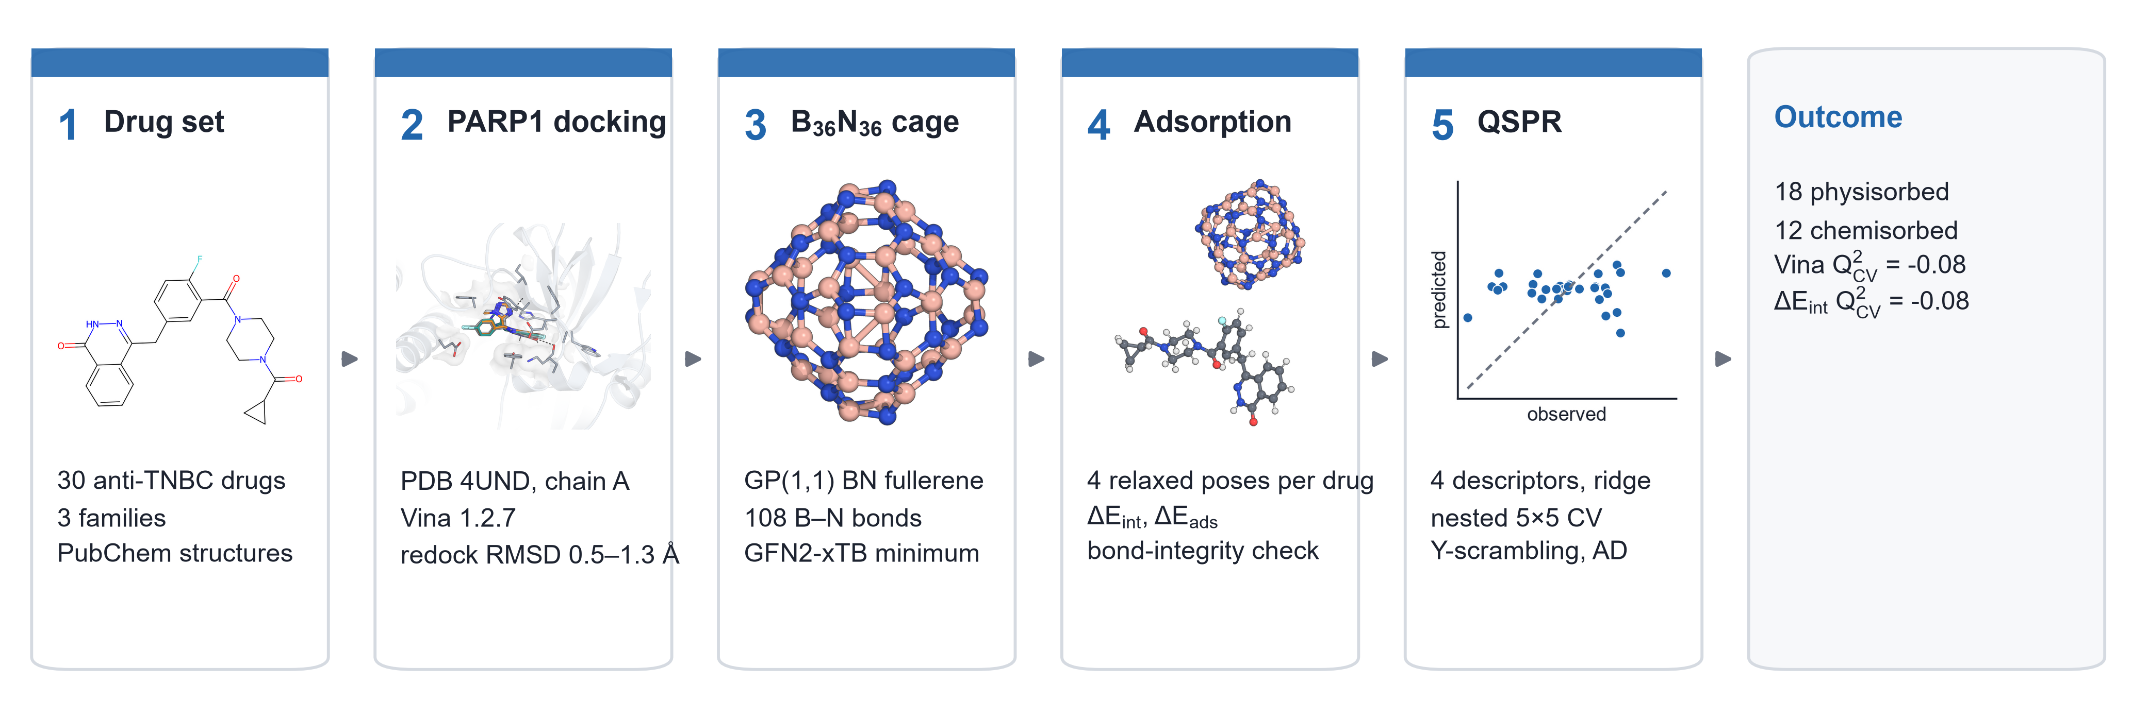
Fig. 1 Workflow of the study: PubChem structures; PARP1 docking validated by redocking; construction and validation of the B₃₆N₃₆ cage; GFN2-xTB adsorption from four orientations with bond-integrity check; QSPR models under nested cross-validation

Methods

Compound set
The cohort comprises 33 drugs used or investigated in TNBC. Every structure was retrieved from PubChem by name [19] and its identity verified by InChIKey (Online Resource 1, Table S1). The three platinum(II) agents were not modelled, because RDKit/MMFF cannot build square-planar Pt(II) complexes reliably and GFN2-xTB is not validated for them, leaving 30 organic drugs: 6 PARP inhibitors, 10 cytotoxic agents and 14 kinase or pathway inhibitors.

Molecular docking
The structure of the human PARP1 catalytic domain bound to talazoparib (PDB 4UND) [20] was prepared with PDBFixer [21]: chain A was kept, waters, ions and the inhibitor were removed, missing atoms were added and the protein was protonated at pH 7.4; AutoDock atom types were assigned with Meeko. Ligands were built from their SMILES with RDKit [22] (ETKDGv3 [23], MMFF94 [24]). Because AutoDock Vina keeps rings rigid, up to five distinct ring conformers per drug were docked and the best score was kept. Docking used AutoDock Vina 1.2.7 [25, 26] in a 22 Å cubic box centred on the talazoparib of chain A (exhaustiveness 16, nine modes, fixed seed). The protocol was validated by self-redocking talazoparib from its crystal conformation and by docking it rebuilt from SMILES through the production protocol; the heavy-atom RMSD to the crystal pose was computed with symmetry correction and without re-alignment. Residues within 4.0 Å of the top pose were counted as contacts and N/O pairs within 3.5 Å as polar contacts.

B₃₆N₃₆ cage
The cage was built as the octahedral Goldberg-type (1,1) polyhedron, obtained as the leapfrog of the truncated octahedron: 72 vertices, six four-membered and 32 six-membered rings. All rings are even, so boron and nitrogen alternate strictly and the cage contains 108 B–N bonds and no B–B or N–N bonds. It was relaxed with GFN2-xTB (tight thresholds) and confirmed as a minimum by the absence of imaginary frequencies (HOMO–LUMO gap 4.30 eV).

Adsorption calculations
All quantum-chemical calculations used GFN2-xTB [27, 28] (xtb 6.7.1, D4 dispersion [29]) in the gas phase. Each drug was relaxed in isolation from its lowest MMFF94 conformer. The drug was then placed 3.2 Å above the cage and four rotations about the approach axis (0, 90, 180 and 270°) were fully relaxed; the lowest-energy converged pose with a closest drug–cage heavy-atom contact of 1.25–4.0 Å was kept. On that geometry the interaction energy ΔE_{int} = E_{complex} − E_{cage} − E_{drug}, with both fragments frozen at the complex geometry, and the adsorption energy ΔE_{ads}, referenced to the separately relaxed fragments, were computed. A complex was classed as chemisorbed when at least one drug–cage distance was shorter than 1.15 times the sum of the covalent radii, and physisorbed otherwise. The bonding of each drug was also compared before and after adsorption to detect proton transfer or bond breaking within the drug.

Descriptors and QSPR models
Four descriptors were fixed before any model was fitted: molecular weight and molar refractivity (RDKit), and the HOMO energy and global electrophilicity ω = μ²/2η from GFN2-xTB on the relaxed isolated drug [30–32]. Two endpoints were modelled: the Vina score on PARP1 and ΔE_{int} on B₃₆N₃₆ (drugs whose own bonding was unchanged on adsorption). Each model is a ridge regression (scikit-learn [33], standardisation and penalty inside one pipeline) evaluated by nested cross-validation: five outer folds for performance and a five-fold inner loop for the penalty [34]. Out-of-fold predictions give Q²_{CV}, RMSE and MAE. Chance correlation was tested by repeating the whole nested procedure on 1,000 permutations of the target [35]. The applicability domain follows OECD principle 3 [36–38]: leverages from the standardised descriptors with intercept, warning leverage h* = 3(p + 1)/n, and standardised residuals within ±3.

Use of AI tools
[AUTHOR TO COMPLETE BEFORE SUBMISSION: statement on the use of AI tools in this work, as required by the journal (Springer policy: use of large language models beyond copy editing must be documented in the Methods).]

Results and discussion
The workflow is summarised in Fig. 1. All quantities are computed; none is fitted to experimental data.

Electronic descriptors of the drugs
All drug LUMOs lie below the LUMO of the cage (−6.08 eV), and all HOMOs lie above the cage HOMO (−10.38 eV) except those of olaparib, talazoparib, paclitaxel, SN-38 and exatecan (Fig. 2a): the frontier levels of the drugs fall largely inside the wide gap of the cage. The anthracyclines epirubicin and doxorubicin are the softest and most electrophilic molecules of the set (Fig. 2b).
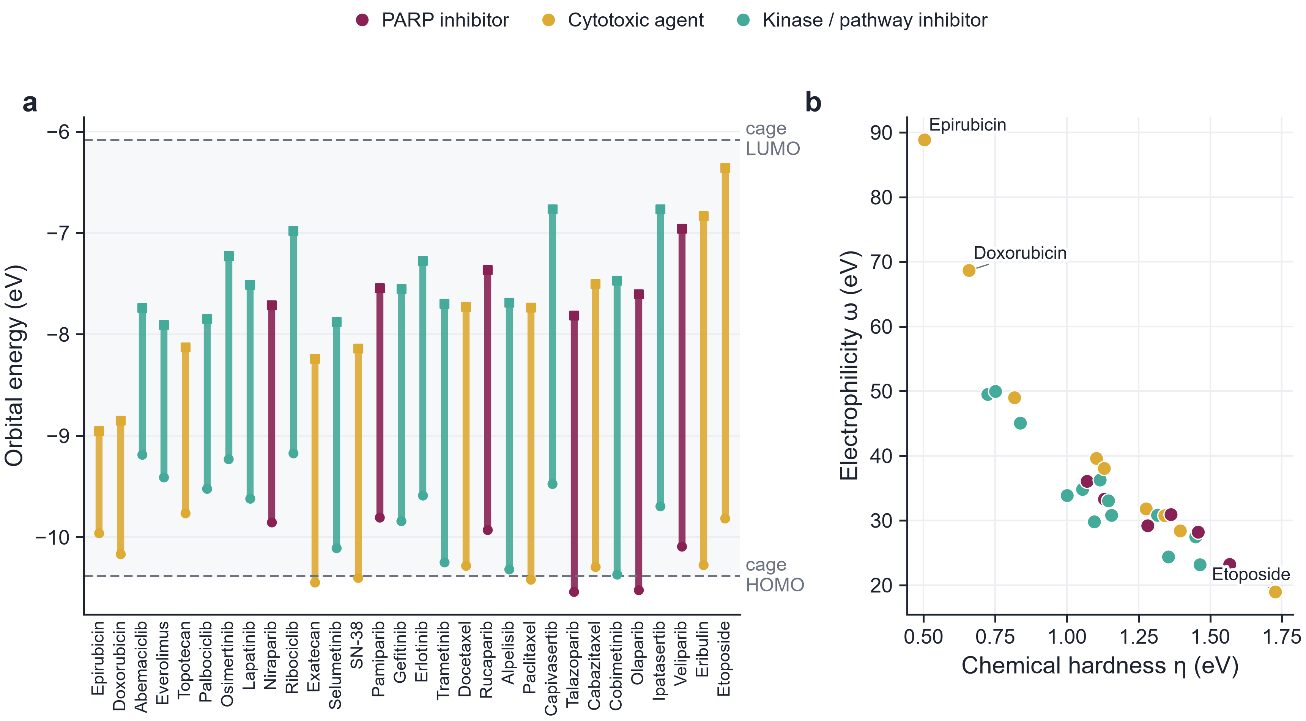
Fig. 2 GFN2-xTB frontier orbitals of the relaxed drugs. a HOMO (circles) and LUMO (squares) of each drug, sorted by gap and coloured by family; dashed lines, HOMO and LUMO of the B₃₆N₃₆ cage. b Chemical hardness η versus electrophilicity ω

Validated docking into the PARP1 nicotinamide pocket
Self-redocking of talazoparib from its crystal conformation reproduced the deposited pose with a heavy-atom RMSD of 0.51 Å (−11.9 kcal mol⁻¹), and the same ligand rebuilt from SMILES through the production protocol reached 1.27 Å (Fig. 3a), both within the usual 2 Å criterion. The ring-conformer ensemble was necessary: a single ETKDG conformer of talazoparib, whose partially saturated ring Vina cannot flex, docked 6.7 Å away from the crystal pose. Across the 30 drugs, the most frequently contacted residues were Tyr907, Tyr896, His862, Tyr889, Asp766, Gly863 (Fig. 3b), the nicotinamide-site residues that anchor clinical PARP inhibitors. Scores ranged from −12.8 to −7.8 kcal mol⁻¹ (Table 1, Fig. 4a). The two best-scoring drugs were the approved PARP inhibitors olaparib (−12.8) and talazoparib (−12.2 kcal mol⁻¹), a useful plausibility check, although the three families did not differ significantly (Kruskal–Wallis p = 0.22).
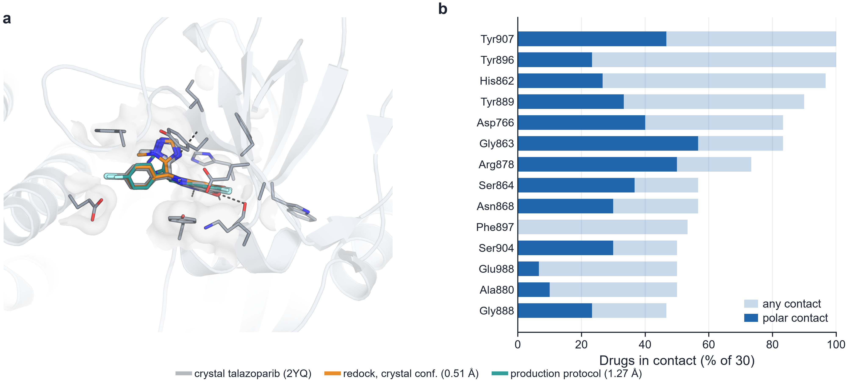
Fig. 3 Docking validation in PARP1 (PDB 4UND, chain A). a Crystallographic talazoparib (grey), its self-redocked pose (orange, RMSD 0.51 Å) and the pose obtained from SMILES with the production protocol (teal, 1.27 Å); contact residues as thin sticks, polar contacts dashed. b Fraction of the 30 docked drugs contacting each residue (heavy atoms within 4.0 Å); dark bars, polar contacts (N/O within 3.5 Å)
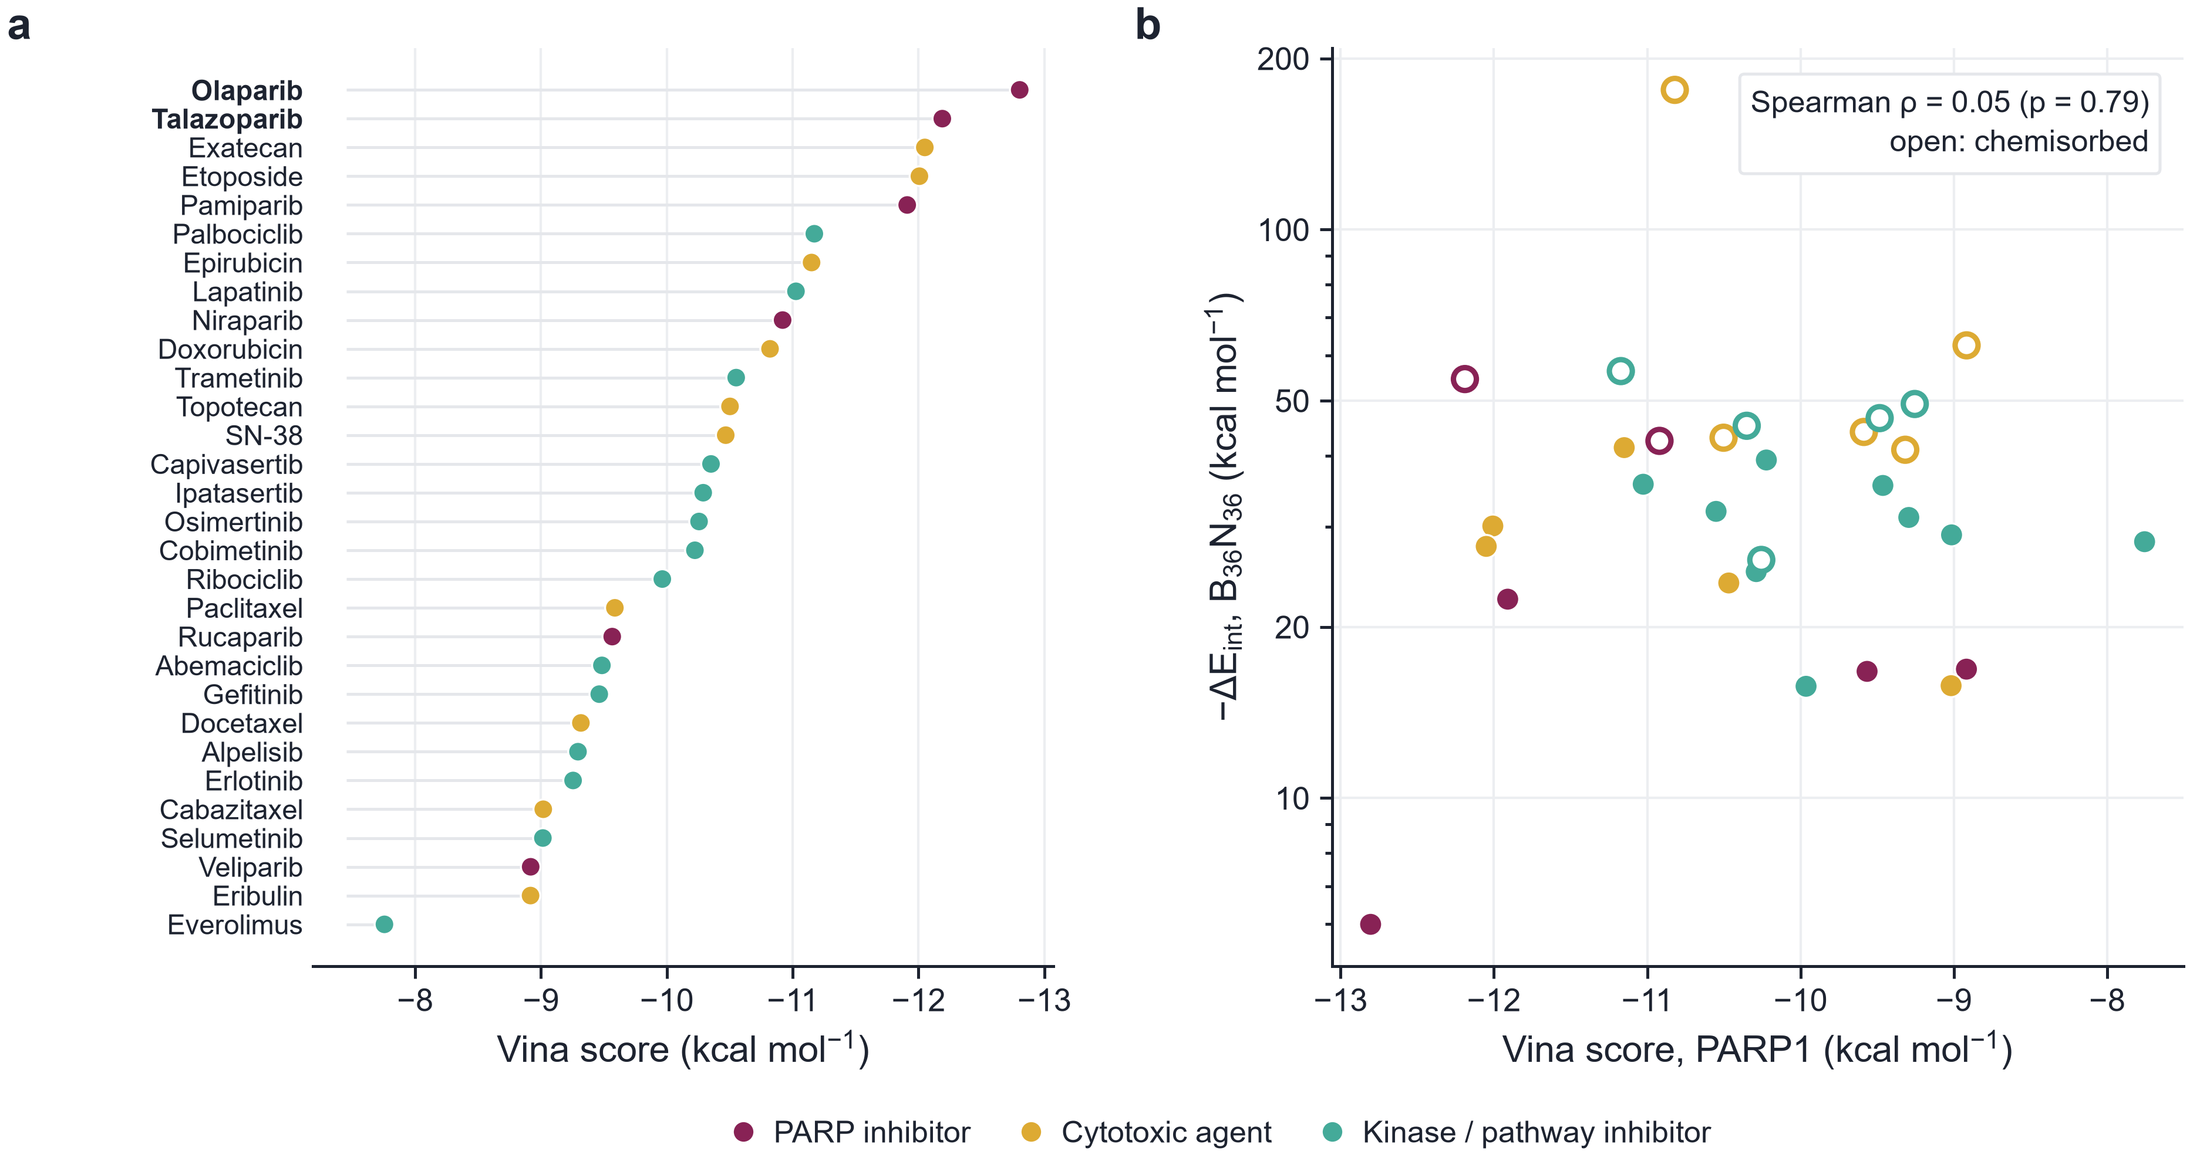
Fig. 4 a Vina scores of the drugs in PARP1, coloured by family. b Vina score versus −ΔE_{int} on B₃₆N₃₆; open symbols, chemisorbed drugs

Physisorption and dative-bond chemisorption on B₃₆N₃₆
The cage used here is a valid B₃₆N₃₆ fullerene-like polyhedron (Fig. 5a). After full relaxation from four orientations, 18 drugs remained physisorbed, with interaction energies of −6.0 to −41.3 kcal mol⁻¹ and closest contacts of 1.76–3.28 Å (the shortest, SN-38, lies just above the B–O bonding threshold of 1.73 Å), whereas 12 formed a bond to a cage boron atom: 8 B–O and 5 B–N dative bonds of 1.43–1.74 Å (Fig. 6a, Table 1). Carbonyl or hydroxyl oxygens and nitrogen lone pairs of the drugs act as the Lewis bases, as expected for the electron-deficient boron sites of BN cages. Chemisorption strengthens the interaction by a factor of about 1.8 (mean −46.5 versus −26.2 kcal mol⁻¹), while the adsorption energy, which includes the strain of both partners, is less different (−28.8 versus −23.5 kcal mol⁻¹), because it also counts the deformation that the dative bond imposes on the drug and on the cage. All three families contain both regimes (Fig. 6b). The cage stays intact throughout: in every complex it keeps its 108 B–N bonds and forms no B–B or N–N bond, and its energy never falls below that of the isolated cage (from 0.0 to 31.6 kcal mol⁻¹ above it, the cost of its distortion).
Doxorubicin is a special case: in the relaxed complex it forms a covalent bond to the cage in addition to a dative one, and an intramolecular proton moves between two of its oxygen atoms. Its very large interaction energy therefore describes a chemical reaction rather than adsorption; it is flagged in Table 1 and excluded from the QSPR model of ΔE_{int}.
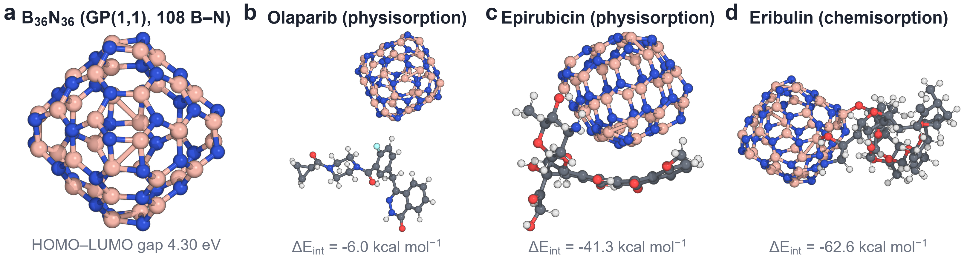
Fig. 5 Relaxed GFN2-xTB structures. a The B₃₆N₃₆ cage (B pink, N blue). b, c Physisorbed olaparib and the most strongly physisorbed drug. d The most strongly chemisorbed drug that keeps its own bonding, attached through B–O dative bonds
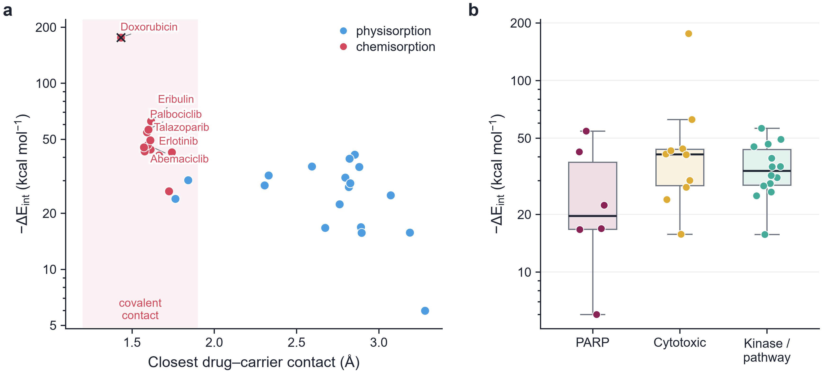
Fig. 6 Adsorption on B₃₆N₃₆. a Closest drug–cage heavy-atom contact versus −ΔE_{int}; red, chemisorbed (drug–cage bond formed); blue, physisorbed; cross, drug whose own bonding changed. b −ΔE_{int} by therapeutic family

Docking and adsorption are independent
The PARP1 docking score and the cage interaction energy are uncorrelated (Spearman ρ = 0.05, p = 0.79; Fig. 4b): a drug's affinity for the target says nothing about how strongly the carrier holds it. For delivery this is favourable, because the two properties can be selected independently; for example, olaparib combines the best docking score with weak physisorption, which would favour release.

QSPR models
Neither endpoint could be predicted from the four pre-selected descriptors. For the docking score (n = 30) the out-of-fold Q²_{CV} was −0.08 (RMSE 1.21 kcal mol⁻¹), and for ΔE_{int} (n = 29) it was −0.08 (RMSE 13.9 kcal mol⁻¹); in both cases Y-scrambled models did as well (p = 0.35 and 0.32; Fig. 7, Table 2). The adsorption result is chemically reasonable: whether a drug chemisorbs depends on whether one of its Lewis-basic groups can reach a boron atom in a favourable geometry, a local structural feature that global descriptors such as molecular weight or electrophilicity do not encode. In both models all drugs except epirubicin lie inside the applicability domain, so the failure is not an extrapolation effect. These negative results are reported as such; they indicate that screening B₃₆N₃₆ carriers requires explicit adsorption calculations rather than descriptor surrogates.
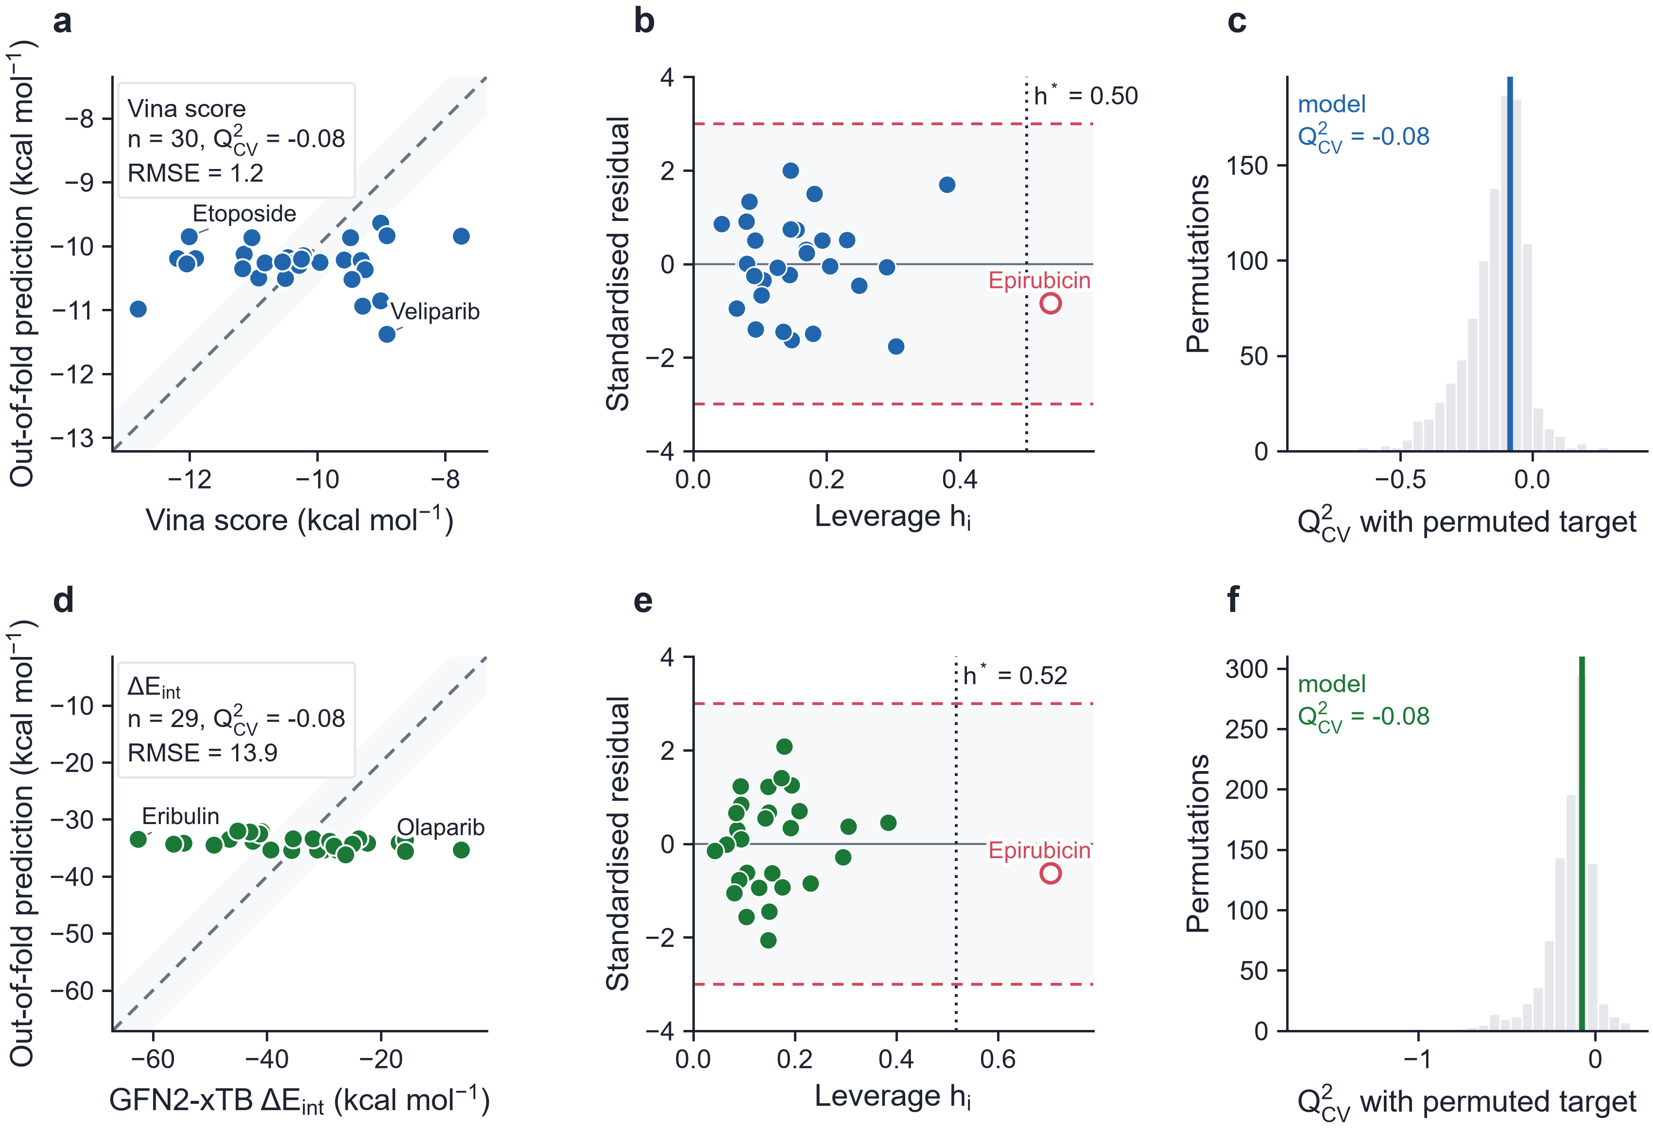
Fig. 7 QSPR models, nested 5×5 cross-validation. Top row, Vina score on PARP1; bottom row, ΔE_{int} on B₃₆N₃₆. a, d Out-of-fold predictions (dashed, identity; shaded, ±10% of the range). b, e Williams plots (dotted, warning leverage h*; dashed, ±3 standardised residuals). c, f Q²_{CV} of 1,000 models fitted to permuted targets
Table 1 Docking and adsorption results for the 30 organic drugs, sorted by Vina score.
Drug | Family | Vina | ΔE_{int} | ΔE_{ads} | d_{min} | Regime
Olaparib | PARP | −12.80 | −6.0 | −6.0 | 3.28 | phys.
Talazoparib | PARP | −12.19 | −54.6 | −37.6 | 1.59 | chem.
Exatecan | Cyto. | −12.05 | −27.7 | −26.4 | 2.82 | phys.
Etoposide | Cyto. | −12.01 | −30.1 | −23.8 | 1.84 | phys.
Pamiparib | PARP | −11.91 | −22.4 | −21.8 | 2.76 | phys.
Palbociclib | Kinase | −11.17 | −56.4 | −36.5 | 1.60 | chem.
Epirubicin | Cyto. | −11.15 | −41.3 | −36.6 | 2.85 | phys.
Lapatinib | Kinase | −11.03 | −35.6 | −31.9 | 2.59 | phys.
Niraparib | PARP | −10.92 | −42.5 | −22.5 | 1.74 | chem.
Doxorubicinª | Cyto. | −10.82 | −176.1 | −59.6 | 1.43 | chem.
Trametinib | Kinase | −10.55 | −31.9 | −29.7 | 2.33 | phys.
Topotecan | Cyto. | −10.50 | −43.0 | −25.1 | 1.58 | chem.
SN-38 | Cyto. | −10.47 | −23.9 | −15.8 | 1.76 | phys.
Capivasertib | Kinase | −10.35 | −45.2 | −24.4 | 1.57 | chem.
Ipatasertib | Kinase | −10.29 | −25.0 | −21.8 | 3.07 | phys.
Osimertinib | Kinase | −10.26 | −26.2 | −15.8 | 1.72 | chem.
Cobimetinib | Kinase | −10.22 | −39.3 | −33.1 | 2.82 | phys.
Ribociclib | Kinase | −9.96 | −15.7 | −15.2 | 2.90 | phys.
Paclitaxel | Cyto. | −9.59 | −44.1 | −27.6 | 1.61 | chem.
Rucaparib | PARP | −9.57 | −16.7 | −15.6 | 2.67 | phys.
Abemaciclib | Kinase | −9.48 | −46.6 | −29.5 | 1.59 | chem.
Gefitinib | Kinase | −9.46 | −35.5 | −30.1 | 2.88 | phys.
Docetaxel | Cyto. | −9.32 | −41.0 | −28.3 | 1.66 | chem.
Alpelisib | Kinase | −9.29 | −31.2 | −28.8 | 2.80 | phys.
Erlotinib | Kinase | −9.26 | −49.3 | −31.6 | 1.61 | chem.
Cabazitaxel | Cyto. | −9.02 | −15.8 | −15.7 | 3.19 | phys.
Selumetinib | Kinase | −9.02 | −29.0 | −27.3 | 2.83 | phys.
Veliparib | PARP | −8.92 | −16.9 | −14.5 | 2.89 | phys.
Eribulin | Cyto. | −8.92 | −62.6 | −37.6 | 1.62 | chem.
Everolimus | Kinase | −7.76 | −28.2 | −29.2 | 2.31 | phys.
Energies in kcal mol⁻¹; Vina, AutoDock Vina score in PARP1 (4UND); ΔE_{int}, ΔE_{ads}, GFN2-xTB interaction and adsorption energies on B₃₆N₃₆; d_{min}, closest drug–cage heavy-atom contact (Å); chem., chemisorption; phys., physisorption. ª The drug's own bonding changed in the complex (reaction); excluded from the ΔE_{int} QSPR model.
Table 2 QSPR models (ridge regression; MolWt, MolMR, E_{HOMO}, ω) under nested 5×5 cross-validation.
Endpoint | n | Q²_{CV} | RMSE | MAE | Q² (perm.) | p | In AD
Vina score, PARP1 | 30 | −0.08 | 1.21 | 0.96 | −0.14 | 0.35 | 29/30
ΔE_{int}, B₃₆N₃₆ | 29 | −0.08 | 13.88 | 11.73 | −0.15 | 0.32 | 28/29
RMSE and MAE in kcal mol⁻¹; Q² (perm.), mean over 1,000 Y-permutations passed through the same nested procedure; p = (1 + number of permutations reaching the model's Q²_{CV})/1,001; In AD, drugs inside the applicability domain.

Conclusions
On a chemically valid B₃₆N₃₆ cage, 12 of 30 anti-TNBC drugs chemisorb through B–O or B–N dative bonds and 18 physisorb; one, doxorubicin, reacts with the cage. The regime, not the therapeutic class, dominates the strength of binding. A docking protocol validated on the crystallographic talazoparib pose places the drugs in the PARP1 nicotinamide pocket and ranks the approved PARP inhibitors first, and target affinity is independent of carrier binding. Descriptor-based QSPR models fail for both endpoints (Q²_{CV} ≈ −0.08 and −0.08), so B₃₆N₃₆ loading must be assessed by explicit adsorption calculations. The study is limited to gas-phase GFN2-xTB energies on a single cage and to rigid-receptor docking; solvation, higher-level energies for the chemisorbed complexes and release kinetics are the natural next steps.

References
1. Foulkes WD, Smith IE, Reis-Filho JS (2010) Triple-negative breast cancer. N Engl J Med 363:1938–1948. https://doi.org/10.1056/NEJMra1001389
2. Dent R, Trudeau M, Pritchard KI, Hanna WM, Kahn HK, Sawka CA, Lickley LA, Rawlinson E, Sun P, Narod SA (2007) Triple-negative breast cancer: clinical features and patterns of recurrence. Clin Cancer Res 13:4429–4434. https://doi.org/10.1158/1078-0432.CCR-06-3045
3. Giaquinto AN, Sung H, Miller KD, Kramer JL, Newman LA, Minihan A, Jemal A, Siegel RL (2022) Breast cancer statistics, 2022. CA Cancer J Clin 72:524–541. https://doi.org/10.3322/caac.21754
4. Lehmann BD, Bauer JA, Chen X, Sanders ME, Chakravarthy AB, Shyr Y, Pietenpol JA (2011) Identification of human triple-negative breast cancer subtypes and preclinical models for selection of targeted therapies. J Clin Invest 121:2750–2767. https://doi.org/10.1172/JCI45014
5. Bianchini G, Balko JM, Mayer IA, Sanders ME, Gianni L (2016) Triple-negative breast cancer: challenges and opportunities of a heterogeneous disease. Nat Rev Clin Oncol 13:674–690. https://doi.org/10.1038/nrclinonc.2016.66
6. Lord CJ, Ashworth A (2017) PARP inhibitors: synthetic lethality in the clinic. Science 355:1152–1158. https://doi.org/10.1126/science.aam7344
7. Pommier Y, O'Connor MJ, de Bono J (2016) Laying a trap to kill cancer cells: PARP inhibitors and their mechanisms of action. Sci Transl Med 8:362ps17. https://doi.org/10.1126/scitranslmed.aaf9246
8. Mateo J, Lord CJ, Serra V, Tutt A, Balmaña J, Castroviejo-Bermejo M, Cruz C, Oaknin A, Kaye SB, de Bono JS (2019) A decade of clinical development of PARP inhibitors in perspective. Ann Oncol 30:1437–1447. https://doi.org/10.1093/annonc/mdz192
9. Robson M, Im SA, Senkus E, Xu B, Domchek SM, Masuda N, Delaloge S, Li W, Tung N, Armstrong A et al (2017) Olaparib for metastatic breast cancer in patients with a germline BRCA mutation. N Engl J Med 377:523–533. https://doi.org/10.1056/NEJMoa1706450
10. Litton JK, Rugo HS, Ettl J, Hurvitz SA, Gonçalves A, Lee KH, Fehrenbacher L, Yerushalmi R, Mina LA, Martin M et al (2018) Talazoparib in patients with advanced breast cancer and a germline BRCA mutation. N Engl J Med 379:753–763. https://doi.org/10.1056/NEJMoa1802905
11. Golberg D, Bando Y, Huang Y, Terao T, Mitome M, Tang C, Zhi C (2010) Boron nitride nanotubes and nanosheets. ACS Nano 4:2979–2993. https://doi.org/10.1021/nn1006495
12. Chen X, Wu P, Rousseas M, Okawa D, Gartner Z, Zettl A, Bertozzi CR (2009) Boron nitride nanotubes are noncytotoxic and can be functionalized for interaction with proteins and cells. J Am Chem Soc 131:890–891. https://doi.org/10.1021/ja807334b
13. Merlo A, Mokkapati VRSS, Pandit S, Mijakovic I (2018) Boron nitride nanomaterials: biocompatibility and bio-applications. Biomater Sci 6:2298–2311. https://doi.org/10.1039/C8BM00516H
14. Genchi GG, Ciofani G (2015) Bioapplications of boron nitride nanotubes. Nanomedicine 10:3315–3319. https://doi.org/10.2217/nnm.15.148
15. Weng Q, Wang X, Wang X, Bando Y, Golberg D (2016) Functionalized hexagonal boron nitride nanomaterials: emerging properties and applications. Chem Soc Rev 45:3989–4012. https://doi.org/10.1039/C5CS00869G
16. Strout DL (2000) Structure and stability of boron nitrides: isomers of B₁₂N₁₂. J Phys Chem A 104:3364–3366. https://doi.org/10.1021/jp994129a
17. Fowler PW, Rogers KM, Seifert G, Terrones M, Terrones H (1999) Pentagonal rings and nitrogen excess in fullerene-based BN cages and nanotube caps. Chem Phys Lett 299:359–367. https://doi.org/10.1016/S0009-2614(98)01265-2
18. Gholami A, Shakerzadeh E, Chigo Anota E (2023) Exploring the potential use of pristine and metal-encapsulated B₃₆N₃₆ fullerenes in delivery of β-lapachone anticancer drug: DFT approach. Polyhedron 232:116295. https://doi.org/10.1016/j.poly.2023.116295
19. Kim S, Chen J, Cheng T, Gindulyte A, He J, He S, Li Q, Shoemaker BA, Thiessen PA, Yu B et al (2021) PubChem in 2021: new data content and improved web interfaces. Nucleic Acids Res 49:D1388–D1395. https://doi.org/10.1093/nar/gkaa971
20. Berman HM, Westbrook J, Feng Z, Gilliland G, Bhat TN, Weissig H, Shindyalov IN, Bourne PE (2000) The Protein Data Bank. Nucleic Acids Res 28:235–242. https://doi.org/10.1093/nar/28.1.235
21. Eastman P, Swails J, Chodera JD, McGibbon RT, Zhao Y, Beauchamp KA, Wang LP, Simmonett AC, Harrigan MP, Stern CD et al (2017) OpenMM 7: rapid development of high performance algorithms for molecular dynamics. PLoS Comput Biol 13:e1005659. https://doi.org/10.1371/journal.pcbi.1005659
22. Landrum G et al (2024) RDKit: open-source cheminformatics, version 2024.03. https://www.rdkit.org. https://doi.org/10.5281/zenodo.591637
23. Wang S, Witek J, Landrum GA, Riniker S (2020) Improving conformer generation for small rings and macrocycles based on distance geometry and experimental torsional-angle preferences. J Chem Inf Model 60:2044–2058. https://doi.org/10.1021/acs.jcim.0c00025
24. Halgren TA (1996) Merck molecular force field. I. Basis, form, scope, parameterization, and performance of MMFF94. J Comput Chem 17:490–519. https://doi.org/10.1002/(SICI)1096-987X(199604)17:5/6<490::AID-JCC1>3.0.CO;2-P
25. Trott O, Olson AJ (2010) AutoDock Vina: improving the speed and accuracy of docking with a new scoring function, efficient optimization, and multithreading. J Comput Chem 31:455–461. https://doi.org/10.1002/jcc.21334
26. Eberhardt J, Santos-Martins D, Tillack AF, Forli S (2021) AutoDock Vina 1.2.0: new docking methods, expanded force field, and Python bindings. J Chem Inf Model 61:3891–3898. https://doi.org/10.1021/acs.jcim.1c00203
27. Bannwarth C, Ehlert S, Grimme S (2019) GFN2-xTB — an accurate and broadly parametrized self-consistent tight-binding quantum chemical method with multipole electrostatics and density-dependent dispersion contributions. J Chem Theory Comput 15:1652–1671. https://doi.org/10.1021/acs.jctc.8b01176
28. Bannwarth C, Caldeweyher E, Ehlert S, Hansen A, Pracht P, Seibert J, Spicher S, Grimme S (2021) Extended tight-binding quantum chemistry methods. WIREs Comput Mol Sci 11:e1493. https://doi.org/10.1002/wcms.1493
29. Caldeweyher E, Ehlert S, Hansen A, Neugebauer H, Spicher S, Bannwarth C, Grimme S (2019) A generally applicable atomic-charge dependent London dispersion correction. J Chem Phys 150:154122. https://doi.org/10.1063/1.5090222
30. Parr RG, Szentpály Lv, Liu S (1999) Electrophilicity index. J Am Chem Soc 121:1922–1924. https://doi.org/10.1021/ja983494x
31. Geerlings P, De Proft F, Langenaeker W (2003) Conceptual density functional theory. Chem Rev 103:1793–1874. https://doi.org/10.1021/cr990029p
32. Karelson M, Lobanov VS, Katritzky AR (1996) Quantum-chemical descriptors in QSAR/QSPR studies. Chem Rev 96:1027–1044. https://doi.org/10.1021/cr950202r
33. Pedregosa F, Varoquaux G, Gramfort A, Michel V, Thirion B, Grisel O, Blondel M, Prettenhofer P, Weiss R, Dubourg V et al (2011) Scikit-learn: machine learning in Python. J Mach Learn Res 12:2825–2830
34. Cawley GC, Talbot NLC (2010) On over-fitting in model selection and subsequent selection bias in performance evaluation. J Mach Learn Res 11:2079–2107
35. Rücker C, Rücker G, Meringer M (2007) y-Randomization and its variants in QSPR/QSAR. J Chem Inf Model 47:2345–2357. https://doi.org/10.1021/ci700157b
36. OECD (2007) Guidance document on the validation of (quantitative) structure-activity relationship [(Q)SAR] models. OECD Series on Testing and Assessment, No. 69. OECD Publishing, Paris. https://doi.org/10.1787/9789264085442-en
37. Gramatica P (2007) Principles of QSAR models validation: internal and external. QSAR Comb Sci 26:694–701. https://doi.org/10.1002/qsar.200610151
38. Tropsha A (2010) Best practices for QSAR model development, validation, and exploitation. Mol Inform 29:476–488. https://doi.org/10.1002/minf.201000061

Statements and Declarations
Author contribution Andrés Monreal Hernández conceived the study, performed all calculations and analyses, and wrote the manuscript.
Funding No funding was received for this work.
Data availability All input structures, relaxed geometries, docking poses, xtb outputs and result tables are available at https://github.com/sircalch/nano-qsar-ai-therapeutics.
Code availability The complete pipeline, which regenerates every number, table and figure of this article from the raw inputs, is available at https://github.com/sircalch/nano-qsar-ai-therapeutics under the MIT licence. Software: xtb 6.7.1, AutoDock Vina 1.2.7, Meeko, RDKit, PDBFixer/OpenMM, scikit-learn, PyMOL (open source).
Ethics approval Not applicable.
Consent to participate Not applicable.
Consent for publication Not applicable.
Competing interests The author declares no competing interests.

