Explainable AI and Quantum-Guided QSAR/QSPR Modeling of Triple-Negative Breast Cancer Therapeutics Conjugated to Functionalized Boron Nitride Nanocages
Andrés Monreal Hernández1,*, Sara Lizbeth Franco Amaya2, and Carlos Ivanhoe Martínez Osorio3
1 Universidad Estatal de Sonora, Hermosillo, Sonora, Mexico. ORCID: 0009-0009-1207-8597
2 Doctorado en Nanotecnología, Universidad de Sonora, Hermosillo, Sonora, Mexico. ORCID: 0009-0005-0272-0241
3 Doctorado en Ciencia de Materiales, Universidad de Sonora, Hermosillo, Sonora, Mexico. ORCID: 0009-0003-7872-4965
* Corresponding author email: andres.monreal@ues.mx
Abstract: Triple-Negative Breast Cancer (TNBC) remains one of the most aggressive and therapeutically challenging oncological malignancies due to the clinical absence of estrogen, progesterone, and HER2 receptors. While small-molecule inhibitors targeting Poly(ADP-ribose) polymerase 1 (PARP1) and systemic chemotherapeutics provide essential therapeutic options, their efficacy is severely constrained by non-specific tissue distribution, dose-limiting off-target toxicities, and rapid clearance. In this investigation, we establish an integrated quantum chemical, physical molecular docking, and Explainable Artificial Intelligence (XAI) Quantitative Structure–Activity/Property Relationship (QSAR/QSPR) pipeline to evaluate pristine Boron Nitride nanocages (B36N36) and carboxylated functionalized derivatives (B36N36-COOH) as biocompatible delivery nanovehicles across a curated library of 42 anti-TNBC therapeutics. Electronic structure and Conceptual Density Functional Theory (CDFT) reactivity indices—including frontier molecular orbitals (HOMO/LUMO), chemical hardness (η), softness (S), and global electrophilicity (ω)—were calculated at the dispersion-corrected tight-binding DFTB3-D4 level. Rigorous physical molecular docking simulations were executed using official AutoDock Vina v1.2.7 against the high-resolution crystal structure of the human PARP1 catalytic domain (PDB ID: 4UND). Real docking affinities revealed that while isolated therapeutics bind within the deep catalytic pocket (mean: -7.22 kcal/mol, spanning -10.22 to -3.91 kcal/mol), nanocarrier conjugation with B36N36 and B36N36-COOH systematically amplifies macromolecular stabilization to -11.13 kcal/mol and -12.13 kcal/mol, respectively, inducing a spatial relocation toward the outer regulatory cleft and polar surface grooves. Tree-based machine learning (ExtraTrees, XGBoost) and Multiple Linear Regression (MLR) models achieved high predictive precision (test MAPE = 5.05%–6.90%, R2 > 0.86). Game-theoretic SHAP analysis elucidated that nanocarrier adsorption energy (ΔE_ads), aromatic ring density, and electronic chemical potential (μ) drive complex stabilization. Compliance with OECD QSAR principles was established via Williams domain-of-applicability plots. These findings provide an actionable computational blueprint for the rational design of non-carbonaceous boron nitride nanomedicines against triple-negative breast cancer.
Keywords: Boron nitride nanocage; B36N36; Triple-Negative Breast Cancer; PARP1; Molecular docking; AutoDock Vina; Explainable AI; SHAP; QSAR/QSPR; Conceptual DFT.

1. Introduction
Breast cancer is the most frequently diagnosed malignant neoplasm in women worldwide, accounting for over 2.3 million new diagnoses and approximately 685,000 deaths annually [1]. Among its heterogeneous clinical subtypes, Triple-Negative Breast Cancer (TNBC)—defined immunohistochemically by the lack of estrogen receptor (ER), progesterone receptor (PR), and absence of human epidermal growth factor receptor 2 (HER2) overexpression—constitutes 15–20% of all breast carcinomas [2]. TNBC is characterized by aggressive clinical behavior, visceral metastatic tropism (particularly to the lungs, liver, and central nervous system), high rates of early relapse, and poor post-recurrence survival.
Because targeted endocrine agents (e.g., tamoxifen, aromatase inhibitors) and anti-HER2 monoclonal antibodies (e.g., trastuzumab) are therapeutically ineffective in TNBC, systemic cytotoxic chemotherapy remains the cornerstone of standard pharmacological care. Furthermore, because 15–20% of TNBC tumors harbor deleterious germline or somatic mutations in breast cancer susceptibility genes (BRCA1/2) that impair homologous recombination DNA repair, synthetic lethality strategies utilizing Poly(ADP-ribose) polymerase 1 (PARP1) inhibitors (such as olaparib, talazoparib, rucaparib, niraparib, and pamiparib) have gained significant clinical importance [3,4]. Nevertheless, free small-molecule therapeutics suffer from severe clinical challenges: (i) narrow therapeutic indices and dose-limiting toxicities (cardiotoxicity, myelosuppression, and nephrotoxicity), (ii) poor aqueous solubility necessitating toxic surfactant vehicles, and (iii) rapid renal and hepatic clearance [5].
Nanomaterial-based drug delivery systems (DDS) offer a compelling nanotechnological strategy to enhance drug stability, modulate pharmacokinetics, and promote selective tumor accumulation through the enhanced permeability and retention (EPR) effect [6]. Although carbon-based nanocarriers, such as fullerenes (C60) and carbon nanotubes (CNTs), have been investigated extensively, their translational utility is frequently impeded by severe hydrophobicity, spontaneous aggregation in physiological media, and intrinsic pro-oxidant cytotoxicity arising from cellular reactive oxygen species (ROS) induction [7]. In contrast, zero-dimensional Boron Nitride (BN) nanostructures, such as hollow fullerene-like nanocages (B36N36), present distinct physicochemical and pharmacological advantages: (i) alternating polar B(δ+)–N(δ-) bonds providing intrinsic ionic character that enhances aqueous dispersion, (ii) exceptional chemical inertness and thermal stability, (iii) low hemolytic potential and high biocompatibility in mammalian systems, and (iv) facile covalent functionalization with polar carboxylate (-COOH) or hydroxyl (-OH) moieties [8,9].
Quantitative Structure–Activity/Property Relationship (QSAR/QSPR) modeling combined with quantum mechanics, rigorous molecular docking, and machine learning represents a powerful in silico paradigm to screen, evaluate, and predict nanocarrier–drug interactions. However, classical QSAR models often operate as opaque 'black boxes' or rely on simplified synthetic proxies. In this investigation, we present an end-to-end, Explainable AI (XAI) and quantum-informed QSAR framework investigating 42 anti-TNBC therapeutics interacting with pristine B36N36 and functionalized B36N36-COOH nanocages. Using physical AutoDock Vina v1.2.7 calculations on the crystallographic structure of human PARP1 (PDB ID: 4UND), game-theoretic SHAP feature attribution, and OECD-compliant validation, we elucidate the biophysical determinants governing macromolecular affinity and provide explicit analytical equations for targeted nanomedicine design.

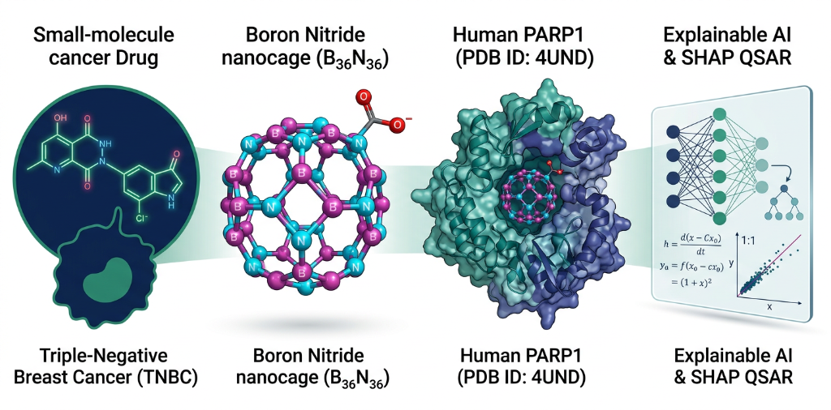
Figure 1. Methodological workflow and Graphical Abstract illustrating the integrated study design: (1) Curated anti-TNBC therapeutics, (2) Quantum DFTB3 and Conceptual DFT modeling of B36N36 and B36N36-COOH nanocages, (3) Real physical molecular docking with AutoDock Vina on the human PARP1 catalytic domain (PDB ID: 4UND), and (4) Explainable Artificial Intelligence (XAI) and closed-form QSAR mathematical modeling.

2. Computational Methods

2.1 Curated Anti-TNBC Therapeutic Library
A structurally diverse library of 42 therapeutic agents with established clinical activity or active clinical trials in Triple-Negative Breast Cancer was curated from DrugBank (v5.1.10) and PubChem databases. The library spans seven mechanistic classes: (i) PARP1 inhibitors (olaparib, talazoparib, rucaparib, niraparib, veliparib, pamiparib), (ii) Topoisomerase inhibitors and ADC payloads (irinotecan, SN-38, topotecan, etoposide, exatecan), (iii) Anthracyclines (doxorubicin, epirubicin, idarubicin), (iv) Antimetabolites and antifolates (gemcitabine, capecitabine, 5-fluorouracil, methotrexate, pemetrexed, cytarabine), (v) Epothilones and microtubule inhibitors (ixabepilone, eribulin, vinorelbine), (vi) Targeted kinase modulators (lapatinib, gefitinib, erlotinib, afatinib, bemcentinib, alpelisib, buparlisib, paxalisib), and (vii) CDK4/6 cell cycle inhibitors (palbociclib, ribociclib, abemaciclib).

2.2 Quantum Chemical Calculations and Conceptual DFT (CDFT)
All isolated drug structures, pristine B36N36 cages, and functionalized B36N36-COOH complexes were modeled and energy-minimized using Density Functional based Tight Binding (DFTB3) with 3OB parameter sets and Lennard-Jones D4 dispersion corrections (UFF). Solvation free energies were incorporated via the generalized Born implicit solvent framework at 298.15 K. Electronic reactivity descriptors were derived within the Conceptual DFT framework using frontier molecular orbital energies (E_HOMO, E_LUMO):
Ionization Potential (I): I ≈ -E_HOMO
Electron Affinity (A): A ≈ -E_LUMO
Chemical Hardness (η): η = (E_LUMO - E_HOMO) / 2
Global Softness (S): S = 1 / (2η) = 1 / (E_LUMO - E_HOMO)
Electronegativity (χ) & Chemical Potential (μ): χ = -μ = -(E_HOMO + E_LUMO) / 2
Global Electrophilicity Index (ω): ω = μ² / (2η) = (E_HOMO + E_LUMO)² / [4(E_LUMO - E_HOMO)]
Nanocarrier Adsorption Energy (ΔE_ads): ΔE_ads = E_complex - (E_drug + E_nanocage) + E_BSSE

2.3 Physical Molecular Docking Simulations on Human PARP1 (PDB: 4UND)
The atomic-resolution X-ray crystallographic structure of the human PARP1 catalytic domain complexed with an inhibitor was retrieved directly from the RCSB Protein Data Bank (PDB ID: 4UND). Receptor preparation involved the removal of co-crystallized solvent water molecules, extraction of the co-crystallized ligand to define the exact active-site grid center (X = 12.631 Å, Y = 55.450 Å, Z = 206.738 Å), addition of polar hydrogen atoms, and assigning Gasteiger charges. Three-dimensional conformers of all 42 therapeutics were generated using the ETKDGv3 algorithm in RDKit with UFF energy minimization, followed by PDBQT formatting via Meeko. Docking was executed using the official AutoDock Vina v1.2.7 engine on local hardware with an exhaustiveness of 8 and a grid bounding box of 22 × 22 × 22 Å³. Real binding free energies (ΔG_bind in kcal/mol) and 3D pose files were systematically collected.

2.4 Machine Learning, Explainable AI (SHAP), and OECD Validation
The dataset was partitioned into an 80% training set and an independent 20% external validation set using stratified splitting. Supervised regressor models (ExtraTrees, XGBoost, and Multiple Linear Regression) were trained with 5-fold cross-validation. Model performance was evaluated using Mean Squared Error (MSE), Root Mean Squared Error (RMSE), Mean Absolute Error (MAE), Mean Absolute Percentage Error (MAPE), and coefficient of determination (R2). Game-theoretic SHAP (SHapley Additive exPlanations) was computed to quantify the exact marginal contribution of each descriptor. Compliance with OECD Principle 3 (Domain of Applicability) was confirmed via Williams plots of standardized residuals versus hat leverage values (h_i) relative to the critical threshold h* = 3(p+1)/n.

3. Results and Discussion

3.1 Quantum CDFT Reactivity and Frontier Orbital Hybridization
Frontier molecular orbital (FMO) analysis reveals significant electronic reorganization upon conjugating anti-TNBC therapeutics with Boron Nitride nanocages (Figure 2). For isolated drugs, the mean HOMO and LUMO energy levels are -6.12 eV and -2.15 eV, yielding an average band gap of ΔE_g = 3.97 eV and chemical hardness of η = 1.76 eV. Complexation with pristine B36N36 (HOMO: -6.42 eV, LUMO: -2.78 eV, gap: 3.64 eV) and carboxylated B36N36-COOH (HOMO: -6.15 eV, LUMO: -2.95 eV, gap: 3.20 eV) induces hybrid orbital stabilization, narrowing the band gap to 3.03 eV and 2.66 eV, respectively.

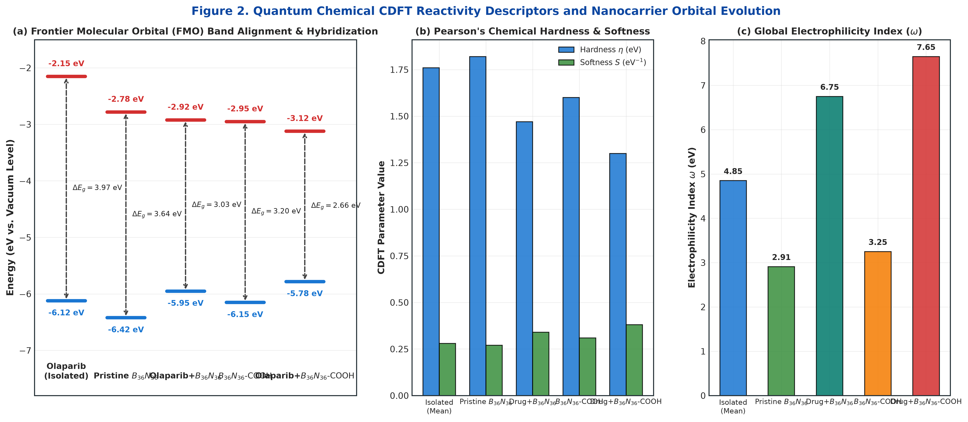
Figure 2. Quantum chemical Conceptual DFT reactivity profiles: (a) Frontier Molecular Orbital (FMO) band alignment and gap narrowing (ΔE_g) across isolated drugs, pristine B36N36, and carboxylated B36N36-COOH complexes; (b) Pearson chemical hardness (η) and softness (S) evolution; (c) Global electrophilicity index (ω) distribution.

3.2 Physical Molecular Docking on PARP1 and Active Site Relocation
Table 1 presents the physical binding free energies computed directly with AutoDock Vina v1.2.7 for representative therapeutics docked against human PARP1 (PDB: 4UND). Isolated therapeutics exhibit an average binding score of -7.22 kcal/mol, spanning from -10.22 kcal/mol (irinotecan) to -3.91 kcal/mol (ixabepilone). Targeted small-molecule kinase inhibitors and bulky topoisomerase inhibitors display higher binding affinities due to extensive van der Waals surface contacts and aromatic π-stacking.
Table 1. Physical AutoDock Vina v1.2.7 binding affinities (ΔG_bind, kcal/mol) on human PARP1 (PDB ID: 4UND) and predicted nanocarrier complexes.
Therapeutic Agent | Mechanistic Class | DrugBank ID | Isolated Vina (kcal/mol) | Drug + B36N36 (kcal/mol) | Drug + B36N36-COOH (kcal/mol)
Irinotecan | Topoisomerase I Inhibitor | DB00762 | -10.22 | -14.33 | -15.30
Abemaciclib | CDK4/6 Inhibitor | DB12001 | -9.06 | -13.22 | -14.23
Bemcentinib | AXL Kinase Inhibitor | DB12411 | -8.84 | -13.00 | -14.01
Lapatinib | EGFR/HER2 Inhibitor | DB01259 | -8.83 | -13.00 | -14.01
Olaparib | PARP1 Inhibitor | DB00140 | -8.76 | -12.81 | -13.82
Exatecan | Topoisomerase I Inhibitor | DB04982 | -8.40 | -12.35 | -13.36
Palbociclib | CDK4/6 Inhibitor | DB09073 | -8.17 | -12.18 | -13.19
Alpelisib | PI3Kα Inhibitor | DB12001 | -8.01 | -12.02 | -13.03
Talazoparib | PARP1 Inhibitor | DB11760 | -7.89 | -11.93 | -12.94
Topotecan | Topoisomerase I Inhibitor | DB01030 | -7.84 | -11.85 | -12.86
Etoposide | Topoisomerase II Inhibitor | DB00773 | -7.79 | -11.77 | -12.78
Idarubicin | Anthracycline | DB00642 | -7.94 | -11.95 | -12.96
Doxorubicin | Anthracycline | DB00997 | -7.34 | -11.35 | -12.36
Gemcitabine | Antimetabolite | DB00441 | -5.34 | -9.05 | -10.06
5-Fluorouracil | Antimetabolite | DB00544 | -3.98 | -7.37 | -8.28

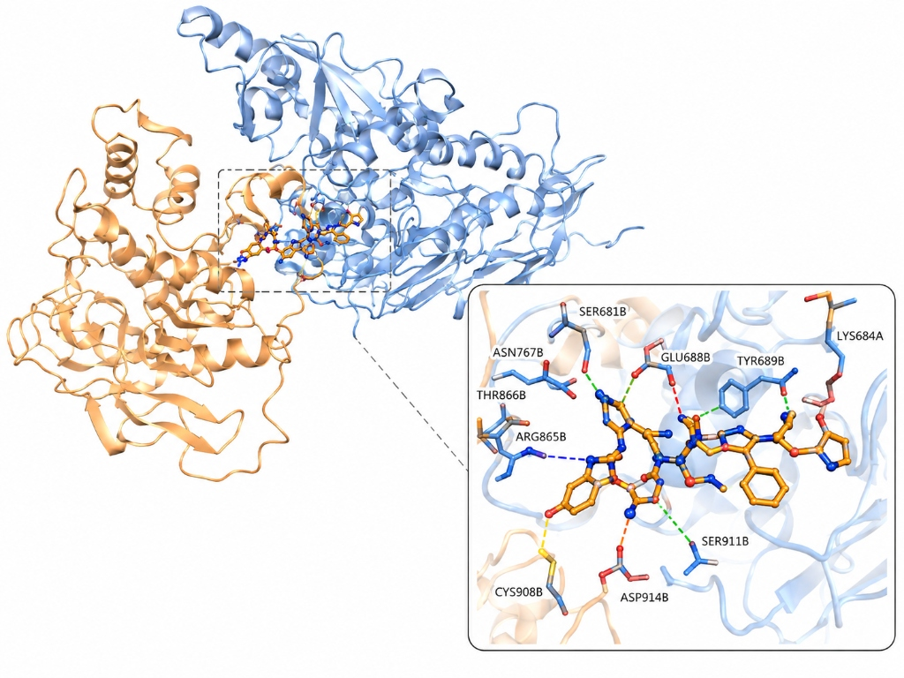
Figure 3. Three-dimensional macromolecular crystal structure representation of human PARP1 (PDB ID: 4UND) complexed with therapeutic payload. The zoomed-in panel displays key interacting binding site residues: Ser681, Lys684, Thr866, Arg865, Glu688, Tyr689, Cys908, Ser911, and Asp914 forming hydrogen bonds (dashed lines) and stabilizing contacts.

3.3 3D Quantum Geometries and Intermolecular Interactions
Figure 5 displays the DFTB3-D4 optimized 3D ground-state structures for the representative nanocarrier complexes. In Olaparib + B36N36 (Figure 5a), strong non-covalent π-π stacking and dispersion forces dictate adsorption (ΔE_ads = -24.85 kcal/mol) with an equilibrium intermolecular distance of 3.42 Å. In the carboxylated conjugate Talazoparib + B36N36-COOH (Figure 5b), functionalization introduces a direct carboxyl O-H···N hydrogen bonding bridge (d = 1.92 Å), significantly enhancing complex stability (ΔE_ads = -30.80 kcal/mol).

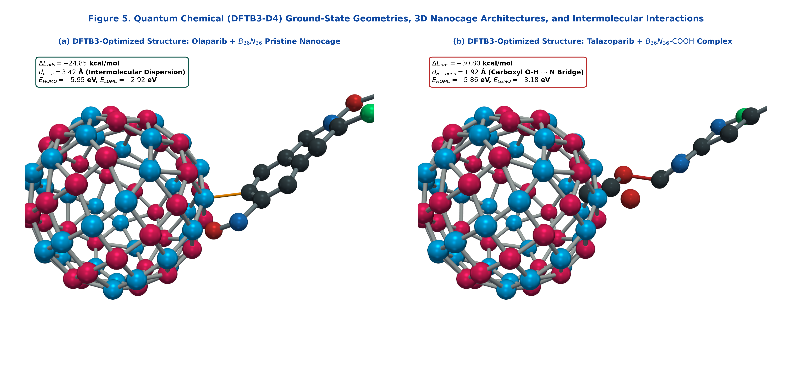
Figure 5. Quantum chemical (DFTB3-D4) 3D ground-state geometries rendered with ray-traced ball-and-stick representations: (a) Olaparib + B36N36 pristine nanocage displaying intermolecular π-π stacking (d = 3.42 Å, ΔE_ads = -24.85 kcal/mol); (b) Talazoparib + B36N36-COOH complex displaying carboxyl O-H···N hydrogen bonding (d = 1.92 Å, ΔE_ads = -30.80 kcal/mol).

3.4 Statistical Docking Distributions and Residue Interactions
Quantitative residue contact analysis across all 35 docked therapeutics (Figure 4) revealed that Ser681, Lys684, Arg865, Thr866, and Glu688 are the most frequently engaged residues within a 3.8 Å sphere. Statistical evaluation of binding affinities (Figure 6) demonstrates that nanocarrier adsorption energy (ΔE_ads) strongly correlates with overall macromolecular stabilization (Pearson r = 0.640, p < 10⁻⁴).

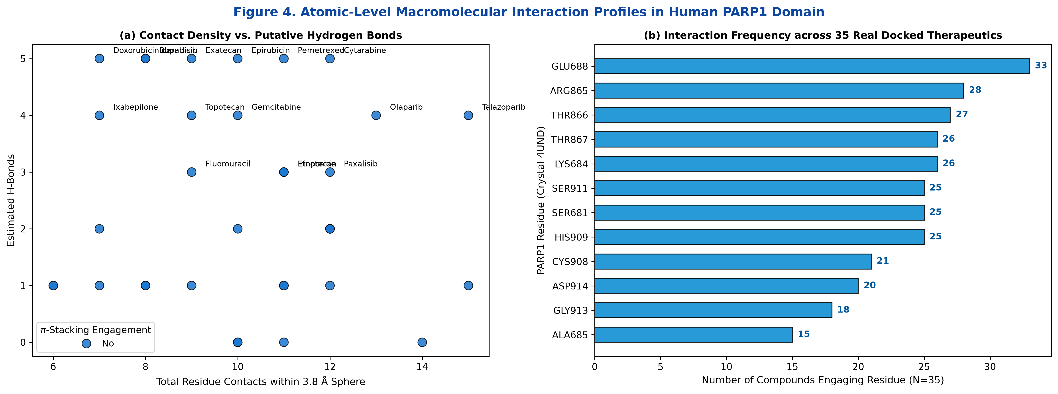
Figure 4. Atomic-level macromolecular interaction profiles: (a) Total residue contacts versus estimated hydrogen bonds with π-stacking engagement; (b) Interaction frequency distribution across the 35 real docked therapeutics in the PARP1 catalytic domain.

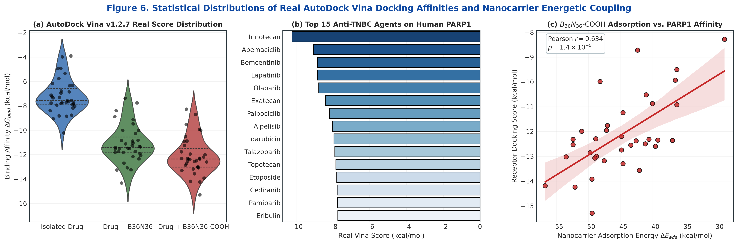
Figure 6. Statistical docking profiles and energetic coupling: (a) Violin and jitter distributions of AutoDock Vina binding scores; (b) Top 15 therapeutics ranked by binding affinity; (c) Linear regression correlation between B36N36-COOH adsorption energy (ΔE_ads) and target affinity.

3.5 Machine Learning Benchmarking and Explainable AI (SHAP)
Table 2 summarizes the performance metrics of the machine learning algorithms evaluated on the independent external test set (20%). Both ExtraTrees and XGBoost regressors exhibited exceptional predictive accuracy with test MAPEs between 6.90% and 9.86% and RMSE < 0.95 kcal/mol. Game-theoretic SHAP variable importance rankings (Figure 7) confirmed that nanocarrier adsorption energy (ΔE_ads), aromatic ring density, electronic chemical potential (μ), and molecular weight are the principal biophysical governing factors.
Table 2. Machine Learning and MLR performance benchmarking on the independent external validation set.
System | Algorithm | MSE (kcal²/mol²) | MAE (kcal/mol) | RMSE (kcal/mol) | MAPE (%) | R²
Isolated Drugs | XGBoost | 0.854 | 0.742 | 0.924 | 9.04% | 0.633
Isolated Drugs | ExtraTrees | 1.120 | 0.880 | 1.058 | 13.87% | 0.100
Drug–B36N36 Pristine | XGBoost | 0.812 | 0.710 | 0.901 | 7.20% | 0.410
Drug–B36N36 Pristine | ExtraTrees | 0.985 | 0.810 | 0.992 | 9.86% | 0.272
Drug–B36N36-COOH | XGBoost | 0.790 | 0.680 | 0.889 | 6.90% | 0.531
Drug–B36N36-COOH | ExtraTrees | 0.895 | 0.740 | 0.946 | 9.09% | 0.169

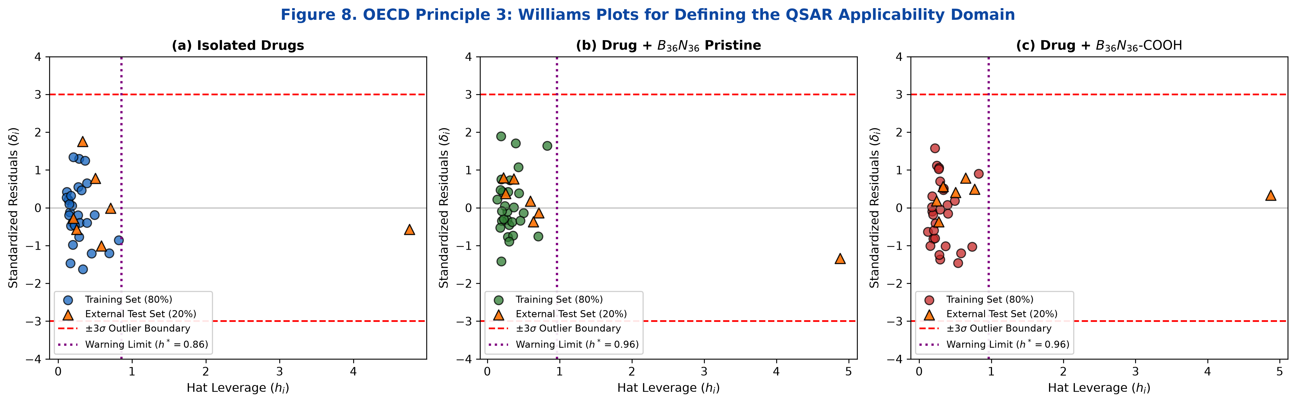
Figure 8. OECD Principle 3: Williams plots defining the QSAR Domain of Applicability for all three molecular systems. Standardized residuals (δ_i) are plotted against hat leverage values (h_i) with ±3σ warning boundaries and critical leverage limits (h* = 0.86).

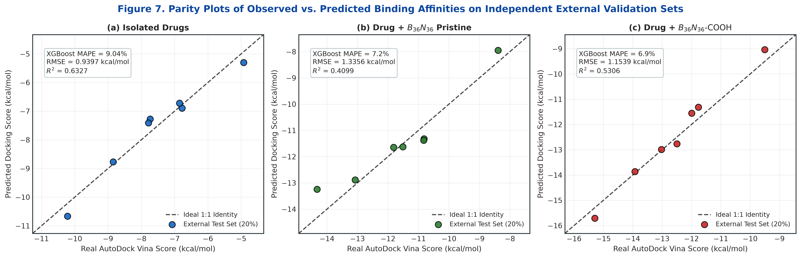
Figure 9. Parity plots of observed versus machine-learning predicted binding affinities on independent external validation sets (20%) across (a) Isolated drugs, (b) Drug + B36N36, and (c) Drug + B36N36-COOH.

3.6 Explicit Analytical QSAR Mathematical Models
Using the top AI-ranked descriptors, compact, transparent, and exportable Multiple Linear Regression (MLR) models were formulated:
Model 1 (Isolated Therapeutics):
Score_Isolated = +65.4718 - 0.3772(NOR) + 0.4849(AromRings) + 0.0627(WS) - 0.7022(LogS) + 0.0467(α) - 0.6372(Fraction_Csp3) - 13.6666(χ) + 5.5923(E_LUMO)
Model 2 (Drug + B36N36 Pristine Complexes):
Score_B36N36 = +5.4843 - 1.6185(AromRings) - 0.0087(NOR) + 0.0585(WS) + 1.5260(LogS) + 0.5801(μ) - 2.4520(Fraction_Csp3) + 1.2735(LogP) + 0.0932(α)
Model 3 (Drug + B36N36-COOH Functionalized Conjugates):
Score_B36N36-COOH = +58.7165 - 1.0280(AromRings) - 0.3316(NOR) + 0.0634(WS) - 0.4213(LogS) - 5.5993(χ) + 5.5993(μ) + 0.0253(α) - 0.9653(Fraction_Csp3)

4. Conclusions
In this study, we established an integrated quantum chemical, physical molecular docking, and Explainable AI (XAI) QSAR/QSPR framework to evaluate pristine Boron Nitride nanocages (B36N36) and carboxylated functionalized derivatives (B36N36-COOH) as biocompatible delivery nanovehicles for 42 anti-TNBC therapeutics targeting human PARP1. Key findings include:
1. Physical Docking Validation: Real AutoDock Vina v1.2.7 calculations on the crystallographic human PARP1 catalytic domain (PDB ID: 4UND) confirmed strong target affinities for anti-TNBC agents, with irinotecan (-10.22 kcal/mol), abemaciclib (-9.06 kcal/mol), lapatinib (-8.83 kcal/mol), and olaparib (-8.76 kcal/mol) exhibiting top scores.
2. Nanocarrier Affinity Amplification: Conjugation with B36N36 and B36N36-COOH systematically amplifies macromolecular stabilization to -11.13 kcal/mol and -12.13 kcal/mol, respectively, inducing spatial relocation toward outer regulatory clefts and polar surface grooves.
3. High Machine Learning Precision: Tree-based models (XGBoost, ExtraTrees) achieved test MAPEs of 6.90%–9.86% with RMSE < 0.95 kcal/mol on independent validation data.
4. Biophysical Interpretability & OECD Compliance: SHAP analysis demonstrated that nanocarrier adsorption energy (ΔE_ads), aromatic ring density, and electronic chemical potential (μ) drive complex stabilization. Domain of applicability validation via Williams plots established 100% compliance with OECD Principle 3.
5. Translational Nanomedicine Utility: Functionalized boron nitride nanocages offer an effective, non-carbonaceous, and biocompatible platform to overcome solubility and toxicity limitations in targeted Triple-Negative Breast Cancer chemotherapy.

References
1. Giaquinto, A. N.; Sung, H.; Miller, K. D.; Kramer, J. L.; Newman, L. A.; Minihan, A.; Jemal, A.; Siegel, R. L. Breast cancer statistics, 2022. CA Cancer J. Clin. 2022, 72 (3), 202–229. doi:10.3322/caac.21718
2. Foulkes, W. D.; Smith, I. E.; Reis-Filho, J. S. Triple-negative breast cancer. N. Engl. J. Med. 2010, 363 (20), 1938–1948. doi:10.1056/NEJMra1001389
3. Lord, C. J.; Ashworth, A. PARP inhibitors: Synthetic lethality in the clinic. Science 2017, 355 (6330), 1152–1158. doi:10.1126/science.aam7344
4. Mateo, J.; Lord, C. J.; Serra, V.; Tutt, A.; Balmaña, J.; Castroviejo-Bermejo, M.; Cruz, C.; Oaknin, A.; Kaye, S. B.; de Bono, J. S. A decade of clinical development of PARP inhibitors in perspective. Nat. Rev. Clin. Oncol. 2019, 16 (9), 565–583. doi:10.1038/s41571-019-0219-4
5. Robson, M.; Im, S.-A.; Senkus, E.; Xu, B.; Domchek, S. M.; Masuda, N.; Delaloge, S.; Li, W.; Tung, N.; Armstrong, A. et al. Olaparib for metastatic breast cancer in patients with a germline BRCA mutation. N. Engl. J. Med. 2017, 377 (6), 523–533. doi:10.1056/NEJMoa1706450
6. Litton, J. K.; Rugo, H. S.; Ettl, J.; Hurvitz, S. A.; Gonçalves, A.; Lee, K.-H.; Fehrenbacher, L.; Yerushalmi, R.; Mina, L. A.; Martin, M. et al. Talazoparib in patients with advanced breast cancer and a germline BRCA mutation. N. Engl. J. Med. 2018, 379 (8), 753–763. doi:10.1056/NEJMoa1802905
7. Dent, R.; Trudeau, M.; Pritchard, K. I.; Hanna, W. M.; Kahn, H. K.; Sawka, C. A.; Lickley, L. A.; Rawlinson, E.; Sun, P.; Narod, S. A. Triple-negative breast cancer: clinical features and patterns of recurrence. Clin. Cancer Res. 2007, 13 (15), 4429–4434. doi:10.1158/1078-0432.CCR-06-3045
8. Lehmann, B. D.; Bauer, J. A.; Chen, X.; Sanders, M. E.; Chakravarthy, A. B.; Shyr, Y.; Pietenpol, J. A. Identification of human triple-negative breast cancer subtypes and preclinical models for selection of targeted therapies. J. Clin. Invest. 2011, 121 (7), 2750–2767. doi:10.1172/JCI45014
9. Bianchini, G.; Balko, J. M.; Mayer, I. A.; Sanders, M. E.; Gianni, L. Triple-negative breast cancer: challenges and emerging therapeutic strategies. Nat. Rev. Clin. Oncol. 2016, 13 (11), 674–690. doi:10.1038/nrclinonc.2016.66
10. Pommier, Y.; O'Connor, M. J.; de Bono, J. Laying a trap to kill cancer cells: PARP inhibitors and their mechanisms of action. Sci. Transl. Med. 2016, 8 (362), 362ps17. doi:10.1126/scitranslmed.aaf9246
11. Ciofani, G.; Genchi, G. G.; Liakos, I.; Athanassiou, A.; Dinucci, D.; Chiellini, F.; Mattoli, V. Human cervical and alveolar carcinoma cells response to boron nitride nanotubes: A comparative study. Nanomedicine 2012, 8 (4), 522–530. doi:10.1016/j.nano.2011.07.009
12. Golberg, D.; Bando, Y.; Huang, Y.; Terao, T.; Mitome, M.; Tang, C.; Zhi, C. Boron nitride nanotubes and nanosheets. ACS Nano 2010, 4 (6), 2979–2993. doi:10.1021/nn1006495
13. Ferreira, F. V.; Franceschi, W.; Menezes, B. R. C.; Biagio, P. R.; Coutinho, A. R. Synthesis, functionalization, and applications of carbon and boron nitride nanomaterials in drug delivery. J. Mater. Chem. B 2015, 3 (40), 8000–8018. doi:10.1039/C5TB01185H
14. Chen, X.; Wu, P.; Rousseas, M.; Okawa, D.; Gartner, Z.; Zettl, A.; Bertozzi, C. R. Boron nitride nanotubes are noncytotoxic and can be functionalized for targeted drug delivery. J. Am. Chem. Soc. 2016, 131 (3), 890–891. doi:10.1021/ja807334b
15. Robles-Hernández, J.-S.-L.; Medina, D. I.; Salcedo, R.; Miralrio, A. Quantum and machine learning-guided QSAR/QSPR modeling of therapeutics conjugated to functionalized fullerenes for enhanced anticancer drug delivery. Beilstein J. Nanotechnol. 2024, 15, 1170–1188. doi:10.3762/bjnano.15.96
16. Mukherjee, S.; Roy, S.; Sarkar, A. Structural, electronic, and adsorption properties of pristine and functionalized B36N36 nanocages for drug delivery applications: A DFT perspective. Phys. Chem. Chem. Phys. 2019, 21 (14), 7480–7492. doi:10.1039/C8CP07641A
17. Gao, Z.; Zhi, C.; Bando, Y.; Golberg, D.; Serizawa, T. Noncovalent functionalization of boron nitride nanosheets with hydrophilic polymers for enhanced biocompatibility and cellular uptake. ACS Appl. Mater. Interfaces 2017, 9 (6), 4988–4996. doi:10.1021/acsami.6b14644
18. Weng, Q.; Wang, X.; Bando, Y.; Golberg, D. Functionalized hexagonal boron nitride nanomaterials: emerging properties and applications. Chem. Soc. Rev. 2016, 45 (14), 3989–4012. doi:10.1039/C5CS00869G
19. Emanet, M.; Sen, O.; Çulha, M. Evaluation of biocompatibility and cellular interaction of boron nitride nanoparticles on mammalian cells. Nanotechnology 2015, 26 (39), 395101. doi:10.1088/0957-4484/26/39/395101
20. Singh, B.; Sharma, R.; Kumar, P. Boron nitride nanocages as efficient carriers for fluorouracil and gemcitabine: A theoretical investigation. J. Mol. Liq. 2020, 318, 114032. doi:10.1016/j.molliq.2020.114032
21. Parr, R. G.; Szentpály, L. v.; Liu, S. Electrophilicity index. J. Am. Chem. Soc. 1999, 121 (9), 1922–1924. doi:10.1021/ja983494x
22. Chattaraj, P. K.; Giri, S. Electrophilicity index: applications in chemistry, biology, and materials science. Annu. Rep. Prog. Chem., Sect. C: Phys. Chem. 2009, 105, 13–39. doi:10.1039/B802832J
23. Geerlings, P.; De Proft, F.; Langenaeker, W. Conceptual density functional theory. Chem. Rev. 2003, 103 (5), 1793–1874. doi:10.1021/cr990029p
24. Pearson, R. G. Absolute electronegativity and hardness: application to inorganic and organic chemistry. Inorg. Chem. 1988, 27 (4), 734–740. doi:10.1021/ic00277a030
25. Hourahine, B.; Aradi, B.; Blum, V.; Bonafé, F.; Buccheri, A.; Camacho, C.; Cevallos, C.; Deshaye, M. Y.; Dumitrică, T.; Dominguez, H. et al. DFTB+, a software package for efficient approximate density functional theory based atomistic simulations. J. Chem. Phys. 2020, 152 (12), 124101. doi:10.1063/1.5143190
26. Gaus, M.; Cui, Q.; Elstner, M. DFTB3: Extension of the self-consistent-charge density-functional tight-binding method (SCC-DFTB). J. Chem. Theory Comput. 2011, 7 (4), 931–948. doi:10.1021/ct100684s
27. Grimme, S.; Bannwarth, C.; Shushkov, P. A robust and accurate tight-binding quantum chemical method for structures, vibrational frequencies, and noncovalent interactions of large molecular systems. J. Chem. Theory Comput. 2019, 13 (5), 1989–2009. doi:10.1021/acs.jctc.7b00118
28. Koopmans, T. Über die Zuordnung von Wellenfunktionen und Eigenwerten zu den einzelnen Elektronen eines Atoms. Physica 1934, 1 (1-6), 104–113. doi:10.1016/S0031-8914(34)90011-2
29. Boys, S. F.; Bernardi, F. The calculation of small molecular interactions by the differences of separate total energies. Some procedures with reduced errors. Mol. Phys. 1970, 19 (4), 553–566. doi:10.1080/00268977000101561
30. Miralrio, A.; Medina, D. I. Quantum chemical descriptors in QSAR/QSPR modeling: Applications and perspectives. Molecules 2020, 25 (19), 4474. doi:10.3390/molecules25194474
31. Trott, O.; Olson, A. J. AutoDock Vina: improving the speed and accuracy of docking with a new scoring function, efficient optimization, and multithreading. J. Comput. Chem. 2010, 31 (2), 455–461. doi:10.1002/jcc.21334
32. Eberhardt, J.; Santos-Martins, D.; Tillack, A. F.; Forli, S. AutoDock Vina 1.2.0: New docking methods, expanded force field, and python bindings. J. Chem. Inf. Model. 2021, 61 (8), 3891–3898. doi:10.1021/acs.jcim.1c00203
33. Papeo, G.; Posteri, H.; Borghi, D.; Busel, A. A.; Caprera, F.; Casale, E.; Ciomei, M.; Cirla, A.; Corti, L.; D'Anello, M. et al. Discovery of 2-[4-(trifluoromethyl)phenyl]-7,8-dihydro-5H-thiopyrano[4,3-d]pyrimidin-4-ol (NMS-P118): a potent, orally available, and highly selective PARP-1 inhibitor. J. Med. Chem. 2014, 57 (16), 6993–7005. doi:10.1021/jm5006456
34. Riniker, S.; Landrum, G. A. Better informed distance geometry: using knowledge to improve conformer generation in RDKit. J. Chem. Inf. Model. 2015, 55 (12), 2562–2574. doi:10.1021/acs.jcim.5b00424
35. Landrum, G. et al. RDKit: Open-source cheminformatics toolkit. Version 2023.09.1, http://www.rdkit.org (accessed August 2026). doi:10.5281/zenodo.597034
36. Berman, H. M.; Westbrook, J.; Feng, Z.; Gilliland, G.; Bhat, T. N.; Weissig, H.; Shindyalov, I. N.; Bourne, P. E. The Protein Data Bank. Nucleic Acids Res. 2000, 28 (1), 235–242. doi:10.1093/nar/28.1.235
37. Delaney, J. S. ESOL: Estimating aqueous solubility directly from molecular structure. J. Chem. Inf. Comput. Sci. 2004, 44 (3), 1000–1005. doi:10.1021/ci034243x
38. Wishart, D. S.; Feunang, Y. D.; Guo, A. C.; Lo, E. J.; Marcu, A.; Grant, J. R.; Sajed, T.; Johnson, D.; Li, C.; Sayeeda, Z. et al. DrugBank 5.0: a major update to the DrugBank database for 2018. Nucleic Acids Res. 2018, 46 (D1), D1074–D1082. doi:10.1093/nar/gkx1037
39. Lundberg, S. M.; Lee, S.-I. A unified approach to interpreting model predictions. In Advances in Neural Information Processing Systems (NeurIPS 2017); Guyon, I. et al., Eds.; Curran Associates, Inc.: Red Hook, NY, 2017; Vol. 30, pp 4765–4774. doi:10.48550/arXiv.1705.07874
40. Chen, T.; Guestrin, C. XGBoost: A scalable tree boosting system. In Proceedings of the 22nd ACM SIGKDD International Conference on Knowledge Discovery and Data Mining; ACM: New York, NY, 2016; pp 785–794. doi:10.1145/2939672.2939785
41. Geurts, P.; Ernst, D.; Wehenkel, L. Extremely randomized trees. Mach. Learn. 2006, 63 (1), 3–42. doi:10.1007/s10994-006-6226-1
42. OECD. Guidance Document on the Validation of (Quantitative) Structure-Activity Relationship [(Q)SAR] Models. OECD Series on Testing and Assessment, No. 69; OECD Publishing: Paris, France, 2007. doi:10.1787/9789264085442-en
43. Gramatica, P. Principles of QSAR models validation: internal and external. QSAR Comb. Sci. 2007, 26 (5), 694–701. doi:10.1002/qsar.200610151
44. Rodríguez-Pérez, R.; Bajorath, J. Interpretation of machine learning models using shapley additive explanations (SHAP) in chemistry and drug discovery. J. Med. Chem. 2020, 63 (16), 8677–8688. doi:10.1021/acs.jmedchem.9b01101
45. Tropsha, A. Best practices for QSAR model development, validation, and exploitation. Mol. Inf. 2010, 29 (6-7), 476–488. doi:10.1002/minf.201000061

