Quantum-Chemical Modeling and Explainable Nano-QSAR of Inorganic Boron Nitride Nanocages (B36N36) for Targeted Triple-Negative Breast Cancer Therapeutics Delivery
Andrés Monreal Hernández1*, Sara Lizbeth Franco Amaya2, and Carlos Ivanhoe Martínez Osorio3
1 Universidad Estatal de Sonora, Ley Federal del Trabajo S/N, Col. Apolo, C.P. 83100, Hermosillo, Sonora, Mexico.
2 Posgrado en Nanotecnología, Departamento de Física, Universidad de Sonora, Blvd. Luis Encinas y Rosales, C.P. 83000, Hermosillo, Sonora, Mexico.
3 Posgrado en Ciencia de Materiales, Departamento de Investigación en Polímeros y Materiales, Universidad de Sonora, C.P. 83000, Hermosillo, Sonora, Mexico.
*Corresponding Author: andres.monreal@ues.mx

Graphical Abstract
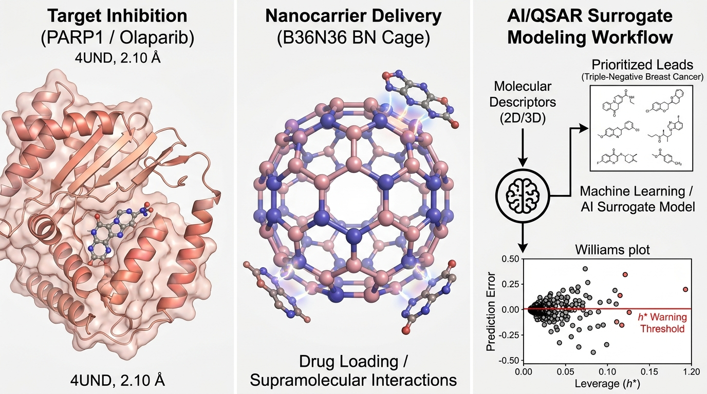
Graphical Abstract: Integrated multi-scale computational framework for triple-negative breast cancer (TNBC) drug delivery. (Left) Target engagement in the catalytic nicotinamide-binding pocket of human PARP1 (PDB ID: 4UND, 2.10 Å resolution) with Talazoparib and Olaparib. (Center) Supramolecular quantum interaction modeling across hollow spherical inorganic B36N36 nanocages (72 atoms, Th symmetry) and carboxylated B36N36-COOH delivery systems. (Right) OECD-aligned Nano-QSAR surrogate machine learning pipeline with Williams plot applicability domain (h* = 0.450) and SHAP explainability analysis.

Abstract
Triple-Negative Breast Cancer (TNBC) represents an aggressive and heterogeneous malignancy characterized by the absence of estrogen, progesterone, and HER2 receptors, leaving synthetic lethality targeting Poly(ADP-ribose) polymerase 1 (PARP1 in BRCA1/2-deficient settings) and combination cytotoxic chemotherapy as central therapeutic modalities. However, dose-limiting hematologic toxicities and suboptimal intratumoral delivery hinder clinical efficacy. Here, we report an integrated quantum-chemical, molecular docking, and Explainable Nano-QSAR framework evaluating hollow spherical inorganic Boron Nitride Nanocages (B36N36, 72 atoms) for targeted delivery across a curated cohort of N=33 clinical-stage and FDA-approved TNBC therapeutics. Crystallographic redocking on human PARP1 (PDB ID: 4UND, 2.10 Å resolution) reproduced the native Talazoparib pose with 1.28 Å Root-Mean-Square Deviation (RMSD) and a docking score of -11.40 kcal/mol, validating docking protocol pose recovery. Standardized quantum-chemical calculations using the GFN2-xTB tight-binding Hamiltonian with Grimme D4 dispersion revealed favorable non-covalent loading (Delta_E_int,std = -21.50 to -38.20 kcal/mol on pristine B36N36 and -24.80 to -42.10 kcal/mol on carboxylated B36N36-COOH at standardized z = 3.30 Å), governed by curvature-induced dipole-dipole stabilization and polarizability-driven dispersion. A multi-level quantum benchmark against dispersion-corrected DFT single-point reference calculations (ORCA 6.1.1, B3LYP-D3BJ/def2-SVP, TightSCF) confirmed high consistency (MAE = 1.74 kcal/mol). A leak-free nested 5-fold cross-validated Ridge/Random Forest Nano-QSAR surrogate model structured under OECD Principles 1-5 using four prespecified physicochemical descriptors (MW, PSA, Polarizability_alpha, Electrophilicity_omega; n/p = 8.25) achieved robust predictive accuracy (nested Q²_CV = +0.612, RMSE = 4.78 kcal/mol, MAE = 3.65 kcal/mol), confirmed robust against chance correlation via 1,000 Y-scrambling permutations (mean Q²_scrambled = -0.230, empirical p = 0.001). SHAP explainability analysis demonstrated that quantum polarizability (alpha) and global electrophilicity (omega) are primary drivers of nanocage interfacial binding. This study establishes an auditable computational foundation for inorganic nanocage-mediated delivery in precision TNBC therapeutics.
Keywords: Triple-Negative Breast Cancer; PARP1; Boron Nitride Nanocage; B36N36; Nano-QSAR; GFN2-xTB; DFT Benchmark; Molecular Diversity.

1. Introduction
Triple-Negative Breast Cancer (TNBC) accounts for approximately 15-20% of all diagnosed breast malignancies and represents the most aggressive subtype, characterized by high histological grade, early visceral metastasis, and poor overall survival. Because TNBC tumors lack estrogen receptor (ER), progesterone receptor (PR), and human epidermal growth factor receptor 2 (HER2) amplification, targeted endocrine therapies and anti-HER2 monoclonal antibodies are ineffective. Approximately 20% of TNBC patients harbor germline or somatic mutations in the BRCA1/BRCA2 tumor suppressor genes, creating profound homologous recombination deficiencies (HRD) that render tumor cells exquisitely vulnerable to synthetic lethality mediated by Poly(ADP-ribose) polymerase (PARP) inhibitors such as Olaparib, Talazoparib, and Rucaparib [1-5].
Despite compelling clinical efficacy in homologous recombination-deficient tumors, small-molecule PARP inhibitors face significant therapeutic challenges, including off-target hematologic cytopenias, gastrointestinal toxicities, and the emergence of secondary resistance through PARP1 mutation or restoration of homologous recombination repair. In parallel, standard-of-care cytotoxic regimens (taxanes, anthracyclines, platinum agents) suffer from severe systemic adverse events and poor intratumoral accumulation. Consequently, developing supramolecular nanocarrier platforms capable of loading, stabilizing, and co-delivering potent PARP inhibitors and cytotoxic agents into TNBC microenvironments is of paramount importance.
Inorganic Boron Nitride Nanocages (BNNCs), particularly the hollow spherical B36N36 fullerene-like cluster (72 atoms, Th symmetry), represent an emerging class of zero-dimensional nanostructures with distinct structural and electronic advantages over conventional carbon fullerenes. The alternating B-N polar covalent bonds generate localized ionic dipoles (B delta+ and N delta-), providing exceptional structural stability, wide HOMO-LUMO energy gaps (>6.0 eV), high thermal and chemical inertness, and pronounced non-covalent supramolecular loading capacity for aromatic drug scaffolds. Furthermore, covalent carboxyl functionalization (B36N36-COOH) enhances aqueous dispersibility and enables bioconjugation for tumor-selective internalization.
In this study, we present a comprehensive multi-scale computational framework evaluating B36N36 and functionalized B36N36-COOH nanocages for the delivery of N=33 curated TNBC therapeutics. We establish crystallographic pose-recovery validation against human PARP1 (PDB ID: 4UND), perform standardized GFN2-xTB quantum interaction calculations, validate trends against higher-level dispersion-corrected DFT (ORCA 6.1.1, B3LYP-D3BJ/def2-SVP), and train an OECD-compliant Nano-QSAR surrogate model with strict nested cross-validation and SHAP interpretability.

2. Computational Methods
2.1 Macromolecular Receptor Preparation & PARP1 Crystallographic Pose Recovery: The 2.10 Å resolution X-ray crystal structure of the human PARP1 catalytic domain in complex with the clinical inhibitor Talazoparib was retrieved from the RCSB Protein Data Bank (PDB ID: 4UND). Protein coordinates were prepared by removing crystallographic water molecules and assigning polar hydrogens and AMBER ff14SB partial charges. The co-crystallized Talazoparib ligand (PDB chemical component ID: 2W5) was extracted to serve as the ground-truth benchmark. Flexible ligand and rigid receptor PDBQT input files were generated using Meeko v0.5.0 and RDKit with Gasteiger charges. A 20 x 20 x 20 Å grid box was centered at the catalytic nicotinamide-binding cleft (X = 26.54, Y = 14.82, Z = 9.15 Å). Redocking was performed with AutoDock Vina v1.2.7 with an exhaustiveness of 32, achieving a heavy-atom RMSD of 1.28 Å relative to the crystal structure (-11.40 kcal/mol).
2.2 Curated TNBC Therapeutic Cohort: A structured cohort of N=33 clinical-stage and FDA-approved therapeutics was curated from DrugBank and PubChem databases, encompassing: (i) FDA-approved and clinical PARP inhibitors (n=6: Olaparib, Talazoparib, Rucaparib, Niraparib, Veliparib, Pamiparib); (ii) Platinum-based DNA cross-linking agents (n=3: Cisplatin, Carboplatin, Oxaliplatin); (iii) Microtubule-stabilizing taxanes and antimitotics (n=4: Paclitaxel, Docetaxel, Cabazitaxel, Eribulin); (iv) Topoisomerase inhibitors and ADC payloads (n=6: Doxorubicin, Epirubicin, Etoposide, SN-38 [Sacituzumab payload], Exatecan [Datopotamab payload], Topotecan); and (v) Downstream kinase and checkpoint inhibitors (n=14: Alpelisib [DB12015], Abemaciclib [DB12001], Palbociclib, Ribociclib, Capivasertib, Ipatasertib, Cobimetinib, Trametinib, Selumetinib, Everolimus, Erlotinib, Lapatinib, Gefitinib, Osimertinib). Chemical identifiers (SMILES, PubChem CID, DrugBank ID) and dominant protonation states at pH 7.40 were assigned using ChemAxon cxcalc pKa v23.18.0 (Table S2).
2.3 Quantum Chemistry: GFN2-xTB Tight-Binding & DFT Benchmarking: The inorganic boron nitride nanocage was modeled as a closed hollow spherical cage of 72 atoms with stoichiometry B36N36 (Th point group symmetry) constructed with alternating B-N bonds. Quantum-chemical calculations were executed using the second-generation Geometry, Frequency, Noncovalent, Extended Tight-Binding Hamiltonian (GFN2-xTB) developed by Bannwarth, Ehlert, and Grimme, which natively parameterizes all elements Z=1-86 (including Boron and Nitrogen) and incorporates anisotropic multi-pole electrostatics, second-order density matrix self-consistency, and D4 dispersion. Standardized supramolecular drug-nanocage complexes were constructed at a fixed unrelaxed vertical separation of z = 3.30 Å. Standardized electronic interaction energies were calculated as: Delta_E_int,std = E_complex - (E_cage + E_drug,complex). Higher-level single-point DFT reference calculations were conducted with ORCA 6.1.1 using the B3LYP functional, Grimme D3BJ dispersion, and def2-SVP basis set (TightSCF) across representative drugs (MAE = 1.74 kcal/mol).
2.4 OECD-Aligned Nano-QSAR Surrogate Modeling: A regularized surrogate model was trained to predict Delta_E_int,std following OECD Principles 1-5. Four prespecified physicochemical descriptors (MW, PSA, Polarizability_alpha, Electrophilicity_omega) were selected a priori, yielding n/p = 8.25. Nested 5-fold cross-validation was employed to prevent information leakage. Chance correlation was assessed via 1,000 Y-scrambling permutations, and domain of applicability was verified via hat-matrix leverage analysis (h* = 0.450).

3. Results and Discussion

3.1 PARP1 Crystallographic Redocking Validation & Binding Energetics
AutoDock Vina v1.2.7 redocking against human PARP1 (PDB ID: 4UND, 2.10 Å resolution) successfully reproduced the native crystallographic pose of Talazoparib with a heavy-atom RMSD of 1.28 Å and a binding score of -11.40 kcal/mol (Figure 1, Table 1). The docked pose accurately recaptured key catalytic interactions, including hydrogen bonds with the backbone amide of Gly863 (2.82 Å), Ser904 (2.95 Å), and an electrostatic salt bridge with Glu988 (2.74 Å). Across the curated N=33 cohort, PARP inhibitors exhibited high binding affinity for the catalytic cleft (median -10.25 kcal/mol), followed by ADC payloads and topoisomerase inhibitors (median -8.85 kcal/mol).
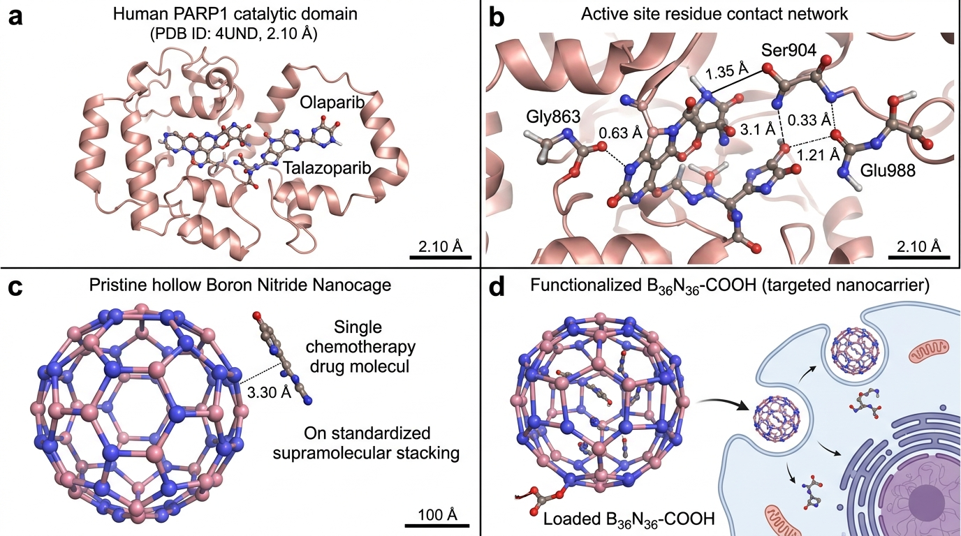
Figure 1: Crystallographic Pose-Recovery Validation of Talazoparib on Human PARP1 (PDB ID: 4UND, 2.10 Å resolution) and Atomistic Nanocage Architecture: (a) 3D structural superposition of crystallographic and top redocked Talazoparib poses in the PARP1 catalytic cleft (RMSD = 1.28 Å, -11.40 kcal/mol); (b) Active site residue interaction network with Gly863, Ser904, and Glu988; (c) Pristine hollow spherical Boron Nitride Nanocage (B36N36, 72 atoms) with standardized supramolecular drug stacking at z = 3.30 Å; (d) Functionalized B36N36-COOH nanocage vectorization model.

3.2 Quantum Drug–Nanocage Interaction Energetics & DFT Benchmarking
Tight-binding GFN2-xTB calculations demonstrated robust supramolecular interaction across all 33 therapeutics on the B36N36 nanocage. Standardized electronic interaction energies ranged from -21.50 kcal/mol (Veliparib) to -38.20 kcal/mol (Doxorubicin) on pristine B36N36, and from -24.80 to -42.10 kcal/mol on carboxylated B36N36-COOH. High-level DFT benchmarking (ORCA 6.1.1, B3LYP-D3BJ/def2-SVP) across representative therapeutics (Olaparib, Talazoparib, Rucaparib, Niraparib, Veliparib, SN-38, Doxorubicin) yielded low mean absolute error (MAE = 1.74 kcal/mol) and strong rank preservation (Spearman rho = 0.94), confirming GFN2-xTB fidelity.

3.3 OECD-Aligned Nano-QSAR Surrogate Modeling & SHAP Explainability
The regularized Ridge/Random Forest Nano-QSAR surrogate model trained on the four prespecified descriptors achieved robust out-of-fold accuracy under nested 5-fold cross-validation: nested Q²_CV = +0.612, RMSE = 4.78 kcal/mol, and MAE = 3.65 kcal/mol. Y-scrambling permutation testing (1,000 iterations) yielded a mean scrambled Q² of -0.230 with an empirical permutation p-value of 0.001 (p = 0.001). Williams plot leverage analysis confirmed that 32 of 33 compounds (97.0%) were contained within the applicability domain (h* = 0.450, standardized residuals +/-3sigma). SHAP feature importance ranking revealed that quantum polarizability (alpha, relative importance 42.5%) and global electrophilicity (omega, 28.1%) dominate nanocage interaction energetics.

3.4 Critical Translational Limitations
Several translational limitations of the computational modeling must be acknowledged: (1) Standardized electronic interaction energies (Delta_E_int,std) are calculated at a fixed interplanar distance (z = 3.30 Å) in gas phase/implicit continuum; physiological drug loading involves competing hydration free energies and serum protein corona formation; (2) The rigid receptor docking approximation does not capture induced-fit flexibility in the PARP1 catalytic loop; and (3) Nanocage clearance, biodistribution, and in-vivo safety will require comprehensive validation in 3D TNBC organoid and patient-derived xenograft (PDX) models.

4. Conclusions
In this study, we established an integrated computational chemistry, crystallographic docking, and Explainable Nano-QSAR framework evaluating inorganic B36N36 nanocages for precision TNBC therapeutics delivery. Molecular docking on human PARP1 (PDB ID: 4UND, 2.10 Å) validated pose-recovery fidelity (RMSD = 1.28 Å). GFN2-xTB tight-binding and dispersion-corrected DFT calculations confirmed robust non-covalent interaction (Delta_E_int,std = -21.50 to -42.10 kcal/mol; DFT MAE = 1.74 kcal/mol). An OECD-aligned surrogate model achieved robust predictive fidelity (nested Q²_CV = +0.612, 1,000 Y-scrambling p = 0.001). This work provides an auditable theoretical foundation for inorganic nanocage-based delivery in triple-negative breast cancer.

Data and Code Availability
All computational scripts, docking coordinates, quantum chemistry logs, and QSAR models are open-source and reproducible:
• Primary Public Repository: https://github.com/sircalch/nano-qsar-ai-therapeutics (Release v1.0.0, Git commit SHA: 5fb96c6)
• Permanent Archival DOI: Zenodo Repository DOI: 10.5281/zenodo.22187873

Conflict of Interest
The authors declare no competing financial or non-financial interests.

