Home

Quick Links
Art, Architecture & Engineering Library
Library Catalog
Catalog for materials owned by the University of Michigan Library
U-M Library Search
Taubman College of Architecture & Urban Planning

Finding Articles using Library Articles Search
You can search across multiple databases by using Library Articles Search. This allows you to search across thousands of publishers and millions of documents. As part of your search, you can limit your results to articles from scholarly journals, from newspapers, or to articles that are available fulltext.
Things to remember:
Library Articles Search is a very good way to start researching a particular topic.
Library Articles Search is great for multi-disciplinary and inter-disciplinary research.
Library Articles Search does not replace subject specific databases for specialized searching, so don't forget about the Avery Index, JSTOR, ScienceDirect, or any of those other standards you've become accustomed to using.
Library Articles Search is not a book catalog (though it does contain ebooks); if you want print and ebooks, search in the Library Catalog.

Architecture Blogs & Conversations
A Daily Dose of Architecture
Architecture Lab
ArchNewsNow.com
BLDG BLOG
City of Sound
Inhabitat : design will save the world
Michigan Architectural Foundation
RogueHAA: a design, architecture, and urban advocacy collaborative
STREETSBLOG.org
Urban Omnibus
The online publication of the Architectural League of NYC.

Citing References
Research Guide : Citation Help
Click on the fourth tab for information about the APA Citation Style or the fifth tab for help with the MLA Citation Style.
Research Guide for Citing Government Document Sources
Includes information on citing government documents as well as an extensive list of links to various citation styles (such as APA, MLA, etc.).

Books

How to Find Books About Architecture
Find books on architecture by doing keyword or title searches in the library catalog. You can start with the simple search, but if you know the title or author you may want to jump to the Advanced Search option to locate your material. When you find the book you're looking for or a book relevant to your search, you may want to use the subject headings listed with that title to guide further searches. Most architecture books are categorized with a Library of Congress call number beginning in NA and will be shelved on the third or second floor of the library.
- Shelving in the AAEL: Books and bound journals with call numbers beginning with A-NA 5999 are shelved on the third floor, those with call numbers beginning with NA 6000-Z and all books designated as Oversize are shelved on the second floor.
- Reference: Reference books, encyclopedias, dictionaries relating to Architecture are located on the second floor of the library. Look for books with call numbers beginning with NA to find the architecture books. Reference books don't circulate, so you'll have to use them in the library.
- Reserve: Some books are kept at the Reserves Desk. These generally can be checked out for 2 or 4 hours. Just ask at the reserve desk on the second floor of the library.
- Folio Storage: Because of their size, age, and/or condition, some books are kept in a storage space in the lower level. These books can be used in the building. Just ask a staff member at the Reserves Desk and the book will be paged for you.
- Special Collections: Some books in our collection are considered rare and are therefore kept in our Special Collections space in the lower level. To use these books, please contact Rebecca Price to arrange an appointment.
- Buhr: Some less frequently used books are stored at our offsite storage facility, Buhr Library. You can request Buhr books be sent to the Art, Architecture & Engineering Library by logging into Mirlyn, or you can visit the Buhr Shelving Facility.

Finding Books in a Series
Finding books published as part of a series can be difficult. A series is different from a journal or serial. Generally each book within the series has its own theme and title. For instance, the series Clog, includes books with such titles as Rendering, National Mall, Prisons, etc. The easiest way to find books published within a series (especially when you don't know the title of the book) is to use the Advanced Search option. Enter the series name and use the pull down arrow to select Series as your search index. Two popular series titles with architectural themes are Clog and Pamphlet Architecture.

Important Reference Works on Architecture
This is a list of useful reference works on architecture and related topics. It includes encyclopedias, handbooks, and dictionaries. These books can be useful when you are looking for information about a specific architect, building, or other topic.
All of these print resources are available in the non-circulating Reference section of the Art, Architecture & Engineering Library, on the second floor.
For more reference works on architecture--such as multivolume works on important architects, periods, movements, or locations--feel free to browse the reference collection on the second floor of the Art, Architecture & Engineering Library.
AccessEngineering (McGraw Hill Reference Collection)
Select "Civil Engineering" Subject to access construction engineering titles.
AIA Detroit : the American Institute of Architects Guide to Detroit Architecture
Call Number: NA 735 .D6 H55 2003
Art, Artifact and Architecture Law
Call Number: KF 4288 .D371 2005
Buildings of Detroit: A History
Call Number: NA 735 .D6 F39 1980
Encyclopedia of 20th Century Architecture
Call Number: NA 680 .H3913 1986
Glossary of Art, Architecture and Design
Call Number: N 34 .W8 1992
A Guide to the Campus of the University of Michigan
Call Number: LD 3281 .M152 (at the Graduate Library)
International Dictionary of Architects and Architecture
Call Number: NA 40 .I481 1993
Knovel: Engineering & Scientific Online References
Look in the Civil Engineering / Construction Materials category.
MacMillan Encyclopedia of Architects
Call Number: NA 40 .M251
Oxford Art Online
Sun Angle Calculator Kit
Call Number: NA 2700 .S94 1974 (AAEL Storage)
Time-Saver Standards for Building Types
Call Number: NA 2760 .D421 2001
The University of Michigan: An Encyclopedic Survey
Call Number: Available online

Multimedia Architecture Resources
Architectural Association (London) Online Lectures
Public lectures on architectural themes posted by the Architectural Association in London.
BBC Radio3 Architecture Programme
Archived interviews and recordings from several major architects.
Chicago Architect's Oral History Project
Since 1983 this project has documented contributions of architects to Chicago during the 20th century.
SCI-Arc Media Archive
An archive of over 1000 hours of architecture and design lectures and events at SCI-Arc (Southern California Institute of Architecture).

Articles

Databases for Architecture Research
The most appropriate database for finding articles on architectural subjects is the Avery Index to Architectural Periodicals.
The Avery Index and other relevant databases for your research are listed here:
ArtBibliographies Modern
Abstracts of articles, books, essays, exhibition catalogs & reviews, and dissertations covering artists & movements from the late 19th century to all aspects of modern & contemporary art, including photography from its invention in 1839 to the present.
Art Source with Art Index Retrospective
Indexes key international English-language arts publications, including periodicals, yearbooks, museum bulletins, competition & award notices, exhibition listings, interviews, film reviews, and more. Includes full text for selected articles since 1997.
JSTOR / Images
Click on the Images Tab to search JSTOR Images (formerly Artstor), a rich archive of images of art and architectural monuments, landscape architecture, public art, and cultural images.
Avery Index to Architectural Periodicals
Citation database focused on periodicals in architecture and related fields, emphasizing architectural design and history, construction, public arts, urban planning and design, etc.
Bibliography of the History of Art
Covering European and American art from late antiquity to the present, the Bibliography of the History of Art indexes and abstracts art-related books, conference proceedings and dissertations, exhibition and dealer's catalogs.
Building Types Online
850 searchable case studies of buildings: expertly authored texts, architectural drawings and photographs selected from Birkhäuser manuals.
CumInCAD
CumInCAD is a cumulative index of publications about computer aided architectural design.
Design & Applied Arts Index (DAAI)
Contains over 100,000 annotated references to articles from over 450 design and craft journals published worldwide; plus data on over 46,000 designers, craftspeople, studios, workshops, firms, etc.
DETAIL Inspiration
A database of visual and textual content of the German architectural magazine, Detail, from 1987- present.
JSTOR
Full-text access to the archives of 2,600+ journals and 35,000+ books in the arts, humanities, social sciences and sciences.
Material ConneXion Database
A searchable/browseable database of innovative and new materials.
Nexis Uni
Full-text access to over 15,000 sources of news, business, legal, and reference information worldwide.
ProQuest Research Library
Searches over 5,000 multi-disciplinary academic and popular journals.
RIBA Library
The library catalog for the Royal Institute of British Architects.
UrbanNext Lexicon
Thematically organized Actar publications (articles, books, and interviews) on urban design issues.

Looking for articles on construction or architectural technology?
In many cases, databases focusing on engineering will be better suited to your architectural technology questions. If you are working on issues of construction, structures, or materials, try these databases.
Engineering Village
ProQuest Technology Collection
Global database combines full text journals with indexing of global literature on technology and applied science, including materials science, aerospace engineering, mechanical engineering, civil engineering, condensed matter physics, computer science and electronic engineering.
ScienceDirect
Web of Science (All Databases)

Images

Finding Architectural Images
AAEL Images Guide
For more information about finding images and other visual resources (for architecture and other disciplines), see the LibGuide for Images.
There are several resources available for finding architectural images. You can access these resources using the links below or by searching for them in Library Databases Search.
Architecture Collections
Allows users to search a range of architectural image collections available through the University of Michigan Digital Library.
Archivision Architectural Images
A rich archive of images of architectural monuments, landscape architecture, public art, etc.
more...
JSTOR / Images
Click on the Images Tab to search JSTOR Images (formerly ARTstor). Provides access to nearly one million images of visual and material culture, including architecture, art, photojournalism, and other materials.
Building Types Online
850 searchable case studies of buildings: expertly authored texts, architectural drawings and photographs selected from Birkhäuser manuals.
DETAIL Inspiration
A database of visual and textual content of the German architectural magazine, Detail, from 1987- present.
Library of Congress Sanborn Maps Collection
The Sanborn Fire Insurance Maps Online Checklist provides a searchable database of the fire insurance maps published by the Sanborn Map Company housed in the collections of the Geography and Map Division.

Architectural Image Resources on the Web
Here are several freely available image resources on the Web.
360Cities
Panoramic Views of Cities, Monuments and Landscapes.
The Architecture of Northwest Ohio
Browsable collection of drawings and illustrations from the Toledo Lucas County Public Library.
ArchNet
Online resource for ArchNet, an online community devoted to the study of Islamic architecture, art, and culture.
Catena: Digital Archive of Historic Gardens & Landscapes
Searchable collection of historic and contemporary images of landscape design centered on the Italian Villa.
Cities Around the World
A database of over 6,000 digital images representing over 450 cities from the photographic collections of the American Geographical Society Library.
Diarna
Images of endangered Jewish sites across the Middle East and North Africa.
Digital Imaging Project (Mary Ann Sullivan) last updated in 2017
Images of architecture from around the world -- provided by Prof. Sullivan, Bluffton College.
Urbanitarian
Browseable and searchable database of multi-family housing types with photographs.
Making of Ann Arbor
Images of the history and architecture of Ann Arbor.
Mapping Gothic France
Images and information about built monuments of 12th and 13th century France.
Muschenheim Digital Archive
Photographs and Drawings of William Muschenheim's architectural work.
New York Public Library Digital Gallery
Access to hundreds of thousands of images crossing many disciplines.
Pacific Coast Architecture Database
Searchable, information-rich database of architects and architecture of the Pacific Coast (Washington, Oregon, and California).
Reuther Library (Wayne State) Image Galleries
Several thousand images from collections of the Archives of Labor and Urban Affairs and the relating the history of Detroit; including urban development, politics, civil rights, ethnic communities, etc.
Views of 20th Century Canada: the Canadian Architectural Photography Digitization Project
Over 10,000 images of 20th-century Canadian architecture.
Vitruvio
A searchable database of historical and contemporary architecture.
World-Architects
Profiles of contemporary architects. Searchable by country or by name.

Archival Research

Finding Archives
Archives hold collections of personal and institutional papers. Descriptions of the collections are often available online in documents called Finding Aids. These outline the contents of the collection, but don't necessarily include digital versions of the contents. These databases will help you find if and where personal and institutional papers are held.
ArchiveGrid
A guide to archives of historical records, personal papers, and family histories.
Archive Finder
A database of over 200,000 manuscript and other special collections in repositories in the U.S., the U.K. and Ireland.
Many archives include entries for their Finding Aids in Worldcat (limit your search to Archival Materials). The University Library subscribes to many databases described as archives, which will put you in touch with primary sources. These resources generally include a single publication (e.g., Vogue Magazine) or have a particular subject focus (e.g., Archive of Americana). The following list is just a sampling. To find more go to Library Search and enter Archive as your search.
Archive of Americana
Google News Archive
New York Times (1851-2014)
ProQuest History Vault
Shoah Foundation Visual History Archive
Times (London) Digital Archive
Vogue Archive

Selected Architectural Archives Organized by City
Listed here are specialized libraries, architectural collections, and online resources related to your projects.
Chicago
Chicago History Museum
Encyclopedia of Chicago
Art Institute of Chicago Archival Collections
Detroit
Bentley Historical Library (University of Michigan)
Detroit Historical Society (see also the Historical Society's, Encyclopedia of Detroit)
Detroit Public Library Burton Historical Collection
Walter P. Reuther Library of Labor and Urban Affairs, Wayne State Univ.
Hong Kong
Hong Kong Heritage Project
Foreign Architect Hong Kong Contemporary Architecture Guide (travel focus, but puts one in touch with sources)
London
RIBA (Royal Institute of British Architects) Library & Collections
National Archives - Finding Architectural Records
Los Angeles
Online Archive of California (includes university and museum archives)
Getty Center. Architecture and Design Collections
New York City
Museum of the City of New York
Skyscraper Museum
World Trade Center (historic buildings in Lower Manhattan)
New York Public Library Archives & Manuscripts
New York Public Library Digital Collections
Sydney
New South Wales State Archives & Records
New South Wales Archives: Colonial (Government) Architect Guide
Sydney City Archives
National Archives of Australia
Directories & Guides
e-architect postings about world buildings, organized by city (online resource for contemporary architecture)
e-architect postings about world buildings, organized by country
ArchDaily Contemporary Architecture City Guides
Archives Hub, a directory of over 300 archives in the U.K.

AAEL Joins Material Order
The University of Michigan Library is a member of the Material Order consortium. Co-founded by Harvard Graduate School of Design and Rhode Island School of Design, the consortium brings together material collections to partner in the creation of a shared resource for materials description and access. Material Order, powered by CollectionSpace (Lyrasis), utilizes and develops standards and best practices to provide a community-based approach to the management of design material collections.

Material

Material ConneXion Materials in the Library
The library provides onsite access to over 1100 innovative and cool materials from Material ConneXion. You'll find the materials on the 2nd floor of the Art, Architecture & Engineering Library. The Materials Collection space is open whenever the Reserve Desk is open. Contact Rebecca at rpw@umich.edu with any questions you have about the collection.
Stop by to see and touch the materials!

Product Information on the Web for Building and Designing
ARCAT - Building Materials
Building product information for the architectural and spec writing communities.
Architonic: the independent resource for architecture and design
Click on the Materials link for a sampling and access to new materials.
The A to Z of Materials
Materials information source for the engineering and design community.
Building Materials (by McGraw-Hill Sweets)
The Sweets directory of building product information can be searched by manufacturer, product, or product type.
CLT Cross Laminated Timber Handbook
2013 handbook on CLT co-published by the USDA and the Binational Softwood Lumber Council.
CMD (formerly Reed Construction Data)
CMD provides commercial construction information. Browse product information and search construction data, news, and building codes. Some parts of the site require free registration.
International Molybdenum Association: Architectural Design Resources for Stainless Steel
Case studies in stainless steel uses in architecture published by the Int'l Molybdenum Association.
IQS (Industrial Quick Search) Directory
The IQS Directory is a comprehensive listing of manufacturers and suppliers serving major segments of the OEM industrial manufacturing marketplace across the United States and Canada.
Material District
Material District (formerly Materia), based in the Netherlands, is a global network of innovative materials.
Materials Lab, UT Austin
This is a web directory of materials and building products websites created by a student at UT-Austin School of Architecture.
Materials Library at Institute of Making
Descriptions and images of materials curated by the Institute of Making in London.
Sustainable Sources - Green Building Materials
Listing of typical building materials with discussion about aspects of sustainability.
Thomas Register of American Manufacturers
A searchable catalog of industrial products and services.

More Info on Materials
See our Materials Collection Research Guide for more information about materials here in the Library.

Graphic Standards

Books on Graphic Standards
These books are available in the Art, Architecture & Engineering Library's reference collection on the second floor.
Architectural Details
Call Number: TH 2031 .R341 2001
Architectural Graphic Standards
Call Number: TH 2031 .A8 2016
Architectural Graphic Standards for Residential Construction
Call Number: TH 2031 .A68 2003
Interior Graphic Standards
Call Number: TH 2031 .M341 2003
Time-Saver Standards for Architectural Lighting
Call Number: TK 4188 .S7531 2000
Time-Saver Standards for Building Types
Call Number: NA 2760 .D421 2001
Time-Saver Standards for Interior Design and Space Planning
Call Number: NK 2110 .D351 2001
Time-Saver Standards for Landscape Architecture
Call Number: SB 475.9 .S72 T551 1998

Building Codes

Electronic Resources for Building Codes
MAD CAD: Building Codes Online
Comprehensive, cross-referenced collection of building, electrical, mechanical, plumbing, fire, and maintenance codes from BOCA, SBCCI, ICBO, ICC, and NFPA; also some state and local codes.
Michigan Building Codes
Links to building codes used in Michigan provided by UP-Codes (a commercial company). Many of these are available via MADCAD (link above).
US Municipal Codes (Municode)
Provides access to over 1,000 local municipal codes from almost all states. Seach by state and locale.
State Department of Licensing and Regulatory Affairs (LARA)
Provides access to state construction codes and regulations.

Books on Building Codes
These books are available in the Art, Architecture & Engineering Library or online via the title link.
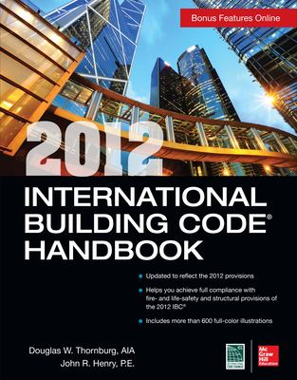
2012 International Building Code Handbook [electronic resource] by Douglas W. Thornburg, John R. Henry
ISBN: 9780071801324
Publication Date: 2013

International Building Code 2009 by International Code Council
ISBN: 9781580017251
Publication Date: 2009-03-26

Significant Changes to the International Building Code
Call Number: TH 420 .T4851 2006

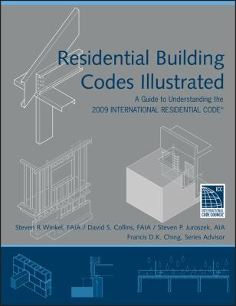
Residential Building Codes Illustrated by Steven R. Winkel; David S. Collins; Steven P. Juroszek; Francis D. K. Ching (Consultant Editor)
ISBN: 9780470173596
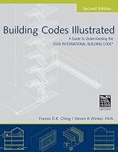
Publication Date: 2010-07-26
Building Codes Illustrated: A Guide to Understanding the 2006 International Building Code
Call Number: TH 420 .C491 2006

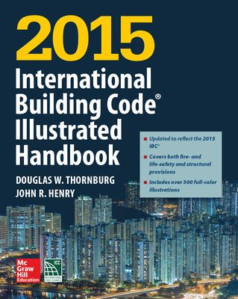
2015 International Building Code Illustrated Handbook [electronic resource]
ISBN: 9781259586125
Publication Date: 2015
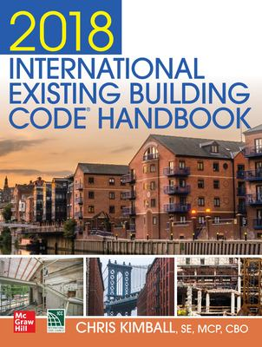
2018 International Existing Building Code Handbook [electronic resource] by Kimball, Chris
ISBN: 9781260134797
Publication Date: 2019
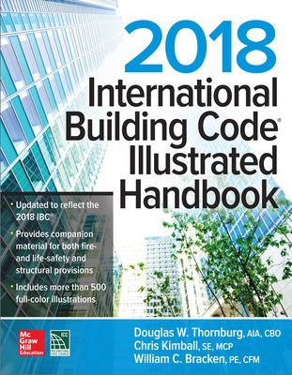
2018 International Building Code Illustrated Handbook [electronic resource] by Thornburg, Douglas W
ISBN: 9781260132304
Publication Date: 2018
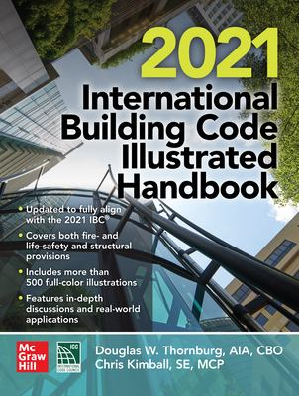
2021 International Building Code Illustrated Handbook [electronic resource] by Thornburg, Douglas W.
ISBN: 1264270127
Publication Date: 2021

Organizations & Societies

Architectural Organizations & Societies
American Institute of Architects
The official homepage of the American Institute of Architects. The site includes links to the AIA Careers Center, a directory of architects, as well as other information.
American Society of Landscape Architects (ASLA)
The ASLA website has information on news, events, firms and academic institutions. It also lists the accredited programs in Landscape Architecture.
Architectural League
An organization based in NYC whose mission is to nurture excellence in architecture, design, and urbanism and stimulate debate and provoke thinking in the design and building issues of our day.
Association of Collegiate Schools of Architecture
The site for the ACSA with links to student competitions, information for students, publications about schools of architecture and architectural education.
Association of Computer Aided Design in Architecture
The site includes links to conferences, competitions, and publications related to computer aided design in architecture.
Michigan Architectural Foundation
National Organization of Minority Architects (NOMA)
Site includes links to NOMA chapters, as well as information on competitions and conferences.
Society of Architectural Historians
The SAH Website offers links to SAH activities, projects, and chapter sites.

Humanitarian Architecture Groups
California Inst. of Earth Art and Architecture
Cal-Earth explores the possibilities of earth art and ceramic architecture to solve homelessness.
Breaking Ground
An organization devoted to ending homelessness by developing supportive housing solutions.
Earthship Biotecture
Michael Reynold's site devoted to his Earthship Biotecture -- efforts to create self-sufficient architecture from recycled materials.
International Development Design Summit
The Mad Housers
An Atlanta based organization engaged in action to shelter the homeless.
MASS : Model of Architecture Serving Society
MSAADA Architects
Red Feather Development Group
Red Feather empowers American Indian nations to create sustainable housing solutions within reservation communities.
Rural Studio
Rural Studio engages students to address and seek solutions to community housing and development needs.
Shelter Centre
An NGO supporting transitional settlement and reconstruction in communities affected by conflicts and natural disasters.
Terreform
Architecture Group for smart city design, ecological planning. and art.

Competitions/Careers

Architectural Competitions
Competitions for Architects, Artists, and Planners
The website for Competitions journal featuring listings of major competitions around the world. The journal can be found on our current journal shelves.
Competitions listed by the American Institute of Architecture Students
Current competitions open to students.
Competitions listed by the Assoc. of Collegiate Schools of Architecture
Competitions particularly geared toward students.
Pritzker Architecture Prize
The Pritzker Architecture Prize, presented annually. Site includes past and present award winners, biographies, photo portraits, acceptance speeches, etc.
The Architect's Newspaper Competitions List
A list of national and international competitions updated biweekly.
The FX Awards
The FX International Interior Design Awards (given annually).
theArchitectureRoom.com
Listing of architectural competitions and competition sites in the UK, Ireland, and the rest of the world.

Careers in Architecture
Association of Collegiate Schools of Architecture
The ACSA offers resources to students and young professionals regarding schools of architecture and career choices.
American Institute of Architecture Students
The AIAS, a student run national organization, helps enrich the educational process and guide you into your career.
Taubman College Career Services
Resources and programs available right here on campus to help you with internships and job searches.

