Environmental Engineering
Use the tabs to the left to learn more about finding information in Environmental Engineering.
- Find Articles: Links to databases for Environmental Engineering research
- Find Books: Books available online and in the Art, Architecture & Engineering Library
- Standards: A quick guide to finding industrial standards
- Web Resources: Other Internet resources useful in Environmental Engineering
- Professional Organizations: Associations/societies that are important for environmental engineers
- Career Resources: Information to help you learn more about engineering careers and job hunting
- Useful Library Services: Links to some of the services offered by the U-M Library

Other Useful Research Guides
Applied Climate Resources
Climate Sciences
Civil Engineering
Landscape Architecture
Materials Science and Engineering
Environment and Sustainability
Virtual Geosicences Library
Essentials of Library Research

Video Tutorials
The library has put together a series of short video tutorials that may be of interest to you. See the relevant topics of interest below:
- Getting Help at the Library | - When MGetIt Doesn't Get It
- How to search the Library Catalog | - How to search inside Reference works
- Speedy Citation Formatting | - News You Can Use

Find Books

Suggest a Title
You may recommend a title for purchase by the Library by filling out the request form found here.

eBook Collections
AccessEngineering
Complete online access to McGraw-Hill's Engineering Handbooks.
Knovel: Engineering & Scientific Online References
Electronic versions of popular reference books in engineering and applied sciences. Features access to books from many different publishers and includes reference handbooks and conference proceedings.
Wiley Online Library
Provides access to online journals and books published by Wiley-Blackwell, covering life, health and physical sciences, social science, and the humanities.

Finding Books
Find books on environmental engineering by doing a "Word(s) anywhere" or title search in U-M Library Catalog Search. A word search is generally the best starting point. If an appropriate title is found, you may want to use the subject headings listed with that title to guide further searches.

Online Encyclopedias, Handbooks, & Dictionaries
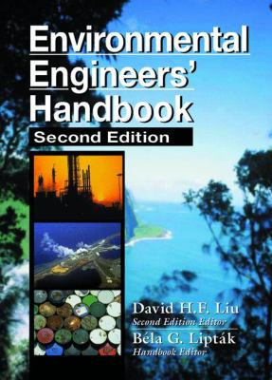
These selected resources are available online to University of Michigan affiliated students, staff & faculty. You can also visit Knovel, AccessEngineering, and Taylor & Francis eBooks and to view other online reference works.
Environmental Engineers' Handbook by Bela G. Liptak (Editor); David H. F. Liu (Editor)
ISBN: 0849399718
Publication Date: 1997
The Environmental Engineers' Handbook, Second Edition is a single source of current information. It covers in depth the interrelated factors and principles that affect our environment and how we have dealt with them in the past, are dealing with them today, and how we will deal with them in the future.
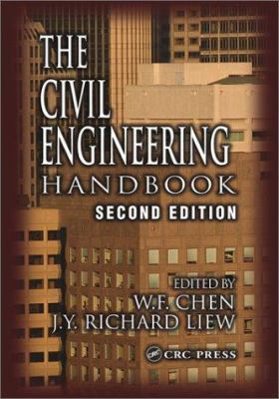
The Civil Engineering Handbook by W. F. Chen (Editor); J. Y. Richard Liew (Editor)
ISBN: 0849309581
Publication Date: 2002
First published in 1995, the Civil Engineering Handbook soon became known as the field's definitive reference.
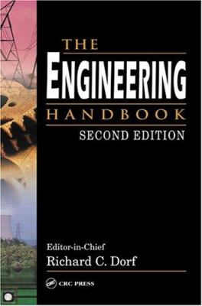
The Engineering Handbook by Richard C. Dorf (Editor)
ISBN: 0849315867
Publication Date: 2004
The Engineering Handbook is designed to enlighten experts in areas outside their own specialties, to refresh the knowledge of mature practitioners, and to educate engineering novices.
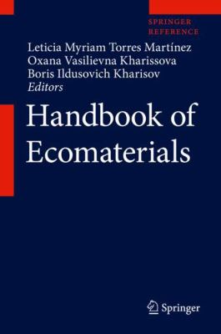
Handbook of Ecomaterials by Leticia Myriam Torres Martínez (Editor); Oxana Vasilievna Kharissova (Editor); Boris Kharisov (Editor)
ISBN: 9783319682549
Publication Date: 2019
In this handbook, the editors systematically present the maximum possible number of known eco-materials, including "cyclic" materials; materials for ecology and environmental protection; materials for society and human health; and materials for energy based on two main criteria: their sources and their functions. Eco-materials are materials that enhance, or refrain from damaging, the environment throughout their life cycles.
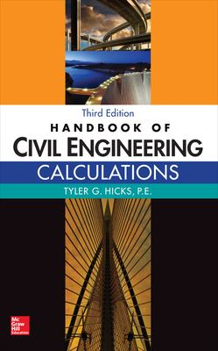
Handbook of Civil Engineering Calculations, Third Edition by Tyler Hicks
ISBN: 9781259586088
Publication Date: 2016
Handbook of Civil Engineering Calculations features more than 3,000 logically organized calculations that align with the latest practices, codes, and standards.
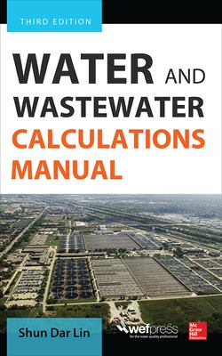
Water and Wastewater Calculations Manual, Third Edition by Shun Dar Lin
ISBN: 9780071819817
Publication Date: 2014
Water and Wastewater Calculations Manual provides basic principles, best practices, and detailed calculations for surface water, groundwater, drinking water treatment, and wastewater engineering.

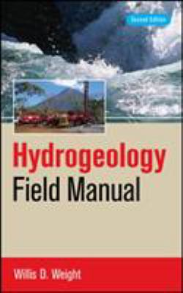
Hydrogeology Field Manual by Willis D. Weight
ISBN: 9780071477499
Publication Date: 2008
Hydrogeology Field Manual provides the latest information on applied applications in groundwater sampling and water-quality assessment, aquifer characterization, contamination issues, karst applications, and more.
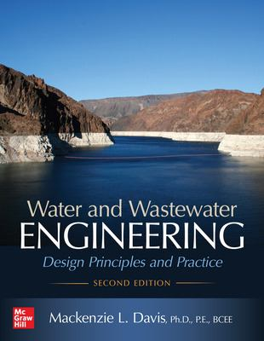
Water and Wastewater Engineering: Design Principles and Practice, Second Edition by Mackenzie L. Davis
ISBN: 9781260132274
Publication Date: 2019
In-Depth Guide to Water and Wastewater Engineering, revised to reflect the latest advances, procedures, and regulations, this authoritative resource contains comprehensive coverage of the design and construction of municipal water and wastewater facilities.

Citation Management Tools
The library can help you with different tools for managing your footnotes and creating bibliographies. Those tools are EndNote, Zotero, and Mendeley. Expert help is available fromScholarspace.
EndNote
You buy the software and install it on your computer. See the EndNote guide for more information.
Zotero
A free Firefox extension that you use on your own computer, not library or Sites machines. It's good for citing web resources but still in beta. Visit the Zotero guide for more information.
Mendeley
Mendeley is a citation management tool that lets you collect and organize citations, and then easily insert them into documents and format bibliographies. Visit the Mendeley guide for more information.

Find Articles

ASCE Citation Style
For a complete guide to the ASCE Citation Style, see the References section of this chapter found on the ASCE website.
Within the text of your report, ASCE uses an author-date method, for example (Smith 2004; Smith and Jones 2004). Your report must include a references section with all references listed alphabetically by last name of the first author. References must be published works only, with theses, dissertations, and forthcoming articles as exceptions to this rule.
Examples of ASCE style for commonly referenced sources follow below.
- Books: Evans, G.M., and J.C. Furlong. 2003. Environmental biotechnology: Theory and applications. Chichester, UK:Wiley
  - If a specific chapter is used, the chapter title and inclusive page numbers should be included
- Journal Articles: Beskos, D.E. 1987. "Boundary element methods in dynamic analysis." Appl. Mech. Rev., 40 (1), 1-23. https://doi.org/10.1115/1.3149529
  - For ASCE journal articles, ASCE no longer uses page numbers. See the source linked above for examples of ASCE style for ASCE journal articles.
- Conference Proceedings: Eschenaur, S.R., J.M. Kulicki, and D.R. Mertz. 1991. "Retrofitting distortion-induced fatigue cracking of noncomposite steel girder-floorbeam-stringer bridges." In Proc., 8th Annual Int. Bridge Conf., 380-388. Pittsburgh: Engineers' Society of Western Pennsylvania.

Indexes and Abstracts
Search for journal articles, conference papers, and research reports in these databases. For a complete list of databases for Environmental Engineering, please see U-M Library Databases Search. (If you already have a citation and wish to find the article in the library, please use the MGetIt MGet It.)
TOP DATABASES
Access Water
Content from the Water Environment Foundation for water quality professionals, including conference proceedings, manuals of practice, standards, journal articles, fact sheets, technical reports, and ebooks.
Scopus
International multi-disciplinary indexing & abstracting database for scientific, medical, technical, and social sciences.
OTHER DATABASES
Aqualine
Coverage of trade, technical, and scientific literature in water resources and supplies, water quality, water and waste analysis, water treatment, underground services and water use, sewage, industrial effluent, and the effects of pollution.
Aquatic Sciences and Fisheries Abstracts - Aquatic Pollution & Environmental Quality (ASFA 3)
Devoted exclusively to research and policy on the contamination of oceans, seas, lakes, rivers, and estuaries.
Engineering Village (Compendex)
The broad subject areas of engineering and applied science are comprehensively represented. Coverage includes nuclear technology, bioengineering, transportation, chemical and process engineering, light and optical technology, agricultural engineering and many more.
Environmental Engineering Abstracts
Indexes and abstracts more than 700 journals relating to the engineering aspects of air and water quality, environmental safety, and energy production.
Agricultural & Environmental Science Database
A multidisciplinary database providing comprehensive coverage of the environmental sciences. Abstracts and citations are drawn from over 10,000 serials including scientific journals, conference proceedings, reports, monographs, books and government publications.
Google Scholar (with "Availability at U-Michigan" links)
Google's scholarly searching with MGetIt links to U-M Library's holdings.
Greenwire
Reports on national environmental, energy and natural resources issues as they are addressed by the White House, federal agencies, courts, states and major media across the country. Users can sign up for daily email alerts of important news stories.
OnePetro
Online library of literature for the oil and gas exploration and production industry.
Pollution Abstracts
Pollution Abstracts provides access to environmental information concerning scientific research and government policies on atmosphere, emissions, and environmental action in response to global pollution issues.
ProQuest Technology Collection
This database combines full text journals with indexing of global literature on technology and applied science, including materials science, aerospace engineering, mechanical engineering, civil engineering, condensed matter physics, computer science and electronic engineering. It fully incorporates ProQuest Engineering Collection, ProQuest Advanced Technologies & Aerospace Collection, ProQuest Materials Science Collection along with deep indexing of technology scholarship and research.
Web of Science
Key index to articles from major journals in all areas of science and technology. Use to find other articles citing a specific article (footnotes in reverse).
Scifinder (Chemical Abstracts)
Indexes journals, patents, technical reports, dissertations, conference proceedings, and books in Biochemistry; Physical, Inorganic, and Analytical Chemistry.
Water Resources Abstracts
Provides comprehensive coverage of water resources issues, including groundwater, lakes, estuaries, water supply, desalination, water yield, water quantity, groundwater management, watersheds, water quality, wastewater, and water law.

Citation Management Tools
The library can help you with different tools for managing your footnotes and creating bibliographies. Those tools are EndNote, Zotero, and Mendeley. Expert help is available from Scholarspace.
EndNote
You buy the software and install it on your computer. See the EndNote guide for more information.
Zotero
A free Firefox extension that you use on your own computer, not library or Sites machines. It's good for citing web resources but still in beta. Visit the Zotero guide for more information.
Mendeley
Mendeley is a citation management tool that lets you collect and organize citations, and then easily insert them into documents and format bibliographies. Visit the Mendeley guide for more information.

Standards

Finding Standards
Getting Standards
For information on finding industry standards from ASTM, ANS, ISO, and other societies, please see the "Getting Standards" guide.

Getting Standards from the Art, Architecture & Engineering Library
How Do I Get a Copy of a Standard in the Art, Architecture & Engineering Library?
Access the standard(s) you need based on the issuing agency:
* ASTM - Standards from the American Society for Testing and Materials can be downloaded from ASTM Compass.
* AAMI - Association for the Advancement of Medical Instrumentation (AAMI) standards are available via AAMI eSubscription. (For access, click on the "Institutional Access" link.)
* AASHTO -American Association of State Highway and Transportation Officials: ASTM Compass.
* ACI - American Concrete Institute standards are published in the ACI Manual of Concrete Practice, available online.
* AIAA - Selected American Institute of Aeronautics and Astronautics standards are available online at Aerospace Research Central.
* AISC - Selected standards from the American Institute of Steel Construction are available online at the AISC website, including ANSI/AISC 360-16, Specification for Structural Steel Buildings.
* ASCE - Standards from the American Society of Civil Engineers are available from the ASCE Research Library.
* ASME - American Society of Mechanical Engineers standards, including the Boiler and Pressure Vessel Codes, are available through the ASME Standards Collection. (For access, click on the "Institutional Access" link.)
* AWS - Standards from the American Welding Society can be downloaded from ASTM Compass.
* AWWA - Standards from the American Water Works Association can be downloaded from ASTM Compass.
Additionally, some AWWA standards are available through Knovel. Look for AWWA standards in Knovel by entering a search for AWWA and then the standard number (for example: AWWA M42).
* ANSI - The American National Standards Institute compiles a record of standards that are referenced in the U.S. Code of Federal Regulations (CFR).
These Incorporated by Reference (IBR) standards - selected standards from ISO, IEC, AHAM, AWS, IAPMO, IES, NEMA, and other societies - are hosted in a read-only format (no downloading or printing options) and available at no cost here.
* ESD - The EOS/ESD Association produces standards on electrostatics. Selected ESD standards are available as complimentary downloads at the ESDA.org website.
* IEC - Standards from the International Electrotechnical Commission are available at ASTM Compass
* IEEE - Standards from the Institute of Electrical and Electronics Engineers (IEEE) are accessible via IEEE Xplore.
* ISO - ISO, the International Organization for Standardization publishes standards on many topics. ISO standards are available at ASTM Compass.
* SAE - The Society of Automotive Engineers (SAE) publishes standards on mobility engineering, including ground vehicle, aerospace, and aerospace materials standards. Both current and historical SAE standards are available online in SAE Mobilus.
* SMPTE - Society of Motion Picture and Television Engineers standards on topics such as audio, broadband, control systems, file and image formats, among others, are available in IEEE Xplore.
* USP - Standards from the United States Pharmacopeia: the National Formulary can be found at USP–NF Online.
>>>For access, users will first need to create a personal account using their umich.edu email. Go here to create your account (leave "subscription key" blank). Once you have created a personal account, you can access the content by logging into USP-NF Online.
* Building and Energy Codes - Building, fire, and energy codes, including standards from International Code Council (ICC) (e.g. 2012 International Building Code), National Fire Protection Association (NFPA), American Society of Heating, Refrigerating, and Air-Conditioning Engineers (ASHRAE), and State of Michigan building codes, are available online through MAD CAD:
* NFPA - National Fire Protection Association codes are available free online (Read-Only format) at the NFPA website.
* UL - Underwriters Laboratories (UL) standards are available in read-only format at no cost at the UL website. Free access requires a personal account at the UL site. Payment is required for printing or downloading at this site.
* HIPAA - The Health Insurance Portability and Accountability Act (HIPAA) of 1996 outlines national standards for electronic health care transactions and code sets, unique health identifiers, and security. Find an overview of HIPAA regulations at the Health and Human Services department website.
* OSHA & MiOSHA - Occupational Safety & Health Administration (OSHA) standards are available online at the OSHA website.
Michigan Occupational Safety & Health Administration (MiOSHA) standards are available online at the MiOSHA website.
* Military Specifications - The Department of Defense (DoD) has made many military standards available for free (registration and approval is required for access). Please see DoD's ASSIST website for coverage and to register for access. Users may also gain access to DoD's ASSIST in person at the Art, Architecture & Engineering Library.
* Municipal Codes - Online access to municipal codes and ordinances of over 1,000 local governments in the United States is available through Municode.com
* Historical standards - The Art, Architecture & Engineering Library maintains a small collection of superseded, or historical, standards in print format. A searchable spreadsheet of these standards holdings is available via Historical Standards at AAEL.
* For all other standards not listed above, please contact an engineering librarian: enginlibrarians@umich.edu
If You Are not affiliated with the University of Michigan Ann Arbor campus:
(U-M-Dearborn & U-M-Flint affiliates should contact their respective libraries for standards access.)
If you are a non-U-M affiliated user who wants to use our standards collection, you may freely visit our library. However, there are few resources available to non-U-M affiliates through the Art, Architecture & Engineering Library.
There may also be other sources outside of the Art, Architecture & Engineering Library available to you, including:
o Other libraries in your area
o Military standards over the internet
o Standards suppliers (for-pay document delivery services):
ANSI Webstore
Accuris Store

Web Resources

Internet Resources
Though the following links are not provided by the U-M Library, you may still find them useful:
University of Michigan Department of Civil & Environmental Engineering
CEE in Deep Blue
Works by U-M affiliated authors (faculty, staff, & students) in the CEE department.
Center for Sustainable Systems Factsheets
Informative factsheets with statistics and charts on topics such as energy, material resources, sustainability indicators, climate change, and more.
Environmental Protection Agency (EPA)
Provides environmental related information from the Environmental Protection Agency. Covers fulltext EPA documents and regulations.
ScienceCinema
Department of Energy multimedia in physics, chemistry, materials, biology, environmental cleanup, energy technologies and renewable energy.
United States Geological Survey (USGS)
The USGS performs a broad range of research and provides information in all areas of earth science, including biology, geology, maps, and water.
Wastewater Engineering Virtual Library
WWW virtual library with links to approximately 1200 Websites in the field of wastewater engineering.

Professional Organizations
Association of Environmental Engineering and Science Professors (AEESP)
The Association of Environmental Engineering and Science Professors (AEESP) is made up of professors in academic programs throughout the world who provide education in the sciences and technologies of environmental protection. Founded in 1963 as a private nonprofit organization, AEESP has more than 700 members in universities throughout the world.
American Society for Engineering Education (ASEE)
Founded in 1893, the American Society for Engineering Education is a nonprofit organization of individuals and institutions committed to furthering education in engineering and engineering technology. It accomplishes this mission by promoting excellence in instruction, research, public service, and practice, exercising worldwide leadership, fostering the technological education of society, and providing quality products and services to members.
International Society of Soil Mechanics and Geotechnical Engineering (ISSMGE)
The ISSMGE is the pre-eminent professional body representing the interests and activities of Engineers, Academics and Contractors all over the world that actively participate in geotechnical engineering.
American Geophysical Union (AGU)
AGU's Vision is a worldwide scientific community that advances, through unselfish cooperation in research, an understanding of Earth and space that is used for the benefit of humanity.
American Society of Civil Engineers (ASCE)
Founded in 1852, the American Society of Civil Engineers (ASCE) represents more than 147,000 members of the civil engineering profession worldwide, and is America's oldest national engineering society. ASCE's vision is to position engineers as global leaders building a better quality of life.
International Water Association (IWA)
WA is comprised of leading water professionals in science, research, technology and practice. There are 10,000 individual and 400 corporate members, spread across 130 countries.
American Water Works Association (AWWA)
Founded in 1881, AWWA is the authoritative resource on safe water, with more than 60,000 members worldwide sharing knowledge on water resource development, water and wastewater treatment technology, water storage and distribution, and utility management and operations. AWWA provides knowledge, info and advocacy to improve the quality and supply of water in N. America and beyond and advances public health, safety and welfare by uniting the efforts of the full spectrum of the water community.
Water Environment Federation (WEF)
The Water Environment Federation is a not-for-profit association that provides technical education and training for thousands of water quality professionals who clean water and return it safely to the environment. WEF members have proudly protected public health, served their local communities, and supported clean water worldwide since 1928.

Career Resources

Company and Industry Profiles
Vault Career Intelligence
Provides in-depth company profiles. A compilation of career information and management tools providing internship, industry, profession, company data and insight used to frame first time employer selection decisions.
IBISWorld
Provides reports on a wide range of industries. IBISWorld's Industry Market Research Reports cover a wide-ranging number of U.S. industries and are updated every four months ensuring that the latest Industry data will always be available. The IBISWorld Industry data enables detailed analysis of key growth trends, the competitive environment, and key issues facing each industry.
Orbis
Orbis has information about 40 million companies, including 18 million European companies from 46 countries, 16 million US and Canadian companies, 6.5 million South and Central American companies, 1.3 million Japanese companies, 300,000 Chinese companies, and 90,000 African companies.

AAEL Career Collection
The Art, Achitecture & Engineering Library has a small collection dedicated to career resources. This collection includes standardized test guides, books with tips on how to write a resume and cover letter, and information about jobs in engineering. These books are in the catalog, so you can search online or come up to the 2nd floor of AAEL and see what's available (collection is located near the reference desk behind the computer cluster).

Online Resources
Engineering Career Resource Center
An office dedicated to U-M engineers to help them prepare for the working world and find internships and jobs.
ECRC Job links
Find links to general career information, job websites, and also more specific engineering job resources.
Career Center
U-M's Career Center provides one-on-one assistance, as well as offering workshops and training sessions throughout the year to help students with their job search and career exploration.

Job Searching E-Books
The following selected books are available in full text online through U-M Library subscriptions. Use U-M Library Catalog Search to find additional e-books on job search topics.
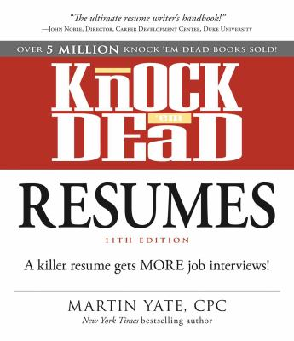
Knock 'em Dead Resumes by Martin Yate
ISBN: 9781440579073
Publication Date: 2014
This edition of Knock 'em Dead Resumes includes completely new examples of resumes, ranging from industry-specific examples to samples covering every stage of a professional's career. Yate also offers valuable advice on what to include from social networking profiles as well as how to make the most of keywords so that search engines move their resume to the top of the pile.
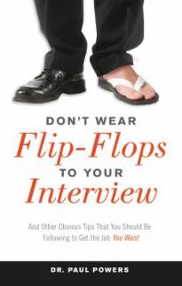
Don't Wear Flip-Flops to Your Interview by Paul Powers
ISBN: 9781632650030
Publication Date: 2015
Don't Wear Flip-Flops to Your Interview is packed with strategies and techniques that are practical, market proven, easy to use, and often humorous.
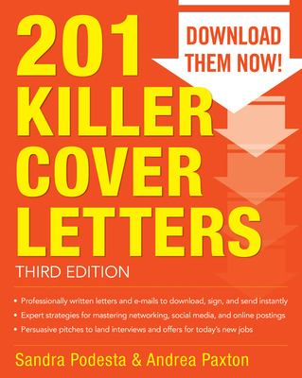
201 Killer Cover Letters Third Edition by Sandra Podesta; Andrea Paxton
ISBN: 9780071831574
Publication Date: 2014
A guide to writing cover letters that make you stand out from the competition
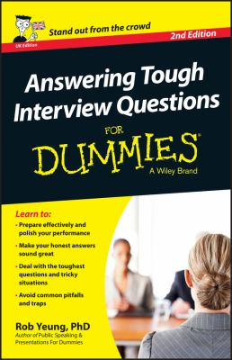
Answering Tough Interview Questions for Dummies - UK by Rob Yeung
ISBN: 9781118679944
Publication Date: 2014
Answering Tough Interview Questions For Dummies teaches you how to perform professionally and productively under stressful interview conditions.
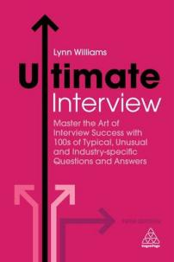
Ultimate Interview by Lynn Williams
ISBN: 9780749481384
Publication Date: 2018-07-28
Ultimate Interview will give you all the guidance you need when preparing to ace the interview for your dream job.
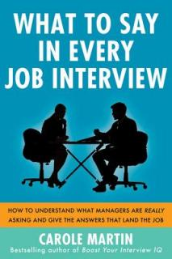
What to Say in Every Job Interview: How to Understand What Managers Are Really Asking and Give the Answers That Land the Job by Carole Martin
ISBN: 9780071818001
Publication Date: 2013
What to Say in Every Job Interview shows you how to focus on the factors of the job, rather than answering questions "correctly."
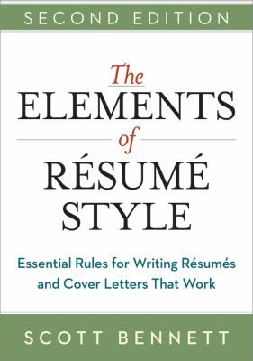
The Elements of Résumé Style by Scott Bennett
ISBN: 9780814433942
Publication Date: 2014
The Elements of Résumé Style shows readers how to craft clear, compelling, targeted résumés and cover letters that actually work.

Useful Library Services
MLibrary has a lot to offer! Check out some of these useful services that you may not have known about.
Ask a Librarian
Have a quick question about library resources or services? Try our Ask a Librarian service – instant messaging with a librarian. This is a library-wide service, so keep in mind that the librarian you speak to may not be from AAEL. Check it out!
Copyright
Not sure about copyright and want to learn more? See the copyright website to learn about your rights as an instructor and/or creator.
Deep Blue + Deep Blue Data
Want to have your scholarly work archived? Deep Blue is our open access institutional repository, and they would love to help you get your articles, videos, data sets, images, etc. into their database.
GroundWorks
Need to print a poster or edit video or audio clips? GroundWorks is the place! It’s open when the Duderstadt Center is open, with consultants available for most of the day. Poster printing is available 9am-4pm on weekdays.
Interlibrary Loan
U-M doesn’t own the article or book you are looking for? Interlibrary Loan is the service you need. We can get almost anything for you!
ScholarSpace
Want to learn how to create websites, posters, or create bibliographies with software? ScholarSpace hosts workshops on how to use all sorts of software. One-on-one sessions can also be scheduled.
Geospatial Data and Mapping
Need help finding data or working with GIS software? Contact the Clark Library or SAND North lab.

