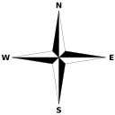

Pangaea

A Kalamazoo mailman, growing annoyed, has discarded any letters not known to impart direction.

Who saw Frost ditch Mackinac Island’s bridge? He took lines less traveled by.

In my town, snowyDetroit, I watch him cut straight toward my own wood mailbox.