ICS4 Java Level 4 Final Project

Spider Solitaire by JavaApplet_Student

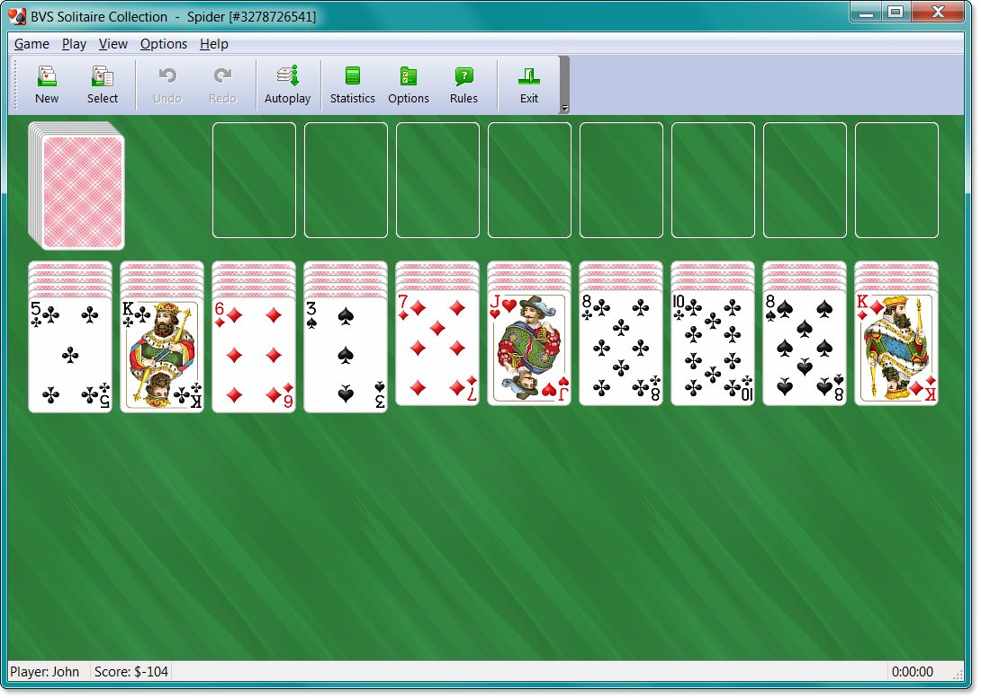Rules

Objective
Spider Solitaire is a solitaire game where the objective is to order all the cards in descending runs from King down to Ace in the same suit. Once a run has been completed, for example King of clubs down to Ace of clubs, then the whole run will be removed from the table. Once the table is completely empty the game has been won.

Setup
Spider Solitaire is played with two full decks, 104 cards. At the beginning 54 of the cards are divided between 10 tableaus, the first 4 tableaus have 6 cards each, the other 6 tableaus have 5 cards each. The top card of each tableau is turned face up, the others are face down. The remaining 50 cards are placed in a stock at the bottom of the screen.

Valid moves
A card can always be moved onto a card that is one higher in rank. You can for example move a 7 of clubs and put it on an 8 of clubs, or an 8 of hearts, diamonds or spades. However, even though you can move cards onto other cards in a different suit, the objective of the game is to create runs in the same suit, so a run will only be removed from the table if it's all in the same suit, a full run in different suits doesn't do anything for you. (Although it can be useful to move cards onto other suits just to get them out of the way).

You can move multiple cards together if they are all part of a run in the same suit. E.g. if you have 8 of clubs, 7 of clubs, 6 of clubs, then you can click the 8 and move them all together onto a 9 of any suit. However if you have 8 of clubs, 7 of hearts, 6 of diamonds, then you can't move them all together, only the top card.
If a tableau is empty then any card or partial run is allowed to be moved onto it.
A full run does not have to be the only thing on a tableau to be removed. For example, a tableau might have three facedown cards and then a full run from King to Ace in the same suit and then the run would disappear, and the three facedown cards would remain.

Adding cards from the stock
When there are no more moves that can be made in the tableaus then you can click on the stock in the lower right corner. That will move 10 cards from the stock onto the tableaus, one card onto each tableau. Try not to do this until you are sure you have no other moves to make. It is required that there is at least one card in each tableau when the stock is clicked. If there is an empty tableau on the table you must first move one or more cards onto it before you can click on the stock.

Scoring
You start with 500 points. For each move you make one point gets subtracted. For each run you remove from the table you'll get a 100 extra points. Example: if you've managed to make three full runs in 70 moves you'll have 500-70+3*100 = 730 points.

Difficulty
The game can be played in three different modes, beginner, intermediate and advanced. In beginner mode there is only one suit (spades), in intermediate mode there are two (spades and hearts) and in advanced mode there are all four suits. There is the same number of cards, 104, in all modes.

