General

Stage 1:

check: is middle occupied?

if no: choose it

if yes: move to stage 2 (also, is it occupied by X or O?)

Stage 2:

check: is there

First Player

Stage 1:

choose middle

strategy: select spot 1,1

Stage 2:

check: is there 4 or 3 corner spaces available?

if 4: choose a corner adjacent to an O (at random)

if 3: … (can either pick an adjacent corner or the diag corner, or maybe a side?)

strategy: look at adjacent spaces to each of the 4 corners (0,1 1,0 1,2 2,1)

identify the 2 adjacent corners (0,0 0,2 2,0 2,2)

if 0,1 or 2,1 are occupied, then look at its row

if 1,0 or 1,2 are occupied, then look at its col

Stage 3 (from 4):

TRIANGLE TECHNIQUE!!!

with 2 corners left, choose the corner that is NOT adjacent to a O

strategy: look at the chosen adjacent space from stage 2

this time, choose the corner that is not adjacent to the O and available

if 0,1 choose 2,0 or 2,2 (whichever is available)

if 1,0 choose 0,2 or 2,2

if 1,2 choose 0,0 or 2,0

if 2,1 choose 0,0 or 0,2

Stage 4 (from 4):

COMPLETE TRIANGLE AND WIN!

this is as simple as choosing the winning space s/a in medium,

EXCEPT ignore the O's (no blocking, focus on winning here)

3 possibilities for (from 3)

1. pick an adjacent corner

2. pick the diag corner

3. pick a side (might have more categories)

1. strategy: look at occupied corner, choose either corner in its row or col at random

next, counter (block)

now, 1 corner and 2 spaces are left

corner is pretty useless, no way to win with it, only blocks

next, choose one of the spaces (non-corner) for a last attempt to win

last, choose last spot

I) counter, COUNTER, counter, WINNING SIDE, counter, LAST (cat) (cx3) (Cx1)

only way to win here is if opponent fails to counter, you are in control here

no chances of losing

i) block, side, last (cat) (3)

takeaway: 2 > 1

2. strategy: look at occupied corner, choose the corner in its diag (1 or 2)

note: opponent does not need to counter, unlike the other 2 corner spaces

from here, block whenever needed, and pick spaces that could win

(block has top priority here, followed by winning spaces, by whats left)

disclaimer = assumes opponent is blocking...

possibilities:

I) wining side, COUNTER, counter, WIN (triangle) (cx1) (Cx1)

guaranteed to win in 4 total moves

II) winning corner, COUNTER, counter, WINNING SIDE, counter, LAST (cat) (cx2)(Cx1)

only way to win is if opp fails to counter, mostly in control

no chances of losing

III) useless side, WINNING SIDE (no counter needed), counter, WINNING CORNER, counter, LAST (cat) (cx2) (Cx1)

b) useless side, WINNING SIDE, counter, COUNTER, counter, LAST (cat) (cx2) (Cx2)

c) useless side, WINNING CORNER, counter, COUNTER, useless side, LAST (cat) (cx1) (Cx1)

d) useless side, WINNING CORNER (tri form), counter, WIN (triangle) (cx1)

guaranteed to win

takeaway: if opponent chooses useless side, choose the tri winning corner

opponent tries to win with a side or corner picked

i) side: block, block, win! (triangle method works here)

ii) corner: block, one of winning sides, end (cat) (3)

opponent picks a useless side, can choose either a winning side or corner

iii) side, corner, last (cat) (3)

iv) corner, win (triangle method here!)

i) block, block, last

ii) block, side at random, last

iii) block, win (triangle method worked here!?!) (non-optimal opponent here…)

iv) corner or side, block, last

v) from iv, choose side that does not result in a block, one of the corners, last

vi)

takeaway: hmm, since 2 has a chance of winning with tri, do a combo of 2 & 3

2 has a chance of winning, but mostly (Cx1)

3 lacks that winning chance, but does guarantee (Cx0)

3. strategy: choose a side space adjacent to the O

choose a side or corner, 2 of which need to be blocked

I) counter, WINNING SIDE, counter, COUNTER, counter, LAST (cat) (cx3) (Cx1)

only way to win is if opp fails to counter, you are in control here

no chances of losing

II) counter, WINNING CORNER, counter, LOSE (L-tech)

III) counter, WINNING SIDE (no counter needed), counter, WINNING CORNER, counter, LAST(cat) (cx3) (Cx0)

only way to win is if opp fails to counter

no chances of losing

IV) counter, WINNING CORNER (no counter needed), counter, WINNING SIDE, counter, LAST (cat) (cx3) (Cx0)

V) counter, USELESS CORNER, winning corner, COUNTER, counter, LAST (cat) (cx2) (Cx1)

only way to win is if opp fails to counter

no chances of losing

b) counter, USELESS CORNER, winning side, COUNTER, counter, LAST (cat) (cx2) (Cx1)

only way to win is if opp fails to counter

no chances of losing

c) counter, USELESS CORNER, useless corner, WINNING SIDE, counter, LAST (cat) (cx2) (Cx0)

only way to win is if opp fails to counter

no chances of losing

d) … for useless side

takeaway: might as well ignore the USELESS CORNER, it just gets complex and

gives control to the opp, stick with III and IV

i) blocked, last (cat)

ii) blocked, lost (this is fail, if the corner that needs to be blocked is picked, then los)

iii) one of winning corners, last (cat)

iv) one of winning sides, last (cat)

3. strategy: choose a side space not adjacent to the O

followed by a block, by a winning side, by last (cat)

followed by a block, by a block, by last (cat)

I) counter, COUNTER, counter, COUNTER, counter, LAST (cat) (cx3) (Cx2)

takeaway: umm, avoid this one, nothing but counters lol

conc: ok, for being the first player, pick the middle first, then…

I. if opp chose a side, do a tri to win (win)

II. if opp chose a corner, choose the diag corner or adjacent side

A. if diag corner is chosen,

1. if opp chooses a side, do a tri to win (win)

2. if opp chooses a corner, counter --> side --> (cat)

B. if adj side is chosen, choose a winning side or corner that does not need to be

re-countered --> corner or side --> (cat)

C. if winning corner is chosen, --> counter --> winning side --> (cat)

D. if non-adj side, counter --> winning side --> (cat)

at ANY time after the first turn, counter takes priority, AND matching takes the top

priority above all else

corners are not always the best over sides, especially when there is no possible

match with them and there is with the sides (chance to win vs. no chance to win)

one problem with this structure: does not support randomability (covering all possible board combinations)

chance of getting lost or missed up

try it out, keep priorities in order

guaranteed to not ever lose

mostly cats

chance to win if opp fails to counter, if tri is formed, if L is formed,

OR if opp's first move is a side,

OR if pop does corner --> side and you do center --> diag corner

actually, its probably best to have a little variety, even among 123

Test 1: diag corner

easy: 95%

medium: 75%

Test 2: adj side

easy: 95%

medium: 60% (measures chance of opp selecting a side or corner as first move)

(50% on average)

ok, now time for the other 1/2, being the 2nd player instead of first…

step 1: check if middle is occupied, if not choose it, else…

pick a corner, any corner (stay away from side on first turn, prone to tri tech)

step 2: depends on where opp places next spot, either adj side, winning corner,

non-adj side, or diag corner

if its diag corner, watch out! do not choose any side, stick with either corner

choose middle if open (and switch to other pattern as first player) then…

I. choose any corner

II. depends on opp move

A. if diag corner, choose either corner, prepare to counter the rest of the way (cat)

B. if adj side, counter

1. if winning side or corner (no re-counter needed), counter the rest of the way (cat)

2. if winning side, counter the rest of the way (cat)

3. if winning corner, counter --> MATCH! (win) (L-tech)

4. if useless corner, choose winning corner or winning side --> counter --> (cat)

C. if winning corner, prepare to counter the rest of the way (cat)

D. if non-adj side, prepare to counter the rest of the way (cat)

techniques to watch out for at ANY time

1. triangle technique (requires middle)(only for strategy 1)(player 1)

condition:

requires owning middle & 1 corner & an open adjacent side & open corner next to adjacent side & at least 1 more open corner (1 is likely blocked)

if all of these are true, then choose the corner next to the open adjacent side

(1 occupied middle, 1 occupied corner, 1 open adjacent space, 2 open corners)

\*Pick middle, pick any corner, pick other corner to make a triangle

2. L technique (mainly useful for strategy 2)(player 1 or 2)

condition: (this one usually results from countering naturally…)

requires owning 2 corners separated by an open adjacent side & 1 open adjacent side & 1 open corner both next to one of the occupied corners

If all of these are true, then choose the open adjacent side

(2 occupied corners in same row/col, 2 open adjacent sides, 1 open corner next to

open adjacent side)

\*

3. side technique (not very common) (mainly useful for strategy 2)

condition:

requires owning 2 sides not in the same row/col, both with open corners next to them

if all of these are true, then choose the corner between these two occupied sides

(2 occupied sides not in the same row/col, 3 open adjacent corners to the occupied sides)

1. Triangle Technique Example:

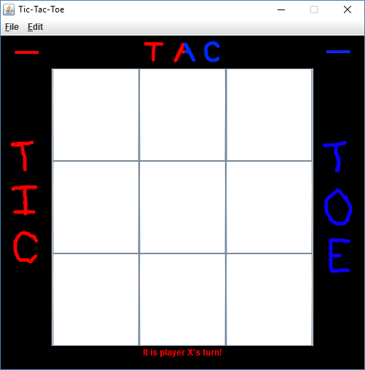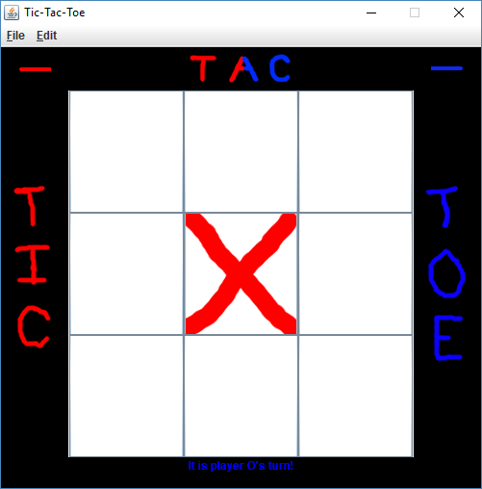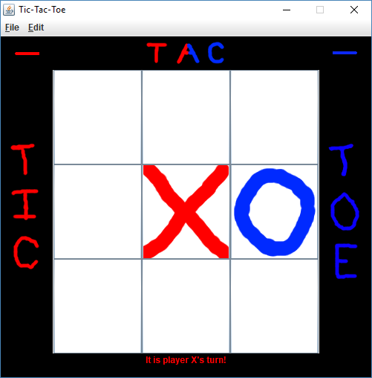

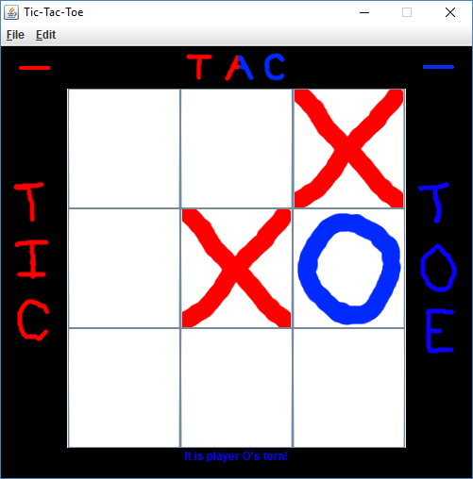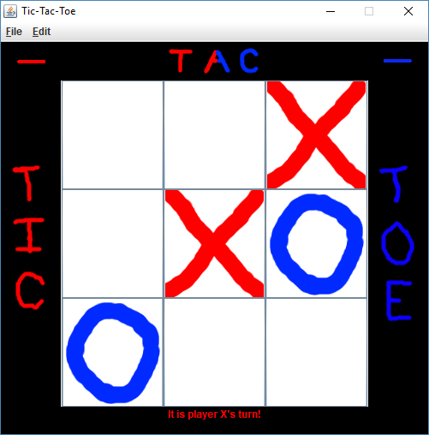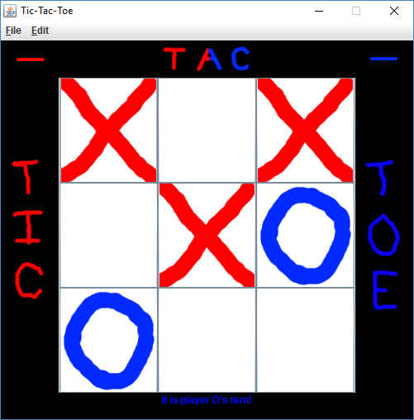

1. L technique Example: