ArewaTech
Product Requirements Document (PRD)

RENT BAUCHI
A trusted digital platform for discovery and connecting with rental spaces in Bauchi

Product Name | RENT BAUCHI
Solution Type | Full-stack Web Application
Prepared By | ArewaTech
Document Version | 1.0
Date | September 2026

1. Product Summary
Rent Bauchi is a web-based platform designed to make finding and renting spaces across Bauchi safer, easier, and more transparent by connecting property seekers with verified landlords and agents. Users can discover student housing, residential properties, shops, offices, commercial spaces, and event centers, while accessing information such as location, price, images, availability, and verification status. The platform also supports communication, price negotiation, reporting of suspicious listings, and reviews, helping reduce rental fraud, improve price transparency, and bridge the gap between available properties and people searching for them.

2. Problem Statement
Problem Statement: Finding rental properties and spaces in Bauchi is often difficult, inefficient, and risky. Property seekers may encounter fake agents, fraudulent listings, inflated or unclear rental prices, multiple allocation of the same property, and outdated information about availability. At the same time, legitimate landlords, agents, and property owners struggle to efficiently reach suitable tenants or customers. The absence of a trusted and centralized platform makes the rental process less transparent and increases the risk of financial loss and wasted time.

Problem Evidence / Assumptions to Validate
- A student paid ₦105,000 for a house whose actual rent was around ₦40,000, showing how intermediaries can significantly inflate rental prices.
Rent Bauchi can improve price transparency by showing clearer rental prices and reducing opportunities for excessive markups.
- A student experienced a case where the same house was rented to multiple students, resulting in financial loss and requiring school management intervention.
Verified property listings and availability tracking can reduce multiple allocation and fraudulent listings.
- New students were approached by fake agents who requested advance payments to reserve houses, only for the students to discover that the houses or agents did not exist when they resumed.
Verified agents/landlords and property verification can reduce rental scams and make seekers more confident before making payments.

3. Product Goal & Objectives

Product Goal
To create a trusted digital platform that makes it easier for residents, students, businesses, and event organizers to discover, verify, and connect with available rental properties and spaces across Bauchi.

Project Objectives
ID | Objective | How Completion Will Be Gauged
01 | Build a platform that enables users to search and discover available residential, student, commercial, office, and event spaces in Bauchi. | A test user can successfully search, filter, and view relevant property listings with their details.
02 | Provide a verification system for property owners, agents, and listed properties to reduce fraud and misleading listings. | An owner/agent can submit verification documents and an authorized administrator can review and approve or reject them.
03 | Enable property seekers to access transparent information such as location, price, images, property type, and availability before making contact. | A user can view complete information about an approved listing and determine whether it meets their requirements.
04 | Provide a platform for users to communicate with property owners/agents and express interest or negotiate where applicable. | An authenticated user can contact the responsible verified owner/agent and submit a valid offer or inquiry.

4. Target Users & Personas
User | Need | Typical Action | Success Condition
Student/Resident | Affordable, genuine and easily accessible housing information. | Search, compare and contact property owners. | Can find and inquire about a suitable verified property without unnecessary physical searching.
Property/Landlord | A trusted way to advertise properties and reach potential tenant. | Upload property details, submit verification and manage listing. | Can successfully list a verified property and receive genuine inquiries.
System Administrator | Control, verification and oversight of platform activities. | Verify users/properties, manage listings and handle reports. | Only authorized administrators can perform management and verification functions.

Primary Personal Example.
Aisha, 22, is a university student looking for accommodation in Bauchi. She finds several properties through Rent Bauchi, compares their prices, locations, images and verification status, and contacts a verified agent about a suitable property. She can negotiate where applicable without having to depend entirely on unverified agents or physically visit multiple locations just to begin her search.

5. Value Proposition & Significance
Value Proposition:
Rent Bauchi provides a trusted and centralized platform where people can find, compare, and connect with verified rental property providers in Bauchi. It provides reliable information such as property location, price, images, availability, and verification status, helping users make better decisions while reducing exposure to rental scams, hidden prices, and fraudulent agents.
Significance:
Rent Bauchi is significant because it addresses real challenges in Bauchi's rental market by improving transparency, reducing fraud, saving users time, and connecting property seekers with legitimate landlords and agents. It also gives property owners and agents a more effective way to reach potential tenants and customers.

6. Proposed Solution & User Experience
Rent Bauchi will be a responsive web application that provides a centralized platform for discovering, verifying, and connecting with rental property providers across Bauchi. Users can search for residential properties, student accommodation, commercial spaces, offices, and event centres based on their needs.
Property owners and agents will be able to create listings and submit required verification information, while authorized administrators will review and approve listings before they become publicly available. Property seekers can view important details such as location, price, images, availability, and verification status before contacting the property owner or agent.
The initial release will focus on property discovery, verification, availability management, user interaction, and negotiation, while additional services such as physical verification and payment will be introduced in later stages.
c
Contact admin & negotiate

Create & login
Open Rent Bauchi
Check price & availability
Search/select properties

Figure 1. Illustrative primary user flow
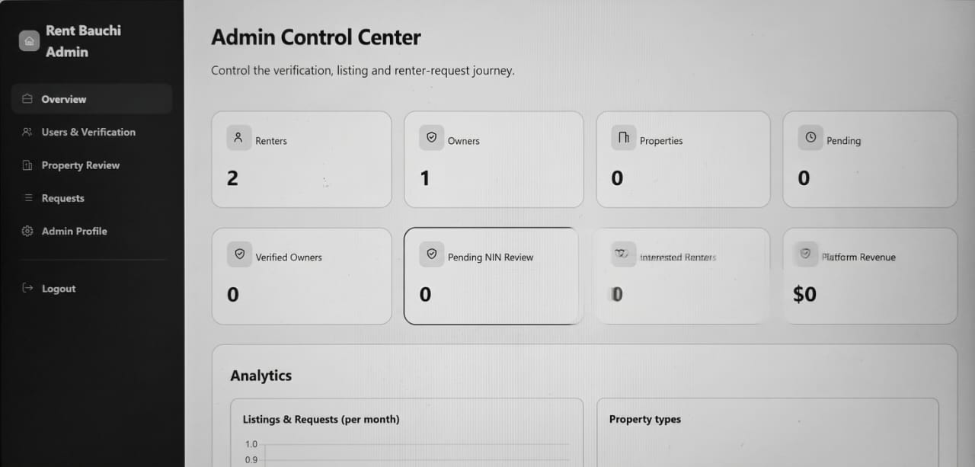
Figure 2. Low-fidelity wireframe for the report-submission screen.
NOTE: A Week 1 wireframe does not need to be visually polished; it should demonstrate layout, hierarchy, and intended interaction.

7. Functional Requirements
ID | Requirement | Priority | Primary User | Acceptance Summary
FR-01 | Register and log in as a property seeker, landlord, or agent | Must | House Owner | Valid credentials create/login to an authorized account successfully.
FR-02 | Submit a property listing with category, description, location, price, and availability | Must | House Owner | Valid property information is submitted and saved successfully.
FR-03 | Valid property information is submitted and saved successfully. | Must | House Owner | Supported files upload successfully and are associated with the correct listing/provider.
FR-04 | Search and filter available properties by location, category, price, and type | Must | Renter | Matching properties are displayed according to selected filters
FR-05 | Verify landlords/agents and approve property listings | Must | Admin | Admin can review submitted information and approve, reject, or request additional information.
FR-06 | View property details, verification status, and availability | Must | Renter | Users can view accurate property information and current status.
FR-07 | Contact a verified landlord or agent about a property | Must | Renter | Authenticated users can contact the provider through the available communication option.
FR-08 | Submit and manage rental price negotiations | Should | Renter/House Owner | Users can make offers, counter offers, accept, or reject negotiations while preserving the original listing price.
FR-09 | Report suspicious properties, agents, or fraudulent activity | Should | Renter | Submitted reports are recorded and made available to administrators for review.
FR-10 | Manage users, properties, verifications, and reports through an admin dashboard | Must | Admin | Authorized administrators can review and manage platform activities.

8. Non-Functional Requirements
Area | Requirement | Target / Constraint | Verification
Usability | Property search and listing process should be simple and easy to understand | Users should complete common tasks with minimal steps | Task walkthrough/user test
Performance | Common pages and property searches should load promptly | Target: normal requests should respond within approximately 2 seconds in the test environment | Basic timing tests
Security | User accounts, admin functions, and verification documents must be protected | Unauthorized users must not access restricted information or functions | Access-control tests
Data validation | Property details, user information, prices, and uploaded files must be validated | Reject missing, invalid, or unsupported data | Negative tests
Reliability | Core property listing, verification, and search workflows should handle common errors without crashing | No data loss during defined test cases | Test checklist
Privacy | Collect and expose only information necessary for Rent Bauchi operations | Private verification documents must not be publicly accessible | PRD/data review

9. MVP Scope & Prioritization

Priority | Included | Reason | Hackathon Decision
Must | User registration/login, property listings, property images, search/filter, landlord/agent verification, property approval, availability status, property details, provider contact, admin dashboard | Required to demonstrate Rent Bauchi's core problem-solution loop | Build and test first
Should | Price negotiation, WhatsApp communication, scam reporting, reviews/ratings, notifications | Adds trust, communication, and stronger user interaction | Build after Must features are stable
Could | Physical property verification, advanced analytics, rent price trends, property recommendations, event-center reservation inquiries | Useful enhancements but not essential to prove the MVP | Only if time remains
Out of Scope | Native mobile apps, online payments/escrow, AI price prediction, demand prediction, automated fraud detection, multi-city expansion | Would significantly increase scope without being necessary to prove the core concept | Document for future work

10. System Architecture & Technical Design
AWS S3
PostgreSQL
Node.js
React/next.js

Open street map
Firebase cloud messaging
Figure 3. Illustrative MVP architecture.

Proposed Technology Stack
Layer | Illustrative Choice | Rationale
Frontend | Next.js / React / TypeScript | Responsive, component-based web interface suitable for property seekers and providers.
Backend | Node.js + Express | Handles authentication, property management, verification, negotiations, and API requests.
Database | PostgreSQL + Prisma | Stores structured data such as users, properties, verification records, negotiations, and reports.
Image storage | Cloud object storage / local development storage | Separates property images and verification documents from core database records.
Maps / location | Browser geo-location + mapping service | Helps users identify and display property locations.
Deployment | Cloud-hosted web service | Allows users, testers, and hackathon judges to access the MVP.

Core Data Entities
- User – stores property seekers, landlords, agents, and admin accounts.
- Property – stores property details such as type, location, price, images, description, and availability.
- Verification – stores verification documents, verification status, and admin decisions for users/properties.
- Negotiation – stores offers, counter-offers, agreed prices, and negotiation status between seekers and property providers.

Key Technical Decisions
- Frontend: Use Next.js, React, and TypeScript for the web interface.
- Backend: Use Node.js with TypeScript to build the server-side API and business logic.
- Database: Use PostgreSQL with Prisma ORM to store and manage structured application data.
- Security & Authentication: Implement role-based access control (RBAC), secure password hashing, server-side validation, and protected verification documents.

11. Acceptance Criteria & Success Metrics
Objective / Area | MVP Acceptance Criterion | Evidence | Pass Condition
01 - Property Listing | Authorized landlord/agent can create a property listing with required information | Live demo + database record | Property is successfully saved and displayed correctly.
02 - Verification | Admin can review and approve/reject property providers and listings | Admin dashboard demo | Verification decision is saved and reflected in the system.
03 – Property Discovery | Property seeker can search and filter available properties | Live demo | Relevant properties are returned according to selected filters.
04 - Property Details | User can view price, location, images, availability, and verification status | Live demo | Correct information is displayed for the selected property.
Reliability | Core listing, verification, and search workflows operate without critical failures | Test checklist | At least 90% of defined core test cases pass before final demo.

12. Risks, Constraints & Assumptions
Risk / Constraint | Impact | Likelihood | Mitigation
Limited hackathon development time | High | High | Freeze Must-have scope early and defer advanced features.
Difficulty obtaining real property data | High | Medium | Use verified sample/demo listings for the MVP while designing the system for real data.
External map/service failure | Medium | Medium | Keep core property discovery functional even if external location services fail.
Large property image uploads | Medium | Medium | Apply file size/type validation and compression where practical.
Unauthorized access to admin/verification functions | High | Low-Medium | Implement authentication, authorization, and endpoint testing.

13. Development Plan & Milestones
Period | Primary Outcome | Planned Evidence | Exit Check
Week 1 - Planning & Design | Validated problem framing, PRD, wireframes, architecture, backlog, initial proof of concept | PRD, user flow, wireframes, architecture diagram, database schema | Scope is realistic; Must features and architecture are agreed
Week 2 - MVP Foundation | Authentication, database, user roles, property listing, and basic search working | Working application, database records, login/listing demo | Core foundation works and major components begin integrating
Week 3 - Verification & Core Features | Provider/property verification, admin dashboard, availability, property details, and contact functions working | Integrated MVP, verification demo, test results | Essential functions work and core workflows are documented
Final Preparation | Fix bugs, test complete workflow, prepare demo data and presentation | Bug fixes, test checklist, demo dataset, pitch/demo rehearsal | Reliable demo and clear explanation of the solution

14. Open Questions / Decisions Pending
Question | Current Decision / Direction
Which property categories should be included in the MVP? | Residential/student housing, shops, offices, and event centers.
Should users be required to create an account before browsing? | For MVP, property browsing can be public; authentication is required before contacting providers or performing restricted actions.
Who verifies landlords and agents? | Designated Rent Bauchi administrators/verification officers will manually review submitted information.
Should online payment be included in the MVP? | No. Payments/escrow are post-MVP to avoid unnecessary financial and security complexity.

