**Questions**

1. Give the output for the following commands:

* 1. echo “hello world”

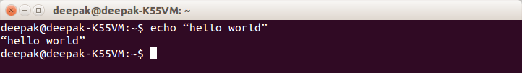

* 1. List all the files(hidden included) present in the current directory in long format displaying files in reverse order , sorted based on the modification time .

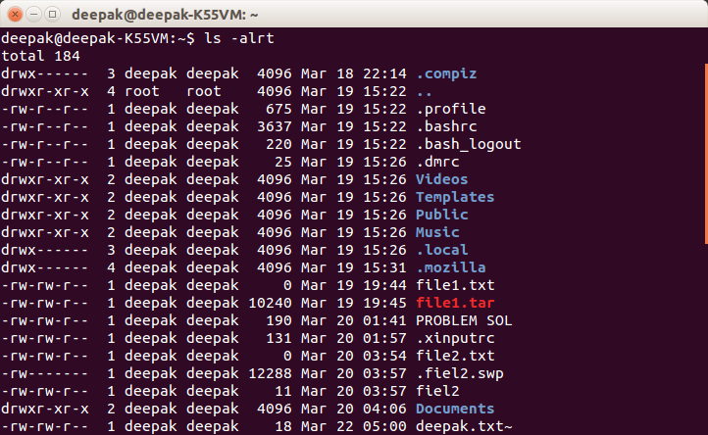

* 1. Change your current password.

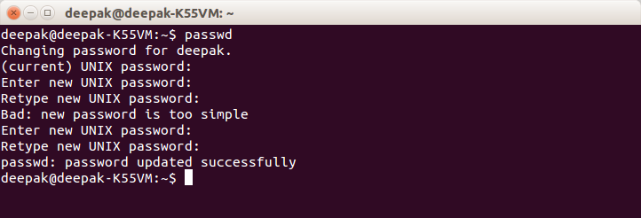

* 1. How to get the current date

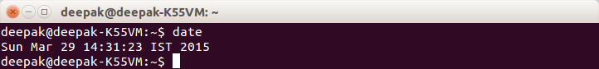

* 1. How to get the current logged in user

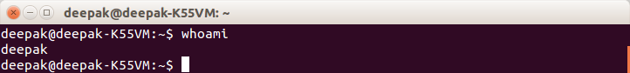

* 1. How to get the current working directory.

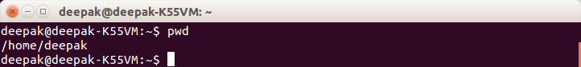

* 1. How to g. get the list of all commands that you have typed so far

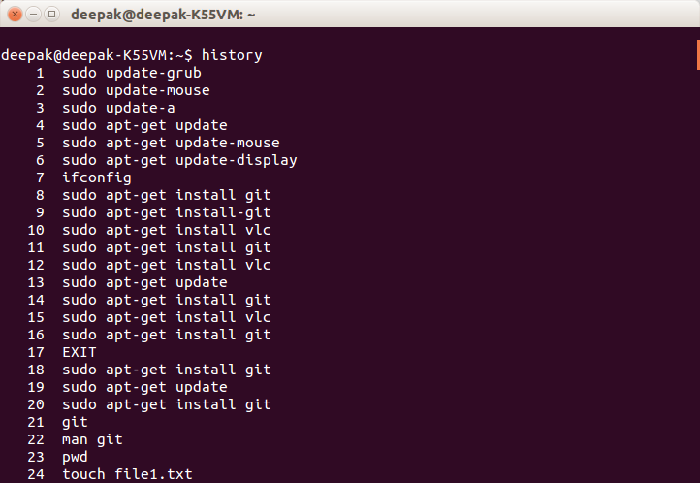

* 1. To get the information on the tcp ports

ans: netstat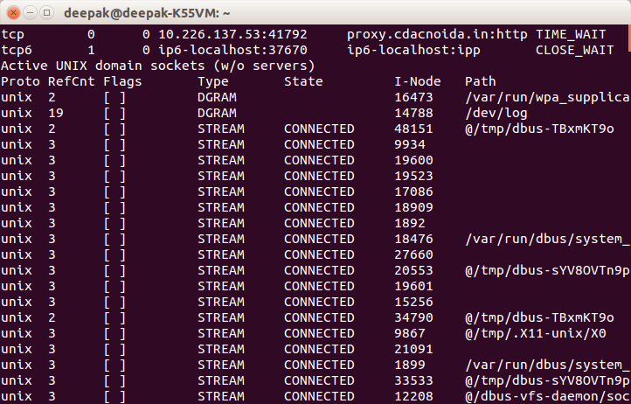

* 1. To get the information about the running processes.

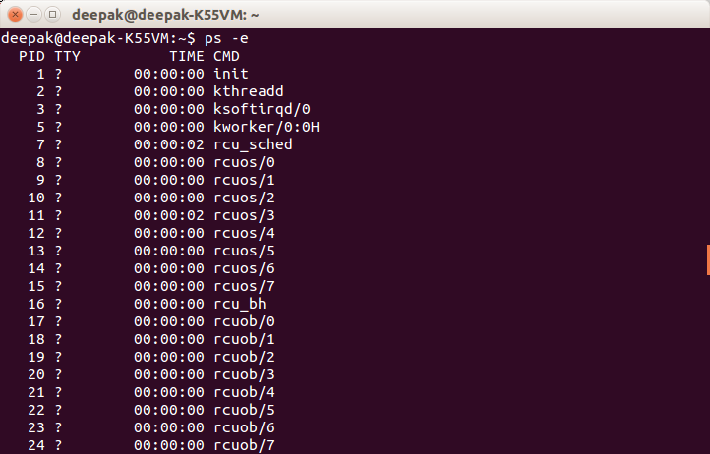

* 1. Search for a word in a file. (Hint – grep)

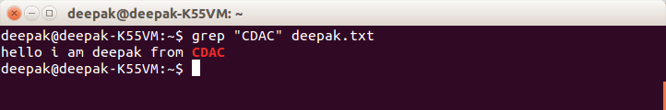

* 1. Search for a specific process. (Hint - use | with ps )

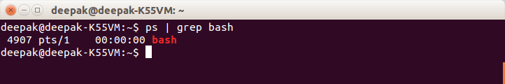

1. Create a directory “exercises” inside your home directory. **cd** to this new directory.

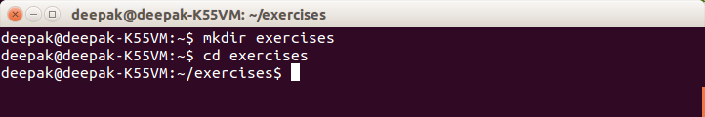

1. Create 3 empty files , file1.txt,file2.txt,file3.txt in current directory (exercises).

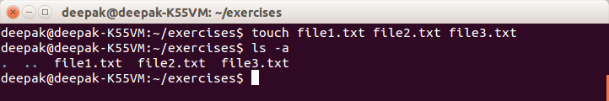

1. Add some text to **file1.txt** and copy this to **~/exercises/files**.

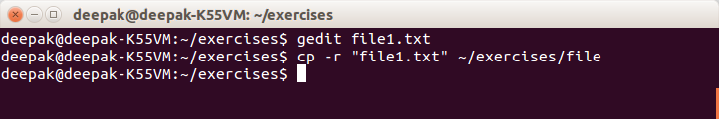

1. Copy the entire **exercise** directory to this **files** directory.

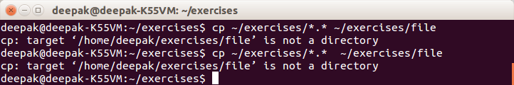

1. Create a symlink “testlink” in your home directory that points to this file1.txt i.e. **~/exercises/files/file1.txt.**

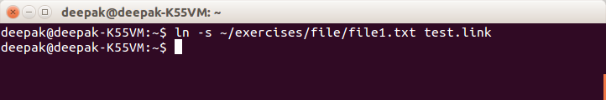

1. Try **7.** creating a hard link in your home directory that points to **“files”** directory .

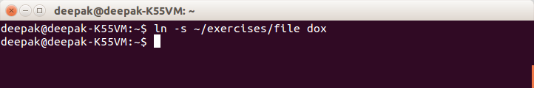

1. Difference between soft and hard link.

A symlink is actually pointing to another path (a file name) and it resolves the name of the file each time you access it through the symlink. If you move the file, the symlink will not follow. If you replace the file with another one, keeping the name, the symlink will point to the new file. Symlinks can span filesystems.

On the other hand, a hardlink isn't a pointer to a file, it's a directory entry (a file) pointing to the same inode. Even if you change the name of the other file, a hardlink still points to the file. If you replace the other file with a new version (by copying it), a hardlink will not point to the new file. You can only have hardlinks within the same filesystem.

1. Change permissions for **files** directory such that nobody other than the user who created the directory, can write/update anything in that directory.

Ans: ~/exercises$ ls

~/exercises$ ls -l

1. Create a new user “test”.

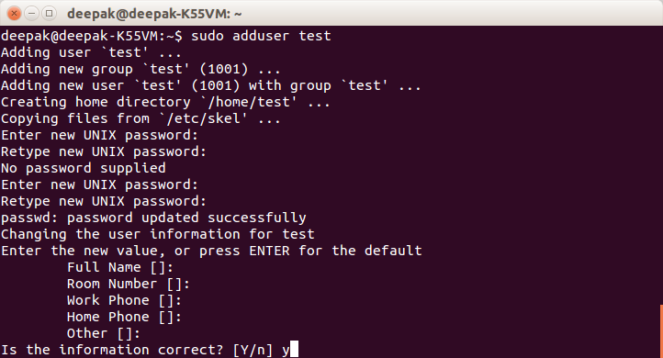

1. Change the owner of **file1.txt** to **test**

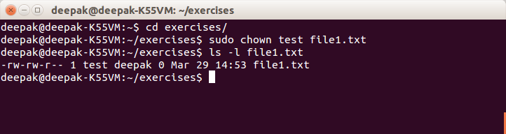

1. create following directory structure with single command -

home

|-john

|-work

|-scripts

|-bash

Assume that you are currently in ‘home’ directory.

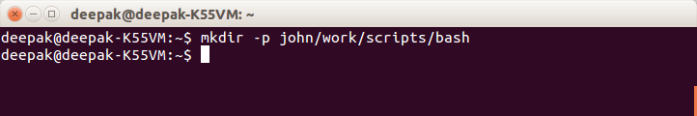

1. Try deleting the ~/exercises/files/exercises directory. See what happens.

Ans:

rmdir ~/exercises/files/exercises

1. A file named employees.odt has a mode of rw-r- -r- -. If John is not the file's owner but is a member of the group that owns this file, what can he do with it?

**only read**

1. Create an alias for clearing the screen.

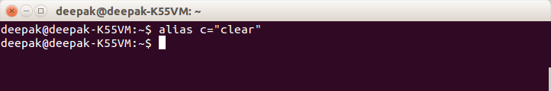

1. Create a tar archive of all the files in the current directory.

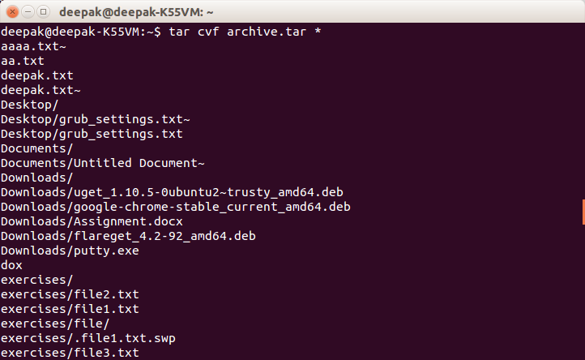

1. How to find if a jar file contains a particular class file?

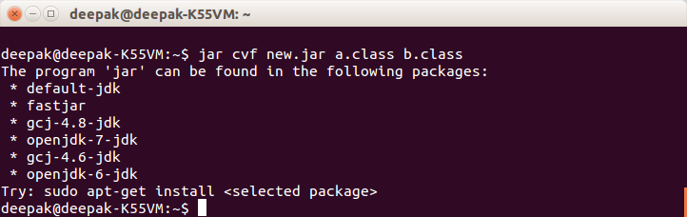

1. How to find all jars with given classname.

Ans: Jar cvf new2.jar a.class

1. How to find files greater than a certain size

find . -size 50k

1. How do u add and remove a variable in the shell environment.

Ans: adding_test='Adding global variable'

1. Install openssh-server on your system

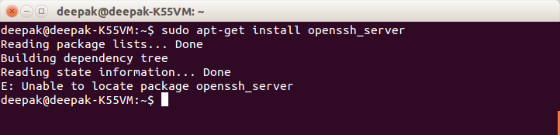

1. try remote login to your friend’s machine using ssh.

Ans: [aroop@10.226.46.220](mailto:aroop@10.226.46.220)

yes

1. Copy some files from your machine to your friend’s machine. (Hint – scp)

Ans: scp deepak.txt [aroop@10.226.46.220](mailto:aroop@10.226.46.220):~/

yes