HOTEL REVENUE ANALYSIS
MODULE 4
1. Objective
The purpose of this module is to analyze booking cancellations, no-show behavior, refund activity, and demand forecasting. By introducing analytical fields such as CancellationFlag, CancellationRate, LeadTime, RefundAmount, RefundFlag, and NoShowFlag, hotels can better identify unreliable Booking, measure cancellation risks, and evaluate the financial impact of refunds.
Using Power BI, DAX calculations, and forecasting models, this module enables hotels to anticipate occupancy, plan pricing strategies, and strengthen revenue management. The forecasting and cancellation analytics layer provides visibility into guest behavior and supports proactive operational decisions.
2. Columns and Measures
2.1 CancellationFlag (Cancelled vs. Completed Booking)
A new column called CancellationFlag was created to classify Booking as cancelled or not cancelled.
DAX Formula:
CancellationFlag =
IF(Booking[Bookingstatus] = "Cancelled", "Yes", "No")
This field helps segment cancellations, calculate ratios, and forecast cancellation trends.
2.2 LeadTime (Booking Behaviour)
LeadTime measures the number of days between the booking date and the check-in date. It is a critical predictor of cancellations, as Booking made either too far in advance or very close to arrival often show higher cancellation rates.
DAX Formula:
LeadTime =
DATEDIFF(Booking[BookingDate], Booking[CheckInDate], DAY)
2.3 RefundAmount (Financial Impact)
RefundAmount calculates the revenue refunded when a booking is cancelled.
DAX Formula:
RefundAmount =
IF(
Booking[Bookingstatus] = "Cancelled",
Booking[Revenue],
0
)
This supports visuals that track refund values and cancellation-related costs.
2.4 RefundFlag (Refund Indicator)
RefundFlag is a binary indicator showing whether a booking resulted in a refund.
DAX Formula:
RefundFlag =
IF(NOT(ISBLANK(Booking[RefundAmount])), 1, 0)
This field helps distinguish cancellations that caused financial loss from those that did not.
2.5 NoShowFlag (Guest Reliability)
A NoShowFlag column was introduced to identify Booking where guests did not arrive despite confirming reservations.
DAX Formula:
NoShowFlag =
IF(Booking[Bookingstatus] = "No-Show", 1, 0)
This enables no-show trend analysis and supports operational strategies such as overbooking.
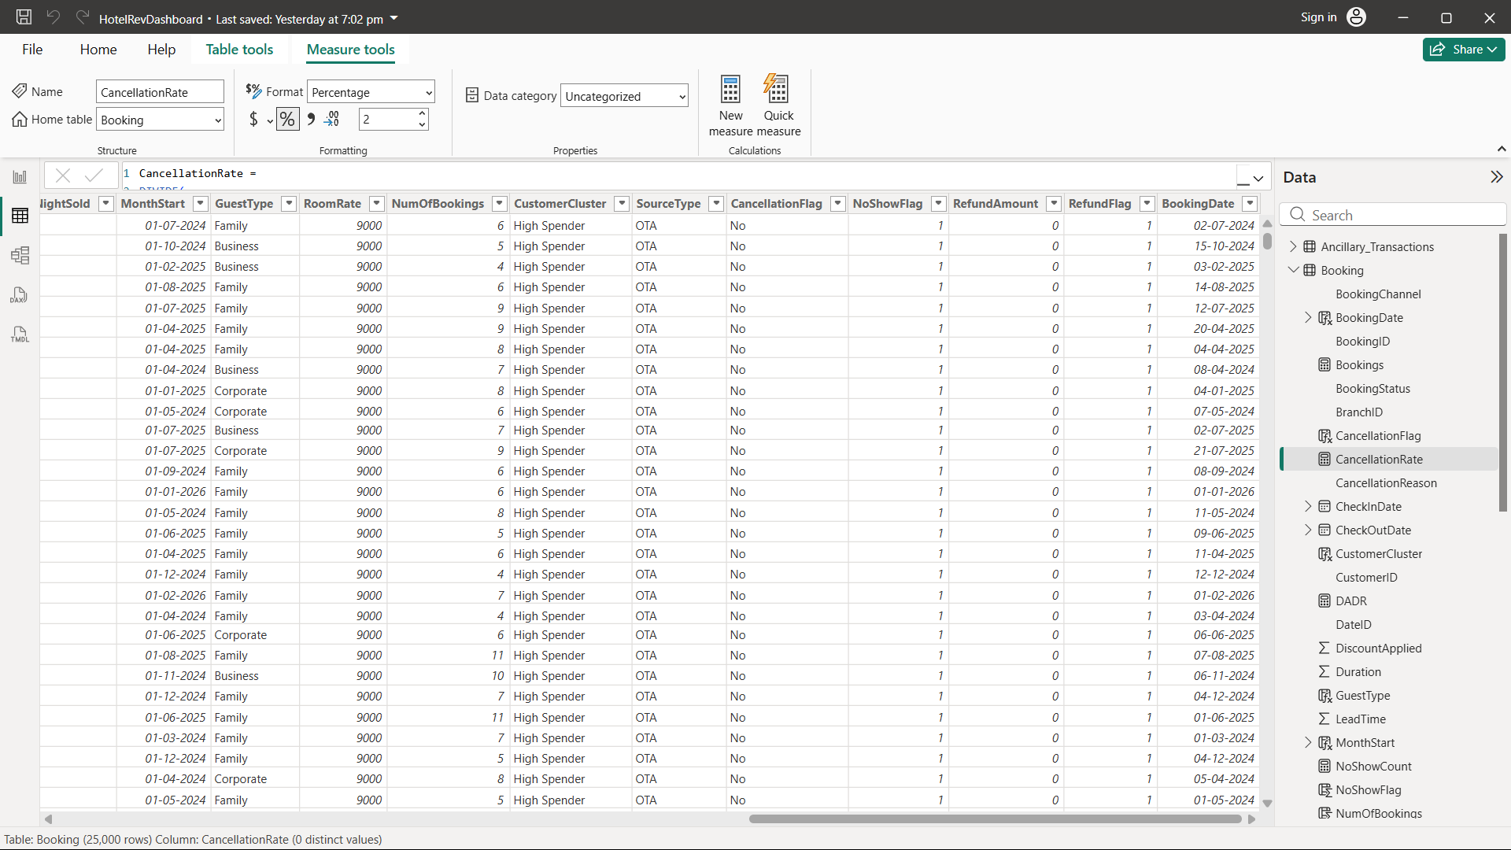
2.6 RoomRate and DADR
- RoomRate is derived from the RoomType table and represents the base price of each room category.
- DADR (Derived ADR) calculates the average daily rate based on room pricing.
DAX Formulas:
RoomRate =
RELATED(RoomType[Price])

(Measure) DADR =
AVERAGE(Booking[RoomRate])
These metrics support forecasting revenue and optimizing pricing.
2.7 Recommended Price (Dynamic Pricing Output) (Measure)
A pricing model was created using seasonality, price uplift, and occupancy elasticity.
DAX Formula:
Recommended Price =
VAR BaseADR = [DADR] -- Use your valid ADR measure
VAR SeasonAdj =
SWITCH(SELECTEDVALUE('Date'[Season]),
"High", 0.15,
"Shoulder", 0.05,
"Low", -0.10,
0
)
VAR Uplift = [Price Uplift % Value]
VAR Elasticity = [Occupancy Sensitivity Value]
RETURN
BaseADR * (1 + SeasonAdj + Uplift) * Elasticity
This simulates how price changes influence occupancy and supports revenue management decisions.
2.8 CancellationRate (Booking Reliability) (Measure)
CancellationRate calculates the ratio of cancelled Booking to total Booking.
DAX Formula:
CancellationRate =
DIVIDE(
COUNTROWS(
FILTER(Booking, Booking[CancellationFlag] = "Yes")
),
COUNTROWS(Booking)
)
This KPI helps compare cancellation behavior across booking channels, room types, and guest segments.
2.9 NoShowCount (Total No-Shows) (Measure)
A measure was created to calculate the total number of no-show Booking.
DAX Formula:
NoShowCount =
CALCULATE(
COUNTROWS(Booking),
Booking[Bookingstatus] = "No-Show"
)
This supports visualizations of no-show patterns by time period, channel, or guest demographics.
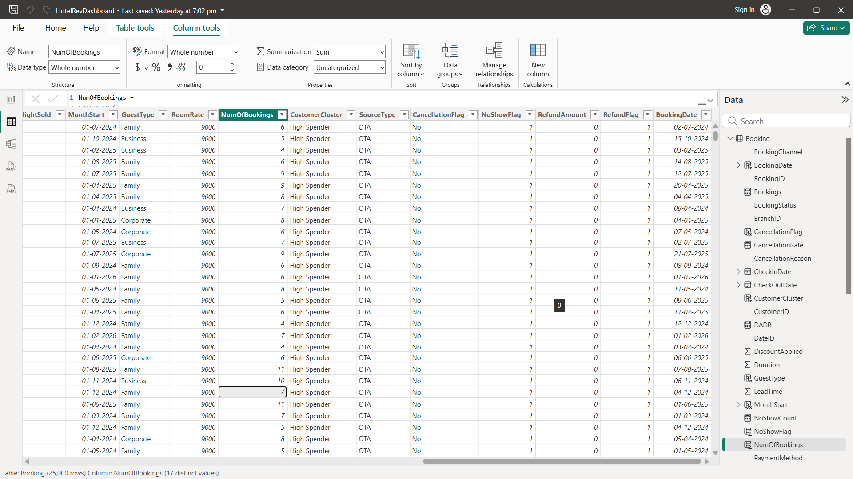
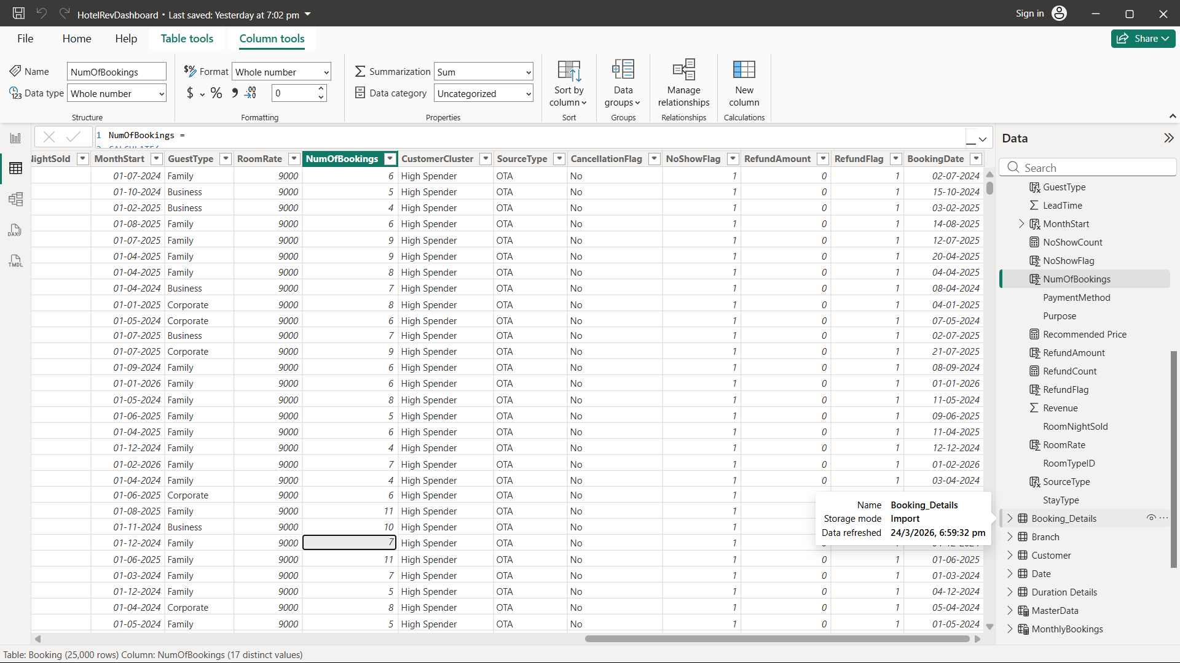
3. Visuals
3.1 Future Occupancy Forecast
A line chart was created using Power BI’s forecasting model to project occupancy for the next 7 months.
- Units: Points
- Forecast Length: 3
- Ignore Last: 0
- Seasonality: Auto-detected
- Confidence Interval: 95%
This visualization helps hotels anticipate demand, plan staffing, adjust inventory, and prepare pricing strategies.
3.2 Cancellation Rate Over Time
A line chart shows monthly and yearly cancellation rates. It highlights seasonal spikes, unstable booking periods, and months with peak cancellations, supporting policy adjustments and forecasting accuracy.
3.3 Lead Time Distribution
A horizontal bar chart illustrates the distribution of LeadTime. It reveals last-minute Booking, early reservations, and the most common lead-time window, helping identify which booking windows carry higher cancellation risks.
3.4 NoShowCount and RefundCount by Year
A stacked bar chart compares yearly NoShowCount and RefundCount. This highlights:
- yearly no-show volumes,
- total refunds issued, and
- whether customer reliability is improving or declining.
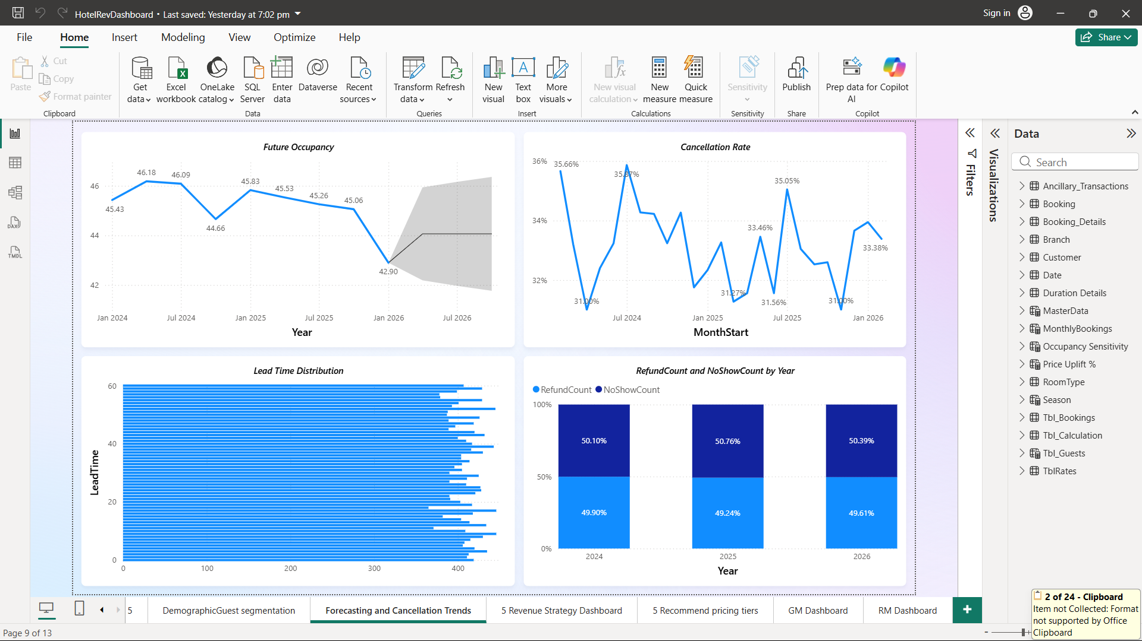
4. Insights and Learning
- Cancellation Trends: Clear seasonal and yearly patterns identified.
- Lead Time Reliability: Very early or last-minute Booking showed higher cancellation likelihood.
- Forecasting Visibility: Power BI’s forecast provided reliable occupancy projections with confidence intervals.
- No-Show & Refund Impact: Consistent no-show volumes and measurable refund losses quantified revenue risk.
- Operational Planning: Insights supported better staffing, pricing, and inventory decisions.
- Predictive Foundation: Metrics like LeadTime, CancellationFlag, and forecasting outputs prepare the system for advanced predictive models and dynamic pricing.

