Building EA313X targets using uVision4 Keil projects

Table of contents
1 Introduction 3
1.1 Target – default 4
1.2 Target - cache 4
1.3 Target – sdram 5
1.4 Target – sdram cache 6

Introduction
The EA31XX example applications are provided with uVision4 Keil projects for building the targets. This document will provide information on selection of targets. There are 4 possible targets that you can build the binaries for. They are
- default
- cache
- sdram
- sdram_cache

Target can be selected in uvision4 GUI from the Build Toolbar as shown below (if build tool bar is not visible, enable it from view menu->Toolbars->Build Toolbar):

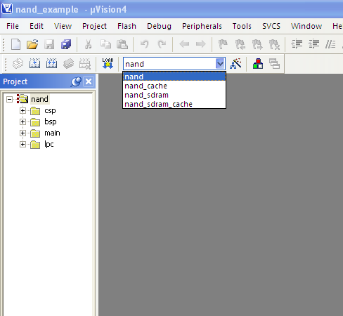
Targets
Build Toolbar

IMPORTANT NOTE:
- Please make sure that while switching from iram target to sdram target or vice versa, use "clean target" to remove the existing objects
- Please note that some applications are too big to fit into internal SRAM, those applications will have SDRAM targets only.

Target – default

Load Memory Device : IRAM (Internal SRAM)
Load Address : 0x11029000
Execute Address : 0x11029000

The default target will generate an image which will run from uncached SRAM area. Instruction Cache is enabled by default, the region of execution is not be cached by D-Cache. For default target, Keil target name will not have “_cache” or “_sdram” keywords. For example, the default nand target will be as shown below:

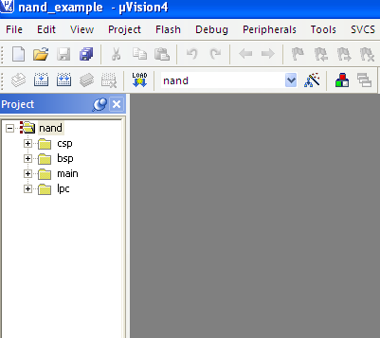

Target - cache
Load Memory Device : IRAM (Internal SRAM)
Load Address : 0x11029000
Execute Address : 0x11129000

This target will generate files (binary, map etc.) with _cache suffix. Executables generated with this target will have both I and D-Caches enabled. Codes that make use of DMA must take care of cache coherency. (See ea31xx_cache_coherency.txt). The cache target will have “_cache” keyword in target name. For example, nand cache target will be as shown below:

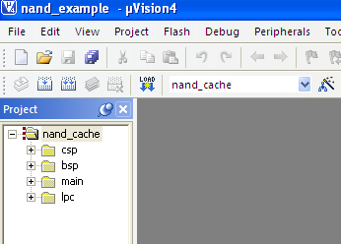

Target – sdram

Load Memory Device : SDRAM (External Memory)
Load Address : 0x31000000
Execute Address : 0x31000000

This target will generate binaries that can be loaded on to SDRAM using any bootloader like (u-boot, apex etc.,). For more details on how to load and execute image from u-boot see section 6 of ea3131_build_targets.txt file. Code that will not fit into smaller memory like Internal SRAM can be built for SDRAM using this target. The sdram target will have “_sdram” keyword in target name. For example, nand cache target will be as shown below:

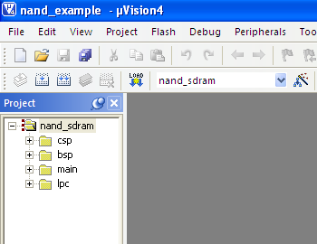

Target – sdram cache
Load Memory Device : SDRAM (External Memory)
Load Address : 0x31000000
Execute Address : 0x41000000

This target will generate files (binary, map etc.) with _cache suffix. Executables generated with this target will have both I and D-Caches enabled. Codes that make use of DMA must take care of cache coherency (See ea31xx_cache_coherency.txt). Binaries generated using this target must be loaded on to external SDRAM using any of the existing boot loaders (Example u-boot, apex, etc.,). For example, nand sdram cache target will be as shown below:

