**HCI – HW3**

**Fitts’s Law Experimentation**

|  |  |
| --- | --- |
| **NAME: SIREESHA BASAMSETTY** | **UIN: 670486396** |

**Fitts’s Law Description:**

Fitts’s law is a predictive model of human movement used in human-computer interaction. It describes how the distance from the source to the destination and the width of the target influence the index of difficulty(ID) of the task.

Different input modalities such as mouse, touch, mid-air, eye gaze, 3D tracker etc can be used to conduct a Fitts’s law experiment.

According to Shannon’s formula for Fitts’s law, the formula for **index of difficulty** is given by:

ID = log2((A/W) +1) [Units: ‘bits’]

**Movement time** – which is the time taken to move a pointer from the source to the destination point is calculated as follows:

MT = a + b * ID or MT = b * ID

Depending on whether the line goes through the origin. b is the slope of the line.

**Throughput –** Combines speed and accuracy in one single measure. The formula is given by:

Throughput = (ID / MT) bits/s

**Fitts’s Law Experiment for Aimed Movement:**

* The input modality I have chosen for my experiment is **MOUSE**.
* The Performance Test I am considering is the **Multi-Directional Tapping test**. Here, I will be considering my targets as circles whose width and amplitude will be randomized on every click.

**Steps to conduct in experiment:**

1. This is the window where the experiment will be conducted and data will be gathered based on the mouse clicks made by the user.

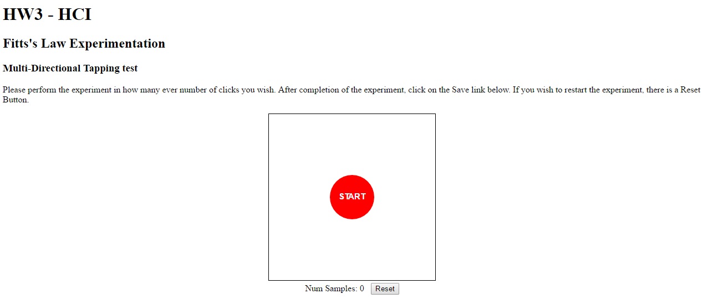

1. The user will click on START.
2. This is how the visualization will look. User will start clicking on the red circles. With every click, the circle(target) size and amplitude will change or be randomized in other words.

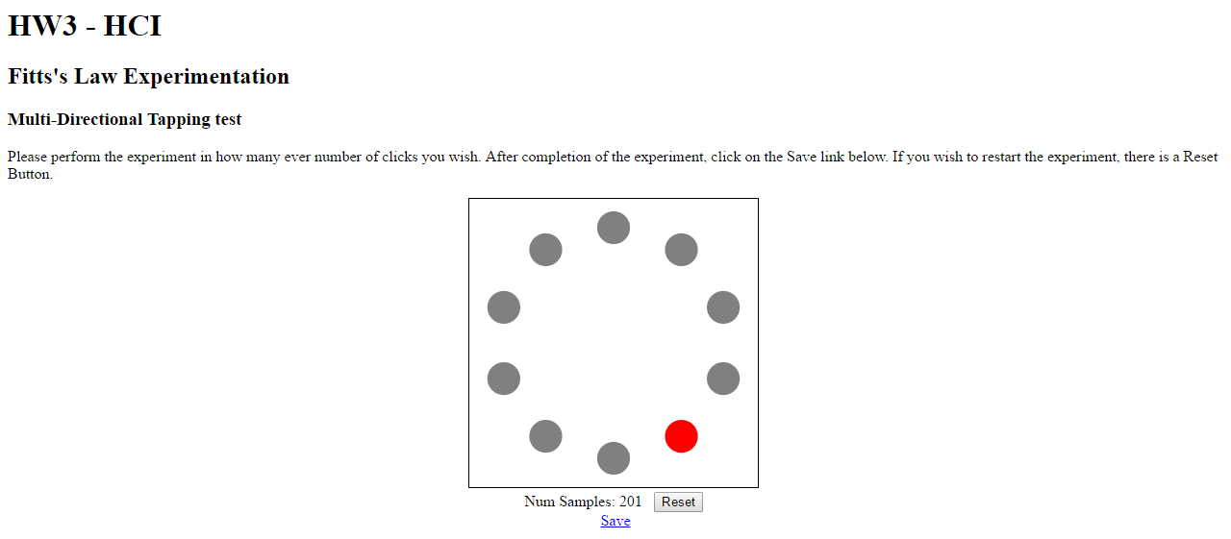

1. The user can collect as many samples as he wants. The number of samples is incremented and displayed below showing how many clicks the user has performed. After he is done, he can click on the save link below.
2. This saves a JSON file of data consisting of:

|  |  |
| --- | --- |
|  | 1.Time |
| 2.Amplitude |
| 3.Width |

1. Copy this “data.json” file into the same directory as the report.py file.
2. Run the report.py file. Experiment has been conducted using Python.
3. Results:

**Plots:**

|  |  |
| --- | --- |
| 1. Movement time over Index of Difficulty | 2.Throughput over Index of Difficulty |
|  |  |

**Regression Coefficients obtained:**

Regression coefficients: A=0.12764162131540122, B=0.20558492356941407

**Analysis of Data collected:**

**Device Assessment Questionnaire:**

|  |  |  |  |  |  |
| --- | --- | --- | --- | --- | --- |
| 1. **The force required for actuation was:** | | | | | |
|  |  | X |  |  | |
| **TOO LOW TOO HIGH** | | | | | |
| 1. **Smoothness during operation was:** | | | | | |
|  |  |  | X |  | |
| **VERY ROUGH VERY SMOOTH** | | | | | |
| 1. **The mental effort required for operation was:** | | | | | |
|  | X |  |  |  | |
| **TOO LOW TOO HIGH** | | | | | |
| 1. **The physical effort required for operation was:** | | | | | |
|  |  | X |  |  | |
| **TOO LOW TOO HIGH** | | | | | |
| 1. **Accurate pointing was:** | | | | | |
|  |  | X |  |  | |
| **EASY DIFFICULT** | | | | | |
| 1. **Operation speed was:** | | | | | |
|  |  | X |  |  | |
| **TOO FAST TOO SLOW** | | | | | |
| 1. **Finger fatigue:** | | | | | |
|  |  |  | X |  | |
| **NONE VERY HIGH** | | | | | |
| 1. **Wrist fatigue:** | | | | | |
|  |  |  | X |  | |
| **NONE VERY HIGH** | | | | | |
| 1. **Arm fatigue:** | | | | | |
|  |  | X |  |  | |
| **NONE VERY HIGH** | | | | | |
| 1. **Shoulder fatigue:** | | | | | |
|  | X |  |  |  | |
| **NONE VERY HIGH** | | | | | |
| 1. **Neck fatigue:** | | | | | |
|  | X |  |  |  | |
| **NONE VERY HIGH** | | | | | |
| 1. **General comfort:** | | | | | |
|  |  |  | X |  | |
| **VERY UNCOMFORTABLE VERY COMFORTABLE** | | | | | |
| 1. **Overall, the input device was** | | | | | |
|  |  |  | X |  | |
| **VERY DIFFICULT TO USE VERY EASY TO USE** | | | | | |
|  | | | | |

**Source Code link to Github Repository:**

<https://github.com/sireesha1231/HCI-HW3>

1. index.html – For visualization and experimentation
2. report.py – For performing regression and displaying output plots