**Task Management Application**

Access app here: <https://main--sparkling-hamster-7d3751.netlify.app/taskList>

Codebase: <https://github.com/sireeshaKambham/TaskManagementApp>

**Steps to run project:**

Make sure Node js is installed and follow the below steps:

Clone project ( from the github link provided above)

Cd task-management-chase

npm install

npm run dev (**used Vite configuration for build)**

Features implemented:

1. Created Reactjs project with typescript template
2. Latest React-router dom
3. Context API
4. Custom hooks
5. react-i18next ( localization) – go to i18n.ts file, line number 14: change the language ( update to lng:”fr”)
6. material UI components / Icons
7. CSS pre-processor (sass)
8. Responsiveness
9. Coding standards

Functionalities:

List of tasks

Add new task

Delete Task

Seach Task and Navigation

Screenshots:

Task list:

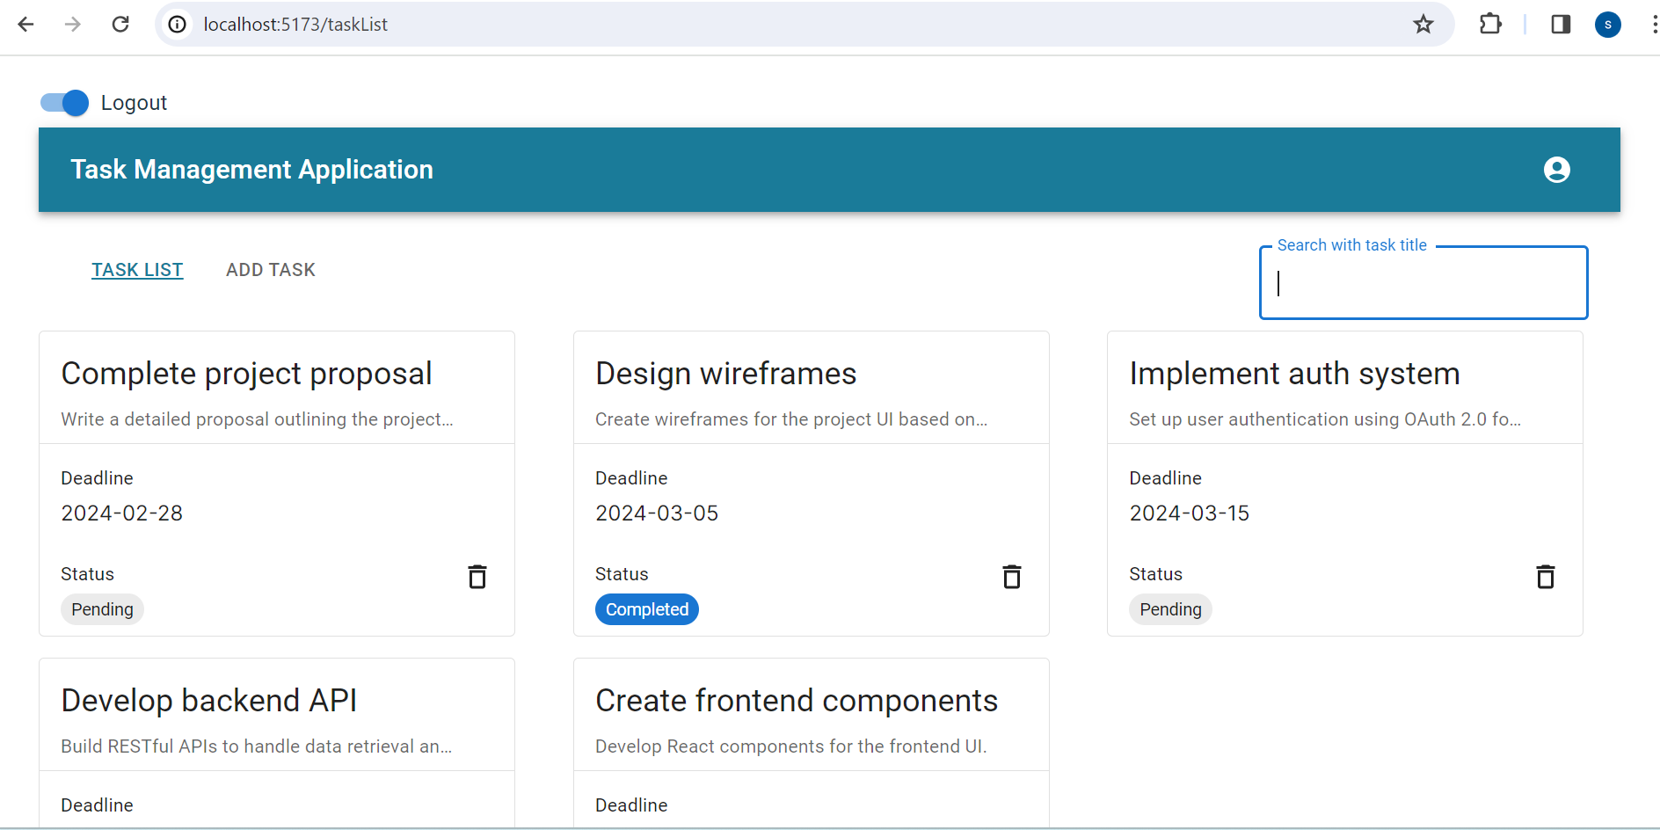

Add Task:

Responsive view :

Task List:

Add task:

