

**Project Details**

|  |  |
| --- | --- |
| **Project Code:** | NEP-NEC-PJ-MPOS-DEVELOP |
| **Project Name:** | NEP-NEC-PJ-MPOS-DEVELOP |
| **Account:** | NEC |
| **Vertical:** | TECH |
| **Location:** | Bangalore |
| **Client Name:** | NEC |
| **Delivery Manager/ Email ID:** | Shankari [Murugesan/Shankari.murugesan@wipro.com](mailto:Murugesan/Shankari.murugesan@wipro.com) |
| **Project Manager / Email ID:** | Tarachand Batchu tarachand.batchu@wipro.com |
| **Client Contact Information:** |  |
|  |
|  |
|  |

|  |  |  |  |  |
| --- | --- | --- | --- | --- |
| 01/25/2019 |  |  |  |  |
| **Prepared by/Date** |  | **Reviewed by/Date** |  | **Approved by/Date** |

**Revision History**

|  |  |  |  |  |  |
| --- | --- | --- | --- | --- | --- |
| **Version (x.yy)** | **Date of Revision** | **Description of Change** | **Reason for Change** | **Affected Sections** | **Approved By** |
| 0.1 | 01/25/2019 | Initial Version |  |  |  |

**CI/CD Implementation using AWS**

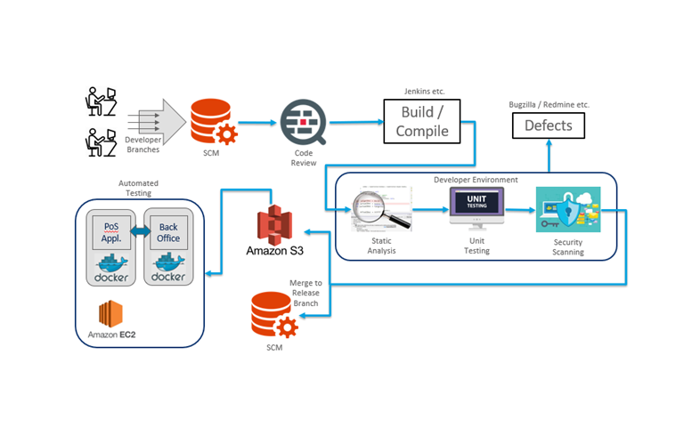

**Overview of Tools**

**GitHub :** GitHub Inc. is a web-based hosting service for version control using Git. It is mostly used for computer code. It offers all of the distributed version control and source code management functionality of Git as well as adding its own features. It provides access control and several collaboration features such as bug tracking, feature requests, task management, and wikis for every project.

**Jenkins:** Jenkins is an open source automation server written in Java. Jenkins helps to automate the non-human part of the software development process, with continuous integration and facilitating technical aspects of continuous delivery. It is a server-based system that runs in servlet containers such as Apache Tomcat. It supports version control tools, including AccuRev, CVS, Subversion, Git, Mercurial, Perforce, TD/OMS, ClearCase and RTC, and can execute Apache Ant, Apache Maven and sbt based projects

**Docker:** Docker is a software platform that allows you to build, test, and deploy applications quickly. Docker packages software into standardized units called containers that have everything the software needs to run including libraries, system tools, code, and runtime. Using **Docker**, you can quickly deploy and scale applications into any environment and know your code will run.

To deploy the same image in different environments we need to add spring profile active jar details in Docker file. So that we can use same image in different environments with different databases.

EX:

java -jar -Dspring.profiles.active=prod application.jar

**AppCentre:** Continuous Everything – Build, Test, Deploy, Engage, Repeat.

Ship iOS, Android, Windows, and macOS apps faster and with greater confidence by automating their lifecycles. Connect your repository and, within minutes, build in the cloud, test on thousands of real devices, distribute to beta testers and app stores, and monitor real-world usage with crash and analytics data. All in one place

**GitHub Url :** [**https://github.com/NEC-mobile-pos/new_mPOS_Source**](https://github.com/NEC-mobile-pos/new_mPOS_Source)

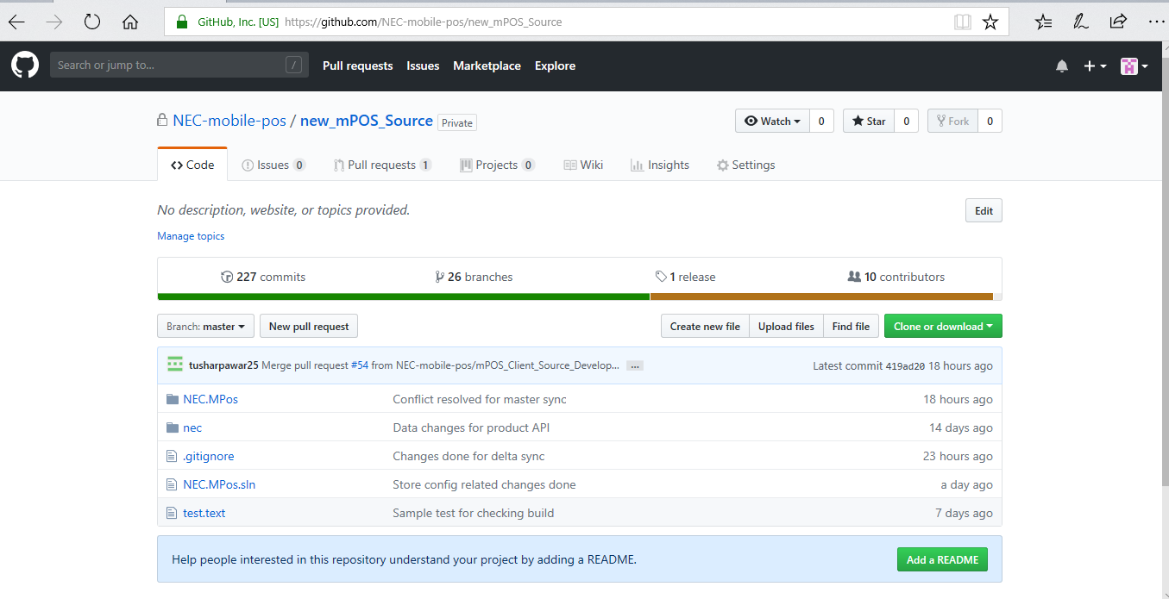

GitHub Repository name : NEC-mobile-pos/new_mPOS_Source

Two branches have created from Master branch one is to maintain baseline code for server and another for client applications (mPOS_Client_Source_Develop). Every developers have created feature branches from these branches.

**App Center Url :** <https://appcenter.ms/users/mPOSClientApp/applications>

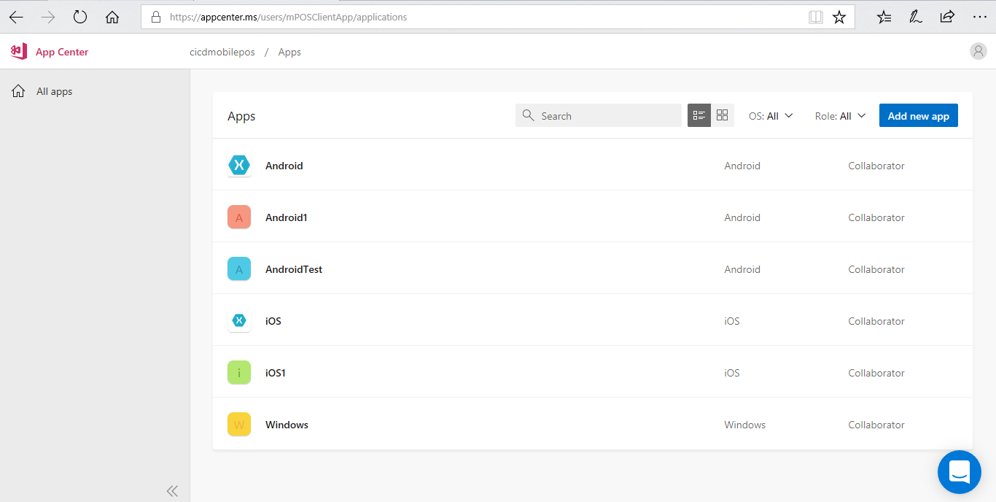

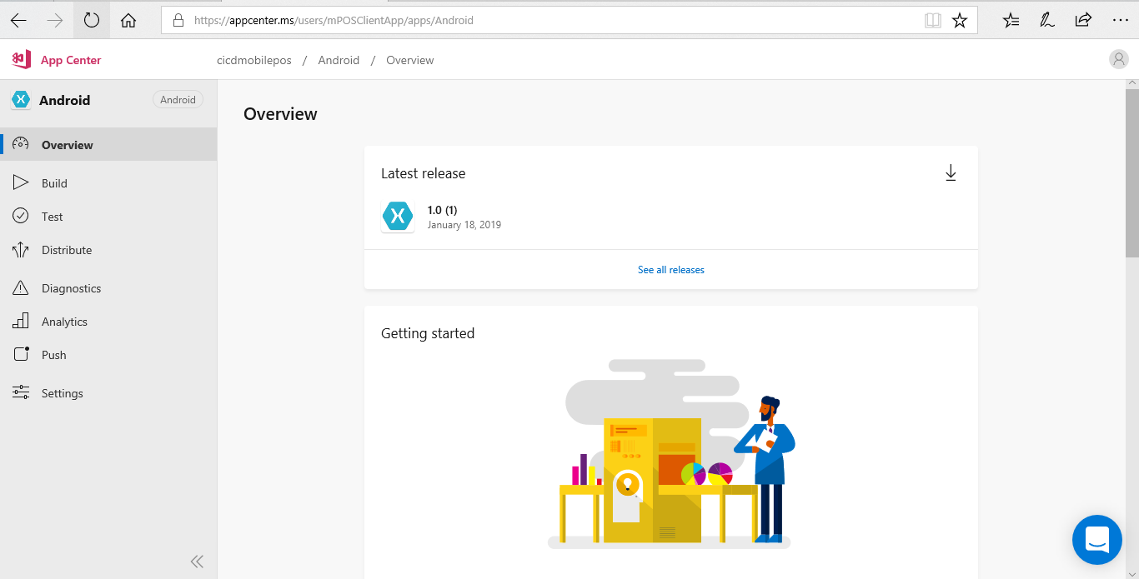

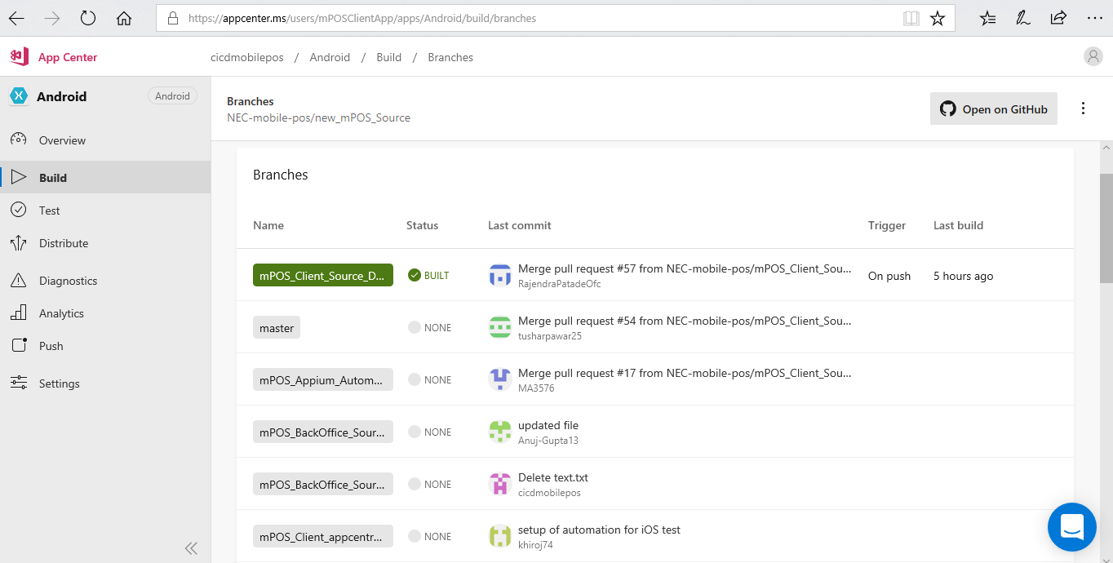

**Jenkins Url** : <http://18.182.120.233:8080/login?from=%2Fconfigure>

